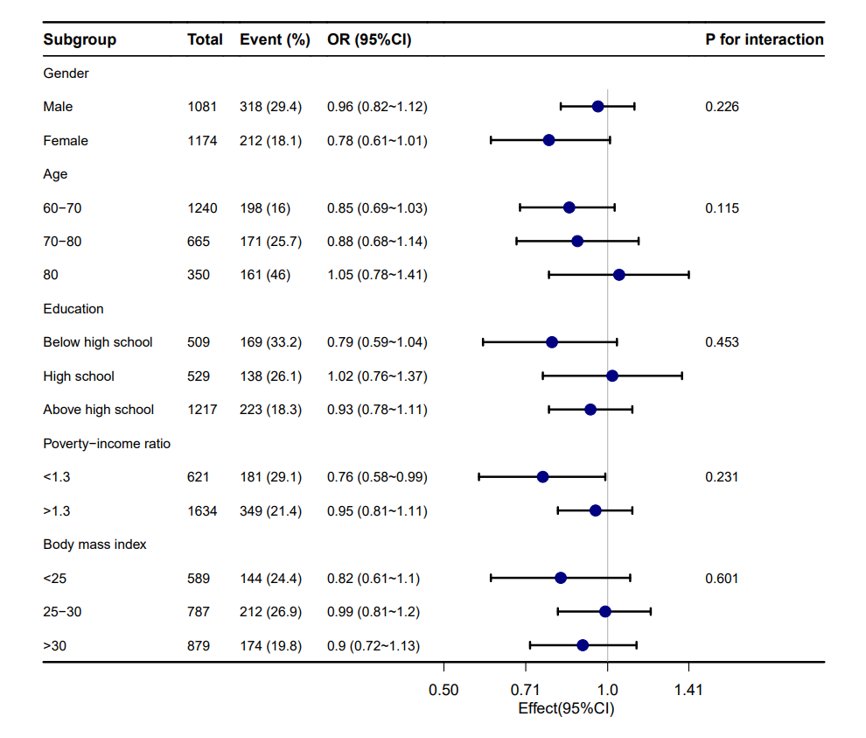
supplement Figure 6. Stratified analyses of the association between low cognitive perfomance and riboflavin intake according to baseline characteristics.
Note: The p value for interaction represents the likelihood of interaction between the variable and riboflavin intake. Abbreviations: OR, odd ratio; CI, confidence interval.

