Expression profile and prognostic value of the circadian clock in clear cell renal cell carcinoma
Supplementary materials
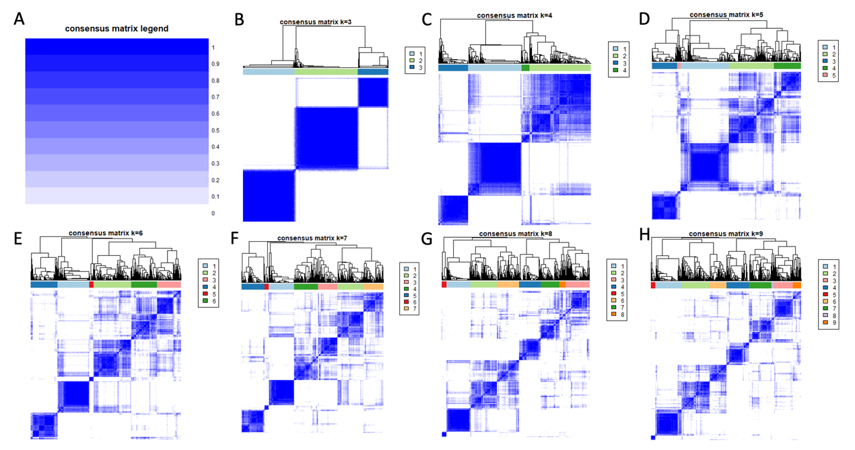
Supplementary Figure 1. 526 ccRCC patients were grouped according to the consensus clustering matrix. (A) consensus matrix legend. (B) k=3. (C) k=4. (D) k=5. (E) k=6. (F) k=7. (G) k=8. (H) k=9.

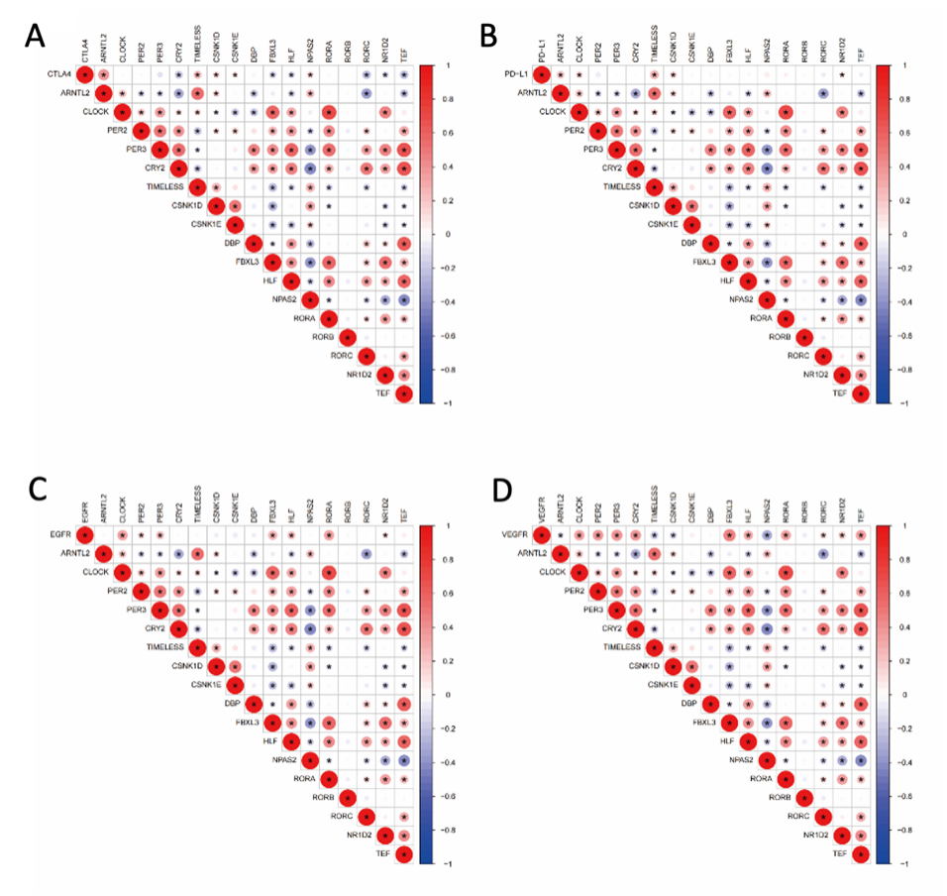
Supplementary Figure 2. The correction between prognostic genes and CTLA4, PD-L1, EGFR and VEGFR. (A) CTLA4. (B) PD-L1. (C) EGFR. (D) VEGFR.
Supplementary Figure 3. Construction and validation of a nomogram. (A) Nomogram for predicting the 1-, 3-, and 5--year OS of ccRCC patients in the training set. (B) ROC curves demonstrated the predictive efficiency of the risk score in training set. (C) ROC curves demonstrated the predictive efficiency of the risk score in test set. (D) Calibration curves of the nomogram for predicting of 1-, 3-, and 5-year OS in the test set.

Supplementary Figure 4. The ssGSEA analysis results and the risk score correlated with immune cell infiltration. (A) The difference of infiltrating score for immune cells in TCGA cohort. (B) The difference of infiltrating score for immune related pathways’ activity in TCGA cohort. (C-H) Correlations between Risk score and immune cell types.

