Supplementary Information
Evaluation of Lytic polysaccharide monooxygenases for cellulose functionalization
L. Verónica Cabañas-Romero^{a,b ⁎}, Josefina Martínez^{a,b}, Susana V. Valenzuela^{a,b}

ª Department of Genetics, Microbiology, and Statistics, Faculty of Biology, Universitat de Barcelona, Av. Diagonal 643, 08028, Barcelona, Spain
^{b} Institute of Nanoscience and Nanotechnology (IN²UB), Universitat de Barcelona, Spain

veronica.cabanas@ub.edu
jmartinez@ub.edu
susanavalenzuela@ub.edu

⁎ Corresponding author at Department of Genetics, Microbiology, and Statistics, Faculty of Biology, Universitat de Barcelona, Av. Diagonal 643, 08028, Barcelona, Spain.

S1. Scheme of the reactions of SamLPMO10C on bacterial cellulose and eucalyptus.
 | BC | eucalyptus
Pulp (dry weight) (g) | 0,5 | 2
SamLPMO10C (mg) | 2 | 8
Ammonium acetate (mM) | 50 | 50
Ascorbic acid (mM) | 2 | 2
Final Volume (ml) | 50 | 40
0,5 M EDTA (ml) | 3,5 | 3,5

S2. HPAEC-PAD Chromatograms of the supernatants of the oxidation reactions. A) Negative control of bacterial cellulose without enzymatic treatment, B) and C) bacterial cellulose oxidized products. D) Negative control of eucalyptus cellulose without enzymatic treatment, E) and F) eucalyptus cellulose oxidized products.
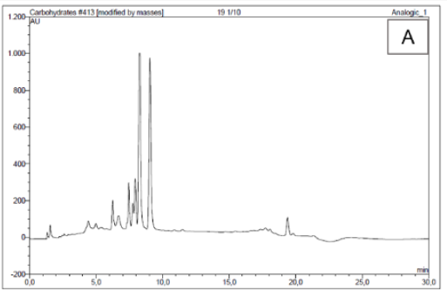
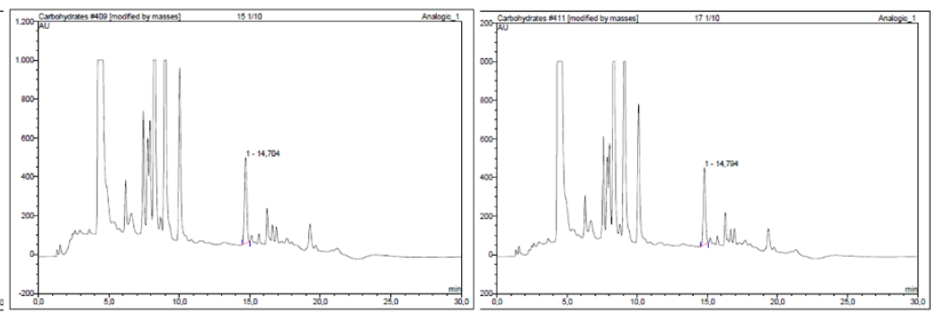
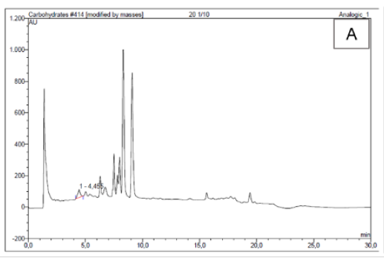
F
E
D
A
C
B
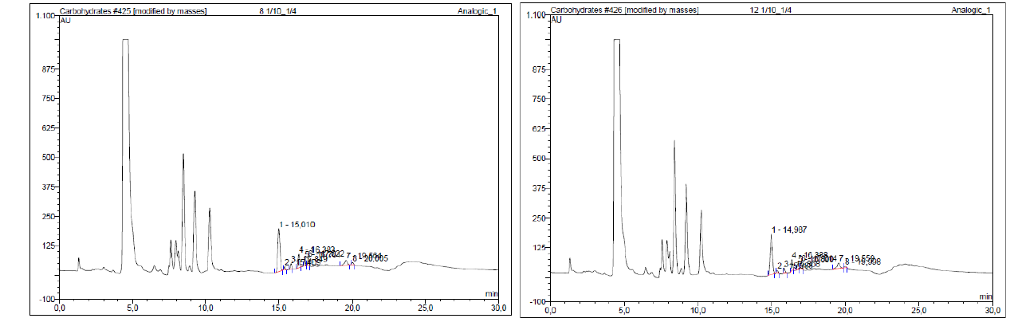

S3. Titration curves of cellulosic substrates
Bacterial cellulose (without oxidation) 1

Bacterial cellulose (without oxidation) 2

Bacterial cellulose (without oxidation) 3

Eucalyptus cellulose (without oxidation) 1

Eucalyptus cellulose (without oxidation) 2

Eucalyptus cellulose (without oxidation) 3

Bacterial cellulose oxidated by SamLPMO10C 1

Bacterial cellulose oxidated by SamLPMO10C 2

Bacterial cellulose oxidated by SamLPMO10C 3

Eucalyptus cellulose oxidated by SamLPMO10C 1

Eucalyptus cellulose oxidated by SamLPMO10C 2

Eucalyptus cellulose oxidated by SamLPMO10C 3

