Supplementary Information for

Transcriptomic insights into archaeal nitrification in the Amundsen Sea Polynya, Antarctica

Joo-Han Gwak¹, Samuel Imisi Awala¹, So-Jeong Kim², Sang-Hoon Lee³, Eun-Jin Yang³, Jisoo Park³, Jinyoung Jung³, and Sung-Keun Rhee^{1*}
¹Department of Biological Sciences and Biotechnology, Chungbuk National University, 1 Chungdae-ro, Seowon-Gu, Cheongju 28644, Republic of Korea. ²Geologic Environment Division, Korea Institute of Geoscience and Mineral Resources, 124 Gwahak-ro, Yuseong-gu, Daejeon 34132, Republic of Korea. ³Korea Polar Research Institute,​ 26 Songdomirae-ro, Yeonsu-gu, Incheon 21990,​ Republic of Korea​.

*Correspondence: rhees@chungbuk.ac.kr

This file includes:
Figures S1 to S4

Other additional files for this manuscript include the following:
Additional file 2: Table S1 and S2
Additional file 3: Dataset S1 and S2

SI Figures
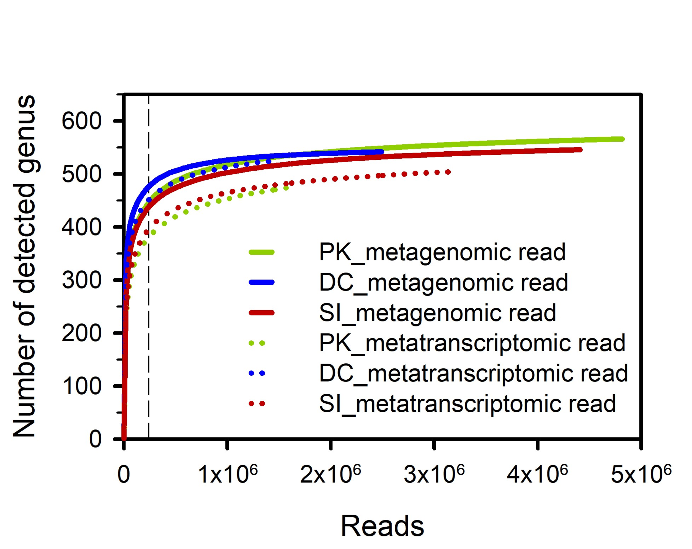
Fig. S1. Genus-level taxonomic richness estimates from metagenomic and metatranscriptomic samples. The dashed black lines indicate the maximum reads required to detect > 80% of the total genera.

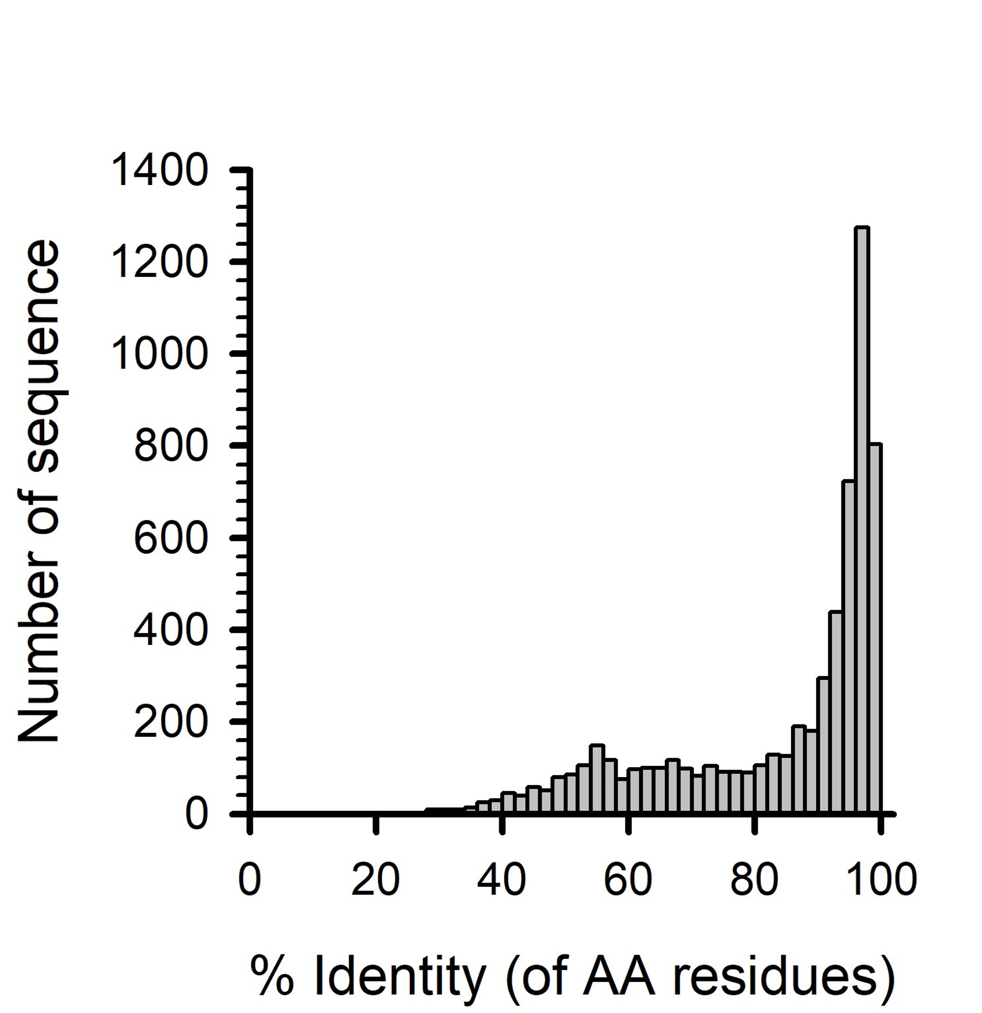
Fig. S2. Amino acid sequence identity distributions of predicted genes from assembled AOA transcripts. The vertical histogram represents the number of BLAST-hit annotated proteins in transcripts.
Fig. S3. Sequence alignment of amoA gene sequences. The names of the sequences used in this study are highlighted in bold and red. The names of the polar-specific type sequences are shaded in green. A clone sequence (GenBank ID: EU238972.1) has one mismatch to the TRINITY_DN1369979_c0_g2_i2 sequence. Mismatches are shown as pink shades.
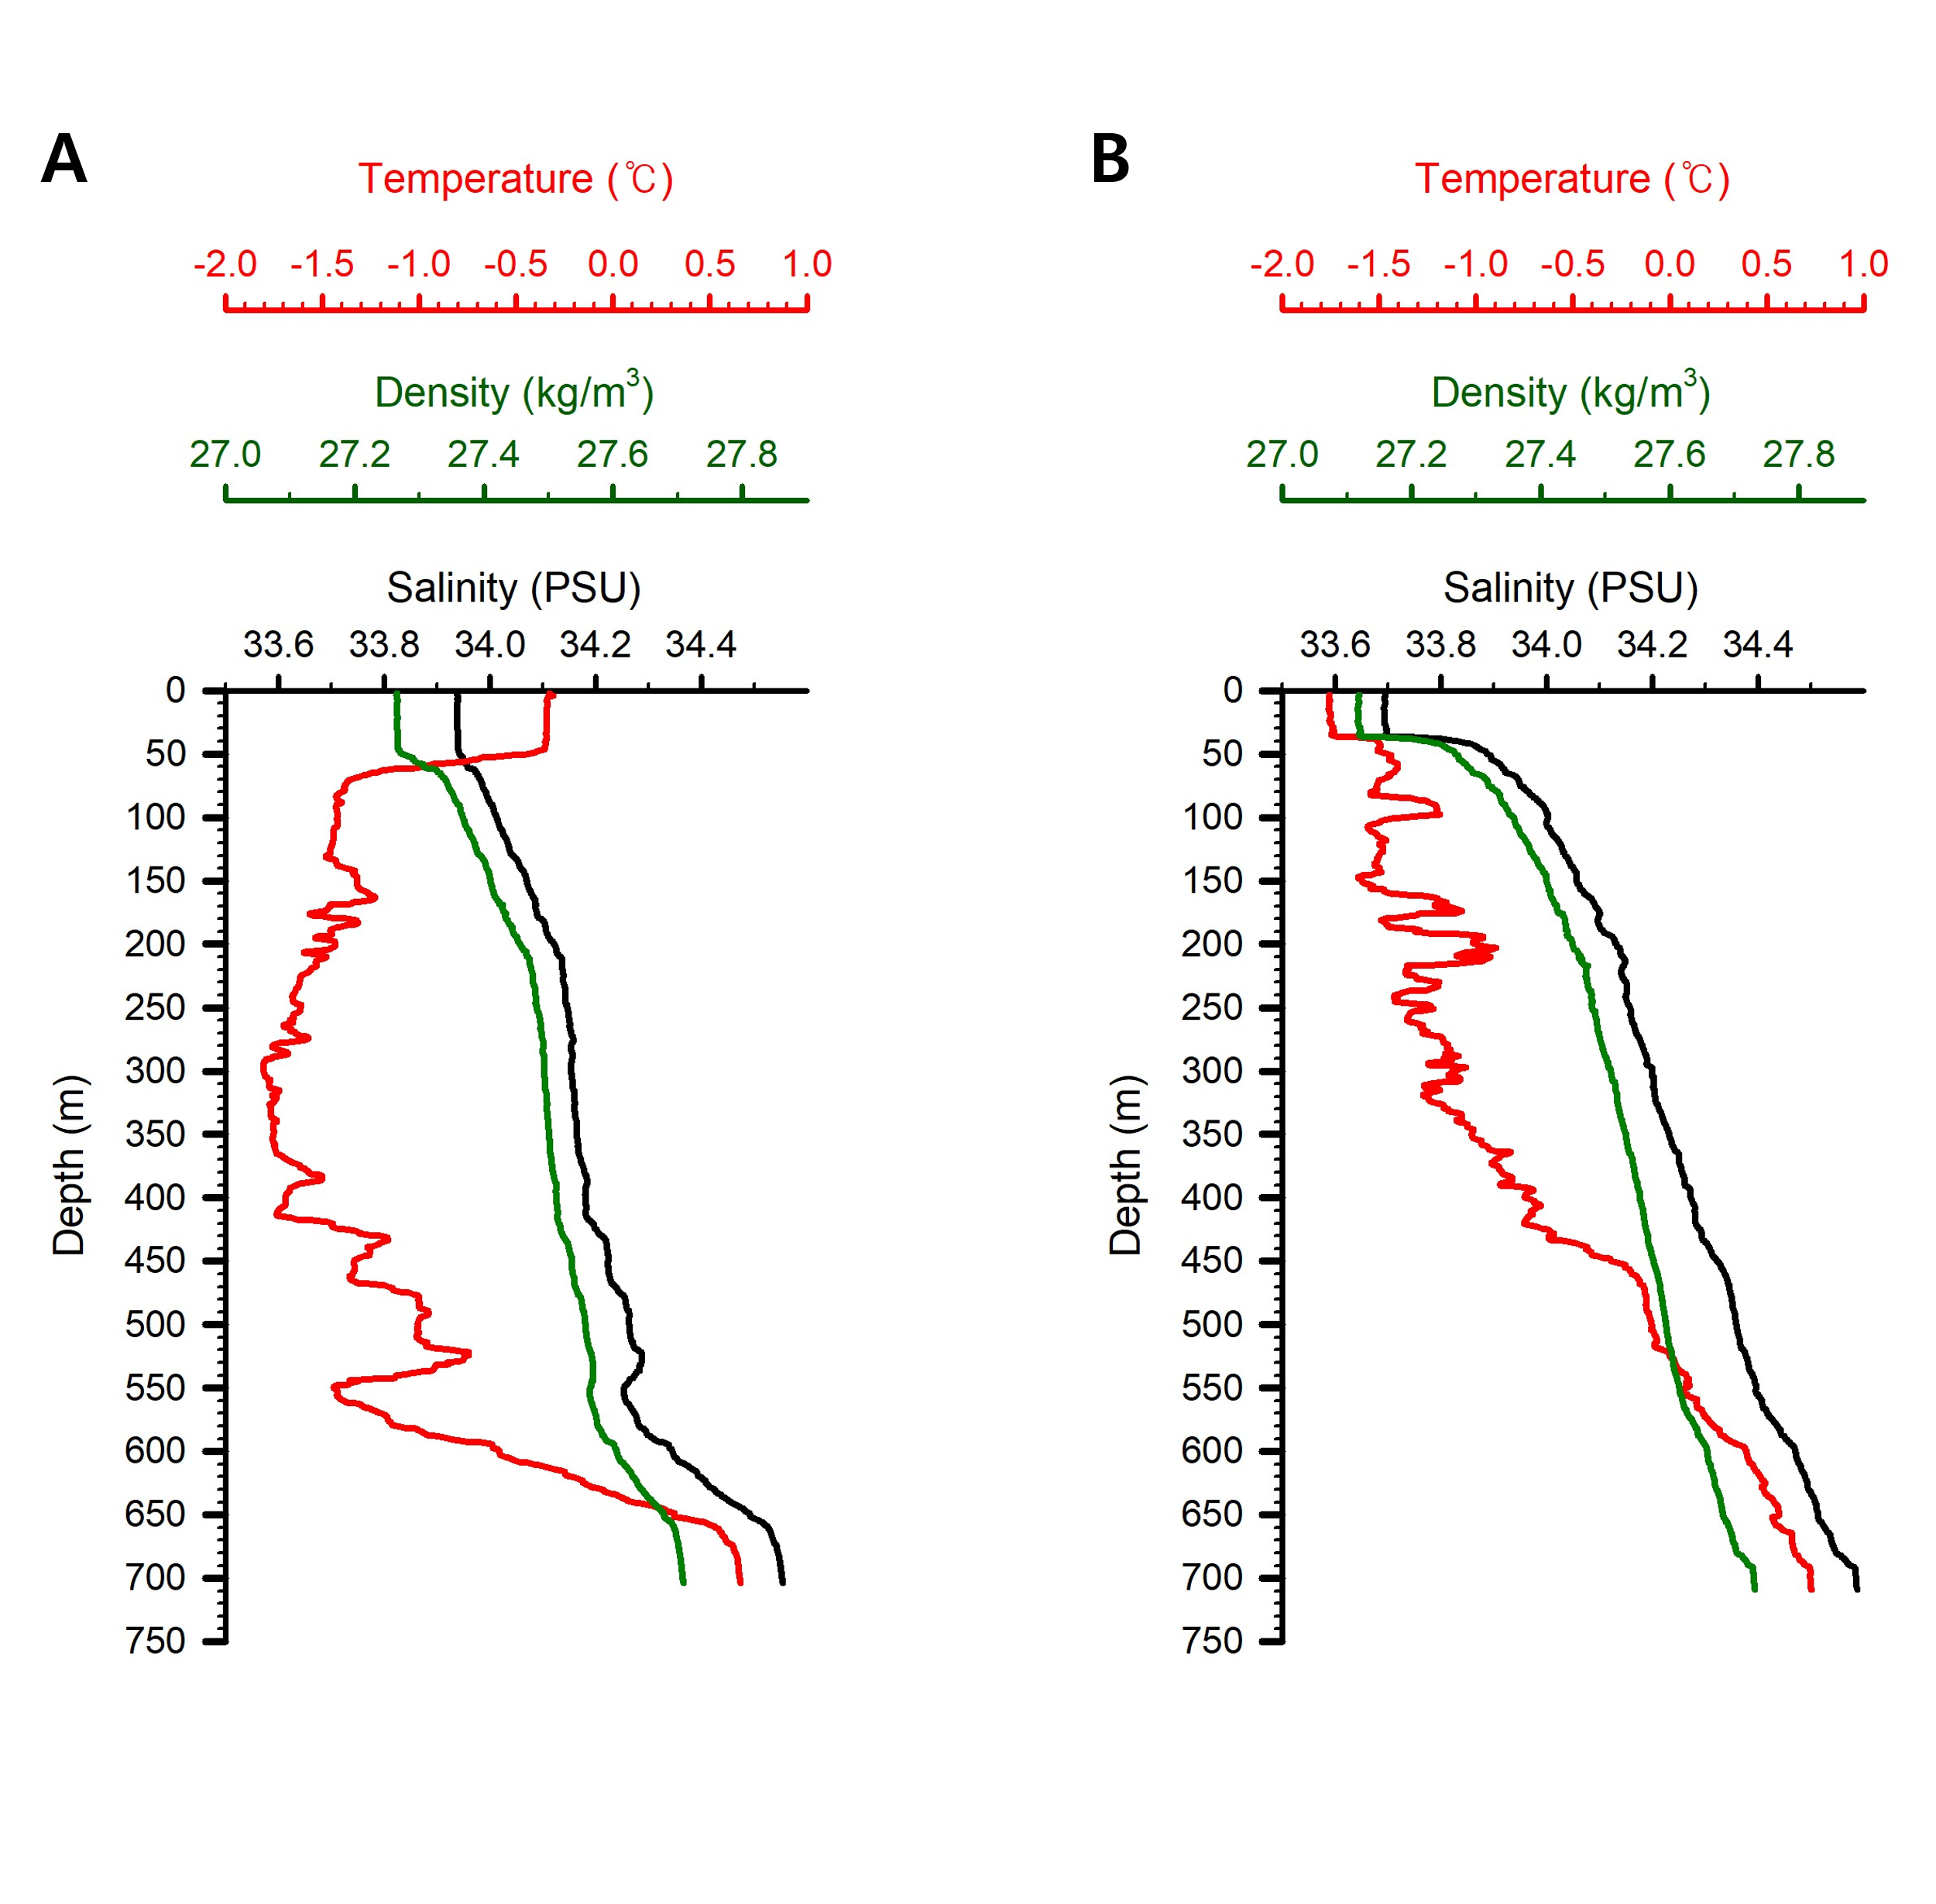
Fig. S4. Vertical CTD profiles of temperature (red), salinity (black), and density (green) at the sampling station during PK (A) and DC (B) of the ASP bloom. The PK and DC samples were collected from surface water (20m).

