Supplementary Material

Supplementary Results

Influence of wean method and speed on hospital length of stay

Supplementary Table 1. Differences in hospital length of stay by wean method

Wean method | Median hospital length of stay in days (IQR) | Statistic
Gradual | 30 (24 - 41.5) | KW, statistic = 0.14, p = 0.93
Removed | 27 (23.5 - 44.5) | KW, statistic = 0.14, p = 0.93
Rapid | 28 (19 - 47) | KW, statistic = 0.14, p = 0.93

Variables suspected of influencing hospital length of stay included: age, sex, wean method, time to clamp, diagnosis, whether the patient had a CNS infection and suffered an episode of radiological vasopasm. These were used to identify the best subset (Supplementary Table 2).

Supplementary Table 2. Best subset multiple linear regression model based on Akaike and Bayesian Information Criterion showing adjusted effect of time to first clamp on length of stay. (CI = confidence interval)

Variable | Coefficient (CI) | p
Intercept | 12.27 (1.16 - 23.38) | 0.03
Days to first clamp | 1.25 (0.33 - 2.16) | 0.008
Any mechanical failure | 6.04 (-2.55 - 14.63) | 0.17
Stroke diagnosis | 16.63 (4.97 - 28.29) | 0.006
Any vasospasm | 6.70 (-3.10 - 16.49) | 0.18
Model parameters: Adj. R² = 0.195, AIC = 564, BIC = 575

Influence of weaning on shunt frequency and timing

Supplementary Table 3. Association between wean method, shunt frequency and timing

Wean method | Shunted | Non-shunted | Statistic | Median time to shunt in days (IQR) | Statistic
Gradual | 6 | 12 | X², statistic = 2.09, p = 0.35 | 23.5 (19.3 - 25.5) | KW, statistic = 7.96, p = 0.02  Dunn:  Gradual vs. removed,, p = 0.01  Rapid vs. removed, p = 0.08  Gradual vs. rapid, p = 0.13
Removed | 5 | 6 | X², statistic = 2.09, p = 0.35 | 10.0 (8.0 - 11.0)
Rapid | 21 | 18 | X², statistic = 2.09, p = 0.35 | 17.0 (12.0 - 24.0)

Variables suspected of influencing time to shunt included: age, sex, wean method, time to clamp, diagnosis, drainage collecting system and drain type. These were used to identify the best subset (S. Table 4).

Supplementary Table 4. Best subset multiple linear regression model showing factors associated with time to shunt based on Akaike and Bayesian Information Criterion. (CI = confidence interval)

Variable | Coefficient (CI) | p
Intercept | -12.65 (-37.5 – 12.22) | 0.213
Age | 0.33 (0.02 – 0.64) | 0.03
Days to clamp | 1.03 (0.17 – 1.88) | 0.02
Sex | 7.74 (-1.38 –16.9) | 0.09
Wean method: removal | -12.40 (-22.87 – -0.73) | 0.06
Model parameters: Adj. R² = 0.23, AIC = 247, BIC = 254

Supplementary Figure 1. Kaplan-Meier cumulative incidence curves showing probability of shunt treatment by different wean methods for the first month of admission

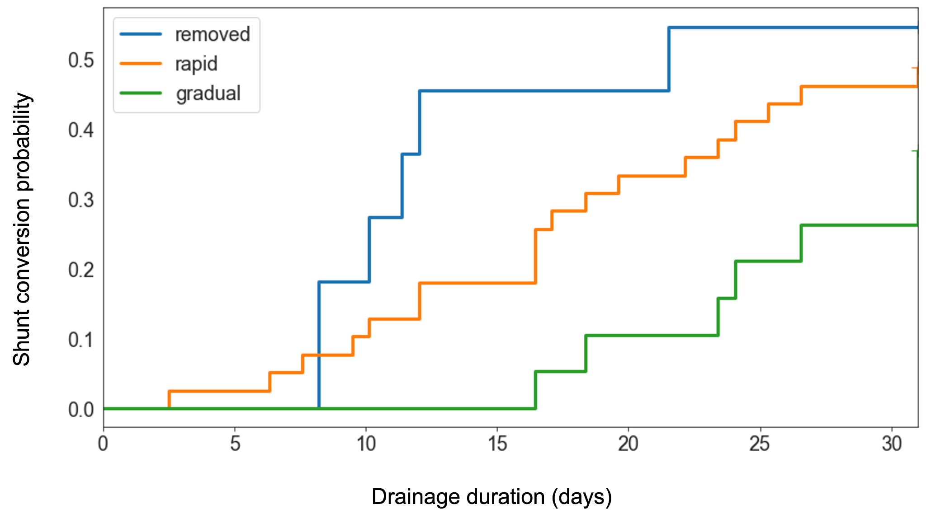

Influence of weaning on risk of CNS infection

Supplementary Table 5. Association between wean method and occurrence of CNS infection. FE = Fisher-Exact with Freeman-Hamilton extension. Only significant or trending post-hoc p-values are reported.

Wean method | CNS infection | No CNS infection | Statistic | Median time to CNS infection in days (IQR) | Statistic
Gradual | 5 | 14 | FE, p = 0.23 | 11 (10 - 13) | KW, statistic = 11.15, p = 0.003  Dunn:  Gradual vs. rapid,, p = 0.008  Gradual vs. removed, p = 0.03
Removed | 1 | 10 | FE, p = 0.23 | 2 (2 - 2)
Rapid | 14 | 25 | FE, p = 0.23 | 5.5 (4 - 7)

Variables suspected of influencing occurrence of CNS infection included: age, sex, wean method, time to clamp, diagnosis, and presence of another infection. These were used to identify the best subset (S. Table 6).

Supplementary Table 6. Best subset multiple linear regression model showing factors associated with time to CNS infection based on Akaike and Bayesian Information Criterion. (CI = confidence interval)

Variable | Coefficient (CI) | p
Intercept | 6.00 (-0.16 - 12.17) | 0.06
Stroke diagnosis | 2.94 (0.16 - 5.72) | 0.04
Meningitis diagnosis | -1.86 (-6.76 - 3.04) | 0.43
Tumour diagnosis | 0.73 (-2.54 - 4.00) | 0.64
Wean method: rapid | -6.31 (-9.07 - -3.54) | <0.001
Wean method: removal | -12.56 (-18.02 - -7.12) | <0.001
Days to clamp | 0.02 (-0.19 - 0.23) | 0.87
Age | 0.09 (-0.01 - 0.19) | 0.09
Model parameters: Adj. R² = 0.70, AIC = 93, BIC = 100

Influence of weaning on mechanical complications

Supplementary Table 7. Association between wean method and occurrence of mechanical complications. Only significant or trending post-hoc p-values are reported. *Excluded from analysis (KW = Kruskal Wallis, MWU = Mann-Whitney U)

Wean method | Mechanical complication | No mechanical complication | Statistic | Median episodes | Statistic | Median time to first mechanical failure (IQR) | Statistic
Gradual | 9 | 10 | X², statistic = 1.84, p = 0.17 | 0 (0 - 2) | MWU, statistic = 427, p = 0.04 | 1 (0 - 4.3) | MWU, statistic = 37.5, p = 0.57
*Removed | 7 | 4 | X², statistic = 1.84, p = 0.17 | 2 (0 - 2.5) | MWU, statistic = 427, p = 0.04 | 1 (0.3 - 3.8) | MWU, statistic = 37.5, p = 0.57
Rapid | 10 | 29 | X², statistic = 1.84, p = 0.17 | 0 (0 - 0.5) | MWU, statistic = 427, p = 0.04 | 0 (0 - 4) | MWU, statistic = 37.5, p = 0.57

Variables suspected of influencing occurrence of mechanical complication included: age, sex, wean method, time to clamp, diagnosis, and presence of another infection. These were used to identify the best subset (Supplementary Table 8).

Supplementary Table 8. Best subset multiple linear regression model showing factors associated with episodes of mechanical failure on Akaike and Bayesian Information Criterion. (CI = confidence interval)

Variable | Coefficient | p
Intercept | 0.56 (0.11 – 1.00) | 0.02
Collecting system: LiquoGuard | 0.33 (-0.18 – 0.83) | 0.20
Collecting system: mixed | 1.88 (0.99 – 2.77) | <0.001
Drain type: lumbar drain | 0.16 (-0.55 – 0.87) | 0.66
Drain type: tunnelled EVD | 1.04 (0.49 – 1.59) | <0.001
Wean method: rapid | -0.54 (-1.04 – -0.05) | 0.03
Wean method: removed | 0.30 (-0.36 – 0.95) | 0.37
Model parameters: Adj. R² = 0.40, AIC = 180, BIC = 196

