Extended Data for
Lightwave-controlled band engineering in quantum materials
Sambit Mitra et al.

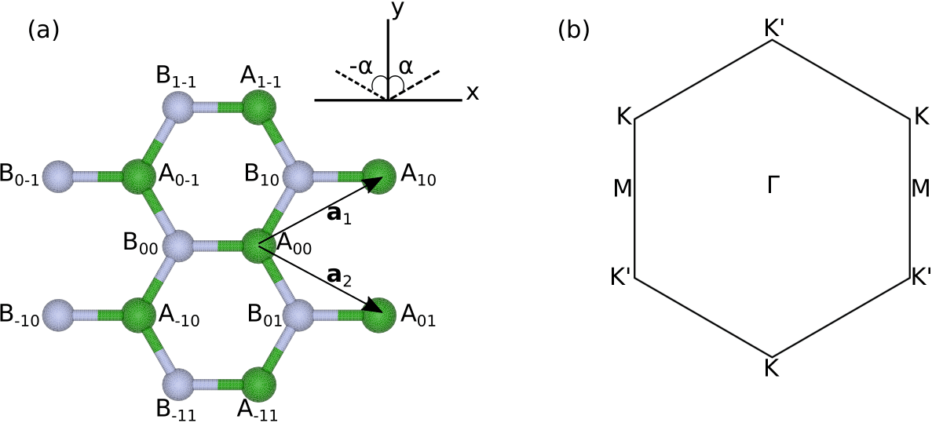

Extended Data Fig. 1: Crystal structure and Brillouin zone of hBN. (a) Crystal lattice of monolayer hBN up to next-nearest neighbours. Each atom A$​_{nm}$ is labeled by its sub-lattice (A or B) and by its lattice vector $R_{nm}=na_{1}+ma_{2}$. In Eq. 2, the angle $α$ between two atoms is defined according to the inset in the top left. (b) First Brillouin zone of monolayer hBN and its high-symmetry points.

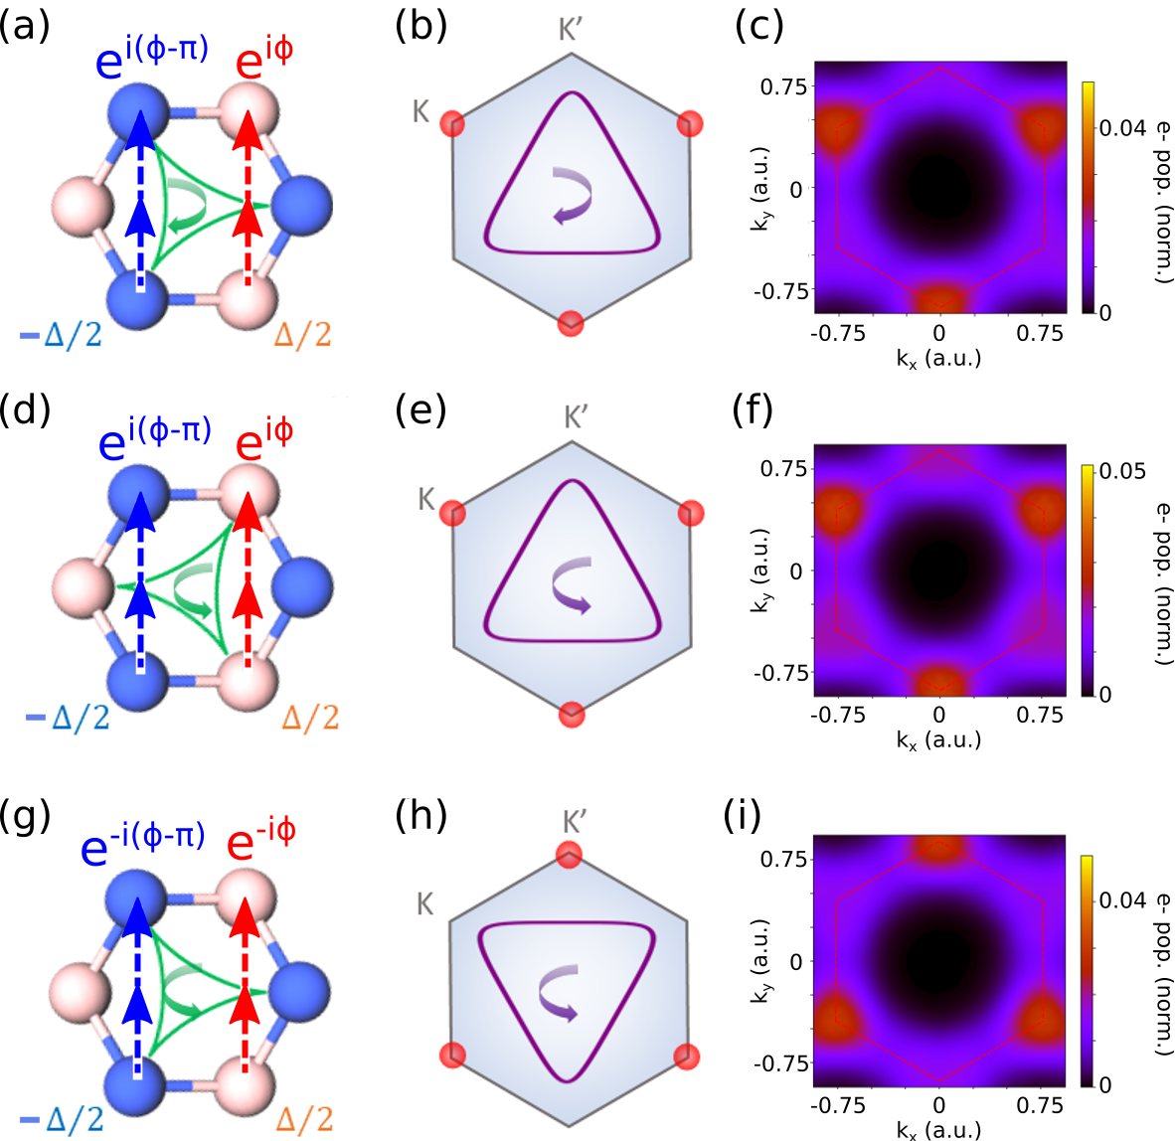

Extended Data Fig. 2: Laser-induced Haldane-type hoppings and band structure modification. (a,d,g) Examples of $⟨γ_{AA'}^{\left(NNN\right)}⟩$ (red) and $⟨γ_{BB'}^{\left(NNN\right)}⟩$ (blue) for different vector potentials. The green curve shows the electric field orientation and the arrow shows the sense of rotation of the field. (b,e,h) The purple curve shows the vector potential that results from the electric field on the left panel, with the arrow showing its sense of rotation. The red circles show the valley at which the band gap is reduced according to the analytical model. (c,f,i) $k$-resolved populations obtained from a time-dependent simulation of a tight binding model of gapped graphene using the electric field and vector potential in the corresponding left panels.

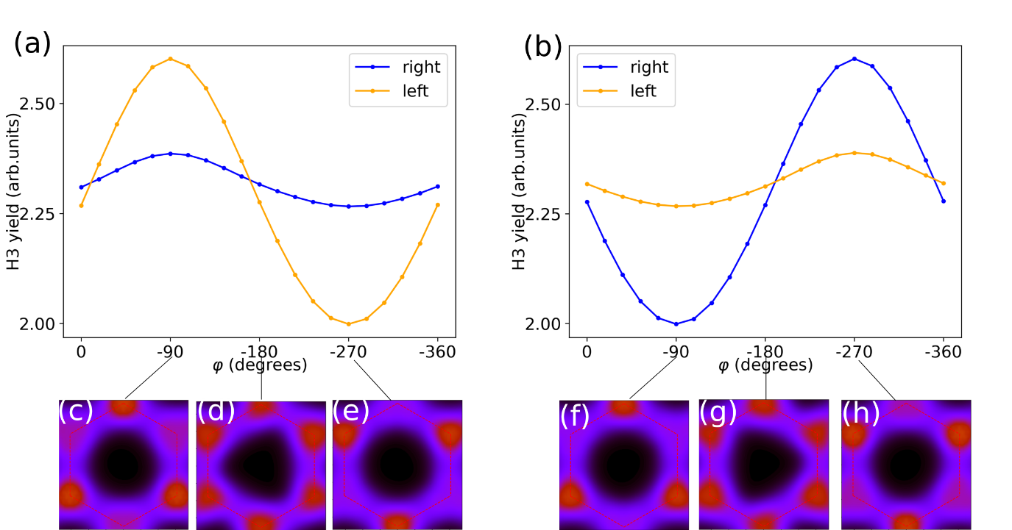

Extended Data Fig. 3: Helicity-resolved yield of third harmonic. Right (blue) and left (orange) helicities of the third harmonic of the probe field calculated from time-dependent simulations on a tight binding model of gapped graphene, for the definitions of the bicircular electric field (vector potential) given by: (a) $F_{↻}$ ($A_{↻}$) in Eq. 3 (Eq. 4), (b)$F_{↺}$ ($A_{↺}$) in Eq. 6. Panels (c-h) show the electron populations in the first Brillouin zone after the bicircular field and before the probe field for $φ=-{90}^{∘},-{180}^{∘}$ and $-{270}^{∘}$. The probe field is oriented along $Γ-M$. The vector potential of the bicircular field does not change its orientation upon a change of its helicity (between panel a and panel b).

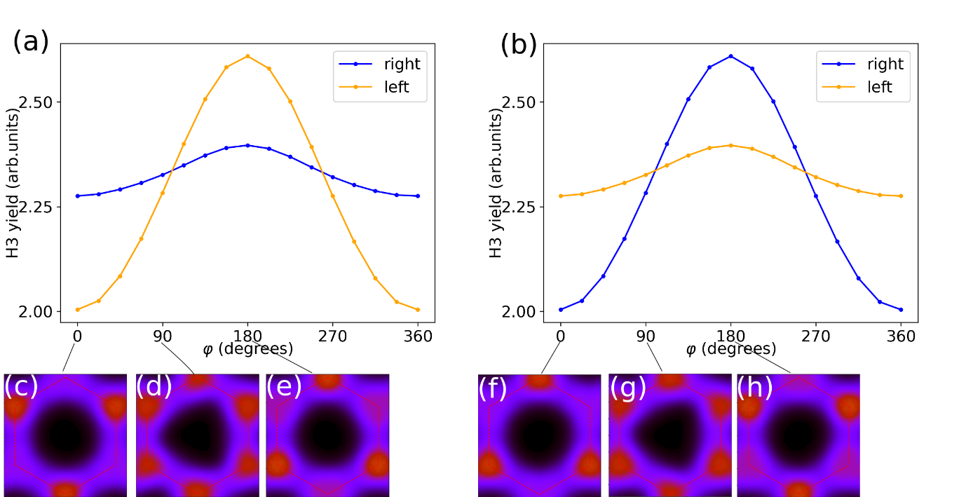

Extended Data Fig. 4: Helicity-resolved yield of third harmonic. Right (blue) and left (orange) helicities of the third harmonic of the probe field calculated from time-dependent simulations on a tight binding model of gapped graphene, for the definitions of the bicircular electric field (vector potential) given by: (a) ${\tilde{F}}_{↻}$ (${\tilde{A}}_{↻}$) in Eq. 7 (Eq. 8), (b) ${\tilde{F}}_{↺}$ (${\tilde{A}}_{↺}$) in Eq. 9 (Eq. 10). Panels (c-h) show the electron populations in the first Brillouin zone after the bicircular field and before the probe field for $φ=0^{∘},{90}^{∘}$ and ${180}^{∘}$. The probe field is oriented along $Γ-M$. The vector potential of the bicircular field changes its orientation by 180$​^{∘}$ upon a change of its helicity (between panel a and panel b)

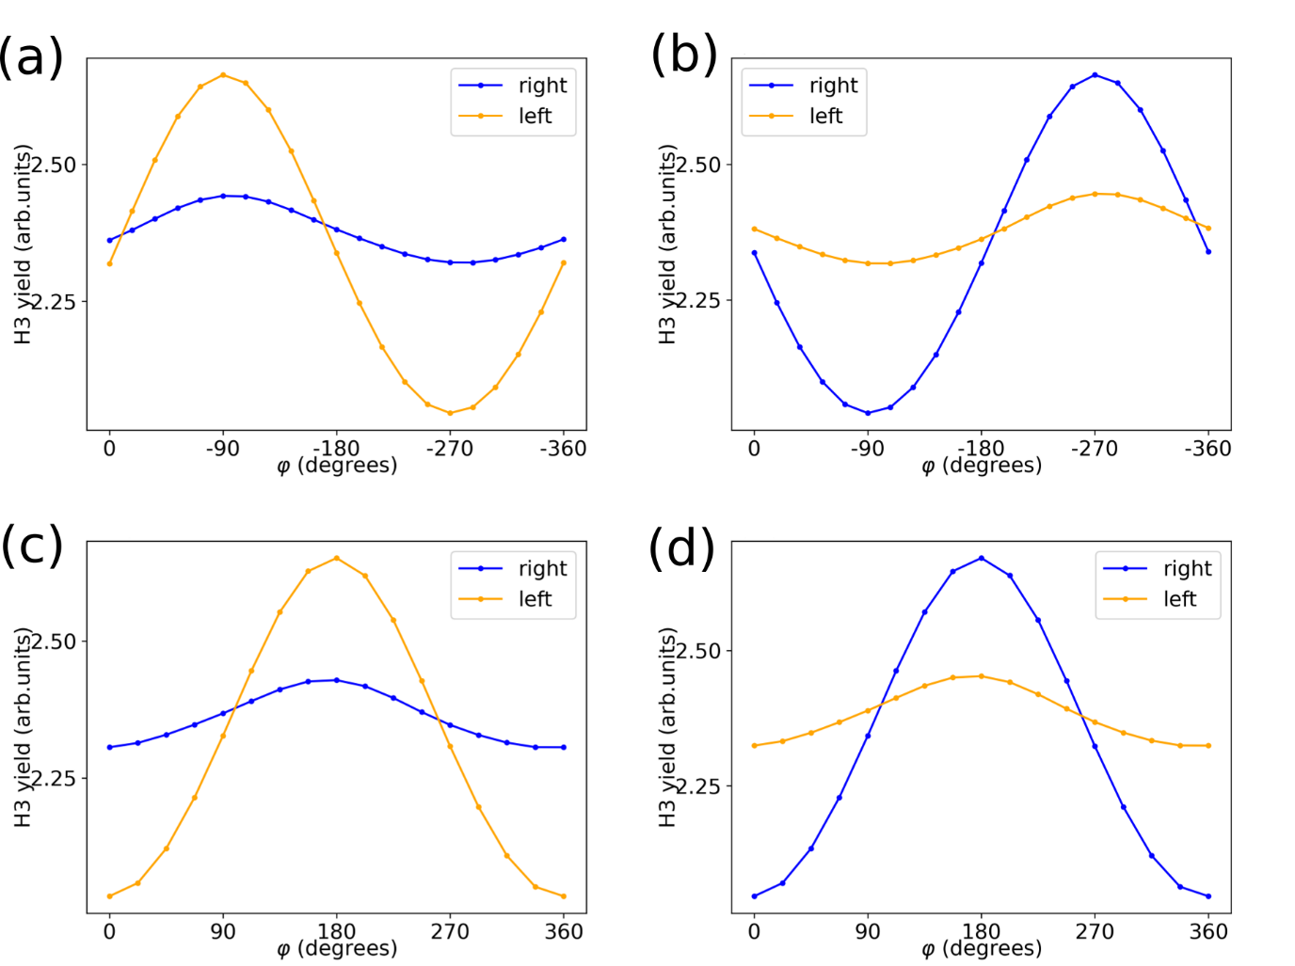
Extended Data Fig. 5: Helicity-resolved yield of third harmonic along perpendicular direction. Results for the probe field polarized along the perpendicular ($Γ-K$) direction (a,b) Results of simulations analogue to Fig. 3(a,b) and (c,d) analogue to Fig. 4 (a,b).. The comparison to Figs. 3 and 4 shows essentially no difference for this probe field polarization.

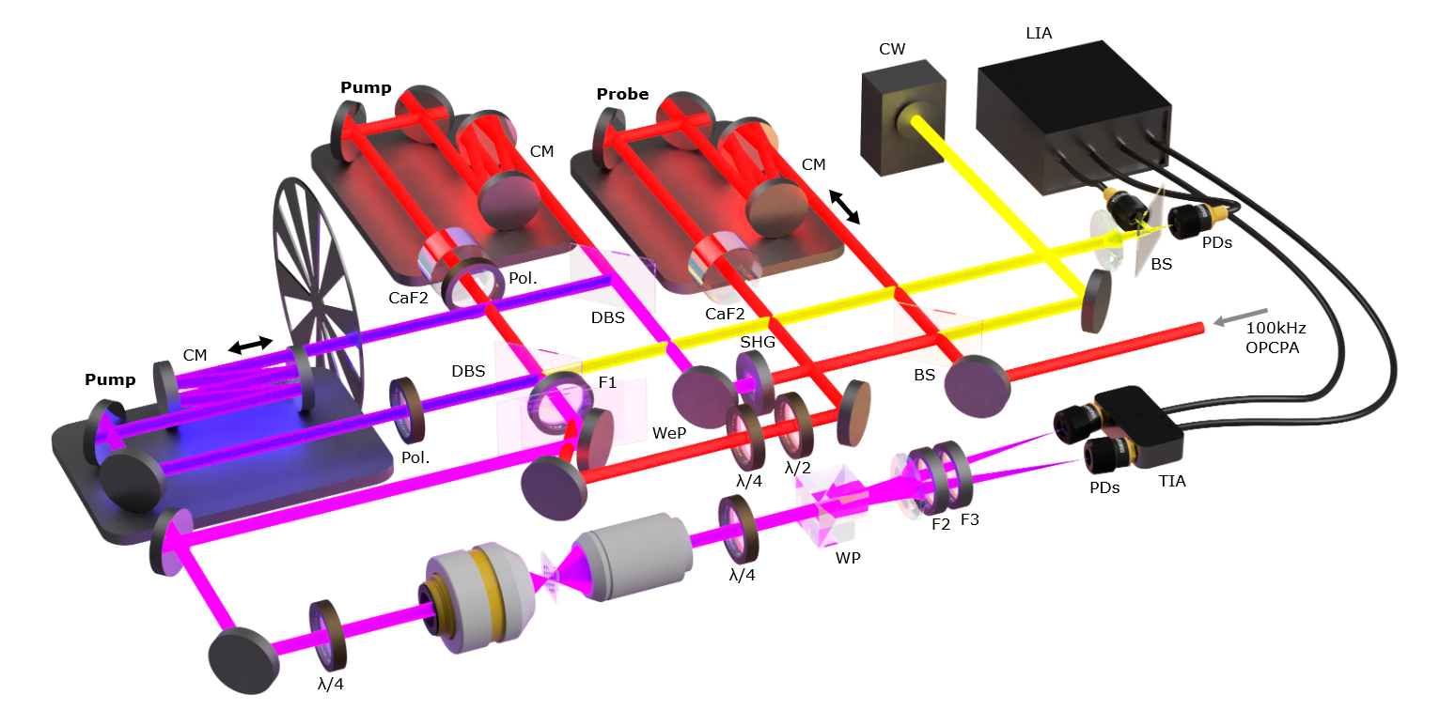

Extended Data Fig. 6: Mach–Zehnder interferometric setup. The acronyms of the components have the following meaning: WP - Wollaston prism, F1 - Long pass filter, F2 - Short pass filter, F3 - Long pass filter, PD - Photodiode, TIA - Trans-impedance amplifier, BS - Beam splitter, DBS – Dichroic beam splitter, Pol. - Polarizer, WeP - Wedged pair, CM - Chirped mirrors, SHG - Second harmonic generation LiNbO₃ crystal, CW - Continuous wave laser, LIA - Lock-in amplifier. A detailed description of the setup is provided in the text.

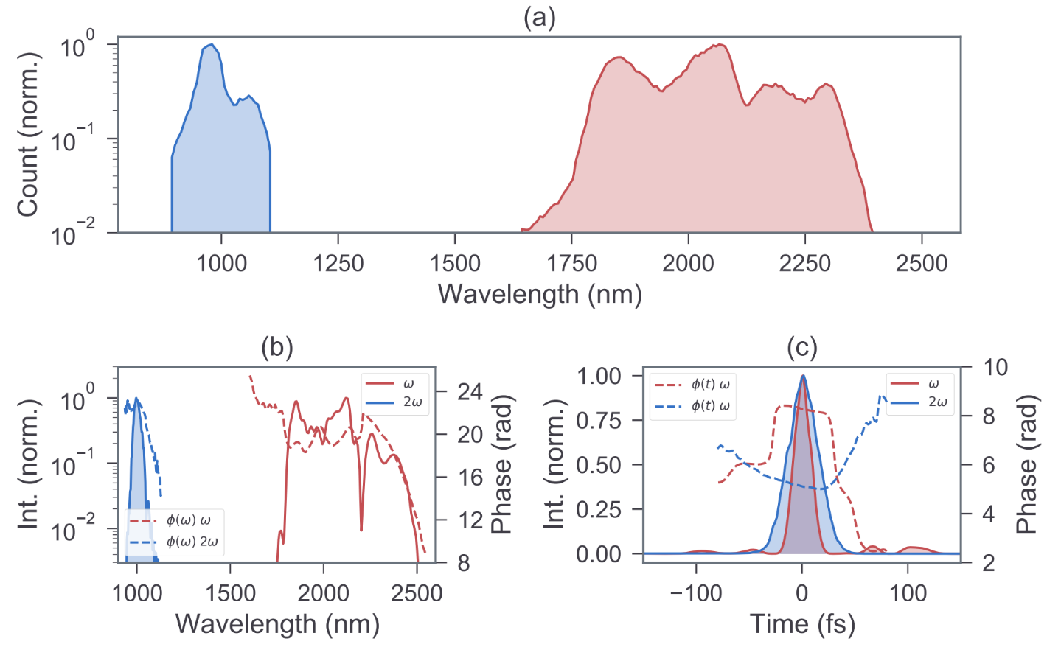

Extended Data Fig. 7: Spectral and temporal properties of the ω - 2ω trefoil pump pulses. Subplot (a) shows the measured laser spectra recorded after the interferometer, right before the focusing objective to give an accurate representation of the laser pulses used. The laser pulses are picked off from the same region for frequency-resolved optical gating (FROG) retrieval. The retrieved spectra and temporal profile along with their phases are shown in subplots (b) and (c), respectively. It suggests the pulse durations of about 26.1 and 48.0 fs for ω and 2ω, respectively.

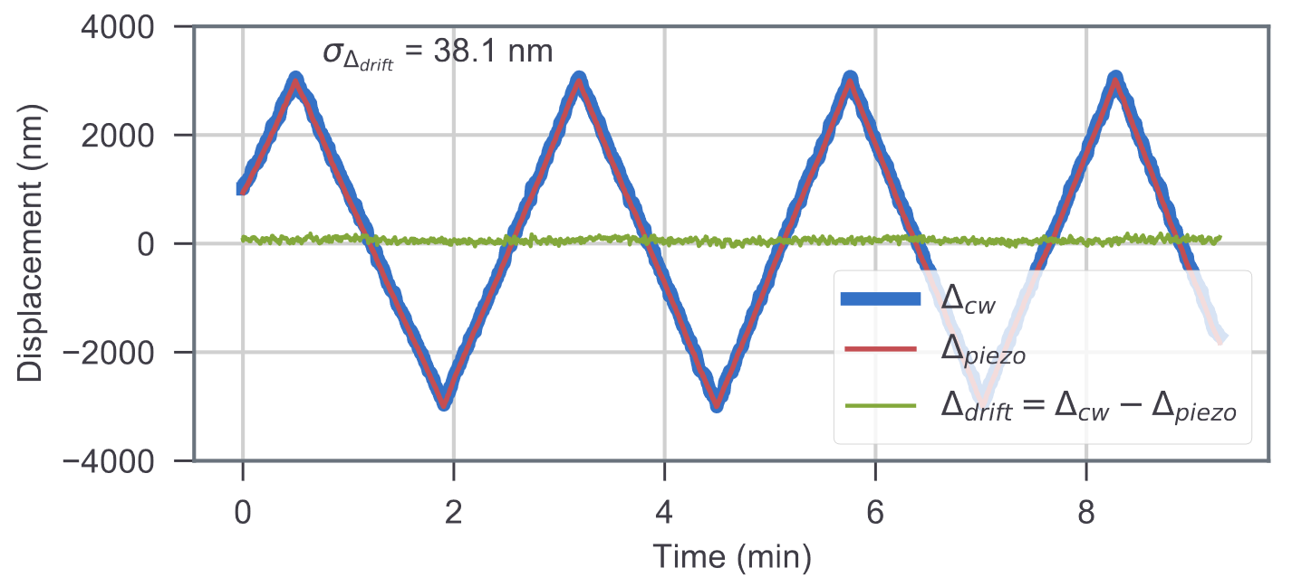
Extended Data Fig. 8: Interferometric stability of the pump arms. The relative displacement between the ω − 2ω pump arms is recorded while a piezo closed-loop stage controlling the displacement is swept over a period of ten minutes. The position read out by the stage is compared to that extracted from an additional CW interferometer to estimate the error in displacement mapping. A standard deviation in drift of 38.1 nm corresponds to an angular jitter of 4.6° in the trefoil pump structure.

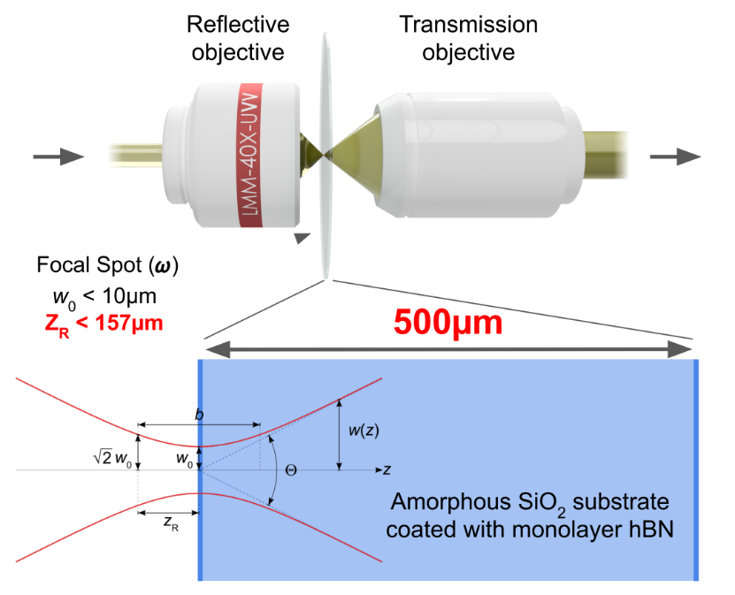

Extended Data Fig. 9: Schematic representation of the microscope arrangement. A reflective objective with NA: 0.4 was used to expose isolated hBN monolayer grains with tailored laser pulses. On the output side a transmission objective of NA: 0.45 was used. This focusing configuration results in a focal spot size (w_{o}) of about 10.0 µm and Rayleigh length (Z_{R}) below 157 µm for 2 µm wavelength pump component. For 1 µm wavelength pump component these numbers are 8.0 µm and 201 µm, respectively. See Extended Data Fig. 9 for the experimental data.

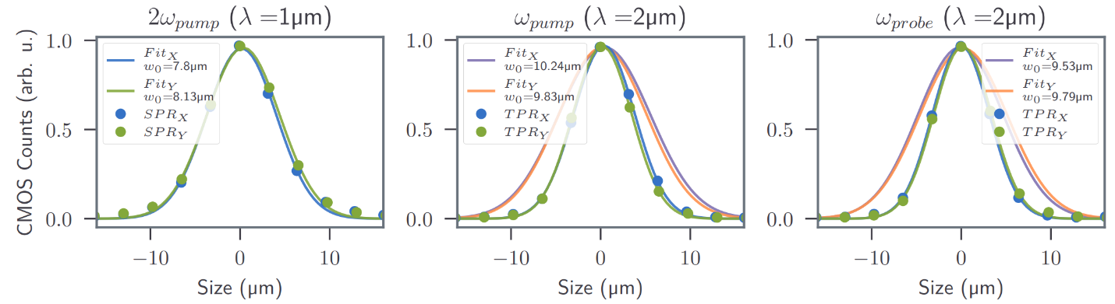
Extended Data Fig. 10: Beam profile cross-section. The beam profiles of three interferometer arms were measured at the focal plane of the objective on a CMOS detector. The wavelength of 2ω arm results in a single-photon response (SPR), whereas the other two arms produce a two-photon response on the detector given the band gap of silicon. To determine the waist (ω₀), this was considered producing the orange and purple curves for the 2 µm cases.
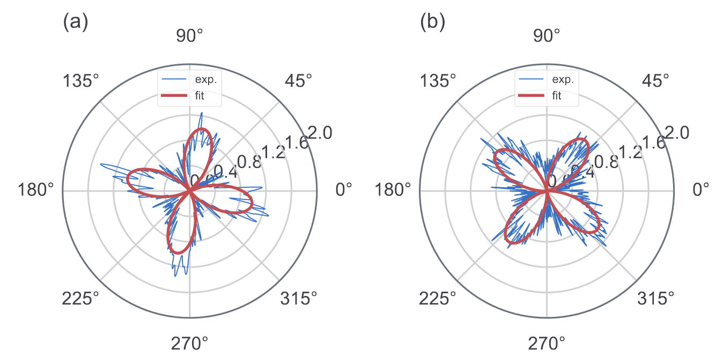
Extended Data Fig. 11: Polarization resolved SHG from hBN. The rotation of SHG as a function of the polarization rotation of a linearly polarized pump pulse is illustrated here. The intensity of the SHG (normalized) is mapped after passing through a polarizer/Wollaston prism for few-odd-layer hBN patch site 1 in subplot (a) and patch site 2 in subplot (b) on a fused silica substrate. The fit function used is Y_{fit} = A cos (−2θ + φ)², where A is the amplitude of the oscillation and θ is the angle of the incoming pump polarization.

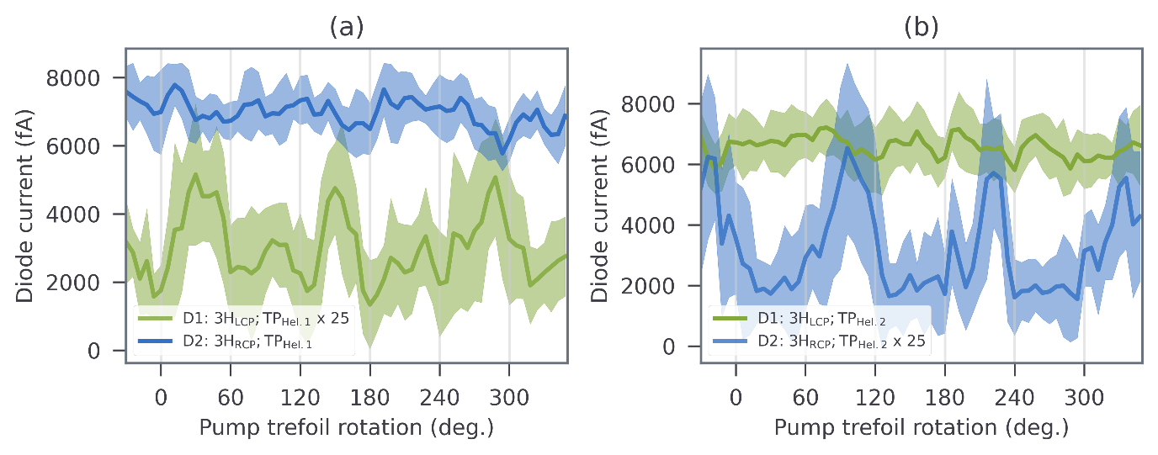
Extended Data Fig. 12: Raw experimental 3ω signals for two opposite pump helicities. (a) The 3ω signals detected by the two diodes for a given pump helicity. One diode (D1) shows expected oscillatory signal, but the other diode (D2) shows background which is an order of magnitude higher and without any modulation features. (b) Same as (a), but for opposite pump helicity. The situation remains broadly the same as (a) except interchanged role of the diodes. The experiments operate in a regime where a residual temporal overlap exists between the probe and pump pulses. Namely, the linearly polarized probe ‘ω’ and circularly polarized ‘2ω’, undergo a three-photon transition (2ω+2ω-ω) to produce a strong ‘3ω’ signal from hBN and the fused silica substrate, overpower the valley-dependent signal and thereby justifying the need to present alternating relevant 3ω data for two unique pump helicities.

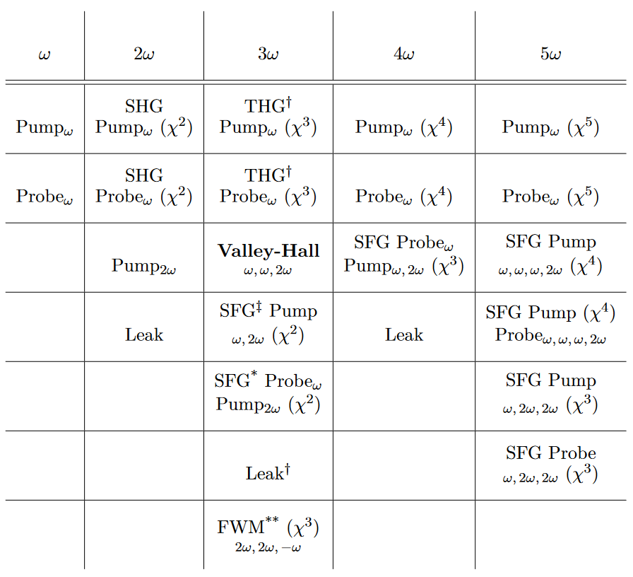
Extended Data Table 1: List of signals picked up by the photo-detector. These signals are sorted by their respective wavelength and non-linear processes involved in giving rise to it. Here, ω refers to λ = 2 μm. The signals at frequencies other than 3ω are all rejected by high extinction ratio spectral filters. Other components are marked with a corresponding blocking method, and they are as follows: † Rejected by lock-in amplifier ‡ Rejected based on selection rules of bicircularly polarized light. * Rejected based on helicity filtering of light. ** Rejected based on modulation with trefoil pump rotation. Only the signal arising from the valley hall effect is let through.

