Supplementary Material

Methods
Psychological ratings
At the end of the recruitment session participants completed several psychological rating scales: Anticipatory and Consummatory Interpersonal Pleasure Scale (ACIPS)⁠ (Gooding et al., 2016; Gooding & Pflum, 2014), Social Avoidance and Distress (SAD)⁠⁠ (Watson & Friend, 1969; Zubeidat et al., 2007), Fear of Negative Evaluation (FNE)⁠ (Watson & Friend, 1969; Zubeidat et al., 2007), Rosenberg Self-Esteem Scale (RSES) (Rojas-Barahona et al., 2009; Rosenberg, 1965)⁠, and Iowa-Netherlands Comparison Orientation Scale (INCOM) (Buunk et al., 2005; Gibbons & Buunk, 1999). In addition, the Inventory of Interpersonal Problems (IIP) (Horowitz et al., 1988; Salazar et al., 2010)⁠ was sent to be completed at home.

The following questionnaires were applied at the beginning of the experimental session: Snaith-Hamilton Pleasure Scale (SHAPS) (Fresán & Berlanga, 2013; Snaith et al., 1995)⁠⁠, the State-Trait Anxiety Inventory (STAI) (Guillén-Riquelme & Buela-Casal, 2011; Spielberger et al., 1971), and the Positive And Negative Affect Schedule (PANAS) (Dufey, 2012; Watson et al., 1988). Finally, participants completed the BDI-II and the LSAS for the last time. All scales were applied in their Spanish versions.

EEG recording and preprocessing
The activity recorded was referenced online to the Common Mode Sense (CMS) and grounded to a passive electrode (Driven Right Leg, DRL), creating a feedback loop that drives the average potential of the participant to the AD-box reference potential. The horizontal electrooculogram (EOGs) were recorded from two electrodes placed at the outer canthi of both eyes and vertical EOGs were recorded from electrodes on the infraorbital and supraorbital regions of the left eye to detect blinking and ocular deviations from the fixation point. Ocular artifacts were carried out through an Independent Component Analysis (ICA)-based strategy (Jung et al., 2000)⁠, as provided by Fieldtrip. After the removal process, a visual inspection of EEG data was conducted in order to manually discard trials in which any further artifacts were present. Noisy channels were corrected by interpolation using the distance-weighted average of adjacent channels located at a distance of at least 5.5 cm (maximum of 5 channels in each subject).

Results

Psychological ratings results
Independent samples t-tests indicated that the MD-SA group scored higher on depressive symptoms (BDI-II, t_{56.98}=-14.25; p<0.001; δ=-2.64), social anxiety symptoms (LSAS, t_{68.83}=-17.96; p<0.001; δ=-3.34) (both in the domains of fear/anxiety: t_{74.11}=-15.99; p<0.001; δ=-2.97 and avoidance: t_{66.57}=-17.64; p<0.001; δ=-3.28), social avoidance and distress (SAD, t_{82.97}=-24.5; p<0.001; δ=-4.24), fear of negative evaluation (FNE, t_{127.2}=-17.4; p<0.001; δ=-3.01), trait and state anxiety (STAI-T: t_{105.6}=-21.1; p<0.001; δ=-3.67; STAI-S: t_{71.03}=-11.58; p<0.001; δ=-2.14), anhedonia (SHAPS, t_{55.64}=-6.29; p<0.001; δ=-1.16), negative affects (PANAS-N, t_{71.32}=-11.37; p<0.001; δ=-2.12) and social comparison orientation (INCOM, t_{116.}6=-5.16; p<0.001; δ=-0.90) than the Control group. In addition, the MD-SA group scored lower on positive affects (PANAS-P t_{113.15}=16.00; p<0.001; δ=2.98), self-esteem (RSES, t_{101.4}=15.7; p<0.001), and anticipatory and consummatory interpersonal pleasure (ACIPS, t_{89.1}=9.7412; p<0.001; δ=1.69) than the Control group (Table 1 in the main text).

Independent samples t-tests also indicated that the MD-SA group scored higher in the total score of interpersonal problems (IIP, t_{115.17}=-13.44; p<0.001; δ=-2.41) and in all of its domains: domineering/controlling (t_{118.38}=-3.16; p<0.001; δ=-0.57), vindictive/self-centered (t_{109.26}=-4.95; p<0.001; δ=-0.89), cold/distant (t_{91.214}=-10.95; p<0.001; δ=-1.96), socially inhibited (t_{87.851}=-13.01; p<0.001; δ=-2.33), non-assertive (t_{112.2}=-12.84; p<0.001; δ=-2.30), overly accommodating (t_{114.4}3=-7.57; p<0.001; δ=-1.36), self-sacrificing (t_{119.21}=-6.74; p<0.001; δ=-1.21) and intrusive/needy (t_{106.84}=-3.20; p<0.001; δ=-0.57) than the Control group (Table 1 in the main text). This suggests higher levels of interpersonal problems in the MD-SA group than in the Control group.

Additionally, for the scores of each psychological questionnaire, we performed a one-way ANOVA with the group factor including three levels: control, volunteers with only MD, and volunteers with only SA (participants with both MD and SA were not included as they were only 10).

The main effect of group was significant for the scores on depressive symptoms (BDI-II, F_{2,105}=246.19; p<0.001), social anxiety symptoms (LSAS, F_{2,104}=183.59; p<0.001) (both in the domains of fear/anxiety: F_{2,104}=150.35; p<0.001 and avoidance: F_{2,104}=168.76; p<0.001), social avoidance and distress (SAD, F_{2,121}=330.15; p<0.001), fear of negative evaluation (FNE, F_{2,121}=129.59; p<0.001), trait and state anxiety (STAI-T: F_{2,120}=232.62; p<0.001; STAI-S: F_{2,105}=72.33; p<0.001), anhedonia (SHAPS, F_{2,105}=64.36; p<0.001), negative affects (PANAS-N, F_{2,104}=62.60; p<0.001) and social comparison orientation (INCOM, F_{2,120}=16.31; p<0.001). Moreover, the main effect of the group was significant for the scores on positive affects (PANAS-P, F_{2,104}=119.23; p<0.001), self-esteem (RSES, F_{2,120}=122.13; p<0.001), and anticipatory and consummatory interpersonal pleasure (ACIPS, F_{2,121}=42.23; p<0.001). Post-hoc pairwise comparisons showed that the MD and SA groups scored higher than the Control group on depressive symptoms (BDI-II, p<0.001), social anxiety symptoms (LSAS, p<0.001) (both in the domains of fear/anxiety: p<0.001 and avoidance: p<0.001), social avoidance and distress (SAD, p<0.001), fear of negative evaluation (FNE, p<0.001), trait and state anxiety (STAI-T: p<0.001; STAI-S: p<0.001), anhedonia (SHAPS, p<0.032), negative affects (PANAS-N, p<0.001), and social comparison orientation (INCOM, p<0.001), and lower on positive affects (PANAS-P, p<0.001), self-esteem (RSES, p<0.001), and anticipatory and consummatory interpersonal pleasure (ACIPS, p<0.001). The MD group scored higher than the SA group on depressive symptoms (BDI-II, p<0.001), trait and state anxiety (STAI-T: p<0.001; STAI-S: p=0.002), and anhedonia (SHAPS, p<0.001), and lower on social anxiety symptoms (LSAS, p<0.001) (both in the domains of fear/anxiety: p<0.001 and avoidance: p=0.039), social avoidance and distress (SAD, p<0.001), positive affects (PANAS-P, p<0.001) and self-esteem (RSES, p=0.008).

For interpersonal problems, the main effect of the group was significant for the scores on the total score of interpersonal problems (IIP, F_{2,112}=78.54; p<0.001) and in all of its domains: domineering/controlling (F_{2,112}=4.65; p=0.011), vindictive/self-centered (F_{2,112}=9.76; p<0.001), cold/distant (F_{2,112}=53.84; p<0.001), socially inhibited (F_{2,112}=83.40; p<0.001), non-assertive (F_{2,112}=71.25; p<0.001), overly accommodating (F_{2,112}=23.42; p<0.001), self-sacrificing (F_{2,112}=18.86; p<0.001), and intrusive/needy (F_{2,112}=6.85; p=0.002). Post-hoc pairwise comparisons showed that the MD and SA groups scored higher than the Control group on the total score (p<0.001) and on the following domains: vindictive/self-centered (p<0.003), cold/distant (p<0.001), socially inhibited (p<0.001), non-assertive (p<0.001), overly accommodating (p<0.001) and, self-sacrificing (p<0.001). The MD group scored higher than the Control group on the intrusive/needy domain (p=0.002) and, the SA group scored higher than the Control group on the domineering/controlling domain (p=0.022). Finally, the SA group scored higher than the MD group on the socially inhibited domain (p=0.001).

Emotional responses results
Analyses with the group factor opened into two levels (Control, MD-SA)
Mixed ANOVAs with factors self-outcome, other-outcome and group (Control, MD-SA) we used to analyze emotional reports. Apart from the findings reported in the main document the following findings were also identified:
- A significant main effect of self-outcome, with the participant being correct eliciting higher happiness (F_{1,111}=711.62; p<0.001; η2p=0.87) and relief (F_{1,111}=200.99; p<0.001; η2p=0.64) and less anger (F_{1,111}=102.79; p<0.001; η2p=0.48), sadness (F_{1,111}=78.18; p<0.001; η2p=0.41), nervousness (F_{1,111}=51.81; p<0.001; η2p=0.31), guilt (F_{1,111}=9.22; p=0.003; η2p=0.07), shame (F_{1,111}=60.66; p<0.001; η2p=0.35), disappointment (F_{1,111}=127.86; p<0.001; η2p=0.53) and envy (F_{1,111}=47.04; p<0.001; η2p=0.29) than the participant being wrong (Figure 2A, Supplementary Table 1).

- A significant main effect of other-outcome, with the co-player being correct eliciting higher anger (F_{1,111}=4.79; p=0.031; η2p=0.04), nervousness (F_{1,111}=4.21; p=0.043; η2p=0.03), shame (F_{1,111}=23.74; p<0.001; η2p=0.17), disappointment (F_{1,111}=16.64; p<0.001; η2p=0.13) and envy (F_{1,111}=39.81; p<0.001; η2p=0.26), and less relief (F_{1,111}=15.62; p<0.001; η2p=0.12) and guilt (F_{1,111}=5.29; p=0.023; η2p=0.04) than the co-player being wrong.

- A significant main effect of group, with the MD-SA group reporting less happiness (F_{1,111}=6.52; p=0.012; η2p=0.05) and higher anger (F_{1,111}=6.98; p=0.009; η2p=0.05), sadness (F_{1,111}=10.84; p<0.001; η2p=0.08), nervousness (F_{1,111}=20.60; p<0.001; η2p=1.57), guilt (F_{1,111}=20.97; p<0.001; η2p=0.15), shame (F_{1,111}=37.62; p<0.001; η2p=0.25) and disappointment (F_{1,111}=10.95; p<0.001; η2p=0.09) than the Control group.

- A significant interaction between self-outcome and group (Control, MD-SA) was found for the emotions of sadness (F _{1,11}=7.99; p=0.006; η2p=0.06), nervousness (F_{1,11}=8.95; p=0.003; η2p=0.07), shame (F_{1,11}=28.66; p<0.001; η2p=0.20) and disappointment (F_{1,11}=5.04; p=0.027 η2p=0.04). The MD-SA group reported higher levels for all these emotions than the Control group both for positive and negative outcomes (p<0.035), but this effect was stronger for the negative outcomes. In addition, a significant interaction between the other-outcome and group was found for the emotion of guilt (F_{1,11}=4.16; p=0.044; η2p=0.03) with the MD-SA group reporting more guilt both for the positive (t_{82.503}=-3.06, p=0.003) and negative (t_{68.34}=-4.02, p<0.001) outcomes compared to the Control group, with this effect being significantly higher for the negative outcome (Figure 2 in the main text and Supplementary Table 1).

Analyses with the group factor opened in three levels (Control, MD, SA)
Mixed ANOVAs with factors self-outcome, other-outcome, and group (Control, MD, SA) (Supplementary Figure 1) showed a significant main effect of group for the emotions of happiness (F_{2,101}=3.42; p=0.037), sadness (F_{2,101}=3.82; p=0.025), nervousness (F_{2,101}=8.70; p<0.001), guilt (F_{2,101}=8.07; p<0.001), shame (F_{2,101}=15.15; p<0.001) and disappointment (F_{2,101}=3.80; p=0.026). The control group reported more happiness, and less disappointment than the SA group (t₁₀₁=2.57, p=0.04; t₁₀₁=-2.56, p=0.04 respectively), less sadness than the MD group (t₁₀₁=-2.46, p=0.05) and less nervousness, guilt, and shame than the MD (t₁₀₁=-2.73, p=0.02; t₁₀₁=-3.52, p=0.002; t₁₀₁=-3.95, p<0.00 respectively) and SA groups (t₁₀₁=-3.78, p<0.001; t₁₀₁=-2.83, p=0.02; t₁₀₁=-4.77, p<0.001 respectively). The remaining post-hoc comparisons were not significant.

In addition, a significant interaction between self-outcome and group was found for the emotion of shame (F_{2,101}=10.61; p<0.001), with the control group reporting less shame than the MD and SA groups both for positive (MD: t₁₀₁=-3.24, p=0.01; SA: t₁₀₁=-2.99, p=0.02) and negative outcomes (MD: t₁₀₁=-3.61, p=0.002; SA: t₁₀₁=-4.54, p<0.001). The remaining post-hoc comparisons were not significant.

A significant interaction between other-outcome and group was found for the emotion of nervousness (F_{2,101}=3.20; p=0.045), with the control group reporting less nervousness than the SA group both for positive (t₁₀₁=-2.82, p=0.03) and negative outcomes (t₁₀₁=-4.45, p<0.001). The remaining post-hoc comparisons were not significant.

Finally, a significant self-outcome*other-outcome*group interaction was found for the emotion of nervousness (F_{2,101}=4.37; p=0.015), with the control group reporting less nervousness than the SA group for “You correct-Other wrong” (t₁₀₁=-4.37, p<0.001), “You wrong-Other correct” (t₁₀₁=-3.80, p=0.003), and “You wrong-Other wrong” (t₁₀₁=-3.50, p=0.008). The remaining post-hoc comparisons were not significant.

One-way ANOVAs on the emotions reported about anticipating meeting again with the co-player showed a significant main effect of group for happiness (F_{2,101}=4.77; p=0.011), nervousness (F_{2,101}=24.99; p<0.001), shame (F_{2,101}=15.83; p<0.001) and anger (F_{2,101}=3.70; p=0.028). The control group reported more happiness than the MD group (t₁₀₁=2.89, p=0.01), less nervousness and shame than the MD (t₁₀₁=-4.72, p<0.001; t₁₀₁=-4.27, p<0.001; respectively) and SA groups (t₁₀₁=-6.35, p<0.001; t₁₀₁=-4.69, p<0.001; respectively), and less anger than the SA group (t₁₀₁=-2.71, p=0.02). The main effect for sadness and the remaining post-hoc comparisons were not significant (Supplementary Figure 1).

Regarding participants' perception of their and the co-player’s performance (Supplementary Figure 1) a significant interaction between group and the subject object of evaluation was found (F_{2,100}=4.00; p=0.021), with the groups not differing in their perception about the co-player’s performance (p>0.05), but the SA group rating their own performance as less accurate than controls (t₁₀₀=3.23, p=0.01). The remaining post-hoc comparisons were not significant.
Event-Related Potentials results by Mixed Linear Models (MLMs)

MFN
Analysis with the group factor opened into two levels (Control, MD-SA)
Apart from the findings reported in the main documents there was a significant self-outcome*other-outcome interaction (F_{1,14.105.58}=22.52; p<0.001). When the participant was correct, the co-player being correct (“You correct-Other correct”) elicited less negativity in the MFN than the co-player being wrong (“You correct-Other wrong”) (p<0.001). However, when the participant was wrong there were no significant differences in MFN amplitudes regardless of the co-player outcomes.

A significant main effect of the trial was found on the MFN (F_{1,14106.89}=49.55; p<0.001) with the mean amplitude of the MFN becoming more positive over the trials (t_{14114.02}=7.42; p<0.001; β=0.001). A significant interaction between trial and self-outcome was also found (F_{1,14105.94}=19.51; p<0.001), with the mean amplitude of MFN becoming more positive over the trials for positive outcomes (t_{14112.02}=8.48; p<0.001; β=0.002) but not changing its slope for negative ones (t_{14113.02}=1.71; p=0.09; β=0.000). These slopes were significantly different (t_{14112.03}=-4.44; p<0.001; β=-0.011).

Analysis with the group factor opened into three levels (Control, MD, SA)
This analysis yielded a significant self-outcome*other-outcome*group interaction reported in the main document. The other effects were similar to the ones reported with the group factor opened into two levels (Control, MD-SA).

P300
Analysis with the group factor opened in two levels (Control, MD-SA)
Apart from the findings reported in the main document, there was a significant main effect of the trial on the P300 (F_{1,14105.86}=12.11; p<0.001), with the mean amplitude of the P300 increasing over the trials (t_{14112.79}=3.58; p<0.001; β=0.001). A significant trial*self-outcome interaction was also found (F_{1,14105.25}=21.23; p<0.001), with the mean amplitude of P300 increasing over the trials for positive outcomes (t_{14111.15}=5.89; p<0.001; β=0.001) but not changing its slope for negative ones (t_{14.111.79}=-1.15; p=0.25; β=0.000). These slopes were significantly different (t_{14111.15}=-4.81; p<0.001; β=-0.001). Since trial 08, the mean amplitude of P300 was larger for positive vs. negative outcomes (p<0.05).

Analyses with the group factor opened in three levels (Control, MD, SA)
A significant trial*group interaction was found for the P300 (F_{1,13282.56}=5.73; p=0.003) with the amplitude increasing over time for the Control group (t_{13289.83}=4.49; p<0.001; β=0.001) but showing no changes for the MD (t_{13289.34}=-1.09; p=0.27; β=0.000) or the SA groups (t_{13289.49}=1.46; p=0.15; β=0.000) (Supplementary Figure 2 B3).

LPP
Analysis with the group factor opened in two levels (Control, MD-SA)
Apart from the findings reported in the main document, there was a significant trial*self-outcome interaction (F_{1,14106.10}=29.91; p<0.001), with the mean amplitude of the LPP increasing over trials for positive outcomes (t_{14112.03}=3.941; p<0.001; β=0.001) and decreasing over trials for negative outcomes (t_{14113.15}=-4.118; p<0.001; β=-0.001). These slopes were significantly different (t_{14112.03}=-5.751; p<0.001; β=-0.002). A significant trial*other-outcome interaction was also found (F_{1,14105.23}=5.42; p=0.020), with the mean amplitude of LPP increasing over the trials for positive outcomes (t_{14111.85}=2.028; p=0.043; β=0.000) and not changing for negative ones (t_{14112.44}=-1.833; p=0.067; β=-0.000). These slopes were significantly different (t_{14111.14}=-2.733; p=0.006; β=-0.001).
Analysis with the group factor opened in three levels (Control, MD, SA)
This analysis yielded very similar results to the ones reported with the group factor opened into two levels (Control, MD-SA).

References
Buunk, A. P., Belmonte, J., Peiró, J. M., Zurriaga, R., & Gibbons, F. X. (2005). Diferencias individuales en la comparación social: Propiedades de la escala española de orientación hacia la comparación social. Revista Latinoamericana de Psicología, 37(3).
Dufey, M. (2012). Validez y confiabilidad del Positive Affect and Negative Affect Schedule (PANAS) en estudiantes universitarios chilenos. 1, 18.
Fresán, A., & Berlanga, C. (2013). Traducción al español y validación de la Escala de Placer Snaith-Hamilton para Anhedonia (shaps): Translation into Spanish and validation of the Snaith-Hamilton Pleasure Scale (SHAPS) for anhedonia. Actas Espanolas de Psiquiatria, 41(4), 227-231.
Gibbons, F. X., & Buunk, B. P. (1999). Individual differences in social comparison: Development of a scale of social comparison orientation. Journal of Personality and Social Psychology, 76(1), 129-142. https://doi.org/10.1037/0022-3514.76.1.129
Gooding, D. C., Pedrero, E. F., Iturriaga, A. P. de A., Sierra, J. O., & Piñeiro, M. de las M. P. (2016). Adaptación española de la versión para adultos de la Escala de Placer Interpersonal Anticipatorio y Consumatorio. Revista de psiquiatría y salud mental, 9(2), 70-77.
Gooding, D. C., & Pflum, M. J. (2014). The assessment of interpersonal pleasure: Introduction of the Anticipatory and Consummatory Interpersonal Pleasure Scale (ACIPS) and preliminary findings. Psychiatry Research, 215(1), 237-243.
Guillén-Riquelme, A., & Buela-Casal, G. (2011). Actualización psicométrica y funcionamiento diferencial de los ítems en el State Trait Anxiety Inventory (STAI). Psicothema, 23(5), 510-515.
Horowitz, L. M., Rosenberg, S. E., Baer, B. A., Ureño, G., & Villaseñor, V. S. (1988). Inventory of interpersonal problems: Psychometric properties and clinical applications. Journal of Consulting and Clinical Psychology, 56(6), 885-892. https://doi.org/10.1037/0022-006X.56.6.885
Jung, T.-P., Makeig, S., Humphries, C., Lee, T.-W., McKeown, M. J., Iragui, V., & Sejnowski, T. J. (2000). Removing electroencephalographic artifacts by blind source separation. Psychophysiology, 37(2), 163-178. https://doi.org/10.1111/1469-8986.3720163
Rojas-Barahona, C. A., Zegers P, B., & Förster M, C. E. (2009). La escala de autoestima de Rosenberg: Validación para Chile en una muestra de jóvenes adultos, adultos y adultos mayores. Revista médica de Chile, 137(6). https://doi.org/10.4067/S0034-98872009000600009
Rosenberg, M. (1965). Society and the adolescent self-image. (Princeton, NJ).
Salazar, J., Martí, V., Soriano, S., Beltran, M., & Adam, A. (2010). Validity of the Spanish Version of the Inventory of Interpersonal Problems and its Use for Screening Personality Disorders in Clinical Practice. Journal of Personality Disorders, 24(4), 499-515. https://doi.org/10.1521/pedi.2010.24.4.499
Snaith, R. P., Hamilton, M., Morley, S., Humayan, A., Hargreaves, D., & Trigwell, P. (1995). A Scale for the Assessment of Hedonic Tone the Snaith–Hamilton Pleasure Scale. British Journal of Psychiatry, 167(1), 99-103. https://doi.org/10.1192/bjp.167.1.99
Spielberger, C. D., Gorsuch, R. L., & Lushene, R. E. (1971). Manual for the State-Trait Anxiety Inventory (Self Evaluation Questionnaire). Consulting Psychologist, 22, 1-24.
Watson, D., Clark, L. A., & Tellegen, A. (1988). Development and validation of brief measures of positive and negative affect: The PANAS scales. Journal of Personality and Social Psychology, 54(6), 1063-1070.
Watson, D., & Friend, R. (1969). Measurement of social-evaluative anxiety. Journal of Consulting and Clinical Psychology, 33(4), 448-457. https://doi.org/10.1037/h0027806
Zubeidat, I., Salinas, J. M., & Sierra, J. C. (2007). Escala de Miedo a la Evaluación Negativa y Escala de Evitación y Malestar Social: Fiabilidad y validez en una muestra de adolescentes españoles. Clínica y Salud, 18(1), 57-81.

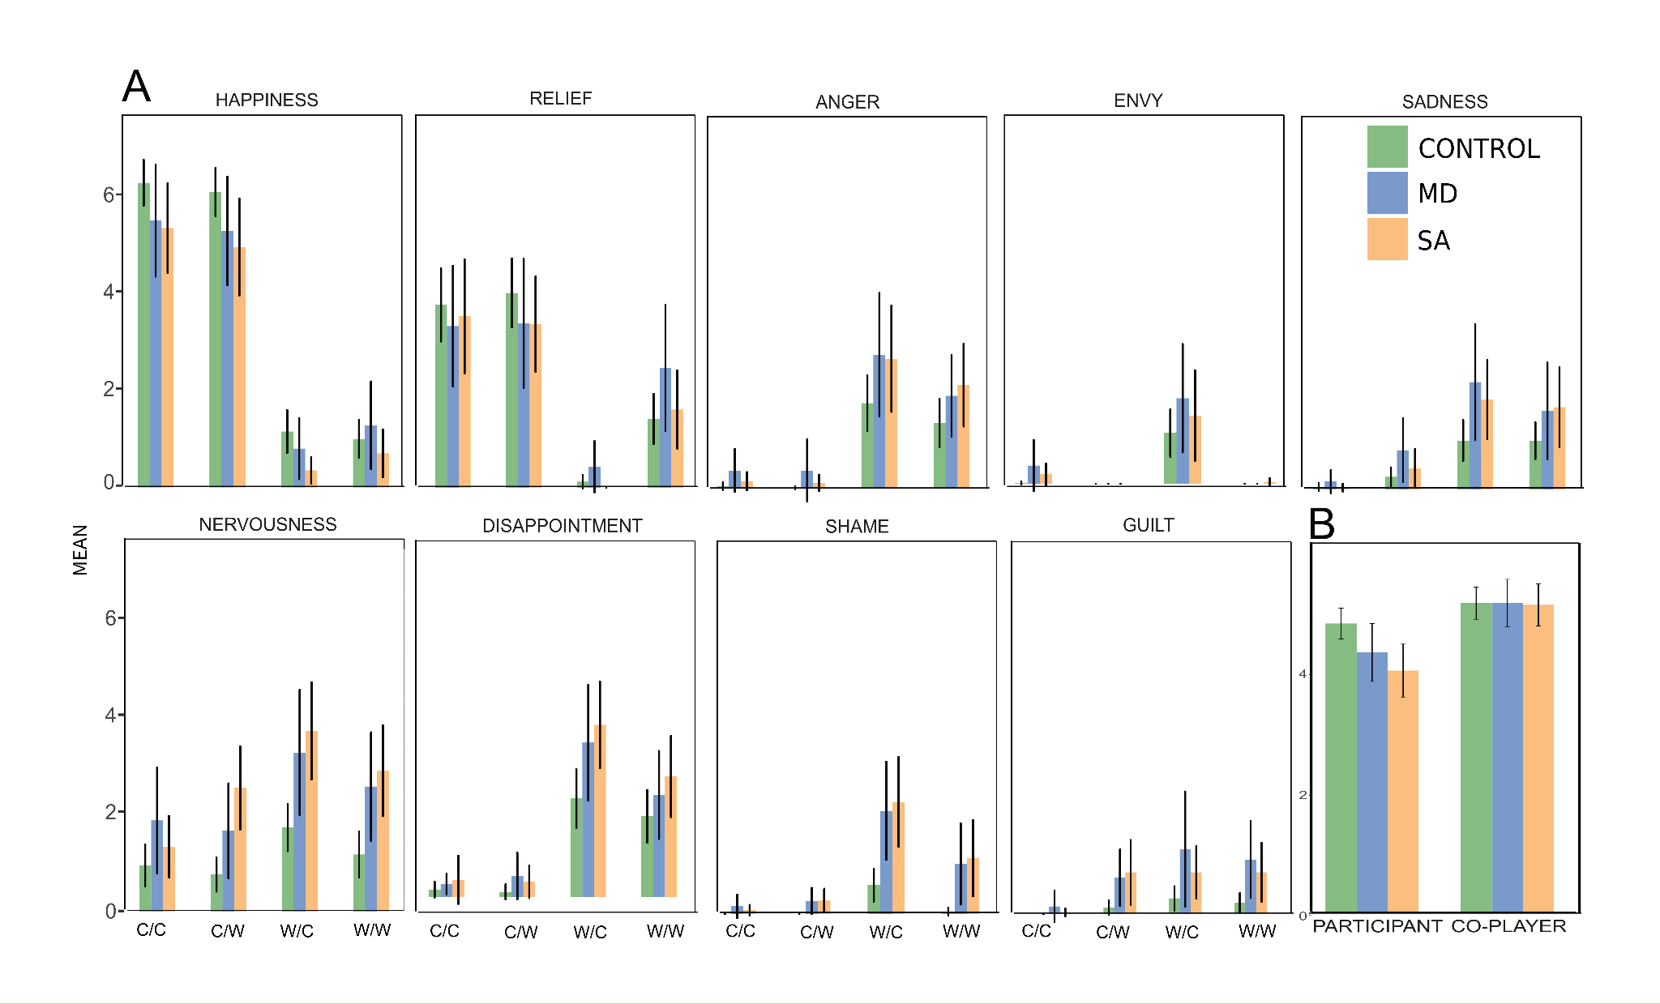Supplementary Figure 1. A) Emotional responses to the task with group opened as Control, MD, and SA. B) Evaluation of their and the co-player’s performance on the task. Error bars denote 95% confidence intervals. C/C: “You correct/Other correct”; C/W: “You correct/Other wrong”; W/C: “You wrong/Other correct”; W/W: “You wrong/Other wrong”.
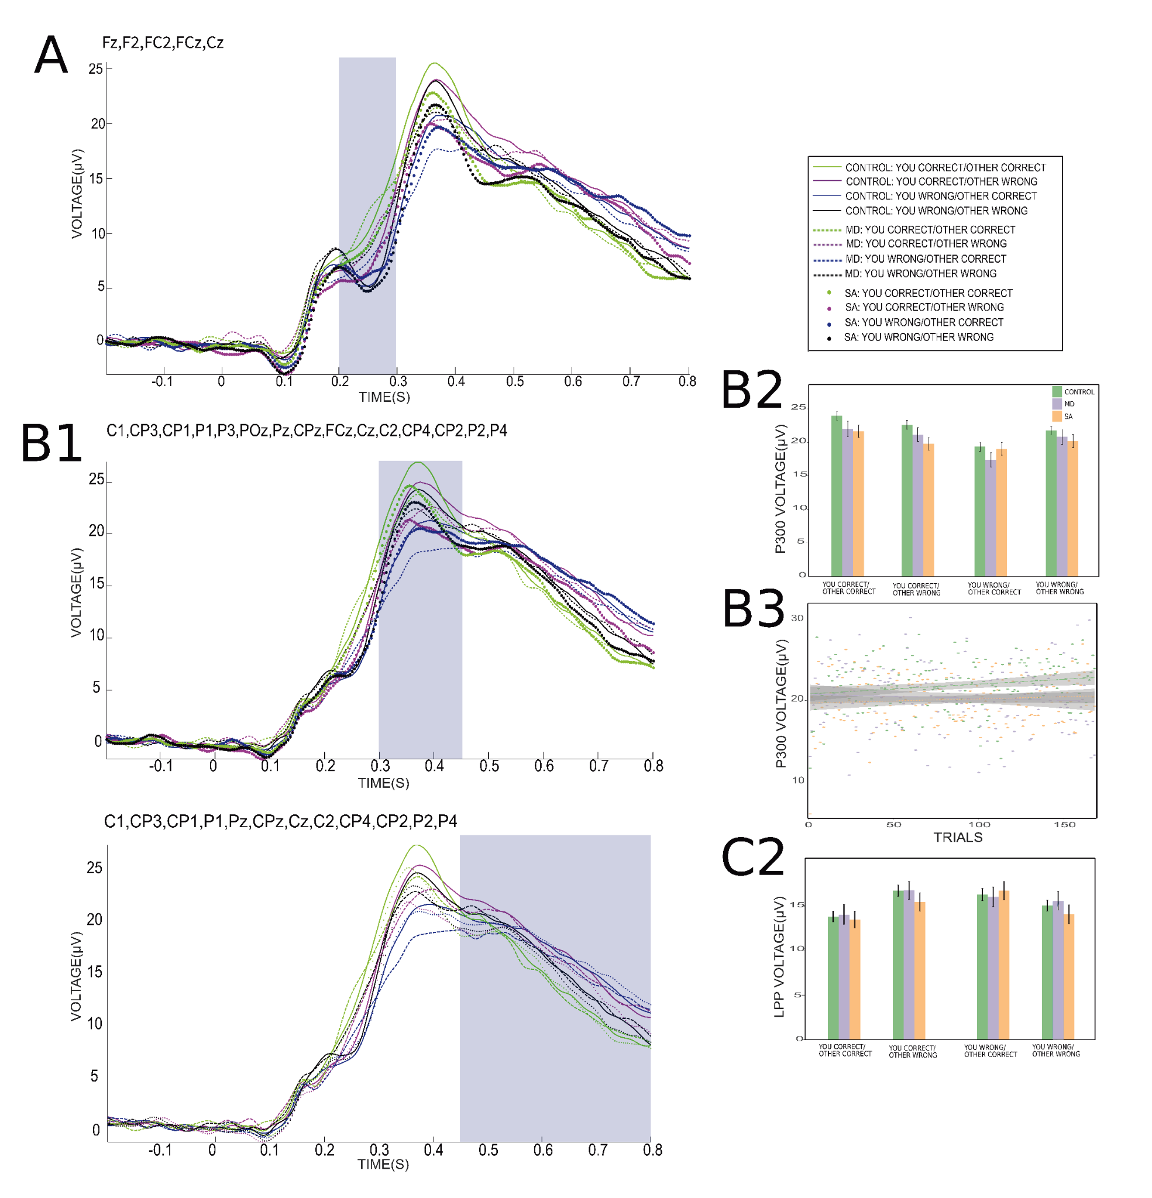Supplementary Figure 2. Event-related potentials. A) Grand-average waveform corresponding to the Medial Frontal Negativity (MFN) (200-300 ms, frontocentral electrodes). B1) Grand-average waveform corresponding to the P300 (300-450 ms, middle-line and centro-parietal electrodes). B2) Mean amplitude of the P300 over the time window and electrodes of interest with group opened as Control, MD and, SA. B3) Slopes across trials of P300 amplitudes with group opened as Control, MD and, SA. C1) Grand-average waveform corresponding to the Late Positive Potential (LPP) (450-800 ms, centro-parietal electrodes). C2) Mean amplitude of the LPP over the time window and electrodes of interest with group opened as Control, MD and, SA. In A, B1 and, C1 the origin of the horizontal axis represents feedback presentation and the shadowed region indicates the time window studied. Error bars denote 95% confidence intervals.

Supplementary Table 1. Results of emotional responses and perception of performance
 | Control | MD-SA
Emotional responses to “You correct-Other correct”
Happiness | 6.2 ± 1.8 | 5.5 ± 2.3
Relief | 3.7 ± 2.8 | 3.7 ± 2.8
Guilt | 0.0 ± 0.0 | 0.7 ± 0.4
Disappointment | 0.2 ± 0.6 | 0.4 ± 1.1
Anger | 0.1 ± 0.3 | 0.2 ± 0.7
Envy | 0.0 ± 0.1 | 0.2 ± 0.8
Nervousness | 0.9 ± 1.6 | 1.5 ± 1.9
Sadness | 0.1 ± 0.3 | 0.1 ± 0.3
Shame | 0.0 ± 0.0 | 0.1 ± 0.4
Emotional responses to “You correct-Other wrong”
Happiness | 6.0 ± 1.9 | 5.0 ± 2.3
Relief | 3.9 ± 2.7 | 3.4 ± 2.5
Guilt | 0.1 ± 0.5 | 1.1 ± 1.8
Disappointment | 1.1 ± 0.6 | 0.4 ± 1.1
Anger | 0.0 ± 0.1 | 0.3 ± 1.0
Envy | 0.0 ± 0.0 | 0.0 ± 0.0
Nervousness | 0.7 ± 1.3 | 2.1 ± 2.1
Sadness | 0.3 ± 0.7 | 0.7 ± 1.3
Shame | 0.0 ± 0.0 | 0.0 ± 0.0
Emotional responses to “You wrong-Other wrong”
Happiness | 1.0 ± 1.5 | 0.8 ± 1.5
Relief | 1.4 ± 1.9 | 2.0 ± 2.4
Guilt | 0.2 ± 0.8 | 1.0 ± 1.7
Disappointment | 1.6 ± 2.0 | 2.4 ± 2.1
Anger | 1.3 ± 2.0 | 2.2 ± 2.0
Envy | 0.0 ± 0.0 | 0.0 ± 0.1
Nervousness | 1.2 ± 1.8 | 2.8 ± 2.3
Sadness | 1.0 ± 1.4 | 1.9 ± 2.2
Shame | 0.1 ± 0.3 | 1.3 ± 2.0
Emotional responses to “You wrong-Other correct”
Happiness | 1.1 ± 1.7 | 0.5 ± 1.0
Relief | 0.1 ± 0.5 | 0.2 ± 0.7
Guilt | 0.3 ± 0.9 | 1.1 ± 1.9
Disappointment | 2.0 ± 2.3 | 3.5 ± 2.3
Anger | 1.7 ± 2.2 | 2.7 ± 2.6
Envy | 1.0 ± 1.9 | 1.6 ± 2.2
Nervousness | 1.7 ± 1.8 | 3.6 ± 2.6
Sadness | 1.0 ± 1.9 | 2.1 ± 2.7
Shame | 0.6 ± 1.3 | 2.5 ± 2.3
Emotional responses to meeting with the co-player
Happiness | 3.1 ± 2.6 | 1.9 ± 1.7
Nervousness | 1.4 ± 1.6 | 4.3 ± 2.4
Shame | 0.5 ± 1.3 | 2.8 ± 2.3
Anger | 0.0 ± 1.9 | 0.3 ± 0.9
Sadness | 0.0 ± 1.9 | 0.2 ± 0.7
Perception of performance
Participant’s performance | 4.9 ± 1.0 | 4.3 ± 1.2
Co-player’s performance | 5.3 ± 1.0 | 5.2 ± 0.9
Values are given as mean ± standard deviation.
Supplementary Table 2. Sample characteristics and clinical rating results
 | Control | MD | SA | MD-SA
n | 72 | 23 | 30 | 10
Sex
Female | 67 | 23 | 26 | 8
Male | 5 | 0 | 4 | 2
Age | 22.5 ± 3.8 | 23.4 ± 4.4 | 23.8 ± 4.7 | 22.8 ± 4.0
Years of education
Undertaken | 15.8 ± 2.8 | 15.2 ± 1.8 | 16.1 ± 3.0 | 16.7 ± 4.5
Complete | 14.2 ± 2.6 | 13.1 ± 1.3 | 13.5 ± 1.7 | 14.6 ± 4.1
Nicotine consumption
No | 62 | 15 | 28 | 10
Yes | 10 | 8 | 2 | 0
Skilful hand
Left-handed | 12 | 2 | 4 | 1
Right-handed | 60 | 21 | 26 | 9
Discipline of study
Health science | 45 | 13 | 18 | 8
Social science and arts | 12 | 5 | 7 | 2
Technology and science | 15 | 5 | 5 | 0
BDI-II | 1.4 ± 1.9 | 30.2 ± 8.5 | 14.8 ± 7.1 | 28.6 ± 9.9
SHAPS | 0.1 ± 0.4 | 4.6 ± 3.3 | 0.9 ± 1.1 | 3.8 ± 3.5
SAD | 2.4 ± 2.6 | 18.5 ± 7.1 | 23.1 ± 3.7 | 25.3 ± 3.0
FNE | 7.1 ± 5.4 | 21.7 ± 6.8 | 24.6 ± 4.9 | 26.6 ± 3.1
LSAS
Total | 13.1 ± 9.8 | 62.9 ± 23.9 | 79.6 ± 20.4 | 88.9 ± 21.1
Fear/anxiety | 7.1 ± 6.1 | 29.5 ± 11.7 | 40.8 ± 11.2 | 45.4 ± 9.8
Avoidance | 6.0 ± 4.8 | 33.5 ± 13.4 | 38.8 ± 10.7 | 43.4 ± 12.7
STAI
Trait | 35.3 ± 5.3 | 62.3 ± 5.6 | 55.8 ± 7.8 | 62.7 ± 5.8
State | 28.1 ± 4.5 | 49.3 ± 12.3 | 42.0 ± 8.6 | 50.6 ± 8.3
INCOM | 30.1 ± 7.6 | 39.1 ± 7.6 | 38.1 ± 9.3 | 34.1 ± 12.0
PANAS
Positive affect | 34.7 ± 5.6 | 17.4 ± 3.1 | 22.1 ± 4.5 | 19.0 ± 3.6
Negative affect | 16.3 ± 2.7 | 27.0 ± 5.3 | 24.6 ± 6.3 | 31.0 ± 5.2
RSES | 25.6 ± 3.7 | 10.7 ± 4.9 | 14.2 ± 6.1 | 11.1 ± 4.1
ACIPS | 90.2 ± 7.5 | 72.2 ± 14.6 | 72.3 ± 13.7 | 61.6 ± 13.2
IIP
Total | 51.1 ± 21.3 | 99.5 ± 24.3 | 107.3 ± 23.4 | 122.9 ± 24.2
Domineering/controlling | 6.2 ± 3.8 | 8.2 ± 4.2 | 8.7 ± 4.7 | 8.4 ± 4.2
Vindictive/self-centered | 4.4 ± 3.0 | 7.2 ± 4.3 | 7.3 ± 3.4 | 8.8 ± 4.0
Cold/distant | 3.7 ± 3.0 | 11.4 ± 4.6 | 11.4 ± 5.5 | 15.1 ± 5.2
Intrusive/needy | 5.9 ± 4.0 | 9.9 ± 5.6 | 8.0 ± 5.2 | 7.2 ± 4.4
Socially inhibited | 4.6 ± 4.0 | 14.5 ± 7.8 | 19.5 ± 6.0 | 24.1 ± 3.9
Nonassertive | 6.6 ± 4.9 | 17.4 ± 6.2 | 19.5 ± 5.7 | 22.1 ± 5.0
Overly accommodating | 8.7 ± 5.1 | 15.5 ± 6.0 | 15.9 ± 5.9 | 18.8 ± 6.2
Self-sacrificing | 11.0 ± 4.6 | 15.6 ± 4.5 | 17.1 ± 5.3 | 18.4 ± 4.5
Values are given as mean ± standard deviation. BDI-II: Beck Depression Inventory-II (scores from the experimental session); SHAPS: Snaith-Hamilton Pleasure Scale; SAD: Social Avoidance and Distress; FNE: Fear of Negative Evaluation; LSAS: Liebowitz Social Anxiety Scale (scores from the experimental session); STAI: State-Trait Anxiety Inventory; INCOM: Iowa-Netherlands Comparison Orientation Scale; PANAS: Positive And Negative Affect Schedule; RSES: Rosenberg Self-Esteem Scale; ACIPS: Anticipatory and Consummatory Interpersonal Pleasure Scale; IIP: Inventory of Interpersonal Problems.

Supplementary Table 3. Results of emotional responses and perception of performance
 | Control | MD | SA | MD-SA
Emotional responses to “You correct-Other correct”
Happiness | 6.2 ± 1.8 | 5.4 ± 2.5 | 5.3 ± 2.3 | 6.1 ± 2.2
Relief | 3.7 ± 2.8 | 3.3 ± 2.7 | 3.5 ± 2.9 | 5.1 ± 2.3
Guilt | 0.0 ± 0.0 | 0.2 ± 0.7 | 0.0 ± 0.2 | 0.0 ± 0.0
Disappointment | 0.2 ± 0.6 | 0.3 ± 0.5 | 0.3 ± 1.2 | 0.8 ± 0.7
Anger | 0.1 ± 0.3 | 0.4 ± 1.0 | 0.2 ± 0.5 | 0.0 ± 0.0
Envy | 0.0 ± 0.1 | 0.4 ± 1.1 | 0.2 ± 0.6 | 0.0 ± 0.0
Nervousness | 0.9 ± 1.6 | 1.8 ± 2.3 | 1.3 ± 1.6 | 1.1 ± 1.5
Sadness | 0.1 ± 0.3 | 0.2 ± 0.5 | 0.0 ± 0.2 | 0.0 ± 0.0
Shame | 0.0 ± 0.0 | 0.2 ± 0.5 | 0.1 ± 0.3 | 0.0 ± 0.0
Emotional responses to “You correct-Other wrong”
Happiness | 6.0 ± 1.9 | 5.2 ± 2.4 | 4.9 ± 2.5 | 4.8 ± 2.0
Relief | 3.9 ± 2.7 | 3.3 ± 2.8 | 3.3 ± 2.5 | 3.6 ± 2.4
Guilt | 0.1 ± 0.5 | 0.7 ± 0.2 | 0.8 ± 1.7 | 2.3 ± 2.7
Disappointment | 1.1 ± 0.6 | 0.4 ± 1.0 | 0.3 ± 0.8 | 0.8 ± 1.6
Anger | 0.0 ± 0.1 | 0.4 ± 1.4 | 0.1 ± 0.4 | 0.4 ± 1.0
Envy | 0.0 ± 0.0 | 0.0 ± 0.0 | 0.0 ± 0.0 | 0.0 ± 0.0
Nervousness | 0.7 ± 1.3 | 1.6 ± 2.1 | 2.5 ± 2.1 | 2.2 ± 2.2
Sadness | 0.3 ± 0.7 | 0.8 ± 1.4 | 0.4 ± 1.0 | 1.2 ± 1.7
Shame | 0.0 ± 0.0 | 0.3 ± 0.6 | 0.3 ± 0.6 | 0.7 ± 0.9
Emotional responses to “You wrong-Other wrong”
Happiness | 1.0 ± 1.5 | 1.3 ± 1.9 | 0.7 ± 1.2 | 0.3 ± 1.0
Relief | 1.4 ± 1.9 | 2.4 ± 2.8 | 1.6 ± 2.0 | 2.1 ± 2.4
Guilt | 0.2 ± 0.8 | 1.1 ± 1.7 | 0.8 ± 1.5 | 1.3 ± 2.2
Disappointment | 1.6 ± 2.0 | 2.1 ± 1.9 | 2.4 ± 2.1 | 2.8 ± 2.5
Anger | 1.3 ± 2.0 | 1.9 ± 1.8 | 2.1 ± 2.2 | 3.0 ± 2.0
Envy | 0.0 ± 0.0 | 0.0 ± 0.0 | 0.0 ± 0.2 | 0.0 ± 0.0
Nervousness | 1.2 ± 1.8 | 2.5 ± 2.4 | 2.8 ± 2.3 | 3.4 ± 2.4
Sadness | 1.0 ± 1.4 | 1.6 ± 2.1 | 1.7 ± 2.0 | 3.1 ± 2.8
Shame | 0.1 ± 0.3 | 1.0 ± 1.8 | 1.1 ± 1.9 | 2.3 ± 2.7
Emotional responses to “You wrong-Other correct”
Happiness | 1.1 ± 1.7 | 0.9 ± 1.4 | 0.3 ± 0.7 | 0.7 ± 1.1
Relief | 0.1 ± 0.5 | 0.4 ± 1.1 | 0.0 ± 0.0 | 0.2 ± 0.4
Guilt | 0.3 ± 0.9 | 1.3 ± 2.5 | 0.8 ± 1.3 | 1.7 ± 1.8
Disappointment | 2.0 ± 2.3 | 3.1 ± 2.5 | 3.5 ± 2.2 | 4.3 ± 2.0
Anger | 1.7 ± 2.2 | 2.7 ± 2.7 | 2.7 ± 2.8 | 2.6 ± 1.6
Envy | 1.0 ± 1.9 | 1.7 ± 2.4 | 1.4 ± 2.3 | 0.0 ± 0.0
Nervousness | 1.7 ± 1.8 | 3.2 ± 2.8 | 3.7 ± 2.5 | 4.3 ± 2.4
Sadness | 1.0 ± 1.9 | 2.2 ± 2.5 | 1.8 ± 2.0 | 2.9 ± 2.4
Shame | 0.6 ± 1.3 | 2.1 ± 2.1 | 2.2 ± 2.3 | 4.3 ± 2.2
Emotional responses to meeting with the co-player
Happiness | 3.1 ± 2.6 | 1.5 ± 1.4 | 2.2 ± 1.7 | 2.2 ± 2.1
Nervousness | 1.4 ± 1.6 | 3.9 ± 2.9 | 4.5 ± 2.3 | 4.5 ± 1.8
Shame | 0.5 ± 1.3 | 2.6 ± 2.4 | 2.5 ± 2.3 | 3.8 ± 2.1
Anger | 0.0 ± 1.9 | 0.2 ± 0.7 | 0.5 ± 1.8 | 0.0 ± 0.0
Sadness | 0.0 ± 1.9 | 0.2 ± 0.5 | 0.3 ± 0.7 | 0.3 ± 1.0
Perception of performance
Participant’s performance | 4.9 ± 1.0 | 4.4 ± 1.1 | 4.1 ± 1.1 | 4.3 ± 1.4
Co-player’s performance | 5.3 ± 1.0 | 5.3 ± 0.9 | 5.2 ± 0.9 | 5.2 ± 1.2
Values are given as mean ± standard deviation.

Supplementary Table 4. Results of ERPs
 | Control | MD | SA | MD-SA
MFN
“You correct-Other correct” | 11.1 ± 13.0 | 11.6 ± 12.7 | 9.6 ± 13.0 | 8.3 ± 11.3
“You correct-Other wrong” | 8.0 ± 12.5 | 9.7 ± 12.2 | 7.5 ± 13.1 | 5.8 ± 10.7
“You wrong-Other wrong” | 7.2 ± 12.1 | 9.5 ± 11.8 | 6.0 ± 13.3 | 3.8 ± 13.0
“You wrong-Other correct” | 6.4 ± 12.5 | 7.9 ± 11.6 | 7.0 ± 13.4 | 5.1 ± 12.1
P300
“You correct-Other correct” | 23.9 ± 13.2 | 22.0 ± 14.6 | 21.6 ± 13.7 | 18.4 ± 12.4
“You correct-Other wrong” | 22.6 ± 13.7 | 21.1 ± 13.2 | 19.8 ± 14.6 | 16.7 ± 12.9
“You wrong-Other wrong” | 21.7 ± 13.3 | 20.8 ± 14.2 | 20.2 ± 15.5 | 16.1 ± 16.7
“You wrong-Other correct” | 19.3 ± 14.3 | 17.4 ± 14.0 | 19.0 ± 15.0 | 15.0 ± 14.7
LPP
“You correct-Other correct” | 13.8 ± 12.8 | 14.1 ± 14.2 | 13.5 ± 14.1 | 13.4 ± 14.5
“You correct-Other wrong” | 16.7 ± 12.9 | 16.8 ± 12.8 | 15.5 ± 15.0 | 14.9 ± 13.9
“You wrong-Other wrong” | 15.0 ± 13.2 | 15.6 ± 13.3 | 14.1 ± 16.2 | 12.0 ± 16.8
“You wrong-Other correct” | 16.3 ± 14.6 | 16.0 ± 14.7 | 16.7 ± 15.9 | 14.3 ± 13.8
Values are given as mean ± standard deviation.

