Supplementary Information

Evaluation of an adapted semi-automated DNA extraction for human salivary shotgun metagenomics

Authors
Victoria Meslier^{1,2*}, Elisa Menozzi^{2,3*}, Aymeric David^{1,2*}, Christian Morabito^{1,2}, Sara Lucas Del Pozo^{2,3}, Alexandre Famechon^{1,2}, Janet North⁴, Benoit Quinquis^{1,2}, Sofia Koletsi^{2,3}, Jane Macnaughtan^{2,5}, Roxana Mezabrovschi^{2,3}, S. Dusko Ehrlich^{2,3}, Anthony HV. Schapira^{2,3$}, Mathieu Almeida^{1,2$}

Affiliation
¹Université Paris-Saclay, INRAE, MGP, Jouy-en-Josas, France
²Aligning Science Across Parkinson's (ASAP) Collaborative Research Network, Chevy Chase, MD, 20815
³Department of Clinical and Movement Neurosciences, Queen Square Institute of Neurology, University College London (UCL), London, United Kingdom
⁴Research Department of Hematology, Cancer Institute, University College London (UCL), London, United Kingdom
⁵Liver Failure Group, Institute for Liver and Digestive Health, University College London, London, United Kingdom

* These authors contributed equally to this work

$ All correspondence should be addressed to mathieu.almeida@inrae.fr ; a.schapira@ucl.ac.uk

Supplementary Methods

Ethics declaration
Participants were recruited through the Remote Assessment of Parkinsonism Supporting Ongoing Development of Interventions in Gaucher Disease study (RAPSODI) (http://rapsodistudy.com) and via the PD FRONTLINE platform (1). All participants who consent to take part in the RAPSODI or PD FRONTLINE studies are screened for genetic variants in the GBA1 and LRRK2 genes. As part of their participation to the RAPSODI or PD FRONTLINE study, participants may be asked to provide a saliva sample for analysis of their oral microbiome, which is part of this project. Ethical approval was provided by the London - Queen Square Research Ethics Committee (REC reference: 15/LO/1155).

Salivary collection using OMNIgene ORAL OM 501 device
All participants were asked to collect one saliva sample using the OMNIgene•ORAL | OM-501 sample collection kit (DNAGenotek, Ottawa, Ontario, Canada). Participants were provided with written instructions on how to collect the sample and asked not to eat, drink, smoke or chew gum for 30 minutes before collection. Samples were collected at the time of the in-person clinical assessment at the Royal Free Hospital (London, UK) and stored at -80°C until further steps. Patients with Parkinson disease and their partners or family-related members were invited to participate (Table S1).

Overall strategy
Before DNA extraction from the salivary sampling device, a pre-process was performed by heating the whole OMNIgene Oral OM 501 tubes into an incubator at 50°C for 2 hours (Fig. 1A). Then, we split the samples as follow: (i) four raw samples were assigned to each of DNA extraction protocols P1 or P2 to evaluate each protocol’s efficiency on extracting microbial DNA by accounting for individual’s inter-variability, and (ii) three pairs of samples were randomly chosen and mixed to produce three new samples (referred herein after as pooled samples) to evaluate differences between protocols (Fig. 1.A and Table S1). For each raw or pooled samples, a volume between 1.5 and 2mL was then transferred into a 2mL Sarstedt tube, depending on the amount of saliva produced by each donor. A total of seven samples (4 raw and 3 pooled) were processed for each of the two DNA extraction protocols, described in the sections below. After DNA extraction, whole genome shotgun (WGS) sequencing was performed using Ion Proton technology followed by bioinformatics and biostatistics analysis (Fig. 1.A).

DNA extraction procedures
The two DNA extraction procedures performed in this study included both mechanical and chemical lysis steps, and differed regarding the purification procedures (semi-automated purification for Procedure 1 and manual for Procedure 2), as presented below and following the manufacturers recommendations.

Procedure 1: MGP Standard Operating Procedure
DNA extraction was performed on an aliquot of salivary samples following the MGP SOP001 v1 (https://mgps.eu/standard-operating-procedure/), adapted from the IHMS (International Human Microbiome Standards) SOP 07 V2 protocol (http://www.human-microbiome.org/index.php?id=Sop&num=005). The protocol is fully available at dx.doi.org/10.17504/protocols.io.dm6gpjm11gzp/v1 (2). First, 250µL of Guanidine Thiocyanate (4M; Sigma G6639) and 40µL of N-Lauroyl Sarcosine (10% w/v; Sigma L9150) were added to 500µL of saliva sample, gently mixed before adding 500µL of N-Lauroyl Sarcosine (5% w/v) and incubating the tubes in a dry incubator for 1h at 70°C. A mechanical lysis was performed by adding 750µL of autoclaved glass beads (0.1 mm) to the tubes that were mixed for 10 minutes at 25 s⁻¹ speed using a bead beater (MixerMill MM400, Retsch). Then, 15 mg of PVPP (Sigma 77627) was added and the tubes were vigorously shaken before a centrifugation at 18 200g, 4°C for 5 minutes. The supernatant was recovered in a sterile 2mL tube and 500µL of TENP solution (50mM Tris pH8, 20mM EDTA pH8, 100mM NaCl and 1% PVPP) was added to the remaining pellet, mixed well and centrifuged at 18 200g, 4°C for 5 minutes. The supernatant was recovered and pooled to the previous one and centrifuged 10 minutes at 18 200g, 4°C. Lysis extracts were then purified using the QIAsymphony SP instrument (QIAGEN), following the QIAsymphony DSP Virus/Pathogen midi kit version 1, that included automated DNA particles binding to magnetic beads, washing and elution steps. Purified DNA samples were re-suspended in 110µL of the elution buffer (AVE) provided in the kit. DNA extracts were stored at -20°C before further steps.

Procedure 2: QIAGEN QIAamp Power Fecal Pro
We used the QIAamp PowerFecal Pro kit as recommended by the manufacturer instructions (available at https://www.qiagen.com/). Briefly, 250µL of saliva sample was added in a dry bead tube with 750µL of PowerBead Solution and 60µL of solution C1. The tubes were heated for 65°C for 10 minutes and mechanical lysis was performed using a Vortex Adapter at maximum speed for 10 minutes. Different series of chemical lysis were performed using C2 and C3 solutions, before proceeding to the purification using C4 and C5 solutions and the MB Spin Column (referred to the kit protocol for additional details). The elution was performed with 110µL of C6 solution provided in the kit. DNA extracts were stored at -20°C before further steps.

DNA yield and quality evaluation
DNA quantification was performed on each tube using the DNA-binding fluorescent Quant-it dsDNA BR assay (Thermo Fisher Scientific, MA, USA) following the manufacturer instructions. DNA quality was determined using the Genomic 50kb kit by capillary electrophoresis using the Fragment Analyzer (Agilent Technologies Inc., CA, USA).

Shotgun metagenomics
The full description for libraries construction and shotgun sequencing using Ion Torrent technology was previously described (3). Briefly, libraries were built with 1µg of high molecular weight DNA and using the Ion Plus Fragment Library kit (Thermo Fisher Scientific) to a targeted length of 150nt. After purification using magnetic beads, libraries were quantified and quality checked using the HS Small fragment kit (Fragment Analyzer, Agilent), with an expected length of 240nt and expected quantity above 1000 pM. Ion Proton and Ion GeneStudio S5 sequencers were used to generate 20 million of 150nt raw reads per sample, as described before (3).

Bioinformatics: Read mapping and microbial species
Raw reads obtained from Ion Torrent sequencing technology were quality trimmed using AlienTrimmer v2.0 (4) with the following parameters: “-k 10 -l 45 -m 5 -p 40 -q 20” and human related reads were removed using Bowtie2 (5) using the Human genome reference GRCh38 (accession GCA_000001405.15, nucleotide identity > 90%). High quality reads were mapped onto the 8.4 million gene oral catalog (https://doi.org/10.15454/WQ4UTV) (6) using the METEOR software (https://forgemia.inra.fr/metagenopolis/meteor), with a two steps procedure as described before (7). The resulting gene count table was then downsized to 1 million mapped reads using the R package MetaOMineR (https://github.com/eprifti/momr) (8) to take into account differences in sequencing depth, was normalized for gene length and finally transformed into a frequency matrix using the FPKM strategy (8). The 8.4 million gene oral catalog was previously organized using MSPminer tool into 853 MSP species (9–12), corresponding to clusters of co-abundant genes used as proxies for microbial species, and containing core and accessory genes. Taxonomical annotation was assigned using the Genome Taxonomy Database (13). MSP definition and taxonomy are available from Data INRAe (https://doi.org/10.15454/WQ4UTV) (11). MSP relative abundance was defined as the mean abundance of 100 marker genes corresponding to core genes with the highest correlations altogether. MSP species with less than 10% of its marker genes detected was considered absent (its abundance was set to 0). Relative abundances at higher taxonomical ranks were computed as the sum of the MSP abundance that belong to a given taxon.

Biostatistics
Statistical analysis was done under the R software v3.6.0 (14). Comparisons between two groups were performed using unpaired Wilcoxon ranked tests, and FDR was controlled by p-values correction with the Benjamini Hochberg (BH) procedure. Results were declared significantly different for a p-value less than 0.05. Correlations between variables were determined by Spearman’s correlations. Alpha and beta diversity indices were determined by using the vegan R package (15). Principal coordinates analysis (PCoA) was performed on the Bray-Curtis dissimilarity with the package ade4 v1.7.16 (16). PCA analysis was performed on log10 transformed msp count table using FactoMineR and Factoextra packages (17,18). Box plots were computed using the ggpubr R package (19), heatmaps were created with the ComplexHeatmap and pheatmap packages (20,21), and metagenomic analyses were performed using the momr R package (8).

References
1. Higgins AL, Toffoli M, Mullin S, Lee CY, Koletsi S, Avenali M, et al. The remote assessment of parkinsonism supporting the ongoing development of interventions in Gaucher disease. Neurodegener Dis Manag. 2021;11(6):451–8.
2. David A, Morabito C. Protocol for DNA extraction from saliva samples, used for shotgun microbiome analysis. 2023; Available from: dx.doi.org/10.17504/protocols.io.dm6gpjm11gzp/v1
3. Meslier V, Quinquis B, Da Silva K, Plaza Oñate F, Pons N, Roume H, et al. Benchmarking second and third-generation sequencing platforms for microbial metagenomics. Sci Data. 2022;9(1):694.
4. Criscuolo A, Brisse S. AlienTrimmer: A tool to quickly and accurately trim off multiple short contaminant sequences from high-throughput sequencing reads. Genomics. 2013;102(5–6):500–6.
5. Langmead B, Salzberg SL. Fast gapped-read alignment with Bowtie 2. Nat Methods. 2012;9(4):357–9.
6. Le Chatelier E, Almeida M, Plaza Oñate F, Pons N, Gauthier F, Ghozlane A, et al. A catalog of genes and species of the human oral microbiota. Data INRAE Rech Data Gouv. 2021;
7. Meslier V, Laiola M, Roager HM, De Filippis F, Roume H, Quinquis B, et al. Mediterranean diet intervention in overweight and obese subjects lowers plasma cholesterol and causes changes in the gut microbiome and metabolome independently of energy intake. Gut. 2020 Jul;69(7):1258–68.
8. Le Chatelier E, Nielsen T, Qin J, Prifti E, Hildebrand F, Falony G, et al. Richness of human gut microbiome correlates with metabolic markers. Nature. 2013;500(7464):541–6.
9. Plaza Oñate F, Le Chatelier E, Almeida M, Cervino ACL, Gauthier F, Magoulès F, et al. MSPminer: abundance-based reconstitution of microbial pan-genomes from shotgun metagenomic data. Bioinforma Oxf Engl. 2019;35(9):1544–52.
10. Nielsen HB, Almeida M, Juncker AS, Rasmussen S, Li J, Sunagawa S, et al. Identification and assembly of genomes and genetic elements in complex metagenomic samples without using reference genomes. Nat Biotechnol. 2014;32(8):822–8.
11. Le Chatelier E, Almeida M, Plaza Oñate F, Pons N, Gauthier F, Ghozlane A, et al. A catalog of genes and species of the human oral microbiota. Recherche Data Gouv. 2021. Available from: https://data.inrae.fr/citation?persistentId=doi:10.15454/WQ4UTV
12. Plaza Oñate F, Le Chatelier E. Metagenomic Species Pan-genomes (MSPs) of the human gastrointestinal microbiota. Portail Data INRAE Rech Data Gouv. 2020;
13. Parks DH, Chuvochina M, Waite DW, Rinke C, Skarshewski A, Chaumeil PA, et al. A standardized bacterial taxonomy based on genome phylogeny substantially revises the tree of life. Nat Biotechnol. 2018;36(10):996–1004.
14. R Core Team. The R Project for Statistical Computing. Vienna: R Foundation; 2017. Available from: https://www.r-project.org/.
15. Oksanen J, Blanchet F, Friendly M, Kindt R, Legendre P, McGlinn D, et al. Vegan: community ecology package. Vienna: Institute for Statistics and Mathematics. 2019. Available from: https://cran.r-project.org/web/packages/vegan/index.html
16. Thioulouse J, Dray S, Dufour AB, Siberchicot A, Jombart T, Pavoine S. Multivariate Analysis of Ecological Data with ade4. 1st ed. 2018. New York, NY: Springer New York : Imprint: Springer; 2018.
17. Lê S, Josse J, Husson F. Lê, S., Josse, J. & Husson, F. (2008). FactoMineR: An R Package for Multivariate Analysis. In: Journal of Statistical Software. 2008. p. 1–18.
18. Kassambara A, Mundt F. Factoextra: Extract and Visualize the Results of Multivariate Data Analyses. R Package Version 1.0.7. 2020. Available from: https://CRAN.R-project.org/package=factoextra
19. Kassambara A. ggpubr: “ggplot2” Based Publication Ready Plots [Internet]. 2023. Available from: https://github.com/kassambara/ggpubr
20. Gu Z, Eils R, Schlesner M. Complex heatmaps reveal patterns and correlations in multidimensional genomic data. Bioinformatics. 2016 Sep 15;32(18):2847–9.
21. Kolde R. pheatmap: Pretty Heatmaps. 2019. Available from: https://github.com/raivokolde/pheatmap

Supplementary Results

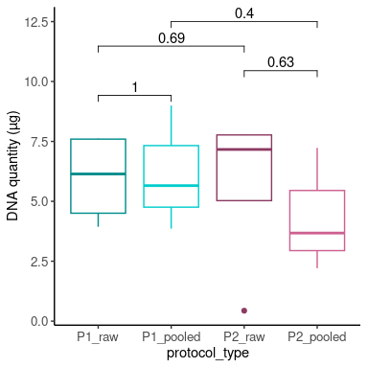
Supplementary Figure S1: Effect of DNA isolation on DNA quantity (µg) per protocol and sample type. P-values from unpaired Wilcoxon tests are reported.

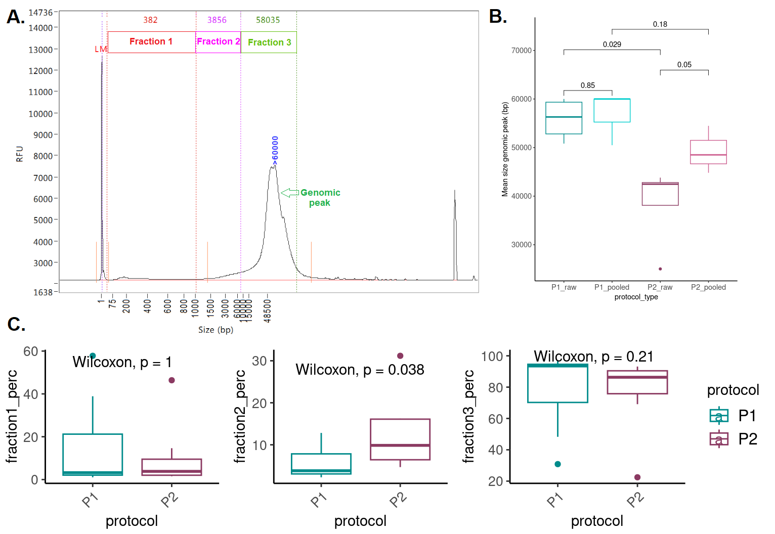
Supplementary Figure S2: Overall assessment of the DNA quality. A. Typical DNA profile obtained from Fragment Analyzer, measuring the quality of the DNA after extraction. Three fractions can be defined depending on the distribution of the size of the DNA: fraction 1, fragments ≤ 1 000bp; fraction 2, >1 000bp and ≤10 000bp and fraction 3 >10 000bp. B. Mean size of the genomic peak per protocol and sample type. C. The area under the fragment analyzer curve was determined for each fraction 1 to 3 for each sample and reported as percentage of the total area under the curve. P-values from unpaired Wilcoxon tests were reported.

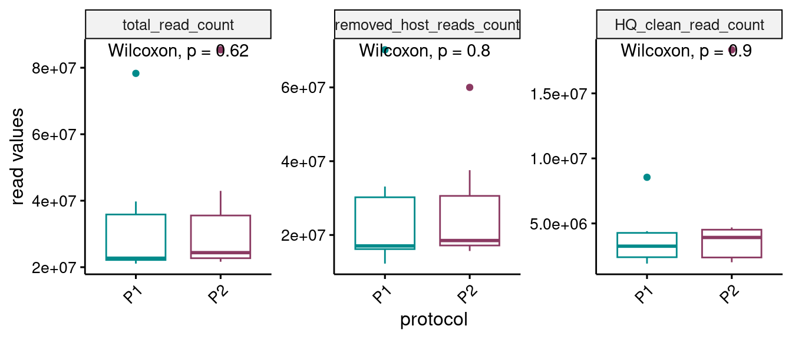
Supplementary Figure S3: Whole Shotgun Sequencing report. The total number of raw reads, the number of human related reads and the number of High Quality (HQ) cleaned reads, corresponding to reads cleaned from low quality and human reads, were used as indicators of WGS sequencing performances.

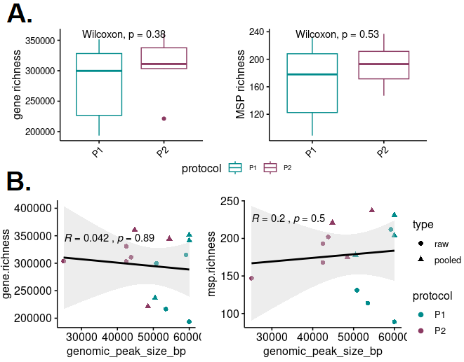
Supplementary Figure S4: Additional comparison for alpha diversity metrics. A. Gene and MSP species richness metrics for all samples per protocol. B. Spearman correlation between gene or MSP species richness and the DNA quality using the size of the genomic peak. Samples were color coded by protocol and shaped by sample type.

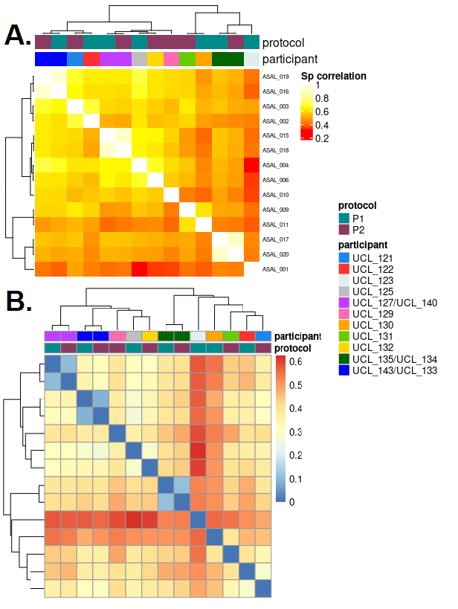
Supplementary Figure S5: Heatmaps based on MSP species composition. A. Spearman correlations. B. Bray-Curtis dissimilarity. Protocols and Participants ID are reported.

