Supplementary Material
Minimising Decalcification Time
To optimise the speed of AutoZooMS, an investigation into the minimum required decalcification time was conducted. Bone fragments (n=24) were place in 5 mL Eppendorf tubes and 4 mL of 0.6 M HCl was added. Then at 2-, 4-, 6- and 24-hour intervals 0.3 mL of acid was removed and frozen. After the final acid had been removed, samples were thawed, and a protein assay was performed using an Invitrogen Qubit Protein Assay Kit and a Qubit 2.0 Fluorometer (Thermofisher Scientific, UK). Protein assay was performed as by product specification. Protein quantification was performed on 24 acid-soluble protein samples. Protein concentration at both 6- and 24-hours was significantly higher than protein concentration at 2- and 4-hours (2~6: p<0.01, 2~24: p<0.0001, 4~6: p<0.01, 4~24: p<0.01). No significant difference in protein concentration was recorded between 2-4 hours, and between 6-24 hours respectively (p>0.05 for all), indicating that a 6-hour decalcification could be considered adequate.

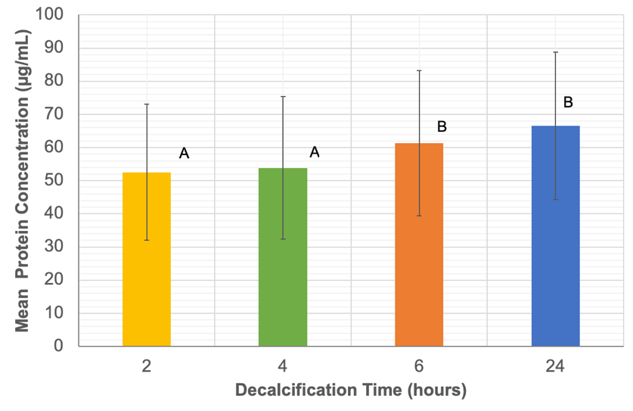
Figure S1: The mean acid-soluble protein concentration of samples after 2-, 4-, 6- and 24-hours decalcification. A and B lettering indicates groups of statistical significance.

Minimising Enzymatic Digestion Time
As ZooMS is typically performed with overnight (~18-24 hour) digests at 37 ˚C, we evaluated reducing this time to 2-, 4-, 6- and 24-hour intervals (Supplementary Figure S2). The success rate of collagen fingerprinting was identical across 2, 6 and 24 hours, while the success rate at 4-hours trypsin digest was slightly higher; these results indicate that 2 hour’s digestion time would be adequate.

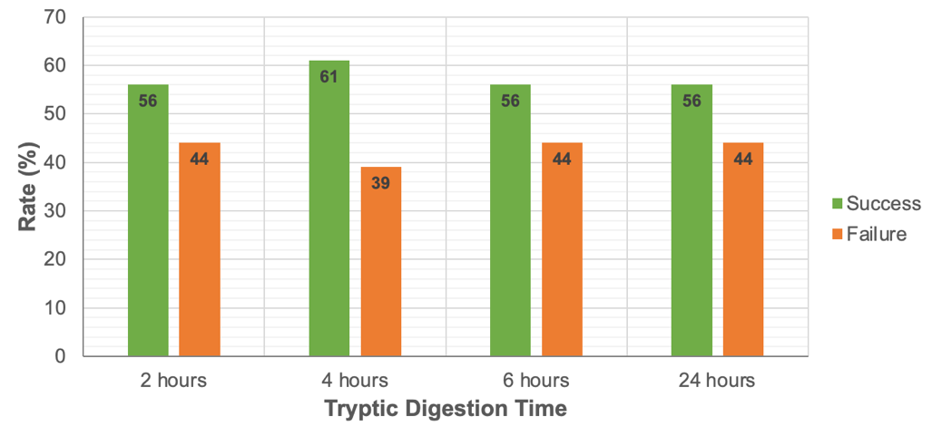

Figure S2: Rate of automated ZooMS success and failure across 2-, 4-, 6- and 24-hour digestion times (n = 24), using 2 µL of 0.04 µg trypsin.

