Sequential Antigen-loss and Branching Evolution in Lymphoma after Anti-CD19 and Anti-CD20 Targeted T Cell Redirecting Immunotherapy
Johannes Duell^{1,}*, Alexander M. Leipold^{2,}*, Silke Appenzeller³, Viktoria Fuhr⁴, Hilka Rauert-Wunderlich⁴, Matteo Da Via^{1,5}, Oliver Dietrich², Christophe Toussaint², Fabian Imdahl², Florian Eisele¹, Lars Grundheber¹, Hermann Einsele¹, Andreas Rosenwald⁴, Max S. Topp¹, Antoine-Emmanuel Saliba^{2,#}, Leo Rasche^{1,#}
Affiliations
¹ Department of Internal Medicine 2, University Hospital of Würzburg, Würzburg, Germany
² Helmholtz Institute for RNA-based Infection Research (HIRI), Helmholtz-Center for Infection Research (HZI), Würzburg, Germany
³ Core Unit Bioinformatics, Comprehensive Cancer Center Mainfranken, University Hospital of Würzburg, Würzburg, Germany
⁴ Institute of Pathology, University of Würzburg, Würzburg, Germany
⁵ Hematology Unit, Fondazione IRCCS Ca’ Granda Ospedale Maggiore Policlinico, Milan, Italy
* These authors contributed equally

EXTENDED DATA FIGURES

Extended Data Figure 1: scRNA-seq analysis of 15 biopsies from 7 patients.
Extended Data Figure 2: MS4A1-deletion in patient 6.
Extended Data Figure 3: An intronic point mutation leading to aberrant splicing of MS4A1 as cause of CD20-loss in patient 2.
Extended Data Figure 4: Expression of T cell exhaustion markers and signature genes (related to Fig 3).
Extended Data Figure 5: CD19-loss and retainment after relapse from CD19 CAR T cell therapy.
Extended Data Figure 6: Exhaustion markers in CD8 effector T cells in CD19-positive relapse after CD19 CAR T therapy in patient 5.
Extended Data Figure 7: CD19 and CD20 loss in patient 1.
Extended Data Figure 8: A MS4A1-positive subclone in Sample 1.4 shows increased energy metabolism and proliferation compared to the MS4A1-negative counterpart.
Extended Data Figure 9: Spatial heterogeneity of target antigen expression in patient 1.
Extended Data Figure 10: Expression of cell type marker genes in Samples 3.2 and 3.3.
SUPPLEMENTARY TABLES LEGENDS

Supplementary Table 1: Patient and Sample characteristics. Page 1, Patient characteristics including age at first diagnosis (column 2), gender (column 3), diagnosis (column 4) and a list with all treatments received by the respective patient before and until the end of the studied period (column 5). Treatments are listed chronologically. Columns 6 & 7 indicate antigen-negative or positive relapse from the respective targeting therapy. Page 2, Sample characteristics including the biopsy site (column 2, ‘Material’; LN = lymph node; BM = bone marrow), methods used to study the biopsy sample (column 3) and the tumor content estimated by pathologists from IHC (column 4). ‘Status’ (column 5) indicates if the lesion biopsied for the respective sample was considered responsive to therapy with the respective therapy in brackets. Columns 6-13 indicate the qualitative expression of CD20/MS4A1 and CD19/CD19 across modalities. ‘+’ indicates ‘expressed’, while ‘-’ indicates ‘not expressed’. ‘/’ indicates missing information. For samples where genomic alterations in MS4A1 were detected this is indicated in column 14 (‘MS4A1 genomic alteration’; based on hg19 MS4A1:NM_021950.3).

Supplementary Table 2: Whole Exome Sequencing (WES) and bulk RNA-sequencing. Page 1, Whole exome sequencing data quality metrics. Shown are the total number of reads sequenced as well as the number and percentage of reads remaining after quality and adapter trimming and the mean coverage for each sample, respectively. Page 2, Bulk RNA-sequencing data quality metrics. Shown are the total number of reads sequenced as well as the number and percentage of reads remaining after quality and adapter trimming for each sample. Respectively. Page 3, Detected gene fusion; Positions refer to hg19. Page 4, Somatic mutations identified in MS4A1 in respective Samples; Positions refer to hg19. Page 5, Expression levels of MS4A1 & CD19 in bulkRNA-seq in fragments per kilobase of transcript per million mapped reads (FPKM; columns 2 & 4) and the qualitative values expressed (+) and non-expressed (-) we assigned each sample (column 3 & 5). ‘/’ was used if a sample does not contain tumor.

Supplementary Table 3: scRNA-seq data quality; QC filtering; gene signatures; antigen expression. Page 1, scRNA-seq data quality metrics from CellRanger output of data generated in the present study. ‘Identifier’ shows the name of the library in the manuscript. ‘Library’ shows the formal library name (used for filenames in EGA). Page 2, Quality metrics and customized parameters used for quality filtering of all libraries. Parameters were customized in order to account for varying underlying data qualities between libraries. Page 3, Description of gene signatures used for module score calculation. ‘Signature Identifier’ is the name of the signature used in the manuscript. Page 4, Log-normalized expression values of MS4A1 and CD19 in B/malignant cells averaged per sample (column 2 & 4) and the qualitative values expressed (+) and non-expressed (-) we gave each sample (column 3 & 5).

Supplementary Table 4: Differential expression analysis using Wilcoxon rank-sum test, Gene ontology enrichment analysis results. Page 1, Statistics related to genes differentially expressed between MS4A1-positive and MS4A1-negative B/malignant cells in Sample 1.4. The table is ordered by group (column 1 ‘group’). Genes (column 2 for gene symbol & column 8 for ENSEMBL ID) are ordered by increasing p-values (column 6) within the respective groups. The average log2 fold-change (column 3) is positive for genes upregulated in MSA41-positive group and negative for genes upregulated in MS4A1-negative group. Bonferroni-method was used to adjust p-values for multiple comparisons (column 7). Percentages of non-zero expressing cells in MS4A1-positive cells (column 4 ‘pct.1’) and MS4A1-negative cells (column 5 ‘pct.2’) are indicated. Page 2, Statistics related to Gene Ontology (GO) enrichment analysis of genes upregulated in MS4A1-positive cells compared to MS4A1-negative cells in Sample 1.4 using clusterProfiler v4.2.2 (ont = “BP”) with GO terms obtained from the R database org.Hs.eg.db v3.16 as reference. Redundant Go terms were removed using the simplify function with 0.7 as similarity cutoff. The table is ordered by increasing p-values (column 6). Benjamini-Hochberg method was used to adjust p-values for multiple comparisons (column 7). GO terms shown in Extended Data Fig. 7b are highlighted in red.

EXTENDED DATA FIGURES

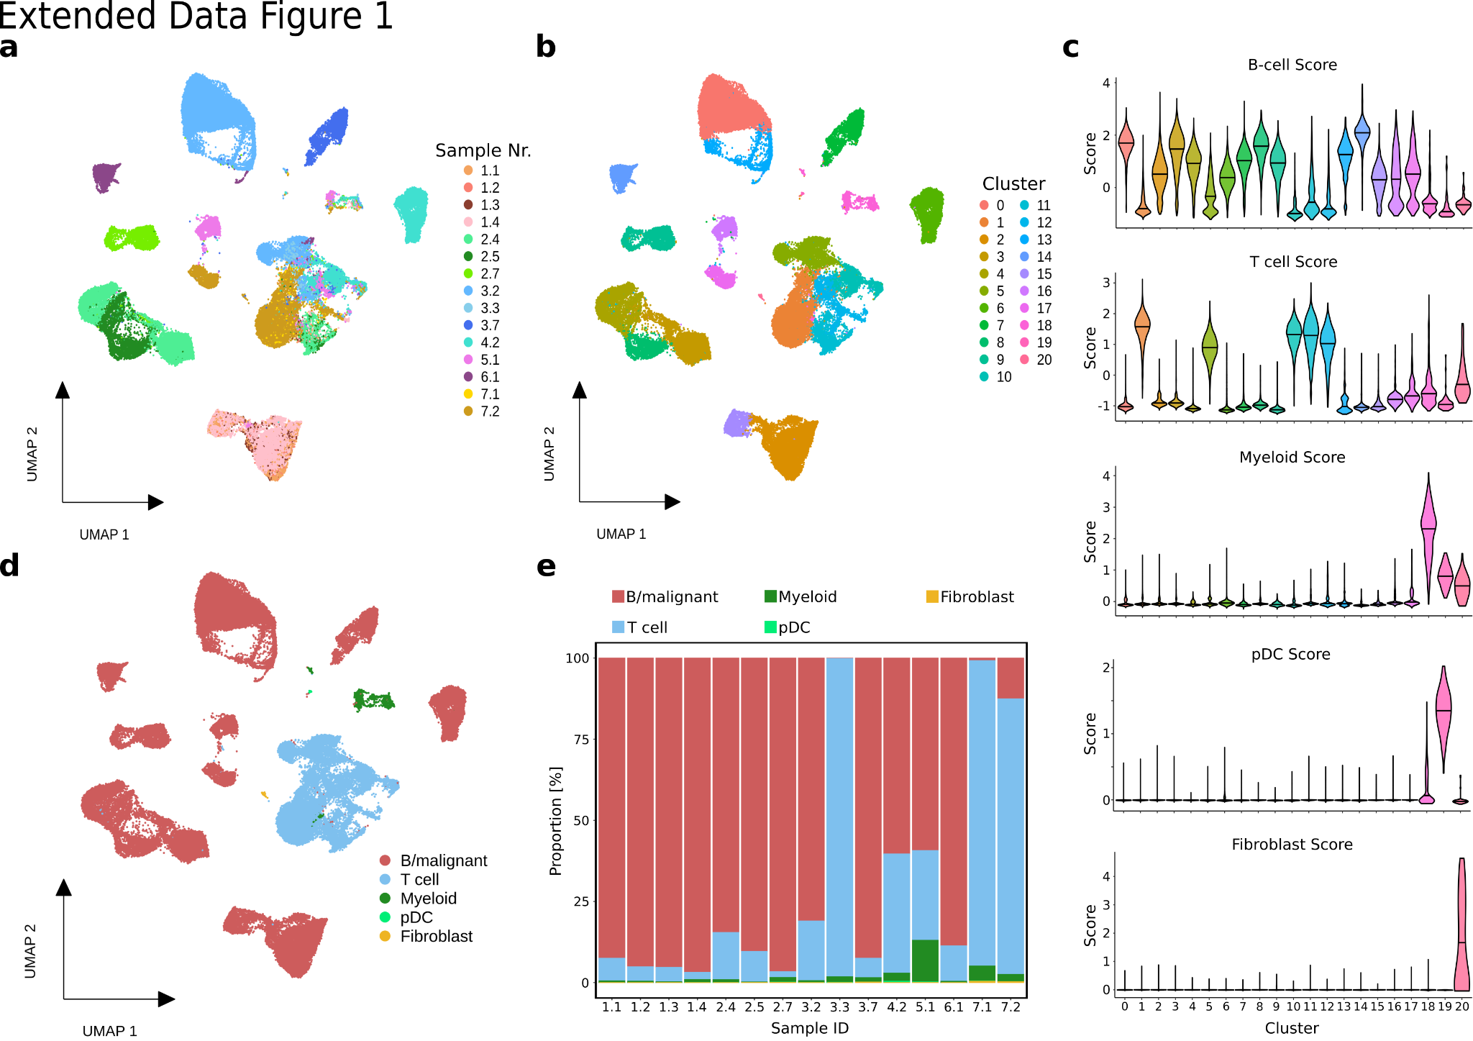
Extended Data Figure 1: scRNA-seq analysis of 15 biopsies from 7 patients.
a, UMAP representation of 90,516 high quality single-cell transcriptomes obtained from 15 biopsies in 7 lymphoma patients. Cells are color-coded by sample number, which is composed of the patient number and the respective sample ID (e.g. Sample 1.1 is Sample 1 from patient 1; see Fig. 1a). b, UMAP as in (a) representation colored by unsupervised clustering analysis results. c, Violon plots showing the major cell type gene signature across the unsupervised clusters found in (b). The details of the scores can be found in Supplementary Table 3.. The lines in the violins correspond to the median scores per cluster. d, UMAP representation as in (a) color-coded by major cell type assigned based on the signature module scores. e, Barplot showing the proportions of major cell types across samples.
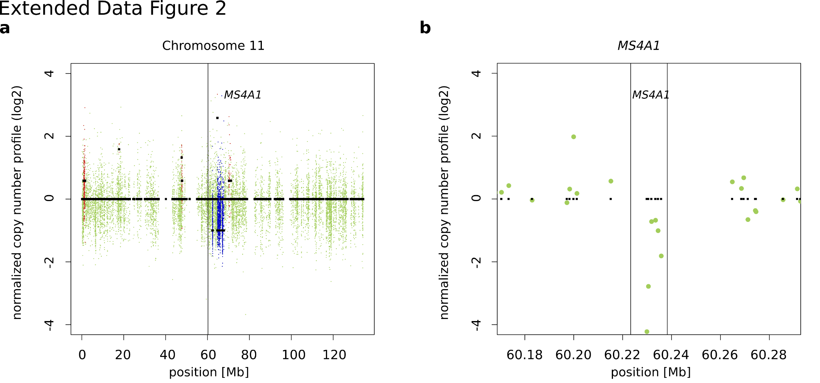
Extended Data Figure 2: MS4A1-deletion in patient 6.
a-b, Control-FREEC was used to detect and visualize copy number variations (CNVs) in tumor Sample 6.3 normalized to patient 6 germline sample. a, CNVs in Chromosome 11, including MS4A1. b, CNVs for MS4A1 suggest biallelic deletion of the gene.
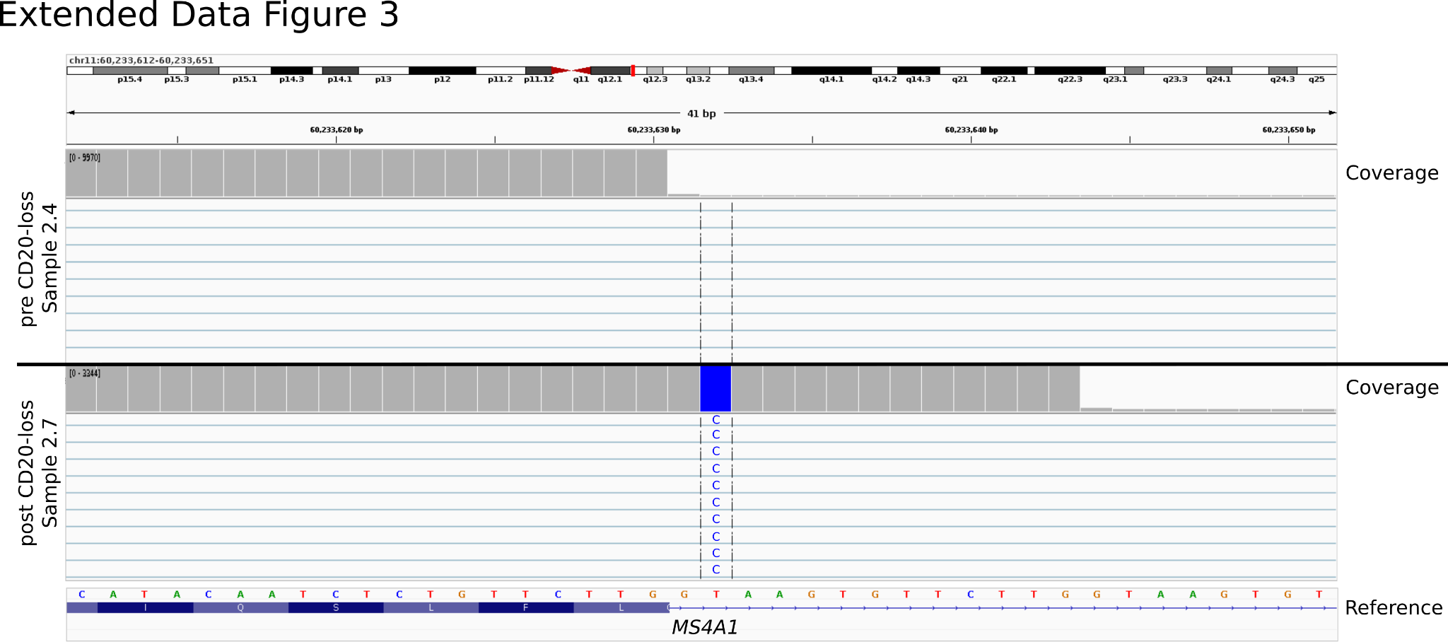
Extended Data Figure 3: An intronic point mutation leading to aberrant splicing of MS4A1 as cause of CD20-loss in patient 2.
Read coverage visualized with the Integrative Genomics Viewer for bulk RNA-seq of samples from patient 2 representing pre CD20-loss (Sample 2.4) and post CD20-loss (Sample 2.7) illustrates aberrant splicing due to intronic 573+2T>C.
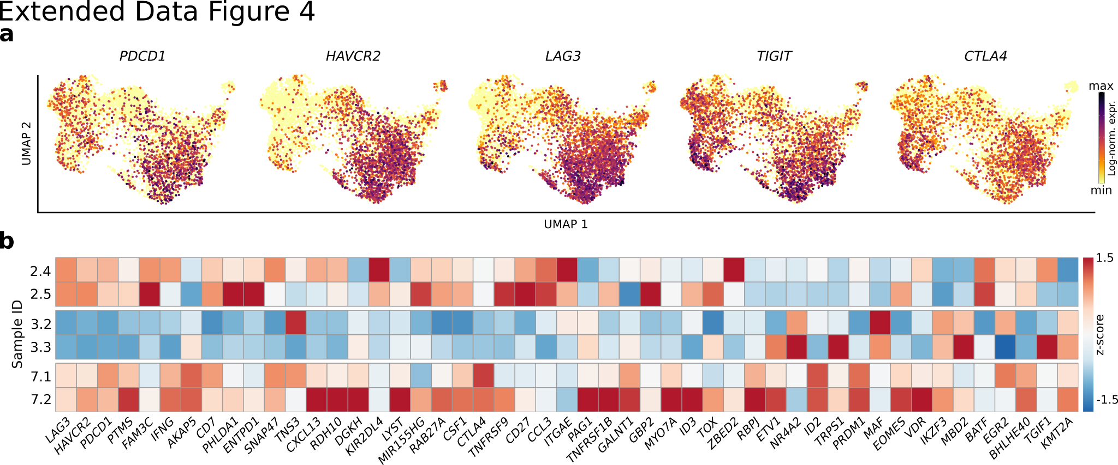
Extended Data Figure 4: Expression of T cell exhaustion markers and signature genes (related to Fig 3).
a, Log-normalized expression of canonical exhaustion marker genes color-coded and projected onto the UMAP embedding from (Fig. 3c) showing high expression of T cell exhaustion markers in CD8 effector T cells. b, Heatmap depicting the scaled mean expression of exhaustion signature genes in CD8 effector T cells across samples.
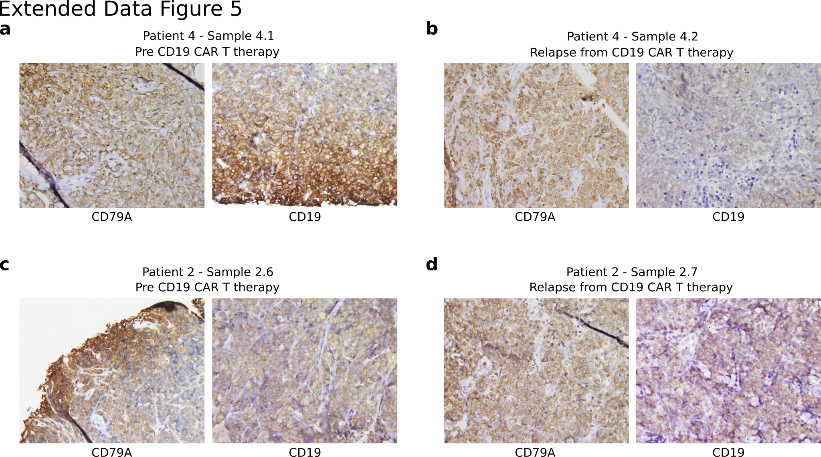
Extended Data Figure 5: CD19-loss and retainment after relapse from CD19 CAR T cell therapy.
a-d, CD79A and CD19 protein expression determined by IHC on formalin-fixed paraffin-embedded biopsy sections. The images show stainings from patient 4 (a-b) and patient 2 (c-d) before CD19 CAR T cell treatment (a & c) and after relapse (b & d) demonstrating relapse accompanied by CD19-loss (a-b) and CD19 retainment (c-d).

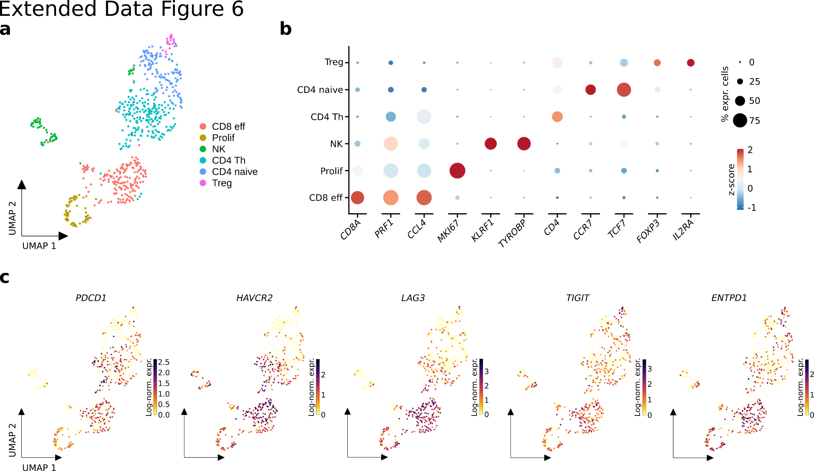
Extended Data Figure 6: Exhaustion markers in CD8 effector T cells in CD19-positive relapse after CD19 CAR T therapy in patient 5.
a, UMAP representation of 648 T cells from Sample 5.1 with cells color coded by T cell subset. b, Dotplot showing scaled mean expression (color) and percentage of expressing cells (dot size) of marker genes per T cell subset. c, Log-normalized expression of canonical T cell exhaustion marker genes color-coded and projected onto the UMAP embedding showing high expression of exhaustion markers in CD8 effector T cells.
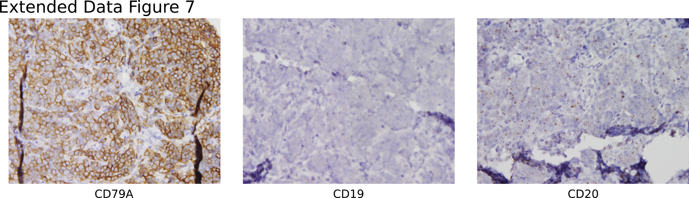

Extended Data Figure 7: CD19 and CD20 loss in patient 1.
CD79A, CD19 and CD20 protein expression determined by IHC on formalin-fixed paraffin-embedded biopsy sections. The images show stainings of Sample 1.2 from patient #1 which was obtained after CD19 CAR T and CD20 bispec treatment demonstrating sequential antigen loss.
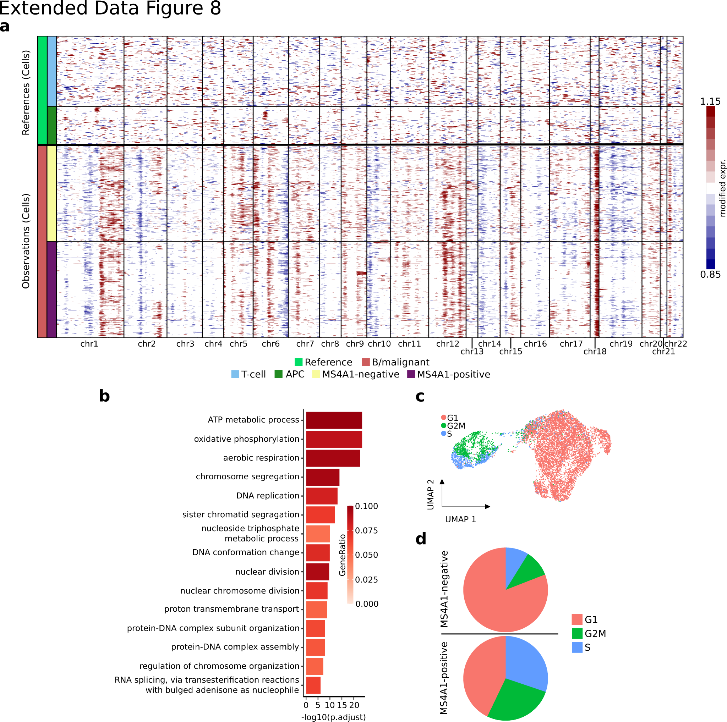

Extended Data Figure 8: A MS4A1-positive subclone in Sample 1.4 shows increased energy metabolism and proliferation compared to the MS4A1-negative counterpart.
a, Copy number variations in MS4A1-negative and MS4A1-positive lymphoma cells of Sample 1.4 predicted using inferCNV with T cells and APCs from the same Sample as reference cells. b, GO-enrichment analysis of genes upregulated in MS4A1-positive vs. MS4A1-negative lymphoma cells in Sample 1.4. Top 15 GO-terms are shown. c, UMAP representation B/malignant cells of Sample 1.4 as in (Fig. 4c) colored by cell cycle phase. d, Pie Charts depicting proportions of actively cycling cells within MS4A1-negative and MS4A1-positive cells, respectively.
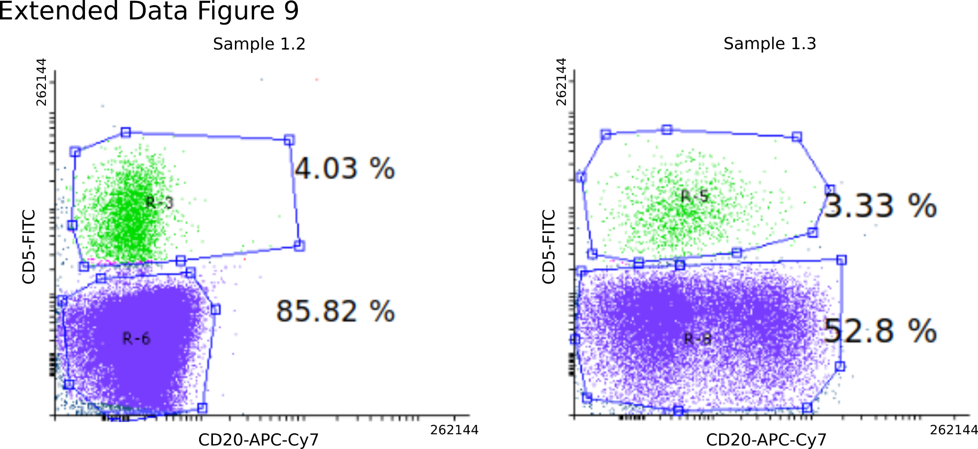

Extended Data Figure 9: Spatial heterogeneity of target antigen expression in patient 1.
Flow cytometry of cell suspensions from two different tumor lesions of one patient (patient #1) after bispec therapy. Sample 1.2 was derived from a non responder lesion (no decrease in tumor size) and showed a complete loss of CD20 after CD20 bispec therapy. Sample 1.3 was derived from a lesion that had decreased in size but still present as a residual tumor mass. In sample 1.3 tumor cells were already partial negative for CD20.
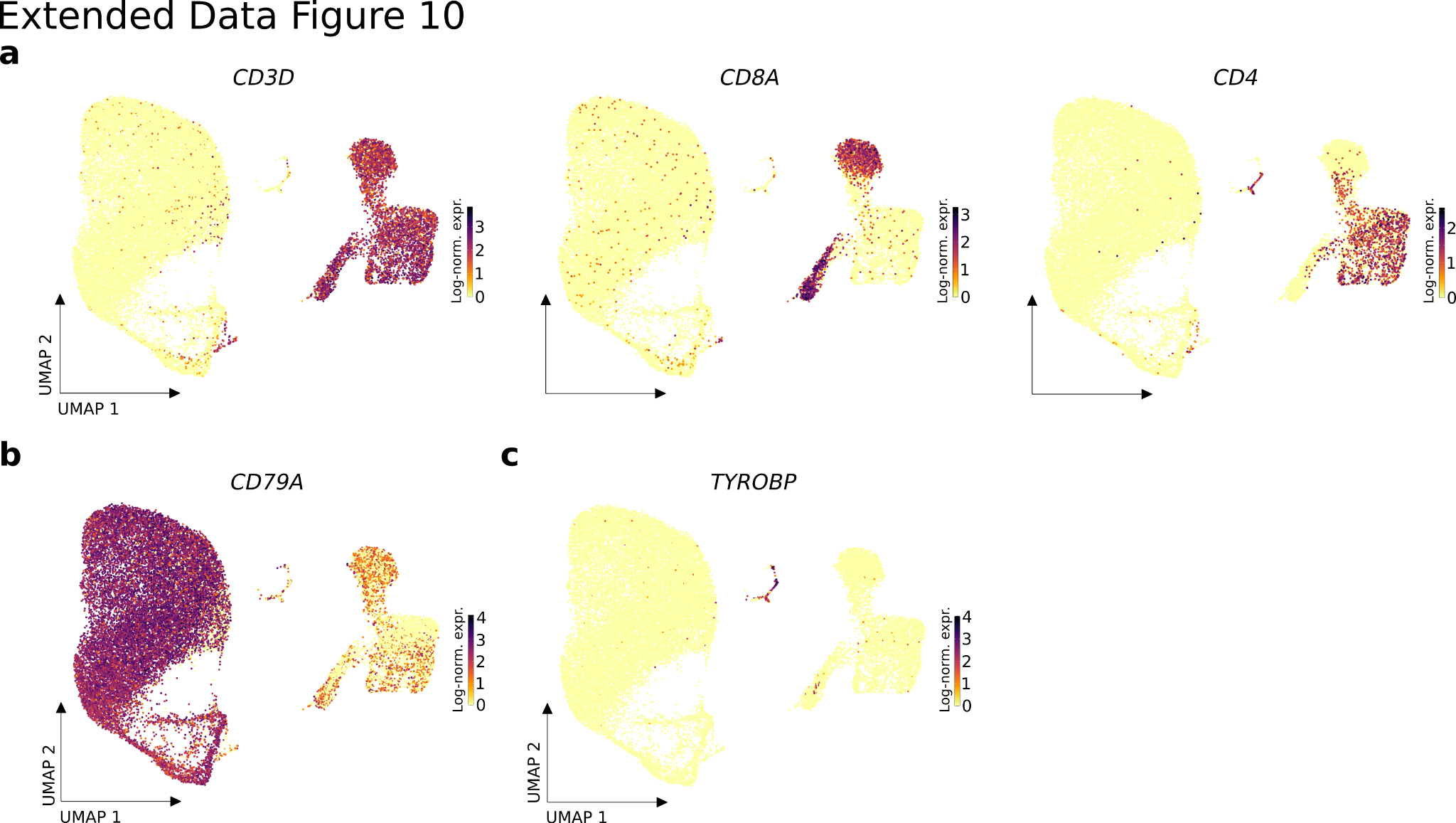

Extended Data Figure 10: Expression of cell type marker genes in Samples 3.2 and 3.3.
a-c, Log-normalized expression of marker genes of T cells (a), B-cells (b) and Myeloid cells (c) projected onto the UMAP embedding of cells from Samples 3.2 and 3.3 as in (Fig. 4f).

