Supplemental Data
Supplemental Figure 1: (A) Uniform Manifold Approximation and Projection (UMAP) representation of 39,721 single cells grouped into 35 distinct cell types (left) with identification of Cigarette Smoke-exposed and Room Air-exposed cells (right). (B-D) Heat map of marker genes for major cell types, including (B) epithelial, (C) endothelial, and (D) stromal, cells.
A
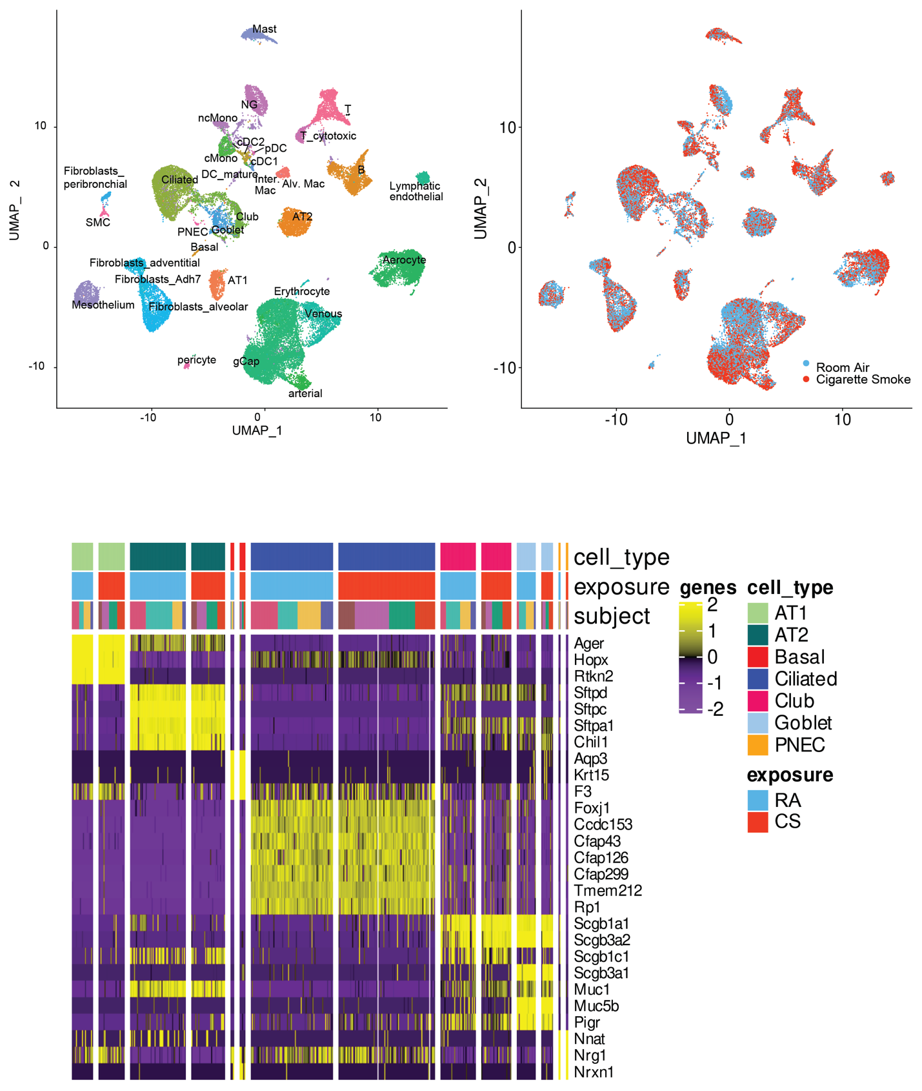
B
Supplemental Table 1 (cont.)

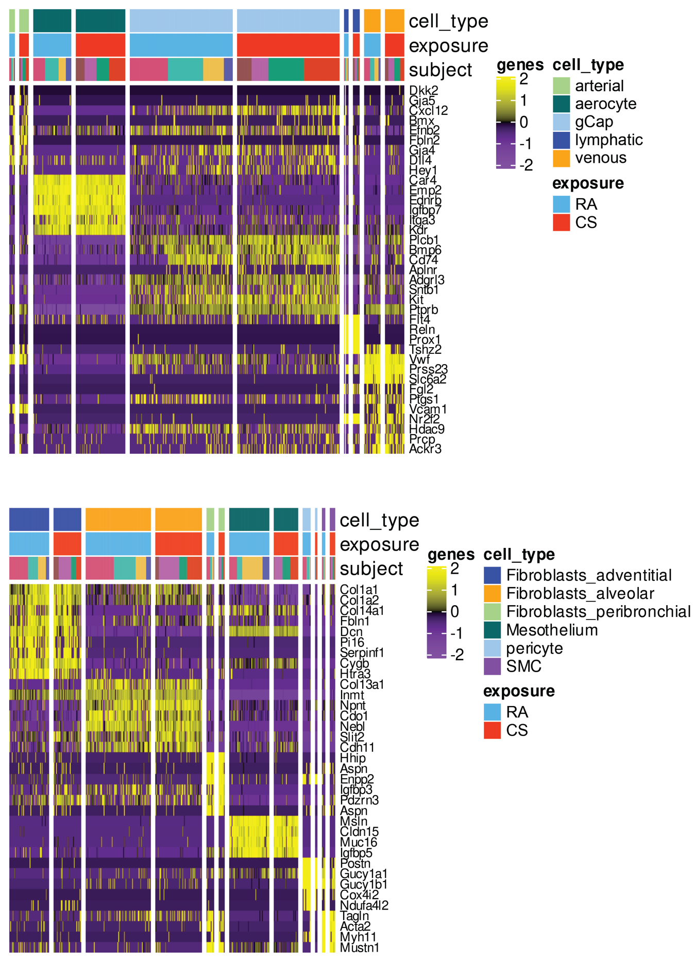
C
D

Supplemental Figure 2: Dot plot of z-scores for marker gene expression values. Dot size reflects percentage of cells with regulon activity; color corresponds to degree of regulon activity.

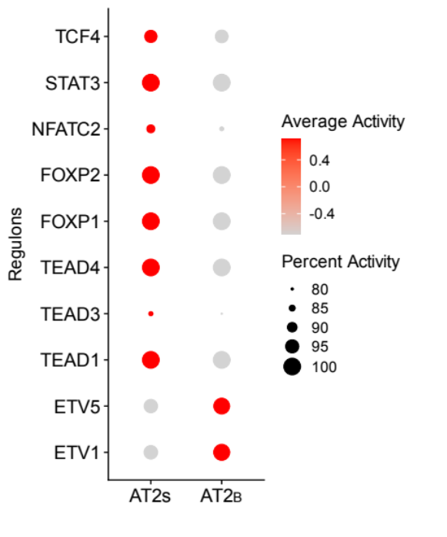

Supplemental Figure 3: A subpopulation of human alveolar epithelial type II cells expresses SPA. (A) Co-expression of SPA mRNA (red) (lower row) and absence of SPA mRNA (upper row) in cells showing immunofluorescence staining for pro-SPC (green). (B) negative control. DAPI was used as nuclear counterstain (blue)
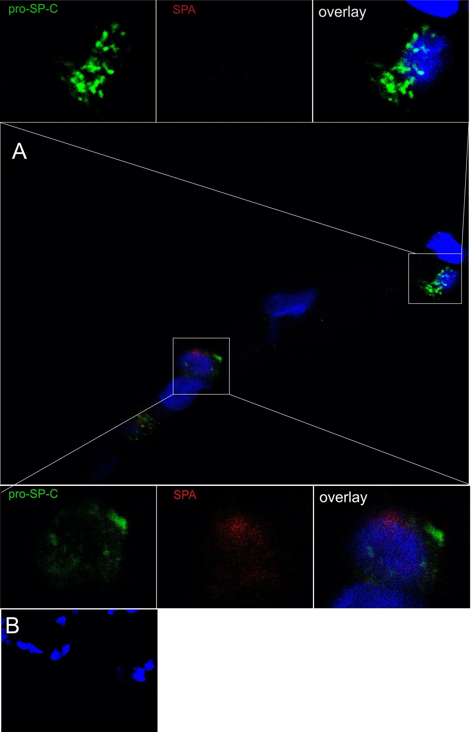

Supplemental Figure 4: Dot plot of z-scores for commonly associated GWAS genes. Dot size reflects percentage of cells with gene expression; color corresponds to degree of expression.

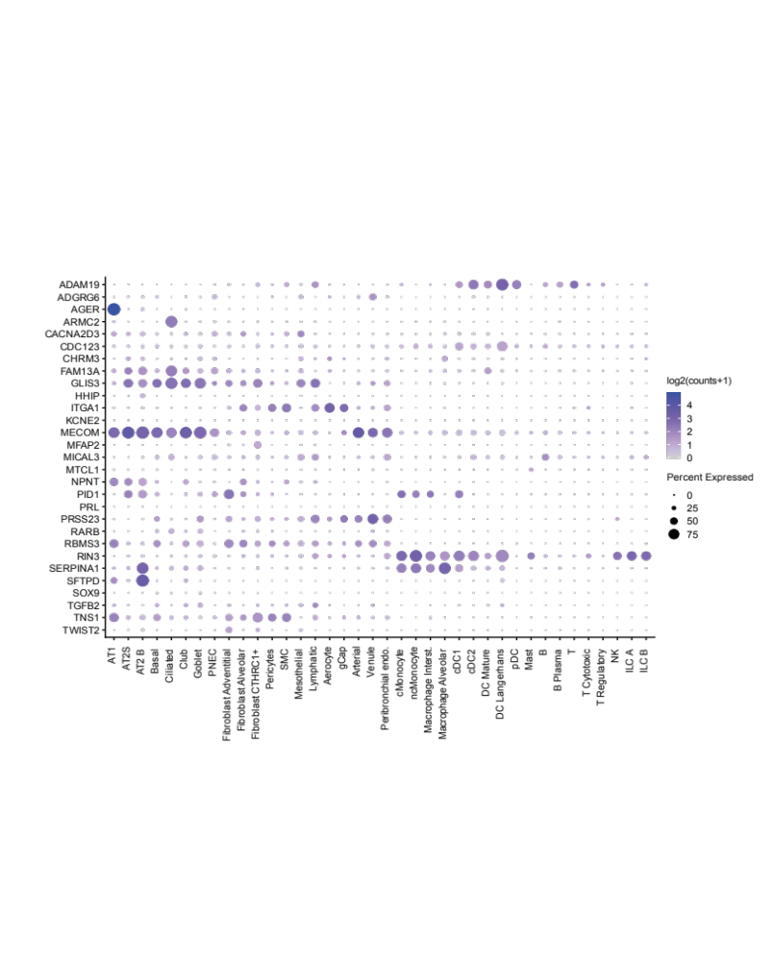

Supplemental Figure 5: (A) CD74 in AT2_{B} cells from human subjects from non-smokers and smokers without COPD, and former smokers with COPD. (B) Cd74 in AT2 cells from mice exposed to room air for 10 months vs. mice exposed to 10 months of cigarette smoke (CS). ***p < 0.0001 using Wilcoxon rank sum with Bonferroni correction.

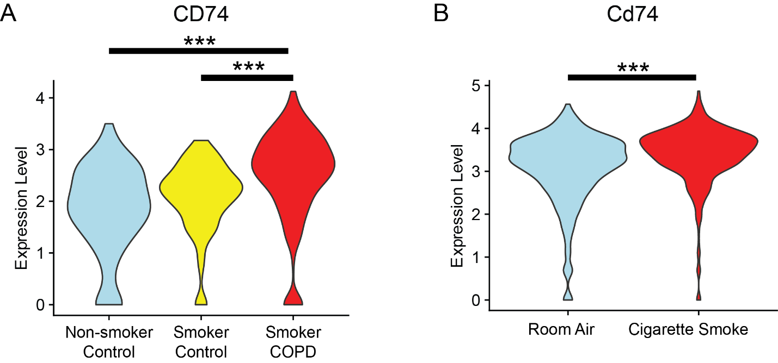

Supplemental Figure 6: Relative NUPR1 expression in A549 cells following treatment with scrambled control (siCTRL) or silencing RNA targeted against NUPR1 (siNUPR1). n=4/group. Error bars represent median ± interquartile range. *p<0.05 using Wilcoxon rank sum.

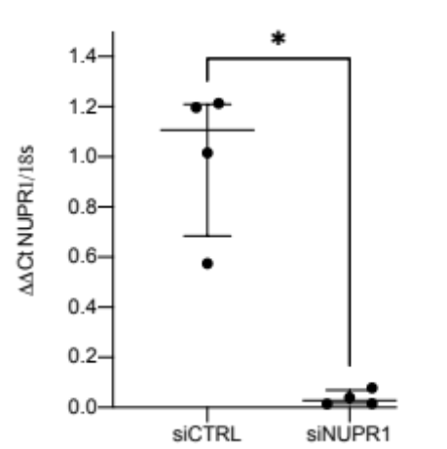

Supplemental Figure 7:
Boxplots of cellular proportions present in COPD and control lung tissues based on fraction of the number of cells per subject for each broad cell type grouping present within the single cell dataset. (A) Endothelial cell fractions. (B) Stromal cell fractions. (C) Lymphoid cell fractions. (D) Myeloid cell fractions. Boxes represent interquartile ranges (IQRs); whiskers are 1.5 x IQR.

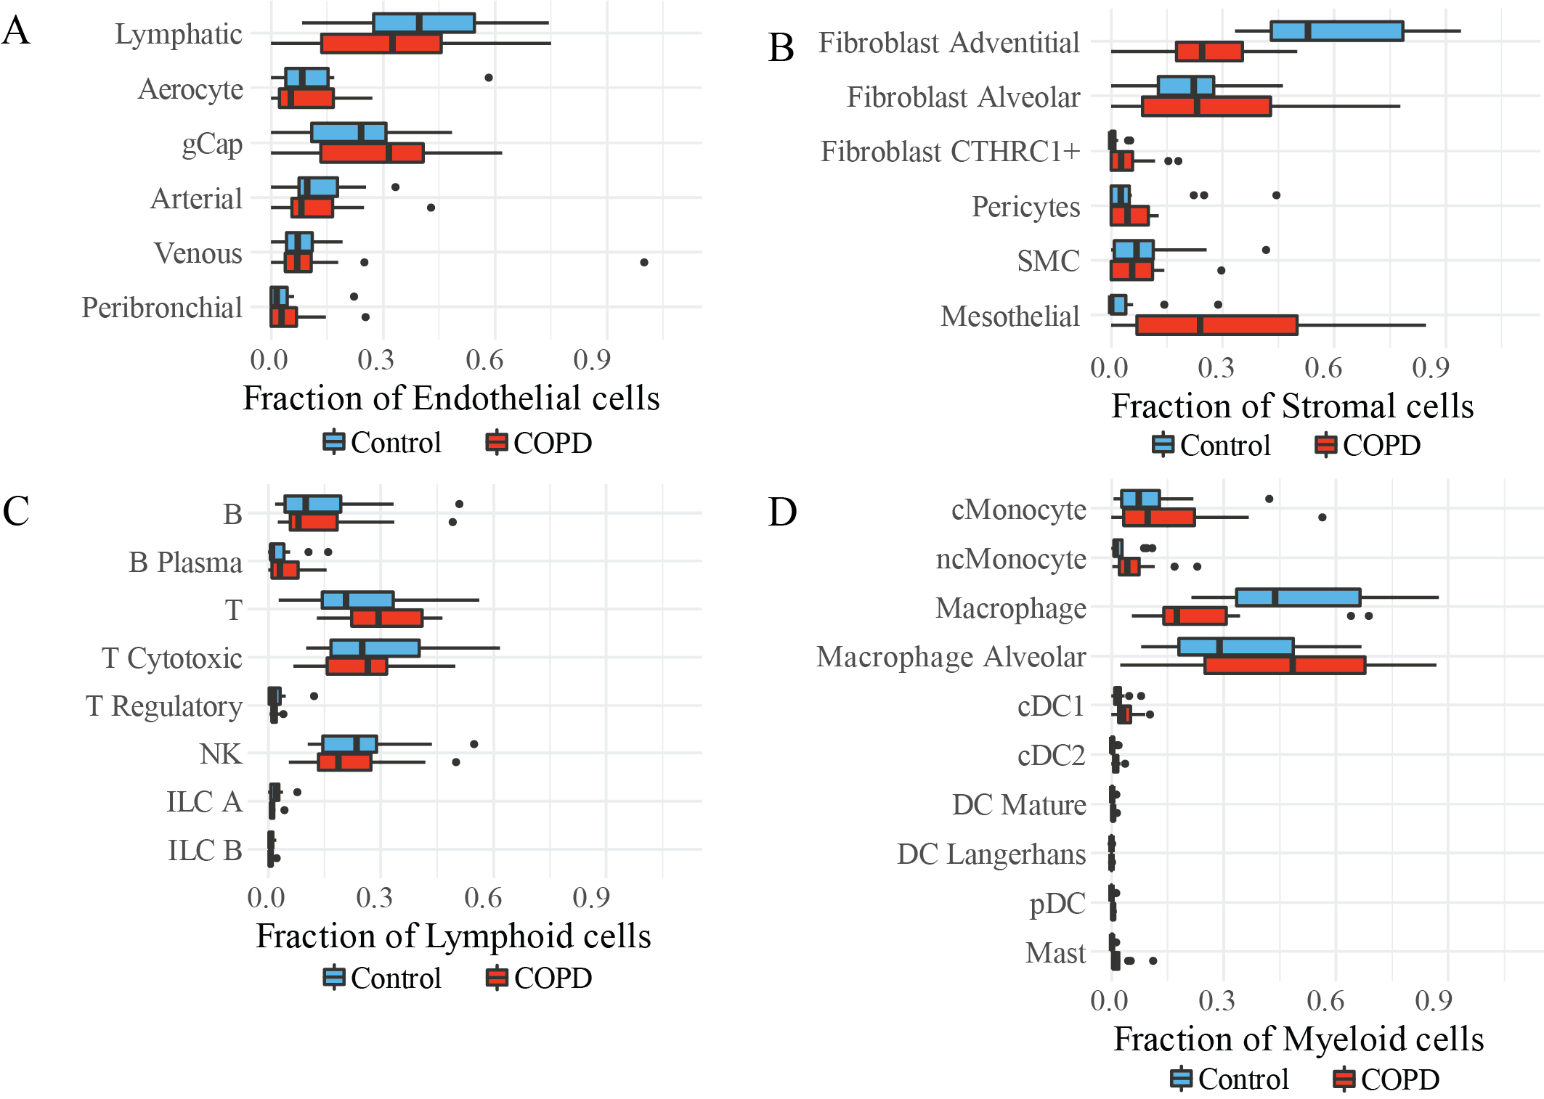

Supplemental Figure 8: Connectome analysis of pathways. Centrality analysis comparing the alveolar connectome for each mode of signalling between control and COPD with a minimal fold change > 0.3 for cell types with the top 3 Kleinberg centrality scores for each signaling mode. Panel shows outgoing edge-weights and Kleinberg hub (outgoing) scores (left) and incoming edge-weights and Kleinberg authority (incoming) scores (right). Cumulative edge-weights (x-axis) have been scaled for each mode of signalling. Dot size is proportional to the Kleinberg scores for each cell type within a given mode of signalling. Individual cell types are colour labelled and numbers shown identify cell types with the largest cumulative edge-weights. **** p<0.0001, *** p<0.001, ** p<0.01, * p<0.05 using the Durbin test to compare control and COPD across cell types for each signalling mode. Interleuk = Interleukins, Semaph = Semaphorins.

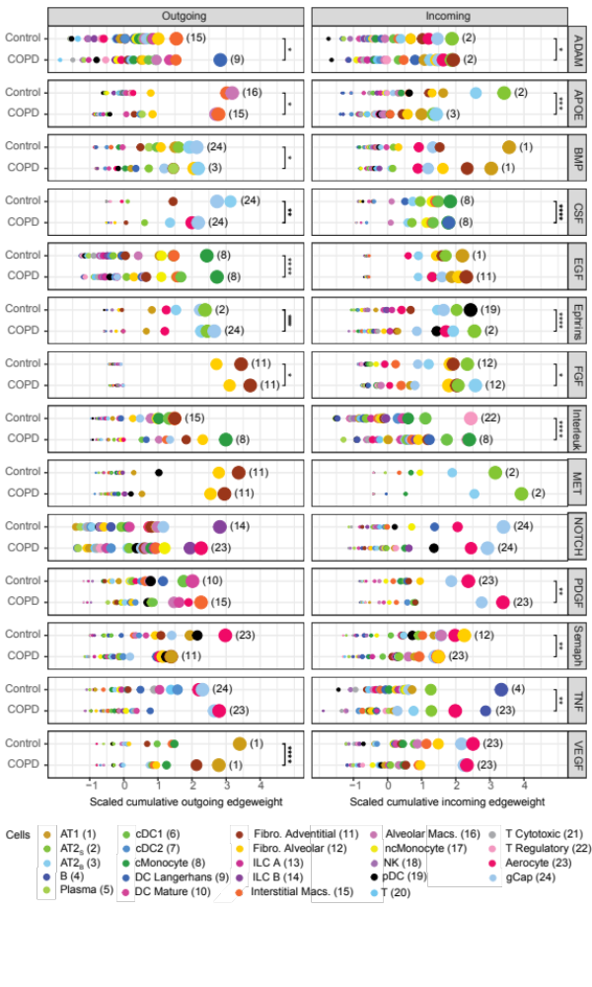

Supplemental Figure 9:
CXCL connectome for mice exposed to room air (RA) or cigarette smoke (CS) demonstrating that the largest relative increase in outgoing CXCL signaling is from gCap endothelial cells. Dot size is proportional to the Kleinberg centrality scores for each cell type within a given mode of signalling. Individual cell types are colour labelled and numbers shown identify cell types with the largest cumulative edge-weights. *** p<0.001 using the Durbin test to compare control and COPD across cell types for each signalling mode.

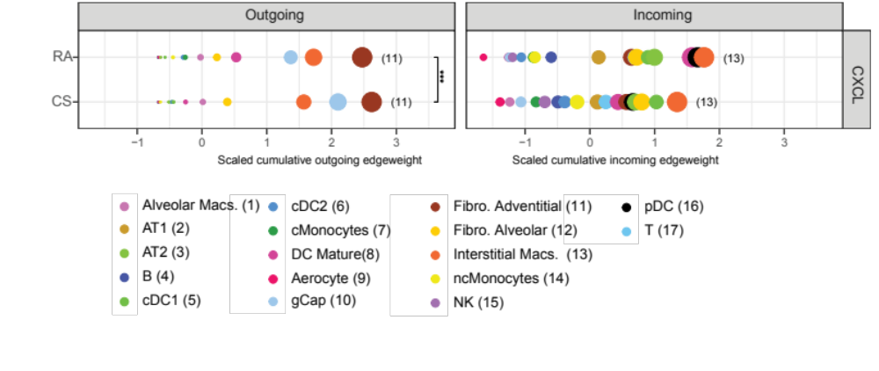.

Supplemental Figure 10:
UMAPs of cell types (left) and disease phenotype (right) for immune cells in our human scRNAseq dataset.

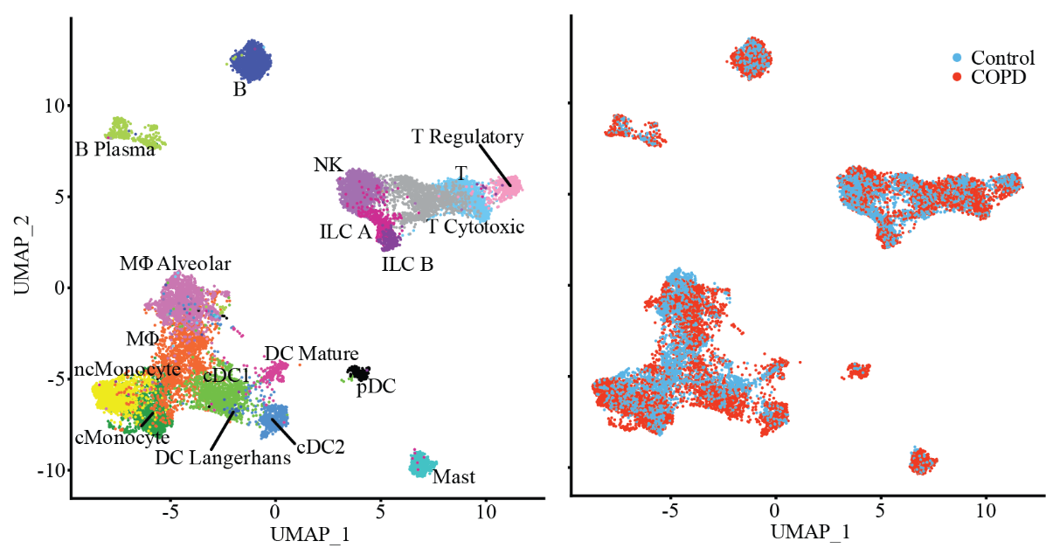

Supplemental Figure 11:
Immunohistochemistry of CD68 positive alveolar macrophage cells (red) showed limited expression of MT2A (green) in control lung tissue (A) and heterogeneity in cellular expression in COPD (B). Scale bar = 50 µm
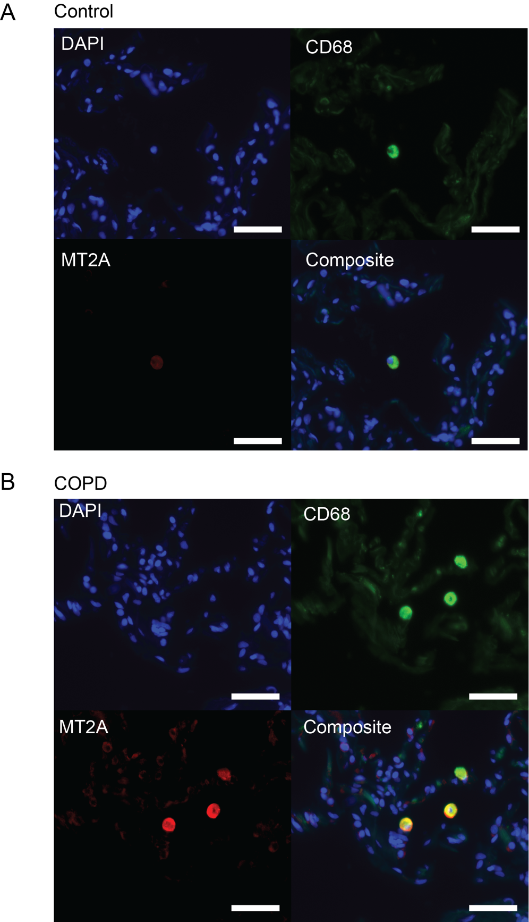

Supplemental Figure 12:
Density plots of THBS1, PELI1 and CDC42 gene expression across all alveolar macrophage cells, grouped by control (blue) and COPD (red) subjects. Within each disease group, subjects are ordered top to bottom from highest within-disease group expression average to lowest.

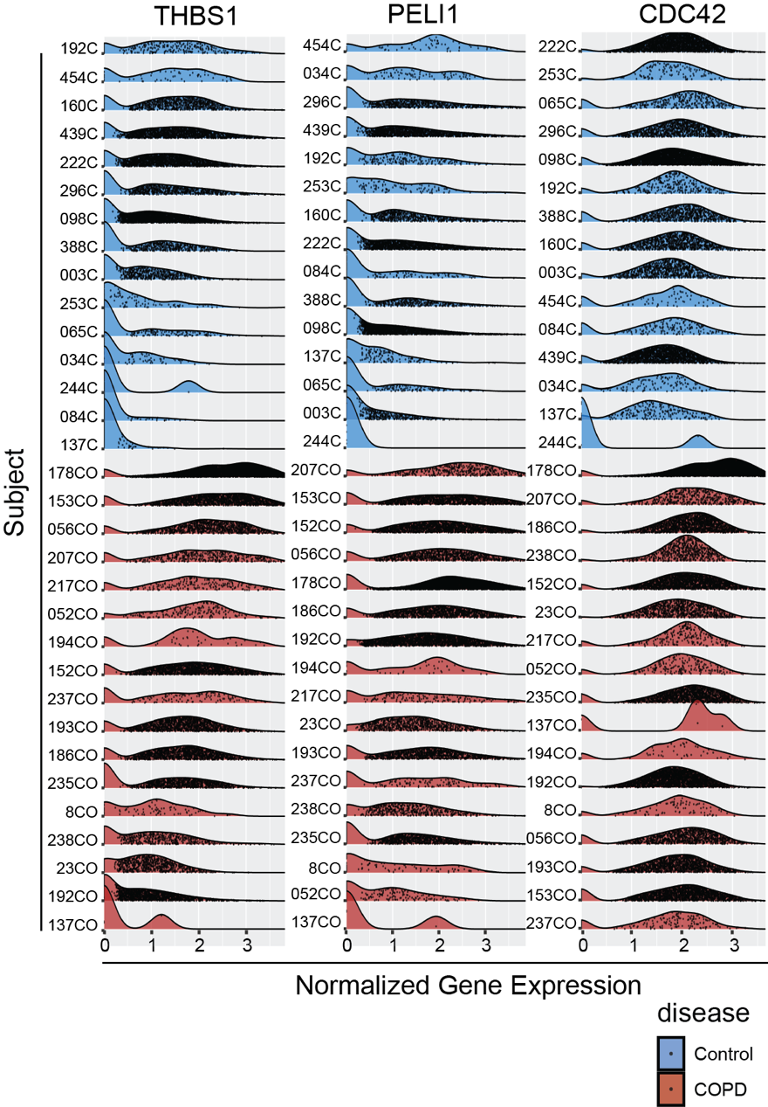

Supplemental Table 1:
Demographics and pulmonary function test results from Control and COPD subjects

 | Control | COPD
Number Subjects | 15 | 17
Sex
female | 8 | 8
male | 7 | 9
Age (mean ± s.d.) | 59.0 ± 10.5 | 62.6 ± 4.8
Ever smoker | 4 | 17
Lung Function
FEV₁ (%) | – | 21.0 ± 5.0 (15)
FVC (%) | – | 48.2 ± 15.3 (15)
FEV₁/FVC | – | 0.36 ± 0.05 (14)
TLC (%) | – | 93.0 ± 57.7 (12)
FRC (%) | – | 161.2 ± 57.2 (11)
DLCO (%) | – | 20.4 ± 8.2 (13)
(n) number of subjects with available data.
Supplemental Table 2:
Total number of cells analyzed per cell type and the number of differentially expressed genes between COPD and control (Wilcoxon rank sum, Bonferroni corrected p value < 0.05).

Cell | # Differentially Expressed Genes | # Cells Control | # Cells COPD
AT1 | 69 | 268 | 363
AT2_{S} | 29 | 313 | 378
AT2_{B} | 217 | 293 | 405
Basal | 3 | 52 | 89
Ciliated | 171 | 544 | 810
Club | 13 | 123 | 444
Goblet | 5 | 59 | 117
PNEC | 0 | 15 | 12
Fibroblast Adventitial | 235 | 544 | 336
Fibroblast Alveolar | 88 | 159 | 349
Fibroblast CTHRC1+ | 0 | 8 | 63
Pericytes | 1 | 23 | 67
SMC | 6 | 64 | 79
Mesothelial | 13 | 34 | 280
Lymphatic | 93 | 615 | 366
gCap | 59 | 182 | 121
Aerocyte | 82 | 395 | 298
Arterial | 43 | 179 | 139
Venous | 4 | 108 | 64
Peribronchial | 2 | 52 | 73
cMonocyte | 237 | 4050 | 3759
ncMonocyte | 226 | 851 | 2141
Macrophage | 191 | 16008 | 6990
Macrophage Alveolar | 151 | 15107 | 22221
cDC1 | 226 | 727 | 1416
cDC2 | 48 | 140 | 508
DC Mature | 33 | 82 | 223
DC Langerhans | 0 | 7 | 14
pDC | 18 | 42 | 209
Mast | 14 | 127 | 648
B | 41 | 650 | 2159
B Plasma | 20 | 135 | 696
T | 53 | 3089 | 5772
T Cytotoxic | 56 | 2462 | 5469
T Regulatory | 6 | 196 | 235
NK | 43 | 2007 | 3929
ILC A | 12 | 192 | 172
ILC B | 3 | 73 | 117

