Table S1 Primers for qRT-PCR
gene-id | Gene annotation | Primers
TR23551|c0_g1 | Cu-Zn SOD | CTGGGAGGAAGCCGATGATG  CTGAGTCAACGTGACAACGC
TR45122|c0_g3 | CAT | AGTGGTTGTCGTTCCAGACC  TCCGCTTCCAACCTCATCAC
TR4881|c1_g2 | glutathione S-transferase | TTCGACTTCCTTCTCGGCCA  AGATACTCGCACACCAGAAGC
TR41924|c1_g19 | chlorophyll a-b binding protein CP24 | TCGCCACCATGGCTAATCTA  TTGATCCATTGTCGCTTGGC
TR48641|c0_g1 | photosystem I P700 apoprotein A1 | AGATCCTAACAACGTCATGGCA  GCCAGATATGGATAAGGTGGCA
TR35369|c0_g1 | ferredoxin--NADP reductase，leaf isozyme, chloroplastic | CCAGCCTCATTGGCTTGTTC  GCAGCCCATATGACCTCGTC
TR5394|c0_g8 | nitric oxide synthase isoform X1 | ACAACACGCCACACCACTAA  GCATCACCAGTCCGTAGAGG
TR12135|c0_g2 | nitric oxide synthase | TGATAGGATTCGCACCAGCA  TGACAGTGATTGCGCTGGTTA
actin | actin | AATCTGGCCCGTCTATTGTCC  GTCTTTCAGCGCCTCTCATCT

Table S2 Summary of sequencing and assembly data
Samples | Clean base（G） | Clean read（M） | Q20 (%) | Q30（%）
T0-1  T0-2  T0-3 | 8.899  9.386  10.800 | 62.335  65.599  75.688 | 99.0  98.9  99.0 | 96.9  96.6  96.8
T5-1  T5-2  T5-3 | 7.411  9.086  9.288 | 52.466  64.437  65.377 | 99.0  99.0  99.0 | 96.9  97.0  96.9
T10-1  T10-2  T10-3 | 10.363  7.754  8.536 | 72.704  54.021  59.092 | 99.0  98.9  99.0 | 97.0  96.7  96.8
Average  Total | 9.058  81.523 | 63.524  571.719 | 98.98 | 96.84

Table S3 Length distribution of assembled scaffolds and unigenes
 | All（≥200 bp） | ≥500 bp | ≥1 000 bp | N50 | GC (%) | Total Length | Average Length
Transcript | 200 924 | 96 771 | 46 068 | 1 068 | 44.04 | 149 571 886 | 744
Unigene | 124 008 | 41 697 | 17 277 | 751 | 44.12 | 740 865 43 | 597

Table S4 Statistics of annotation analysis of unigenes
Unigene | Swiss_Prot | TrEMBL | Nr | Pfam | KOG | GO | KO
124008 | 48332 | 78485 | 79478 | 55665 | 61508 | 63457 | 26712
100% | 39.0% | 63.3% | 64.1% | 44.9% | 49.6% | 51.2% | 21.5%

a b
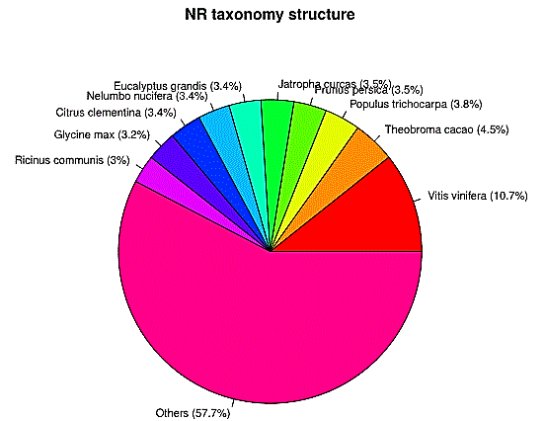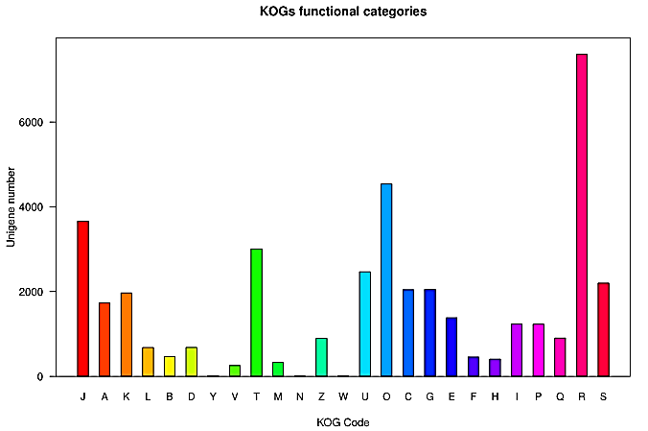
Fig. S1 Gene annotation and functional classification (a) NR taxonomy structure Eukaryotic. (b) Ortholog Groups (KOG) functional classification of unigenes of H. erythrostictum leaves. From a total of 124,008 final unigenes, 61,508 annotated unigenes with significant homology in the KOG database (E-value ≤10-5) were classified into 25 KOG categories. Each letter on the abscissa is denoted as [J] Translation, ribosomal structure and biogenesis [A] RNA processing and modification [K] Transcription [L] Replication, recombination and repair [B] Chromatin structure and dynamics [D] Cell cycle control, cell division, chromosome partitioning [Y] Nuclear structure [V] Defense mechanisms [T] Signal transduction mechanisms [M] Cell wall/membrane/envelope biogenesis. [N] Cell motility [Z] Cytoskeleton [W] Extracellular structures [U] Intracellular trafficking, secretion, and vesicular transport [O] Posttranslational modification, protein turnover, chaperones [C] Energy production and conversion [G] Carbohydrate transport and metabolism [E] Amino acid transport and metabolism [F] Nucleotide transport and metabolism [H] Coenzyme transport and metabolism [I] Lipid transport and metabolism [P] Inorganic ion transport and metabolism [Q] Secondary metabolites biosynthesis, transport and catabolism [R] General function prediction only [S] Function unknown.
a b
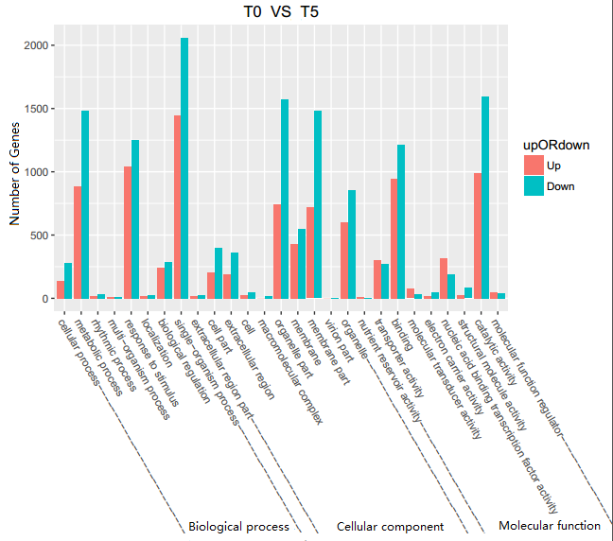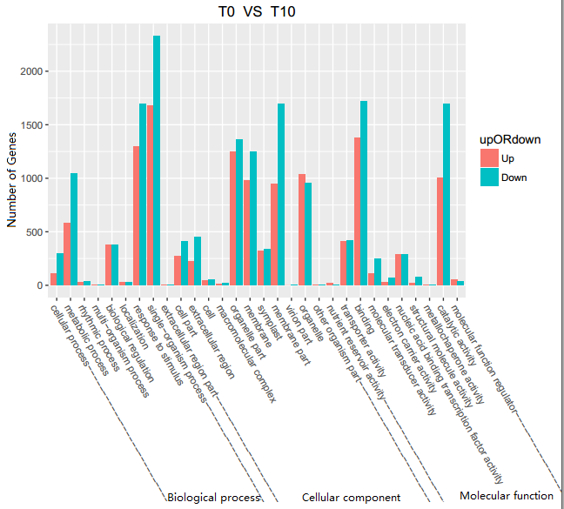
c d
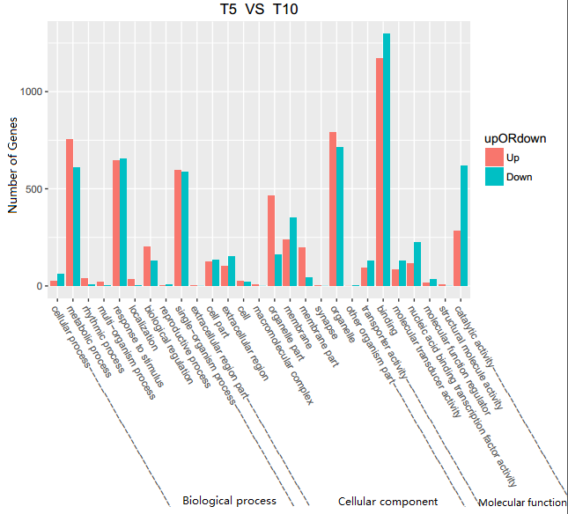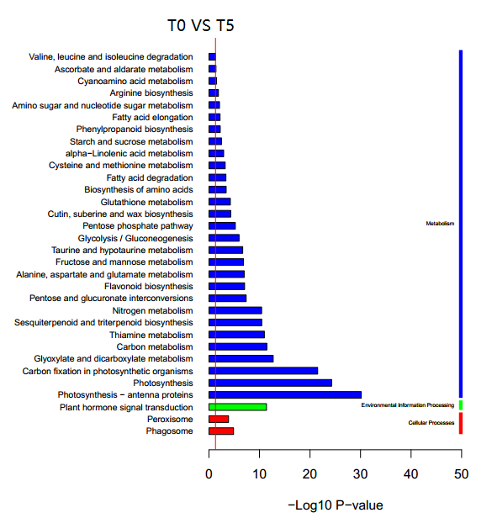
e f
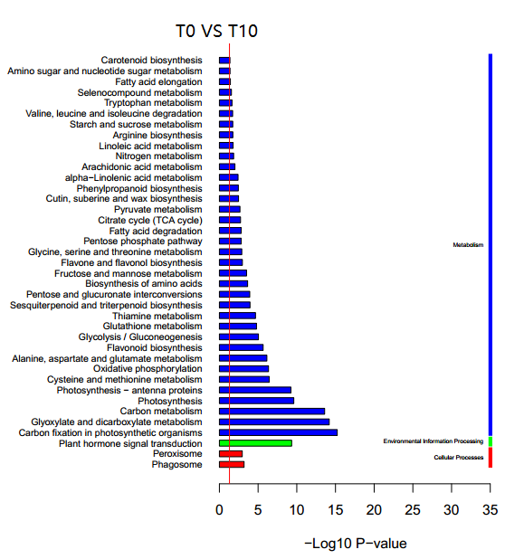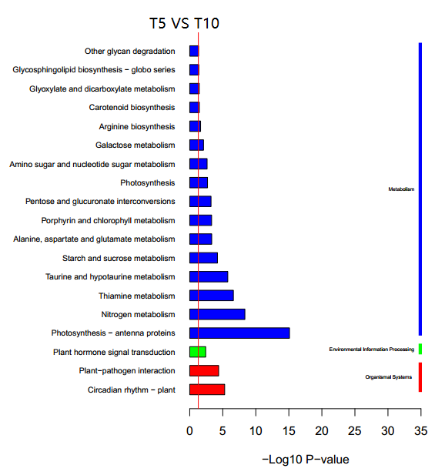
Fig. S2 The analysis of differential expressed genes between samples. (a) GO enrichment of differently expressed genes on T0 VS T5. (b) GO enrichment of differently expressed genes on T0 VS T10. (c) GO enrichment of differently expressed genes on T5 VS T10. (d)Significant enrichment KEGG pathway of T0 VS T5. The red line show P=0.05. (e) Significant enrichment KEGG pathway of T0 VS T10. The red line show P=0.05. (f) Significant enrichment KEGG pathway of T5 VS T10. The red line show P=0.05.

Table S5 The genes about salt stress
 | gene_id | gene-name | gene expression
 | gene_id | gene-name | T0 | T5 | T10
Photosynthetic | TR605|c0_g3 | pheophorbide a oxygenase | 5.32 | 4.80 | 12.05
Photosynthetic | TR2493|c0_g1 | ATP synthase CF1 alpha chain | 14.66 | 3.80 | 1.32
Photosynthetic | TR31123|c0_g2 | photosystem II protein D1 | 217.06 | 79.03 | 47.58
Photosynthetic | TR35369|c0_g1 | ferredoxin--NADP reductase | 128.75 | 49.20 | 46.46
Photosynthetic | TR2796|c9_g2 | PEPCase | 1.48 | 6.44 | 7.25
Photosynthetic | TR41374|c10_g1 | chloroplast NADP-malic enzyme | 24.75 | 37.38 | 124.41
Photosynthetic | TR41553|c0_g1 | chloroplast NADP-malic enzyme | 13.17 | 26.44 | 58.64
Photosynthetic | TR48641|c0_g1 | photosystem I P700 apoprotein A1 | 19.55 | 7.10 | 4.31
Photosynthetic | TR25694|c0_g1 | chlorophyll a/b-binding protein CP24 | 41.76 | 3.09 | 15.13
Photosynthetic | TR41924|c1_g19 | chlorophyll a-b binding protein CP24 | 127.53 | 1.51 | 14.72
Photosynthetic | TR8974|c0_g5 | chlorophyll a-b binding protein CP26 | 92.84 | 36.44 | 135.83
ROS system | TR4881|c1_g2 | glutathione S-transferase F13 | 72.13 | 165.70 | 158.17
ROS system | TR10636|c5_g1 | Isocitrate dehydrogenase (NADP⁺) | 59.51 | 128.36 | 117.32
ROS system | TR23551|c0_g1 | Cu-Zn SOD | 36.13 | 87.65 | 135.36
ROS system | TR6124|c5_g9 | Cu-Zn superoxide dismutase | 41.47 | 61.64 | 118.75
ROS system | TR6124|c5_g7 | Cu-Zn superoxide dismutase | 25.18 | 55.26 | 98.06
ROS system | TR45122|c0_g3 | catalase | 27.59 | 76.17 | 68.30
ROS system | TR45122|c0_g1 | catalase | 17.86 | 42.26 | 15.59
ROS system | TR39488|c0_g1 | ascorbate oxidase precursor family protein | 13.67 | 7.09 | 2.72
ROS system | TR24362|c0_g1 | L-ascorbate oxidase homolog | 11.94 | 4.12 | 1.22
ROS system | TR28689|c5_g3 | glutathione peroxidase | 10.11 | 15.87 | 50.76
ROS system | TR17622|c4_g9 | thioredoxin h | 22.73 | 57.49 | 57.74
NO synthase | TR5394|c0_g8 | nitric oxide synthase | 58.93 | 100.35 | 112.86
NO synthase | TR12135|c0_g2 | nitric oxide synthase | 0.35 | 1.52 | 2.89

