Supplementary Information for

Mounting Nutritional and Environmental Pressures of the Global Food Loss and Waste Call for Urgent Policy Action

Contents
Tracing Food Loss & Waste along global food supply chains 2
Food Loss and Waste data 4
Data adjustments 14
Additional Figures 16
References 18

Tracing Food Loss & Waste along global food supply chains
To trace flows of food loss and waste (FLW) along global food supply chains (FSC) we adopt a full supply-chain approach, linking FLW estimates to the supply chain stages of countries where food is produced, processed and/or finally consumed (Figure S1).
From the constructed FLW database (see Data section, Tables A-H) we derive commodity- and country-specific shares of lost and discarded food along the FSC and define the following coefficient
${FLW_SHR}_{c,d}^{r,g}$ $(1)$
where r represents the country where losses or waste are generated, g represents a stage of the food supply chain at which the losses/waste are occurring, c represents a primary food commodity being lost or wasted and d represents a dummy variable that has a value of “1” when a commodity enters the manufacturing stage (i.e. is finally consumed as a processed food product) and a value of “0” when it does not (i.e. is finally consumed as a fresh food product).
To quantify physical (Mtons) food supply we retrieve information from the Global Trade Analysis Project Food Balance Sheets (GTAP-FBS) database (Chepeliev, 2022) defining a food supply coefficient as following
${FOOD}_{r,s,t}^{c,f,k}$ $(2)$
where c represents a primary food commodity flowing into primary food, processed food or food services which provides information on the primary composition of non-primary foods, f represents the final food product (primary, processed or from food services) consumed by households, k represents a metric category on which the food supply is specified i.e. metric tons, calories, proteins, fats, or carbohydrates, r and s represent regional source (r) and destination (s) of the food supply (if r = s, food is produced and consumed domestically within a country), and t represents a reference year of food supply i.e. 2004, 2007, 2011 or 2014. The computation of equation (2) is available in (Chepeliev, 2022) and is briefly illustrated in the left side of Figure S1 below. The information provided in coefficient (2) is developed to match the physical and nutritional food supply estimates from the FAO Food Balance Sheets.
To quantify physical flows of FLW, we multiply the FLW coefficient (1) by the physical food flows represented by coefficient (2), tracing FLW along global food supply chains as following
${FLW_FSC}_{a,f,t}^{r,s,d}= {FLW_SHR}_{c,d}^{r,g} * {FOOD}_{r,s,t}^{c,f,k}$ (3)
where r represents the region where primary commodity a is produced (source region), hence where losses from Agricultural Production up to Distribution & Retail stages occur, s represents the region where final consumption occurs (destination region) hence where Consumption waste is generated, f represents the food commodity or food service consumed by final consumers in region s and to which primary food flows a are flowing to, t represents the stage of the supply chain at which losses are occurring and k represents a metric category i.e. metric tons, calories, proteins, fats, or carbohydrates.
The five stages of the food supply chain defined from the developed FLW database in coefficient (1) are combined with the information obtained from coefficient (2). Agricultural Production and Post-Harvest Handling & Storage stages are associated with primary production, while Manufacturing and Consumption stages are linked to the intermediate/final food production and final demand, respectively. As a Distribution & Retail stage is not explicitly available from the material flows of equation (2) we allocate Distribution & Retail losses to food flowing from Manufacturing to Consumption stage.
Since FLW data is mainly available in primary equivalents, we define the food supply within coefficient (2) in primary equivalents, applying (1) to primary food commodities as they flow to the point of final consumption (primary food, processed food or food service sectors). This allows to avoid the double counting of losses/waste when a processed commodity is employed in the production of another processed commodity or food service along the supply chain. FLW data are from the perspective that the physical supply of a food commodity decreases after each supply chain stage, entering the next stage net of losses occurred in previous stages. The definition of a dummy variable in (1) allows to divide between products consumed as processed and fresh, applying manufacturing losses only to the processed foods.
In cases where r = d (the food commodity is produced and consumed in the same country/region), FLW is entirely generated domestically within a country. Differently, when r ≠ d food is produced in country r and consumed in country s hence FLW are attributed differently. If food is imported by s as fresh, farm-level losses i.e. Agricultural Production and Post-Harvest Handling & Storage losses are attributed to exporting country r (and not to the importing country s). If food is imported by s as processed, Manufacturing losses are also attributed to exporting country r (and not to the importing country s). Differently, if a product is imported by s as fresh and successively domestically processed, Manufacturing losses are attributed to the importing country s. As Distribution & Retail and Consumption stages are by definition linked to the point of consumption, waste generated at these stages is always attributed to the country where food is finally consumed. An attribution discussed above is used to link the country/region-specific FLW shares across stages (as estimated within the coefficient (1)) with the food flows along the global FSC. From the FLW tracing point of view, both consumption (attribution to the point of final consumption) or production (attribution to the point of production) approaches can be implemented for quantifying the related flows (of FLW and/or environmental impacts).
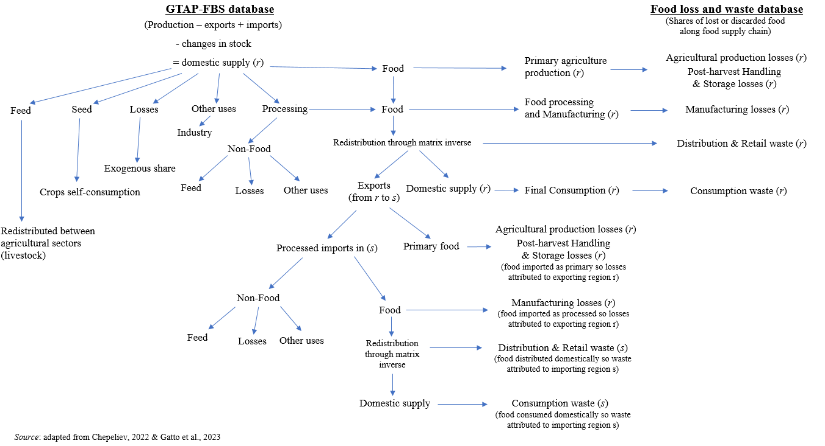
Figure S1. Methodological framework for tracing food loss and waste along global food supply chains.

Food Loss and Waste data
Food Loss and Waste data
Definitions
We define FLW as “food (including inedible parts) lost or discarded along the food supply chain, comprising pre-harvest losses, and excluding food diverted to animal feed, seed or to other non-food material uses such as bio-based products”. With this classification, we align with SDG12.3 considering only food produced for human consumption, including all food types, disposal routes and stages of the FSC. We consider the entirety of food products, including inedible foods parts. Including this (unavoidable) type of FLW we overcome a broadly debated (Delgado et al., 2021) on the methodological limitations of the FLW estimates in Gustavsson et al. (FAO, 2011). Moreover, we exclude from FLW food produced for other purposes than human consumption, to avoid counting biomass for biofuels or biobased industrial products as FLW. Finally, we report data as percentage losses of total food weight since the percentage estimates are more stable and representative across years (Fabi and English, 2018).
Database and integration of data into the GTAP framework
The core of our FLW database is the FAO–FLW database (FAO, 2019). Within the FAO–FLW database we use the standard data computation method building on edible and inedible shares of commodities, excluding other non-food biomass flows (i.e. feed, seed, etc.) from FLW. To assure consistent FLW estimates we restrict additional data merged with the FAO-FLW data to sources using this method. We group FAO-FLW data in eight global regions, complemented with 3 single countries (China, India, and United States) defining eleven commodity groups produced along five macro-stages of the FSC. While this aggregation procedure influences detail in the final estimates it is necessary due to unavailability of data at single country/commodity level.
The FAO–FLW database mainly covers low-income regions. Data is mostly available for sub-Saharan Africa, South-East Asia and North Africa & Middle East, while for high-income regions such as Europe and North America & Oceania observations are limited. This geographical focus influences overall data availability for commodities and supply chain stages. Most reported losses occur at early stages of the supply chain, i.e. Agriculture Production and Post-Harvest Handling & Storage and involve horticultural commodities and cereals, usually prevailing in low-income regions’ diets. Data is mostly unavailable for animal-sourced products, particularly in the final stages of the supply chain such as Distribution & Retail and Consumption. Despite the broad temporal coverage of the database (1945-2021), observations are concentrated between 2000 and 2017, with peaks between 2009 and 2011.
To address the coverage limitations of the FAO-FLW database we perform a literature review, building on previous reviews (Xue et al., 2017; Porter et al., 2016; Affognon et al., 2015; OECD, 2021). We only collect data computed in consistency with our FLW definition, enhancing data availability mainly for Europe, North America & Oceania and North Africa & Middle East. To achieve a global data coverage, we complement our database replacing non-available data with a consistent gap-filling methodology based on FLW in comparable regions, commodities, and stages of the FSC. Such gap-filling procedure urges for a careful utilization and interpretation of final estimates as data assumptions and aggregations may impact the magnitude of estimates. Moreover, as we aggregate data through physical mass, our methodology does not allow a direct assessment of SDG12.3, for which an indicator based on economic weights (Fabi and English, 2018) is adopted as a quantification approach. To integrate FLW data into the global multi-region input-output GTAP framework we map commodity groups to the sectors available in GTAP. Tables S1-S11 report estimates of percentage losses and waste of total food weight, illustrating respective data sources. In case of estimates reporting intervals, the mean between the lower and upper bound of the interval has been adopted as reference value. To link our regional estimates to single countries in GTAP we map regional FLW shares to single countries available in GTAP. Table S12 reports the mapping between countries available in GTAP and macro-regions defined to gather FLW data.
Table S1 - Western Europe
Commodity (GTAP) | Agricultural production | Post-harvest handling & storage | Manufacturing | Distribution & Retail | Consumption
Grains (gro) | 4.2¹ | 1.4 – 1.5^{2,3} | 3.2² | 2.2² | 13.7²
Wheat (wht) | 9.4¹ | 1.4 – 1.5^{2,3} | 3.2² | 2.2² | 13.7²
Paddy rice (pdr) | 4.2¹ | 1.4 – 1.5^{2,3} | 3.2² | 2.2² | 28.0¹
Fruits & Vegetables (v_f) | 12.8¹ | 9.0¹ | 8.5¹ | 6.2¹ | 15.4¹
Other crops (ocr) | 4.2¹ | 1.4 – 1.5^{2,3} | 3.2² | 2.2² | 13.7²
Oil seeds (osd) | 2.5² | 2.5^{2,3} | 6.0² | 0.3² | 4.8²
Sugar cane/beet (c_b) | 2.6² | 3.0³ | 3.2² | 0.3² | 1.3²
Cattle meat (ctl) | 0.8^{2,3} | 0.1^{4,5} | 7.8¹ | 2.7 – 3.8^{2,9} | 8.0 – 50.3^{2,7,10,11}
Dairy (rmk) | 0.3^{2,3} | 0.1 – 0.3^{2,4,5} | 3.0¹ | 0.2 – 0.8^{2,7,8} | 3.2 – 12.1^{2,7,10,11}
Other animal prod. (oap) | 3.6 – 4.8^{2,3,4} | 1.0^{4,5} | 1.6² | 1.4 – 1.6^{2,7} | 22.6 – 36.0^{2,7,10}
Fish (fsh) | 0.0 – 0.7^{2,3} | 0.1^{4,5} | 37.8² | 2.4 – 3.6^{2,7} | 9.7 – 22.3^{2,7,10}
¹ FAO - Food Loss and Waste Database 2019 http://www.fao.org/platform-food-loss-waste/flw-data/en/ (Accessed 03 2023)
² Calculated from Caldeira, C., De Laurentiis, V., Corrado, S., van Holsteijn, F., Sala, S., 2019. Quantification of food waste per product group along the food supply chain in the European Union: a mass flow analysis. Resour. Conserv. Recycl. 149, 479–488. https://doi.org/10.1016/j.resconrec.2019.06.011
³ Hartikainen, H., Mogensen, L., Svanes, E., Franke, U., 2018. Food waste quantification in primary production – The Nordic countries as a case study. Waste Management. 71, 502–511. https://doi.org/10.1016/j.wasman.2017.10.026 (calculated using the FUSIONS (2014) definition of Food Loss and Waste)
⁴ Koester, U., Empen, J., Holm, T. 2013. Food Losses and Waste in Europe and Central Asia. Draft synthesis report. FAO – Regional Office for Europe and Central Asia. http://www.fao.org/3/a-au843e.pdf
⁵ Themen, D. 2014. Reducing of Food Losses and Waste in Europe and Central Asia for Improved Food Security and Agrifood Chain Efficiency. FAO – Regional Office for Europe and Central Asia. http://www.fao.org/3/a-au844e.pdf
⁶ Aerni V., Brinkhof, M.W.G., Wechsler, B., Oester, H., Fröhlich, E. 2005. Productivity and mortality of laying hens in aviaries: A systematic review. World's Poultry Science Journal 2005; 61(01):13
⁷ Beretta, C., Stoessel, F., Baier, U., Hellweg, S., 2013. Quantifying food losses and the potential for reduction in Switzerland. Waste Management. 33, 764–773. https://doi.org/10.1016/j.wasman.2012.11.007
⁸ Lebersorger, S., Schneider, F., 2014. Food loss rates at the food retail, influencing factors and reasons as a basis for waste prevention measures. Waste Management. 34, 1911–1919. https://doi.org/10.1016/j.wasman.2014.06.013
⁹ Mena, C., Terry, L.A., Williams, A., Ellram, L., 2014. Causes of waste across multi-tier supply networks: Cases in the UK food sector. Int. J. Prod. Econ., Sustainable Food Supply Chain Management 152, 144–158. https://doi.org/10.1016/j.ijpe.2014.03.012
¹⁰ WRAP, 2014. Household Food and Drink Waste: a Product Focus. The Waste and Resources Action Programme, UK.
¹¹ Vanham, D., Bouraoui, F., Leip, A., Grizzetti, B., Bidoglio, G., 2015. Lost water and nitrogen resources due to EU consumer food waste. Environ. Res. Lett. 10, 084008. https://doi.org/10.1088/1748-9326/10/8/084008

Table S2 - Eastern Europe
Commodity (GTAP) | Agricultural production | Post-harvest handling & storage | Manufacturing | Distribution & Retail | Consumption
Grains (gro) | 4.2¹ | 1.4 – 1.5^{2,3} | 3.2² | 2.2² | 13.7²
Wheat (wht) | 11.4¹ | 18.0¹ | 11.5¹ | 12.3¹ | 13.7²
Paddy rice (pdr) | 4.2¹ | 1.4 – 1.5^{2,3} | 3.2² | 2.2² | 28.0¹
Fruits & Vegetables (v_f) | 13.3¹ | 18.3¹ | 10.7¹ | 7.3¹ | 15.4¹
Other crops (ocr) | 4.2¹ | 1.4 – 1.5^{2,3} | 3.2² | 2.2² | 13.7²
Oil seeds (osd) | 2.5² | 2.5^{2,3} | 6.0¹ | 0.3² | 4.8²
Sugar cane/beet (c_b) | 2.6² | 3.0³ | 3.2² | 0.3² | 1.3²
Cattle meat (ctl) | 0.8^{2,3} | 0.1^{4,5} | 7.8¹ | 2.7 – 3.8^{2,9} | 8.0 – 50.3^{2,7,10,11}
Dairy (rmk) | 0.3^{2,3} | 0.1 – 0.3^{2,4,5} | 9.0¹ | 9.5¹ | 3.2 – 12.1^{2,7,10,11}
Other animal prod. (oap) | 3.6 – 4.8^{2,3,4} | 1.0^{4,5} | 1.6² | 1.4 – 1.6^{2,7} | 22.6 – 36.0^{2,7,10}
Fish (fsh) | 0.0 – 0.7^{2,3} | 0.1^{4,5} | 37.8² | 2.4 – 3.6^{2,7} | 9.7 – 22.3^{2,7,10}
¹ FAO - Food Loss and Waste Database 2019 http://www.fao.org/platform-food-loss-waste/flw-data/en/ (Accessed 03 2023)
² Calculated from Caldeira, C., De Laurentiis, V., Corrado, S., van Holsteijn, F., Sala, S., 2019. Quantification of food waste per product group along the food supply chain in the European Union: a mass flow analysis. Resour. Conserv. Recycl. 149, 479–488. https://doi.org/10.1016/j.resconrec.2019.06.011
³ Hartikainen, H., Mogensen, L., Svanes, E., Franke, U., 2018. Food waste quantification in primary production – The Nordic countries as a case study. Waste Management. 71, 502–511. https://doi.org/10.1016/j.wasman.2017.10.026 (calculated using the FUSIONS (2014) definition of Food Loss and Waste)
⁴ Koester, U., Empen, J., Holm, T. 2013. Food Losses and Waste in Europe and Central Asia. Draft synthesis report. FAO – Regional Office for Europe and Central Asia. http://www.fao.org/3/a-au843e.pdf
⁵ Themen, D. 2014. Reducing of Food Losses and Waste in Europe and Central Asia for Improved Food Security and Agrifood Chain Efficiency. FAO – Regional Office for Europe and Central Asia. http://www.fao.org/3/a-au844e.pdf
⁶ Aerni V., Brinkhof, M.W.G., Wechsler, B., Oester, H., Fröhlich, E. 2005. Productivity and mortality of laying hens in aviaries: A systematic review. World's Poultry Science Journal 2005; 61(01):13
⁷ Beretta, C., Stoessel, F., Baier, U., Hellweg, S., 2013. Quantifying food losses and the potential for reduction in Switzerland. Waste Management. 33, 764–773. https://doi.org/10.1016/j.wasman.2012.11.007
⁸ Lebersorger, S., Schneider, F., 2014. Food loss rates at the food retail, influencing factors and reasons as a basis for waste prevention measures. Waste Management. 34, 1911–1919. https://doi.org/10.1016/j.wasman.2014.06.013
⁹ Mena, C., Terry, L.A., Williams, A., Ellram, L., 2014. Causes of waste across multi-tier supply networks: Cases in the UK food sector. Int. J. Prod. Econ., Sustainable Food Supply Chain Management 152, 144–158. https://doi.org/10.1016/j.ijpe.2014.03.012
¹⁰ WRAP, 2014. Household Food and Drink Waste: a Product Focus. The Waste and Resources Action Programme, UK.
¹¹ Vanham, D., Bouraoui, F., Leip, A., Grizzetti, B., Bidoglio, G., 2015. Lost water and nitrogen resources due to EU consumer food waste. Environ. Res. Lett. 10, 084008. https://doi.org/10.1088/1748-9326/10/8/084008

Table S3 – North America & Oceania
Commodity (GTAP) | Agricultural production | Post-harvest handling & storage | Manufacturing | Distribution & Retail | Consumption
Grains (gro) | 7.2² | 4.0⁴ | 3.2¹³ | 15.0⁷ | 18.5⁶
Wheat (wht) | 7.2² | 4.0⁴ | 3.2¹³ | 15.0⁷ | 18.5⁶
Paddy rice (pdr) | 7.2² | 4.0⁴ | 3.2¹³ | 15.0⁷ | 18.5⁶
Fruits & Vegetables (v_f) | 13.2¹ | 19.8⁴ | 17.5¹ | 9.3¹ | 17.0⁷
Other crops (ocr) | 7.2² | 4.0⁴ | 3.2¹³ | 15.0⁷ | 18.5⁶
Oil seeds (osd) | 12.0¹⁰ | 2.5¹² | 6.0¹³ | 15.0⁷ | 18.5⁶
Sugar cane/beet (c_b) | 10.0² | 4.0⁴ | 3.2¹³ | 11.0¹ | 18.0⁷
Cattle meat (ctl) | 3.5¹¹ | 1.0¹¹ | 7.8¹³ | 3.5¹ | 34.0⁷
Dairy (rmk) | 3.5¹¹ | 0.4⁴ | 3.0¹³ | 12.0¹ | 18.0¹
Other animal prod. (oap) | 4.0³ | 1.0¹³ | 1.6¹³ | 9.0⁶ | 20.9⁹
Fish (fsh) | 12.0¹¹ | 0.5¹¹ | 37.8¹³ | 2.7⁵ - 8.0⁶ | 31.6⁶
¹ FAO - Food Loss and Waste Database 2019. http://www.fao.org/platform-food-loss-waste/flw-data/en/ (Accessed 03 2023)
² Clarke, J.M. 1989. Drying rate and harvest losses of windrowed versus direct combined barley. Canadian Journal of Plant Science 1989; 69(3):713-20.
³ Aerni V., Brinkhof, M.W.G., Wechsler, B., Oester, H., Fröhlich, E. 2005. Productivity and mortality of laying hens in aviaries: A systematic review. World's Poultry Science Journal 2005; 61(01):13
⁴ USDA ERS - food availability (per capita) data system; Available from: http://www.ers.usda.gov/data-products/food-availability-(per-capita)-data-system/.aspx. Accessed 1 Sept 2015. (calculated on whole commodity, including inedible food parts)
⁵ Gooch, M., Felfel, A., Marenick, N. 2010. Food Waste in Canada; Value Chain Management Centre: Oakville, ON, Canada, 2010. https://vcm-international.com/wp-content/uploads/2013/04/Food-Waste-in-Canada-112410.pdf
⁶ Canadian Statistical Bureau. 2010. https://www.statcan.gc.ca/eng/start
⁷ Buzby, J.C., Farah-Wells, H., Hyman, J., 2014. The Estimated Amount, Value, and Calories of Postharvest Food Losses at the Retail and Consumer Levels in the United States. SSRN Electron. J. https://doi.org/10.2139/ssrn.2501659 (calculated on whole commodity, including inedible food parts)
⁸ World Wide Fund for Nature. 2018. Maximizing farm resources and edible food rescue. Specialty Crop Loss Report.
https://c402277.ssl.cf1.rackcdn.com/publications/1243/files/original/WWF_Farm_Loss_Technical_Report_Redacted_0619.pdf?1560175295
⁹ OCED Food Waste Database. https://www.oecd-ilibrary.org/agriculture-and-food/data/waste/food-waste_ba9da2b7-en (Accessed 03 2023)
¹⁰ Kulkarni, S. (Undated). Importance of minimizing field losses during soybean harvest, Division of agriculture, University of Arkansas.
¹¹ FAO (Food and Agriculture Organization of the United Nations). 2011. Global Food Losses and Food Waste. Extent, Causes and Prevention. Rome: FAO.
¹² Assumption made by taking the higher boundry of the interval reported for West Europe.
¹³ Assumption based on values for West Europe.
¹⁴ Assumption based on values for United States of America.

Table S4 – Industrialised Asia
Commodity (GTAP) | Agricultural production | Post-harvest handling & storage | Manufacturing | Distribution & Retail | Consumption
Grains (gro) | 12.6¹ | 13.5¹ | 13.0¹ | 15.0¹ | 11.1¹
Wheat (wht) | 10.5¹ | 12.5¹ | 15.0¹ | 15.0¹ | 11.1¹
Paddy rice (pdr) | 11.8¹ | 15.0¹ | 16.0¹ | 10.0¹ | 16.6¹
Fruits & Vegetables (v_f) | 10.3¹ | 20.5¹ | 15.9¹ | 35.0¹ | 17.2²
Other crops (ocr) | 12.6¹ | 13.5¹ | 13.0¹ | 15.0¹ | 11.1¹
Oil seeds (osd) | 6.0⁵ | 2.5⁶ | 6.0⁷ | 0.3⁷ | 4.8⁷
Sugar cane/beet (c_b) | 12.6¹ | 13.5¹ | 13.0¹ | 15.0¹ | 11.1¹
Cattle meat (ctl) | 8.7² | 2.0 - 3.6² | 1.3² | 3.5² | 16.3²
Dairy (rmk) | 3.5⁵ | 0.1⁶ | 3.0⁷ | 0.2⁶ | 2.6⁴
Other animal prod. (oap) | 6.0³ | 1.0⁷ | 1.6⁷ | 1.4⁶ | 13.5²
Fish (fsh) | 3.6² | 7.3² | 37.8⁷ | 5.8² | 26.1²
Table S5 – Middle East & North Africa
Commodity (GTAP) | Agricultural production | Post-harvest handling & storage | Manufacturing | Distribution & Retail | Consumption
Grains (gro) | 15.0¹ | 15.0¹ | 2.0² | 1.0² | 5.0²
Wheat (wht) | 14.6¹ | 7.1¹ | 2.0² | 0.3¹ | 5.0²
Paddy rice (pdr) | 15.0¹ | 15.0¹ | 2.0² | 1.0² | 5.0²
Fruits & Vegetables (v_f) | 19.6¹ | 10.0¹ | 7.0¹ | 11.2¹ | 10.0¹ – 35.4³
Other crops (ocr) | 15.0¹ | 15.0¹ | 2.0² | 1.0² | 5.0²
Oil seeds (osd) | 15.0^{2,3} | 5.0² | 7.0² | 1.0² | 4.0²
Sugar cane/beet (c_b) | 15.0¹ | 29.3¹ | 2.0² | 1.0² | 5.0²
Cattle meat (ctl) | 10.0² | 0.2² | 5.0² | 0.5² | 7.4³
Dairy (rmk) | 10.0² | 1.0² | 1.5² | 6.0² | 5.5³
Other animal prod. (oap) | 5.0¹ | 1.0² | 2.0² | 3.1¹ | 2.0³
Fish (fsh) | 10.0² | 0.02² | 0.05² | 0.01² | 4.8³
¹ FAO - Food Loss and Waste Database 2019. http://www.fao.org/platform-food-loss-waste/flw-data/en/ (Accessed 03 2023)
² Liu, G., 2014. Food Losses and Food Waste in China: A First Estimate. https://doi.org/10.1787/5jz5sq5173lq-en (calculated on whole commodity, including inedible food parts)
³ Aerni V., Brinkhof, M.W.G., Wechsler, B., Oester, H., Fröhlich, E. 2005. Productivity and mortality of laying hens in aviaries: A systematic review. World's Poultry Science Journal 2005; 61(01):13
⁴ Song, G., Li, M., Semakula, H.M., Zhang, S. 2015. Food consumption and waste and the embedded carbon, water and ecological footprints of households in China. Sci Total Environ 2015, Oct 1; 529:191-7. http://dx.doi.org/10.1016/j.scitotenv.2015.05.068
⁵ FAO (Food and Agriculture Organization of the United Nations). 2011. Global Food Losses and Food Waste. Extent, Causes and Prevention. Rome: FAO.
⁶ Assumption made by taking the lower boundry of the interval reported for West Europe.
⁷ Assumption based on values for West Europe.
⁸ Assumption based on values for North America.

¹ FAO - Food Loss and Waste Database 2019. http://www.fao.org/platform-food-loss-waste/flw-data/en/ (Accessed 03 2023)
² Koester, U., Empen, J., Holm, T. 2013. Food Losses and Waste in Europe and Central Asia. Draft synthesis report. FAO – Regional Office for Europe and Central Asia. http://www.fao.org/3/a-au843e.pdf
³ OCED Food Waste Database. https://www.oecd-ilibrary.org/agriculture-and-food/data/waste/food-waste_ba9da2b7-en (Accessed 03 2023)

Table S6 – Latin America & Caribbean
Commodity (GTAP) | Agricultural production | Post-harvest handling & storage | Manufacturing | Distribution & Retail | Consumption
Grains (gro) | 10.7¹ | 22.5¹ | 3.4¹ | 0.5¹ | 5.0³
Wheat (wht) | 3.0¹ | 9.9¹ | 3.0¹ | 0.5¹ | 5.0³
Paddy rice (pdr) | 4.0¹ | 11.3¹ | 3.4¹ | 0.5¹ | 5.0³
Fruits & Vegetables (v_f) | 13.1¹ | 6.4¹ | 5.6¹ | 10.1¹ | 3.4¹
Other crops (ocr) | 10.7¹ | 22.5¹ | 3.4¹ | 0.5¹ | 5.0³
Oil seeds (osd) | 15.0³ | 15.0¹ | 7.0³ | 1.0³ | 4.0³
Sugar cane/beet (c_b) | 10.7¹ | 22.5¹ | 3.4¹ | 1.2¹ | 5.0³
Cattle meat (ctl) | 5.6² | 1.1² | 5.0³ | 0.5³ | 7.4³
Dairy (rmk) | 3.5² | 1.0³ | 1.5³ | 6.0³ | 5.5³
Other animal prod. (oap) | 6.0^{2,3} | 1.0³ | 2.0³ | 1.0³ | 2.0³
Fish (fsh) | 5.7² | 5.0² | 0.05³ | 0.1³ | 4.8³
¹ FAO - Food Loss and Waste Database 2019. http://www.fao.org/platform-food-loss-waste/flw-data/en/ (Accessed 03 2023)
² FAO (Food and Agriculture Organization of the United Nations). 2011. Global Food Losses and Food Waste. Extent, Causes and Prevention. Rome: FAO.
³ Assumption based on values for North Africa & Central-West Asia.

Table S7 – Southeast Asia
Commodity (GTAP) | Agricultural production | Post-harvest handling & storage | Manufacturing | Distribution & Retail | Consumption
Grains (gro) | 2.6¹ | 8.7¹ | 3.0¹ | 0.6¹ | 4.0³
Wheat (wht) | 8.7¹ | 3.4¹ | 3.0¹ | 2.9¹ | 4.0³
Paddy rice (pdr) | 6.5¹ | 5.8¹ | 2.1¹ | 2.0¹ | 4.0³
Fruits & Vegetables (v_f) | 6.3¹ | 8.5¹ | 2.4¹ | 7.1¹ | 4.0¹
Other crops (ocr) | 0.6¹ | 1.2¹ | 3.0¹ | 5.4¹ | 4.0³
Oil seeds (osd) | 0.9¹ | 1.3¹ | 13.0¹ | 1.0⁶ | 4.0⁶
Sugar cane/beet (c_b) | 1.2¹ | 0.4¹ | 3.0¹ | 5.4¹ | 4.0³
Cattle meat (ctl) | 5.6⁴ | 0.3⁴ | 5.0⁶ | 0.5⁶ | 7.4⁶
Dairy (rmk) | 3.5⁴ | 3.4⁵ | 1.5⁶ | 6.0⁶ | 5.5⁶
Other animal prod. (oap) | 34.7¹ | 1.0⁶ | 2.0⁶ | 7.5¹ | 2.0⁶
Fish (fsh) | 8.2⁴ | 6.0⁴ | 0.05⁶ | 12.3² | 4.8⁶
¹ FAO - Food Loss and Waste Database 2019. http://www.fao.org/platform-food-loss-waste/flw-data/en/ (Accessed 03 2023)
² Hossain, M.M., Rahman, M., Hassan, M.N., Nowsad, A.A. 2013. Post-harvest loss of farm raised Indian and Chinese major carps in the distribution channel from Mymensingh to Rangpur of Bangladesh. Pak J Biol Sci 2013, Jun 15; 16(12):564-9.
³ Hossain, A., Miah, M. 2009. Post-harvest losses and technical efficiency of potato storage systems in Bangladesh. Final Report CF # 2/08 Bangladesh Agricultural Research Institute.
⁴ FAO (Food and Agriculture Organization of the United Nations). 2011. Global Food Losses and Food Waste. Extent, Causes and Prevention. Rome: FAO.
⁵ Assumption based on FAOSTAT, 2020 and on values for North Africa & Central-West Asia.
⁶ Assumption based on values for North Africa & Central-West Asia.

Table S8 – Sub-Saharan Africa
Commodity (GTAP) | Agricultural production | Post-harvest handling & storage | Manufacturing | Distribution & Retail | Consumption
Grains (gro) | 3.1¹ | 2.6¹ | 3.1¹ | 1.2¹ | 4.0⁷
Wheat (wht) | 3.5¹ | 2.5¹ | 3.1¹ | 1.7¹ | 4.0⁷
Paddy rice (pdr) | 2.5¹ | 2.6¹ | 4.5¹ | 1.8¹ | 4.0⁷
Fruits & Vegetables (v_f) | 13.2¹ | 10.7¹ | 7.4¹ | 14.9¹ | 4.0⁷
Other crops (ocr) | 11.1¹ | 2.6¹ | 3.1¹ | 10.8¹ | 4.0⁷
Oil seeds (osd) | 4.6¹ | 16.8¹ | 9.5¹ | 16.6¹ | 4.0⁷
Sugar cane/beet (c_b) | 3.1¹ | 2.6¹ | 3.1¹ | 1.2¹ | 4.0⁷
Cattle meat (ctl) | 19.0⁴ | 3.0² | 5.0⁴ | 0.5⁴ | 7.4⁴
Dairy (rmk) | 6.0⁴ | 8.2² | 1.5⁴ | 13.8³ | 5.5⁴
Other animal prod. (oap) | 1.8¹ | 1.0⁵ | 2.0⁴ | 7.5⁷ | 2.0⁴
Fish (fsh) | 5.7⁴ | 14.3 - 27.3² | 9.0⁶ | 12.3⁷ | 4.8⁴
¹ FAO - Food Loss and Waste Database 2019. http://www.fao.org/platform-food-loss-waste/flw-data/en/ (Accessed 03 2023)
² Affognon, H., Mutungi, C., Sanginga, P., Borgemeister, C. 2015. Unpacking postharvest losses in sub-Saharan Africa: A meta-analysis. World Development 2015, Feb; 66:49-68. http://dx.doi.org/10.1016/j.worlddev.2014.08.002
³ Wesana, J., Gellynck, X., Dora, M.K., Pearce, D., De Steur, H., 2019. Measuring food and nutritional losses through value stream mapping along the dairy value chain in Uganda. Resour. Conserv. Recycl. 150, 104416. https://doi.org/10.1016/j.resconrec.2019.104416
⁴ FAO (Food and Agriculture Organization of the United Nations). 2011. Global Food Losses and Food Waste. Extent, Causes and Prevention. Rome: FAO.
⁵ Assumption based on values for North Africa & Central-West Asia.
⁶ Davies, R. M., Davies, O.A. 2009. "Traditional and Improved Fish Processing Technologies in Bayelsa State, Nigeria." European Journal of Scientific Research 26: 539-548.
⁷ Assumption based on values for South & South-East Asia.

Table S9 - China
Commodity (GTAP) | Agricultural production | Post-harvest handling & storage | Manufacturing |  | Distribution & Retail | Consumption
Grains (gro) | 5.0¹ | 9.4¹ | 2.7¹ | 1.2¹ |  | 11.1⁶
Wheat (wht) | 5.0¹ | 5.9¹ | 2.7¹ | 1.2¹ |  | 11.1⁶
Paddy rice (pdr) | 5.0¹ | 7.1¹ | 2.7¹ | 0.5¹ |  | 16.6⁶
Fruits & Vegetables (v_f) | 5.5¹ | 17.7¹ | 14.6¹ | 7.0¹ |  | 17.2²
Other crops (ocr) | 5.0¹ | 9.4¹ | 2.7¹ | 1.2¹ |  | 11.1⁶
Oil seeds (osd) | 5.0¹ | 9.4¹ | 2.7¹ | 1.2¹ |  | 4.8⁵
Sugar cane/beet (c_b) | 5.0¹ | 9.4¹ | 2.7¹ | 1.2¹ |  | 11.1⁶
Cattle meat (ctl) | 1.7¹ | 3.1¹ | 1.3¹ | 3.5² |  | 16.3²
Dairy (rmk) | 3.5⁴ | 0.1⁵ | 3.0⁵ | 0.2⁷ |  | 2.6³
Other animal prod. (oap) | 8.9¹ | 1.0⁷ | 1.6⁵ | 1.4⁷ |  | 13.5²
Fish (fsh) | 3.6² | 7.3² | 37.8⁵ | 5.8² |  | 26.1²
¹ FAO - Food Loss and Waste Database 2019. http://www.fao.org/platform-food-loss-waste/flw-data/en/ (Accessed 03 2023)
² Calculated from Liu, G., 2014. Food Losses and Food Waste in China: A First Estimate. https://doi.org/10.1787/5jz5sq5173lq-en (calculated on whole commodity, including inedible food parts)
³ Calculated from Song, G., Li, M., Semakula, H.M., Zhang, S. 2015. Food consumption and waste and the embedded carbon, water and ecological footprints of households in China. Sci Total Environ 2015, Oct 1; 529:191-7.
⁴ FAO (Food and Agriculture Organization of the United Nations). 2011. Global Food Losses and Food Waste. Extent, Causes and Prevention. Rome: FAO.
⁵ Assumption based on values for West Europe.
⁶ Assumption base on values for Industrialised Asia.
⁷ Assumption made by taking the higher boundry of the interval reported for West Europe.

¹ FAO - Food Loss and Waste Database 2019. http://www.fao.org/platform-food-loss-waste/flw-data/en/ (Accessed 03 2023)
² Assumption based on values for South East Asia.
³ FAO (Food and Agriculture Organization of the United Nations). 2011. Global Food Losses and Food Waste. Extent, Causes and Prevention. Rome: FAO.
⁴ Assumption based on values for China.
⁵ Assumption based on values for North Africa & Middle East.

Table S11 – India
Commodity (GTAP) | Agricultural production | Post-harvest handling & storage | Manufacturing |  | Distribution & Retail | Consumption
Grains (gro) | 2.0¹ | 1.2¹ | 5.3¹ | 2.6¹ |  | 4.0²
Wheat (wht) | 0.9¹ | 1.0¹ | 5.3¹ | 3.3¹ |  | 4.0²
Paddy rice (pdr) | 0.9¹ | 1.5¹ | 5.3¹ | 0.2¹ |  | 4.0²
Fruits & Vegetables (v_f) | 3.3¹ | 1.3¹ | 14.6⁴ | 3.5¹ |  | 4.0²
Other crops (ocr) | 1.4¹ | 1.6¹ | 5.3¹ | 0.2¹ |  | 4.0²
Oil seeds (osd) | 1.2¹ | 0.5¹ | 5.3¹ | 3.5¹ |  | 4.0²
Sugar cane/beet (c_b) | 1.7¹ | 0.4¹ | 5.3¹ | 0.2¹ |  | 4.0²
Cattle meat (ctl) | 1.4¹ | 0.5¹ | 1.3⁴ | 2.7¹ |  | 7.4²
Dairy (rmk) | 0.3¹ | 0.2¹ | 1.5⁵ | 0.04¹ |  | 5.5²
Other animal prod. (oap) | 1.5¹ | 1.3¹ | 2.0⁵ | 1.1¹ |  | 2.0²
Fish (fsh) | 8.2³ | 6.0³ | 0.05⁵ | 5.8⁴ |  | 4.8²
Table S10 – United States of America
Commodity (GTAP) | Agricultural production | Post-harvest handling & storage | Manufacturing | Distribution & Retail | Consumption
Grains (gro) | 1.6¹ | 4.0⁵ | 3.2¹⁰ | 12.0¹ | 15.0¹
Wheat (wht) | 1.6¹ | 4.0⁵ | 3.2¹⁰ | 12.0¹ | 15.0¹
Paddy rice (pdr) | 1.6¹ | 4.0⁵ | 3.2¹⁰ | 12.0¹ | 15.0¹
Fruits & Vegetables (v_f) | 13.2² | 19.8⁵ | 5.5¹ | 15.3¹ | 23.6¹
Other crops (ocr) | 1.6¹ | 4.0⁵ | 3.2¹⁰ | 12.0¹ | 15.0¹
Oil seeds (osd) | 12.0³ | 2.5¹ | 6.0¹⁰ | 12.0¹ | 15.0¹
Sugar cane/beet (c_b) | 10.0² | 4.0⁵ | 3.2¹⁰ | 12.0¹ | 18.0⁶
Cattle meat (ctl) | 3.5⁷ | 1.0⁷ | 13.3¹ | 3.5⁹ | 34.0⁶
Dairy (rmk) | 3.5⁷ | 0.4⁵ | 3.0¹⁰ | 12.0¹ | 14.0⁶
Other animal prod. (oap) | 4.0⁴ | 1.0¹⁰ | 1.6¹⁰ | 9.0¹ | 20.9⁸
Fish (fsh) | 12.0⁷ | 0.5⁷ | 37.8¹⁰ | 2.7 - 8.0⁹ | 31.6⁹
¹ FAO - Food Loss and Waste Database 2019. http://www.fao.org/platform-food-loss-waste/flw-data/en/ (Accessed 03 2023)
² Clarke, J.M. 1989. Drying rate and harvest losses of windrowed versus direct combined barley. Canadian Journal of Plant Science 1989; 69(3):713-20.
³ Kulkarni, S. (Undated). Importance of minimizing field losses during soybean harvest, Division of agriculture, University of Arkansas.
⁴ Clarke, J.M. 1989. Drying rate and harvest losses of windrowed versus direct combined barley. Canadian Journal of Plant Science 1989; 69(3):713-20.
⁵ USDA ERS - food availability (per capita) data system; Available from: http://www.ers.usda.gov/data-products/food-availability-(per-capita)-data-system/.aspx. Accessed 1 Sept 2015. (calculated on whole commodity, including inedible food parts).
⁶ Buzby, J.C., Farah-Wells, H., Hyman, J., 2014. The Estimated Amount, Value, and Calories of Postharvest Food Losses at the Retail and Consumer Levels in the United States. SSRN Electron. J. https://doi.org/10.2139/ssrn.2501659 (calculated on whole commodity, including inedible food parts).
⁷ FAO (Food and Agriculture Organization of the United Nations). 2011. Global Food Losses and Food Waste. Extent, Causes and Prevention. Rome: FAO.
⁸ OCED Food Waste Database. https://www.oecd-ilibrary.org/agriculture-and-food/data/waste/food-waste_ba9da2b7-en (Accessed 03 2023)
⁹ Assumption based on values for North America & Oceania
¹⁰ Assumption based on values for West Europe

Table S13. Mapping between GTAP countries and FLW data regions.
GTAP Country | Description | Mapping to FLW data regions
aus | Australia | North America & Oceania
nzl | New Zealand | North America & Oceania
xoc | Rest of Oceania | North America & Oceania
chn | China | China
hkg | Hong Kong | Industrialised Asia
jpn | Japan | Industrialised Asia
kor | Korea | Industrialised Asia
mng | Mongolia | Southeast Asia
twn | Taiwan | Industrialised Asia
xea | Rest of East Asia | Southeast Asia
brn | Brunei Darussalam | Southeast Asia
khm | Cambodia | Southeast Asia
idn | Indonesia | Southeast Asia
lao | Lao People's Democratic Republic | Southeast Asia
mys | Malaysia | Southeast Asia
phl | Philippines | Southeast Asia
sgp | Singapore | Southeast Asia
tha | Thailand | Southeast Asia
vnm | Viet Nam | Southeast Asia
xse | Rest of Southeast Asia | Southeast Asia
bgd | Bangladesh | Southeast Asia
ind | India | India
npl | Nepal | Southeast Asia
pak | Pakistan | Southeast Asia
lka | Sri Lanka | Southeast Asia
xsa | Rest of South Asia | Southeast Asia
can | Canada | North America & Oceania
usa | United States of America | United States of America
mex | Mexico | Latin America & Caribbean
xna | Rest of North America | North America & Oceania
arg | Argentina | Latin America & Caribbean
bol | Bolivia | Latin America & Caribbean
bra | Brazil | Latin America & Caribbean
chl | Chile | Latin America & Caribbean
col | Colombia | Latin America & Caribbean
ecu | Ecuador | Latin America & Caribbean
pry | Paraguay | Latin America & Caribbean
per | Peru | Latin America & Caribbean
ury | Uruguay | Latin America & Caribbean
ven | Venezuela | Latin America & Caribbean
xsm | Rest of South America | Latin America & Caribbean
cri | Costa Rica | Latin America & Caribbean
gtm | Guatemala | Latin America & Caribbean
hnd | Honduras | Latin America & Caribbean
nic | Nicaragua | Latin America & Caribbean
pan | Panama | Latin America & Caribbean
slv | El Salvador | Latin America & Caribbean
xca | Rest of Central America | Latin America & Caribbean
dom | Dominican Republic | Latin America & Caribbean
jam | Jamaica | Latin America & Caribbean
pri | Puerto Rico | Latin America & Caribbean
tto | Trinidad and Tobago | Latin America & Caribbean
xcb | Caribbean | Latin America & Caribbean
aut | Austria | Western Europe
bel | Belgium | Western Europe
bgr | Bulgaria | Eastern Europe
hrv | Croatia | Eastern Europe
cyp | Cyprus | Eastern Europe
cze | Czech Republic | Eastern Europe
dnk | Denmark | Western Europe
est | Estonia | Eastern Europe
fin | Finland | Western Europe
fra | France | Western Europe
deu | Germany | Western Europe
grc | Greece | Western Europe
hun | Hungary | Eastern Europe
irl | Ireland | Western Europe
ita | Italy | Western Europe
lva | Latvia | Eastern Europe
ltu | Lithuania | Eastern Europe
lux | Luxembourg | Western Europe
mlt | Malta | Western Europe
nld | Netherlands | Western Europe
pol | Poland | Eastern Europe
prt | Portugal | Western Europe
rou | Romania | Eastern Europe
svk | Slovakia | Eastern Europe
svn | Slovenia | Eastern Europe
esp | Spain | Western Europe
swe | Sweden | Western Europe
gbr | United Kingdom | Western Europe
che | Switzerland | Western Europe
nor | Norway | Western Europe
xef | Rest of EFTA | Western Europe
alb | Albania | Eastern Europe
blr | Belarus | Eastern Europe
rus | Russian Federation | Eastern Europe
ukr | Ukraine | Eastern Europe
xee | Rest of Eastern Europe | Eastern Europe
xer | Rest of Europe | Eastern Europe
kaz | Kazakhstan | Middle-East & North Africa
kgz | Kyrgyzstan | Middle-East & North Africa
tjk | Tajikistan | Middle-East & North Africa
xsu | Rest of Former Soviet Union | Middle-East & North Africa
arm | Armenia | Middle-East & North Africa
aze | Azerbaijan | Middle-East & North Africa
geo | Georgia | Middle-East & North Africa
bhr | Bahrain | Middle-East & North Africa
irn | Iran Islamic Republic of | Middle-East & North Africa
isr | Israel | Middle-East & North Africa
jor | Jordan | Middle-East & North Africa
kwt | Kuwait | Middle-East & North Africa
omn | Oman | Middle-East & North Africa
qat | Qatar | Middle-East & North Africa
sau | Saudi Arabia | Middle-East & North Africa
tur | Turkey | Middle-East & North Africa
are | United Arab Emirates | Middle-East & North Africa
xws | Rest of Western Asia | Middle-East & North Africa
egy | Egypt | Middle-East & North Africa
mar | Morocco | Middle-East & North Africa
tun | Tunisia | Middle-East & North Africa
xnf | Rest of North Africa | Middle-East & North Africa
ben | Benin | Sub-Saharan Africa
bfa | Burkina Faso | Sub-Saharan Africa
cmr | Cameroon | Sub-Saharan Africa
civ | Cote d'Ivoire | Sub-Saharan Africa
gha | Ghana | Sub-Saharan Africa
gin | Guinea | Sub-Saharan Africa
nga | Nigeria | Sub-Saharan Africa
sen | Senegal | Sub-Saharan Africa
tgo | Togo | Sub-Saharan Africa
xwf | Rest of Western Africa | Sub-Saharan Africa
xcf | Central Africa | Sub-Saharan Africa
xac | South Central Africa | Sub-Saharan Africa
eth | Ethiopia | Sub-Saharan Africa
ken | Kenya | Sub-Saharan Africa
mdg | Madagascar | Sub-Saharan Africa
mwi | Malawi | Sub-Saharan Africa
mus | Mauritius | Sub-Saharan Africa
moz | Mozambique | Sub-Saharan Africa
rwa | Rwanda | Sub-Saharan Africa
tza | Tanzania | Sub-Saharan Africa
uga | Uganda | Sub-Saharan Africa
zmb | Zambia | Sub-Saharan Africa
zwe | Zimbabwe | Sub-Saharan Africa
xec | Rest of Eastern Africa | Sub-Saharan Africa
bwa | Botswana | Sub-Saharan Africa
nam | Namibia | Sub-Saharan Africa
zaf | South Africa | Sub-Saharan Africa
xsc | Rest of South African Customs | Sub-Saharan Africa
xtw | Rest of the World | Sub-Saharan Africa

Data adjustments
Merging gross food supply data from FAO-FBS with available FLW estimates provides information on net food intakes by country. In certain cases, net food intakes estimated using this procedure might be too low and inconsistent with the plausible (expected) net energy intakes in specific countries. To compare net food intakes obtained in this study with estimates available from the literature we define a range of plausible estimates of net food intakes (calories/capita/day) for each macro-region reported in tables S1-S8, retrieving data from currently available sources. For cases in which the net food intake estimates are below the lower bound of the target range we adjust FLW shares based on similar regions to remain within the estimated range of values (reaching the lower bound). This procedure shows the current mismatch between available nutritional data and FLW data and advocates for further (country-specific) research in the field of FLW and nutrition to enhance the link between two key aspects of the global food system. Table S14 illustrates the minimum plausible target net-intake ranges and associated sources used as benchmark for the macro-regions associated with FLW shares (Tables S1-S8). Additionally, Table S15 reports the changes applied to county-specific FLW shares for obtaining net-intake estimates in line with the benchmarks reported in Table S14.
Table S14. Minimum plausible net intake (kcal/cap/day) ranges by region
Region | Range of plausible net intake (kcal/capita/day) | Source
European Union - 27 | 2200-2500 | Verma et al., 2020  Lopez Barrera & Hertel, 2020  Willett et al., 2019  Schmidhuber et al., 2018  Smith et al., 2016  Global Nutrient Database, 2018
North America & Oceania | 2200-2500 | Verma et al., 2020  Lopez Barrera & Hertel, 2020  Willett, et al., 2019  Schmidhuber et al., 2018  Smith et al., 2016  Global Nutrient Database, 2018
Industrialised Asia | 2100-2400 | Verma et al., 2020  Lopez Barrera & Hertel, 2020  Schmidhuber et al., 2018  Smith et al., 2016  Global Nutrient Database, 2018
Rest of Europe & Central Asia | 2100-2300 | Verma et al., 2020  Lopez Barrera & Hertel, 2020  Schmidhuber et al., 2018  Smith et al., 2016  Global Nutrient Database, 2018
Middle East & North Africa | 2100-2300 | Verma et al., 2020  Lopez Barrera & Hertel, 2020  Schmidhuber et al., 2018  Smith et al., 2016  Global Nutrient Database, 2018
Latin America & Caribbean | 2100-2300 | Lazarte, 2014  Lopez Barrera & Hertel, 2020  Schmidhuber et al., 2018  Smith et al., 2016  Global Nutrient Database, 2018
Southeast Asia | 2000-2200 | Verma et al., 2020  Lopez Barrera & Hertel, 2020  Schmidhuber et al., 2018  Smith et al., 2016  Global Nutrient Database, 2018
Sub-Saharan Africa | 1850-2100 | Verma et al., 2020  Mekonnen et al., 2020  Schmidhuber et al., 2018  Smith et al., 2016  Global Nutrient Database, 2018

Table 15. Adjustments of FLW shares (%) by country, supply chain stage and commodity based on acceptable ranges of net food intakes

Macro-region | Country | Supply chain stage | Commodity | Original value (%) | Adjusted value (%) | Ratio of adjustment
European  Union - 27 | Croatia | Agricultural Production | wht | 11.4 | 9.4 | based on Western Europe values
European  Union - 27 | Croatia | Agricultural Production | v_f | 13.3 | 12.8 | based on Western Europe values
European  Union - 27 | Croatia | Agricultural Production | oap | 8.4 | 4.2 | based on Western Europe values
North America &  Oceania | Australia  New Zealand  Canada  Rest of Oceania | Agricultural Production | pdr | 7.2 | 4.2 | based on Western Europe values
North America &  Oceania | Australia  New Zealand  Canada  Rest of Oceania | Agricultural Production | wht | 7.2 | 4.2 | based on Western Europe values
North America &  Oceania | Australia  New Zealand  Canada  Rest of Oceania | Agricultural Production | gro | 7.2 | 4.2 | based on Western Europe values
North America &  Oceania | Australia  New Zealand  Canada  Rest of Oceania | Agricultural Production | v_f | 13.2 | 12.8 | based on Western Europe values
North America &  Oceania | Australia  New Zealand  Canada  Rest of Oceania | Agricultural Production | osd | 12.0 | 2.5 | based on Western Europe values
North America &  Oceania | Australia  New Zealand  Canada  Rest of Oceania | Agricultural Production | ocr | 7.2 | 4.2 | based on Western Europe values
Industrialized Asia | Japan  South Korea  Taiwan  Hong-Kong | Agricultural Production | pdr | 11.8 | 4.2 | based on Western Europe values
Industrialized Asia | Japan  South Korea  Taiwan  Hong-Kong | Agricultural Production | wht | 10.5 | 4.2 | based on Western Europe values
Industrialized Asia | Japan  South Korea  Taiwan  Hong-Kong | Agricultural Production | gro | 12.6 | 4.2 | based on Western Europe values
Industrialized Asia | Japan  South Korea  Taiwan  Hong-Kong | Agricultural Production | osd | 6.0 | 2.5 | based on Western Europe values
Industrialized Asia | Japan  South Korea  Taiwan  Hong-Kong | Agricultural Production | ocr | 12.6 | 4.2 | based on Western Europe values
Industrialized Asia | Japan  South Korea  Taiwan  Hong-Kong | Agricultural Production | ctl | 8.7 | 0.8 | based on Western Europe values
Industrialized Asia | Japan  South Korea  Taiwan  Hong-Kong | Agricultural Production | oap | 6.0 | 3.6 | based on Western Europe values
Rest of Europe &  Central Asia | Tajikistan  Rest of Soviet Union | Agricultural Production | pdr | 15.0 | 4.2 | based on Eastern Europe values
Rest of Europe &  Central Asia | Tajikistan  Rest of Soviet Union | Agricultural Production | wht | 14.6 | 11.0 | based on Eastern Europe values
Rest of Europe &  Central Asia | Tajikistan  Rest of Soviet Union | Agricultural Production | gro | 15.0 | 4.2 | based on Eastern Europe values
Rest of Europe &  Central Asia | Tajikistan  Rest of Soviet Union | Agricultural Production | v_f | 19.6 | 13.0 | based on Eastern Europe values
Rest of Europe &  Central Asia | Tajikistan  Rest of Soviet Union | Agricultural Production | osd | 15.0 | 2.5 | based on Eastern Europe values
Rest of Europe &  Central Asia | Tajikistan  Rest of Soviet Union | Agricultural Production | c_b | 15.0 | 2.6 | based on Eastern Europe values
Rest of Europe &  Central Asia | Tajikistan  Rest of Soviet Union | Agricultural Production | ocr | 15.0 | 4.2 | based on Eastern Europe values
Rest of Europe &  Central Asia | Tajikistan  Rest of Soviet Union | Agricultural Production | ctl | 10.0 | 0.8 | based on Eastern Europe values
Rest of Europe &  Central Asia | Tajikistan  Rest of Soviet Union | Agricultural Production | oap | 5.0 | 3.6 | based on Eastern Europe values
Rest of Europe &  Central Asia | Tajikistan  Rest of Soviet Union | Agricultural Production | rmk | 10.0 | 0.03 | based on Eastern Europe values
Rest of Europe &  Central Asia | Tajikistan  Rest of Soviet Union | Agricultural Production | fsh | 10.0 | 0.03 | based on Eastern Europe values
Latina America &  Caribbean | Honduras | Agricultural production | gro | 10.7 | 4.2 | based on Eastern Europe values
Latina America &  Caribbean | Honduras | Agricultural production | osd | 15.0 | 2.5 | based on Eastern Europe values
Latina America &  Caribbean | Bolivia  Guatemala  Ecuador  Venezuela  El Salvador | Agricultural production | gro | 10.7 | 4.2 | based on Eastern Europe values
Latina America &  Caribbean | Bolivia  Guatemala  Ecuador  Venezuela  El Salvador | Agricultural production | osd | 15.0 | 2.5 | based on Eastern Europe values
Latina America &  Caribbean | Bolivia  Guatemala  Ecuador  Venezuela  El Salvador | Agricultural production | c_b | 10.7 | 2.6 | based on Eastern Europe values
Latina America &  Caribbean | Bolivia  Guatemala  Ecuador  Venezuela  El Salvador | Agricultural production | ocr | 10.7 | 4.2 | based on Eastern Europe values
Latina America &  Caribbean | Bolivia  Guatemala  Ecuador  Venezuela  El Salvador | Agricultural production | ctl | 5.6 | 0.8 | based on Eastern Europe values
Latina America &  Caribbean | Bolivia  Guatemala  Ecuador  Venezuela  El Salvador | Agricultural production | oap | 6.0 | 3.6 | based on Eastern Europe values
Latina America &  Caribbean | Bolivia  Guatemala  Ecuador  Venezuela  El Salvador | Agricultural production | rmk | 3.5 | 0.03 | based on Eastern Europe values
Latina America &  Caribbean | Bolivia  Guatemala  Ecuador  Venezuela  El Salvador | Agricultural production | fsh | 5.7 | 0.03 | based on Eastern Europe values
South-East Asia | Rest of southeast Asia | Agricultural production | oap | 34.7 | 6.0 | based on Industrialized Asia values
South-East Asia | Rest of southeast Asia | Post-Harvest Handling & Storage | rmk | 3.4 | 0.01 | based on Industrialized Asia values
South-East Asia | Rest of southeast Asia | Manufacturing | oap | 2.0 | 1.6 | based on Industrialized Asia values
South-East Asia | Rest of southeast Asia | Distribution & Retail | fsh | 12.3 | 5.8 | based on Industrialized Asia values

Additional Figures
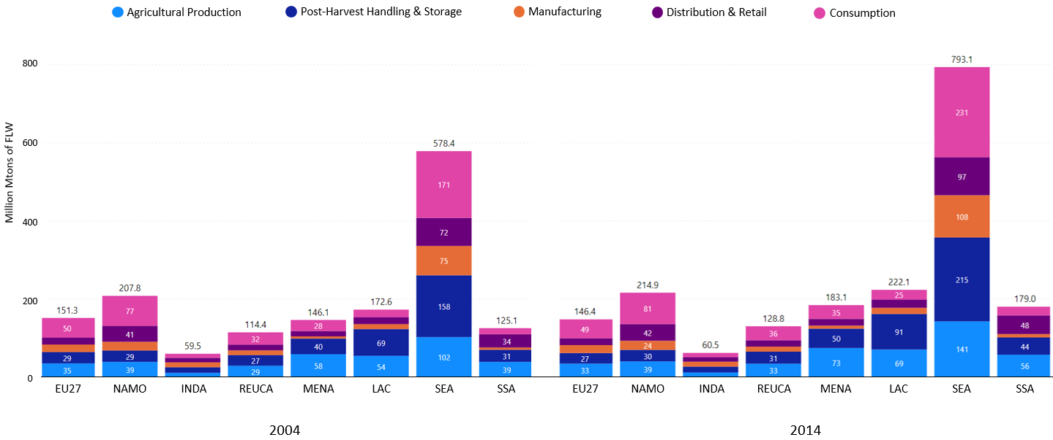
Figure 1. Food Loss and Waste (million Mtons) generated along stages of the food supply chain, by region and reference year.

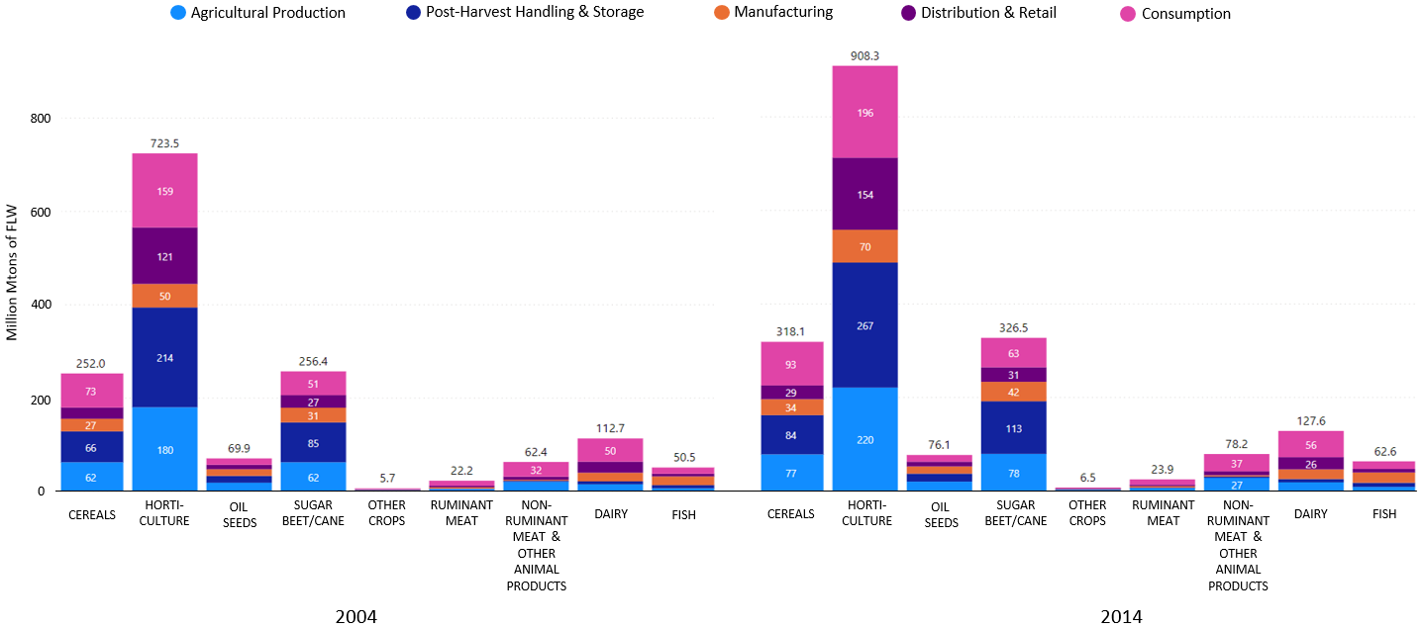
Figure 2. Food Loss and Waste (million Mtons) generated along stages of the food supply chain, by commodity and reference year.

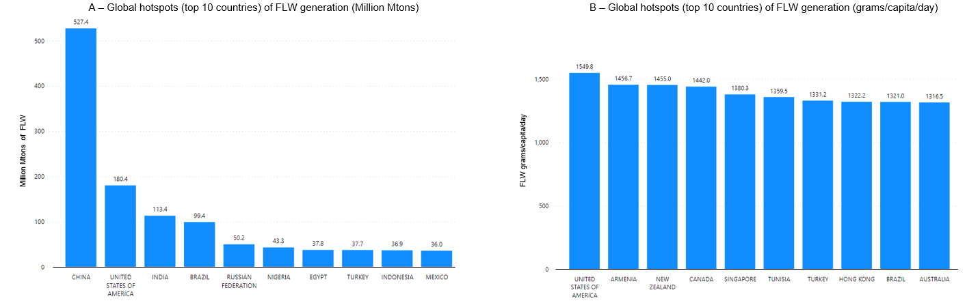
Figure 3. Global hotspots (top 10 countries) of FLW generation (million Mtons and grams/capita/day) along global supply chains in 2014.
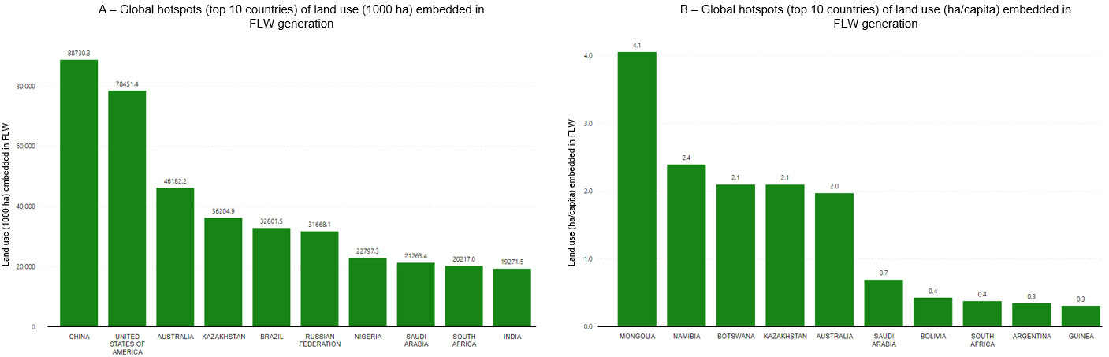
Figure 4. Global hotspots (top 10 countries) of land use (1000 hectares and hectares per capita/year) embedded in FLW generation along global supply chains in 2014.

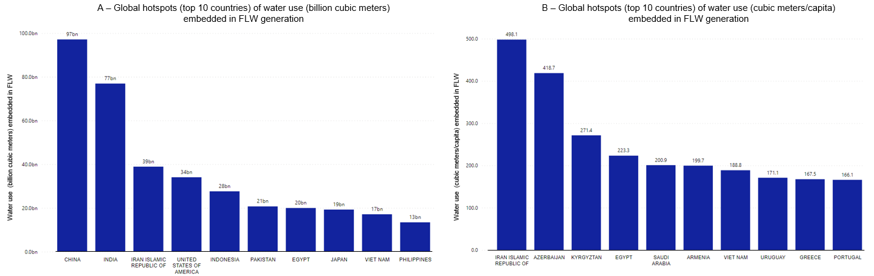
Figure 5. Global hotspots (top 10 countries) of water use (billion cubic meters and cubic meters per capita/year) embedded in FLW generation along global supply chains in 2014.

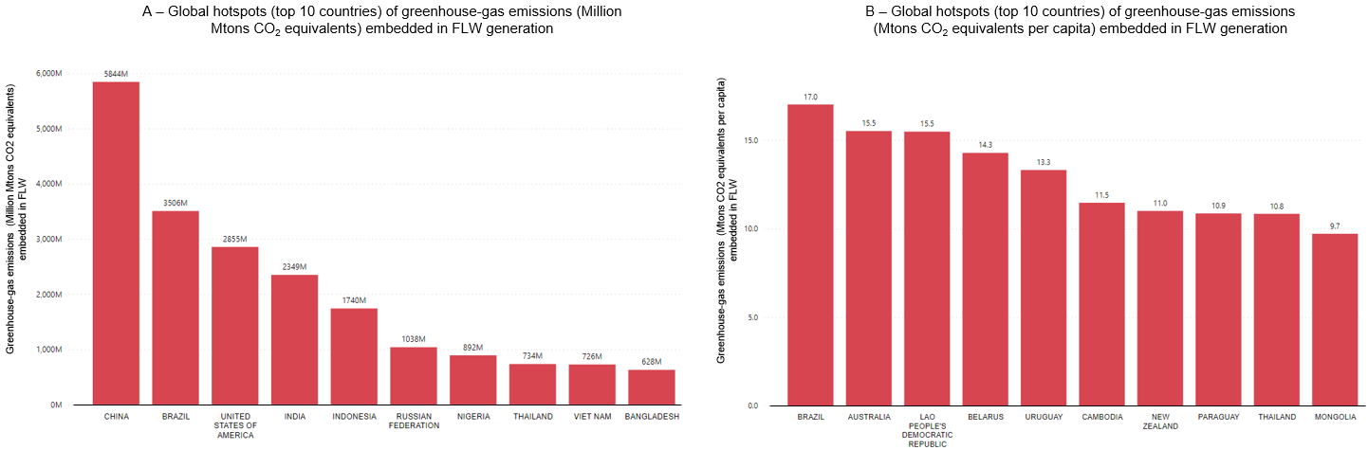
Figure 6. Global hotspots (top 10 countries) of greenhouse-gas emissions (Million Mtons CO₂ equivalents and Mtons CO₂ equivalents per capita/year) embedded in FLW generation along global supply chains in 2014.

References

Affognon, H., Mutungi, C., Sanginga, P., & Borgemeister, C. (2015). Unpacking Postharvest Losses in Sub-Saharan Africa: A Meta-Analysis. World Development, 66, 49–68. https://doi.org/10.1016/j.worlddev.2014.08.002
Chepeliev, M. 2022. Incorporating Nutritional Accounts to the GTAP Data Base. Journal of Global Economic Analysis, 7(1), 1–43. https://doi.org/10.21642/JGEA.070101AF
Delgado, L., Schuster, M., & Torero, M. (2021). Quantity and quality food losses across the value Chain: A Comparative analysis. Food Policy, 101958. https://doi.org/10.1016/j.foodpol.2020.101958
Fabi, C., & English, A. (2018). FAO STATISTICAL DIVISION. 54.
FAO. (2011). Global food losses and food waste – Extent, causes and prevention. Rome
FAO. (2019). Food Loss and Waste Database. Food and Agriculture Organization of the United Nations. http://www.fao.org/platform-food-loss-waste/flw-data/en/
Global Nutrient Database. (2018). https://public.tableau.com/views/GlobalNutrientDatabase/Dashboard1?%3Aincrement_view_count=no&%3Aembed=y&%3Atoolbar=yes&%3Aembed_code_version=3&%3AloadOrderID=0&%3Adisplay_count=yes&publish=yes&%3Atabs=no&%3AshowVizHome=no (Accessed 03 2023)
Lazarte, C. (2014). Nutritional Assessment in a Rural Area of Bolivia. A Study of Zinc and Iron Deficiencies and Bioavailability [Thesis/doccomp, Lund University]. http://lup.lub.lu.se/record/4195825
Lopez Barrera, E., & Hertel, T. (2020). Global food waste across the income spectrum: Implications for food prices, production and resource use. Food Policy, 101874. https://doi.org/10.1016/j.foodpol.2020.101874
Mekonnen, D.A., Talsma, E.F., Trijsburg, L. et al. (2020) Can household dietary diversity inform about nutrient adequacy? Lessons from a food systems analysis in Ethiopia. Food Sec. 12, 1367–1383. https://doi.org/10.1007/s12571-020-01056-5
OECD (2021). "Waste: Food Waste", OECD Environment Statistics (database). https://doi.org/10.1787/ba9da2b7-en.
Porter, S. D., Reay, D. S., Higgins, P., & Bomberg, E. (2016). A half-century of production-phase greenhouse gas emissions from food loss & waste in the global food supply chain. Science of The Total Environment, 571, 721–729. https://doi.org/10.1016/j.scitotenv.2016.07.041
Schmidhuber, J., Sur, P., Fay, K., Huntley, B., Salama, J., Lee, A., Cornaby, L., Horino, M., Murray, C., & Afshin, A. (2018). The Global Nutrient Database: Availability of macronutrients and micronutrients in 195 countries from 1980 to 2013. The Lancet Planetary Health, 2(8), e353–e368. https://doi.org/10.1016/S2542-5196(18)30170-0
Smith, M. R., Micha, R., Golden, C. D., Mozaffarian, D., & Myers, S. S. (2016). Global Expanded Nutrient Supply (GENuS) Model: A New Method for Estimating the Global Dietary Supply of Nutrients. PLOS ONE, 11(1), e0146976. https://doi.org/10.1371/journal.pone.0146976
Verma, M. van den B., Vreede, L. de, Achterbosch, T., & Rutten, M. M. (2020). Consumers discard a lot more food than widely believed: Estimates of global food waste using an energy gap approach and affluence elasticity of food waste. PLOS ONE, 15(2), e0228369. https://doi.org/10.1371/journal.pone.0228369
Willett, W., Rockström, J., Loken, B., Springmann, M., Lang, T., Vermeulen, S., Garnett, T., Tilman, D., DeClerck, F., Jonell, M., Clark, M., Gordon, L. J., Fanzo, J., Hawkes, C., Zurayk, R., Rivera, J. A., Afshin, A., Chaudhary, A., Herrero, M., … Murray, C. J. L. (2019). Food in the Anthropocene: The EAT–Lancet Commission on healthy diets from sustainable food systems. 393, 46.
Xue, L., Liu, G., Parfitt, J., Liu, X., Van Herpen, E., Stenmarck, Å., O’Connor, C., Östergren, K., & Cheng, S. (2017). Missing Food, Missing Data? A Critical Review of Global Food Losses and Food Waste Data. Environmental Science & Technology, 51(12), 6618–6633. https://doi.org/10.1021/acs.est.7b00401

As discussed below, we consider the following FLW stages: (1) Agricultural production; (2) Post-harvest handling and storage; (3) Manufacturing; (4) Distribution and retail and (5) Consumption.
SDG12.3 - Food Loss Index (FLI) and Food Waste Index (FWI) – see Fabi and English, 2018. For an integral explanation see FAO, 2019, p. 32-34.

