Supplementary Material
for
Anthropogenic mineral classification assists resource sustainability
Guochang Xu†, Jinhui Li†, and Xianlai Zeng*

State Key Joint Laboratory of Environment Simulation and Pollution Control, School of Environment, Tsinghua University, Beijing 100084, China

† These authors contributed equally to this work.
* Corresponding author: xlzeng@tsinghua.edu.cn

This PDF file includes:
- Supplementary Text 1−5
- Supplementary Tables 1−59
- Supplementary Figures 1−2
- References

Other supplementary materials for this manuscript include the following:
- Supplementary Dataset
Contents
Abbreviations and Acronyms 5
Supplementary Methods 6
Text 1. Technology roadmap 6
Text 2. Necessity of an AM assessment methodology 8
Table 1. Comparison between GM and AM classification codes 9
Table 2. Target metals and products 10
Table 3. Typical weights of products 11
Table 4. Typical concentrations of metals in products 12
Table 5. Historical new-sale numbers of products in China in 2000−2021 18
Fig. 1. Lifespan distributions of products in China 21
Table 6. Estimated in-use numbers of products in China in 2000−2021 22
Table 7. Estimated EoL numbers of products in China in 2000−2021 25
Text 3. Survey of ELV and WEEE recyclers in China 28
Text 4. Scenario setting for urban mining 30
Table 8. Unit prices of metals 32
Table 9. Estimated current absolute economic value (price) of target metals in products 33
Table 10. Estimated current relative economic proportion (a metal/all materials) of target metals in products 34
Table 11. Estimated current economic recyclability of target metals in products in China under LS 35
Table 12. Estimated current economic recyclability of target metals in products in China under HS 36
Table 13. Review on metal dismantling (liberation) and refining ratios 37
Table 14. Review of DGMR (amount and distribution) in China in 2021 38
Supplementary Results 40
Fig. 2. Inclusion relation between AM categories 40
Text 5. Comparison of related methodologies 41
Table 15. Iron characteristics, applications, and recycling 42
Table 16. Aluminum characteristics, applications, and recycling 43
Table 17. Copper characteristics, applications, and recycling 44
Table 18. Chromium characteristics, applications, and recycling 45
Table 19. Zinc characteristics, applications, and recycling 46
Table 20. Tin characteristics, applications, and recycling 47
Table 21. Manganese characteristics, applications, and recycling 48
Table 22. Magnesium characteristics, applications, and recycling 49
Table 23. Antimony characteristics, applications, and recycling 50
Table 24. Bismuth characteristics, applications, and recycling 51
Table 25. Tungsten characteristics, applications, and recycling 52
Table 26. Niobium characteristics, applications, and recycling 53
Table 27. Vanadium characteristics, applications, and recycling 54
Table 28. Molybdenum characteristics, applications, and recycling 55
Table 29. Gallium characteristics, applications, and recycling 56
Table 30. Germanium characteristics, applications, and recycling 57
Table 31. Tantalum characteristics, applications, and recycling 58
Table 32. Titanium characteristics, applications, and recycling 59
Table 33. Beryllium characteristics, applications, and recycling 60
Table 34. Thallium characteristics, applications, and recycling 61
Table 35. Indium characteristics, applications, and recycling 62
Table 36. Nickel characteristics, applications, and recycling 63
Table 37. Lithium characteristics, applications, and recycling 64
Table 38. Cobalt characteristics, applications, and recycling 65
Table 39. Lead characteristics, applications, and recycling 66
Table 40. Silver characteristics, applications, and recycling 67
Table 41. Gold characteristics, applications, and recycling 68
Table 42. Palladium characteristics, applications, and recycling 69
Table 43. Platinum characteristics, applications, and recycling 70
Table 44. Rhodium characteristics, applications, and recycling 71
Table 45. Lanthanum characteristics, applications, and recycling 72
Table 46. Cerium characteristics, applications, and recycling 73
Table 47. Praseodymium characteristics, applications, and recycling 74
Table 48. Neodymium characteristics, applications, and recycling 75
Table 49. Samarium characteristics, applications, and recycling 76
Table 50. Europium characteristics, applications, and recycling 77
Table 51. Gadolinium characteristics, applications, and recycling 78
Table 52. Terbium characteristics, applications, and recycling 79
Table 53. Dysprosium characteristics, applications, and recycling 80
Table 54. Erbium characteristics, applications, and recycling 81
Table 55. Scandium characteristics, applications, and recycling 82
Table 56. Yttrium characteristics, applications, and recycling 83
Table 57. Mass and value losses of target metals 84
Table 58. Raw material demands for target industries in China in 2021 85
Table 59. Sensitivity analysis 86
References 87

Abbreviations and Acronyms
Material-related
AM Anthropogenic mineral
AMB Anthropogenic mineral reserve base
AME Anthropogenic mineral resource
AMR Anthropogenic mineral reserve
AMSE Anthropogenic mineral subeconomic resource
AMTB Anthropogenic mineral technique-limited reserve base
GM Geological mineral
OFM Other ferrous metal
ONFM Other non-ferrous metal
OSM Other specialty metal
PAMR Potential anthropogenic mineral reserve (by current
economic and technical conditions of urban mining from all in-use products)
PGM Platinum group metal
DGMR Discovered geological mineral reserve
REE Rare earth element

Product-related
AC Air conditioner
BEV Battery electric vehicle
CRT Cathode-ray tube
EEE Electrical and electronic equipment
ELV End-of-life vehicle
EoL End-of-life (product)
EWH Electric water heater
FM Fax machine
GWH Gas water heater
HEV Hybrid electric vehicle
ICEV Internal combustion engine vehicle
LCD Liquid-crystal display
MP Mobile phone
RH Range hood
VP Video player
WEEE Waste electrical and electronic equipment
WM Washing machine

Method-related
CRIRSCO Committee for Mineral Reserves International Reporting Standards
HS High scenario (for urban mining)
LS Low scenario (for urban mining)
UNFC United Nations Framework Classification for Resources

Name-related
NDRC National Development and Reform Commission of China
USGS United States Geological Survey

Supplementary Methods

Text 1. Technology roadmap
This study mainly consists of three phases: classification of AM, quantification of AM, and analysis of AM loss and resupply; seven steps: design of AM categories, dynamic anthropogenic metabolism modeling, measurement of economic recyclability, review of technical recycling efficiencies, evaluation of AM categories, analysis of industrial circularity and resource substitution ratios, and uncertainty analysis, as shown in the below flow chart.
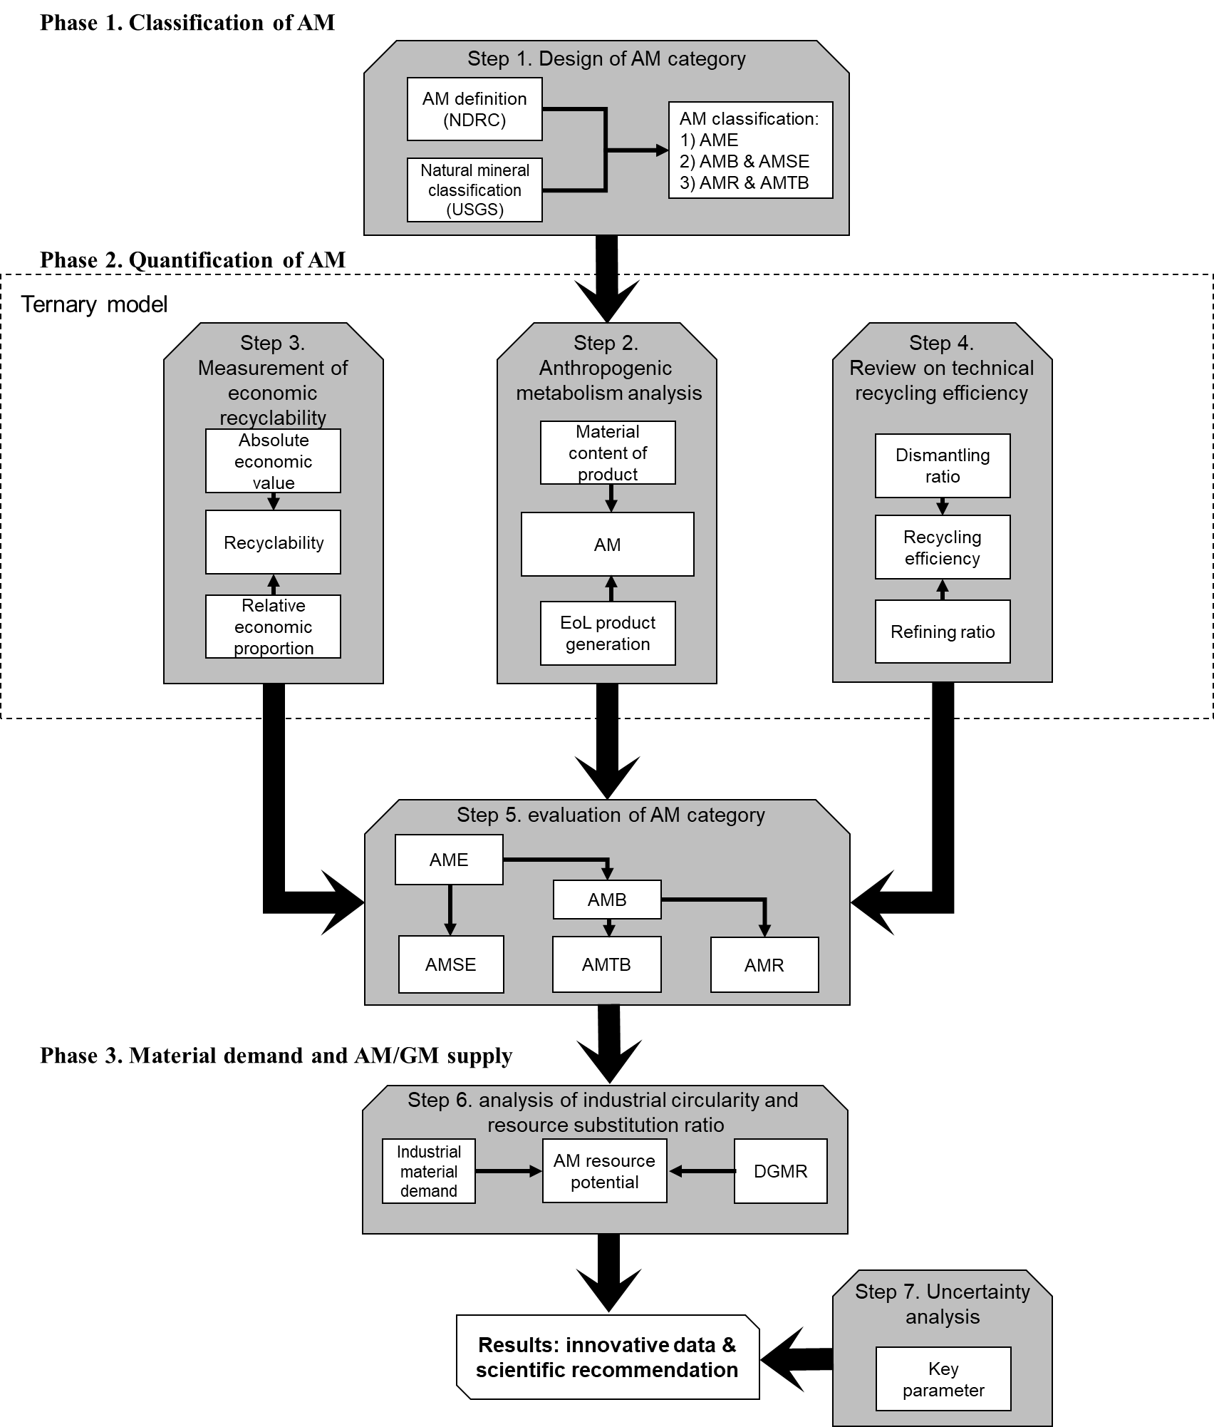
Flow chart. Visualization of technology roadmap
During phase 1, based on information (definition of AM and GM classification code) from the National Development and Reform Commission of China and USGS^{1, 2}, five AM categories were designed. Their inclusion relation can be found in Supplementary Fig. 2. So, an AM classification framework was built (step 1).
During phase 2, the ternary model consisting of a dynamical anthropogenic metabolism analysis, a measurement of product economic recyclability, and a review of material recycling efficiency was developed to convert AM from AME into AMB, then to AMR. We chose China as the study case and considered 42 target metals in 21 modern products³. In the beginning, the quantities of AME were estimated by combining material contents of products and amounts of EoL products (step 2). Secondly, the economic recyclability of products was measured using AMB threshold of absolute economic value and threshold of relative economic proportion (step 3). Thirdly, the technical recycling efficiencies of metals were identified by a review (the overall recycling efficiencies sometimes were found directly, sometimes were calculated by combining dismantling ratios and refining ratios) (step 4). Afterward, by integrating all these intermediate results, quantities of AM categories were clarified (step 5).
During phase 3, We depleted and redelivered AM in WEEE and ELV in China in 2021, considering the five stages of the material life cycle: extraction, production, use, recycling, and disposal⁴. We have analyzed the industrial circularity of EEE and automobiles, assuming that their internal material cycles are established. We analyzed the resource substitution rate of PAMR versus DGMR in complementary AM-GM supply systems (step 6).
Finally, an uncertainty analysis was conducted to help to improve the implementation of innovative data and scientific recommendations found by this study (step 7).

Text 2. Necessity of an AM assessment methodology
In recent years, researchers, engineers, and policymakers in the field of resources and the environment have used various terms (e.g., recovery potential, recycling potential, or recycling capacity) to describe the availability (theoretical maximum amount) of secondary resources^{5, 6}. Sometimes their meanings have overlapped or been inconsistently used, causing nonuniformity and confusion. To mine AMs efficiently, a systematic assessment on their quantities and distributions in the anthroposphere is essential to increase confidence levels on the accessibility (practical retrievable amount) of AM from preliminary exploration to subsequent extraction.
Although AMs are derived from GMs, there are distinct differences between them. First, GMs are formed by geological processes underground, and their discovery can be unpredictable; whereas AMs are derived from human-made activities, and their formation is predictable. Second, AMs generally have higher grades than GMs, but their impurity compositions are more complex, which confers an advantage in refining but a disadvantage in dismantling compared with GMs. Third, GM mining is not time-bound and can be exploited whenever needed, whereas AM mining is basically time-bound because of stockpiling costs and potential environmental impacts. In practice this means it is better to extract them sooner than later, or they will be lost to the environment. These differences mean that the division of AMs cannot directly duplicate that of GMs. An exclusively designed AM assessment methodology, based on existing GM classification and quantification principles, with consideration of the characteristics of anthropogenic metabolism, is needed to guide and foster urban mining practices.

Table 1. Comparison between GM and AM classification codes
Term (source) | Definition
GM resource (USGS²) | “A concentration of naturally occurring solid, liquid, or gaseous material in or on the Earth’s crust in such form and amount that economic extraction of a commodity from the concentration is currently or potentially feasible.”
GM reserve base (USGS²) | “The encompassed part of the resource that has a reasonable potential for becoming economically available within planning horizons beyond those that assume proven technologies and current economics.”
GM reserve (USGS²) | “The part of the reserve base which can be economically extracted or produced at the time of determination.”
GM subeconomic resource (USGS²) | “The part of the identified resource that does not meet the economic criteria of reserves and marginal reserves. The term 'economic' implies that profitable extraction or production under defined investment assumptions has been established, analytically demonstrated, or assumed with reasonable certainty.”
DGMR (USGS²) | “The reserve for which location, grade, quality, and quantity are known or estimated from specific geologic, technical, and economic evidence.”
AM (NDRC¹) | “Recyclable materials such as metals, plastics, and rubbers in EoL products such as obsolete industrial machinery, electric cables, communication equipment, automobiles, and EEE generate in processes of anthropogenic metabolism.”
AME (this study) | An embedded material (pure substance or compound) in related EoL products generated by anthropogenic metabolism, in forms and amounts that urban mining of it is possible now or in the future.
AMB and AMSE (this study) | The encompassed part of AME that has reasonable potential for being economically extracted at present, whereas the economically unextractable part is regarded as AMSE.
AMR and AMTB (this study) | The encompassed part of AMB that can be functionally extracted by proven techniques currently, whereas the unfunctional extractable part and final residue are regarded as AMTB.
PAMR (this study) | The inferred functionally extracted part of a material’s all anthropogenic stocks based on current available economic and technical conditions of urban mining. It approximately reflects the accessibility of the material in its in-use products, whose theoretical basis is that anthropogenic stocks are yet not AM but will eventually become AM when reaching their service lifespans.
Note, the AME consists of the AMB and AMSE; the AMB consists of the AMR and AMTB; the PAMR is inferred from its all anthropogenic material stocks (cumulative in-use products).

Table 2. Target metals and products
Considered element³
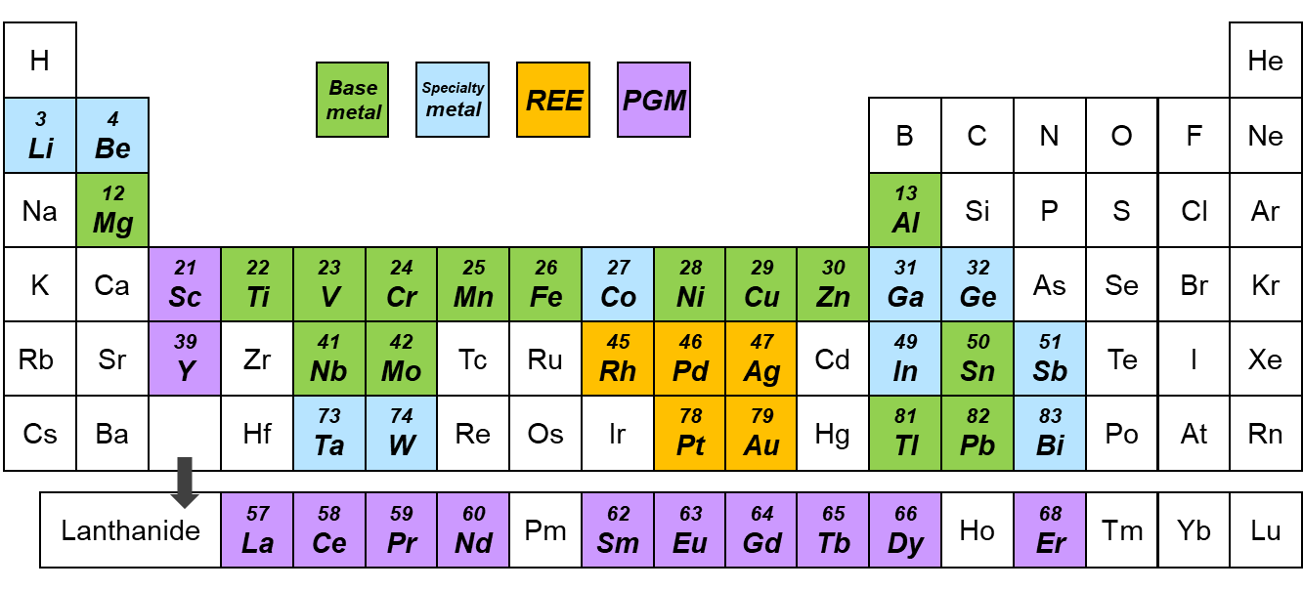
Considered Product⁷ | Identified element in product⁸⁻¹⁰
ICEV | 41 metals: Fe, Al, Cu, Cr, Zn, Sn, Mn, Mg, Sb, Bi, W, Nb, V, Mo, Ga, Ge, Ta, Ti, Be, In, Ni, Li, Co, Pb, Ag, Au, Pd, Pt, Rh, La, Ce, Pr, Nd, Sm, Eu, Gd, Tb, Dy, Er, Sc, Y
HEV
BEV
CRT TV | 36 metals: Fe, Al, Cu, Cr, Zn, Sn, Mn, Mg, Sb, Bi, W, Nb, V, Mo, Ti, Be, Tl, Ni, Co, Pb, Ag, Au, Pd, Pt, Rh, La, Ce, Pr, Nd, Sm, Eu, Gd, Dy, Er, Sc, Y
LCD TV | 36 metals: Fe, Al, Cu, Cr, Zn, Sn, Mn, Mg, Sb, Bi, W, Nb, V, Mo, Ti, Be, Tl, In, Ni, Co, Pb, Ag, Au, Pd, Pt, Rh, La, Pr, Nd, Sm, Eu, Gd, Dy, Er, Sc, Y
Printer | 25 metals: Fe, Al, Cu, Cr, Zn, Sn, Mn, Mg, Sb, Bi, W, Nb, V, Mo, Ti, Be, Pb, Ni, Ag, Au, Pd, Pt, Rh, Sc, Y
Copier | 25 metals: Fe, Al, Cu, Cr, Zn, Sn, Mn, Mg, Sb, Bi, W, Nb, V, Mo, Ti, Be, Pb, Ni, Ag, Au, Pd, Pt, Rh, Sc, Y
Laptop | 42 metals: Fe, Al, Cu, Cr, Zn, Sn, Mn, Mg, Sb, Bi, W, Nb, V, Mo, Ga, Ge, Ta, Ti, Be, Tl, In, Ni, Li, Co, Pb, Ag, Au, Pd, Pt, Rh, La, Ce, Pr, Nd, Sm, Eu, Gd, Tb, Dy, Er, Sc, Y
CRT desktop | 40 metals: Fe, Al, Cu, Cr, Zn, Sn, Mn, Mg, Sb, Bi, W, Nb, V, Mo, Ga, Ge, Ta, Ti, Be, Tl, Ni, Co, Pb, Ag, Au, Pd, Pt, Rh, La, Ce, Pr, Nd, Sm, Eu, Gd, Tb, Dy, Er, Sc, Y
LCD desktop | 42 metals: Fe, Al, Cu, Cr, Zn, Sn, Mn, Mg, Sb, Bi, W, Nb, V, Mo, Ga, Ge, Ta, Ti, Be, Tl, In, Ni, Co, Pb, Ag, Au, Pd, Pt, Rh, La, Ce, Pr, Nd, Sm, Eu, Gd, Tb, Dy, Er, Sc, Y
VP | 36 metals: Fe, Al, Cu, Cr, Zn, Sn, Mn, Mg, Sb, Bi, W, Nb, V, Mo, Ti, Be, Tl, Ni, Co, Pb, Ag, Au, Pd, Pt, Rh, La, Ce, Pr, Nd, Sm, Eu, Gd, Dy, Er, Sc, Y
FM | 36 metals: Fe, Al, Cu, Cr, Zn, Sn, Mn, Mg, Sb, Bi, W, Nb, V, Mo, Ti, Be, Tl, Ni, Co, Pb, Ag, Au, Pd, Pt, Rh, La, Ce, Pr, Nd, Sm, Eu, Gd, Dy, Er, Sc, Y
MP | 42 metals: Fe, Al, Cu, Cr, Zn, Sn, Mn, Mg, Sb, Bi, W, Nb, V, Mo, Ga, Ge, Ta, Ti, Be, Tl, In, Ni, Li, Co, Pb, Ag, Au, Pd, Pt, Rh, La, Ce, Pr, Nd, Sm, Eu, Gd, Tb, Dy, Er, Sc, Y
AC | 35 metals: Fe, Al, Cu, Cr, Zn, Sn, Mn, Mg, Sb, Bi, W, Nb, V, Mo, Ti, Be, Tl, Ni, Co, Pb, Ag, Au, Pd, Pt, Rh, La, Pr, Nd, Sm, Eu, Gd, Dy, Er, Sc, Y
WM
Refrigerator | 36 metals: Fe, Al, Cu, Cr, Zn, Sn, Mn, Mg, Sb, Bi, W, Nb, V, Mo, Ti, Be, Tl, Ni, Co, Pb, Ag, Au, Pd, Pt, Rh, La, Ce, Pr, Nd, Sm, Eu, Gd, Dy, Er, Sc, Y
Dishwasher
EWH
GWH
RH
Microwave

Table 3. Typical weights of products
Product | Sample 1 | Sample 2 | Sample 3 | Average
Product | Unit: kg
ICEV | 1088 | 1240 | 972 | 1100
HEV | 1410 | 1377 | 933 | 1240
BEV | 1285 | 1438 | 1359 | 1361
CRT TV | 9.2 | 10 | 5.7 | 8.3
LCD TV | 20 | 13 | 14 | 16
Printer | 6.0 | 22 | 9.5 | 12
Copier | 72 | 89 | 73 | 78
Laptop | 2.2 | 2.8 | 1.7 | 2.2
CRT desktop | 17 | 15 | 8.3 | 13
LCD desktop | 6.0 | 8.0 | 8.1 | 7.4
VP | 0.89 | 1.0 | 0.87 | 0.92
FM | 2.2 | 9.0 | 4.0 | 5.1
MP | 0.07 | 0.10 | 0.06 | 0.08
AC | 76 | 87 | 67 | 77
Refrigerator | 20 | 135 | 48 | 68
WM | 26 | 80 | 28 | 45
DW | 40 | 44 | 38 | 41
EWH | 19 | 20 | 32 | 24
GWH | 12 | 14 | 11 | 12
RH | 24 | 39 | 28 | 30
Microwave | 9.9 | 15 | 6.9 | 11
Note, data sources are mainly online databases and academic articles^{11, 12}. AC has two separated indoor and outdoor parts, here the shown weight is the total weight.

Table 4. Typical concentrations of metals in products
Material | Total | Automobile part
Material | ICEV | Engine, frame, rest | Catalytic converter | Electronic controller | Pb-acid battery | Motor
Material | Unit: ppm
Fe | 5.67E+05 | 5.77E+05 | 3.49E+03 | 1.72E+04 | 1.04E+05 | 6.57E+05
Al | 1.30E+05 | 1.32E+05 | 9.19E+05 | 4.98E+04 | 5.22E+04 | 1.43E+02
Cu | 3.46E+04 | 3.29E+04 | 2.54E+01 | 5.41E+04 | 1.39E+04 | 3.29E+05
Cr | 7.52E+03 | 7.72E+03 | 2.26E+02 | 1.36E+03 | - | 2.90E+01
Zn | 1.82E+04 | 1.86E+04 | 8.48E+02 | 3.69E+03 | - | -
Sn | 5.02E+02 | 3.31E+02 | 4.24E+00 | 2.56E+04 | - | -
Mn | 6.67E+03 | 6.85E+03 | 1.91E+01 | 2.06E+02 | - | 3.08E+02
Mg | 4.59E+03 | 4.54E+03 | 3.67E+04 | 1.89E+04 | - | -
Sb | 7.48E+01 | 7.35E+01 | 2.83E+00 | 4.63E+02 | - | -
Bi | 3.12E+01 | 3.09E+01 | - | 1.59E+02 | - | -
W | 1.20E+01 | 4.43E+00 | 7.77E+00 | 7.43E+02 | - | 4.05E+02
Nb | 9.78E+01 | 1.00E+02 | 2.33E+01 | 4.97E+01 | - | -
V | 5.15E+01 | 5.27E+01 | 2.83E+00 | 2.72E+01 | - | -
Mo | 2.79E+02 | 2.85E+02 | 1.20E+02 | 2.66E+02 | - | -
Ga | 3.18E-01 | 1.07E-01 | 3.74E+01 | 2.53E+01 | - | -
Ge | 1.82E+00 | 2.59E-02 | - | 2.56E+02 | - | -
Ta | 7.10E+00 | 6.20E+00 | - | 1.52E+02 | - | -
Ti | 7.08E+02 | 6.98E+02 | 2.90E+02 | 3.94E+03 | - | 1.75E+02
Be | 1.23E-01 | 1.26E-01 | - | 4.26E-02 | - | -
Tl | - | - | - | - | - | -
In | 9.09E-01 | 3.36E-01 | - | 8.30E+01 | - | -
Ni | 2.69E+03 | 2.75E+03 | 1.20E+02 | 2.99E+03 | - | 1.81E+00
Li | 1.06E+01 | 1.07E+01 | 2.26E+01 | 1.71E+01 | - | -
Co | 6.16E+01 | 5.75E+01 | 1.41E+00 | 3.00E+01 | - | 9.07E+02
Pb | 1.20E+04 | 4.16E+03 | 4.24E+00 | 5.62E+03 | 6.00E+05 | -
Ag | 2.58E+01 | 2.46E+01 | 1.41E+00 | 2.68E+02 | - | -
Au | 2.35E+00 | 2.03E+00 | - | 5.32E+01 | - | -
Pd | 3.76E+00 | 2.48E+00 | 9.19E+02 | 6.23E+01 | - | -
Pt | 6.82E-01 | 3.19E-02 | 6.32E+02 | 3.89E+00 | - | -
Rh | 3.64E-01 | 2.03E-02 | 3.46E+02 | 3.52E-01 | - | -
La | 1.82E+01 | 8.65E+00 | 3.96E+03 | 1.54E+02 | - | 7.94E+02
Ce | 5.01E+01 | 4.42E+00 | 3.32E+04 | 1.86E+03 | - | -
Pr | 5.75E+00 | 5.49E+00 | 2.12E+00 | 5.77E+01 | - | -
Nd | 3.49E+00 | 2.36E+00 | 9.89E+00 | 3.49E+01 | - | 1.57E+02
Sm | 5.09E+00 | 5.07E+00 | 1.41E+00 | 2.14E+01 | - | -
Eu | 9.09E-02 | 8.61E-02 | - | 1.02E+00 | - | -
Gd | 2.73E-01 | 7.66E-02 | 1.41E+00 | 2.80E+01 | - | -
Tb | 9.09E-02 | 8.53E-02 | 2.12E+00 | 8.37E-01 | - | -
Dy | 3.15E+00 | 2.98E+00 | 2.83E+00 | 4.91E+00 | - | 3.50E+01
Er | 5.45E-01 | 8.33E-02 | 2.12E+00 | 1.02E+00 | - | 7.56E+01
Sc | 1.82E-01 | 4.73E-02 | - | 1.94E+01 | - | -
Y | 1.89E+00 | 1.62E+00 | 1.34E+01 | 4.27E+01 | - | -
Non-metal | 2.15E+05 | 2.12E+05 | 3.99E+02 | 8.12E+05 | 2.29E+05 | 1.10E+04
Note, -: none or no data. Data were mainly collected or estimated from academic literatures^{6, 8-10, 13-19}. ppm: one part per million denotes one part per 1,000,000 parts, and a value of 10⁻⁶.

Continue to previous table
Material | Total | Automobile part
Material | ICEV | Engine, frame, rest | Catalytic converter | Electronic controller | NiMH battery | Motor
Material | Unit: ppm
Fe | 5.59E+05 | 5.69E+05 | 3.36E+03 | 1.32E+04 | 2.82E+05 | 6.44E+05
Al | 1.50E+05 | 1.54E+05 | 9.38E+05 | 5.63E+04 | 1.01E+04 | 3.21E+02
Cu | 4.94E+04 | 4.72E+04 | 6.33E+01 | 5.69E+04 | 5.37E+01 | 3.22E+05
Cr | 5.78E+03 | 6.00E+03 | 4.77E+02 | 9.27E+02 | 9.26E+01 | -
Zn | 1.96E+04 | 2.03E+04 | 1.09E+02 | 2.98E+03 | 2.15E+03 | -
Sn | 4.74E+02 | 2.59E+02 | 1.88E+01 | 2.41E+04 | 1.21E+01 | -
Mn | 6.28E+03 | 6.21E+03 | 2.27E+01 | 1.59E+02 | 1.74E+04 | 1.49E+02
Mg | 3.49E+03 | 3.43E+03 | 3.75E+04 | 1.28E+04 | 2.15E+03 | -
Sb | 1.23E+02 | 1.25E+02 | 7.82E-01 | 3.95E+02 | 2.68E+00 | -
Bi | 3.85E+01 | 3.89E+01 | 3.75E+01 | 1.10E+02 | - | -
W | 5.77E+00 | - | 1.33E+02 | 4.93E+02 | 6.71E+00 | 8.24E+01
Nb | 7.36E+01 | 7.63E+01 | 2.35E+00 | 3.59E+01 | - | -
V | 5.07E+01 | 5.25E+01 | 4.93E+01 | 2.02E+01 | 2.68E+00 | -
Mo | 2.63E+02 | 2.72E+02 | 7.35E+01 | 1.77E+02 | 1.07E+01 | -
Ga | 7.98E+00 | - | 4.69E+01 | 1.79E+01 | 4.43E+02 | -
Ge | 1.83E+00 | 1.36E-16 | 1.56E+00 | 1.71E+02 | 1.34E+01 | -
Ta | 6.81E+00 | 6.09E+00 | - | 1.01E+02 | - | -
Ti | 5.19E+02 | 5.01E+02 | 3.21E+03 | 3.31E+03 | 2.42E+02 | -
Be | 3.25E+01 | 3.38E+01 | - | 2.83E-02 | - | -
Tl | - | - | - | - | - | -
In | 8.88E-01 | 3.64E-16 | - | 9.48E+01 | - | -
Ni | 8.97E+03 | 9.23E-13 | 1.64E+02 | 2.50E+03 | 5.10E+05 | 6.32E+00
Li | 2.03E+02 | 2.01E+02 | 7.82E+00 | 1.53E+01 | 5.90E+02 | -
Co | 6.06E+02 | 1.14E-03 | 2.35E+01 | 2.26E+01 | 3.35E+04 | 1.52E+03
Pb | 7.17E+03 | 7.42E+03 | - | 4.61E+03 | 2.68E+00 | -
Ag | 2.45E+01 | 2.31E+01 | 2.35E+01 | 2.47E+02 | - | -
Au | 4.23E+00 | 4.02E+00 | - | 3.97E+01 | - | -
Pd | 3.37E+00 | - | 3.05E+03 | 6.44E+01 | - | -
Pt | 1.53E+00 | 5.07E-02 | 1.61E+03 | 2.31E+00 | - | -
Rh | 1.77E-01 | 1.76E-02 | 1.72E+02 | 4.72E-01 | - | -
La | 1.47E+03 | 4.29E-01 | 1.33E+03 | 1.04E+02 | 8.32E+04 | 3.80E+02
Ce | 6.32E+02 | 6.32E-01 | 8.60E+03 | 1.24E+03 | 3.49E+04 | -
Pr | 6.24E+01 | 1.22E-14 | 2.35E+00 | 3.87E+01 | 3.49E+03 | 7.31E+01
Nd | 4.18E+02 | 8.39E-02 | 3.05E+01 | 2.39E+02 | 1.09E+04 | 2.01E+04
Sm | 3.94E+00 | 3.96E+00 | 7.82E-01 | 1.49E+01 | - | -
Eu | 8.72E-03 | 1.42E-18 | - | 9.31E-01 | - | -
Gd | 1.70E+00 | - | 6.96E+01 | 1.88E+01 | 8.32E+01 | -
Tb | 6.94E-01 | 6.41E-01 | 2.35E+00 | 5.57E-01 | 4.03E+00 | -
Dy | 5.70E+01 | - | - | 1.21E+01 | 2.68E+00 | 5.08E+03
Er | 7.70E-02 | - | - | 6.79E-01 | 4.03E+00 | -
Sc | 1.35E-01 | 2.27E-17 | 1.09E+01 | 1.34E+01 | - | -
Y | 1.51E+02 | - | 7.82E-01 | 1.12E+01 | 8.59E+03 | -
Non-metal | 1.85E+05 | 1.84E+05 | 1.66E+03 | 8.18E+05 | 2.63E+02 | 6.84E+03

Continue to previous table
Material | Total | Automobile part
Material | BEV | Engine, frame, rest | Electronic controller | Li-ion battery | Motor
Material | Unit: ppm
Fe | 5.30E+05 | 8.15E+05 | 1.28E+04 | 1.90E+02 | 6.31E+05
Al | 4.85E+04 | 3.49E+04 | 5.49E+04 | 7.60E+04 | 3.57E+02
Cu | 6.59E+04 | 4.67E+04 | 5.96E+04 | 9.30E+04 | 3.16E+05
Cr | 4.92E+03 | 7.67E+03 | 8.92E+02 | 9.00E+00 | -
Zn | 1.78E+04 | 2.77E+04 | 3.07E+03 | 1.50E+01 | -
Sn | 4.27E+02 | 2.97E+02 | 2.37E+04 | 7.40E+01 | -
Mn | 5.75E+04 | 1.06E+00 | 1.54E+02 | 1.70E+05 | 4.62E+01
Mg | 3.84E+03 | 5.74E+03 | 1.23E+04 | 1.70E+02 | -
Sb | 2.06E+02 | 3.17E+02 | 3.79E+02 | - | -
Bi | 2.01E+01 | 3.00E+01 | 1.06E+02 | - | -
W | 7.41E+00 | - | 4.71E+02 | 7.00E+00 | 6.53E+01
Nb | 1.46E+02 | 2.27E+02 | 3.44E+01 | - | -
V | 1.27E+02 | 1.94E+02 | 1.97E+01 | 8.00E+00 | -
Mo | 3.03E+02 | 4.70E+02 | 1.70E+02 | 1.00E+00 | -
Ga | 3.91E+00 | 9.96E-16 | 1.74E+01 | 1.00E+01 | 2.91E+01
Ge | 1.47E+00 | 2.18E-02 | 1.63E+02 | - | -
Ta | 1.15E+01 | 1.65E+01 | 1.02E+02 | - | -
Ti | 6.02E+02 | 8.78E+02 | 3.33E+03 | 3.20E+01 | -
Be | 2.94E+01 | 4.59E+01 | 2.71E-02 | - | -
Tl | - | - | - | - | -
In | 8.09E-01 | 2.49E-16 | 9.07E+01 | - | -
Ni | 1.76E+04 | 5.66E-13 | 2.57E+03 | 5.20E+04 | 2.92E+00
Li | 7.10E+03 | - | 1.51E+01 | 2.10E+04 | -
Co | 4.43E+03 | 1.99E-13 | 2.18E+01 | 1.30E+04 | 2.87E+03
Pb | 6.56E+03 | 1.02E+04 | 4.42E+03 | - | -
Ag | 2.63E+01 | 3.71E+01 | 2.88E+02 | - | -
Au | 3.42E+00 | 4.80E+00 | 3.90E+01 | - | -
Pd | 1.62E+00 | 1.65E+00 | 6.27E+01 | - | -
Pt | 1.62E-01 | 2.22E-01 | 2.21E+00 | - | -
Rh | 1.62E-01 | 2.46E-01 | 4.51E-01 | - | -
La | 4.76E+00 | - | 9.97E+01 | - | 3.01E+02
Ce | 1.06E+01 | - | 1.19E+03 | - | -
Pr | 2.05E+01 | - | 3.71E+01 | 9.00E+00 | 1.33E+03
Nd | 4.47E+02 | 1.15E-01 | 2.29E+02 | - | 3.46E+04
Sm | 3.28E+00 | 4.92E+00 | 1.43E+01 | - | -
Eu | 7.95E-03 | 1.95E-18 | 8.91E-01 | - | -
Gd | 1.61E-01 | - | 1.80E+01 | - | -
Tb | 6.39E-01 | 9.90E-01 | 6.23E-01 | - | -
Dy | 1.37E+02 | - | 1.31E+01 | - | 1.07E+04
Er | 5.88E-03 | 1.38E-04 | 6.49E-01 | - | -
Sc | 3.85E-01 | 1.01E-01 | 1.28E+01 | 6.10E-01 | -
Y | 1.38E-01 | - | 1.55E+01 | - | -
Non-metal | 2.34E+05 | 5.00E+04 | 8.19E+05 | 5.74E+05 | 2.55E+03

Continue to previous table
Material | CRT TV | LCD TV | Printer | Copier | Laptop | CRT desktop
Material | Unit: ppm
Fe | 1.23E+05 | 3.00E+05 | 3.20E+05 | 1.60E+05 | 2.00E+05 | 4.50E+05
Al | 2.00E+04 | 4.00E+04 | 1.80E+05 | 2.00E+05 | 1.50E+04 | 3.50E+04
Cu | 3.67E+04 | 1.00E+04 | 5.00E+03 | 3.50E+04 | 5.70E+04 | 5.65E+04
Cr | 1.66E+00 | 3.11E+00 | 1.94E+01 | 6.56E+00 | 1.47E+01 | 2.80E+00
Zn | 4.72E-02 | 8.86E-02 | 3.56E+02 | 1.20E+02 | 2.57E-01 | 7.24E-02
Sn | 1.44E+03 | 2.71E+03 | 1.44E+03 | 4.88E+02 | 2.74E+03 | 6.37E+02
Mn | 6.18E-01 | 1.16E+00 | 2.33E+00 | 7.87E-01 | 3.84E+00 | 2.72E+00
Mg | 2.18E+01 | 4.10E+01 | 2.18E+01 | 7.37E+00 | 8.56E+01 | 1.99E+01
Sb | 7.44E-01 | 1.40E+00 | 8.66E+01 | 2.93E+01 | 8.35E-01 | 8.92E-02
Bi | 4.03E+00 | 7.57E+00 | 4.03E+00 | 1.36E+00 | 5.63E+00 | 1.31E+00
W | 6.89E-01 | 1.29E+00 | 6.89E-01 | 2.33E-01 | 1.58E+01 | 3.67E+00
Nb | 2.38E-01 | 4.47E-01 | 2.38E-01 | 8.03E-02 | 1.38E+00 | 3.20E-01
V | 3.57E-02 | 6.70E-02 | 1.11E-01 | 3.74E-02 | 1.39E+00 | 4.17E-01
Mo | 8.75E-01 | 1.64E+00 | 8.61E-02 | 2.91E-02 | 3.50E+00 | 3.44E-01
Ga | - | - | - | - | 3.42E+00 | 7.95E-01
Ge | - | - | - | - | 1.22E+01 | 2.83E+00
Ta | - | - | - | - | 8.00E+00 | 1.86E+00
Ti | 3.54E+01 | 6.65E+01 | 3.54E+01 | 1.20E+01 | 2.33E+02 | 5.42E+01
Be | 8.20E-04 | 1.54E-03 | 1.23E-02 | 4.16E-03 | 8.53E-03 | 3.30E-03
Tl | 3.69E-03 | 6.93E-03 | - | - | 1.28E-02 | 6.61E-04
In | - | 1.02E+02 | - | - | 3.61E+02 | -
Ni | 2.05E-03 | 3.85E-03 | 1.90E+02 | 6.42E+01 | 1.56E-02 | 9.25E-04
Li | - | - | - | - | 9.24E+03 | 0.00E+00
Co | 1.05E-01 | 1.96E-01 | - | - | 3.38E+00 | 1.72E-01
Pb | 1.43E-01 | 2.68E-01 | 1.40E+02 | 4.73E+01 | 1.15E+00 | 1.53E-01
Ag | 1.21E+01 | 2.27E+01 | 4.97E+01 | 1.68E+01 | 9.04E+01 | 2.08E+01
Au | 1.35E+00 | 2.53E+00 | 8.16E+00 | 2.76E+00 | 3.17E+01 | 7.42E+00
Pd | 8.00E-01 | 1.50E+00 | 8.00E-01 | 2.70E-01 | 1.69E+01 | 3.93E+00
Pt | 2.05E-02 | 3.85E-02 | 2.05E-02 | 6.93E-03 | 6.11E-01 | 1.42E-01
Rh | 6.15E-02 | 1.16E-01 | 6.15E-02 | 2.08E-02 | 8.10E-01 | 1.88E-01
La | 2.81E+02 | 4.00E-03 | - | - | 3.73E-01 | 2.27E+02
Ce | 2.34E+00 | - | - | - | 6.84E-01 | 2.18E+00
Pr | 1.76E+01 | 1.39E-02 | - | - | 5.55E-02 | 1.42E+01
Nd | 1.39E-02 | 2.61E-02 | - | - | 1.73E-01 | 6.94E-02
Sm | 2.62E-03 | 4.93E-03 | - | - | 3.70E-02 | 1.39E-02
Eu | 5.74E-03 | 1.08E-02 | - | - | 3.06E-01 | 3.44E-02
Gd | 2.50E-03 | 4.70E-03 | - | - | 1.92E-01 | 5.48E-02
Tb | - | - | - | - | 1.98E-01 | 4.60E-02
Dy | 1.17E+01 | 3.31E-03 | - | - | 4.41E-02 | 9.53E+00
Er | 1.72E-03 | 3.23E-03 | - | - | 1.28E-02 | 4.63E-03
Sc | 1.07E+00 | 2.00E+00 | 1.64E-02 | 5.54E-03 | 2.08E+00 | 8.34E-01
Y | 3.30E-02 | 6.21E-02 | 1.31E-01 | 4.43E-02 | 1.42E-02 | 7.10E-02
Non-metal | 8.18E+05 | 6.47E+05 | 4.93E+05 | 6.04E+05 | 7.15E+05 | 4.58E+05

Continue to previous table
Material | LCD desktop | VP | FM | MP | AC | Refrigerator
Material | Unit: ppm
Fe | 1.80E+05 | 5.00E+05 | 3.00E+05 | 1.93E+05 | 5.02E+05 | 4.90E+05
Al | 3.60E+04 | 6.60E+04 | 1.50E+05 | 2.81E+04 | 7.90E+04 | 1.80E+04
Cu | 7.20E+04 | 6.00E+04 | 4.00E+04 | 4.13E+04 | 1.80E+05 | 3.70E+04
Cr | 2.40E+00 | 5.83E-01 | 5.16E-01 | 2.67E-01 | 1.06E-01 | 6.30E-02
Zn | 6.19E-02 | 6.62E-04 | 6.12E-04 | 1.32E+00 | 4.92E-04 | 1.10E-03
Sn | 5.45E+02 | 2.59E+02 | 5.39E+02 | 4.05E+03 | 3.77E+01 | 1.90E+01
Mn | 2.33E+00 | 2.16E-01 | 5.32E-01 | 7.05E+00 | 1.60E-02 | 1.64E-02
Mg | 1.70E+01 | 3.91E+00 | 8.14E+00 | 1.26E+02 | 5.69E-01 | 2.87E-01
Sb | 7.63E-02 | 1.93E+00 | 5.06E-01 | 4.13E+00 | 3.77E-02 | 9.86E-03
Bi | 1.12E+00 | 7.23E-01 | 1.50E+00 | 8.32E+00 | 1.05E-01 | 5.31E-02
W | 3.14E+00 | 1.23E-01 | 2.57E-01 | 2.33E+01 | 1.80E-02 | 9.07E-03
Nb | 2.74E-01 | 4.26E-02 | 8.87E-02 | 2.04E+00 | 6.21E-03 | 3.13E-03
V | 3.56E-01 | 6.10E-03 | 3.32E-02 | 2.01E+00 | 1.95E-03 | 4.34E-03
Mo | 2.94E-01 | 1.19E-01 | 3.45E-01 | 2.88E+00 | 2.48E-02 | 1.95E-02
Ga | 6.80E-01 | - | - | 5.05E+00 | - | -
Ge | 2.42E+00 | - | - | 1.80E+01 | - | -
Ta | 1.59E+00 | - | - | 1.18E+01 | - | -
Ti | 4.64E+01 | 6.35E+00 | 1.32E+01 | 3.44E+02 | 9.24E-01 | 4.67E-01
Be | 2.83E-03 | 1.47E-04 | 2.45E-04 | 1.89E-02 | 4.28E-05 | 2.92E-05
Tl | 5.65E-04 | 8.75E-04 | 3.01E-02 | 4.83E-03 | 5.99E-05 | 1.30E-04
In | 1.08E+02 | - | - | 3.97E+02 | - | -
Ni | 7.92E-04 | 9.56E-05 | 4.74E-04 | 6.72E-02 | 3.42E-05 | 1.24E-05
Li | - | - | - | 1.85E+04 | - | -
Co | 1.48E-01 | 5.49E-02 | 6.17E-02 | 4.06E+00 | 1.07E-02 | 4.28E-03
Pb | 1.31E-01 | 1.09E-01 | 7.77E-02 | 1.32E+00 | 4.22E-03 | 1.04E-03
Ag | 1.78E+01 | 1.00E+00 | 4.08E-01 | 1.10E+02 | 2.01E-02 | 1.93E-01
Au | 6.35E+00 | 1.39E-01 | 3.64E-02 | 6.63E+01 | 2.17E-03 | 4.92E-03
Pd | 3.36E+00 | 1.43E-01 | 2.98E-01 | 2.50E+01 | 2.09E-02 | 1.05E-02
Pt | 1.22E-01 | 3.68E-03 | 7.65E-03 | 9.03E-01 | 5.35E-04 | 2.70E-04
Rh | 1.61E-01 | 1.10E-02 | 2.30E-02 | 1.20E+00 | 1.61E-03 | 8.10E-04
La | 1.39E-01 | 4.48E-03 | 9.49E-03 | 1.44E+03 | 1.28E-03 | 1.50E-03
Ce | 2.49E-01 | 2.33E-02 | - | 1.28E+01 | - | 1.67E-03
Pr | 2.35E-02 | 7.35E-04 | 3.21E-03 | 9.01E+01 | 1.82E-01 | 3.08E-04
Nd | 5.94E-02 | 2.28E-03 | 8.11E-03 | 5.19E-01 | 4.60E-01 | 8.26E-04
Sm | 1.19E-02 | 4.78E-04 | 1.53E-03 | 4.41E-02 | 8.10E-02 | 1.67E-04
Eu | 2.94E-02 | 4.19E-03 | 5.81E-04 | 4.85E-01 | 8.56E-05 | 4.70E-05
Gd | 4.69E-02 | 8.09E-04 | 1.07E-03 | 2.69E-01 | 1.07E-04 | 4.16E-04
Tb | 3.93E-02 | - | - | 2.92E-01 | - | -
Dy | 7.35E-02 | 4.19E-04 | 1.53E-03 | 6.00E+01 | 7.10E-02 | 1.35E-04
Er | 3.96E-03 | 3.01E-04 | 9.18E-04 | 1.76E-02 | 4.92E-05 | 6.48E-05
Sc | 7.13E-01 | 1.51E-01 | 1.23E-01 | 6.90E+00 | 2.97E-02 | 1.12E-02
Y | 6.08E-02 | 1.81E-02 | 7.50E-03 | 3.59E-01 | 9.42E-04 | 1.66E-03
Non-metal | 7.11E+05 | 3.74E+05 | 5.09E+05 | 7.12E+05 | 2.39E+05 | 4.55E+05

Continue to previous table, in total six sub-tables
Material | WM | Dishwasher | EWH | GWH | RH | Microwave
Material | Unit: ppm
Fe | 4.96E+05 | 5.00E+05 | 3.50E+05 | 3.00E+05 | 3.00E+05 | 7.13E+05
Al | 3.87E+04 | 2.50E+04 | 1.00E+05 | 1.00E+05 | 8.00E+04 | 3.90E+04
Cu | 3.13E+04 | 2.50E+04 | 5.00E+04 | 8.00E+04 | 1.00E+05 | 3.90E+04
Cr | 7.06E-04 | 6.30E-02 | 6.30E-02 | 6.30E-02 | 6.30E-02 | 6.30E-02
Zn | 7.48E-03 | 1.10E-03 | 1.10E-03 | 1.10E-03 | 1.10E-03 | 1.10E-03
Sn | 4.88E+02 | 1.90E+01 | 1.90E+01 | 1.90E+01 | 1.90E+01 | 1.90E+01
Mn | 8.60E-01 | 1.64E-02 | 1.64E-02 | 1.64E-02 | 1.64E-02 | 1.64E-02
Mg | 7.37E+00 | 2.87E-01 | 2.87E-01 | 2.87E-01 | 2.87E-01 | 2.87E-01
Sb | 2.76E-01 | 9.86E-03 | 9.86E-03 | 9.86E-03 | 9.86E-03 | 9.86E-03
Bi | 1.36E+00 | 5.31E-02 | 5.31E-02 | 5.31E-02 | 5.31E-02 | 5.31E-02
W | 2.33E-01 | 9.07E-03 | 9.07E-03 | 9.07E-03 | 9.07E-03 | 9.07E-03
Nb | 8.03E-02 | 3.13E-03 | 3.13E-03 | 3.13E-03 | 3.13E-03 | 3.13E-03
V | 2.05E-02 | 4.34E-03 | 4.34E-03 | 4.34E-03 | 4.34E-03 | 4.34E-03
Mo | 1.06E+00 | 1.95E-02 | 1.95E-02 | 1.95E-02 | 1.95E-02 | 1.95E-02
Ga | - | - | - | - | - | -
Ge | - | - | - | - | - | -
Ta | - | - | - | - | - | -
Ti | 1.20E+01 | 4.67E-01 | 4.67E-01 | 4.67E-01 | 4.67E-01 | 4.67E-01
Be | 4.16E-04 | 2.92E-05 | 2.92E-05 | 2.92E-05 | 2.92E-05 | 2.92E-05
Tl | 2.35E-03 | 1.30E-04 | 1.30E-04 | 1.30E-04 | 1.30E-04 | 1.30E-04
In | - | - | - | - | - | -
Ni | 5.12E-04 | 1.24E-05 | 1.24E-05 | 1.24E-05 | 1.24E-05 | 1.24E-05
Li | - | - | - | - | - | -
Co | 1.21E-01 | 4.28E-03 | 4.28E-03 | 4.28E-03 | 4.28E-03 | 4.28E-03
Pb | 5.35E-02 | 1.04E-03 | 1.04E-03 | 1.04E-03 | 1.04E-03 | 1.04E-03
Ag | 2.15E-01 | 1.93E-01 | 1.93E-01 | 1.93E-01 | 1.93E-01 | 1.93E-01
Au | 1.25E-01 | 4.92E-03 | 4.92E-03 | 4.92E-03 | 4.92E-03 | 4.92E-03
Pd | 2.70E-01 | 1.05E-02 | 1.05E-02 | 1.05E-02 | 1.05E-02 | 1.05E-02
Pt | 6.93E-03 | 2.70E-04 | 2.70E-04 | 2.70E-04 | 2.70E-04 | 2.70E-04
Rh | 2.08E-02 | 8.10E-04 | 8.10E-04 | 8.10E-04 | 8.10E-04 | 8.10E-04
La | 2.01E-02 | 1.50E-03 | 1.50E-03 | 1.50E-03 | 1.50E-03 | 1.50E-03
Ce | - | 1.67E-03 | 1.67E-03 | 1.67E-03 | 1.67E-03 | 1.67E-03
Pr | 2.60E-01 | 3.08E-04 | 3.08E-04 | 3.08E-04 | 3.08E-04 | 3.08E-04
Nd | 6.40E-01 | 8.26E-04 | 8.26E-04 | 8.26E-04 | 8.26E-04 | 8.26E-04
Sm | 1.20E-01 | 1.67E-04 | 1.67E-04 | 1.67E-04 | 1.67E-04 | 1.67E-04
Eu | 1.39E-03 | 4.70E-05 | 4.70E-05 | 4.70E-05 | 4.70E-05 | 4.70E-05
Gd | 2.08E-03 | 4.16E-04 | 4.16E-04 | 4.16E-04 | 4.16E-04 | 4.16E-04
Tb | - | - | - | - | - | -
Dy | 4.30E-01 | 1.35E-04 | 1.35E-04 | 1.35E-04 | 1.35E-04 | 1.35E-04
Er | 1.66E-03 | 6.48E-05 | 6.48E-05 | 6.48E-05 | 6.48E-05 | 6.48E-05
Sc | 4.23E-01 | 1.12E-02 | 1.12E-02 | 1.12E-02 | 1.12E-02 | 1.12E-02
Y | 2.77E-02 | 1.66E-03 | 1.66E-03 | 1.66E-03 | 1.66E-03 | 1.66E-03
Non-metal | 4.34E+05 | 4.50E+05 | 5.00E+05 | 5.20E+05 | 5.20E+05 | 2.09E+05

Table 5. Historical new-sale numbers of products in China in 2000−2021
Year | ICEV | HEV | BEV | CRT TV | LCD TV | Printer | Copier
1990 | 1.57E+05 | - | - | 2.75E+06 | 3.44E+05 | - | 1.00E+04
1991 | 1.58E+05 | - | - | 3.21E+06 | 4.02E+05 | - | 2.61E+04
1992 | 1.54E+05 | - | - | 3.55E+06 | 4.44E+05 | - | 4.23E+04
1993 | 1.45E+05 | - | - | 3.83E+06 | 4.79E+05 | - | 5.84E+04
1994 | 1.40E+05 | - | - | 4.50E+06 | 5.63E+05 | 1.00E+04 | 7.45E+04
1995 | 1.37E+05 | - | - | 5.49E+06 | 6.86E+05 | 1.32E+05 | 9.06E+04
1996 | 1.44E+05 | - | - | 6.77E+06 | 8.46E+05 | 2.53E+05 | 1.07E+05
1997 | 1.49E+05 | - | - | 7.23E+06 | 9.04E+05 | 2.44E+06 | 1.23E+05
1998 | 1.59E+05 | - | - | 9.33E+06 | 1.17E+06 | 4.62E+06 | 1.39E+05
1999 | 2.51E+06 | - | - | 1.14E+07 | 1.42E+06 | 6.81E+06 | 8.55E+05
2000 | 3.51E+06 | - | - | 1.05E+07 | 1.31E+06 | 9.00E+06 | 1.57E+06
2001 | 3.82E+06 | - | - | 1.09E+07 | 1.36E+06 | 1.02E+07 | 1.44E+06
2002 | 3.37E+06 | - | - | 1.37E+07 | 1.72E+06 | 1.15E+07 | 2.07E+06
2003 | 4.34E+06 | - | - | 1.74E+07 | 2.18E+06 | 1.27E+07 | 2.64E+06
2004 | 4.51E+06 | - | - | 1.98E+07 | 2.48E+06 | 1.40E+07 | 3.25E+06
2005 | 5.29E+06 | - | - | 2.21E+07 | 2.76E+06 | 1.52E+07 | 4.04E+06
2006 | 6.73E+06 | - | - | 2.23E+07 | 2.79E+06 | 1.64E+07 | 4.68E+06
2007 | 6.08E+06 | - | - | 2.15E+07 | 3.39E+06 | 1.77E+07 | 4.52E+06
2008 | 7.63E+06 | 1.67E+02 | - | 2.20E+07 | 4.29E+06 | 1.89E+07 | 5.84E+06
2009 | 1.25E+07 | 3.33E+02 | - | 2.24E+07 | 5.28E+06 | 2.02E+07 | 4.21E+06
2010 | 1.53E+07 | 6.66E+02 | 3.29E+03 | 2.52E+07 | 7.10E+06 | 2.14E+07 | 5.35E+06
2011 | 1.62E+07 | 1.12E+03 | 5.54E+03 | 2.45E+07 | 8.15E+06 | 2.26E+07 | 6.55E+06
2012 | 1.77E+07 | 1.68E+03 | 8.30E+03 | 2.39E+07 | 9.40E+06 | 2.39E+07 | 6.10E+06
2013 | 2.03E+07 | 2.33E+03 | 1.15E+04 | 2.21E+07 | 1.02E+07 | 2.51E+07 | 6.35E+06
2014 | 2.21E+07 | 1.05E+04 | 5.17E+04 | 2.14E+07 | 1.16E+07 | 2.64E+07 | 7.13E+06
2015 | 2.33E+07 | 4.41E+04 | 2.18E+05 | 2.08E+07 | 1.32E+07 | 2.49E+07 | 7.34E+06
2016 | 2.72E+07 | 6.79E+04 | 3.36E+05 | 2.04E+07 | 1.53E+07 | 2.65E+07 | 7.40E+06
2017 | 2.75E+07 | 1.04E+05 | 6.50E+05 | 1.71E+07 | 1.52E+07 | 2.91E+07 | 7.46E+06
2018 | 2.57E+07 | 1.69E+05 | 1.17E+06 | 1.56E+07 | 1.66E+07 | 3.08E+07 | 7.52E+06
2019 | 2.47E+07 | 1.60E+05 | 1.10E+06 | 1.37E+07 | 1.86E+07 | 3.10E+07 | 7.58E+06
2020 | 2.33E+07 | 1.45E+05 | 1.37E+06 | 1.07E+07 | 1.78E+07 | 3.12E+07 | 7.64E+06
2021 | 2.25E+07 | 2.92E+05 | 3.52E+06 | 9.20E+06 | 2.02E+07 | 3.14E+07 | 7.70E+06
Note, -: none or no data. Data were mainly collected or estimated from government statistics and online database^{20, 21}.

Continue to previous table
Year | Laptop | CRT desktop | LCD desktop | VP | FM | MP | AC
1990 | 1.57E+05 | - | - | 2.75E+06 | 3.44E+05 | - | 1.00E+04
1991 | 1.58E+05 | - | - | 3.21E+06 | 4.02E+05 | - | 2.61E+04
1992 | 1.54E+05 | - | - | 3.55E+06 | 4.44E+05 | - | 4.23E+04
1993 | 1.45E+05 | - | - | 3.83E+06 | 4.79E+05 | - | 5.84E+04
1994 | 1.40E+05 | - | - | 4.50E+06 | 5.63E+05 | 1.00E+04 | 7.45E+04
1995 | 1.37E+05 | - | - | 5.49E+06 | 6.86E+05 | 1.32E+05 | 9.06E+04
1996 | 1.44E+05 | - | - | 6.77E+06 | 8.46E+05 | 2.53E+05 | 1.07E+05
1997 | 1.49E+05 | - | - | 7.23E+06 | 9.04E+05 | 2.44E+06 | 1.23E+05
1998 | 1.59E+05 | - | - | 9.33E+06 | 1.17E+06 | 4.62E+06 | 1.39E+05
1999 | 2.51E+06 | - | - | 1.14E+07 | 1.42E+06 | 6.81E+06 | 8.55E+05
2000 | 3.51E+06 | - | - | 1.05E+07 | 1.31E+06 | 9.00E+06 | 1.57E+06
2001 | 3.82E+06 | - | - | 1.09E+07 | 1.36E+06 | 1.02E+07 | 1.44E+06
2002 | 3.37E+06 | - | - | 1.37E+07 | 1.72E+06 | 1.15E+07 | 2.07E+06
2003 | 4.34E+06 | - | - | 1.74E+07 | 2.18E+06 | 1.27E+07 | 2.64E+06
2004 | 4.51E+06 | - | - | 1.98E+07 | 2.48E+06 | 1.40E+07 | 3.25E+06
2005 | 5.29E+06 | - | - | 2.21E+07 | 2.76E+06 | 1.52E+07 | 4.04E+06
2006 | 6.73E+06 | - | - | 2.23E+07 | 2.79E+06 | 1.64E+07 | 4.68E+06
2007 | 6.08E+06 | - | - | 2.15E+07 | 3.39E+06 | 1.77E+07 | 4.52E+06
2008 | 7.63E+06 | 1.67E+02 | - | 2.20E+07 | 4.29E+06 | 1.89E+07 | 5.84E+06
2009 | 1.25E+07 | 3.33E+02 | - | 2.24E+07 | 5.28E+06 | 2.02E+07 | 4.21E+06
2010 | 1.53E+07 | 6.66E+02 | 3.29E+03 | 2.52E+07 | 7.10E+06 | 2.14E+07 | 5.35E+06
2011 | 1.62E+07 | 1.12E+03 | 5.54E+03 | 2.45E+07 | 8.15E+06 | 2.26E+07 | 6.55E+06
2012 | 1.77E+07 | 1.68E+03 | 8.30E+03 | 2.39E+07 | 9.40E+06 | 2.39E+07 | 6.10E+06
2013 | 2.03E+07 | 2.33E+03 | 1.15E+04 | 2.21E+07 | 1.02E+07 | 2.51E+07 | 6.35E+06
2014 | 2.21E+07 | 1.05E+04 | 5.17E+04 | 2.14E+07 | 1.16E+07 | 2.64E+07 | 7.13E+06
2015 | 2.33E+07 | 4.41E+04 | 2.18E+05 | 2.08E+07 | 1.32E+07 | 2.49E+07 | 7.34E+06
2016 | 2.72E+07 | 6.79E+04 | 3.36E+05 | 2.04E+07 | 1.53E+07 | 2.65E+07 | 7.40E+06
2017 | 2.75E+07 | 1.04E+05 | 6.50E+05 | 1.71E+07 | 1.52E+07 | 2.91E+07 | 7.46E+06
2018 | 2.57E+07 | 1.69E+05 | 1.17E+06 | 1.56E+07 | 1.66E+07 | 3.08E+07 | 7.52E+06
2019 | 2.47E+07 | 1.60E+05 | 1.10E+06 | 1.37E+07 | 1.86E+07 | 3.10E+07 | 7.58E+06
2020 | 2.33E+07 | 1.45E+05 | 1.37E+06 | 1.07E+07 | 1.78E+07 | 3.12E+07 | 7.64E+06
2021 | 2.25E+07 | 2.92E+05 | 3.52E+06 | 9.20E+06 | 2.02E+07 | 3.14E+07 | 7.70E+06

Continue to previous table, in total three sub-tables
Year | Refrigerator | WM | Dishwasher | EWH | GWH | RH | Microwave
1990 | 1.57E+05 | 0.00E+00 | 0.00E+00 | 2.75E+06 | 3.44E+05 | - | 1.00E+04
1991 | 1.58E+05 | 0.00E+00 | 0.00E+00 | 3.21E+06 | 4.02E+05 | - | 2.61E+04
1992 | 1.54E+05 | 0.00E+00 | 0.00E+00 | 3.55E+06 | 4.44E+05 | - | 4.23E+04
1993 | 1.45E+05 | 0.00E+00 | 0.00E+00 | 3.83E+06 | 4.79E+05 | - | 5.84E+04
1994 | 1.40E+05 | 0.00E+00 | 0.00E+00 | 4.50E+06 | 5.63E+05 | 1.00E+04 | 7.45E+04
1995 | 1.37E+05 | 0.00E+00 | 0.00E+00 | 5.49E+06 | 6.86E+05 | 1.32E+05 | 9.06E+04
1996 | 1.44E+05 | 0.00E+00 | 0.00E+00 | 6.77E+06 | 8.46E+05 | 2.53E+05 | 1.07E+05
1997 | 1.49E+05 | 0.00E+00 | 0.00E+00 | 7.23E+06 | 9.04E+05 | 2.44E+06 | 1.23E+05
1998 | 1.59E+05 | 0.00E+00 | 0.00E+00 | 9.33E+06 | 1.17E+06 | 4.62E+06 | 1.39E+05
1999 | 2.51E+06 | 0.00E+00 | 0.00E+00 | 1.14E+07 | 1.42E+06 | 6.81E+06 | 8.55E+05
2000 | 3.51E+06 | 0.00E+00 | 0.00E+00 | 1.05E+07 | 1.31E+06 | 9.00E+06 | 1.57E+06
2001 | 3.82E+06 | 0.00E+00 | 0.00E+00 | 1.09E+07 | 1.36E+06 | 1.02E+07 | 1.44E+06
2002 | 3.37E+06 | 0.00E+00 | 0.00E+00 | 1.37E+07 | 1.72E+06 | 1.15E+07 | 2.07E+06
2003 | 4.34E+06 | 0.00E+00 | 0.00E+00 | 1.74E+07 | 2.18E+06 | 1.27E+07 | 2.64E+06
2004 | 4.51E+06 | 0.00E+00 | 0.00E+00 | 1.98E+07 | 2.48E+06 | 1.40E+07 | 3.25E+06
2005 | 5.29E+06 | 0.00E+00 | 0.00E+00 | 2.21E+07 | 2.76E+06 | 1.52E+07 | 4.04E+06
2006 | 6.73E+06 | 0.00E+00 | 0.00E+00 | 2.23E+07 | 2.79E+06 | 1.64E+07 | 4.68E+06
2007 | 6.08E+06 | 0.00E+00 | 0.00E+00 | 2.15E+07 | 3.39E+06 | 1.77E+07 | 4.52E+06
2008 | 7.63E+06 | 1.67E+02 | 0.00E+00 | 2.20E+07 | 4.29E+06 | 1.89E+07 | 5.84E+06
2009 | 1.25E+07 | 3.33E+02 | 0.00E+00 | 2.24E+07 | 5.28E+06 | 2.02E+07 | 4.21E+06
2010 | 1.53E+07 | 6.66E+02 | 3.29E+03 | 2.52E+07 | 7.10E+06 | 2.14E+07 | 5.35E+06
2011 | 1.62E+07 | 1.12E+03 | 5.54E+03 | 2.45E+07 | 8.15E+06 | 2.26E+07 | 6.55E+06
2012 | 1.77E+07 | 1.68E+03 | 8.30E+03 | 2.39E+07 | 9.40E+06 | 2.39E+07 | 6.10E+06
2013 | 2.03E+07 | 2.33E+03 | 1.15E+04 | 2.21E+07 | 1.02E+07 | 2.51E+07 | 6.35E+06
2014 | 2.21E+07 | 1.05E+04 | 5.17E+04 | 2.14E+07 | 1.16E+07 | 2.64E+07 | 7.13E+06
2015 | 2.33E+07 | 4.41E+04 | 2.18E+05 | 2.08E+07 | 1.32E+07 | 2.49E+07 | 7.34E+06
2016 | 2.72E+07 | 6.79E+04 | 3.36E+05 | 2.04E+07 | 1.53E+07 | 2.65E+07 | 7.40E+06
2017 | 2.75E+07 | 1.04E+05 | 6.50E+05 | 1.71E+07 | 1.52E+07 | 2.91E+07 | 7.46E+06
2018 | 2.57E+07 | 1.69E+05 | 1.17E+06 | 1.56E+07 | 1.66E+07 | 3.08E+07 | 7.52E+06
2019 | 2.47E+07 | 1.60E+05 | 1.10E+06 | 1.37E+07 | 1.86E+07 | 3.10E+07 | 7.58E+06
2020 | 2.33E+07 | 1.45E+05 | 1.37E+06 | 1.07E+07 | 1.78E+07 | 3.12E+07 | 7.64E+06
2021 | 2.25E+07 | 2.92E+05 | 3.52E+06 | 9.20E+06 | 2.02E+07 | 3.14E+07 | 7.70E+06

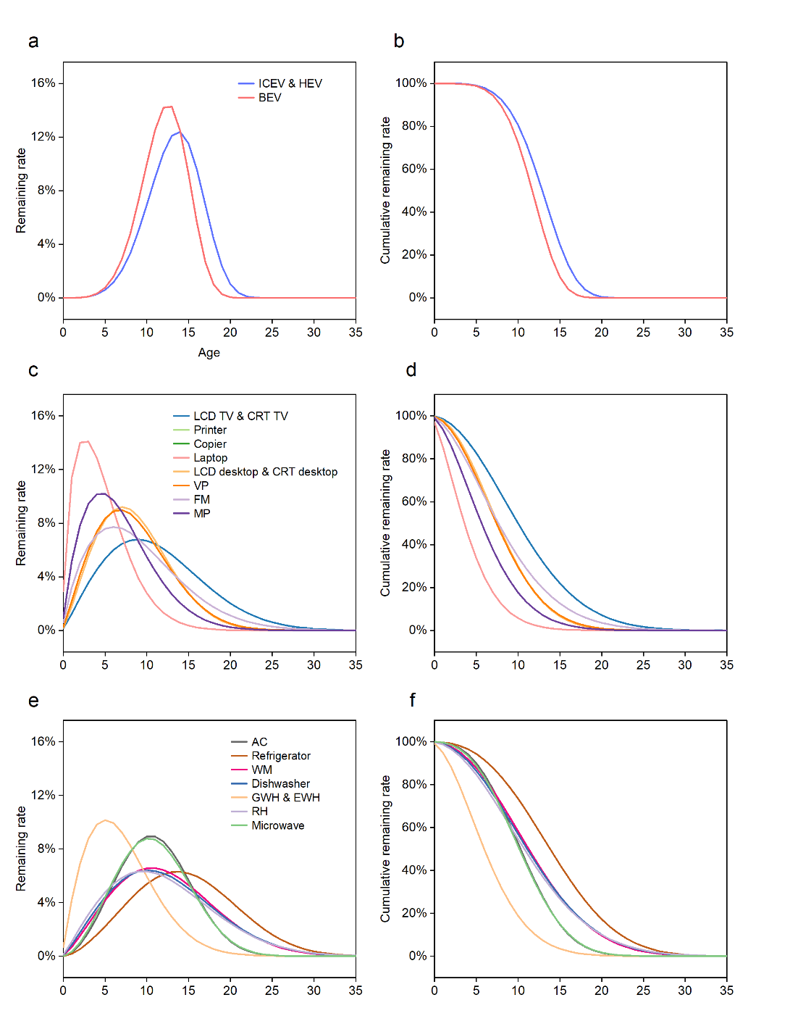

Fig. 1. Lifespan distributions of products in China
Note, a and b refer to remaining rate and cumulative remaining rate of automobiles; c and d refer to remaining rate and cumulative remaining rate of electronic devices; e and f refer to remaining rate and cumulative remaining rate of electric home appliances. In the Weibull distribution, the estimated shape parameter (μ) and scale parameter (η) are 4.79 and 14.46 for ICEV and BEV, 5.08 and 13.11 for BEV, 2.00 and 12.60 for TV, 1.70 and 10.10 for printer, copier and FM, 1.50 and 5.20 for laptop, 2.10 and 9.60 for desktop, 2.00 and 9.50 for VP, 1.70 and 7.60 for MP, 2.80 and 12.30 for AC, 2.60 and 16.50 for refrigerator, 2.20 and 13.90 for WM, 2.10 and 13.80 for dishwasher, 1.80 and 7.90 for water heater, 2.00 and 13.50 for RH, 2.70 and 12.20 for microwave, respectively^{7, 22}.

Table 6. Estimated in-use numbers of products in China in 2000−2021
Year | ICEV | HEV | BEV | CRT TV | LCD TV | Printer | Copier
2000 | 7.29E+06 | 0.00E+00 | 0.00E+00 | 5.94E+07 | 7.43E+06 | 2.21E+07 | 2.87E+06
2001 | 1.11E+07 | 0.00E+00 | 0.00E+00 | 6.74E+07 | 8.42E+06 | 3.11E+07 | 4.16E+06
2002 | 1.44E+07 | 0.00E+00 | 0.00E+00 | 7.75E+07 | 9.69E+06 | 4.08E+07 | 5.99E+06
2003 | 1.86E+07 | 0.00E+00 | 0.00E+00 | 9.07E+07 | 1.13E+07 | 5.09E+07 | 8.27E+06
2004 | 2.30E+07 | 0.00E+00 | 0.00E+00 | 1.06E+08 | 1.32E+07 | 6.14E+07 | 1.10E+07
2005 | 2.81E+07 | 0.00E+00 | 0.00E+00 | 1.22E+08 | 1.52E+07 | 7.22E+07 | 1.43E+07
2006 | 3.46E+07 | 0.00E+00 | 0.00E+00 | 1.37E+08 | 1.72E+07 | 8.32E+07 | 1.80E+07
2007 | 4.03E+07 | 0.00E+00 | 0.00E+00 | 1.51E+08 | 1.96E+07 | 9.43E+07 | 2.13E+07
2008 | 4.74E+07 | 1.67E+02 | 0.00E+00 | 1.64E+08 | 2.27E+07 | 1.06E+08 | 2.55E+07
2009 | 5.91E+07 | 5.00E+02 | 0.00E+00 | 1.76E+08 | 2.67E+07 | 1.17E+08 | 2.78E+07
2010 | 7.33E+07 | 1.17E+03 | 3.29E+03 | 1.90E+08 | 3.22E+07 | 1.28E+08 | 3.09E+07
2011 | 8.81E+07 | 2.28E+03 | 8.83E+03 | 2.02E+08 | 3.86E+07 | 1.40E+08 | 3.49E+07
2012 | 1.04E+08 | 3.96E+03 | 1.71E+04 | 2.12E+08 | 4.59E+07 | 1.51E+08 | 3.80E+07
2013 | 1.22E+08 | 6.29E+03 | 2.87E+04 | 2.19E+08 | 5.37E+07 | 1.62E+08 | 4.10E+07
2014 | 1.41E+08 | 1.67E+04 | 8.04E+04 | 2.25E+08 | 6.24E+07 | 1.74E+08 | 4.44E+07
2015 | 1.60E+08 | 6.08E+04 | 2.98E+05 | 2.28E+08 | 7.22E+07 | 1.82E+08 | 4.77E+07
2016 | 1.83E+08 | 1.29E+05 | 6.34E+05 | 2.31E+08 | 8.35E+07 | 1.91E+08 | 5.07E+07
2017 | 2.05E+08 | 2.33E+05 | 1.28E+06 | 2.29E+08 | 9.40E+07 | 2.02E+08 | 5.34E+07
2018 | 2.25E+08 | 4.02E+05 | 2.45E+06 | 2.25E+08 | 1.05E+08 | 2.13E+08 | 5.58E+07
2019 | 2.42E+08 | 5.61E+05 | 3.55E+06 | 2.20E+08 | 1.18E+08 | 2.23E+08 | 5.79E+07
2020 | 2.57E+08 | 7.05E+05 | 4.91E+06 | 2.10E+08 | 1.28E+08 | 2.32E+08 | 5.98E+07
2021 | 2.69E+08 | 9.95E+05 | 8.42E+06 | 2.00E+08 | 1.41E+08 | 2.40E+08 | 6.15E+07
Note, data in this table was estimated from Supplementary Table 5 and Supplementary Fig. 1, detailed methods are provided in the Anthropogenic Metabolism Analysis section.
Continue to previous table
Year | Laptop | CRT desktop | LCD desktop | VP | FM | MP | AC
2000 | 0.00E+00 | 1.43E+07 | 6.15E+05 | 1.13E+08 | 8.89E+06 | 1.91E+08 | 4.42E+07
2001 | 0.00E+00 | 1.68E+07 | 1.17E+06 | 1.42E+08 | 1.14E+07 | 2.49E+08 | 5.69E+07
2002 | 0.00E+00 | 1.95E+07 | 1.99E+06 | 1.68E+08 | 1.35E+07 | 3.09E+08 | 7.40E+07
2003 | 7.57E+06 | 2.23E+07 | 3.13E+06 | 1.91E+08 | 1.99E+07 | 3.70E+08 | 1.01E+08
2004 | 1.62E+07 | 2.51E+07 | 4.62E+06 | 2.12E+08 | 2.70E+07 | 4.33E+08 | 1.36E+08
2005 | 2.66E+07 | 2.79E+07 | 6.50E+06 | 2.29E+08 | 3.58E+07 | 4.99E+08 | 1.72E+08
2006 | 3.86E+07 | 3.06E+07 | 8.78E+06 | 2.43E+08 | 4.53E+07 | 5.68E+08 | 2.08E+08
2007 | 5.35E+07 | 3.31E+07 | 1.15E+07 | 2.55E+08 | 5.10E+07 | 6.43E+08 | 2.49E+08
2008 | 7.25E+07 | 3.54E+07 | 1.47E+07 | 2.65E+08 | 5.48E+07 | 7.22E+08 | 2.88E+08
2009 | 9.33E+07 | 3.74E+07 | 1.83E+07 | 2.73E+08 | 5.72E+07 | 8.09E+08 | 3.25E+08
2010 | 1.16E+08 | 3.91E+07 | 2.24E+07 | 2.78E+08 | 5.40E+07 | 9.04E+08 | 3.76E+08
2011 | 1.36E+08 | 4.04E+07 | 2.70E+07 | 2.83E+08 | 5.14E+07 | 1.01E+09 | 4.42E+08
2012 | 1.49E+08 | 4.10E+07 | 3.17E+07 | 2.86E+08 | 4.86E+07 | 1.12E+09 | 5.00E+08
2013 | 1.54E+08 | 4.08E+07 | 3.62E+07 | 2.83E+08 | 4.49E+07 | 1.25E+09 | 5.53E+08
2014 | 1.59E+08 | 4.01E+07 | 4.07E+07 | 2.78E+08 | 4.10E+07 | 1.39E+09 | 6.11E+08
2015 | 1.59E+08 | 3.86E+07 | 4.48E+07 | 2.67E+08 | 3.75E+07 | 1.54E+09 | 6.69E+08
2016 | 1.59E+08 | 3.67E+07 | 4.89E+07 | 2.52E+08 | 3.39E+07 | 1.82E+09 | 7.23E+08
2017 | 1.59E+08 | 3.44E+07 | 5.30E+07 | 2.34E+08 | 3.05E+07 | 2.04E+09 | 7.72E+08
2018 | 1.59E+08 | 3.18E+07 | 5.70E+07 | 2.14E+08 | 2.72E+07 | 2.19E+09 | 8.18E+08
2019 | 1.59E+08 | 2.89E+07 | 6.11E+07 | 1.95E+08 | 2.41E+07 | 2.30E+09 | 8.58E+08
2020 | 1.59E+08 | 2.56E+07 | 6.54E+07 | 1.75E+08 | 2.13E+07 | 2.31E+09 | 8.95E+08
2021 | 1.60E+08 | 2.26E+07 | 6.93E+07 | 1.56E+08 | 1.87E+07 | 2.34E+09 | 9.27E+08

Continue to previous table, in total three sub-tables
Year | Refrigerator | WM | Dishwasher | EWH | GWH | RH | Microwave
2000 | 5.23E+07 | 5.94E+07 | 0.00E+00 | 9.72E+06 | 6.76E+06 | 1.83E+07 | 1.04E+07
2001 | 5.92E+07 | 6.48E+07 | 0.00E+00 | 1.11E+07 | 7.11E+06 | 2.03E+07 | 1.36E+07
2002 | 6.72E+07 | 7.13E+07 | 0.00E+00 | 1.29E+07 | 7.74E+06 | 2.21E+07 | 1.64E+07
2003 | 7.87E+07 | 7.95E+07 | 0.00E+00 | 1.62E+07 | 9.15E+06 | 2.27E+07 | 1.76E+07
2004 | 9.43E+07 | 9.06E+07 | 0.00E+00 | 2.16E+07 | 1.16E+07 | 2.58E+07 | 2.25E+07
2005 | 1.09E+08 | 1.04E+08 | 0.00E+00 | 2.86E+07 | 1.49E+07 | 2.91E+07 | 2.78E+07
2006 | 1.27E+08 | 1.20E+08 | 0.00E+00 | 3.85E+07 | 1.97E+07 | 3.48E+07 | 3.68E+07
2007 | 1.50E+08 | 1.38E+08 | 0.00E+00 | 5.14E+07 | 2.60E+07 | 4.10E+07 | 4.64E+07
2008 | 1.74E+08 | 1.58E+08 | 0.00E+00 | 6.52E+07 | 3.29E+07 | 4.97E+07 | 5.98E+07
2009 | 2.04E+08 | 1.80E+08 | 0.00E+00 | 7.82E+07 | 3.93E+07 | 5.86E+07 | 7.35E+07
2010 | 2.42E+08 | 2.09E+08 | 5.93E+03 | 9.17E+07 | 4.60E+07 | 6.92E+07 | 8.99E+07
2011 | 2.86E+08 | 2.39E+08 | 1.77E+04 | 1.09E+08 | 5.44E+07 | 7.93E+07 | 1.06E+08
2012 | 3.29E+08 | 2.68E+08 | 4.13E+04 | 1.21E+08 | 6.07E+07 | 9.02E+07 | 1.22E+08
2013 | 3.74E+08 | 2.98E+08 | 8.81E+04 | 1.39E+08 | 6.96E+07 | 1.03E+08 | 1.41E+08
2014 | 4.15E+08 | 3.27E+08 | 1.82E+05 | 1.56E+08 | 7.81E+07 | 1.18E+08 | 1.65E+08
2015 | 4.50E+08 | 3.54E+08 | 3.69E+05 | 1.66E+08 | 8.29E+07 | 1.32E+08 | 1.86E+08
2016 | 4.81E+08 | 3.79E+08 | 8.94E+05 | 1.74E+08 | 8.70E+07 | 1.45E+08 | 2.07E+08
2017 | 5.11E+08 | 4.02E+08 | 1.75E+06 | 1.80E+08 | 9.01E+07 | 1.57E+08 | 2.25E+08
2018 | 5.38E+08 | 4.23E+08 | 2.94E+06 | 1.85E+08 | 9.26E+07 | 1.68E+08 | 2.43E+08
2019 | 5.62E+08 | 4.41E+08 | 4.44E+06 | 1.89E+08 | 9.44E+07 | 1.78E+08 | 2.58E+08
2020 | 5.84E+08 | 4.58E+08 | 6.24E+06 | 1.91E+08 | 9.57E+07 | 1.87E+08 | 2.71E+08
2021 | 6.03E+08 | 4.72E+08 | 9.40E+06 | 1.93E+08 | 9.66E+07 | 1.95E+08 | 2.83E+08

Table 7. Estimated EoL numbers of products in China in 2000−2021
Year | ICEV | HEV | BEV | CRT TV | LCD TV | Printer | Copier
2000 | 2.99E+04 | 0.00E+00 | 0.00E+00 | 2.41E+06 | 3.01E+05 | 6.91E+05 | 8.20E+04
2001 | 4.39E+04 | 0.00E+00 | 0.00E+00 | 2.97E+06 | 3.71E+05 | 1.19E+06 | 1.50E+05
2002 | 6.25E+04 | 0.00E+00 | 0.00E+00 | 3.57E+06 | 4.47E+05 | 1.83E+06 | 2.41E+05
2003 | 8.76E+04 | 0.00E+00 | 0.00E+00 | 4.25E+06 | 5.31E+05 | 2.59E+06 | 3.63E+05
2004 | 1.23E+05 | 0.00E+00 | 0.00E+00 | 5.01E+06 | 6.26E+05 | 3.45E+06 | 5.23E+05
2005 | 1.74E+05 | 0.00E+00 | 0.00E+00 | 5.88E+06 | 7.35E+05 | 4.41E+06 | 7.24E+05
2006 | 2.50E+05 | 0.00E+00 | 0.00E+00 | 6.86E+06 | 8.57E+05 | 5.44E+06 | 9.73E+05
2007 | 3.63E+05 | 0.00E+00 | 0.00E+00 | 7.92E+06 | 9.91E+05 | 6.53E+06 | 1.26E+06
2008 | 5.28E+05 | 1.67E-05 | 0.00E+00 | 9.05E+06 | 1.14E+06 | 7.67E+06 | 1.58E+06
2009 | 7.60E+05 | 3.24E-03 | 0.00E+00 | 1.02E+07 | 1.32E+06 | 8.85E+06 | 1.93E+06
2010 | 1.07E+06 | 4.04E-02 | 2.05E-04 | 1.14E+07 | 1.52E+06 | 1.01E+07 | 2.26E+06
2011 | 1.47E+06 | 2.30E-01 | 5.45E-02 | 1.26E+07 | 1.78E+06 | 1.13E+07 | 2.61E+06
2012 | 1.96E+06 | 8.89E-01 | 7.65E-01 | 1.38E+07 | 2.09E+06 | 1.25E+07 | 2.97E+06
2013 | 2.51E+06 | 2.72E+00 | 4.56E+00 | 1.49E+07 | 2.46E+06 | 1.38E+07 | 3.34E+06
2014 | 3.12E+06 | 7.08E+00 | 1.78E+01 | 1.60E+07 | 2.90E+06 | 1.50E+07 | 3.70E+06
2015 | 3.78E+06 | 1.65E+01 | 5.42E+01 | 1.70E+07 | 3.41E+06 | 1.63E+07 | 4.06E+06
2016 | 4.49E+06 | 3.64E+01 | 1.47E+02 | 1.79E+07 | 3.99E+06 | 1.75E+07 | 4.43E+06
2017 | 5.28E+06 | 8.21E+01 | 3.85E+02 | 1.87E+07 | 4.65E+06 | 1.86E+07 | 4.78E+06
2018 | 6.18E+06 | 1.90E+02 | 9.99E+02 | 1.92E+07 | 5.39E+06 | 1.97E+07 | 5.12E+06
2019 | 7.25E+06 | 4.33E+02 | 2.50E+03 | 1.97E+07 | 6.19E+06 | 2.09E+07 | 5.44E+06
2020 | 8.51E+06 | 9.48E+02 | 5.92E+03 | 1.99E+07 | 7.05E+06 | 2.20E+07 | 5.74E+06
2021 | 9.99E+06 | 1.95E+03 | 1.31E+04 | 1.99E+07 | 7.96E+06 | 2.31E+07 | 6.01E+06
Note, data in this table was estimated from Supplementary Table 5, Supplementary Fig. 1, and Supplementary Table 6, detailed methods are provided in the Anthropogenic Metabolism Analysis section.
Continue to previous table
Year | Laptop | CRT desktop | LCD desktop | VP | FM | MP | AC
2000 | 0.00E+00 | 8.21E+05 | 7.43E+03 | 4.11E+06 | 5.40E+05 | 1.18E+07 | 8.76E+05
2001 | 0.00E+00 | 1.03E+06 | 1.95E+04 | 6.27E+06 | 6.75E+05 | 1.77E+07 | 1.25E+06
2002 | 0.00E+00 | 1.27E+06 | 4.19E+04 | 8.82E+06 | 8.45E+05 | 2.46E+07 | 1.74E+06
2003 | 2.29E+05 | 1.52E+06 | 7.96E+04 | 1.16E+07 | 1.06E+06 | 3.22E+07 | 2.35E+06
2004 | 1.18E+06 | 1.80E+06 | 1.38E+05 | 1.46E+07 | 1.41E+06 | 4.04E+07 | 3.14E+06
2005 | 2.59E+06 | 2.10E+06 | 2.22E+05 | 1.75E+07 | 1.87E+06 | 4.91E+07 | 4.17E+06
2006 | 4.44E+06 | 2.40E+06 | 3.37E+05 | 2.03E+07 | 2.48E+06 | 5.82E+07 | 5.50E+06
2007 | 6.71E+06 | 2.72E+06 | 4.89E+05 | 2.29E+07 | 3.18E+06 | 6.78E+07 | 7.18E+06
2008 | 9.55E+06 | 3.04E+06 | 6.82E+05 | 2.53E+07 | 3.86E+06 | 7.80E+07 | 9.23E+06
2009 | 1.30E+07 | 3.35E+06 | 9.19E+05 | 2.73E+07 | 4.47E+06 | 8.87E+07 | 1.17E+07
2010 | 1.71E+07 | 3.65E+06 | 1.21E+06 | 2.90E+07 | 4.98E+06 | 1.00E+08 | 1.45E+07
2011 | 2.14E+07 | 3.92E+06 | 1.54E+06 | 3.05E+07 | 5.28E+06 | 1.13E+08 | 1.77E+07
2012 | 2.55E+07 | 4.17E+06 | 1.93E+06 | 3.16E+07 | 5.43E+06 | 1.26E+08 | 2.13E+07
2013 | 2.87E+07 | 4.39E+06 | 2.37E+06 | 3.25E+07 | 5.46E+06 | 1.41E+08 | 2.52E+07
2014 | 3.09E+07 | 4.55E+06 | 2.84E+06 | 3.31E+07 | 5.37E+06 | 1.57E+08 | 2.95E+07
2015 | 3.23E+07 | 4.65E+06 | 3.34E+06 | 3.33E+07 | 5.18E+06 | 1.75E+08 | 3.41E+07
2016 | 3.31E+07 | 4.69E+06 | 3.85E+06 | 3.31E+07 | 4.93E+06 | 1.96E+08 | 3.90E+07
2017 | 3.35E+07 | 4.66E+06 | 4.37E+06 | 3.26E+07 | 4.63E+06 | 2.22E+08 | 4.40E+07
2018 | 3.37E+07 | 4.57E+06 | 4.88E+06 | 3.16E+07 | 4.30E+06 | 2.50E+08 | 4.91E+07
2019 | 3.38E+07 | 4.41E+06 | 5.39E+06 | 3.02E+07 | 3.95E+06 | 2.76E+08 | 5.43E+07
2020 | 3.38E+07 | 4.19E+06 | 5.89E+06 | 2.85E+07 | 3.59E+06 | 2.98E+08 | 5.95E+07
2021 | 3.39E+07 | 3.93E+06 | 6.39E+06 | 2.66E+07 | 3.24E+06 | 3.15E+08 | 6.45E+07

Continue to previous table, in total three sub-tables
Year | Refrigerator | WM | Dishwasher | EWH | GWH | RH | Microwave
2000 | 1.00E+06 | 2.21E+06 | 0.00E+00 | 8.83E+05 | 7.79E+05 | 8.34E+05 | 1.46E+05
2001 | 1.28E+06 | 2.66E+06 | 0.00E+00 | 1.05E+06 | 8.47E+05 | 9.71E+05 | 2.37E+05
2002 | 1.60E+06 | 3.12E+06 | 0.00E+00 | 1.24E+06 | 9.10E+05 | 1.11E+06 | 3.60E+05
2003 | 1.96E+06 | 3.61E+06 | 0.00E+00 | 1.45E+06 | 9.84E+05 | 1.26E+06 | 5.16E+05
2004 | 2.36E+06 | 4.13E+06 | 0.00E+00 | 1.75E+06 | 1.10E+06 | 1.40E+06 | 6.99E+05
2005 | 2.81E+06 | 4.69E+06 | 0.00E+00 | 2.19E+06 | 1.28E+06 | 1.55E+06 | 9.11E+05
2006 | 3.33E+06 | 5.31E+06 | 0.00E+00 | 2.82E+06 | 1.56E+06 | 1.72E+06 | 1.16E+06
2007 | 3.92E+06 | 6.02E+06 | 0.00E+00 | 3.70E+06 | 1.97E+06 | 1.94E+06 | 1.46E+06
2008 | 4.59E+06 | 6.83E+06 | 0.00E+00 | 4.87E+06 | 2.53E+06 | 2.20E+06 | 1.83E+06
2009 | 5.35E+06 | 7.76E+06 | 0.00E+00 | 6.29E+06 | 3.22E+06 | 2.53E+06 | 2.28E+06
2010 | 6.24E+06 | 8.82E+06 | 5.59E+00 | 7.88E+06 | 4.00E+06 | 2.93E+06 | 2.85E+06
2011 | 7.28E+06 | 1.01E+07 | 6.15E+01 | 9.63E+06 | 4.86E+06 | 3.42E+06 | 3.56E+06
2012 | 8.50E+06 | 1.15E+07 | 2.29E+02 | 1.16E+07 | 5.81E+06 | 3.97E+06 | 4.41E+06
2013 | 9.92E+06 | 1.31E+07 | 6.20E+02 | 1.35E+07 | 6.79E+06 | 4.60E+06 | 5.43E+06
2014 | 1.16E+07 | 1.49E+07 | 1.45E+03 | 1.57E+07 | 7.86E+06 | 5.32E+06 | 6.60E+06
2015 | 1.34E+07 | 1.68E+07 | 3.17E+03 | 1.79E+07 | 8.95E+06 | 6.13E+06 | 7.95E+06
2016 | 1.55E+07 | 1.89E+07 | 6.79E+03 | 1.99E+07 | 9.94E+06 | 7.02E+06 | 9.46E+06
2017 | 1.77E+07 | 2.10E+07 | 1.50E+04 | 2.16E+07 | 1.08E+07 | 7.97E+06 | 1.11E+07
2018 | 2.01E+07 | 2.32E+07 | 3.10E+04 | 2.31E+07 | 1.16E+07 | 8.96E+06 | 1.29E+07
2019 | 2.26E+07 | 2.53E+07 | 5.78E+04 | 2.44E+07 | 1.22E+07 | 9.96E+06 | 1.47E+07
2020 | 2.51E+07 | 2.74E+07 | 9.83E+04 | 2.54E+07 | 1.27E+07 | 1.10E+07 | 1.66E+07
2021 | 2.76E+07 | 2.95E+07 | 1.56E+05 | 2.61E+07 | 1.31E+07 | 1.19E+07 | 1.85E+07

Text 3. Survey of ELV and WEEE recyclers in China
To understand the actual situation of ELV and WEEE recycling in China, we conducted two on-site surveys, investigating an ELV recycling enterprise in Sichuan, China and a WEEE recycling enterprise in Guangdong, China (anonymous), as shown in the below table.
Table On-site recycling enterprise survey
ELV recycling enterprise
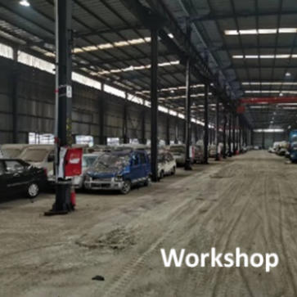 | 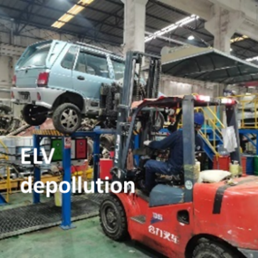 | 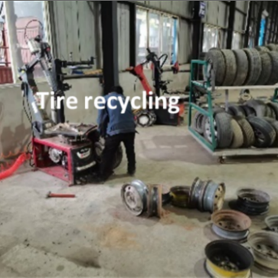
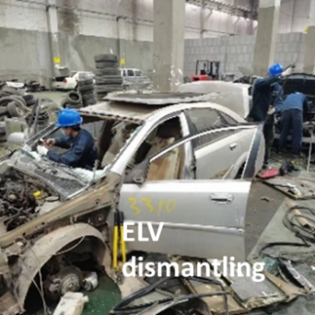 | 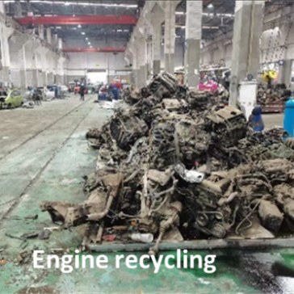 | 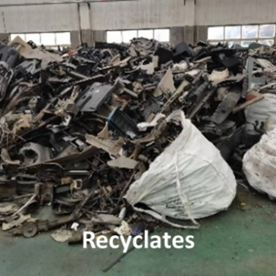
WEEE recycling enterprise
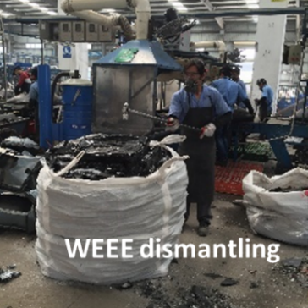 | 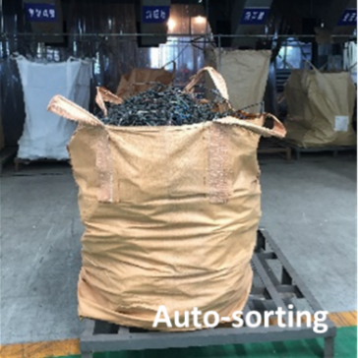 | 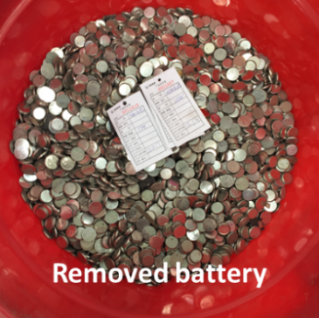
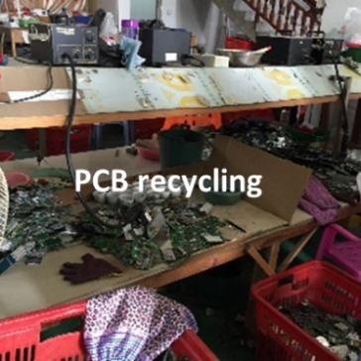 | 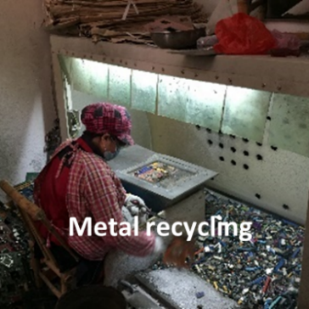 | 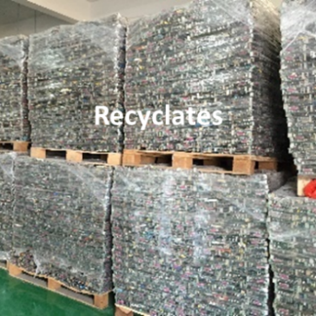
Note, PCB: printed circuit board.
The ELV recycling enterprise covers an area of 27,171 m² (about 18,000 m² workshop area), with an ICEV dismantling line and an EV dismantling line, two sets of waste oil and liquid extraction machines, two sets of refrigerant recovery machines, a set of airbag detonator, a set of general dismantling equipment, a set of power battery dismantling equipment, a set of power battery disconnection equipment, and other recycling supporting facilities. Its annual recycling capacity is about 40,000 ELVs.
The WEEE recycling enterprise mainly engages in pro-processing treatment, dismantling, smelting of rare and precious metals, scrap and other industrial solid waste utilization, and industrialization application research. It is designed to process 20,000 t of waste Printed circuit boards annually, with an annual output of about 4,000 t of anode copper and 700 t of sodium bromide. The plant covers an area of 21,700 m², with a total construction area of 8,200 m², including four workshops and a comprehensive office building.
Through these surveys, we collected first-hand information and data on recycling objects, technical, and economic situations of Chinese ELV and WEEE recyclers, which is used to analyze the economic recyclability (Supplementary Tables 9 and 10) and technical recovery efficiency, especially for the dismantling ratio (Supplementary Table 11). In addition, managers of the two recyclers also provided consulting assistance to setting urban mining scenarios (i.e., LS and HS), details can be found in Supplementary Text 4.

Text 4. Scenario setting for urban mining
Recycling is a chain of activities. The volume, quality, and value of the metals produced by recycling are determined by the combined stages in that chain. With each stage dependent on its success on the preceding ones, the final result is profoundly affected by the weakest link in the chain²³.
In practice, a major limitation of metal recycling lies in the need for metal production to pay for itself. For many rare and valuable metals, the demand and supply volume of various minor elements generally is too small to justify a dedicated recycling plant for such metals in EoL products. So far, for example, iron, aluminum, copper, tin, titanium, and chromium still represent the largest volumes for metal recycling. The organization of the industry tends to create inertia due to high capital investment, long plant life, etc., encouraging the continuation of single-carrier metal operations. Without enough incentives or new economic patterns, this situation is unlikely to change by itself.
In this study, we set two urban mining scenarios, i.e., LS and HS, to cover the ranges of results caused by different economic and technical recycling intensities, as shown in the below chart.
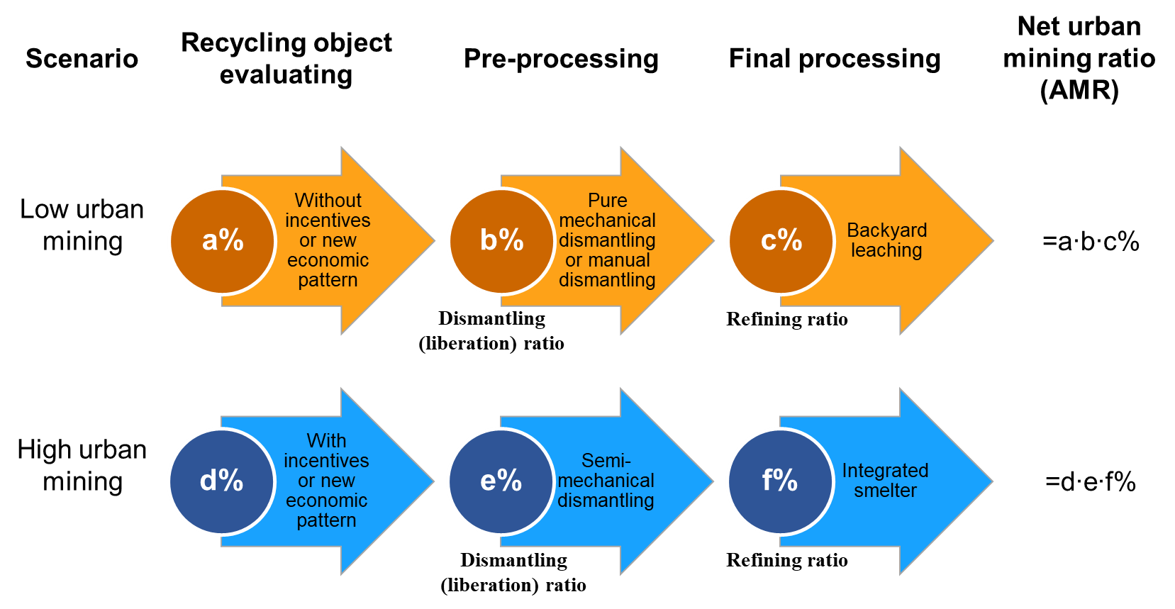
Chart. Scenario setting for LS and HS
The economic viability of recycling is a critical factor in the amount of recycling taking place. Its success is mainly determined by: 1) the supply and demand of metals and their resulting monetary value, including the metal scrap price; 2) the technologies and processes used, including economies of scale; 3) the political support on the economy, affecting designing and operating a metal recycling chain²³.
Pre-processing methods affect the outcome. Purely mechanical dismantling is appropriate for recycling base metals shared main proportions by weight, but it leads to some major losses of precious metals and so on in dust and ferrous fractions. For rare and precious metals, recycling efficiency improves with detailed manual dismantling, but it is limited by efficiency, which is challenging to be used in a large-scale practice. Therefore, a semi-mechanical and multiple-metals treatment becomes the desired option from an economical and eco-efficiency perspective. The refining ratio of metals from recycled sources can vary hugely with the sophistication of the metallurgical processes applied but becomes optimal when using integrated best-available-technique systems.

Table 8. Unit prices of metals
Metal | Note | Average (original unit) | Average (USD/t)
Fe | Iron and steel, producer price index for steel mill products | 1.90E+02 | 1.90E+02
Al | Ingot, average U.S. market (spot), cents per pound | 9.64E+01 | 2.12E+03
Cu | Grade A, annual average, cents per pound | 2.68E+02 | 5.90E+03
Cr | Chromium metal (gross weight), average annual value of imports | 9.85E+03 | 9.85E+03
Zn | Average, cents per pound | 1.15E+02 | 2.54E+03
Sn | Average, cents per pound | 8.51E+02 | 1.88E+04
Mn | Metallurgical-grade ore containing 44% manganese | 5.56E+00 | 5.56E+00
Mg | Annual average | 2.31E+03 | 2.31E+03
Sb | Metal, average, dollars per pound | 3.82E+00 | 8.42E+03
Bi | Average, dollars per pound | 4.00E+00 | 8.81E+03
W | Tungsten trioxide, concentrate, average U.S. spot market | 2.52E+02 | 2.52E+02
Nb | Ferroniobium, unit value, dollars per kilogram | 2.18E+01 | 2.18E+04
V | Vanadium pentoxide, average, dollars per pound | 9.26E+00 | 2.04E+04
Mo | Average value, dollars per kilogram | 2.12E+01 | 2.12E+04
Ga | High-purity, refined, dollars per kilogram | 5.63E+02 | 5.63E+05
Ge | Germanium metal, annual average, dollars per kilogram | 1.19E+03 | 1.19E+06
Ta | Tantalite, Ta2O5 content, dollars per kilogram | 1.84E+02 | 1.84E+05
Ti | Rutile, bulk, minimum 95% TiO2 | 9.66E+02 | 9.66E+02
Be | Annual average unit value, beryllium-copper master alloy | 5.96E+02 | 5.96E+05
Tl | Metal, dollars per kilogram | 7.73E+03 | 7.73E+06
In | Annual average, dollars per kilogram | 2.18E+02 | 2.18E+05
Ni | Annual average | 1.22E+04 | 1.22E+04
Li | Annual average, battery-grade lithium carbonate | 1.23E+04 | 2.63E+04
Co | Average, dollars per pound | 1.97E+01 | 4.35E+04
Pb | Average, cents per pound | 9.28E+01 | 2.05E+03
Ag | Bullion, average, dollars per troy ounce | 1.74E+01 | 6.15E+05
Au | Dollars per troy ounce | 1.39E+03 | 4.90E+07
Pd | Dollars per troy ounce | 1.23E+03 | 4.35E+07
Pt | Dollars per troy ounce | 9.08E+02 | 3.20E+07
Rh | Dollars per troy ounce | 3.43E+03 | 1.21E+08
La | 99.9% min, free on board (FOB) China | 5.40E+03 | 5.40E+03
Ce | 99% min, FOB China | 5.50E+03 | 5.50E+03
Pr | 99.5% min, FOB China | 1.06E+05 | 1.06E+05
Nd | 99% min, FOB China | 6.50E+04 | 6.50E+04
Sm | 99.5% min, FOB China | 1.40E+04 | 1.40E+04
Eu | 99.5% min, FOB China | 2.95E+05 | 2.95E+05
Gd | - | - | -
Tb | 99.9% min, FOB China | 7.80E+05 | 7.80E+05
Dy | 99.5% min, FOB China | 3.85E+05 | 3.85E+05
Er | - | - | -
Sc | 99.99% min, ex-works China | 3.34E+06 | 3.34E+06
Y | 99.9% min, ex-works China | 3.34E+04 | 3.34E+04
Note, -: none or no data. Sources include the Shanghai Metals Market, London Metal Exchange, European free market, and reports of USGS^{2, 24}.

Table 9. Estimated current absolute economic value (price) of target metals in products
Note, -: none or no data. 1−5 are engine/frame/rest, catalytic converter, electronic controller, Pb-acid battery, motor of ICEV; 6−10 are engine/frame/rest, catalytic converter, electronic controller, NiMH battery, motor of HEV; 11−14 are engine/frame/rest, catalytic converter, electronic controller, Li-ion battery, motor of HEV; 15−24 are CRT TV, LCD TV, printer, copier, laptop, CRT desktop, LCD desktop, VP, FM, MP; 25−32 are AC refrigerator, WM, DW, EWH, GWH, RH, microwave, respectively.

Table 10. Estimated current relative economic proportion (a metal/all materials) of target metals in products
Note, -: none or no data. 1−5 are engine/frame/rest, catalytic converter, electronic controller, Pb-acid battery, motor of ICEV; 6−10 are engine/frame/rest, catalytic converter, electronic controller, NiMH battery, motor of HEV; 11−14 are engine/frame/rest, catalytic converter, electronic controller, Li-ion battery, motor of HEV; 15−24 are CRT TV, LCD TV, printer, copier, laptop, CRT desktop, LCD desktop, VP, FM, MP; 25−32 are AC refrigerator, WM, DW, EWH, GWH, RH, microwave, respectively

Table 11. Estimated current economic recyclability of target metals in products in China under LS
Metal | ICEV |  |  |  |  | HEV |  |  |  |  | BEV |  |  |  | Electronic device |  |  |  |  |  |  |  |  |  | Electric home applicant
Metal | 1 | 2 | 3 | 4 | 5 | 6 | 7 | 8 | 9 | 10 | 11 | 12 | 13 | 14 | 15 | 16 | 17 | 18 | 19 | 20 | 21 | 22 | 23 | 24 | 25 | 26 | 27 | 28 | 29 | 30 | 31 | 32
Fe | √ |  |  |  | √ | √ |  |  |  |  | √ |  |  |  |  | √ |  |  |  | √ |  | √ | √ |  | √ | √ | √ | √ | √ | √ | √ | √
Al | √ |  |  | √ |  | √ |  |  |  |  | √ |  | √ |  |  | √ | √ | √ |  | √ |  | √ | √ |  | √ |  | √ | √ | √ | √ | √ | √
Cu | √ |  |  | √ | √ | √ |  | √ |  | √ | √ | √ | √ | √ | √ | √ |  | √ | √ | √ | √ | √ | √ |  | √ | √ | √ | √ | √ | √ | √ | √
Cr | √ |  |  |  |  | √ |  |  |  |  | √
Zn |  |  |  |  |  |  |  |  |  |  | √
Sn |  |  | √ |  |  |  |  | √ |  |  |  | √ |  |  |  | √
Mn
Mg
Sb
Bi
W
Nb
V
Mo
Ga
Ge
Ta
Ti
Be
Tl
In
Ni |  |  |  |  |  |  |  |  | √ |  |  |  | √
Li |  |  |  |  |  |  |  |  |  |  |  |  | √ |  |  |  |  |  | √ |  |  |  |  | √
Co |  |  |  |  |  |  |  |  | √ |  |  |  | √
Pb |  |  |  | √
Ag
Au | √ |  | √ |  |  | √ |  | √ |  |  | √ | √ |  |  | √ | √ | √ | √ | √ | √ | √ |  |  | √
Pd | √ | √ | √ |  |  |  | √ | √ |  |  | √ | √ |  |  |  | √ |  |  | √ | √ | √ |  |  | √
Pt |  | √ |  |  |  |  | √
Rh |  | √ |  |  |  |  | √
La
Ce
Pr
Nd |  |  |  |  |  |  |  |  | √ | √ |  |  |  | √
Sm
Eu
Gd
Tb
Dy |  |  |  |  |  |  |  |  |  | √ |  |  |  | √
Er
Sc
Y
Threshold of absolute economic value, 0.05 US$, and relative economic proportion, 5% of the total value; detailed value of each value can be found in Supplementary Tables 9 and 10. Note, √: economic recyclable; green: value higher than both absolute economic threshold and relative economic threshold; purple: value only higher than absolute economic threshold; orange: only higher than relative economic threshold. 1−5 are engine/frame/rest, catalytic converter, electronic controller, Pb-acid battery, motor of ICEV; 6−10 are engine/frame/rest, catalytic converter, electronic controller, NiMH battery, motor of HEV; 11−14 are engine/frame/rest, catalytic converter, electronic controller, Li-ion battery, motor of HEV; 15−24 are CRT TV, LCD TV, printer, copier, laptop, CRT desktop, LCD desktop, VP, FM, MP; 25−32 are AC refrigerator, WM, DW, EWH, GWH, RH, microwave, respectively.

Table 12. Estimated current economic recyclability of target metals in products in China under HS
Metal | ICEV |  |  |  |  | HEV |  |  |  |  | BEV |  |  |  | Electronic device |  |  |  |  |  |  |  |  |  | Electric home applicant
Metal | 1 | 2 | 3 | 4 | 5 | 6 | 7 | 8 | 9 | 10 | 11 | 12 | 13 | 14 | 15 | 16 | 17 | 18 | 19 | 20 | 21 | 22 | 23 | 24 | 25 | 26 | 27 | 28 | 29 | 30 | 31 | 32
Fe | √ |  |  | √ | √ | √ |  |  |  | √ | √ |  |  | √ | √ | √ | √ | √ | √ | √ | √ | √ | √ |  | √ | √ | √ | √ | √ | √ | √ | √
Al | √ | √ | √ | √ |  | √ |  | √ |  |  | √ | √ | √ |  | √ | √ | √ | √ |  | √ | √ | √ | √ |  | √ | √ | √ | √ | √ | √ | √ | √
Cu | √ |  | √ | √ | √ | √ |  | √ |  | √ | √ | √ | √ | √ | √ | √ | √ | √ | √ | √ | √ | √ | √ | √ | √ | √ | √ | √ | √ | √ | √ | √
Cr | √ |  |  |  |  | √ |  |  |  |  | √
Zn | √ |  |  |  |  | √ |  |  |  |  | √
Sn |  |  |  |  |  |  |  | √ |  |  |  | √ |  |  | √ | √ | √ |  | √ |  |  |  | √ | √
Mn
Mg | √ |  |  |  |  |  |  |  |  |  | √
Sb
Bi
W
Nb
V
Mo
Ga |  |  |  |  |  |  |  |  | √
Ge |  |  | √ |  |  |  |  | √ |  |  |  | √
Ta
Ti
Be |  |  |  |  |  | √ |  |  |  |  | √
Tl
In |  |  |  |  |  |  |  |  |  |  |  |  |  |  |  | √ |  |  | √ |  | √ |  |  | √
Ni | √ |  |  |  |  |  |  |  | √ |  |  |  | √
Li |  |  |  |  |  |  |  |  |  |  |  |  | √ |  |  |  |  |  | √ |  |  |  |  | √
Co |  |  |  |  | √ |  |  |  | √ | √ |  |  | √ | √
Pb |  |  |  | √ |  | √ |  |  |  |  | √
Ag | √ |  | √ |  |  | √ |  | √ |  |  | √ | √ |  |  |  | √ | √ | √ | √ |  |  |  |  | √
Au | √ |  | √ |  |  | √ |  | √ |  |  | √ | √ |  |  | √ | √ | √ | √ | √ | √ | √ |  |  | √
Pd | √ | √ | √ |  |  |  | √ | √ |  |  | √ | √ |  |  | √ | √ | √ | √ | √ | √ | √ |  | √ | √ |  |  | √
Pt |  | √ | √ |  |  |  | √ | √ |  |  |  | √
Rh |  | √ |  |  |  |  | √ |  |  |  | √ |  |  |  |  | √ |  |  | √ | √ | √ |  |  | √
La |  |  |  |  |  |  |  |  | √
Ce |  |  |  |  |  |  |  |  | √
Pr |  |  |  |  |  |  |  |  | √ |  |  |  |  | √
Nd |  |  |  |  |  |  |  |  | √ | √ |  |  |  | √
Sm
Eu
Gd
Tb
Dy |  |  |  |  |  |  |  |  |  | √ |  |  |  | √
Er
Sc
Y
Threshold of absolute economic value, 0.01 US$, and relative economic proportion, 1% of the total value; detailed value of each value can be found in Supplementary Tables 9 and 10. Note, √: economic recyclable; green: value higher than both absolute economic threshold and relative economic threshold; purple: value only higher than absolute economic threshold; orange: only higher than relative economic threshold. 1−5 are engine/frame/rest, catalytic converter, electronic controller, Pb-acid battery, motor of ICEV; 6−10 are engine/frame/rest, catalytic converter, electronic controller, NiMH battery, motor of HEV; 11−14 are engine/frame/rest, catalytic converter, electronic controller, Li-ion battery, motor of HEV; 15−24 are CRT TV, LCD TV, printer, copier, laptop, CRT desktop, LCD desktop, VP, FM, MP; 25−32 are AC refrigerator, WM, DW, EWH, GWH, RH, microwave, respectively.

Table 13. Review on metal dismantling (liberation) and refining ratios
Metal | Main carrier | Separation ratio (LS−HS) | Typical technology | Recovery ratio (LS−HS)²⁵ | Overall recycling efficiency (LS−HS) | Recycled product
Fe | Iron, steel, magnet | 80−100% | BOF, EAF | 80−82%²⁶ | 64−82% | Metal
Al | aluminum, alloy | 80−100% | Remelt, refine | 82−90% | 66−90% | Metal
Cu | Wire, printed circuit board | 50−90% | Smelt, refine | 80−95%²⁷ | 40−86% | Metal
Cr | Steel | 80−100% | Refine | 30−70% | 24−70% | Metal
Zn | Alloy | 80−100% | ISP | 85−90%²⁸ | 68−90% | Metal
Sn | Steel, solder | 50−90% | Smelt, refine | 85%¹⁰ | 43−77% | Metal
Mn | Steel, battery | 80−100% | Refine | 80−90%²⁹ | 64−90% | Metal
Mg | Alloy | 80−100% | Hydro-metallurgy | 80% | 64−80% | Metal
Sb | Alloy, battery, solder | 80−100% | - | 92−95% | 74−95% | Metal
Bi | Alloy, magnet, solder | 40−60% | - | - | - | -
W | Steel, alloy | 50−90% | - | - | - | -
Nb | Steel | 80−100% | - | - | - | -
V | Alloy, stainless steel | 80−100% | - | - | - | -
Mo | Alloy | 80−100% | - | - | - | -
Ga | Semiconductor | 40−60% | - | - | - | -
Ge | Semiconductor | 40−60% | - | - | - | -
Ta | Alloy, printed circuit board | 25−50% | - | - | - | -
Ti | Alloy | 80−100% | Pyro-metallurgy | - | - | -
Be | Semiconductor | 60−80% | - | - | - | -
Tl | Photoresistor | 60−80% | - | - | - | -
In | Displayer | 60−80% | - | 82−94% | 49−75% | Metal, oxide
Ni | Stainless steel, alloy, battery | 80−100% | Smelt, refine, acid leaching (Brunp, GEM) | 30−85%³⁰ | 24−85% | Metal
Li | Battery | 80−100% | Hydro & pyro-metallurgy | 0−97%³⁰ | 0−97% | Oxide
Co | Alloy, battery | 80−100% | Special battery recycling | 90−96%³⁰ | 72−96% | Metal
Pb | Alloy, battery | 80−100% | Smelt, refine | 95−98%³¹ | 76−98% | Metal
Ag | Wire, printed circuit board | 30−50% | Smelting and electrorefining (Umicore), leaching | 89−99%^{32, 33} | 27−50% | Metal
Au | printed circuit board | 40−60% | Smelting and electrorefining (Umicore), leaching | 99−100%^{32, 33} | 39−60% | Metal
Pd | Catalyst, capacitor | 50−90% | Closed electric furnace (Tanaka), leaching | 98−99%^{32, 33} | 49−89% | Metal
Pt | Catalyst, hard disk drives | 50−90% | Closed electric furnace (Tanaka), leaching | 95−96%^{32, 33} | 48−85% | Metal
Rh | Catalyst, headlight | 80−100% | Closed electric furnace (Tanaka), leaching | 86−92%^{32, 33} | 69−92% | Metal
La | printed circuit board, battery | 50−90% | Hydro-metallurgy, special battery recycling, special magnet recycling | 29−50% | 14−45% | Oxide
Ce | printed circuit board, catalyst | 50−90% |  | 29−50% | 14−45% | Oxide
Pr | Magnet | 20−40% |  | 31−55% | 6−22% | Oxide
Nd | Magnet | 20−40% |  | 31−55% | 6−22% | Oxide
Sm | Magnet | 20−40% |  | 31−55% | 6−22% | Oxide
Eu | CRT | 40−60% |  | 40−80% | 16−48% | Oxide
Gd | Magnet | 20−40% |  | 31−55% | 6−22% | Oxide
Tb | Kinescope | 40−60% |  | 40−80% | 16−48% | Oxide
Dy | Magnet | 20−40% |  | 31−55% | 6−22% | Oxide
Er | Fiber optic | 40−60% |  | 40−80% | 16−48% | Oxide
Sc | Alloy, lamp | 80−100% |  | - | - | -
Y | Alloy | 80−100% |  | - | - | -
Note, -: none or no data. Separation ratios were presumed based on the on-site survey (Supplementary Text 3). Overall recycling efficiencies of Pd, Ni, Co, Li, Ag, Au, Pd, Pt, Rh were calculated from collection and recovery ratios. Brunp and GEM are Chinese recyclers, Umicore and Tanaka are based in Belgium and Japan. Metal phase includes solid and liquid metals. In the table, BOF, EAF, and ISP signify electric arc furnace, basic oxygen furnace, and imperial smelting process, respectively.

Table 14. Review of DGMR (amount and distribution) in China in 2021
Metal | Amount³⁴
Metal | Unit: t (in metal content)
PGM | 4.00E+02
Ni | 4.00E+06
Cu | 2.70E+07
Li | 1.50E+06
In | 1.30E+04
Co | 1.37E+05
Au | 1.93E+03
Al | 2.50E+08
Ag | 5.06E+04
Pb | 1.23E+07
Mg | *
Zn | 3.09E+07
Sn | 7.23E+05
Fe | 6.90E+09
Cr | 2.86 E+08
REE | 2.31E+07
Distribution³⁵
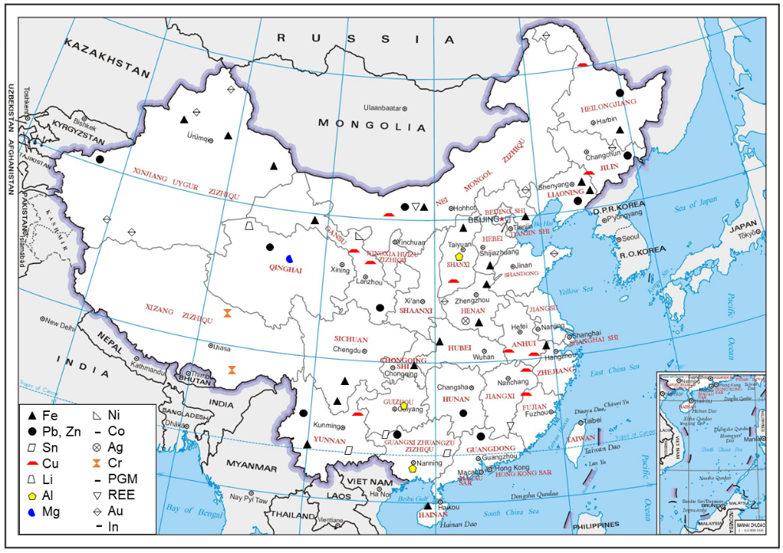
Note, *: Mg metal can be derived from seawater, natural brines, dolomite, serpentine, and other minerals. The reserves for this metal are sufficient to supply current and future requirements². Ni, Cu, Li, Co, Au, Al, Sn, Fe, Cr, and REE are listed as strategic metals in the China (2016) National Mineral Resources Planning (2016-2020).

Additional information for mineral distribution in China
So far, 59 types of metal mineral resources have been discovered in China³⁶. The basic characteristics of China's metal mineral resources are: 1) The total amount of resources is relatively large, and the minerals are relatively complete. China has a relatively wide variety of proven mineral resources, and the total amount of resources are relatively abundant. Pillar minerals such as iron, copper, aluminum, lead, and zinc have more proven resource reserves. Mineral resources such as rare earth, tungsten, tin, molybdenum, antimony, titanium, and magnesite have apparent advantages in the world; 2) The per capita resources are small, and the supply and demand of some resources are out of balance. There is a big gap between the supply and demand of mineral resources such as PGM and chromite; 3) Good and bad minerals coexist. There are both high-quality ores and low-grade ores with complex components. Mineral resources such as tungsten, tin, rare earth, molybdenum, antimony, and magnesite are relatively high quality, while iron, manganese, aluminum, copper, and other mineral resources have many poor ores, many symbiotic and associated ores, and many refractory ores.

Supplementary Results

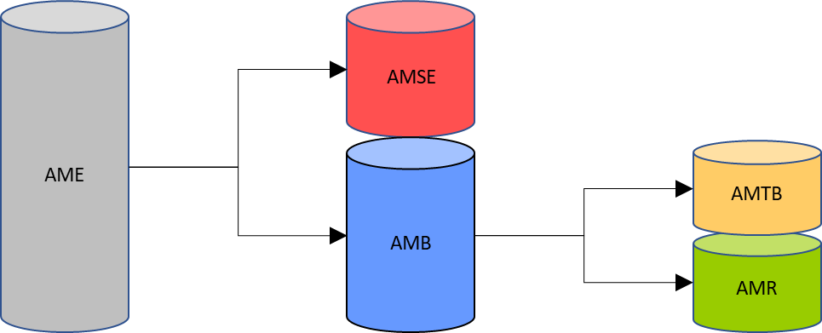

Fig. 2. Inclusion relation between AM categories
Their inclusion relation (three layers) was set as that AME includes AMSE and AMB, and AMB includes AMTB and AMR.

Text 5. Comparison of related methodologies
Also relying on the McKelvey diagram, Habib³⁷ presented a qualitative study on AM assessment focusing on Nd in related products and provided a three-category classification framework; Maung et al.³⁸⁻⁴⁰ conducted a series of quantitative studies on AM assessment concerning Cu, Al, and Zn in related products and applied a top-down approach based on approximate discard ratios. In comparison, in this study, we recreated more detailed AM categories, covering unextractable AMs, and quantified AM categories through a bottom-up approach. That is, the approach uses population balance modeling in the anthropogenic metabolism analysis, based on registered new-sale data that are generally considered to be richer statistical sources. In addition, population balance modeling offers another advantage in that it allows forecasts of future trends based on government developmental targets and product lifespans⁴¹.

Table 15. Iron characteristics, applications, and recycling
Characteristic | Iron (Fe) is a lustrous, ductile, malleable, and silver-gray metal. It rusts in damp air but not in dry air. Iron dissolves readily in dilute acids. It is chemically active and forms two major chemical compounds: ferrous and ferric compounds⁴².  Atomic number: 26; relative atomic mass: 55.845; density: 7.874 g/cm³; melting point: 1,538 °C (1,811 K)⁴³
General application⁴⁴ | Most iron is used to manufacture carbon steel in civil engineering (e.g., reinforced concrete, girders) and manufacturing. Alloy steels are carbon steel with other additives such as nickel, chromium, vanadium, tungsten, and manganese. They are stronger and tougher than carbon steel and have various applications, including bridges, electricity pylons, bicycle chains, and automobile engines⁴⁵. Stainless steel is very resistant to corrosion. It is used in architecture, bearings, cutlery, surgical instruments, and jewelry. Iron and its alloys and compounds can make magnets⁴⁶.
Use in automobiles and EEE | 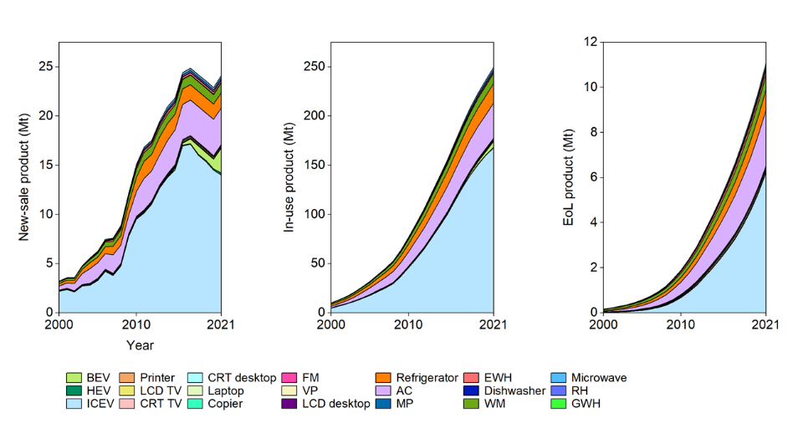  Iron in the new-sale products increased from 3.2 Mt to 24 Mt in 2000−2021 (with a pick, 2.5 Mt, in 2017). In this period, iron in in-use products increased 25 times to 250 Mt in 2021, and it in EoL products increased 66 times to 11 Mt. The most essential carriers include ICEV, AC, refrigerator, WM, and recent BEV.
Recycling⁴⁷ | Metal cuttings or imperfect products (“new scrap”) are recycled by remelting, recasting, and redrawing entirely within the steel mill. On the other hand, “old scrap” steel makes up a significant percentage of the feed to electric arc and basic oxygen furnaces. The scrap comes from various manufacturing operations using steel as a basic material and discarded or obsolete goods made from iron and steel. One of the largest sources of scrap steel is the reprocessing of old automobile bodies.  Overall EoL recycling ratio (from all applications): 52%, 67%, 78%, 90%²⁵
Occurrence in nature | Iron is the cheapest and one of the most abundant metals, comprising nearly 5.6% of the earth's crust and almost all of the earth's core. Iron is primarily obtained from the minerals: hematite and magnetite. The minerals: taconite, limonite, and siderite are other important sources⁴³. The global largest reserves holders are Australia, Brazil, and Russia⁴⁸; the global top pig iron producer in 2020 was China (70% of the world)².

Table 16. Aluminum characteristics, applications, and recycling
Characteristic | Aluminum (Al) is a soft and lightweight metal. It has a dull silvery appearance because of a thin layer of oxidation that forms quickly when exposed to air. Aluminum is nontoxic, nonmagnetic, and non-sparking⁴².  Atomic number: 13; relative atomic mass: 26.982; density: 2.70 g/cm³ (considered as a light material as about one-third of iron); melting point: 660 °C (933 K)⁴³
General application⁴⁴ | Aluminum is used in various products, including cans, foils, kitchen utensils, window frames, and beer kegs. Aluminum is often used as an alloy, and its alloys with copper, manganese, magnesium, and silicon are lightweight but strong. They are essential in the construction of airplanes and other forms of transport⁴⁹. Aluminum is a good electrical conductor and is often used in electrical transmission lines⁵⁰. Aluminum coatings have many uses, including telescope mirrors, decorative paper, and toys.
Use in automobiles and EEE | 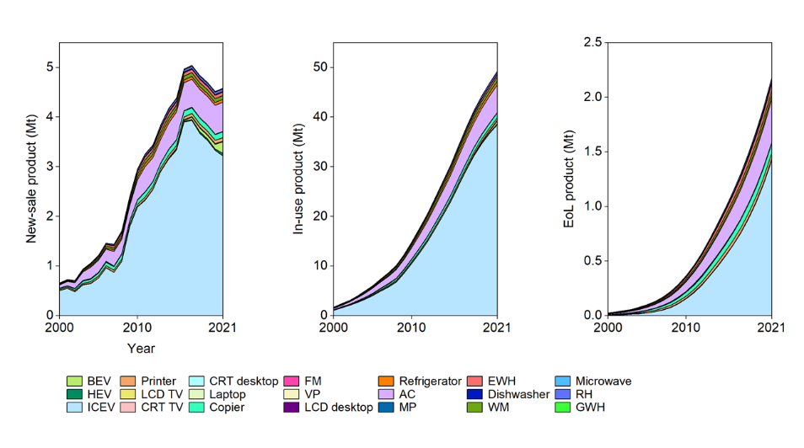  Aluminum in the new-sale products increased from 0.7 Mt to 4.6 Mt in 2000−2021 (with a pick, 5.0 Mt, in 2017). In this period, aluminum in in-use products increased 29 times to 49 Mt in 2021, and it in EoL products increased 90 times to 2.2 Mt. The most essential carriers include ICEV, AC, copier, and recent BEV.
Recycling⁴⁷ | Secondary aluminum reprocessing is a large industry involving recycling machine turnings, rejected castings, siding, and even aluminum covered with decorative plastic. The items are thrown into a reverberatory furnace (in which heat is radiated from the roof into the material treated) and melted while the impurities are burned off. The resulting material is cast into ingots and resold for drawing or forming operations. Aluminum recycling is far less costly and energy-intensive (as many as 95% reduction⁵¹) than producing new aluminum by electrolysis of alumina⁵².  Overall EoL recycling ratio (from all applications): 42%, 60%, 70%²⁵
Occurrence in nature | Although aluminum is the most abundant metal in the earth's crust (8.2%), all of the earth's aluminum has combined with other elements to form compounds. Two of the most common compounds are alum, such as potassium aluminum sulfate and aluminum oxide⁴³. The global largest reserves holders are Guinea and Australia⁴⁸; the global largest producers in 2020 were China (37 Mt), Russia (3.6 Mt), and India (3.6 Mt)².

Table 17. Copper characteristics, applications, and recycling
Characteristic | Copper (Cu) is a reddish metal with a face-centered cubic crystalline structure. It is malleable, ductile, and an excellent conductor of heat and electricity⁴². Copper has low chemical reactivity. In moist air, it slowly forms a greenish surface film called patina; this coating protects the metal from further attack⁵³.  Atomic number: 29; relative atomic mass: 63.546; density: 8.933 g/cm³; melting point: 1,085 °C (1,358 K)⁴³
General application⁴⁴ | Traditionally it has been one of the metals used to make coins, along with silver and gold. Nowadays, most copper is used in EEE such as wiring and motors⁵⁴. This is because it conducts heat and electricity very well and can be drawn into wires⁵⁵. It also has uses in construction (e.g., roofing and plumbing) and industrial machinery (e.g., heat exchangers).
Use in automobiles and EEE | 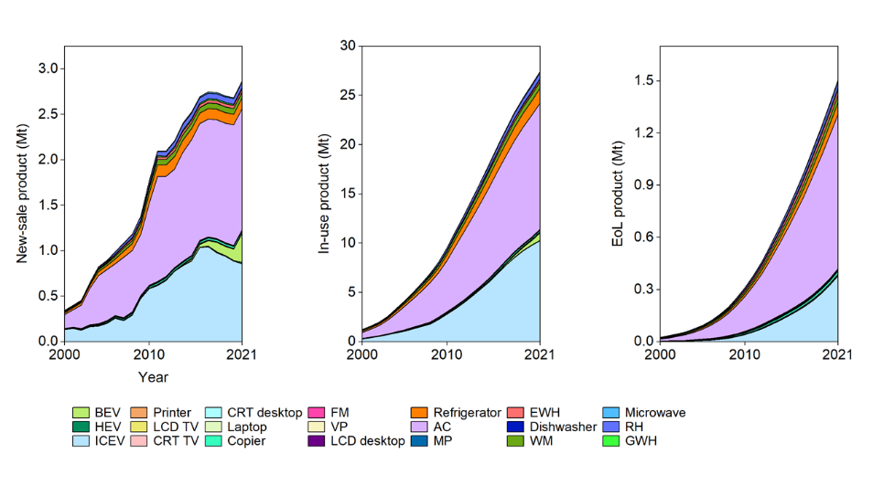  Copper in the new-sale products increased from 342 kt to 2.9 Mt in 2000−2021. In this period, copper in in-use products increased 22 times to 27 Mt in 2021, and it in EoL products increased 60 times to 1.5 Mt. The most essential carriers include ICEV, AC, refrigerator, and recent BEV.
Recycling | Copper is one of the few materials that can be recycled repeatedly without any performance loss. There is also no difference in the quality of recycled copper (secondary production) and mined copper (primary production)⁵⁶. Scrap from the forming or shaping of copper and its alloys is generally reprocessed on the spot, either by remelting and adjusting to grade or by using it as a starting material for less demanding applications. Scrap is also recovered from many obsolete appliances: wire, cables, WEEE, fractions from shredding ELVs and household appliances, etc⁵⁷.  Overall EoL recycling ratio (from all applications): 43%, 53%²⁵
Occurrence in nature | Copper is primarily obtained from the ores: cuprite, tenorite, malachite, chalcocite, covellite, and bornite⁴³. Copper is obtained from these ores and minerals by smelting, leaching, and electrolysis⁵⁸. The largest reserve holders are Chile (200 Mt), Peru (92 Mt), and Australia (88 Mt); the leading refinery producers in 2020 were China (9.8 Mt), Chile (2.4 Mt), and Japan (1.6 Mt)².

Table 18. Chromium characteristics, applications, and recycling
Characteristic | Chromium (Cr) is a lustrous, brittle, hard metal. Its color is silver-gray, and it can be highly polished. It does not tarnish in the air, and when heated, it forms green chromic oxide⁴². Hexavalent chromium, Cr(VI), is toxic and carcinogenic, and chromium trioxide used in industrial electroplating processes is a substance of very serious concern⁵⁹.  Atomic number: 24; relative atomic mass: 51.996; density: 7.15 g/cm³; melting point: 1,907 °C (2,180 K)⁴³
General application⁴⁴ | Chromium is used to harden steel, manufacture stainless steel, and produce several alloys. Chromium plating can be used to give a polished mirror finish to steel. Chromium-plated automobile parts, such as bumpers. It is also possible to use chromium plate plastics, often used in bathroom fittings⁶⁰. About 90% of all leather is tanned using chrome. However, the waste effluent is toxic⁶¹.
Use in automobiles and EEE | 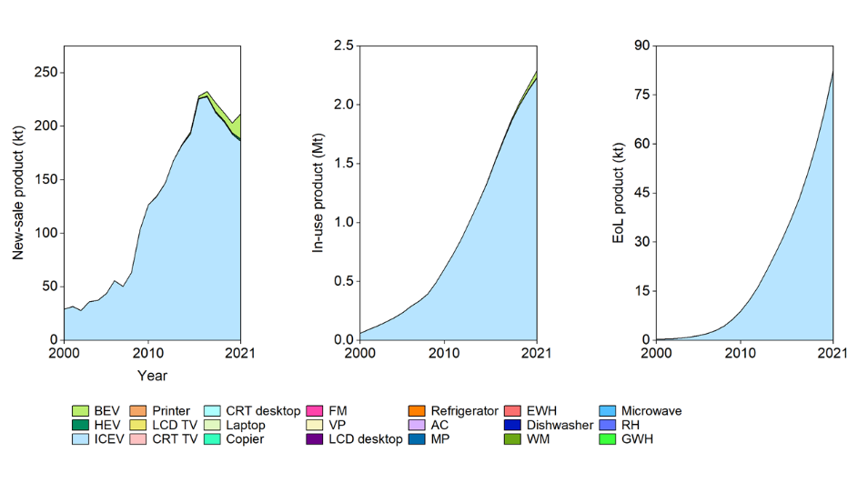  Chromium in the new-sale products increased from 29 kt to 212 Mt in 2000−2021 (with a pick, 233 kt, in 2017). In this period, chromium in in-use products increased 38 times to 2.3 Mt in 2021, and it in EoL products soared to 83 kt. The most essential carriers are ICEV and BEV.
Recycling | Stainless and heat-resistant steel are recycled with their nickel and chromium contents. Most other chromium-containing steels and alloys can be recycled, but not specifically for their chromium content⁶². Chromium chemicals are typically used for dissipative end uses and are, therefore, not recycled⁶³.  Overall EoL recycling ratio (from all applications): 87%, 93%²⁵
Occurrence in nature | Chromium is primarily obtained by heating the mineral chromite in the presence of aluminum or silicon⁴³. Its metal is usually produced by reducing chromite with carbon in an electric-arc furnace or reducing chromium(III) oxide with aluminum or silicon⁶⁴. In 2020, the largest reserve holders are Kazakhstan (230 Mt), South Africa (200 Mt), and India (100 Mt); the leading mine producers in 2020 were South Africa (16 Mt), Kazakhstan (6.7 Mt), and Turkey (6.3 Mt)². In comparison, China lacks chromium ore resources.

Table 19. Zinc characteristics, applications, and recycling
Characteristic | Zinc (Zn) is a lustrous bluish-white metal. It is brittle and crystalline at ordinary temperatures but becomes ductile and malleable when heated between 110°C and 150°C. It is a fairly reactive metal that will combine with oxygen and other non-metals and will react with dilute acids to release hydrogen⁴².  Atomic number: 30; relative atomic mass: 65.38; density: 7.134 g/cm³; melting point: 420 °C (693 K)⁴³
General application⁴⁴ | Most zinc is used to galvanize other metals, such as iron, to prevent rusting. Galvanized steel is used for car bodies, street lamp posts, safety barriers, and suspension bridges. Large quantities of zinc are used to produce die-castings, which are important in the automobile, electrical, and hardware industries⁶⁵. Zinc is also used in alloys and as solder. Zinc oxide is widely used in the manufacture of very many products such as paints, rubber, plastics, inks, batteries, textiles, and EEE⁶⁶.
Use in automobiles and EEE | 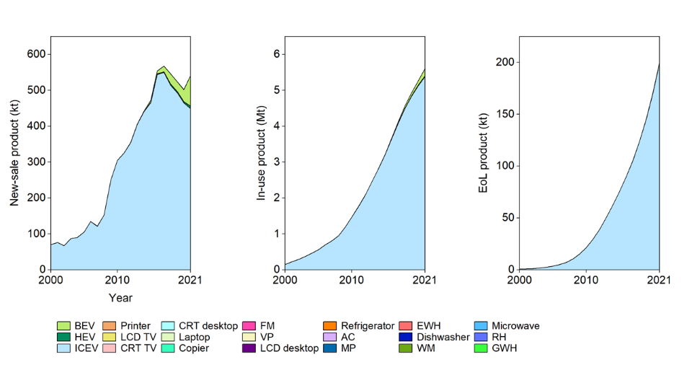  Zinc in the new-sale products increased from 70 kt to 542 kt in 2000−2021 (with a pick, 568 kt, in 2017). In this period, zinc in in-use products increased 38 times to 5.6 Mt in 2021, and it in EoL products soared to 200 kt. The most essential carriers are ICEV and BEV.
Recycling | Nowadays, about 34% comes directly from recovered zinc, and the secondary materials included galvanizing residues and crude zinc oxide recovered from electric arc furnace dust⁶⁷.  Overall EoL recycling ratio (from all applications): 19%, 34%, 35−60%, 52%²⁵
Occurrence in nature | Most zinc is produced through the electrolysis of aqueous zinc sulfate. Commercially, zinc is obtained from its ores by concentrating and roasting the ore, then reducing it to zinc by heating it with carbon or electrolysis⁴³. The top three reserve holders are Australia (68 Mt), China (44 Mt), and Mexico and Russia (both have 22 Mt); the leading mine producers in 2020 were China (4.2 Mt), Australia (1.4 Mt), and Peru (1.2 Mt)².

Table 20. Tin characteristics, applications, and recycling
Characteristic | Tin (Sn) is a soft, pliable, silvery-white metal. Tin is not easily oxidized and resists corrosion because an oxide film protects it. Tin resists corrosion from distilled sea and soft tap water⁴².  Atomic number: 50; relative atomic mass: 118.710; density: 7.287 g/cm³; melting point: 232 °C (505 K)⁴³
General application⁶⁸ | Tin takes a high polish and coats other metals to prevent corrosion, such as in tin cans, which are made of tin-coated steel. Alloys of tin are important for soft solder⁶⁹. A niobium-tin alloy is used for superconducting magnets⁷⁰. Tin(IV) oxide is used for ceramics and gas sensors. Zinc stannate is a fire-retardant used in plastics. Some tin compounds have been used as anti-fouling paint for ships and boats to prevent barnacles.
Use in automobiles and EEE | 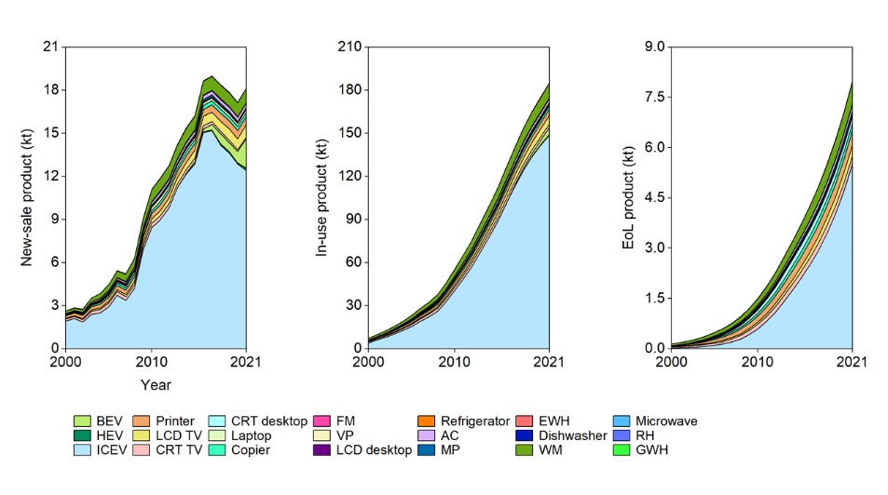  Tin in the new-sale products increased from 2.6 kt to 18 kt in 2000−2021 (with a pick, 19 kt, in 2017). In this period, tin in in-use products increased 25 times to 185 kt in 2021, and it in EoL products increased 57 times to 8.0 kt. The most essential carriers include ICEV, HEV, TV, refrigerator, and recent BEV.
Recycling⁷¹ | In 2020 the recycling input rate of tin was 33%. Recycled tin contributed 17% of total tin use, while reused or reformulated alloys made up the remaining portion. The recycling input rate has varied between 30−35% over the last decade, with dips generally corresponding to periods of low tin prices.  Overall EoL recycling ratio (from all applications): 30−35%, 75%²⁵
Occurrence in nature | Tin is primarily obtained from the mineral cassiterite and is extracted by roasting cassiterite in a furnace with carbon. It makes up only about 0.001% of the earth's crust⁴³. However, tin concentrations are low even in the most tin-rich mining areas, which means that to mine 1 kg of cassiterite, as many as 7−8 t of ore must be mined⁷². The largest reserve holders are China (1.1 Mt), Indonesia (0.8 Mt), and the USA (0.4 Mt); the top three mine producers in 2020 were China (81 kt), Indonesia (66 kt), and Myanmar (33 kt)².

Table 21. Manganese characteristics, applications, and recycling
Characteristic | Manganese (Mn) is a pinkish-gray, chemically active element. It is a hard metal and is very brittle. Manganese is hard to melt, but easily oxidized⁴².  Atomic number: 25; relative atomic mass: 54.938; density: 7.3 g/cm³; melting point: 1,246 °C (1,519 K)⁴³
General application⁴⁴ | Manganese is too brittle to be of much use as a pure metal. It is mainly used in alloys, such as steel. Steel contains about 1.2% manganese, to increase the strength and also improve workability and resistance to wear⁷³. Manganese steel contains about 10−14% manganese. This is extremely strong and is used for railway tracks, safes, and rifle barrels⁷⁴.
Use in automobiles and EEE | 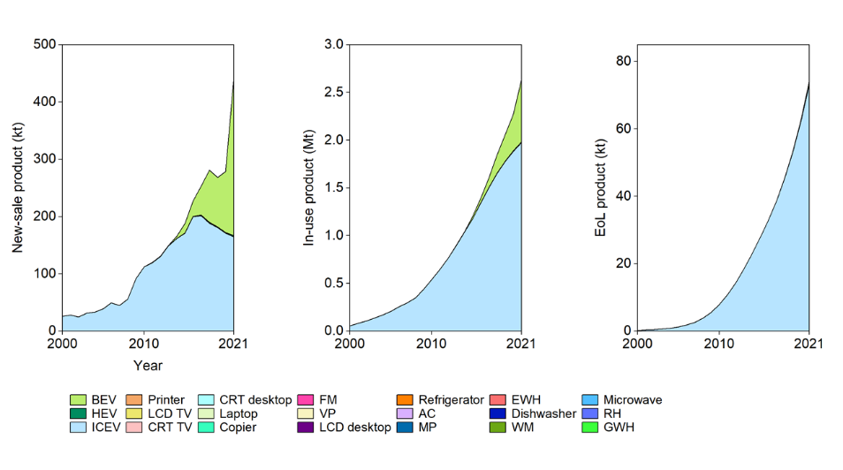  Manganese in the new-sale products increased from 26 kt to 442 kt in 2000−2021 (with a sharp increase from 2020). In this period, manganese in in-use products increased 49 times to 2.6 Mt in 2021, and it in EoL products soared to 74 kt. The most essential carriers include ICEV and recent BEV.
Recycling | Manganese is recycled into steel scrap and, to a lesser extent, into used aluminum beverage cans. The recycling rate is 37%, and efficiency is estimated at 53%⁷⁵.  Overall EoL recycling ratio (from all applications): 53%
Occurrence in nature | Most manganese is obtained from pyrolusite, although it is usually burned in a furnace with powdered aluminum or is treated with sulfuric acid to form manganese sulfate, which is then electrolyzed⁴³.  The top three reserve holders are South Africa (520 Mt), Brazil (270 Mt), and Australia (230 Mt); the top three mine producers in 2020 were South Africa (5.2 Mt), Australia (3.3 Mt), and Gabon (2.8 Mt). China’s reserve is 54 Mt and mine production in 2020 was 1.3 Mt².

Table 22. Magnesium characteristics, applications, and recycling
Characteristic | Magnesium (Mg) is silvery white and very light. Magnesium is very chemically active, it takes the place of hydrogen in boiling water, and many metals can be produced by the thermic reduction of its salts and oxidized forms with magnesium⁴².  Atomic number: 12; relative atomic mass: 24.305; density: 1.74 g/cm³ (known as a very lighter structural metal as about one-third of aluminum); melting point: 650 °C (923 K)⁴³
General application⁴⁴ | Magnesium improves aluminum's mechanical, fabrication, and welding characteristics when used as an alloying agent. These alloys are helpful in airplane and automobile construction⁷⁶. Magnesium is used in products that benefit from being lightweight, such as luggage, laptops, cameras, and power tools. Magnesium hydroxide is added to plastics to make them fire retardant⁷⁷.
Use in automobiles and EEE | 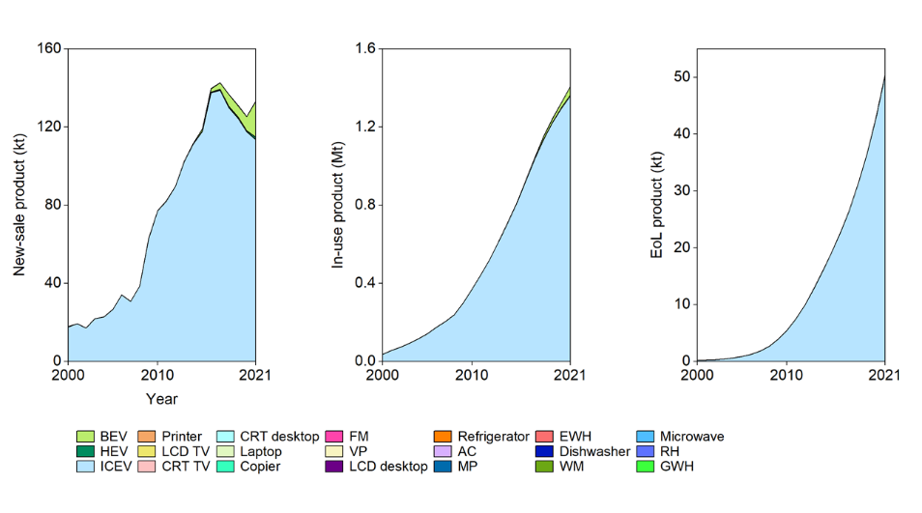  Magnesium in the new-sale products increased from 18 kt to 133 kt in 2000−2021 (with a pick, 143 kt, in 2017). In this period, magnesium in in-use products increased 38 times to 1.4 Mt in 2021, and it in EoL products soared to 51 kt. The most essential carriers are ICEV and BEV.
Recycling²⁹ | Recycling magnesium turnings and chips from machining of die castings is a common recycling process. Most recycling processes involve aqueous washing treatment combined with centrifugal force to remove machining lubricants and oils. The clean material is then pressed into briquettes which allow them to be used as a direct alloying material. "New scrap" recycling reduces the demand for primary material by up to 50%.  Overall EoL recycling ratio (from all applications): 39%²⁵
Occurrence in nature | Magnesium can be extracted from the minerals dolomite and carnallite, but is most often obtained from seawater⁴³. Seawater contains about 0.13% magnesium, mainly in the form of dissolved chloride⁷⁸. The largest reserve holders are Russia, China, and North Korea⁴⁸; the leading smelter producers in 2020 were China (900 kt), Russia (60 kt), and Brazil and Israel (both have 20 kt)².

Table 23. Antimony characteristics, applications, and recycling
Characteristic | Antimony is a semimetallic chemical element that can exist in two forms: 1) the metallic form is bright, silvery, hard, and brittle; 2) the nonmetallic form is a grey powder. Antimony is a poor conductor of heat and electricity, stable in dry air, and unaffected by diluted acids and bases. Antimony and some of its alloys expand when cooled⁴².  Atomic number: 51; relative atomic mass: 121.760; density: 6.685 g/cm³; melting point: 631 °C (904 K)⁴³
General application⁴⁴ | Antimony is used in the electronics industry to make semiconductors, such as infrared detectors and diodes. Antimony is alloyed with lead or other metals to improve their hardness and strength. A lead-antimony alloy is used in batteries. Other uses of antimony alloys include type metal (in printing presses) and cable sheathing⁷⁹. Antimony compounds make flame-retardant materials, paints, enamels, glass, and pottery⁸⁰.
Use in automobiles and EEE | 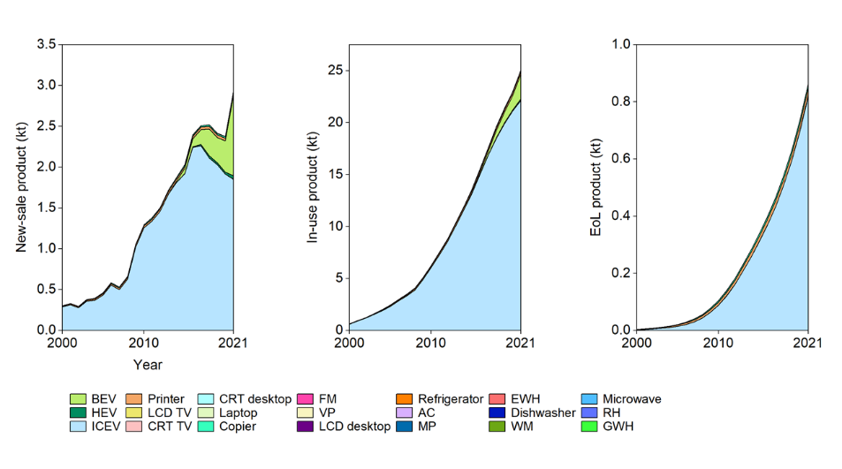  Antimony in the new-sale products increased from 0.3 kt to 2.9 kt in 2000−2021. In this period, antimony in in-use products increased 40 times to 25 kt in 2021, and it in EoL products soared to 0.9 kt. The most essential carriers include ICEV and recent BEV.
Recycling⁵⁷ | Generally, the main EoL recycling option is from spent lead-acid batteries, where antimony is directly recovered as a lead-antimony alloy. Sufficient technologies are available to make antimony recycling a success, and current recycling rates of approximately 20%⁸¹. In addition, Umicore developed a process in which antimony is recovered from complex lead-bearing concentrates and various complex residues from the lead/copper/zinc industry. The antimony is extracted during the lead refining process in sodium antimonate.  Overall EoL recycling ratio (from all applications): <5%, 20%, 89%²⁵
Occurrence in nature | Antimony makes up about 0.00002% of the Earth's crust. It is most often found as antimony sulfide. Antimony is extracted by roasting the antimony sulfide to the oxide and then reducing it with carbon. Antimony can also be found as a native metal⁴³. The largest reserve holders are China (480 kt), Russia (350 kt), and Bolivia (310 kt); the top three mine producers in 2020 were China (80 kt), Russia (30 kt), and Tajikistan (28 kt)².

Table 24. Bismuth characteristics, applications, and recycling
Characteristic | Bismuth is a white, crystalline, brittle metal with a pinkish tinge. It is the most diamagnetic of all metals, and its thermal conductivity is lower than any metal except mercury. Bismuth has a high electrical resistance. It is stable to oxygen and water⁴².  Atomic number: 83; relative atomic mass: 208.980; density: 9.807 g/cm³; melting point: 271 °C (545 K)⁴³
General application⁴⁴ | Bismuth alloys with tin or cadmium have low melting points and are used in fire detectors and extinguishers, electric fuses, and solders⁸². Some bismuth compounds are also manufactured and used as pharmaceuticals, starting materials for synthetic fibers and rubbers, and yellow pigments for cosmetics and paints. Chemical manufacturing accounts for about half of bismuth consumption, and metallurgical additives are about 30%⁸³.
Use in automobiles and EEE | 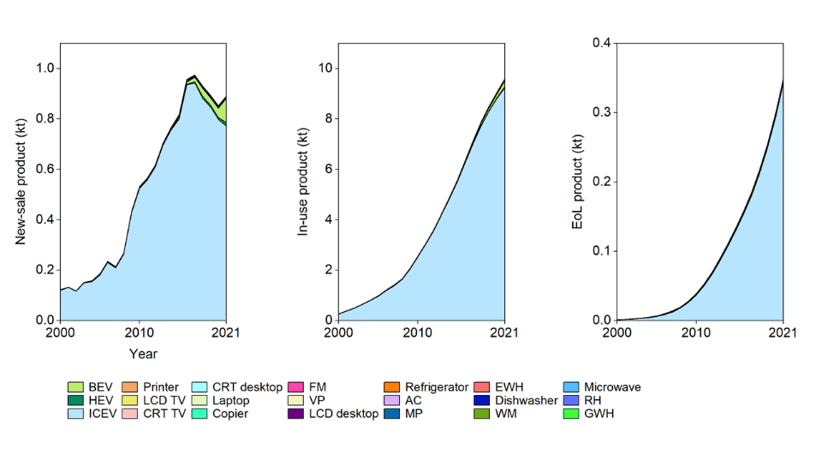  Bismuth in the new-sale products increased from 122 t to 891 t in 2000−2021 (with a pick, 975 kt, in 2017). In this period, bismuth in in-use products increased 37 times to 9.6 Mt in 2021, and it in EoL products soared to 350 t. The most essential carriers are ICEV and BEV.
Recycling⁵⁷ | Bismuth is challenging to recycle because it is used in many dissipative applications. It is obtained from the lead, copper, tin, silver, and gold refining process. For example, at Umicore's integrated smelter, bismuth is recovered from lead ingots from the lead blast furnace. Hydrometallurgical recovery of bismuth from copper smelter converter dust has been trialed as a potential secondary source of bismuth recently (up to 92% recovery efficacy)⁸⁴.  Overall EoL recycling ratio (from all applications): <1%²⁵, 92%
Occurrence in nature | Bismuth does occur freely in nature, such as bismuthinite and bismite. The major commercial bismuth source is a by-product of refining lead, copper, tin, silver, and gold ores⁴³. The largest reserve holders are China, Peru, and Mexico⁴⁸; the top three refinery producers in 2020 were China (14 kt), Laos (1,000 t), and South Korea (830 t)².

Table 25. Tungsten characteristics, applications, and recycling
Characteristic | Tungsten (W), also called wolfram, is a lustrous and silvery white metal. The bulk metal resists attack by oxygen, acids and alkalis. Tungsten has the highest melting point of any metal⁴².  Atomic number: 74; relative atomic mass: 183.84; density: 19.3 g/cm³; melting point: 3,422 °C (3,695 K, highest melting point in metals)⁴³
General application⁴⁴ | Tungsten was used extensively for the filaments of old-style incandescent light bulbs, but these have been phased out in many countries. This is because they are not very energy efficient. Tungsten carbide is tough and is very important to the metal-working, mining, and petroleum industries. Calcium and magnesium tungstate are widely used in fluorescent lighting⁸⁵.
Use in automobiles and EEE | 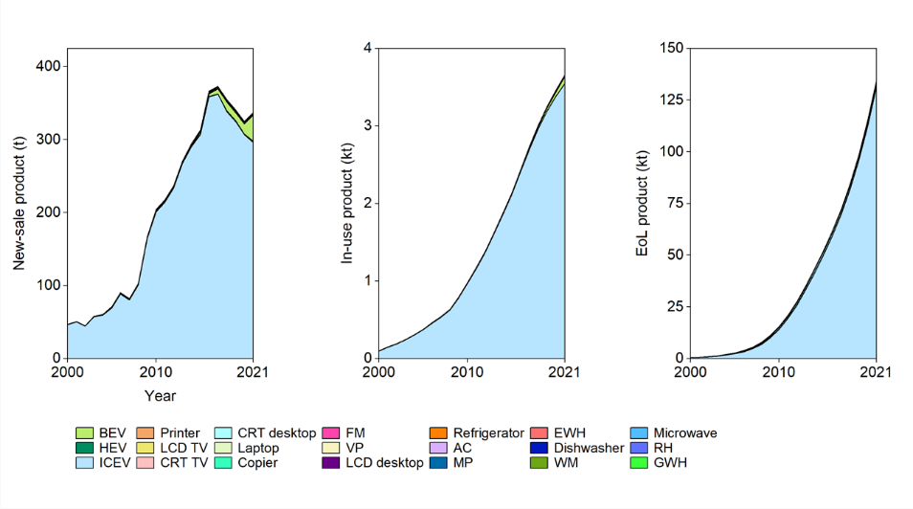  Tungsten in the new-sale products increased from 47 t to 337 t in 2000−2021 (with a pick, 373 kt, in 2017). In this period, tungsten in in-use products increased 37 times to 3.7 kt in 2021, and it in EoL products soared to 135 t. The most essential carriers are ICEV and BEV.
Recycling⁵⁷ | The tungsten processing industry can treat almost every kind of tungsten-containing scrap and waste to recover tungsten. Cemented carbide scrap, turnings, grinding, and powder scrap from the tooling industry are oxidized and chemically processed⁸⁶.  Overall EoL recycling ratio (from all applications): 10−25%, 66%²⁵
Occurrence in nature | Tungsten is primarily obtained from wolframite and scheelite. The Earth's crust, by far the most significant source of tungsten in the ecosphere, is estimated to contain 0.00013% tungsten on a mass basis⁸⁷. The metal is obtained commercially by reducing tungsten oxide with hydrogen or carbon⁴³. The largest reserve holders are China (1.9 Mt), Russia (400 kt), and Vietnam (95 kt); the leading mine producers in 2020 were China (69 kt), Vietnam (43 kt), and Russia (22 kt)².

Table 26. Niobium characteristics, applications, and recycling
Characteristic | Niobium (Nb) is a rare, soft, malleable, ductile, gray-white metal. Its physical and chemical properties resemble tantalum. Niobium metal is inert to acids, even to aqua regia at room temperatures, but is attacked by hot, concentrated acids, especially by alkalis and oxidizing agents⁴². Niobium becomes a superconductor at low temperatures⁸⁸.  Atomic number: 41; relative atomic mass: 92.906; density: 8.57 g/cm³; melting point: 2,477 °C (2,750 K)⁴³
General application⁴⁴ | Alloys containing niobium are used in jet engines and rockets, beams and girders for buildings and oil rigs, and oil and gas pipelines. Niobium is used in superconducting magnets for particle accelerators, magnetic resonance imaging scanners, and nuclear magnetic resonance equipment. Niobium can be used to make electron tubes and other electronic vacuum devices⁸⁹.
Use in automobiles and EEE | 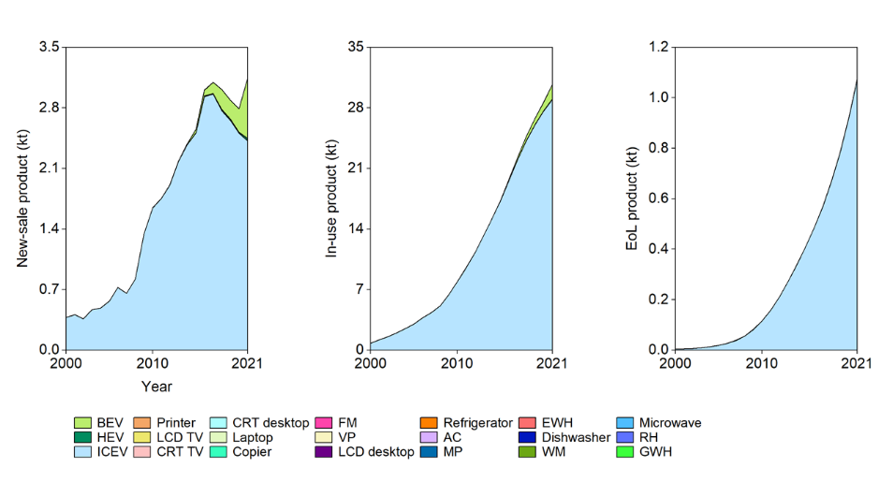  Niobium in the new-sale products increased from 378 t to 3.1 kt in 2000−2021. In this period, tungsten in in-use products increased 39 times to 31 kt in 2021, and it in EoL products soared to 1.1 kt. The most essential carriers are ICEV and BEV.
Recycling | Niobium scrap from aerospace, manufacturing, and electronics can be recycled. Such waste includes alloy waste, solids, turnings, powders, regrind, tailings, and sludge⁹⁰.  Overall EoL recycling ratio (from all applications): 50%, 56%²⁵
Occurrence in nature | Niobium is primarily obtained from the minerals columbite and pyrochlore. It is a rare element containing 0.0008% in the earth's crust⁹¹.  These minerals also contain tantalum, and the two elements are mined together. Some niobium is also produced as a by-product of tin extraction.⁴³ The top two reserve holders are Brazil (16 Mt) and Canada (1.6 Mt); the top two mine producers in 2020 were Brazil (71 kt) and Canada (6.2 kt)². China lacks niobium ore resources.

Table 27. Vanadium characteristics, applications, and recycling
Characteristic | Vanadium (V) is a rare, hard, ductile gray-white element found combined in certain minerals and used mainly to produce certain alloys. Vanadium resists corrosion due to a protective film of oxide on the surface⁴². The metal oxidizes in air at around 660 °C to the pentoxide⁹².  Atomic number: 23; relative atomic mass: 50.942; density: 6.0 g/cm³; melting point: 1,910 °C (2,183 K)⁴³
General application⁴⁴ | About 80−85% of the vanadium produced is used as a steel additive. Vanadium-steel alloys are very tough and are used for armor plates, axles, tools, piston rods, and crankshafts. Less than 1% of vanadium makes steel shock-resistant and vibration-resistant⁹³. Vanadium(V) oxide is used as a pigment for ceramics and glass, as a catalyst, and in producing superconducting magnets⁹⁴.
Use in automobiles and EEE | 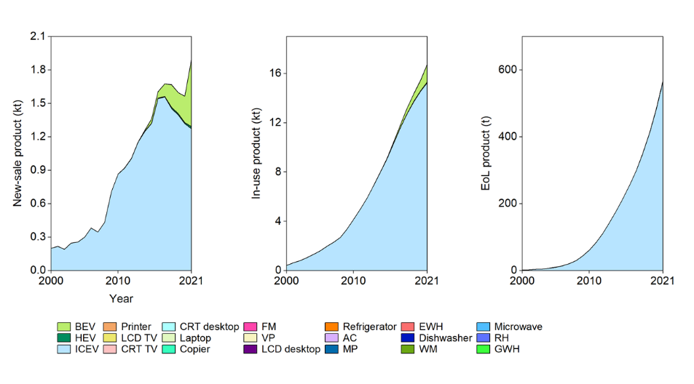  Vanadium in the new-sale products increased from 199 t to 1.9 kt in 2000−2021. In this period, vanadium in in-use products increased 41 times to 17 kt in 2021, and it in EoL products soared to 568 t. The most essential carriers are ICEV and BEV.
Recycling⁹⁵ | The use of vanadium in steel is almost completely dissipated because vanadium recovery from scrap steel is chemically hindered under the oxidizing conditions of steelmaking furnaces. The most significant recoveries of vanadium are in the vanadium market's superalloys, other alloys, and catalyst segments.  Overall EoL recycling ratio (from all applications): <1%²⁵
Occurrence in nature | Vanadium is found in about 65 different minerals including vanadinite, carnotite, and patronite. It is also found in phosphate rock, certain iron ores, and some crude oils in the form of organic complexes. Vanadium metal is obtained by reducing vanadium(V) oxide with calcium in a pressure vessel. Vanadium of high purity can be obtained by reducing vanadium(III) chloride with magnesium⁴⁴. The largest reserve holders are China (9.6 Mt), Russia (5.0 Mt), and Australia (4.0 Mt); the leading mine producers in 2020 were China (53 kt), Russia (18 kt), and South Africa (8.2 kt)².

Table 28. Molybdenum characteristics, applications, and recycling
Characteristic | Molybdenum (Mo) metal is silvery white, very hard transition metal. It has a high elastic modulus. Molybdenum has one of the highest melting points of all pure elements⁹⁶. It is attacked slowly by acids⁴².  Atomic number: 42; relative atomic mass: 55.95; density: 10.2 g/cm³; melting point: 2,623 °C (2,896 K)⁴³
General application⁴⁴ | Most molybdenum is used to make alloys. It is used in steel alloys to increase strength, hardness, electrical conductivity and resistance to corrosion and wear. These moly steel alloys are used in parts of automobile engines⁹⁷. Other alloys are used in heating elements, drills and saw blades. Other uses for molybdenum include catalysts for the petroleum industry, inks for circuit boards, pigments and electrodes⁹⁸.
Use in automobiles and EEE | 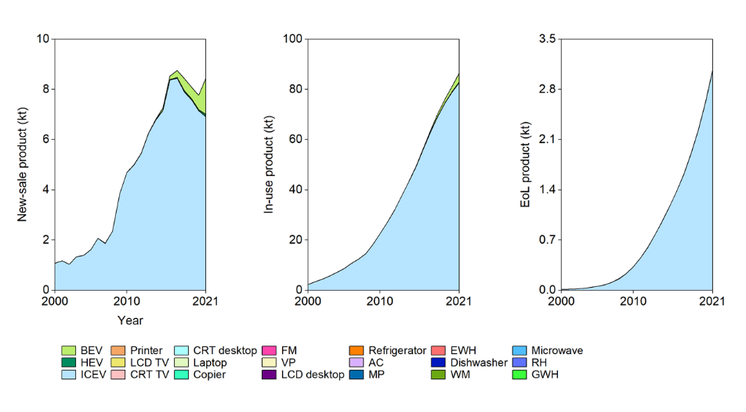  Molybdenum in the new-sale products increased from 1.1 kt to 8.5 kt in 2000−2021. In this period, molybdenum in in-use products increased 39 times to 87 kt in 2021, and it in EoL products soared to 3.1 kt. The most essential carriers are ICEV and BEV.
Recycling⁹⁹ | Molybdenum comes from two sources: 1) mining and 2) recycling. The molybdenum unit returns to the furnace, where it is smelted into steel along with the raw molybdenum and other raw materials.  Overall EoL recycling ratio (from all applications): 30%²⁵
Occurrence in nature | Most molybdenum is obtained from molybdenite, wulfenite and powellite. These ores typically occur in conjunction with ores of tin and tungsten. Molybdenum is also obtained as a by-product of mining and processing tungsten and copper⁴³. The largest reserve holders are China (8.3 Mt), Peru (2.8 Mt), and the USA (2.7 Mt); the top three mine producers in 2020 were China (120 kt), Chile (58 kt), and the USA (49 kt)².

Table 29. Gallium characteristics, applications, and recycling
Characteristic | Solid gallium (Ga) is a blue-gray metal, and very pure gallium has a stunning silvery color. Gallium is solid at normal room temperatures, but it becomes liquid when heated slightly. Liquid gallium expands by 3.1% when frozen¹⁰⁰. Solid gallium is soft enough to be cut with a knife. It is stable in air and water⁴².  Atomic number: 31; relative atomic mass: 69.723; density: 5.91 g/cm³; melting point: 29.76 °C (302,91 K)⁴³
General application⁴⁴ | Gallium arsenide is an essential component of many semiconductors. It is also used in red light-emitting diodes because it converts electricity to light. Gallium nitride is also a semiconductor. It has important uses in Blu-ray technology, mobile phones, blue and green light-emitting diodes, and pressure sensors for touch switches¹⁰¹. Gallium readily alloys with most metals.
Use in automobiles and EEE | 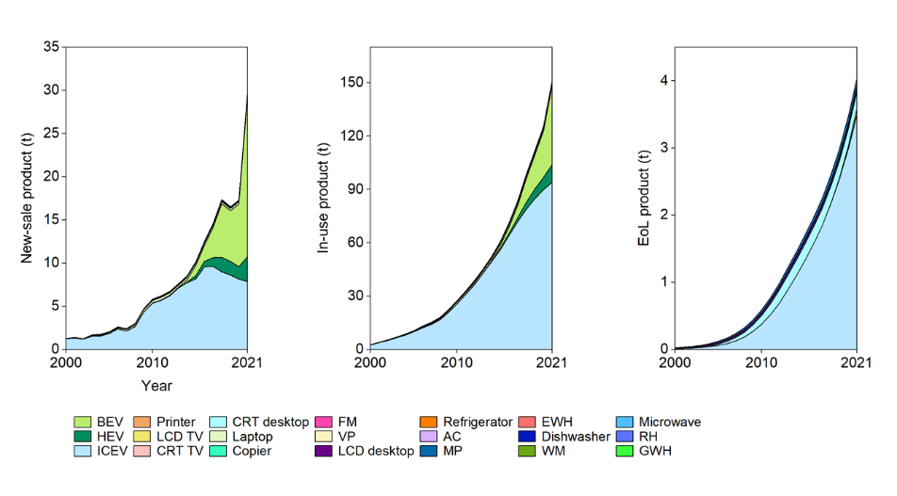  Gallium in the new-sale products increased from 1.3 t to 30 t in 2000−2021 (with a sharp increase from 2020). In this period, gallium in in-use products increased 54 times to 152 t in 2021, and it in EoL products soared to 4.0 t. The most essential carriers include ICEV, HEV, and recent BEV.
Recycling⁵⁷ | EoL recycling is challenging due to the dissipative use of gallium. Much of the recovered gallium comes from gallium production residues from epitaxial processes used to make semiconductors.  Overall EoL recycling ratio (from all applications): <1%²⁵
Occurrence in nature | Trace amounts of gallium are found in diaspore, sphalerite, germanite, and bauxite, as well as in the by-products of burning coal. It is mainly produced as a by-product of zinc refining. The metal can be obtained by electrolysis of a gallium(III) hydroxide solution in potassium hydroxide⁴³. The largest reserve holders are China, Germany, and Kazakhstan⁴⁸; the leading primary producers in 2020 were China (290 t), Russia (4.0 t), and Japan and South Korea (both have 3.0 t)².

Table 30. Germanium characteristics, applications, and recycling
Characteristic | Pure germanium (Ge) is a hard, lustrous, gray-white, brittle metalloid. Germanium is stable in air and water and is unaffected by alkalis and acids, except nitric acid¹⁰².  Atomic number: 32; relative atomic mass: 72.630; density: 5.323 g/cm³; melting point: 938 °C (1,211 K)⁴³
General application⁴⁴ | Germanium is a semiconductor. The pure element was commonly doped with arsenic, gallium, or other elements and used as a transistor in thousands of electronic applications. However, other semiconductors have replaced it today¹⁰³. Germanium oxide has a high index of refraction and dispersion. This makes it suitable for wide-angle camera lenses and objective lenses for microscopes. This is now the major use for this element. Germanium is also used as an alloying agent, in fluorescent lamps, and as a catalyst⁵⁷.
Use in automobiles and EEE | 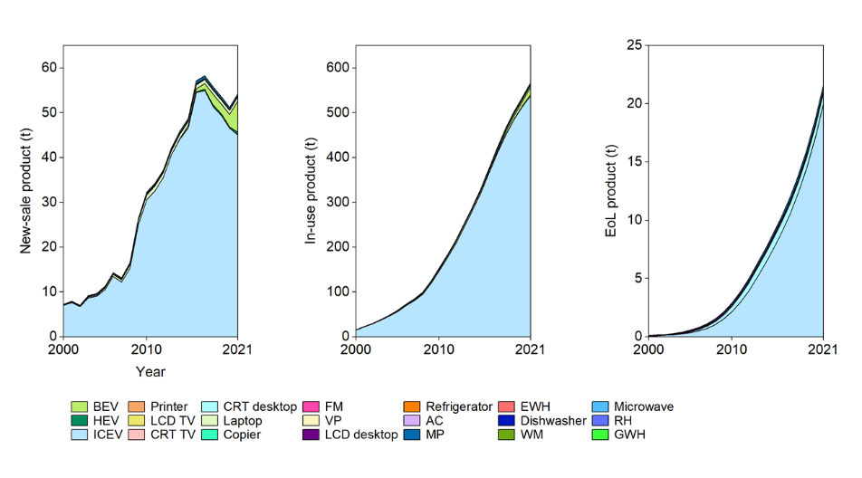  Germanium in the new-sale products increased from 7.2 t to 54 t in 2000−2021 (with a pick, 58 t, in 2017). In this period, germanium in in-use products increased 37 times to 567 t in 2021, and it in EoL products soared to 22 t. The most essential carriers are ICEV and BEV.
Recycling¹⁰⁴ | Globally, about 30% of the total germanium consumed is produced from recycled materials. During the manufacture of most optical devices, more than 60% of the germanium metal used is routinely recycled as new scrap.  Overall EoL recycling ratio (from all applications): <1%, 76%²⁵
Occurrence in nature | Germanium ores are very rare and are found in small quantities as the minerals germanite and argyrodite. Commercial production of germanium is carried out by processing zinc smelter flue dust. It can also be recovered from the by-products of the combustion of coals⁴³. The largest reserve holders are China, Russia, and Germany (likely)⁴⁸; the top two primary producers in 2020 were China (86 t) and Russia (5.0 t)².

Table 31. Tantalum characteristics, applications, and recycling
Characteristic | Tantalum (Ta) is a shiny, silvery metal that is soft. When pure, it is almost immune to chemical attack at temperatures below 150 C. Tantalum is virtually resistant to corrosion due to an oxide film on its surface⁴².  Atomic number: 73; relative atomic mass: 180.948; density: 16.4 g/cm³; melting point: 3,017 °C (3,290 K) ⁴³
General application⁴⁴ | Tantalum can be used to coat other metals with a very thin layer, and a high capacitance can be achieved in a small volume. This makes tantalum capacitors attractive for portable electronics such as mobile phones¹⁰⁵. It is very resistant to corrosion and is used in equipment for handling corrosive materials. It has also found uses as electrodes for neon lights, rectifiers, and in glass for special lenses. Tantalum alloys can be extremely strong and have been used for turbine blades, rocket nozzles, and nose caps for supersonic aircraft¹⁰⁶.
Use in automobiles and EEE | 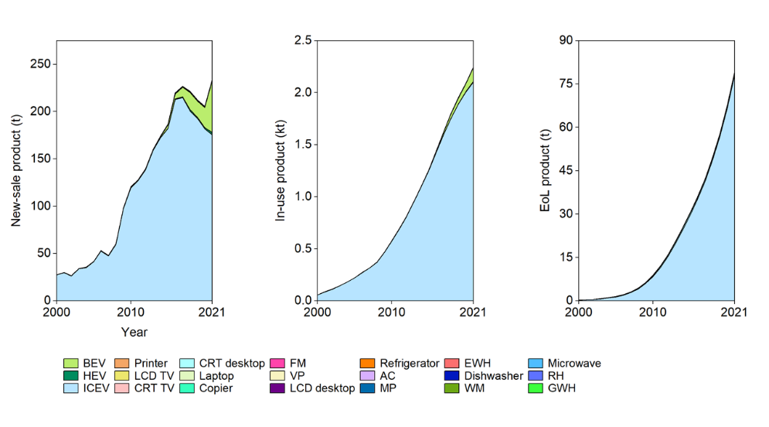  Tantalum in the new-sale products increased from 28 t to 234 t in 2000−2021. In this period, tantalum in in-use products increased 39 times to 2.3 kt in 2021, and it in EoL products soared to 79 t. The most essential carriers are ICEV and BEV.
Recycling⁵⁷ | Tantalum is recovered from slags resulting from the smelting of tin. It is also recovered from powder sweepings, wire scrap of capacitor manufacturing, and EoL capacitors.  Overall EoL recycling ratio (from all applications): <1%, 35%²⁵
Occurrence in nature | Tantalum is primarily obtained from the minerals columbite, tantalite, and euxenite. There are several complicated steps involved in separating the tantalum from the niobium. A lot of tantalum is obtained commercially as a by-product of tin extraction⁴⁴. The top two reserve holders are Australia (99 kt) and Brazil (40 kt); the leading mine producers in 2020 were Congo (670 t), Brazil (370 t), and Rwanda (270t). China produced 70 t mine in 2020².

Table 32. Titanium characteristics, applications, and recycling
Characteristic | Titanium (Ti) is a transition metal light with a white-silvery-metallic colour. It is strong, lustrous, corrosion-resistant. Pure titanium is not soluble in water but is soluble in concentrated acids. This metal forms a passive but protective oxide coating when exposed to elevated temperatures in air. Titanium is not easily attacked by seawater⁴².  Atomic number: 22; relative atomic mass: 47.867; density: 4.5 g/cm³; melting point: 1,668 °C (1,941 K)⁴³
General application⁴⁴ | Titanium alloys are mainly used in aircraft, spacecraft, and missiles because of their low density and ability to withstand extremes of temperature. They are also used in golf clubs, laptops, bicycles, and crutches. Power plant condensers use titanium pipes because of their resistance to corrosion¹⁰⁷. It is used in desalination plants and to protect the hulls of ships, submarines, and other structures exposed to seawater. The largest use of titanium is in the form of titanium(IV) oxide. It is extensively used as a pigment in house paint, artists’ paint, plastics, enamels, and paper¹⁰⁸.
Use in automobiles and EEE | 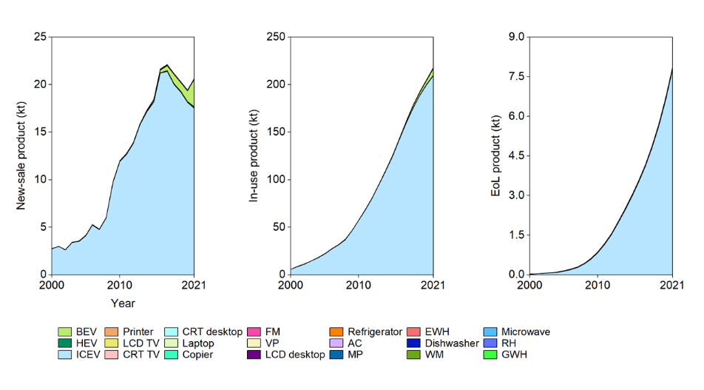  Titanium in the new-sale products increased from 2.8 kt to 21 kt in 2000−2021 (with a pick, 22 kt, in 2017). In this period, titanium in in-use products increased 38 times to 218 kt in 2021, and it in EoL products soared to 7.9 kt. The most essential carriers are ICEV.
Recycling¹⁰⁹ | Titanium is primarily recovered using a process called vacuum arc remelting. Since metals cannot be smelted in open-air furnaces, this method is used instead. Another emerging process, known as cold furnace smelting, is considered more economical, reducing titanium recovery costs.  Overall EoL recycling ratio (from all applications): 91%²⁵
Occurrence in nature | Titanium is the ninth most abundant element in the Earth's crust (0.57%). It occurs in the minerals: ilmenite, rutile, and sphene and is present in titanates and many iron ores. Titanium is produced commercially by reducing titanium(IV) chloride with magnesium⁴³. The largest reserve holders (ilmenite) are China (230 kt), Australia (150 kt), and India (85 kt); the leading ilmenite mine producers in 2020 were China (2.3 kt), South Africa (1000 t), and Australia (800 t)².

Table 33. Beryllium characteristics, applications, and recycling
Characteristic | Beryllium (Be) is a toxic bivalent element, steel gray, strong, light-weight, primarily used as a hardening agent in alloys. Beryllium has one of the highest melting points of light metals. It has excellent thermal conductivity, is nonmagnetic, it resists attack by concentrated nitric acid⁴². The elastic modulus of beryllium is about 50% larger than that of steel¹¹⁰.  Atomic number: 4; relative atomic mass: 9.012; density: 1.85 g/cm³; melting point: 1,287 °C (1,560 K)⁴³
General application⁴⁴ | Beryllium is used in alloys with copper or nickel to make gyroscopes, springs, electrical contacts, spot-welding electrodes, and non-sparking tools. Mixing beryllium with these metals increases their electrical and thermal conductivity¹¹¹. Other beryllium alloys are used as structural materials for high-speed aircraft, missiles, spacecraft, and communication satellites¹¹².
Use in automobiles and EEE | 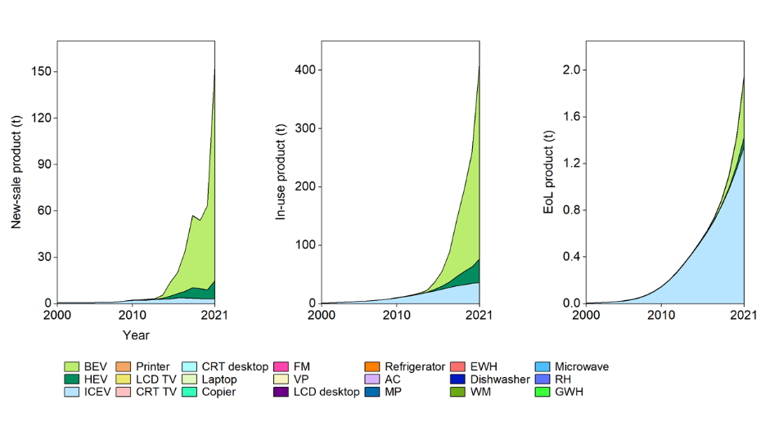  Beryllium in the new-sale products increased from 477 kg to 155 t in 2000−2021 (with a sharp increase from 2020). In this period, beryllium in in-use products soared to 413 t in 2021, and it in EoL products soared to 2.0 t. The most essential carriers include BEV and HEV.
Recycling¹¹³ | Recycling, mainly from waste generated during the manufacture of beryllium products, can account for up to 10% of apparent consumption. However, due to small component size, separation difficulties, low overall beryllium content per device, and low beryllium content in copper beryllium alloys, recycling EoL products is difficult.  Overall EoL recycling ratio (from all applications): <1%, 7%²⁵
Occurrence in nature | Beryllium is found in about 30 different mineral species. The most important are beryl and bertrandite. The metal is usually prepared by reducing beryllium fluoride with magnesium metal⁴⁴. The top reserve holder is likely to be the USA⁴⁸; the leading mine producers in 2020 were the USA (150 t), China (70 t), and Mozambique (15 t)².

Table 34. Thallium characteristics, applications, and recycling
Characteristic | Thallium (Tl) exhibits a metallic luster when freshly exposed to air, but soon develops a blueish-grey tinge. A heavy oxide builds up on thallium if left in the air, and the hydroxide is formed in the presence of water. The metal is very soft and malleable. It can be cut with a knife¹¹⁴.  Atomic number: 81; relative atomic mass: 204.383; density: 11.8 g/cm³; melting point: 304 °C (577 K)⁴³
General application⁴⁴ | The use of thallium is limited as it is a toxic element. Most thallium is used by the electronics industry in photoelectric cells¹¹⁵. Thallium oxide is used to produce special glass with a high index of refraction¹¹⁶.
Use in automobiles and EEE | 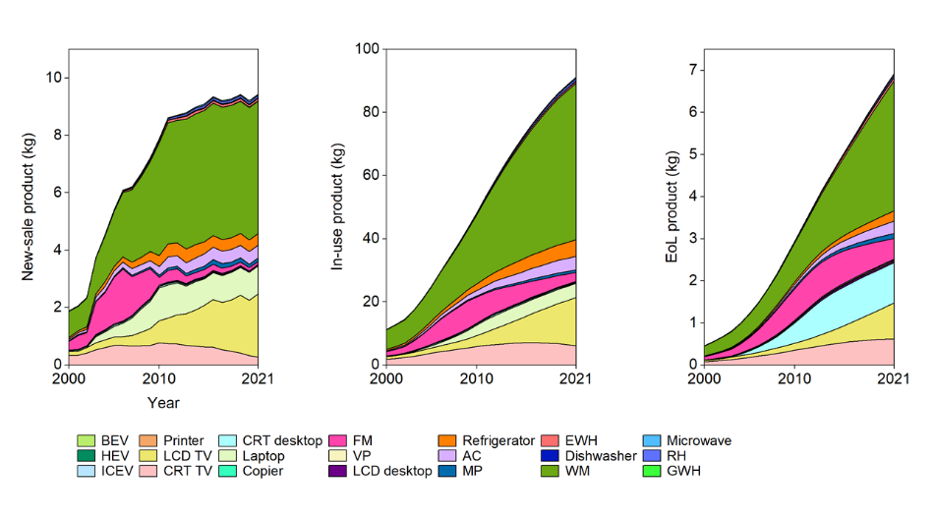  Thallium in the new-sale products increased from 1.9 kg to 9.4 kg in 2000−2021. In this period, thallium in in-use products increased 8 times to 91 kg in 2021, and it in EoL products increased 15 times to 6.9 kg. Essential carriers are HEV, LCD TV, laptop, etc.
Recycling | Thallium recycling is currently difficult and challenging¹¹⁷.  Overall EoL recycling ratio (from all applications): 0%²⁵
Occurrence in nature | Thallium is found in the minerals crooksite, lorandite, and hutchinsonite, but is usually obtained as a byproduct of the production of sulfuric acid or as a byproduct of refining zinc or lead. Thallium is also present in manganese nodules found on the ocean floor¹¹⁸. Quantitative estimates of thallium reserves are not available².

Table 35. Indium characteristics, applications, and recycling
Characteristic | Indium (In) is a soft, ductile, malleable, lustrous metallic metal. Its color is silvery white. Indium is liquid over a wide range of temperatures, like gallium, that belongs to its same group. Indium is stable in air and water but dissolves in acids. Below the critical temperature of 3.41 K, indium becomes a superconductor¹¹⁹.  Atomic number: 49; relative atomic mass: 114.818; density: 7.31 g/cm³; melting point: 157 °C (430 K)⁴³
General application⁴⁴ | Most indium (364 t of 662 t in 2011¹²⁰) is used to make indium tin oxide, which is an important part of touch screens, flatscreen TVs, and solar panels. This is because it conducts electricity, bonds strongly to glass, and is transparent. Indium nitride, phosphide, and antimonide are semiconductors used in transistors and microchips¹²¹.
Use in automobiles and EEE | 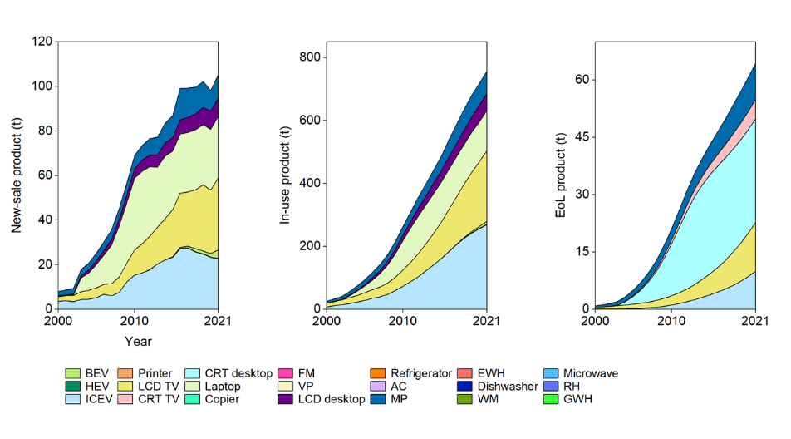  Indium in the new-sale products increased from 7.9 t to 105 t in 2000−2021. In this period, indium in in-use products increased 30 times to 758 t in 2021, and it in EoL products increased 74 times to 64 t. Essential carriers are ICEV, LCD TV, laptop, LCD desktop, and MP.
Recycling⁵⁷ | Indium recovery from spent indium tin oxide targets for conductive coatings. Recycling indium from dissipative applications such as flat panel displays and photovoltaics remains a very challenging process, especially in terms of economics.  Overall EoL recycling ratio (from all applications): <1%²⁵
Occurrence in nature | Indium is one of the minor abundant minerals on Earth. It has been found uncombined in nature but is typically associated with zinc minerals and iron, lead, and copper ores. It is commercially produced as a by-product of zinc refining⁴⁴. The leading refinery producers in 2020 were China (500 t), South Korea (200 t), Japan (65 t), and Canada and France (both have 50 t). Quantitative estimates of thallium reserves are not available².

Table 36. Nickel characteristics, applications, and recycling
Characteristic | Nickel (Ni) is silvery-white. hard, malleable, and ductile metal. It is a fairly good conductor of heat and electricity. It also forms several complex compounds. Most nickel compounds are blue or green. Metallic nickel, nickel sulfide and nickel oxide are poorly soluble in water compared to soluble nickel salts (chloride, nitrate, sulfate)¹²².  Atomic number: 28; relative atomic mass: 58.693; density: 8.912 g/cm³; melting point: 1,455 °C (1,728 K)⁴³
General application⁴⁴ | Nickel has a long history of being used in coins. Today, nickel is mainly used in making alloys such as stainless steel. Nickel is used in batteries, including rechargeable nickel-cadmium batteries and nickel-metal hydride batteries used in HEVs¹²³.
Use in automobiles and EEE | 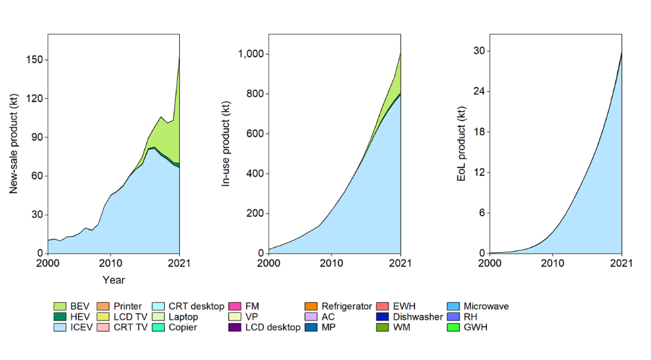  Nickel in the new-sale products increased from 14 kt to 154 kt in 2000−2021 (with a sharp increase from 2020). In this period, nickel in in-use products increased 47 times to 1010 kt in 2021, and it in EoL products soared to 30 kt. The most essential carriers include BEV and HEV.
Recycling¹²⁴ | Nowadays, 57% of discarded nickel is recycled within the nickel and stainless steel industries, and 14% is lost to other metal markets where nickel is an unwanted constituent of carbon steel and copper alloy scrap.  Overall EoL recycling ratio (from all applications): 57%, 58−63%²⁵
Occurrence in nature | Most nickel is extracted from the mineral pentlandite. The large nickel deposit is believed to be the result of an ancient meteorite impact¹²⁵. The largest reserve holders are Indonesia (21 Mt), Australia (20 Mt), and Brazil (16 Mt); the leading mine producers in 2020 were Indonesia (760 kt), Philippines (320 kt), and Russia (280 kt)².

Table 37. Lithium characteristics, applications, and recycling
Characteristic | Lithium is the lightest solid metal, soft, silvery-white, low melting point, and reactive. Metallic lithium’s reaction with water is extremely vigorous. It has the lowest density of all solid elements at room temperature¹²⁶.  Atomic number: 3; relative atomic mass: 6.941; density: 0.534 g/cm³; melting point: 181 °C (454 K)⁴³
General application⁴⁴ | The most important use of lithium is in rechargeable batteries for mobile phones, laptops, digital cameras, and EVs¹²⁷. Lithium is also used in some non-rechargeable batteries for things like toys and clocks. A magnesium-lithium alloy is used for armor plating. Aluminum-lithium alloys are used in aircraft, bicycle frames, and high-speed trains¹²⁸. Lithium oxide is used in special glasses and glass ceramics. Lithium hydride is used as a means of storing hydrogen for use as a fuel¹²⁹.
Use in automobiles and EEE | 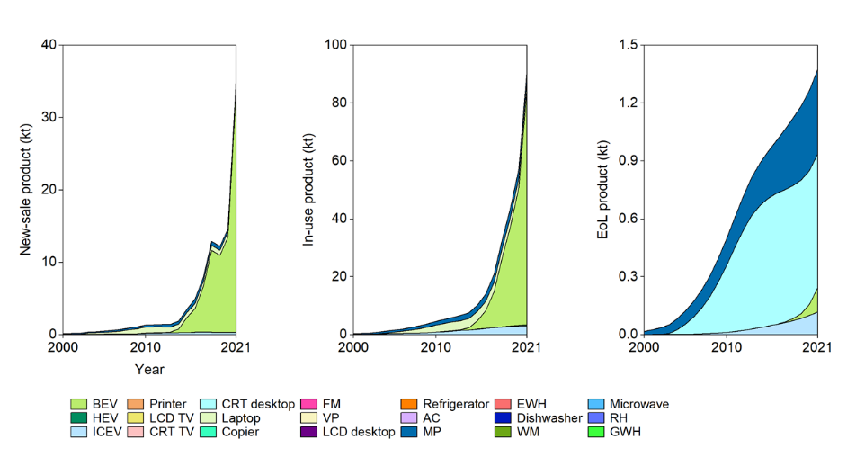  Lithium in the new-sale products increased from 136 t to 36 kt in 2000−2021 (with a sharp increase from 2020). In this period, lithium in in-use products soared to 91 kt in 2021, and it in EoL products increased 82 times to 1.4 kt. The most essential carriers include BEV, MP, and computers.
Recycling⁵⁷ | Due to the abundance of lithium in nature, lithium recovery has not been a priority for many players in the lithium-ion battery, glass, or ceramic industries. The recent surge in demand for lithium from electric vehicles has highlighted the importance of recycling, as both pyrometallurgical and hydrometallurgical processes can now recover lithium from lithium-ion battery waste.  Overall EoL recycling ratio (from all applications): <1%²⁵
Occurrence in nature | Lithium is not found free in nature and makes up only 0.0007% of the Earth's crust. Today, larger amounts of metal are obtained through lithium chloride electrolysis⁴³. The largest holders are Chile (9.2 Mt), Australia (4.7 Mt), Argentina (1.9 Mt), and China (1.5); the leading mine producers in 2020 were Australia (40 kt), Chile (18 kt), China (14 kt), and Argentina (6.2 kt)².

Table 38. Cobalt characteristics, applications, and recycling
Characteristic | Cobalt (Co) is a hard ferromagnetic, silver-white, hard, lustrous, brittle element. Cobalt is active chemically, forming many compounds. Cobalt is stable in the air and unaffected by water but is slowly attacked by dilute acids. Like iron, cobalt can be magnetized, and it has a relative permeability of two-thirds that of iron¹³⁰.  Atomic number: 27; relative atomic mass: 58.933; density: 8.68 g/cm³; melting point: 1,495 °C (1,768 K)⁴³
General application⁴⁴ | Cobalt is alloyed with aluminum and nickel to make particularly powerful magnets¹³¹. Other alloys of cobalt are used in jet turbines and gas turbine generators, where high-temperature strength is important. Cobalt metal is sometimes used in electroplating because of its attractive appearance, hardness, and resistance to corrosion¹³².
Use in automobiles and EEE | 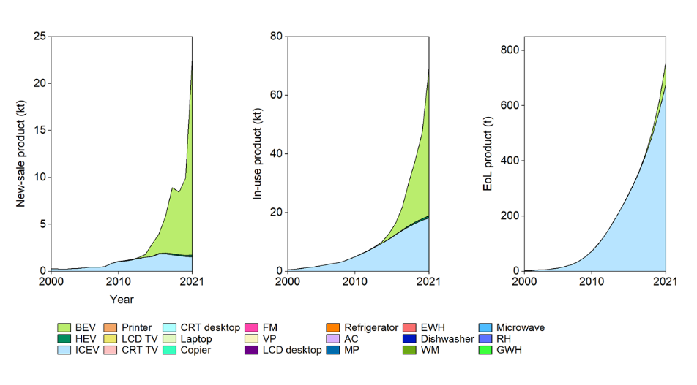  Cobalt in the new-sale products increased from 238 t to 23 kt in 2000−2021 (with a sharp increase from 2020). In this period, cobalt in in-use products soared to 70 kt in 2021, and it in EoL products increased 82 times to 758 t. The most essential carriers include ICEV and BEV.
Recycling⁵⁷ | Most cobalt is recovered from manufacturers' production processes for applications such as cemented carbide and cemented carbide tools or rechargeable lithium-ion batteries. Cobalt can also be retrieved from end-of-life products such as spent rechargeable batteries, petrochemical catalysts, and alloys used in aerospace applications.  Overall EoL recycling ratio (from all applications): 68%²⁵
Occurrence in nature | Cobalt's primary ores are cobaltite and erythrite. Cobalt is usually recovered as a by-product of mining and refining nickel, silver, lead, copper, and iron⁴³. The largest reserve holders are Congo (3.6 Mt), Australia (1.4 Mt), and Cuba (500 kt); the leading mine producers in 2020 were Congo (95 kt), Russia (6.3 kt), and Australia (5.7 kt). Reserve and production in China were 80 kt and 2.3 kt in 2020².

Table 39. Lead characteristics, applications, and recycling
Characteristic | Lead (Pb) is soft and malleable and has a relatively low melting point. When freshly cut, lead is silvery with a hint of blue; it tarnishes to a dull gray color when exposed to air. The properties of lead include high density, flexibility, ductility, and high corrosion resistance due to passivation¹³³.  Atomic number: 82; relative atomic mass: 207.2; density: 11.342 g/cm³; melting point: 327 °C (601 K)⁴³
General application⁴⁴ | Lead is commonly used in automobile batteries, paint, ammunition, cable sheathing, weightlifting, diving weight belts, lead crystal glass, radiation shields, and some plumb bobs¹³⁴. It is also sometimes used in architecture, roofing, and stained glass windows¹³⁵.
Use in automobiles and EEE | 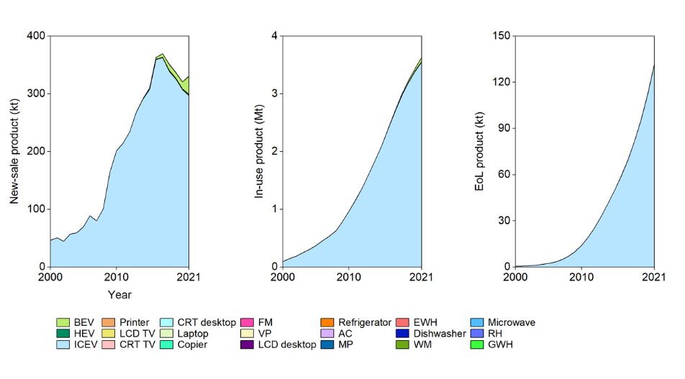  Lead in the new-sale products increased from 46 kt to 331 kt in 2000−2021 (with a pick, 369 kt, in 2017). In this period, lead in in-use products increased 38 times to 3.6 Mt in 2021, and it in EoL products soared to 132 kt. The most essential carriers are ICEV and BEV.
Recycling¹³⁶ | Lead-acid batteries are the most recycled consumer product in the world. Over 99% of lead-acid batteries are recycled, even more than any other common daily waste (e.g., tires, paper, aluminum cans, glass). Some lead products are not recycled, either because it is not currently economical or because it is not practical at all.  Overall EoL recycling ratio (from all applications): 52%, 68%, 95%, 99%²⁵
Occurrence in nature | Lead is sometimes found free in nature but is usually obtained from the ores galena, anglesite, and cerussite. Although lead makes up only about 0.0013% of the earth's crust, it is not considered to be a rare element since it is easily mined and refined. Most lead is obtained by roasting galena in hot air, although nearly one-third of the lead used is obtained through recycling efforts⁴³. The top three reserve holders are Australia (36 Mt), China (18 Mt) and Peru (6 Mt); the top three mine producers in 2020 were China (1.9 Mt), Australia (480 kt), and the USA (290 kt)².

Table 40. Silver characteristics, applications, and recycling
Characteristic | Pure silver (Ag) is nearly white, lustrous, soft, ductile, and malleable. It is an excellent conductor of heat and electricity. It is not a chemically active metal but is attacked by nitric acid (forming the nitrate) and hot concentrated sulfuric acid. It has the highest electrical conductivity of all metals, but its greater cost has prevented it from being widely used for electrical purposes. Silver is stable in water¹³⁷.  Atomic number: 47; relative atomic mass: 107.868; density: 10.501 g/cm³; melting point: 962 °C (1,235 K)⁴³
General application⁴⁴ | Sterling silver contains 92.5% silver¹³⁸. It is used for jewelry and silver tableware, where appearance is important. Silver is used to making mirrors, as it is the best reflector of visible light known, although it does tarnish with time. It is also used in dental alloys, solder and brazing alloys, electrical contacts, and batteries. Silver paints are used for making printed circuits¹³⁹.
Use in automobiles and EEE | 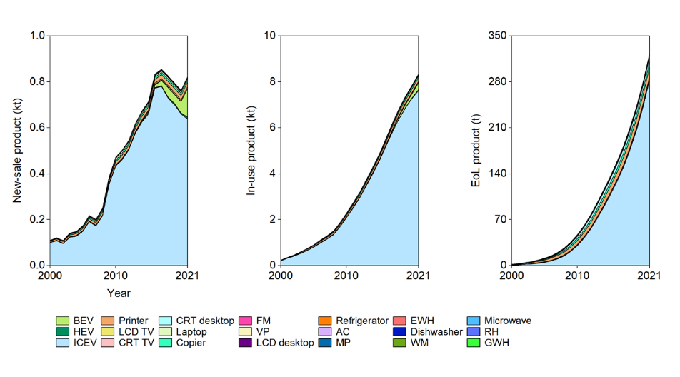  Silver in the new-sale products increased from 111 t to 0.8 kt in 2000−2021 (with a pick, 0.9 kt, in 2017). In this period, silver in in-use products increased 35 times to 8.4 Mt in 2021, and it in EoL products soared to 323 t. The most essential carriers are ICEV, BEV, and etc.
Recycling | Silver is extracted from the tailings of copper, nickel, and lead refining processes because it is mainly present in the ore body along with these metals. Silver can also be recovered from jewelry, industrial waste, and EoL uses such as electronics and WEEE¹⁴⁰.  Overall EoL recycling ratio (from all applications): 30−50%, 58%, 97%²⁵
Occurrence in nature | Silver occurs in unbound ores such as argentite and chalcopyrite (horn silver). However, it is mainly extracted from lead-zinc, copper, gold, and copper-nickel ores as a by-product of mining these metals. The metal is recovered either from the ore or during the electrolytic refining of copper⁴⁴. The largest reserve holders are Peru (91 kt), Australia (88 kt), and Poland (70 kt); the leading mine producers in 2020 were Mexico (5.6 kt), Peru (3.4 kt), and China (3.2 kt)².

Table 41. Gold characteristics, applications, and recycling
Characteristic | Gold (Au) is metallic, with a yellow color in a mass, but when finely divided, it may be black ruby or purple. It is the most malleable and ductile metal. It is a soft metal and is usually alloyed to give it more strength. It is a good conductor of heat and electricity and is unaffected by air and most reagents¹⁴¹.  Atomic number: 79; relative atomic mass: 196.967; density: 19.282 g/cm³; melting point: 1,064 °C (1,337 K)⁴³
General application⁴⁴ | Gold metal is also used for coinage, art, decoration, and architectural ornamentation. Gold electroplating is used in gears for watches, artificial limb joints, cheap jewelry, and electrical connectors¹⁴². It is ideal for protecting electrical copper components because it conducts electricity well and does not corrode (which would break the contact). Thin gold wires are used inside computer chips to produce circuits¹⁴³.
Use in automobiles and EEE | 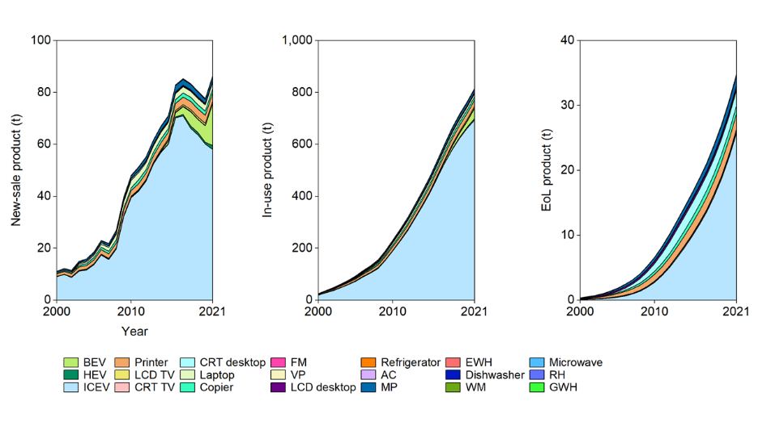  Gold in the new-sale products increased from 11 t to 87 t in 2000−2021. In this period, gold in in-use products increased 32 times to 816 t in 2021, and it in EoL products increased 97 times to 35 t. Essential carriers are ICEV, printer, MP, laptop, and recent BEV.
Recycling | The electrical contacts in cell phones, computers, or cars sometimes contain small amounts of gold, which improves conductivity. Factories, workshops, and houses are also golden carriers. 1 t old computer circuit boards can yield more than 200 g of precious metals. However, only about 15% of gold comes from WEEE¹⁴⁴.  Overall EoL recycling ratio (from all applications): 15−20%, 40%, 96%²⁵
Occurrence in nature | Gold is one of the few elements to occur in a natural state. It is found in veins and alluvial deposits. Seawater contains about 4 g of gold in 1,000 kt of water. Overall, this is a considerable amount of gold stored in the oceans but because the concentration is so low, attempts to reclaim this gold have consistently failed⁴⁴. The largest reserve holders are Australia (10 kt), Russia (7.5 kt), and The USA (3.0 kt); the leading mine producers in 2020 were China (380 t), Australia (320 t), and Russia (300 t)².

Table 42. Palladium characteristics, applications, and recycling
Characteristic | Palladium (Pd), together with rhodium, ruthenium, osmium, iridium, and platinum, form a group of elements referred to as the PGM. Palladium is a lustrous silver-white metal. At ordinary temperatures, it is strongly resistant to corrosion in air and the action of acids. It is attacked by hot acids, and it dissolves in aqua regia¹⁴⁵.  Atomic number: 46; relative atomic mass: 106.42; density: 12.0 g/cm³; melting point: 1,555 °C (1,828 K)⁴³
General application⁴⁴ | Most palladium is used in catalytic converters for automobiles. It is also used in jewelry and some dental fillings and crowns. Palladium is used in the electronics industry in ceramic capacitors, found in laptop computers and MPs¹⁴⁶.
Use in automobiles and EEE | 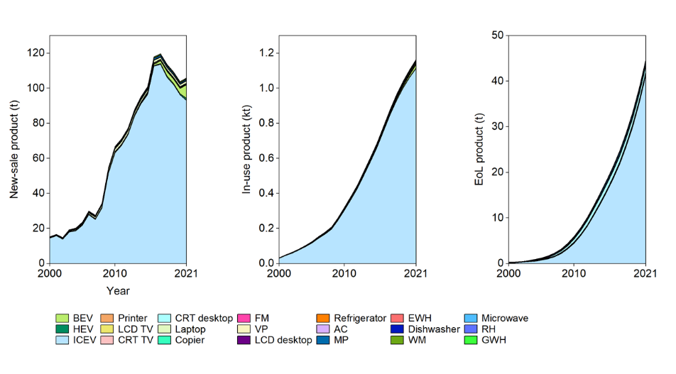  Palladium in the new-sale products increased from 15 t to 106 t in 2000−2021. In this period, palladium in in-use products increased 35 times to 1.2 kt in 2021, and it in EoL products soared to 45 t. The most essential carriers are ICEV and BEV.
Recycling | Palladium can be infinitely recycled without losing its intrinsic characteristics, and because of its high value, it is recycled quite readily. Most recycled volumes come from spent automotive catalysts and old jewelry, with electronics making up the remainder⁵⁷.  Overall EoL recycling ratio (from all applications): 60−70%²⁵
Occurrence in nature | Palladium has been found uncombined in nature, but mostly occurs in sulfide minerals such as braggite. It is obtained commercially as a by-product of nickel refining. It is also obtained as a by-product of copper and zinc refining⁴⁴. The top three reserve holders are South Africa, Russia, and USA; the top three producers are South Africa, Russia, and Zimbabwe⁴⁸. China lacks palladium ore resources.

Table 43. Platinum characteristics, applications, and recycling
Characteristic | Platinum (Pt), a PGM, is a lustrous silvery-white, malleable, ductile metal. It has the third highest density, behind osmium and iridium. Platinum is unaffected by air and water, but will dissolve in hot aqua regia, in hot concentrated phosphoric and sulphuric acids, and molten alkali. It is as resistant as gold to corrosion and tarnishing¹⁴⁵.  Atomic number: 78; relative atomic mass: 195.084; density: 21.46 g/cm³; melting point: 1,768 °C (2,042 K)⁴³
General application⁴⁴ | Platinum is used extensively for jewelry. Its main use, however, is in catalytic converters for cars, trucks, and buses. This accounts for about 50% of demand each year¹⁴⁷. Platinum is also used as a catalyst to improve the efficiency of fuel cells. The electronics industry uses platinum for computer hard disks and thermocouples. Platinum is also used to make optical fibers and LCDs, turbine blades, spark plugs, pacemakers, and dental fillings¹⁴⁸.
Use in automobiles and EEE | 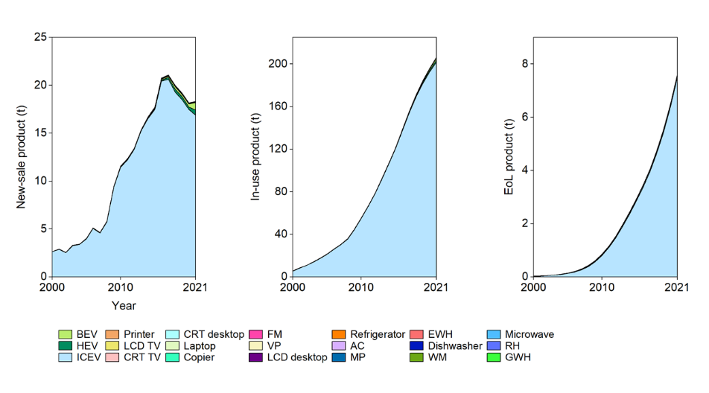  Platinum in the new-sale products increased from 2.7 t to 18 t in 2000−2021 (with a pick, 21 t, in 2017). In this period, platinum in in-use products increased 37 times to 207 t in 2021, and it in EoL products soared to 7.6 t. The most essential carrier is ICEV.
Recycling | Because of its value, platinum is usually easy to recycle. Most of the recycling comes from used automotive catalysts, with the remainder from old jewelry and electronics. In addition to end-of-life recycling, large quantities of platinum are used in closed-loop production processes such as glass manufacturing, where old platinum equipment is recycled and converted into new equipment or used in the chemical and pharmaceutical sectors⁵⁷.  Overall EoL recycling ratio (from all applications): 60−70%, 76%²⁵
Occurrence in nature | Platinum's primary occurrence is with other metal ores associated with basic igneous rocks. Platinum nuggets occur naturally as an uncombined metal, as does an alloy of platinum-iridium. Most commercially produced platinum comes from the mineral cooperite (platinum sulfide). Some platinum is prepared as a by-product of copper and nickel refining⁴². The largest reserve holders are South Africa, Russia, and the USA; the largest producers are South Africa, Russia, and Zimbabwe⁴⁸.

Table 44. Rhodium characteristics, applications, and recycling
Characteristic | Rhodium (Rh), a PGM, has a high reflectance and is hard and durable. Sputtering targets of rhodium are used to make the reflective surface for automobile mirrors and other optical instruments. Rhodium is also used for a range of catalyst applications and as alloys and coatings for jewelry¹⁴⁵.  Atomic number: 45; relative atomic mass: 102.906; density: 12.4 g/cm³; melting point: 1,964 °C (2,237 K)⁴³
General application⁴⁴ | The major use of rhodium is in catalytic converters for automobiles (80%)¹⁴⁹. It reduces nitrogen oxides in exhaust gases. Rhodium is used to coat optic fibers and optical mirrors, and for thermocouple elements and headlight reflectors. It is used as an electrical contact material as it has a low electrical resistance and is highly resistant to corrosion¹⁵⁰.
Use in automobiles and EEE | 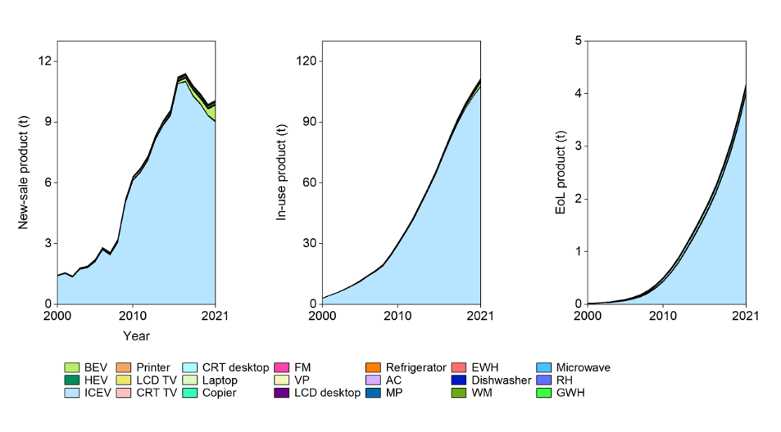  Rhodium in the new-sale products increased from 1.5 t to 10 t in 2000−2021 (with a pick, 11 t, in 2017). In this period, rhodium in in-use products increased 36 times to 112 t in 2021, and it in EoL products soared to 4.2 t. The most essential carrier is ICEV.
Recycling | Rhodium is mainly recovered from spent auto-catalysts. It is used in so-called "closed loops" (and therefore also recycled, often in the glass industry) or in such small quantities in various applications that recycling is not technically and economically feasible. It rarely returns loops from other uses⁵⁷.  Overall EoL recycling ratio (from all applications): 50−60%²⁵
Occurrence in nature | Rhodium is the rarest of all non-radioactive metals. It occurs uncombined in nature, along with other platinum metals, in river sands. It is also found in copper-nickel sulfide ores. Rhodium is obtained commercially as a by-product of copper and nickel refining. World production is about 30 t per year⁴⁴. The largest reserve holders are South Africa, Russia, and USA; the leading producers are South Africa, Russia, and Zimbabwe⁴⁸.

Table 45. Lanthanum characteristics, applications, and recycling
Characteristic | Lanthanum (La), a REE, is a soft, malleable, ductile, silver-white metal. Lanthanum is naturally found in sediments. It oxidizes rapidly in the air and reacts with water to form hydroxide⁴².  Atomic number: 57; relative atomic mass: 138.905; density: 6.15 g/cm³; melting point: 918 °C (1,191 K)⁴³
General application⁴⁴ | Lanthanum metal has no commercial uses. However, its alloys have a variety of uses. A lanthanum-nickel alloy is used to store hydrogen gas in hydrogen-powered vehicles¹⁵¹. Lanthanum is also found in the anode of nickel metal hydride batteries used in HEVs¹⁵². REE compounds containing lanthanum are used extensively in carbon lighting applications, such as studio lighting and cinema projection. They increase the brightness and give an emission spectrum similar to sunlight.
Use in automobiles and EEE | 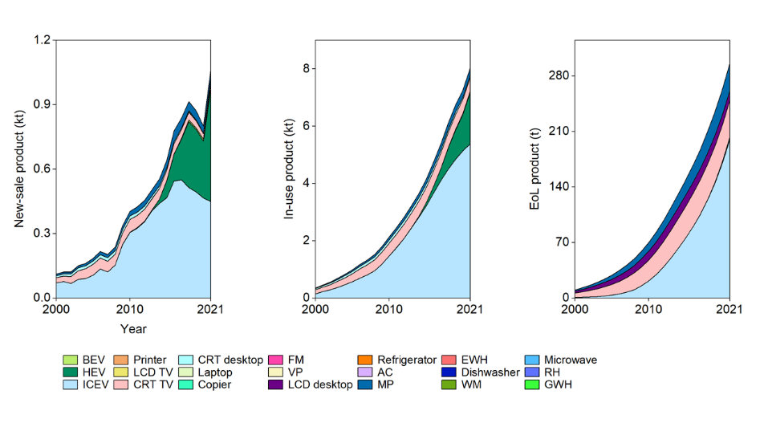  Lanthanum in the new-sale products increased from 111 t to 1.1 kt in 2000−2021. In this period, lanthanum in in-use products increased 23 times to 8.0 kt in 2021, and it in EoL products increased 30 times to 296 t. The most essential carrier is ICEV, HEV, and CRT TV.
Recycling¹⁵³ | REEs, including lanthanum, are very challenging to recycle commercially due to their very dispersed use. In lab scale, the recycling rate from spent nickel metal hydride batteries can reach over 90%¹⁵⁴.  Overall EoL recycling ratio (from all applications): <1%²⁵
Additional information
Occurrence in nature | Lanthanum is found in REE minerals, principally monazite (25% lanthanum) and bastnaesite (38% lanthanum). Ion-exchange and solvent extraction techniques are used to isolate the REE elements from the minerals. Lanthanum metal is usually obtained by reducing the anhydrous fluoride with calcium⁴⁴. For REEs, the largest reserve holders are China, Russia, and USA; the leading producers are China, Russia, and Malaysia⁴⁸.

Table 46. Cerium characteristics, applications, and recycling
Characteristic | Cerium (Ce), a REE, is a soft, ductile, and malleable (about like tin) metal with a color going from the iron gray of the commercial grade to silvery when in a pure form. It is rarely used because it tarnishes quickly, reacts with water (slowly in cold water and very rapidly in hot water), and burns when heated¹⁵⁵.  Atomic number: 58; relative atomic mass: 140.116; density: 6.770 g/cm³; melting point: 798 °C (1,071 K)⁴³
General application⁴⁴ | Cerium metal is used as a core for the carbon electrodes of arc lamps and incandescent mantles for gas lighting. Cerium is used in aluminum and iron alloys in stainless steel as a precipitation-hardening agent to make permanent magnets¹⁵⁶. Cerium oxide is part of the catalyst of catalytic converters used to clean up exhaust vehicles, and it also catalyzes the reduction of nitrogen oxides to nitrogen gas¹⁴⁹. Cerium sulfide is likely to replace cadmium in red pigments for containers, toys, household wares, and crates since cadmium is now considered environmentally undesirable. In chromium plating, other uses of cerium are in flat-screen televisions, low-energy light bulbs, and magnetic-optic compact discs.
Use in automobiles and EEE | 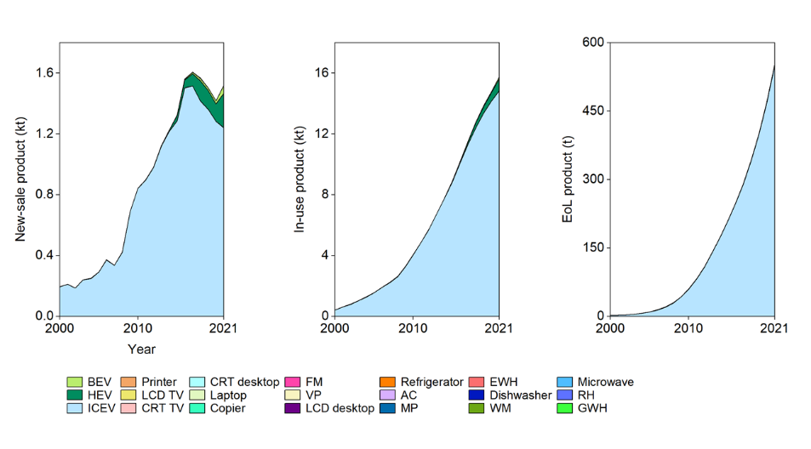  Cerium in the new-sale products increased from 0.2 kt to 1.5 kt in 2000−2021 (with a pick, 1.6 kt, in 2017). In this period, cerium in in-use products increased 39 times to 16 kt in 2021, and it in EoL products soared to 553 t. The most essential carriers are ICEV and HEV.
Recycling¹⁵³ | REEs, including cerium, are very challenging to recycle commercially due to their very dispersed use. In lab scale, the recycling rate from spent nickel metal hydride batteries can reach over 90%¹⁵⁷.  Overall EoL recycling ratio (from all applications): <1%²⁵
Occurrence in nature⁴² | Cerium is the most abundant of the rare earth elements. It makes up about 0.0046 % of the Earth's crust by weight. Cerium comes mainly from the major lanthanide ores but some are obtained from perovskite, a titanium mineral, and allanite, both of which can have enough cerium to make them viable sources. The global annual production amounts to 23 kt.

Table 47. Praseodymium characteristics, applications, and recycling
Characteristic | Praseodymium (Pr), a REE, is a soft malleable, silvery-yellow metal. It reacts slowly with oxygen: when exposed to air it forms a green oxide that does not protect it from further oxidation. It reacts rapidly with water⁴².  Atomic number: 59; relative atomic mass: 140.908; density: 6.77 g/cm³; melting point: 1,204 °C (931 K)⁴³
General application⁴⁴ | Praseodymium is used in a variety of alloys. The high-strength alloy it forms with magnesium is used in aircraft engines¹⁵⁸. Praseodymium is also used in alloys for permanent magnets¹⁵⁹. Along with other lanthanide elements, it is used in carbon arc electrodes for studio lighting and projection. Praseodymium salts are used to color glasses, enamel, and glazes an intense and unusually clean yellow.
Use in automobiles and EEE | 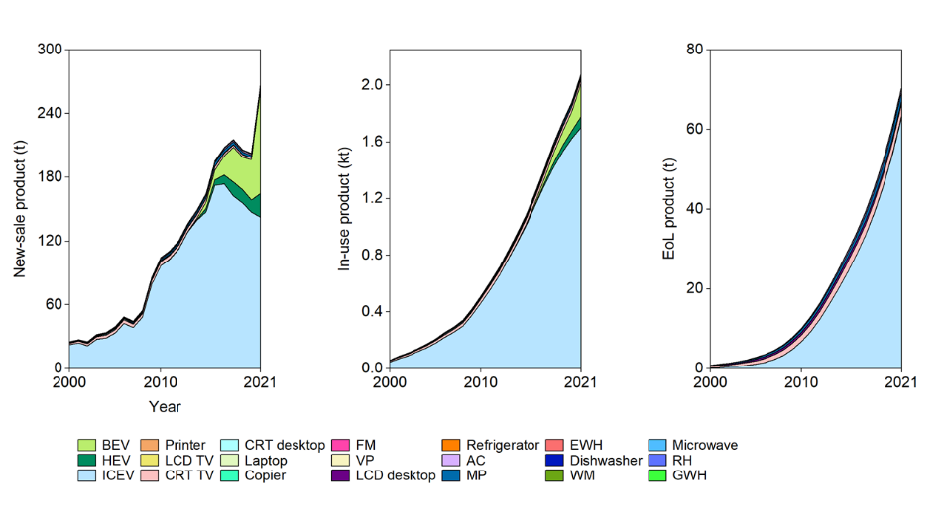  Praseodymium in the new-sale products increased from 25 t to 269 t in 2000−2021. In this period, praseodymium in in-use products increased 35 times to 2.1 kt in 2021, and it in EoL products increased 87 times to 71 t. The most essential carriers are ICEV, BEV, and HEV.
Recycling¹⁵³ | REEs, including praseodymium, are very challenging to recycle commercially due to their very dispersed use. In lab scale, the recycling rate from spent neodymium magnets can reach approximately 89.2%¹⁶⁰.  Overall EoL recycling ratio (from all applications): <1%²⁵
Occurrence in nature⁴² | The major commercial ores in which praseodymium is found are monazite and bastnasite. The main mining areas are China, the USA, Brazil, India, Sri Lanka, and Australia. Reserves of praseodymium are estimated to be around 2 Mt. The global production of praseodymium is about 2,5 kt per year.

Table 48. Neodymium characteristics, applications, and recycling
Characteristic | Neodymium (Nd), a REE, is a lustrous silvery-yellow metal. It is very reactive, and quickly tarnishes in air, and the coated formed does not protect the metal from further oxidation, so it must be stored away from contact with air. It reacts slowly with cold water and rapidly with hot¹⁶¹.  Atomic number: 60; relative atomic mass: 144.242; density: 7.01 g/cm³; melting point: 1,294 °C (1,021 K)⁴³
General application⁴⁴ | The most important use for neodymium is in an alloy with iron and boron to make powerful permanent magnets¹⁶². Neodymium can be used to miniaturize many electronic devices, including mobile phones, microphones, loudspeakers, and electronic musical instruments. These magnets are also used in car windscreen wipers and wind turbines. Neodymium is a component, along with praseodymium, of didymium glass¹⁶³.
Use in automobiles and EEE | 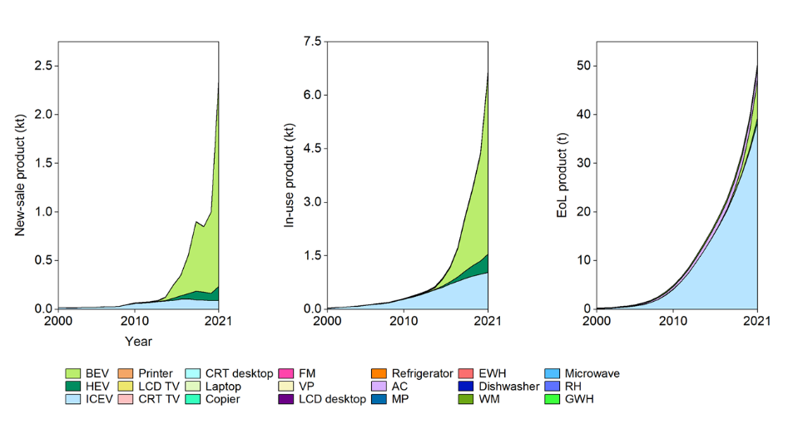  Neodymium in the new-sale products increased from 14 t to 238 t in 2000−2021. In this period, neodymium in in-use products soared to 6.7 kt in 2021, and it in EoL products soared to 51 t. The most essential carriers are ICEV, BEV and HEV.
Recycling¹⁵³ | REEs, including neodymium, are very challenging to recycle commercially due to their very dispersed use. Although the current recycling rate is less than 1%, the recycling technologies, including leaching and molten salt extraction, is developed rapidly¹⁶⁴.  Overall EoL recycling ratio (from all applications): <1%²⁵
Occurrence in nature⁴² | Neodymium is the second most abundant of the rare-earth elements (after cerium) and is almost as abundant as copper. It is found in minerals that include all lanthanide minerals, such as monazite and bastnasite. The main areas are Brazil, China, the USA, India, Sri Lanka, and Australia. Reserves of neodymium are estimated to be 8 Mt, and the world production of neodymium oxide is about 7 kt a year.

Table 49. Samarium characteristics, applications, and recycling
Characteristic | Samarium (Sm), a REE, is a moderately hard silvery metal that slowly oxidizes in air. It has no significant biological role, but it is slightly toxic¹⁶¹.  Atomic number: 62; relative atomic mass: 150.36; density: 7.52 g/cm³; melting point: 1,074 °C (1,347 K)⁴³
General application⁴⁴ | Samarium-cobalt magnets are much more powerful than iron magnets; they remain magnetic at high temperatures and so are used in microwave applications¹⁶⁵. Samarium-cobalt magnets enabled the miniaturization of electronic devices like headphones and the development of personal stereos. However, neodymium magnets are now more commonly used instead. Samarium is used to dope calcium chloride crystals for use in optical lasers. Similar to other lanthanides, samarium is used in carbon arc lighting for studio lighting and projection¹⁶⁶.
Use in automobiles and EEE | 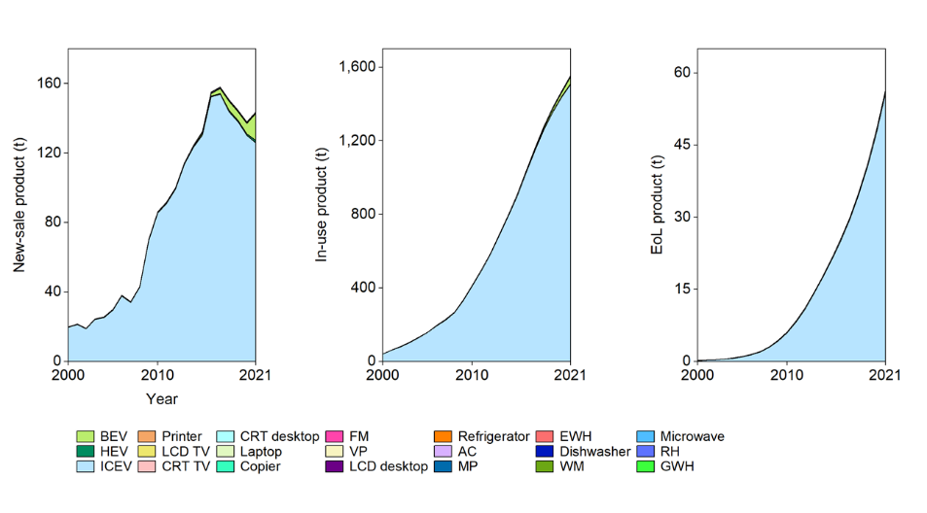  Samarium in the new-sale products increased from 20 t to 144 t in 2000−2021 (with a pick, 158 t, in 2017). In this period, samarium in in-use products increased 38 times to 1.6 kt in 2021, and it in EoL products soared to 57 t. The most essential carriers are ICEV and BEV.
Recycling¹⁵³ | REEs, including samarium, are very challenging to recycle commercially due to their very dispersed use.  Overall EoL recycling ratio (from all applications): <1%²⁵
Occurrence in nature⁴² | Samarium is the fifth most abundant of the rare elements and is almost four times as common as tin. It is never found free in nature, but is contained in many minerals, including monazite, bastnasite, and samarskite. Samarium containing ores is found in the USA, China, Brazil, India, Australia, and Sri Lanka. World production of samarium oxide is about 700 t per year, and worldwide reserves are estimated to be around 2 Mt.

Table 50. Europium characteristics, applications, and recycling
Characteristic | Europium (Eu), a REE, is a ductile metal with a hardness similar to that of lead. It has the second lowest melting point and the lowest density of all lanthanides¹⁶⁷.  Atomic number: 63; relative atomic mass: 151.964; density: 5.24 g/cm³; melting point: 822 °C (1,095 K)⁴³
General application⁴⁴ | Low-energy light bulbs contain a little europium to give a more natural light, by balancing the blue (cold) light with a little red (warm) light¹⁶⁸. Europium-doped plastic has been used as a laser material. It is also used in making thin super-conducting alloys¹⁶⁹.
Use in automobiles and EEE | 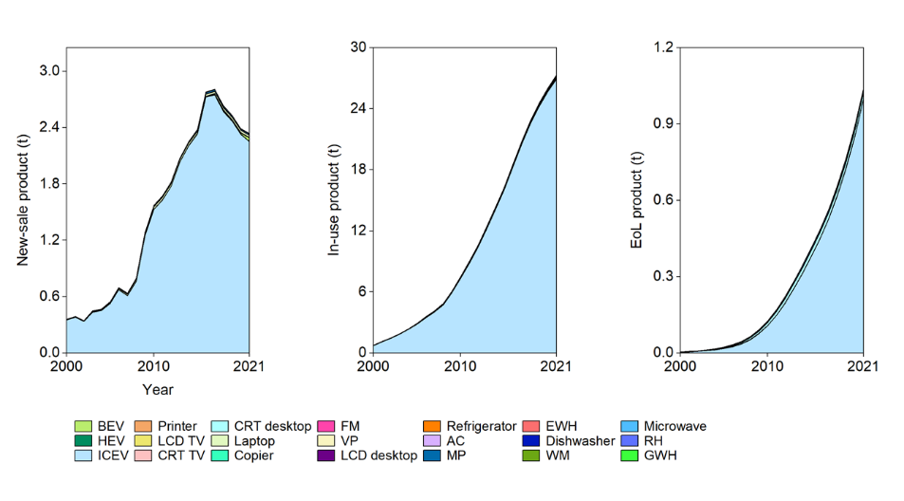  Europium in the new-sale products increased from 357 kg to 2.3 t in 2000−2021 (with a pick, 2.8 t, in 2017). In this period, europium in in-use products increased 36 times to 27 t in 2021, and it in EoL products soared to 1.0 t. The most essential carrier is ICEV.
Recycling¹⁵³ | REEs, including europium, are very challenging to recycle commercially due to their very dispersed use.  Overall EoL recycling ratio (from all applications): <1%²⁵
Occurrence in nature⁴² | Europium is one of the less abundant rare-earth elements: it is almost as abundant as tin. It is never found in nature as a free element, but there are many elements containing europium. The main mining areas are China and USA. Reserves of europium are estimated to be around 150 kt, and the world production of the pure metal is around 100 t a year.

Table 51. Gadolinium characteristics, applications, and recycling
Characteristic | Gadolinium (Gd), a REE, is a silvery-white, malleable and ductile metal with low shear strength. At room temperature to about 1262 °C it crystallizes in the hexagonal, close-packed a form. Thus, gadolinium itself possesses good lubrication ability¹⁷⁰.  Atomic number: 64; relative atomic mass: 157.25; density: 7.90 g/cm³; melting point: 1,313 °C (1,586 K)⁴³
General application⁴⁴ | Gadolinium has useful properties in alloys. Gadolinium improves the machinability of iron and chromium alloys and their resistance to high temperatures and oxidation. It is also used to make alloys for magnets, electronic components, and data storage disks¹⁷¹. Gadolinium compounds can be used in magnetic resonance imaging, especially in the diagnosis of cancerous tumors¹⁷².
Use in automobiles and EEE | 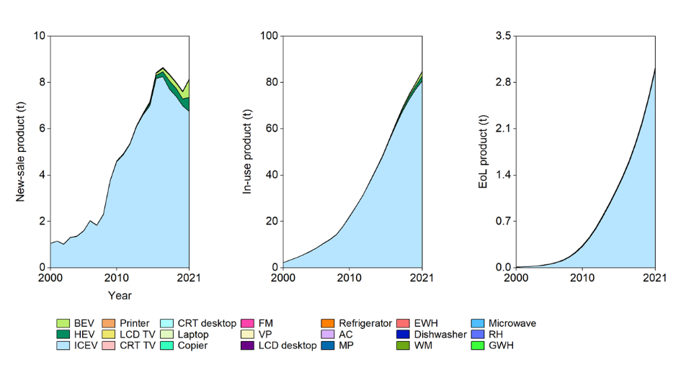  Gadolinium in the new-sale products increased from 1.1 t to 8.2 t in 2000−2021 (with a pick, 8.6 t, in 2017). In this period, gadolinium in in-use products increased 38 times to 85 t in 2021, and it in EoL products soared to 3.0 t. The most essential carriers are ICEV, HEV, and BEV.
Recycling¹⁵³ | REEs, including gadolinium, are very challenging to recycle commercially due to their very dispersed use.  Overall EoL recycling ratio (from all applications): <1%²⁵
Occurrence in nature⁴² | Gadolinium is one of the more abundant rare-earth elements. It is never found as a free element in nature, but it is contained in many rare minerals. The main mining areas are China, the USA, Brazil, Sri Lanka, India, and Australia, with reserves expected to exceed 1 Mt. The world production of pure gadolinium is about 400 t per year.

Table 52. Terbium characteristics, applications, and recycling
Characteristic | Terbium (Tb), a REE, is a silvery-white rare earth metal that is malleable, ductile, and soft enough to be cut with a knife. Terbium burns readily to form a mixed terbium(III, IV) oxide¹⁷³.  Atomic number: 65; relative atomic mass: 158.925; density: 8.23 g/cm³; melting point: 1,356 °C (1,629 K)⁴³
General application⁴⁴ | Terbium is used in low-energy lightbulbs and mercury lamps. Terbium salts are used in laser devices¹⁷⁴. An alloy of terbium, dysprosium, and iron lengthens and shortens in a magnetic field, and this effect forms the basis of loudspeakers that sit on a flat surface, such as a window pane, which then acts as the speaker¹⁷⁵.
Use in automobiles and EEE | 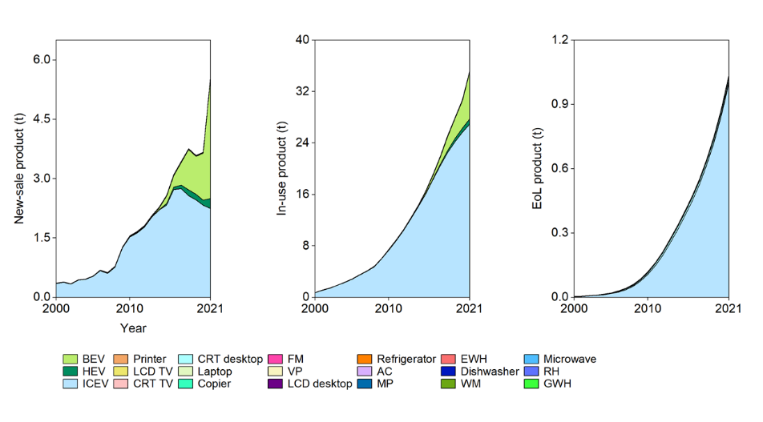  Terbium in the new-sale products increased from 355 kg to 5.6 t in 2000−2021. In this period, terbium in in-use products increased 47 times to 35 t in 2021, and it in EoL products soared to 1.0 t. The most essential carriers are ICEV and BEV.
Recycling¹⁵³ | REEs, including terbium, are very challenging to recycle commercially due to their very dispersed use.  Overall EoL recycling ratio (from all applications): <1%²⁵
Occurrence in nature⁴² | Terbium is one of the rarer REEs, although it is twice as common in the Earth's crust as silver. It is never found in nature as a free element but is contained in many minerals. The most important ore are monazite, bastnasite and cerite. The main mining areas are China, the USA, India, Sri Lanka, Brazil, and Australia, and reserves of terbium are estimated to be around 300 kt. The world production is 10 t a year.

Table 53. Dysprosium characteristics, applications, and recycling
Characteristic | Dysprosium (Dy), a REE, has a metallic, bright silver luster, relatively stable in air at room temperature, but dissolving readily in dilute or concentrated mineral acids with the emission of hydrogen. Soluble dysprosium salts are slightly toxic, while insoluble salts are considered nontoxic¹⁷⁶.  Atomic number: 66; relative atomic mass: 162.500; density: 8.55 g/cm³; melting point: 1,412 °C (1,685 K)⁴³
General application⁴⁴ | Dysprosium’s main use is in alloys for neodymium-based magnets, which is because it is resistant to demagnetization at high temperatures. This property is important for magnets used in motors or generators¹⁷⁷. These magnets are used in wind turbines and electrical vehicles, so demand for dysprosium is growing rapidly. Dysprosium iodide is used in halide discharge lamps. The salt enables the lamps to give out a very intense white light¹⁷⁸.
Use in automobiles and EEE | 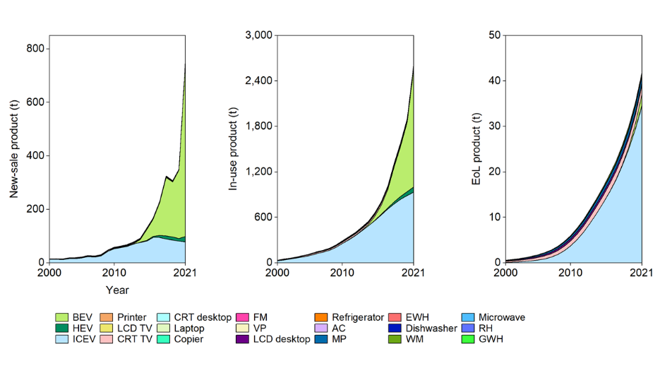  Dysprosium in the new-sale products increased from 14 t to 760 t in 2000−2021. In this period, dysprosium in in-use products increased 75 times to 2,620 t in 2021, and it in EoL products increased 77 times to 42 t. The most essential carriers are ICEV, BEV and CRT TV.
Recycling¹⁵³ | REEs, including dysprosium, are very challenging to recycle commercially due to their very dispersed use. Additionally, as much as 15% recycling rate were reported in some cases¹⁷⁹.  Overall EoL recycling ratio (from all applications): <1%²⁵
Occurrence in nature⁴² | Dysprosium is one of the more abundant lanthanide elements and is more than twice as abundant as tin. Dysprosium is never encountered as a free element, but is found in many minerals. The most important ores are monazite and bastnasite. The world annual production is around 100 t.

Table 54. Erbium characteristics, applications, and recycling
Characteristic | Erbium (Er), a REE, is a silvery-white solid metal when artificially isolated, natural erbium is always found in chemical combination with other elements on Earth¹⁷³.  Atomic number: 68; relative atomic mass: 167.259; density: 9.07 g/cm³; melting point: 1,592 °C (1,802 K)⁴³
General application⁴⁴ | Erbium oxide is occasionally used in infrared absorbing glass, for example, safety glasses for welders and metal workers. When erbium is added to glass, it gives the glass a pink tinge¹⁸⁰. Broadband signals, carried by fiber optic cables, are amplified by including erbium in the glass fiber.
Use in automobiles and EEE | 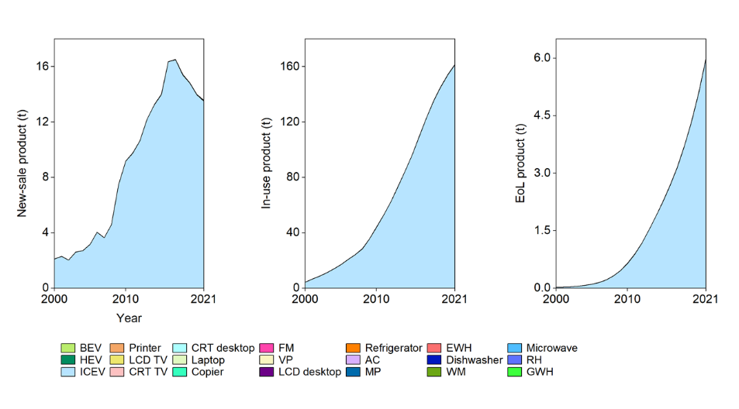  Erbium in the new-sale products increased from 2.1 t to 14 t in 2000−2021 (with a pick, 17 t, in 2017). In this period, erbium in in-use products increased 37 times to 162 t in 2021, and it in EoL products soared to 6.0 t. The most essential carrier is ICEV.
Recycling¹⁵³ | REEs, including erbium, are very challenging to recycle commercially due to their very dispersed use.  Overall EoL recycling ratio (from all applications): <1%²⁵
Occurrence in nature¹⁸¹ | Erbium is primarily obtained through an ion exchange process from the minerals: xenotime and euxenite. It can be extracted by ion exchange and solvent extraction. The world production of erbium is 500 t per year⁴².

Table 55. Scandium characteristics, applications, and recycling
Characteristic | Scandium (Sc), a REE, is a silvery-white metallic d-block element, it has historically been classified as a rare-earth element, together with yttrium and the lanthanides¹⁰².  Atomic number: 21; relative atomic mass: 44.956; density: 2.99 g/cm³; melting point: 1,541 °C (1,814 K)⁴³
General application⁴⁴ | Scandium is mainly used for research purposes. Aluminum-scandium alloys are used in high-end bicycle frames and baseball bats, etc¹⁸². Scandium iodide is added to mercury vapor lamps to produce a highly efficient light source similar to sunlight. These lights help TV cameras reproduce colors well when shooting indoors or at night¹⁸³.
Use in automobiles and EEE | 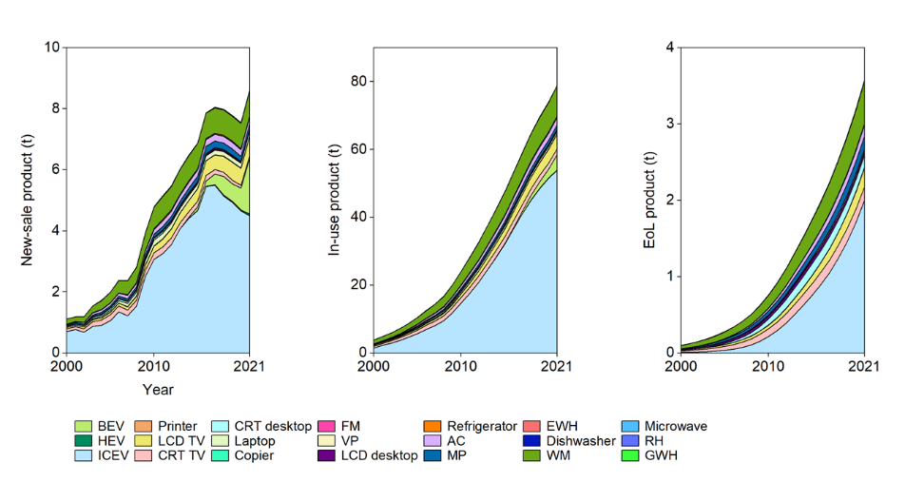  Scandium in the new-sale products increased from 1.1 t to 8.6 t in 2000−2021. In this period, scandium in in-use products increased 21 times to 79 t in 2021, and it in EoL products increased 36 times to 3.6 t. The most essential carriers are ICEV, HEV, BEV, LCD TV, etc.
Recycling¹⁵³ | REEs, including scandium, are very challenging to recycle commercially due to their very dispersed use.  Overall EoL recycling ratio (from all applications): <1%²⁵
Occurrence in nature⁴² | Scandium can rarely be found in nature, as it occurs in very small amounts. Scandium is usually found only in two different kinds of ores. Thortveitite is the primary source of scandium, with uranium mill tailings by-products also being an important source. The world annual production amount to only 50 kg. There is no estimate of how much is potentially available.

Table 56. Yttrium characteristics, applications, and recycling
Characteristic | Yttrium (Y), a REE, is a soft, silver-metallic, lustrous, and highly crystalline transition metal. Yttrium is almost always found in combination with lanthanide elements in rare-earth minerals and is never found in nature as a free element¹⁸⁴.  Atomic number: 39; relative atomic mass: 88.905; density: 4.47 g/cm³; melting point: 1,522 °C (1,795 K)⁴³
General application⁴⁴ | Yttrium-aluminum garnet is used in lasers that can cut through metals. It is also used in white light-emitting diode lights¹⁸⁵. Yttrium oxide is added to the glass used to make camera lenses to make them heat and shock-resistant. It is also used to make superconductors. Yttrium oxysulfide used to be widely used to produce red phosphors for old-style color television tubes¹⁸⁶.
Use in automobiles and EEE | 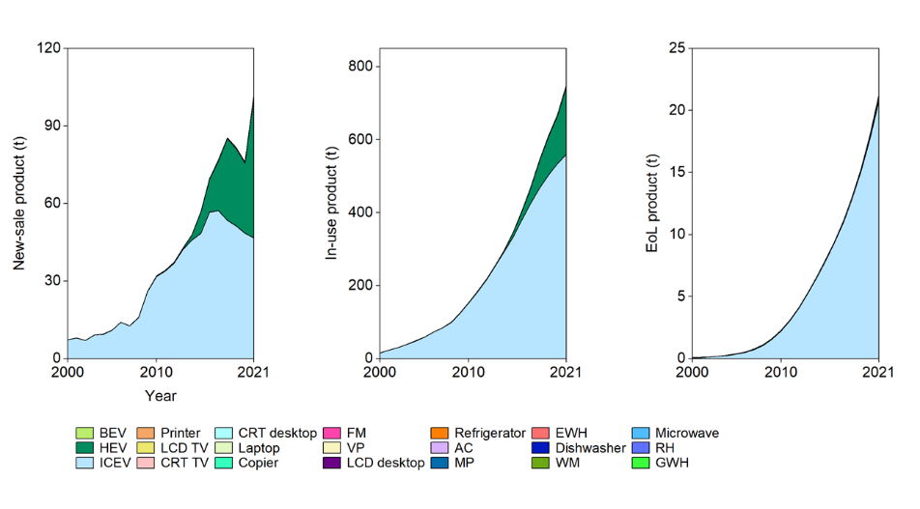  Yttrium in the new-sale products increased from 7.4 t to 102 t in 2000−2021. In this period, yttrium in in-use products increased 49 times to 479 t in 2021, and it in EoL products soared to 21 t. The most essential carriers are ICEV and HEV.
Recycling¹⁵³ | REEs, including yttrium, are very challenging to recycle commercially due to their very dispersed use.  Overall EoL recycling ratio (from all applications): <1%²⁵
Occurrence in nature⁴² | Yttrium never occurs in nature as a free element. It is found in almost all rare earth minerals and uranium ores. The yellow-brown ore xenotime can contain as much as 50% yttrium phosphate. The output of yttrium is about 600 t per year, measured as yttrium oxide, and world reserves are estimated to be around 9 Mt.

Table 57. Mass and value losses of target metals
Metal | Mass |  |  | Value
Metal | LS | HS | Mean | LS | HS | Mean
Metal | Unit: t |  |  | Unit: US$
Fe | 4.17E+06 | 2.03E+06 | 3.10E+06 | 7.92E+08 | 3.87E+08 | 5.90E+08
Al | 7.86E+05 | 2.20E+05 | 5.03E+05 | 1.67E+09 | 4.67E+08 | 1.07E+09
Cu | 9.07E+05 | 2.19E+05 | 5.63E+05 | 5.36E+09 | 1.29E+09 | 3.32E+09
Cr | 6.29E+04 | 2.49E+04 | 4.39E+04 | 6.20E+08 | 2.45E+08 | 4.33E+08
Zn | 2.00E+05 | 2.04E+04 | 1.10E+05 | 5.07E+08 | 5.18E+07 | 2.79E+08
Sn | 7.02E+03 | 5.50E+03 | 6.26E+03 | 1.32E+08 | 1.03E+08 | 1.17E+08
Mg | 5.05E+04 | 1.16E+04 | 3.11E+04 | 1.17E+08 | 2.68E+07 | 7.17E+07
In | 6.44E+01 | 2.33E+01 | 4.39E+01 | 1.41E+07 | 5.09E+06 | 9.57E+06
Ni | 2.99E+04 | 4.87E+03 | 1.74E+04 | 3.65E+08 | 5.95E+07 | 2.12E+08
Li | 1.38E+03 | 1.58E+02 | 7.67E+02 | 3.62E+07 | 4.16E+06 | 2.02E+07
Co | 7.01E+02 | 6.24E+02 | 6.62E+02 | 3.05E+07 | 2.71E+07 | 2.88E+07
Pb | 6.59E+04 | 4.67E+04 | 5.63E+04 | 1.35E+08 | 9.55E+07 | 1.15E+08
Ag | 3.23E+02 | 1.66E+02 | 2.44E+02 | 1.99E+08 | 1.02E+08 | 1.50E+08
Au | 2.12E+01 | 1.41E+01 | 1.76E+01 | 1.04E+09 | 6.89E+08 | 8.64E+08
PGM | 2.91E+01 | 7.06E+00 | 1.81E+01 | 1.34E+09 | 3.40E+08 | 8.42E+08
REE | 1.10E+03 | 1.10E+03 | 1.10E+03 | 3.10E+07 | 3.08E+07 | 3.09E+07
Other metals | 8.83E+04 | 8.83E+04 | 8.83E+04 | 1.63E+08 | 1.63E+08 | 1.63E+08
Measuring the value of materials is an essential complement to mass-based metrics. Recycled value retention rates provide information on quality, price, and practical options for replacing new merchandise with recycled content. It also uncovers new revenue opportunities for the private sector and thus may spur innovation. For example, European public statistics are already improving, with indicators shifting from the proportion of sorted, recycled material to an indicator showing the value of recycled material produced, sold, or lost¹⁸⁷. Thus, price and quality data would be an excellent addition.

Table 58. Raw material demands for target industries in China in 2021
Metal | Automobile | EEE
Metal | Unit: t
PGM | 1.31E+02 | 4.42E+00
Ni | 1.62E+05 | 1.19E+02
Cu | 1.40E+06 | 1.98E+06
Li | 3.62E+04 | 1.26E+03
In | 2.81E+01 | 8.28E+01
Co | 2.42E+04 | 8.29E-01
Au | 7.67E+01 | 1.09E+01
Al | 4.12E+06 | 1.27E+06
Ag | 7.80E+02 | 5.11E+01
Pb | 3.89E+05 | 9.80E+01
Mg | 1.57E+05 | 6.96E+01
Zn | 6.37E+05 | 2.49E+02
Sn | 1.63E+04 | 3.91E+03
Fe | 1.97E+07 | 8.68E+06
Cr | 2.49E+05 | 1.78E+01
REE | 6.89E+03 | 8.97E+01
Other metals | 5.35E+05 | 2.07E+02
Total | 2.74E+07 | 1.19E+07

Table 59. Sensitivity analysis
Parameter, x | Sensitivity, S(x)
Parameter, x | When x +10% | When x -10%
Metal concentration | 109.95% | 90.00%
Product weight | 110.00% | 90.00%
Product new-sale number | 110.02% | 90.00%
Product lifespan distribution shape parameter | 98.25% | 101.94%
Product lifespan distribution scale parameter | 86.62% | 116.13%
Metal price | 100.02% | 99.98%
Economic threshold | 101.57% | 98.68%
Material separation ratio | 104.74% | 90.00%
Material recovery ratio | 109.67% | 90.00%
Note, dismantling ratio has an upper limit of 100%, therefore, when the collection level has reached 75–100%, it can only increase to 83–100%. The most sensitive parameter is product lifespan distribution scale parameter, which means that the lifespan data of products is essential for our estimation model. Other important parameters are product new-sale number, product weight, metal concentration, material recovery ratio, and material separation ratio. Parameter has the lowest sensitivity is metal price, because the AMB threshold of relative economic proportion (as a percentage) can offset the change in the input data when all metal prices go up or down. This is an advantage of our model, which can avoid errors caused by the statistical caliber of prices.

References

1. National Development and Reform Commission of China. Notice on construction of anthropogenic mineral demonstration base (in Chinese): http://www.gov.cn/zwgk/2010-05/27/content_1614890.htm (Accessed May 2022).

2. Mineral commodity summaries 2021. United States Geological Survey (USGS), Reston, Virginia, the U.S. (2021).

3. Elshkaki, A., Graedel, T. E., Ciacci, L. & Reck, B. K. Resource Demand Scenarios for the Major Metals. Environ Sci Technol 52, 2491-2497 (2018).

4. Nuss, P. & Eckelman, M. J. Life Cycle Assessment of Metals: A Scientific Synthesis. PLOS One 9, e101298 (2014).

5. Xu, G., Yano, J. & Sakai, S. Recycling Potentials of Precious Metals from End-of-Life Vehicle Parts by Selective Dismantling. Environ Sci Technol 53, 733-742 (2019).

6. Zeng, X., Gong, R., Chen, W.-Q. & Li, J. Uncovering the Recycling Potential of “New” WEEE in China. Environ Sci Technol 50, 1347-1358 (2016).

7. Zeng, X., Ali, S. H., Tian, J. & Li, J. Mapping anthropogenic mineral generation in China and its implications for a circular economy. Nat Commun 11, 1544 (2020).

8. Yano, J., Xu, G., Liu, H., Toyoguchi, T., Iwasawa, H. & Sakai, S.-i. Resource and toxic characterization in end-of-life vehicles through dismantling survey. J Mater Cycles Waste Manag 21, 1488-1504 (2019).

9. Islam, M. T. & Huda, N. Assessing the recycling potential of "unregulated" e-waste in Australia. Resour Conserv Recycl 152, 15 (2020).

10. The Global E-waste Monitor – 2017. United Nations University, Tokyo, Japan (2017).

11. PConline. Product base (in Chinese): https://www.pconline.com.cn/ (Accessed May 2022).

12. Holgersson, S., Steenari, B.-M., Björkman, M. & Cullbrand, K. Analysis of the metal content of small-size Waste Electric and Electronic Equipment (WEEE) printed circuit boards—part 1: Internet routers, mobile phones and smartphones. Resour Conserv Recycl 133, 300-308 (2018).

13. Alonso, E. et al. An Assessment of the Rare Earth Element Content of Conventional and Electric Vehicles. SAE Int J Mater Manuf 5, 473-477 (2012).

14. Cullbrand, K.; Magnusson, O., The Use of Potentially Critical Materials in Passenger Cars [D], Chalmers University of Technology (2012).

15. Field, F. R., Wallington, T. J., Everson, M. & Kirchain, R. E. Strategic Materials in the Automobile: A Comprehensive Assessment of Strategic and Minor Metals Use in Passenger Cars and Light Trucks [J]. Environ Sci Technol 51, 14436-14444 (2017).

16. Bhuwalka, K., Field, F. R., De Kleine, R. D., Kim, H. C., Wallington, T. J. & Kirchain, R. E. Characterizing the Changes in Material Use due to Vehicle Electrification. Environ Sci Technol 55, 10097-10107 (2021).

17. Yan, G., Xue, M. & Xu, Z. Disposal of waste computer hard disk drive: data destruction and resources recycling. Waste Manag Res 31, 559-567 (2013).

18. Christian, B., Romanov, A., Romanova, I. & Turbini, L. J. Elemental Compositions of Over 80 Cell Phones. J Electron Mater 43, 4199-4213 (2014).

19. Oguchi, M., Murakami, S., Sakanakura, H., Kida, A. & Kameya, T. A preliminary categorization of end-of-life electrical and electronic equipment as secondary metal resources. Waste Manage 31, 2150-2160 (2011).

20. National Bureau of Statistics of China. National data (in Chinese): https://data.stats.gov.cn/index.htm (Accessed May 2022).

21. Zhonghong Industry Research Platform. Secondary industry (in Chinese): http://mcin.macrochina.cn/MacroCy/index.html (Accessed May 2022).

22. Oguchi, M. & Fuse, M. Regional and Longitudinal Estimation of Product Lifespan Distribution: A Case Study for Automobiles and a Simplified Estimation Method [J]. Environ Sci Technol 49, 1738-1743 (2015).

23. Metal Recycling: Opportunities, Limits, Infrastructure. United Nations Environment Programme (UNEP), Nairobi, Kenya (2013).

24. Mineral commodity summaries 2020. United States Geological Survey (USGS), Reston, Virginia, the U.S. (2020).

25. Recycling Rates of Metals: A Status Report. United Nations Environment Programme (UNEP), Nairobi, Kenya (2011).

26. Gronostajski, J., Marciniak, H. & Matuszak, A. New methods of aluminium and aluminium-alloy chips recycling. J Mater Process Technol 106, 34-39 (2000).

27. Soulier, M. et al. The Chinese copper cycle: Tracing copper through the economy with dynamic substance flow and input-output analysis. J Clean Prod 195, 435-447 (2018).

28. Yan, L., Wang, A., Chen, Q. & Li, J. Dynamic material flow analysis of zinc resources in China. Resour Conserv Recycl 75, 23-31 (2013).

29. International Magnesium Association, Magnesium recycling in the EU - Material flow analysis of magnesium (metal) in the EU and a derivation of the recycling rate, Minnesota, the U.S. (2017).

30. Chen, M. et al. Recycling End-of-Life Electric Vehicle Lithium-Ion Batteries. Joule 3, 2622-2646 (2019).

31. Pan, H., Geng, Y., Dong, H., Ali, M. & Xiao, S. Sustainability evaluation of secondary lead production from spent lead acid batteries recycling. Resour Conserv Recycl 140, 13-22 (2019).

32. Islam, A. et al. Advances in sustainable approaches to recover metals from e-waste-A review. J Clean Prod 244, 118815 (2020).

33. Ding, Y., Zhang, S., Liu, B., Zheng, H., Chang, C.-c. & Ekberg, C. Recovery of precious metals from electronic waste and spent catalysts: A review. Resour Conserv Recycl 141, 284-298 (2019).

34. Ministry of Land and Resources of China. National Mineral Resources Plan (2016-2020) (in Chinese): https://www.cgs.gov.cn/tzgg/tzgg/201612/t20161206_418714.html (Accessed May 2022).

35. Map of the Earth, Distribution map of major non-energy minerals in China (in Chinese): http://ditu.ps123.net/china/11428.html (Accessed May 2022).

36. China Mineral Resources 2021. Ministry of Natural Resources of China, Beijing, China (2021).

37. Habib, K. A product classification approach to optimize circularity of critical resources – the case of NdFeB magnets. J Clean Prod 230, 90-97 (2019).

38. Maung, K. N., Hashimoto, S., Mizukami, M., Morozumi, M. & Lwin, C. M. Assessment of the Secondary Copper Reserves of Nations. Environ Sci Technol 51, 3824-3832 (2017).

39. Maung, K. N., Yoshida, T., Liu, G., Lwin, C. M., Muller, D. B. & Hashimoto, S. Assessment of secondary aluminum reserves of nations. Resour Conserv Recycl 126, 34-41 (2017).

40. Maung, K. N., Lwin, C. M. & Hashimoto, S. Assessment of secondary zinc reserves of nations. J Ind Ecol 23, 1109-1120 (2019).

41. Müller, E., Hilty, L. M., Widmer, R., Schluep, M. & Faulstich, M. Modeling Metal Stocks and Flows: A Review of Dynamic Material Flow Analysis Methods. Environ Sci Technol 48, 2102-2113 (2014).

42. Lenntech. Elements: https://www.lenntech.com/periodic/elements/index.htm (Accessed May 2022).

43. Thomas Jefferson National Accelerator Facility. The Periodic Table of Elements: https://education.jlab.org/itselemental/ (Accessed May 2022).

44. Royal Society of Chemistry. Periodic Table: https://www.rsc.org/periodic-table/ (Accessed May 2022).

45. Link, H. & Schmitt, R. Iron, Carbon Steel, and Alloy Steel. Materials of Construction Review. Industrial & Engineering Chemistry 53, 590-595 (1961).

46. Coey, J. M. D. Magnetic materials. Journal of Alloys and Compounds 326, 2-6 (2001).

47. Britannica. Recycling: https://www.britannica.com/science/recycling (Accessed May 2022).

48. British Geological Survey. Data: https://www.bgs.ac.uk/geological-data/ (Accessed May 2022).

49. Sharma, A. K., Bhandari, R., Aherwar, A., Rimašauskienė, R. & Pinca-Bretotean, C. A study of advancement in application opportunities of aluminum metal matrix composites. Materials Today: Proceedings 26, 2419-2424 (2020).

50. Varshney, D. & Kumar, K. Application and use of different aluminium alloys with respect to workability, strength and welding parameter optimization. Ain Shams Engineering Journal 12, 1143-1152 (2021).

51. United States Environmental Protection Agency. Wastes - WasteWise Program: https://archive.epa.gov/epawaste/conserve/smm/wastewise/web/html/factoid.html (Accessed May 2022).

52. Liu, G., Bangs, C. E. & Müller, D. B. Stock dynamics and emission pathways of the global aluminium cycle. Nat Clim Chang 3, 338-342 (2013).

53. Yadav, P., Dwivedi, S. P., Shahnawaz, M., Singh, A. & Yadav, J. Development of copper based composite by stir casting technique. Materials Today: Proceedings 25, 649-653 (2020).

54. Liu, S. et al. Recycling the domestic copper scrap to address the China’s copper sustainability. Journal of Materials Research and Technology 9, 2846-2855 (2020).

55. Copper Development Association. Applications: https://copper.org/applications/ (Accessed May 2022).

56. International Copper Association. Copper Recycling: https://copperalliance.org/resource/copper-recycling/#:~:text=Copper%20is%20100%25%20Recyclable&text=There%20is%20also%20no%20difference,they%20can%20be%20used%20interchangeably.&text=Recycling%20copper%20is%20a%20highly,material%20back%20into%20the%20economy (Accessed May 2022).

57. Umicore. Our metals: https://www.umicore.com/en/about/our-metals/ (Accessed May 2022).

58. Gordon, R. B. Production residues in copper technological cycles. Resources, Conservation and Recycling 36, 87-106 (2002).

59. European Chemicals Agency. Substance Information: Chromium trioxide: https://echa.europa.eu/substance-information/-/substanceinfo/100.014.189 (Accessed May 2022).

60. Lunk, H.-J. Discovery, properties and applications of chromium and its compounds. ChemTexts 1, 6 (2015).

61. Sivaram, N. & Barik, D. Toxic waste from leather industries. In: Energy from toxic organic waste for heat and power generation). Elsevier (2019).

62. Srivastava, R. R., Kim, M.-s., Lee, J.-c., Jha, M. K. & Kim, B.-S. Resource recycling of superalloys and hydrometallurgical challenges. Journal of Materials Science 49, 4671-4686 (2014).

63. 911Metallurgist. Chromium Recycling: https://www.911metallurgist.com/chromium-recycling/#:~:text=Chromium%20chemicals%20generally%20are%20consumed,and%20thus%20are%20not%20recycled (Accessed May 2022).

64. ScienceDirect. Chromite Ore: https://www.sciencedirect.com/topics/engineering/chromite-ore (Accessed May 2022).

65. Gordon, R. et al. The characterization of technological zinc cycles. Resources, Conservation and Recycling 39, 107-135 (2003).

66. Jamshaid, M., Khan, A. A., Ahmed, K. & Saleem, M. Heavy metal in drinking water its effect on human health and its treatment techniques-a review. Int J Biosci 12, 223-240 (2018).

67. International Zinc Association. About Cycles, Recycling, and Circular Economy: https://sustainability.zinc.org/recycling/ (Accessed May 2022).

68. Chemicool. Tin Element Facts: https://www.chemicool.com/elements/tin.html (Accessed May 2022).

69. Zhang, Y. Tin and tin alloys for lead-free solder. Mod Electroplat 139, 204 (2011).

70. Godeke, A., Den Ouden, A., Nijhuis, A. & ten Kate, H. H. State of the art powder-in-tube niobium–tin superconductors. Cryogenics 48, 308-316 (2008).

71. International Tin Association. Tin Recycling: https://www.internationaltin.org/recycling/ (Accessed May 2022).

72. Britannica. Tin processing: https://www.britannica.com/technology/tin-processing#ref82118 (Accessed May 2022).

73. Jafarian, H. R., Sabzi, M., Mousavi Anijdan, S. H., Eivani, A. R. & Park, N. The influence of austenitization temperature on microstructural developments, mechanical properties, fracture mode and wear mechanism of Hadfield high manganese steel. Journal of Materials Research and Technology 10, 819-831 (2021).

74. Sabzi, M., Far, S. M. & Dezfuli, S. M. Effect of melting temperature on microstructural evolutions, behavior and corrosion morphology of Hadfield austenitic manganese steel in the casting process. International Journal of Minerals, Metallurgy, and Materials 25, 1431-1438 (2018).

75. Hagelstein, K. Globally sustainable manganese metal production and use. Journal of Environmental Management 90, 3736-3740 (2009).

76. Mordike, B. & Ebert, T. Magnesium: properties—applications—potential. Materials Science and Engineering: A 302, 37-45 (2001).

77. Zhu, Z. et al. Magnesium hydroxide coated hollow glass microspheres/chitosan composite aerogels with excellent thermal insulation and flame retardancy. Journal of Colloid and Interface Science 612, 35-42 (2022).

78. Britannica. Magnesium: https://www.britannica.com/science/magnesium (Accessed May 2022).

79. Dupont, D., Arnout, S., Jones, P. T. & Binnemans, K. Antimony Recovery from End-of-Life Products and Industrial Process Residues: A Critical Review. Journal of Sustainable Metallurgy 2, 79-103 (2016).

80. Turner, A. & Filella, M. Antimony in paints and enamels of everyday items. Science of the total environment 713, 136588 (2020).

81. Liu, T. & Qiu, K. Removing antimony from waste lead storage batteries alloy by vacuum displacement reaction technology. Journal of Hazardous Materials 347, 334-340 (2018).

82. Kumar, N. & Maurya, A. Development of lead free solder for electronic components based on thermal analysis. Materials Today: Proceedings, (2022).

83. Ojebuoboh, F. K. Bismuth—Production, properties, and applications. JOM 44, 46-49 (1992).

84. Deady, E., Moon, C., Moore, K., Goodenough, K. M. & Shail, R. K. Bismuth: Economic geology and value chains. Ore Geology Reviews 143, 104722 (2022).

85. Michaux, S. Outlook for Tungsten. (2021).

86. Zeiler, B., Bartl, A. & Schubert, W.-D. Recycling of tungsten: Current share, economic limitations, technologies and future potential. International Journal of Refractory Metals and Hard Materials 98, 105546 (2021).

87. Koutsospyros, A., Braida, W., Christodoulatos, C., Dermatas, D. & Strigul, N. A review of tungsten: from environmental obscurity to scrutiny. Journal of hazardous materials 136, 1-19 (2006).

88. Zeng, H. et al. Kondo effect and superconductivity in niobium with iron impurities. Scientific Reports 11, 14256 (2021).

89. Stanford Advanced Materials. What are the Applications of Niobium: https://www.samaterials.com/content/what-are-the-applications-of-niobium.html (Accessed May 2022).

90. McCaffrey, D. M., Nassar, N. T., Jowitt, S. M., Padilla, A. J. & Bird, L. R. Embedded critical material flow: The case of niobium, the United States, and China. Resources, Conservation and Recycling 188, 106698 (2023).

91. Rudnick, R. L. & Gao, S. 3.01 - Composition of the Continental Crust. In: Treatise on Geochemistry (eds Holland HD, Turekian KK). Pergamon (2003).

92. Chemicool. Vanadium Element Facts: https://www.chemicool.com/elements/vanadium.html (Accessed May 2022).

93. Moskalyk, R. & Alfantazi, A. Processing of vanadium: a review. Minerals engineering 16, 793-805 (2003).

94. Bjergfelt, M. et al. Superconducting vanadium/indium-arsenide hybrid nanowires. Nanotechnology 30, 294005 (2019).

95. Vanadium Recycling in the United States in 2004. United States Department of the Interior, Washington, D.C., the US (2004).

96. Han, Z., Zhou, S., Chen, H., Niu, H. & Wang, N. Enhancement of the hydrogen storage properties of Mg/C nanocomposites prepared by reactive milling with molybdenum. Journal of Wuhan University of Technology-Mater Sci Ed 32, 299-304 (2017).

97. dos Reis, A., de Ataide, M. G., de Souza, J. A. G., Vaughan, L. L. T., Viana, R. & Machado, Á. R. Machinability of high strength molybdenum-refined graphite grey cast iron and conventional vermicular automobile engine heads using heptagonal and double-sided carbide inserts. (2022).

98. Shields, J. A. & Lipetzky, P. Molybdenum applications in the electronics market. JOM 52, 37-39 (2000).

99. Molybdenum scrap saves resources. International Molybdenum Associatio, London, the UK (2013).

100. Liu, Z., Zheng, R., Ratinac, K. R. & Ringer, S. P. THE BEHAVIOR OF GALLIUM CONFINED IN CARBON NANOTUBES DURING HEATING AND COOLING. Functional Materials Letters 01, 55-58 (2008).

101. DenBaars, S. P. et al. Development of gallium-nitride-based light-emitting diodes (LEDs) and laser diodes for energy-efficient lighting and displays. Acta Materialia 61, 945-951 (2013).

102. Emsley, J. Nature's building blocks: an AZ guide to the elements. Oxford University Press (2011).

103. Kasera, R. & Khan, M. Semiconductor Devices and Electronic World. Journal of Pure Applied and Industrial Physics 9, 29-39 (2019).

104. Ruiz, A. G., Sola, P. C., Palmerola, N. M. & Lee, S. Germanium: current and novel recovery processes. Advanced material and device applications with germanium, (2018).

105. Niu, B., Chen, Z. & Xu, Z. Application of pyrolysis to recycling organics from waste tantalum capacitors. Journal of hazardous materials 335, 39-46 (2017).

106. Blakey-Milner, B. et al. Metal additive manufacturing in aerospace: A review. Materials & Design 209, 110008 (2021).

107. Baker, I. Titanium. In: Fifty Materials That Make the World). Springer (2018).

108. Gázquez, M. J., Bolívar, J. P., García-Tenorio García-Balmaseda, R. & Vaca, F. A review of the production cycle of titanium dioxide pigment. (2014).

109. Alnor Industries. Titanium recycling and its various scrap grades: https://alnorindustries.com/a-brief-overview-of-titanium-recycling-and-its-scrap-grades.html#:~:text=How%20is%20titanium%20recycled%3F,instead%20processed%20using%20this%20method (Accessed May 2022).

110. Walsh, K. A. Beryllium chemistry and processing. ASM international (2009).

111. Naik, B. & Sivasubramanian, N. Applications of beryllium and its alloys. Mineral Processing and Extractive Metullargy Review 13, 243-251 (1994).

112. Zheng, L. F., Wang, X. G., Yue, L. N., Xie, Y. J., Wu, B. P. & Zhong, J. M. Progress in the application of rare light metal beryllium. In: Materials Science Forum). Trans Tech Publ (2020).

113. Beryllium Science and Technology Association. ABOUT BERYLIUM: https://www.berylliumsafety.eu/recycling-beryllium (Accessed May 2022).

114. Petar, A. V. Thallium. US Department of Commerce, Bureau of Mines (1931).

115. Genchi, G., Carocci, A., Lauria, G., Sinicropi, M. S. & Catalano, A. Thallium use, toxicity, and detoxification therapy: an overview. Applied Sciences 11, 8322 (2021).

116. Raghvender, R., Bouzid, A., Hamani, D., Thomas, P. & Masson, O. A Buckingham interatomic potential for thallium oxide (Tl2O): Application to the case of thallium tellurite glasses. Computational Materials Science 201, 110891 (2022).

117. Rickwood, C., King, M. & Huntsman-Mapila, P. Assessing the fate and toxicity of thallium I and thallium III to three aquatic organisms. Ecotoxicology and Environmental Safety 115, 300-308 (2015).

118. Hein, J. R., Koschinsky, A. & Kuhn, T. Deep-ocean polymetallic nodules as a resource for critical materials. Nature Reviews Earth & Environment 1, 158-169 (2020).

119. Sharmin, S. Study of the structural, optical and electrical properties of indium doped zinc oxide thin films synthesized by spray pyrolysis technique. (2017).

120. Licht, C., Peiró, L. T. & Villalba, G. Global substance flow analysis of gallium, germanium, and indium: quantification of extraction, uses, and dissipative losses within their anthropogenic cycles. Journal of Industrial Ecology 19, 890-903 (2015).

121. Lee, H. J., Gamel, M. M. A., Ker, P. J., Jamaludin, M. Z., Wong, Y. H. & David, J. P. Absorption Coefficient of Bulk III-V Semiconductor Materials: A Review on Methods, Properties and Future Prospects. Journal of Electronic Materials, 1-26 (2022).

122. Barceloux, D. G. & Barceloux, D. Nickel. Journal of Toxicology: Clinical Toxicology 37, 239-258 (1999).

123. Arun, V. et al. Review on Li-Ion Battery vs Nickel Metal Hydride Battery in EV. Advances in Materials Science and Engineering 2022, (2022).

124. Reck, B. K., Müller, D. B., Rostkowski, K. & Graedel, T. Anthropogenic nickel cycle: Insights into use, trade, and recycling. Environ Sci Technol 42, 3394-3400 (2008).

125. Queffurus, M. & Barnes, S.-J. A review of sulfur to selenium ratios in magmatic nickel–copper and platinum-group element deposits. Ore Geology Reviews 69, 301-324 (2015).

126. Johanson, P. Lithium. The Rosen Publishing Group, Inc (2007).

127. Liang, Y. et al. A review of rechargeable batteries for portable electronic devices. InfoMat 1, 6-32 (2019).

128. Wang, B.-J., Luan, J.-Y., Xu, D.-K., Sun, J., Li, C.-Q. & Han, E.-H. Research progress on the corrosion behavior of magnesium–lithium-based alloys: a review. Acta Metallurgica Sinica (English Letters) 32, 1-9 (2019).

129. Tarhan, C. & Çil, M. A. A study on hydrogen, the clean energy of the future: Hydrogen storage methods. Journal of Energy Storage 40, 102676 (2021).

130. Ma, Z., Mohapatra, J., Wei, K., Liu, J. P. & Sun, S. Magnetic Nanoparticles: Synthesis, Anisotropy, and Applications. Chemical Reviews, (2021).

131. Mohapatra, J., Xing, M., Elkins, J. & Liu, J. P. Hard and semi-hard magnetic materials based on cobalt and cobalt alloys. Journal of Alloys and Compounds 824, 153874 (2020).

132. Cutler, C. P. Use of metals in our society. In: Metal allergy). Springer (2018).

133. Boldyrev, M. Lead: Properties, history, and applications. WikiJournal of Science 1, 1-23 (2018).

134. De Keersmaecker, M., Dowsett, M. & Adriaens, M. A short historical overview on the use of lead. Chemical interactions between cultural artefacts and indoor environment, 193-214 (2018).

135. Le Roux, G., De Vleeschouwer, F., Weiss, D., Masson, O., Pinelli, E. & Shotyk, W. Learning from the past: Fires, architecture, and environmental lead emissions.). ACS Publications (2019).

136. Huang, B., Pan, Z., Su, X. & An, L. Recycling of lithium-ion batteries: Recent advances and perspectives. Journal of Power Sources 399, 274-286 (2018).

137. Watt, S. Silver. Marshall Cavendish (2003).

138. Niedderer, K., Johns, P. & Harrison, C. Exploring the Creative Possibilities of Argentium™ Sterling Silver. (2006).

139. Cheng, T. et al. Silver tape: Inkjet-printed circuits peeled-and-transferred on versatile substrates. Proceedings of the ACM on Interactive, Mobile, Wearable and Ubiquitous Technologies 4, 1-17 (2020).

140. Eckelman, M. J. & Graedel, T. Silver emissions and their environmental impacts: a multilevel assessment. Environ Sci Technol 41, 6283-6289 (2007).

141. Grimwade, M. The metallurgy of gold. Interdisciplinary Science Reviews 17, 371-381 (1992).

142. Ling, S., Xu, L., Li, D. & Zhai, G. Fretting wear reliability assessment methodology of gold-plated electrical connectors considering manufacture parameters distribution. Microelectronics Reliability 114, 113787 (2020).

143. Goodman, P. Current and future uses of gold in electronics. Gold bulletin 35, 21-26 (2002).

144. Gold.Info. Gold Recycling – the Environmentally-Friendly Alternative: https://www.gold.info/en/gold-recycling/ (Accessed May 2022).

145. Keefe, J. C. & Rome, N. A brief introduction to precious metals. AMMTIAC Quarterly 2, 9-14 (2007).

146. Panda, R., Jha, M. K., Lee, J.-c. & Pathak, D. D. Developed Commercial Processes to Recover Au, Ag, Pt, and Pd from E-waste. In: Rare Metal Technology 2021). Springer (2021).

147. Xun, D., Hao, H., Sun, X., Liu, Z. & Zhao, F. End-of-life recycling rates of platinum group metals in the automotive industry: Insight into regional disparities. Journal of Cleaner Production 266, 121942 (2020).

148. Tercero, L. Report on the future use of critical raw materials. SCRREEN project, Deliverable D 2, (2019).

149. Kritsanaviparkporn, E., Baena-Moreno, F. M. & Reina, T. Catalytic converters for vehicle exhaust: Fundamental aspects and technology overview for newcomers to the field. Chemistry 3, 630-646 (2021).

150. Wu, W., Liu, J., Zhang, Y., Wang, X. & Zhang, Y. The influence of current density and bath temperature on electrodeposition of rhodium film from sulfate–phosphate aqueous solutions. Journal of Applied Electrochemistry 49, 1043-1054 (2019).

151. Schlapbach, L. Hydrogen-fuelled vehicles. Nature 460, 809-811 (2009).

152. Vargas, S. J., Schaeffer, N., Souza, J. C., da Silva, L. H. & Hespanhol, M. C. Green separation of lanthanum, cerium and nickel from waste nickel metal hydride battery. Waste Management 125, 154-162 (2021).

153. Balaram, V. Rare earth elements: A review of applications, occurrence, exploration, analysis, recycling, and environmental impact. Geoscience Frontiers 10, 1285-1303 (2019).

154. Sinha, S., Meshram, P. & Pandey, B. D. Metallurgical processes for the recovery and recycling of lanthanum from various resources—A review. Hydrometallurgy 160, 47-59 (2016).

155. Scirè, S. & Palmisano, L. Cerium and cerium oxide: a brief introduction. In: Cerium Oxide (CeO₂): Synthesis, Properties and Applications). Elsevier (2020).

156. Nouri, A. & Wen, C. Stainless steels in orthopedics. In: Structural Biomaterials). Elsevier (2021).

157. Innocenzi, V. & Veglio, F. Recovery of rare earths and base metals from spent nickel-metal hydride batteries by sequential sulphuric acid leaching and selective precipitations. Journal of Power Sources 211, 184-191 (2012).

158. Gupta, V. K., Goyal, R. N., Pal, M. K. & Sharma, R. A. Comparative studies of praseodymium (III) selective sensors based on newly synthesized Schiff's bases. Analytica chimica acta 653, 161-166 (2009).

159. Yang, Y., Lan, C., Guo, L., An, Z., Zhao, Z. & Li, B. Recovery of rare-earth element from rare-earth permanent magnet waste by electro-refining in molten fluorides. Separation and Purification Technology 233, 116030 (2020).

160. Hua, Z. et al. Selective extraction of rare earth elements from NdFeB scrap by molten chlorides. ACS Sustainable Chemistry & Engineering 2, 2536-2543 (2014).

161. Rajasekhar, T. M. K., Sushanth, V. S. & Sumathi, M. Study and practical investigations of Nano Supercapacitors. Materials Today: Proceedings 24, 2309-2317 (2020).

162. Bailey, G. et al. Life cycle inventory of samarium-cobalt permanent magnets, compared to neodymium-iron-boron as used in electric vehicles. Journal of Cleaner Production 286, 125294 (2021).

163. Papai, R. et al. Additivity of optical emissions applied to neodymium and praseodymium quantification in metallic didymium and (Nd, Pr)-Fe-B alloy samples by low-resolution atomic emission spectrometry: An evaluation of the mathematical approach used to solve spectral interferences. Analytica chimica acta 1085, 21-28 (2019).

164. Yao, T., Geng, Y., Sarkis, J., Xiao, S. & Gao, Z. Dynamic neodymium stocks and flows analysis in China. Resources, Conservation and Recycling 174, 105752 (2021).

165. Velez, C. et al. Investigation of ferromagnetic resonance shift in screen-printed barium ferrite/samarium cobalt composites. IEEE Transactions on Microwave Theory and Techniques 67, 3230-3236 (2019).

166. Balaram, V. Sources and applications of rare earth elements. (2022).

167. Kaphle, K. P. Rare earth elements, their occurrences and industrial uses. NEPAL GEOLOGICAL SOCIETY 30, 49-56 (2013).

168. Shinde, K. & Dhoble, S. Europium-activated orthophosphate phosphors for energy-efficient solid-state lighting: a review. Critical Reviews in Solid State and Materials Sciences 39, 459-479 (2014).

169. Borukhovich, A. S. & Troshin, A. V. Europium Monoxide. Springer (2018).

170. Boshui, C., Junxiu, D. & Guoxu, C. Tribochemistry of gadolinium dialkyldithiophosphate. Wear 196, 16-20 (1996).

171. Preinfalk, C. & Morteani, G. The industrial applications of rare earth elements. In: Lanthanides, tantalum and niobium). Springer (1989).

172. Cheng, Z., Thorek, D. L. & Tsourkas, A. Gadolinium‐conjugated dendrimer nanoclusters as a tumor‐targeted T1 magnetic resonance imaging contrast agent. Angewandte Chemie 122, 356-360 (2010).

173. Lekha, L. Studies on the synthesis, characterisation and antimicrobial applications of rare earth metal schiff base complexes.). BS ABDUR RAHMAN UNIVERSITY (2014).

174. Zhang, J., Anawati, J. & Azimi, G. Urban mining of terbium, europium, and yttrium from real fluorescent lamp waste using supercritical fluid extraction: Process development and mechanistic investigation. Waste Management 139, 168-178 (2022).

175. Rahman, A. Study of magnetostriction and magneto mechanical coupling factors of some magnetostrictive materials. (1996).

176. Zamani, H. A., Faridbod, F. & Ganjali, M. R. Dysprosium selective potentiometric membrane sensor. Materials Science and Engineering: C 33, 608-612 (2013).

177. Jha, A. R. Rare earth materials: properties and applications. CRC Press (2014).

178. Lapatovich, W. P. Metal-halide lamp design: atomic and molecular data needed. Physica Scripta 2009, 014024 (2009).

179. Sverdrup, H. U., Ragnarsdottir, K. V. & Koca, D. An assessment of metal supply sustainability as an input to policy: security of supply extraction rates, stocks-in-use, recycling, and risk of scarcity. Journal of cleaner production 140, 359-372 (2017).

180. Muhammad Noorazlan, A., Mohamed Kamari, H., Zulkefly, S. S. & Mohamad, D. W. Effect of erbium nanoparticles on optical properties of zinc borotellurite glass system. Journal of Nanomaterials 2013, (2013).

181. Cover, T. M. & Thomas, J. A. Elements of Information Theory (John Wiley & Sons, New York, ed. 2, 2006).

182. Venkateswarlu, K., Rajinikanth, V., Ray, A. K., Xu, C. & Langdon, T. G. The characteristics of aluminum–scandium alloys processed by ECAP. Materials Science and Engineering: A 527, 1448-1452 (2010).

183. Davies, I., Jackson, M. & Rogers, B. Lighting techniques and associated equipment for outdoor colour television with particular reference to football stadium lighting. Lighting Research & Technology 4, 181-201 (1972).

184. Lyu, K., Wang, X., Wang, L. & Wang, G. Rare-earth element yttrium enhances the tolerance of curly-leaf pondweed (Potamogeton crispus) to acute nickel toxicity. Environmental Pollution 248, 114-120 (2019).

185. Lee, S. & Seo, S. Y. Optimization of yttrium aluminum garnet: Ce3+ phosphors for white light-emitting diodes by combinatorial chemistry method. Journal of the electrochemical society 149, J85 (2002).

186. Ou, Z., Li, J. & Wang, Z. Application of mechanochemistry to metal recovery from second-hand resources: a technical overview. Environmental Science: Processes & Impacts 17, 1522-1530 (2015).

187. Commission, E., Centre, J. R., Talens Peiró, L., Blengini, G., Mathieux, F. & Nuss, P. Towards recycling indicators based on EU flows and raw materials system analysis data : supporting the EU-28 raw materials and circular economy policies through RMIS. Publications Office (2018).

