Supplemental Tables and Figures
Article Title: Soil biotic and abiotic thresholds in sugar maple and American beech seedling establishment in forests of the northeastern United States
Journal: Plant and Soil
Authors: Jordon C. Tourville^{1,2*}, Michael R. Zarfos¹, Gregory B. Lawrence³, Todd C. McDonnell⁴, Timothy J. Sullivan⁴, and Martin Dovciak¹
¹Department of Environmental Biology, State University of New York College of Environmental Science and Forestry, 1 Forestry Drive, Syracuse, NY 13210, USA,
²Research Department, Appalachian Mountain Club, PO Box 298 Gorham, NH 03818, USA
³U.S. Geological Survey, New York Water Science Center, Troy, NY, USA
⁴E&S Environmental Chemistry, Inc., Corvallis, OR, USA
*Corresponding Author: email: jtourville@outdoors.org

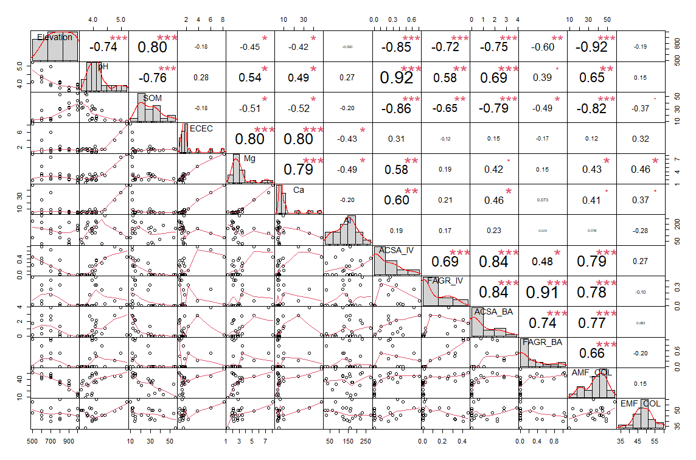
Supplemental Figure S1: Spearman rank correlation matrix between sugar maple (ACSA_IV) and American beech (FAGR_IV) species importance values and soil chemical, mycorrhizal, and vegetative variables from data collected in the Green Mountains of Vermont. Bolded values indicate significant correlations with p < 0.05 (*), p < 0.01 (**), and p < 0.001 (***).

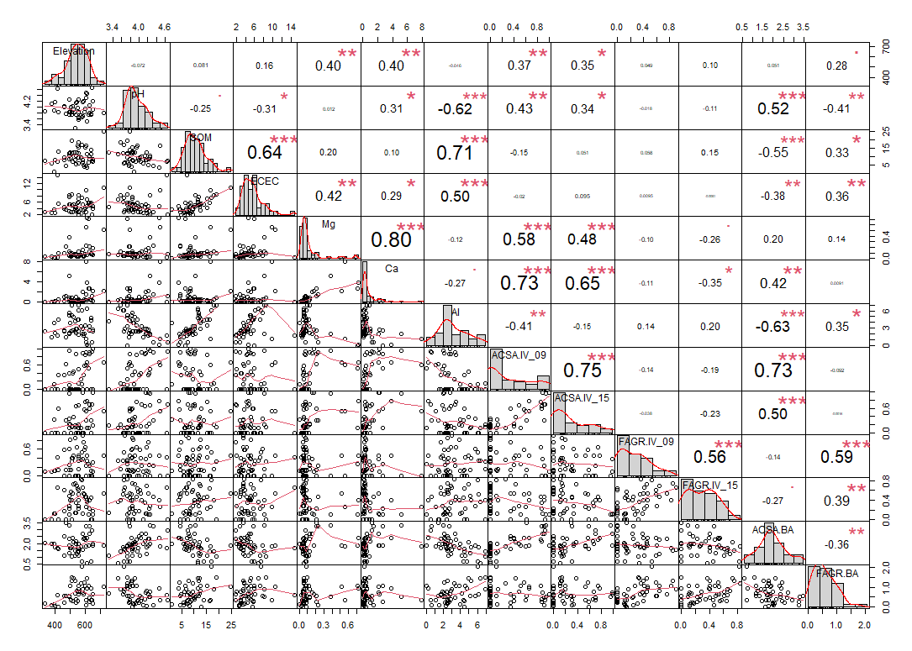
Supplemental Figure S2: Spearman rank correlation matrix between sugar maple (ACSA_IV) and American beech (FAGR_IV) species importance values and soil chemical as well as vegetative variables from data collected from the Adirondacks of New York (in 2009 and 2015). Bolded values indicate significant correlations with p < 0.05 (*), p < 0.01 (**), and p < 0.001 (***).

Supplemental Table S1: Diagnostics from generalized linear breakpoint analyses from multiple comparisons between sugar maple (SM) and American beech (AB) seedling species importance (IV) and soil and environmental variables for both the Adirondacks (ADK) and Green Mountains (GREENS). For each comparison we report estimated breakpoints (±SE), AIC and ∆AIC values for segmented vs generalized linear models. Segmented models performed better than linear models (thus breakpoints improved model fit) if segmented >2 ∆AIC linear (bolded). Comparisons with NA did not have resolved breakpoints.
Study Location | Species | Data Year | Predictor | Breakpoint |  | Standard Error | Break Min | Break Max | AIC Linear | AIC Segmented | ∆AIC | Segmented Model Better?
ADK | SM | 2009 | Ca | 1.44 |  | 0.26 | 0.93 | 1.95 | 25.15 | 11.89 | 13.26 | Y
ADK | SM | 2015 | Ca | 2.09 |  | 0.69 | 0.74 | 3.44 | 19.91 | 11.79 | 8.12 | Y
ADK | SM | 2015 | Mg | 0.35 |  | 0.09 | 0.17 | 0.53 | 19.09 | 13.81 | 5.28 | Y
ADK | SM | 2009 | Mg | 0.24 |  | 0.12 | 0.00 | 0.48 | 49.52 | 44.95 | 4.57 | Y
GREENS | SM | 2019 | pH | 3.74 |  | 0.19 | 3.37 | 4.11 | 18.19 | 13.89 | 4.3 | Y
GREENS | SM | 2019 | SOM | 21.22 |  | 4.42 | 12.56 | 29.88 | 19.89 | 15.73 | 4.16 | Y
GREENS | SM | 2019 | Ca | 26.06 |  | 1.87 | 22.39 | 29.73 | 18.01 | 15.36 | 2.65 | Y
GREENS | SM | 2019 | Colonization | 27.53 |  | 4.62 | 18.47 | 36.59 | 20.43 | 18.01 | 2.42 | Y
ADK | AB | 2015 | Ca | 0.93 |  | 1.04 | -1.11 | 2.97 | 63.76 | 64.38 | -0.62 | N
ADK | SM | 2015 | SM BA | 3.13 |  | 0.43 | 2.29 | 3.97 | 53.61 | 54.69 | -1.08 | N
GREENS | AB | 2019 | AB BA | 0.54 |  | 0.07 | 0.40 | 0.68 | 18.91 | 20.46 | -1.55 | N
GREENS | SM | 2019 | Mg | 6.98 |  | 0.91 | 5.20 | 8.76 | 14.76 | 16.32 | -1.56 | N
ADK | AB | 2015 | AB BA | 0.31 |  | 0.29 | -0.26 | 0.88 | 62.68 | 64.81 | -2.13 | N
GREENS | SM | 2019 | Elevation | 797 |  | 74.61 | 650.76 | 943.24 | 18.11 | 20.63 | -2.52 | N
ADK | SM | 2009 | Elevation | 549 |  | 117.47 | 318.76 | 779.24 | 53.76 | 56.71 | -2.95 | N
ADK | SM | 2015 | Elevation | 554 |  | 149.22 | 261.53 | 846.47 | 56.41 | 59.58 | -3.17 | N
ADK | SM | 2015 | pH | 4.46 |  | 0.31 | 3.85 | 5.07 | 56.08 | 59.26 | -3.18 | N
ADK | SM | 2009 | SM BA | 1.86 |  | 0.52 | 0.84 | 2.88 | 40.86 | 44.06 | -3.2 | N
ADK | AB | 2009 | AB BA | 1.06 |  | 0.49 | 0.10 | 2.02 | 50.39 | 53.72 | -3.33 | N
ADK | SM | 2009 | Al* | 3.51 |  | 3.77 | -3.88 | 10.90 | 48.89 | 52.87 | -3.98 | N
GREENS | AB | 2019 | SM BA | 0.36 |  | 0.15 | 0.07 | 0.65 | 10.21 | 14.29 | -4.08 | N
GREENS | AB | 2019 | Elevation | 750 |  | 137.11 | 481.26 | 1018.74 | 10.15 | 14.23 | -4.08 | N
GREENS | AB | 2019 | SOM | 12.51 |  | 1.86 | 8.86 | 16.16 | 10.07 | 14.23 | -4.16 | N
GREENS | AB | 2019 | pH | 3.88 |  | 0.07 | 3.74 | 4.02 | 9.91 | 14.08 | -4.17 | N
ADK | SM | 2009 | pH | 4.35 |  | 0.42 | 3.53 | 5.17 | 58.32 | 62.66 | -4.34 | N
GREENS | SM | 2019 | SM BA | NA |  | NA | NA | NA | NA | NA | NA | NA
* One outlier was removed during both linear and breakpoint analyses. Site N1-2 has an unusual combination of very high exchangeable Al, Mg, and Ca.

