An artificial intelligence method using ¹⁸F-FDG PET maximum intensity projections to predict 2-year time-to-progression in diffuse large B-cell lymphoma patients
Authors and Affilliations: Maria C. Ferrández^{1,2}, Sandeep S. V. Golla^{1,2}, Jakoba J. Eertink^{2,3}, B.M. de Vries^{1,2}, Pieternella.J. Lugtenburg⁴, Sanne E. Wiegers^{1,2}, Gerben J. C. Zwezerijnen^{1,2}, Simone Pieplenbosch^{2,3}, Lars Kurch⁵, Andreas Hüttmann⁶, Christine Hanoun⁶, Ulrich Dührsen⁶, Henrica C.W. de Vet^{7,8}, Josée M. Zijlstra^{2,3} and Ronald Boellaard^{1,2} on behalf of the PETRA consortium
¹Cancer Center Amsterdam, Department of Radiology and Nuclear Medicine, Amsterdam UMC, Vrije Universiteit Amsterdam, De Boelelaan 1117, Amsterdam, Netherlands
²Cancer Center Amsterdam, Imaging and Biomarkers, Amsterdam, Netherlands
³Cancer Center Amsterdam, Department of Hematology, Amsterdam UMC, Vrije Universiteit Amsterdam, De Boelelaan 1117, Amsterdam, Netherlands
⁴Department of Hematology, Erasmus MC Cancer Institute, University Medical Center Rotterdam, Rotterdam, The Netherlands
⁵Department of Nuclear Medicine, University of Leipzig, Liebigstr. 18, 04103, Leipzig, Germany
⁶Department of Hematology, West German Cancer Center, University Hospital Essen, University of Duisburg-Essen, 45147 Essen, Germany
⁷Department of Epidemiology and Data Science, Amsterdam Public Health Research Institute, Amsterdam UMC, Vrije Universiteit Amsterdam, Amsterdam, The Netherlands
⁸Amsterdam Public Health research institute, Methodology, Amsterdam, The Netherland

Corresponding Author: Maria C. Ferrández
m.c.ferrandezferrandez@amsterdamumc.nl
Amsterdam UMC, De Boelelaan 1117, 1118,
1081 HV Amsterdam, The Netherlands
Tel: +31(0)204449638
Fax: +31(0)204444329

Supplemental Material 1
For BR-MIP CNN, the brain was removed from the MIPs during preprocessing. The CNN preprocessing tool (an in-house built tool), used to generate the MIPs from the 3D PET scans, located the brain exactly at the centre of the x axis (x = 100) for every image, which provides a reference value for the brain location to generate these new MIPs. An intensity profile was defined along the y axis at x = 100 from which the transition from brain to non-brain region (i.e. high intensity to low intensity) could be identified. This enabled the definition of a box which contained the brain segment for each image. Within this box, the Otsu threshold was calculated to generate a brain mask (25). As a final step, these masks were dilated and used to remove the brains from the images.
DLBCL patients might develop lesions nearby or within the brain region. To keep these lesions while removing the brain, the MIPs were thresholded at different SUV intensities generating a mask of the lesions. This mask was used to recover any partially truncated lesions during the process of removing the brain.

Supplemental Material 2
The loss and accuracy of the CNN were reported after every epoch using categorical cross entropy and categorical accuracy, respectively. The best model was saved for the epoch with the best performance, indicated by an increase in both training and validation accuracy or decrease in loss. This process was performed for each of the subsets A-E (Supplemental Figure 1) which were divided into training and internal validation sets (80% and 20% respectively) following a 5-fold cross validation. In addition, the confusion matrix with associated true positive (TP), true negative (TN), false positive (FP) and false negative (FN) predictions were retrieved for each fold. This allowed for the sensitivity (TP/ TP + FN) and specificity (TN / FP + TN) to be determined (6). Differences in sensitivity and specificity between models are compared at a probability threshold of 0.5.

Supplemental Table 1. Patients Characteristics.
HOVON-84 |  | PETAL
Characteristic | N (%) | Characteristic | N (%)
Age  Median (IQR)  ≤ 60 years  > 60 years | 65 (55-72)  97 (33)  199 (67) | Age  Median (IQR)  ≤ 60 years  > 60 years | 60 (50-69)  172 (51)  168 (49)
Sex Male  Female | 152 (51)  144 (49) | Sex Male  Female | 194 (57)  146 (43)
Ann Arbor stage  I  II  III  IV  missing | 0 (0)  48 (16)  62 (21)  186 (63)  0 (0) | Ann Arbor stage  I  II  III  IV  missing | 65 (19)  79 (23)  65 (19)  130 (38)  1 (1)
LDH normal  > normal  missing | 97 (33)  199 (67)  0 (0) | LDH normal  > normal  missing | 148 (44)  191 (55)  1 (1)
Extranodal localizations ≤1 >1  missing | 175 (59)  121 (41)  0 (0) | Extranodal localizations ≤1 >1  missing | 239 (70)  99 (29)  2 (1)
WHO performance status 0  1  2  3  missing | 170 (57)  87 (29)  37 (13)  0 (0)  2 (1) | WHO performance status 0  1  2  3  missing | 156 (46)  150 (44)  25 (7)  6 (2)  3 (1)
IPI Low  Low-intermediate  High-intermediate  High | 48 (16)  73 (25)  103 (35)  72 (24) | IPI Low  Low-intermediate  High-intermediate  High | 123 (36)  92 (27)  84 (25)  40 (12)
Abbreviations: IQR: Interquartile range, LDH: lactate dehydrogenase level, WHO: World Health Organization, IPI: International Prognostic Index

Supplemental Table 2. Cross-validation (±SD) of AUC (training and internal validation), sensitivity and specificity for BR-MIP CNN.
 | CV-AUC |  | Sensitivity |  | Specificity
 | Training | Validation | Training | Validation | Training | Validation
Subset A | 0.751 (0.035) | 0.684 (0.077) | 0.639 (0.057) | 0.656 (0.021) | 0.726 (0.051) | 0.689 (0.168)
Subset B | 0.759 (0.015) | 0.601 (0.081) | 0.759 (0.076) | 0.589 (0.197) | 0.610 (0.099) | 0.556 (0.178)
Subset C | 0.768 (0.086) | 0.717 (0.109) | 0.727 (0.174) | 0.710 (0.142) | 0.687 (0.11) | 0.629 (0.195)
Subset D | 0.749 (0.015) | 0.646 (0.137) | 0.768 (0.056) | 0.65 (0.157) | 0.591 (0.053) | 0.512 (0.172)
Subset E | 0.760 (0.066) | 0.626 (0.053) | 0.721 (0.176) | 0.65 (0.140) | 0.677 (0.127) | 0.621 (0.168)
Abbreviations: AUC: Area Under the Curve, SD: Standard Deviation

Supplemental Table 3. Cross-validation (±SD) of AUC (training and internal validation), sensitivity and specificity for MIP CNN.
 | CV-AUC |  | Sensitivity |  | Specificity
 | Training | Validation | Training | Validation | Training | Validation
Subset A | 0.751 (0.026) | 0.688 (0.066) | 0.653 (0.079) | 0.636 (0.24) | 0.706 (0.048) | 0.669 (0.122)
Subset B | 0.752 (0.014) | 0.648 (0.105) | 0.764 (0.077) | 0.767 (0.134) | 0.586 (0.092) | 0.556 (0.148)
Subset C | 0.792 (0.028) | 0.703 (0.062) | 0.759 (0.045) | 0.750 (0.084) | 0.639 (0.063) | 0.554 (0.102)
Subset D | 0.739 (0.015) | 0.665 (0.094) | 0.759 (0.059) | 0.727 (0.180) | 0.61 (0.120) | 0.501 (0.102)
Subset E | 0.761 (0.065) | 0.641 (0.115) | 0.682 (0.135) | 0.612 (0.129) | 0.716 (0.066) | 0.643 (0.12)
Abbreviations: AUC: Area Under the Curve, SD: Standard Deviation

Supplemental Table 4. Cross-validation (±SD) of AUC (training and internal validation), sensitivity and specificity for lesion MIP CNN.
 | CV-AUC |  | Sensitivity |  | Specificity
 | Training | Validation | Training | Validation | Training | Validation
Subset A | 0.731 (0.020) | 0.562 (0.094) | 0.624 (0.066) | 0.481 (0.098) | 0.692 (0.043) | 0.581 (0.239)
Subset B | 0.727 (0.028) | 0.616 (0.142) | 0.639 (0.056) | 0.610 (0.198) | 0.673 (0.045) | 0.596 (0.077)
Subset C | 0.807 (0.023) | 0.764 (0.07) | 0.696 (0.063) | 0.632 (0.195) | 0.764 (0.019) | 0.730 (0.076)
Subset D | 0.752 (0.039) | 0.646 (0.14) | 0.706 (0.032) | 0.650 (0.154) | 0.663 (0.113) | 0.556 (0.153)
Subset E | 0.775 (0.021) | 0.676 (0.060) | 0.706 (0.042) | 0.618 (0.105) | 0.754 (0.017) | 0.707 (0.116)
Abbreviations: AUC: Area Under the Curve, SD: Standard Deviation

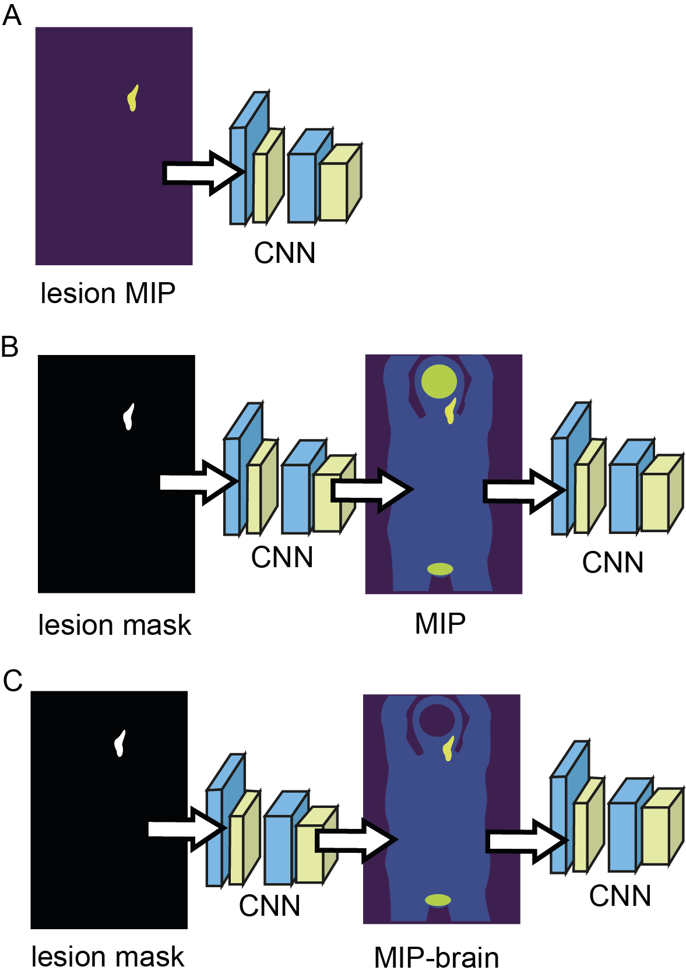
Supplemental Figure 1. Illustration of the three different training schemes implemented in this study (a) Lesion MIP CNN, (b) MIP CNN (c) BR-MIP CNN.

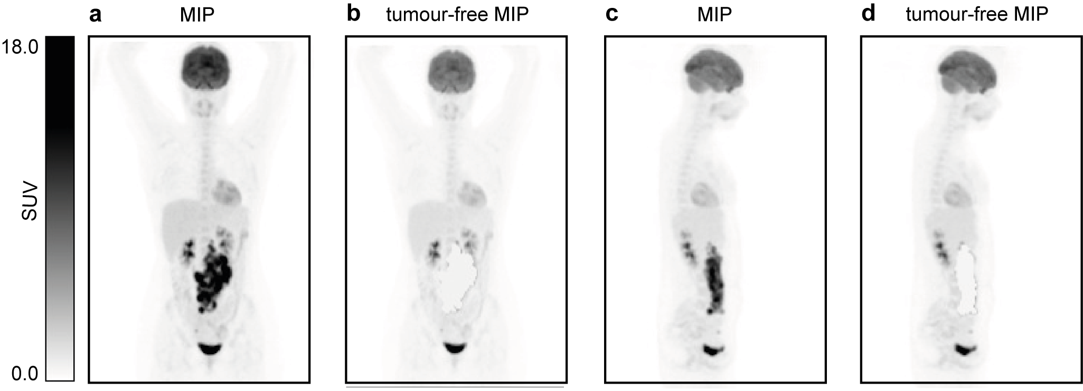
Supplemental Figure 2. Illustration of MIPs before and after removing the tumours. (A) Coronal view. (B) Sagittal view.

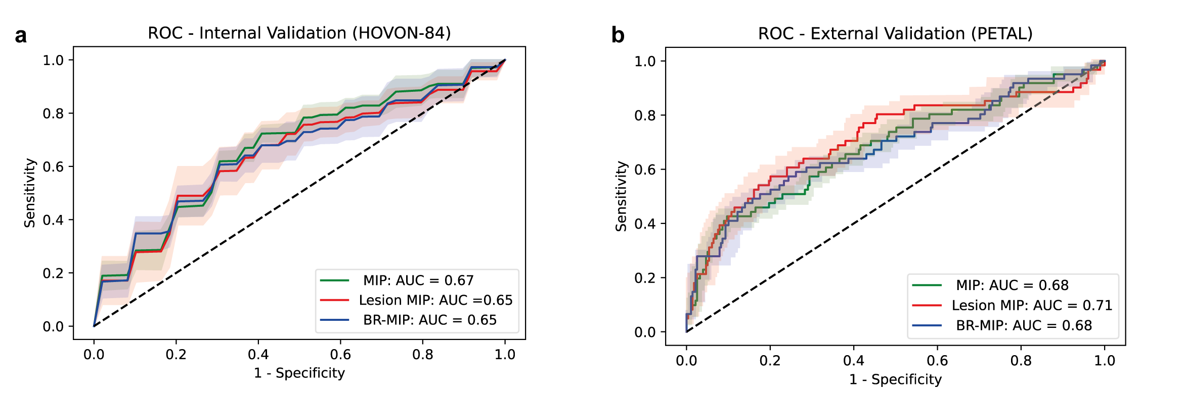
Supplemental Figure 3. Average Receiver Operator Curves (± standard deviation) for the models trained on the 5 subsets (A to E) for the 3 CNNs. (a) ROC and AUC for internal validation performed on HOVON-84 dataset. (b) ROC and AUC for external validation performed on PETAL dataset. Standard deviations associated with the 5 subsets (A to E) are shown in faded colours around the AUC curves. For reference, a model without any predictive performance is depicted (AUC = 0.5).
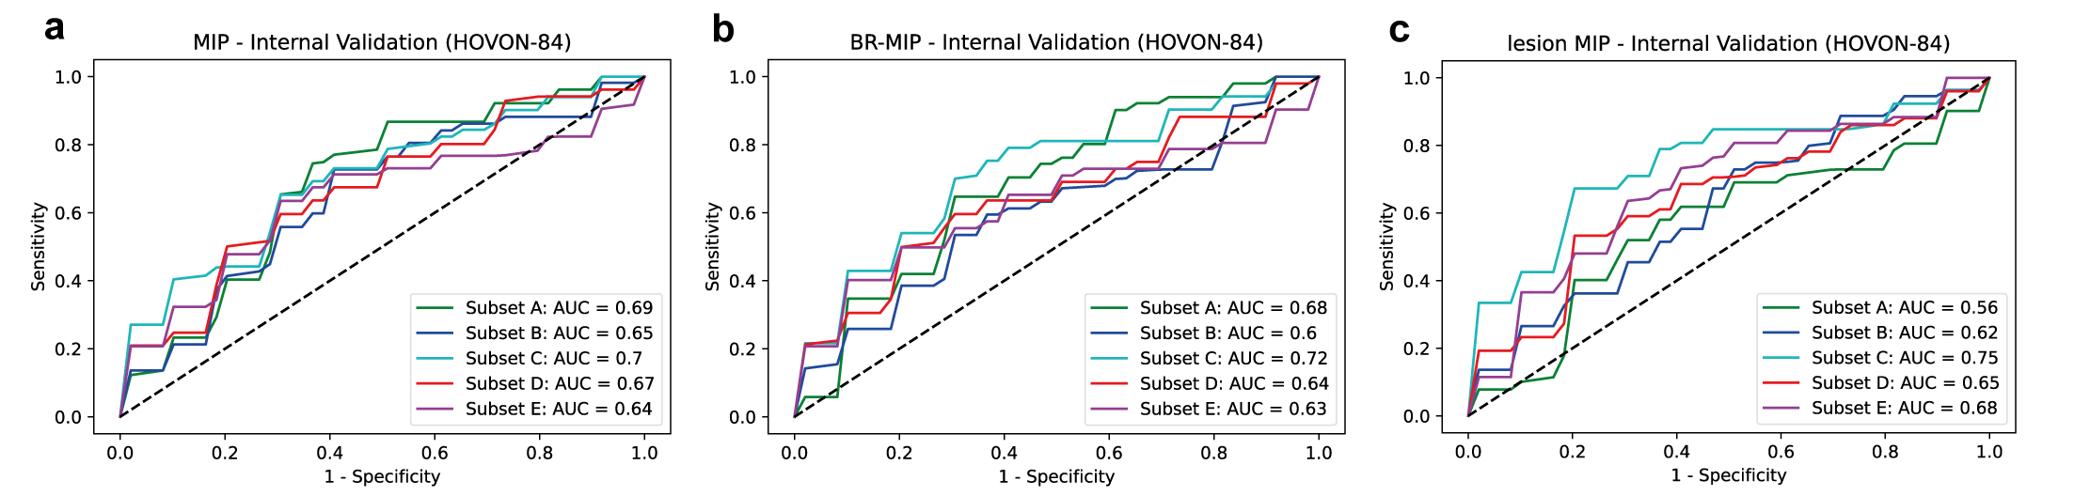
Supplemental Figure 4. Receiver Operator Curves for all models trained on subsets A to E for internal validation performed on HOVON-84 dataset. (a) MIP CNN (b) BR-MIP CNN (c) Lesion MIP CNN.
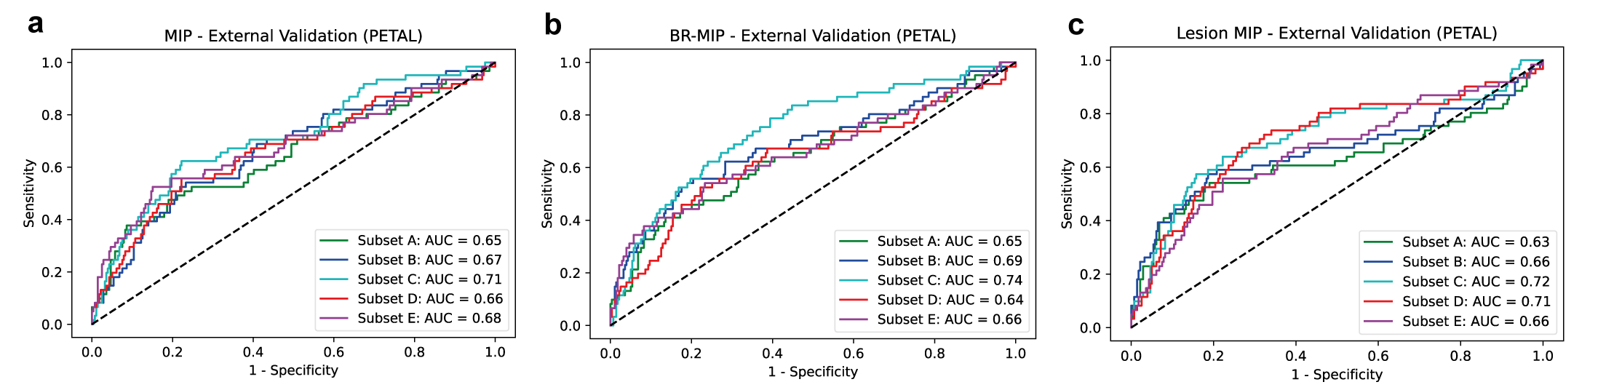
Supplemental Figure 5. Receiver Operator Curves for all models trained on subsets A to E for external validation performed on PETAL dataset. (a) MIP CNN (b) BR-MIP CNN (c) Lesion MIP CNN.

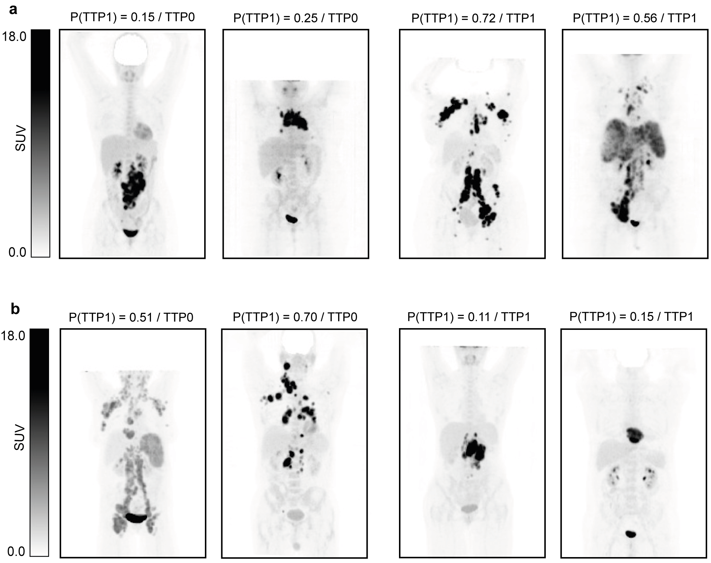
Supplemental Figure 6. BR-MIP CNN predictions. (a) Four patients which were correctly classified by the model trained and cross-validated on subset C. (b) Four examples which were wrongly classified by the model. P(TTP1) indicates the CNN calibrated probabilities and /TTP0 or /TTP1 indicates the original label.

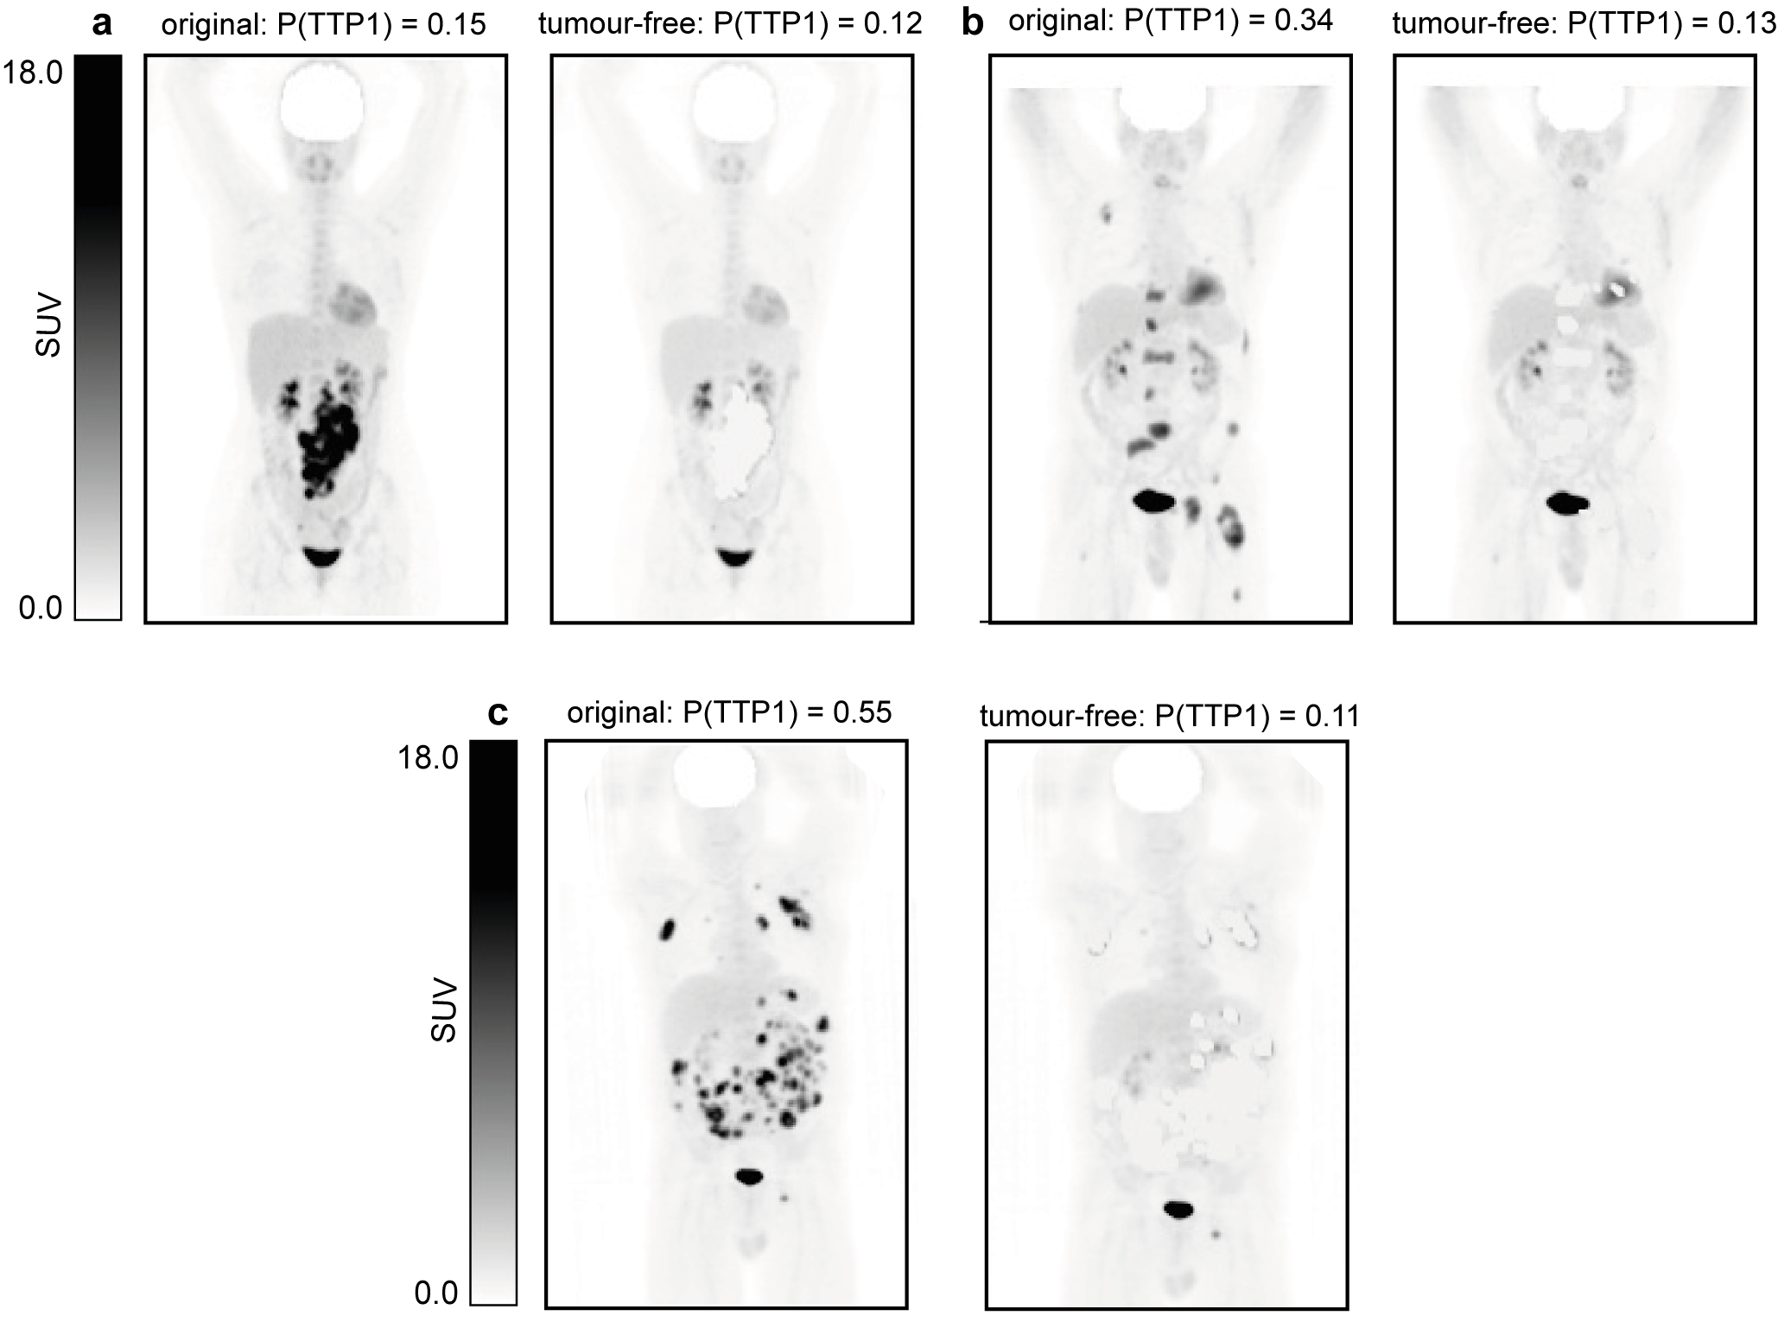
Supplemental Figure 7. TTP1 calibrated probabilities before and after removing the tumours. Figures (a) to (c) show 3 different patients before and after removing (‘ablating’) the tumours (i.e. tumour-free MIPs).

