Supplementary Material
Supplementary Figures
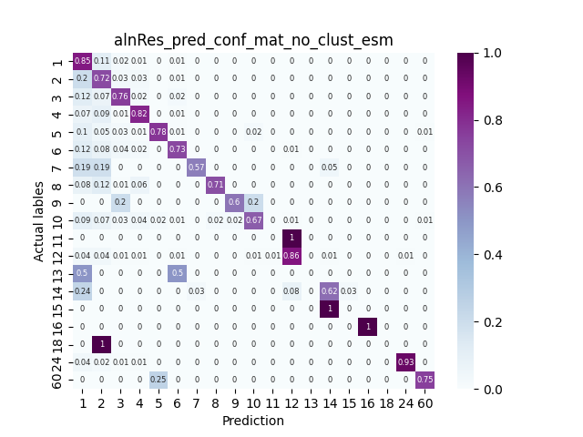
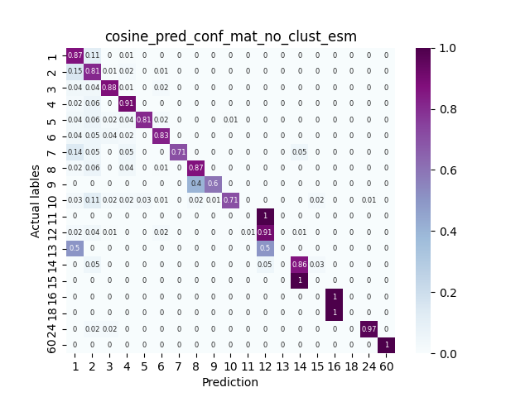
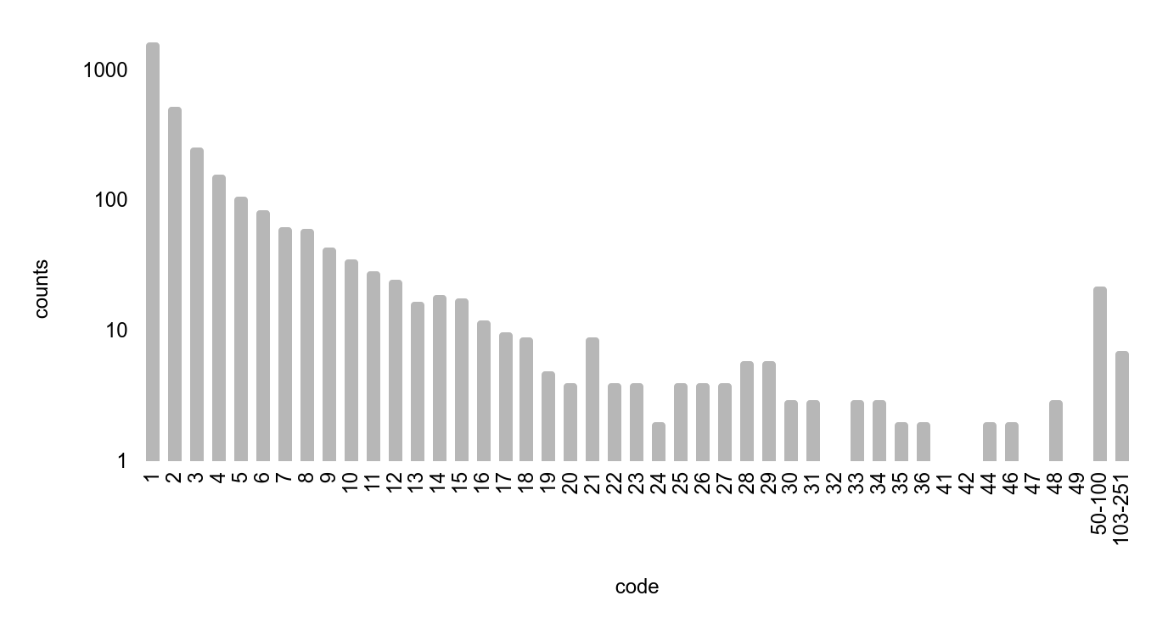
Supplementary Figure S2: Success of nearest neighbor annotation transfer when close homologs are available. A. Sequence-based annotation transfer (balanced accuracy, BA=0.6), B. Cosine similarity-based annotation transfer (BA=0.67). Accompanies Figures 4A and B, respectively.
Sequence based
nearest neighbor
pLM based
nearest neighbor

ECOD family size
Number of families
Number of sequences (pdbs) in each ECOD family
Supplementary Figure S1: ECOD family sizes. X-axis shows the family size, y-axis the amount of families of the corresponding size. Large families are grouped together for clarity. Accompanies Figure 2.

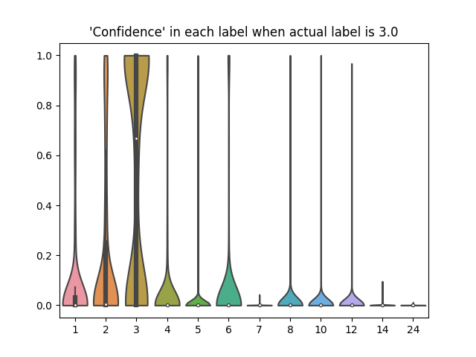
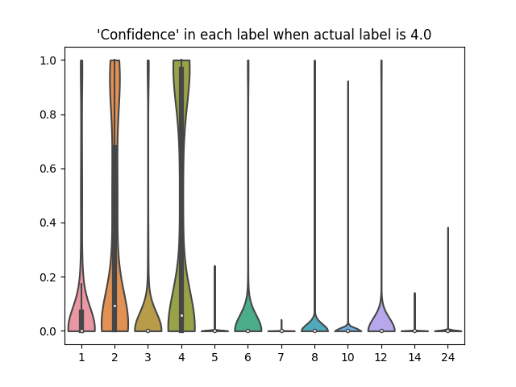
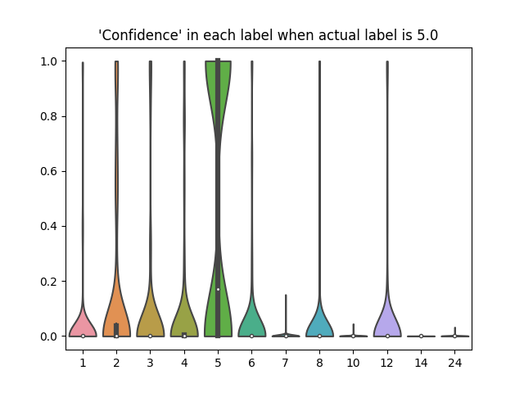
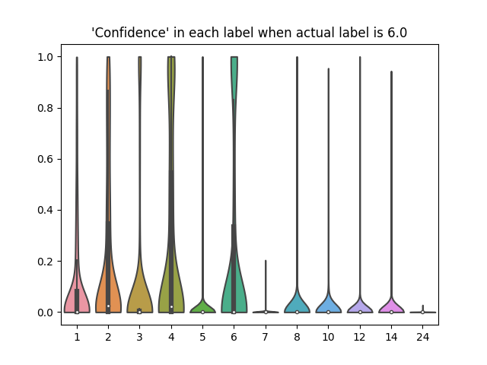
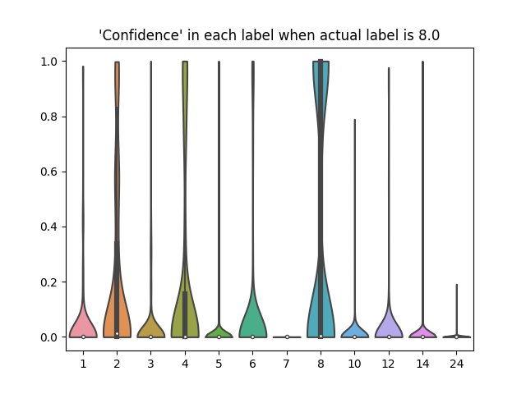
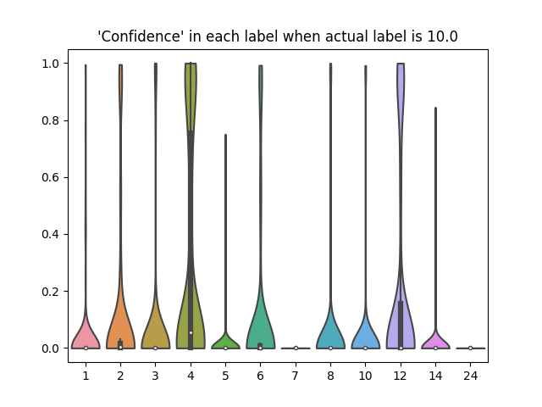
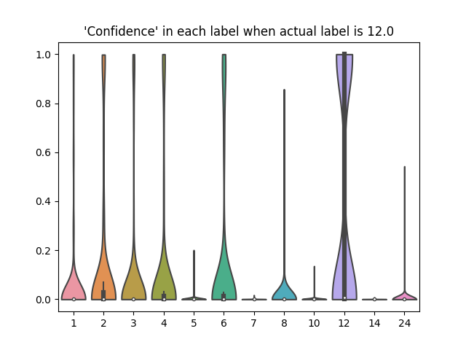
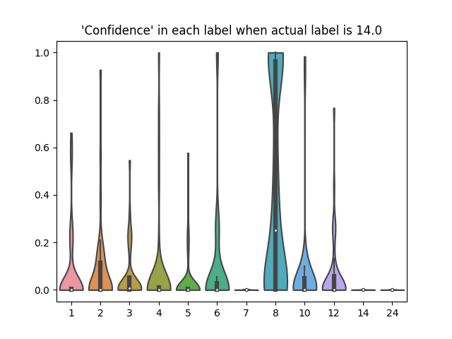
Supplementary Figure S3: Distribution of predicted probability (‘confidence’) for representative qs categories.
The plots show violin plots of the prediction probabilities (y-axis) for different qs labels (x-axis), for actual qs=3,4,5,6,8,10,12 and 14 (indicated in the title and highlighted in cyan on the x-axis). Accompanies Figure 7.

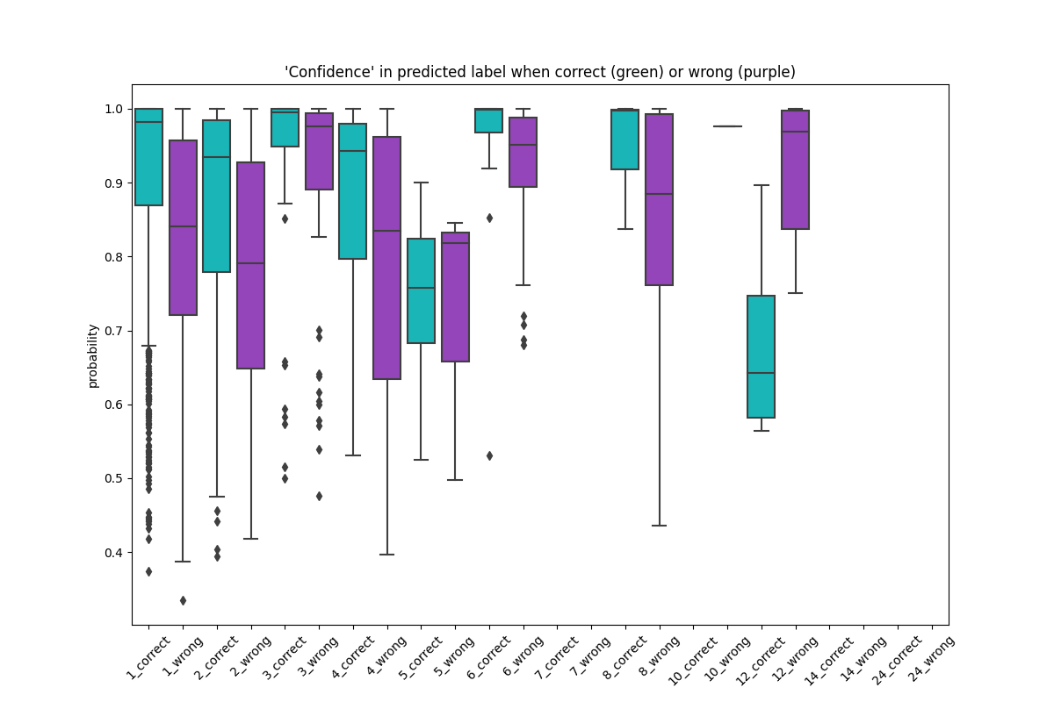
Supplementary Figure S4: QUEEN predictions shows higher confidence for correct assignments also for the hold out set. Accompanies Figure 10.
For each qs (x-axis) box plots and dots show the distribution of the probabilities of correct (green) and incorrect (purple) predictions. Correct predictions are consistently predicted with higher probability than incorrect predictions, for most qs. This separation can be used to assess correct predictions, also in the absence of homologs.

Supplementary Tables

Supplementary Tables SI and II are available on github at:
https://github.com/Furman-Lab/QUEEN/blob/main/Supplementary_Table_I_embed_tab_with_sets.tsv
https://github.com/Furman-Lab/QUEEN/blob/main/Supplementary_Table_II_all_model_data.tsv

Supplementary Table SIII(a) - Wilcoxon statistics and P-values of full homology annotation transfer
qs | statistic | p-value
1 | 38.66 | 0
2 | 35.44 | 2.05E-275
3 | 14.40 | 2.46E-47
4 | 25.92 | 1.96E-148
5 | 5.02 | 2.61E-07
6 | 14.14 | 1.10E-45
7 | 1.64 | 0.051
8 | 10.10 | 2.69E-24
9 | 1.96 | 0.025
10 | 5.00 | 2.89E-07
11 | nan | nan
12 | 5.82 | 2.95E-09
13 | nan | nan
14 | 2.93 | 0.002
15 | nan | nan
16 | 2.24 | 0.013
18 | nan | nan
24 | 3.74 | 9.10E-05
60 | nan | nan

Supplementary Table SIII(b) - Wilcoxon statistics and P-values of no homology information annotation transfer
qs | statistic | p-value
1 | 1.84 | 0.033
2 | 6.20 | 2.82E-10
3 | 2.90 | 0.002
4 | 3.38 | 3.56E-04
5 | 0.93 | 0.177
6 | 0.97 | 0.165
7 | nan | nan
8 | 0.00 | 0.500
10 | nan | nan
12 | 1.47 | 0.071
14 | nan | nan
24 | nan | nan

Supplementary Table SIV - Wilcoxon statistics and P-values of QUEENl
qs | statistic | p-value
1 | 19.84 | 6.30E-88
2 | 8.83 | 5.40E-19
3 | 11.63 | 1.46E-31
4 | 12.21 | 1.35E-34
5 | 4.87 | 5.71E-07
6 | 4.84 | 6.53E-07
7 | nan | nan
8 | 7.36 | 9.50E-14
10 | 2.59 | 0.005
12 | 8.85 | 4.33E-19
14 | nan | nan
24 | 1.75 | 0.040

