Non-alcoholic fatty liver disease promotes breast cancer progression through upregulated hepatic fibroblast growth factor 21

Yue SUI¹, Qingqing LIU¹, Cong XU¹, Kumar GANESAN¹, Zhen YE², Yan LI³, Jianmin WU⁴, Bing DU⁵, Fei GAO⁶, Jianping CHEN^{1,7}

1. School of Chinese Medicine, The University of Hong Kong, Pokfulam, Hong Kong, China.
2. Chengdu University of Traditional Chinese Medicine, Chengdu, 611137, China
3. Xiamen University, Xiamen, 361005, China.
4. School of Pharmacy, Southwest Medical University, Luzhou, 646000, China
5. South China Agricultural University, Guangzhou, 510000, China
6. School of Pharmacy, Chengdu University of Traditional Chinese Medicine, Chengdu, 615000, China.
7. Shenzhen Institute of Research and Innovation, The University of Hong Kong, Shenzhen, 518000, China

Supplementary Figure S1-S3
Supplementary Materials Table S1

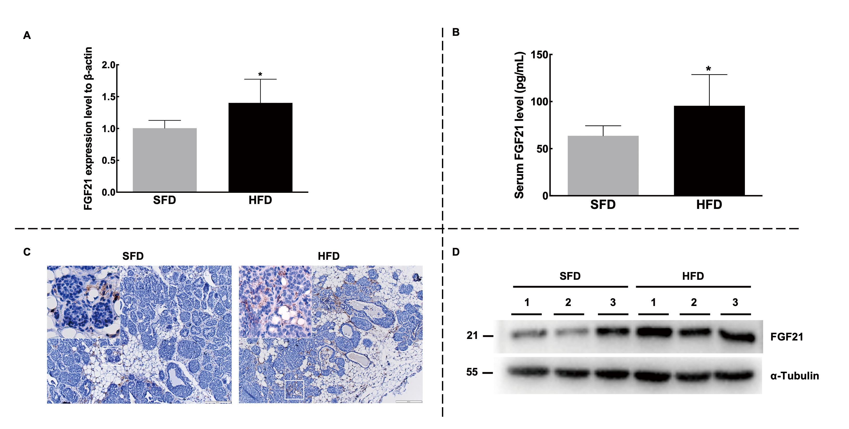
Fig.S1 FGF21 is over-expressed in the liver and tumor tissues of HFD-fed PyVT mice. (A) Hepatic mRNA expression levels detected by RT-qPCR. (B) The serum concentration of FGF21 was determined by ELISA kit. (C) FGF21 in tumor tissues was visualized by immunohistochemistry staining. Images were shown at 4×magnification, scale bars 200 μm, and insert images were at 20×magnification. (D) Tumoral FGF21 expression levels were detected by western blot. n = 6 for each group in A, B and D. Data are expressed as mean ± SEM. The difference between groups was assessed by Student’s t-test, * p < 0.05, **p < 0.01. Abbreviation: HFD, high-fat diet group; SFD, standard-food diet group.

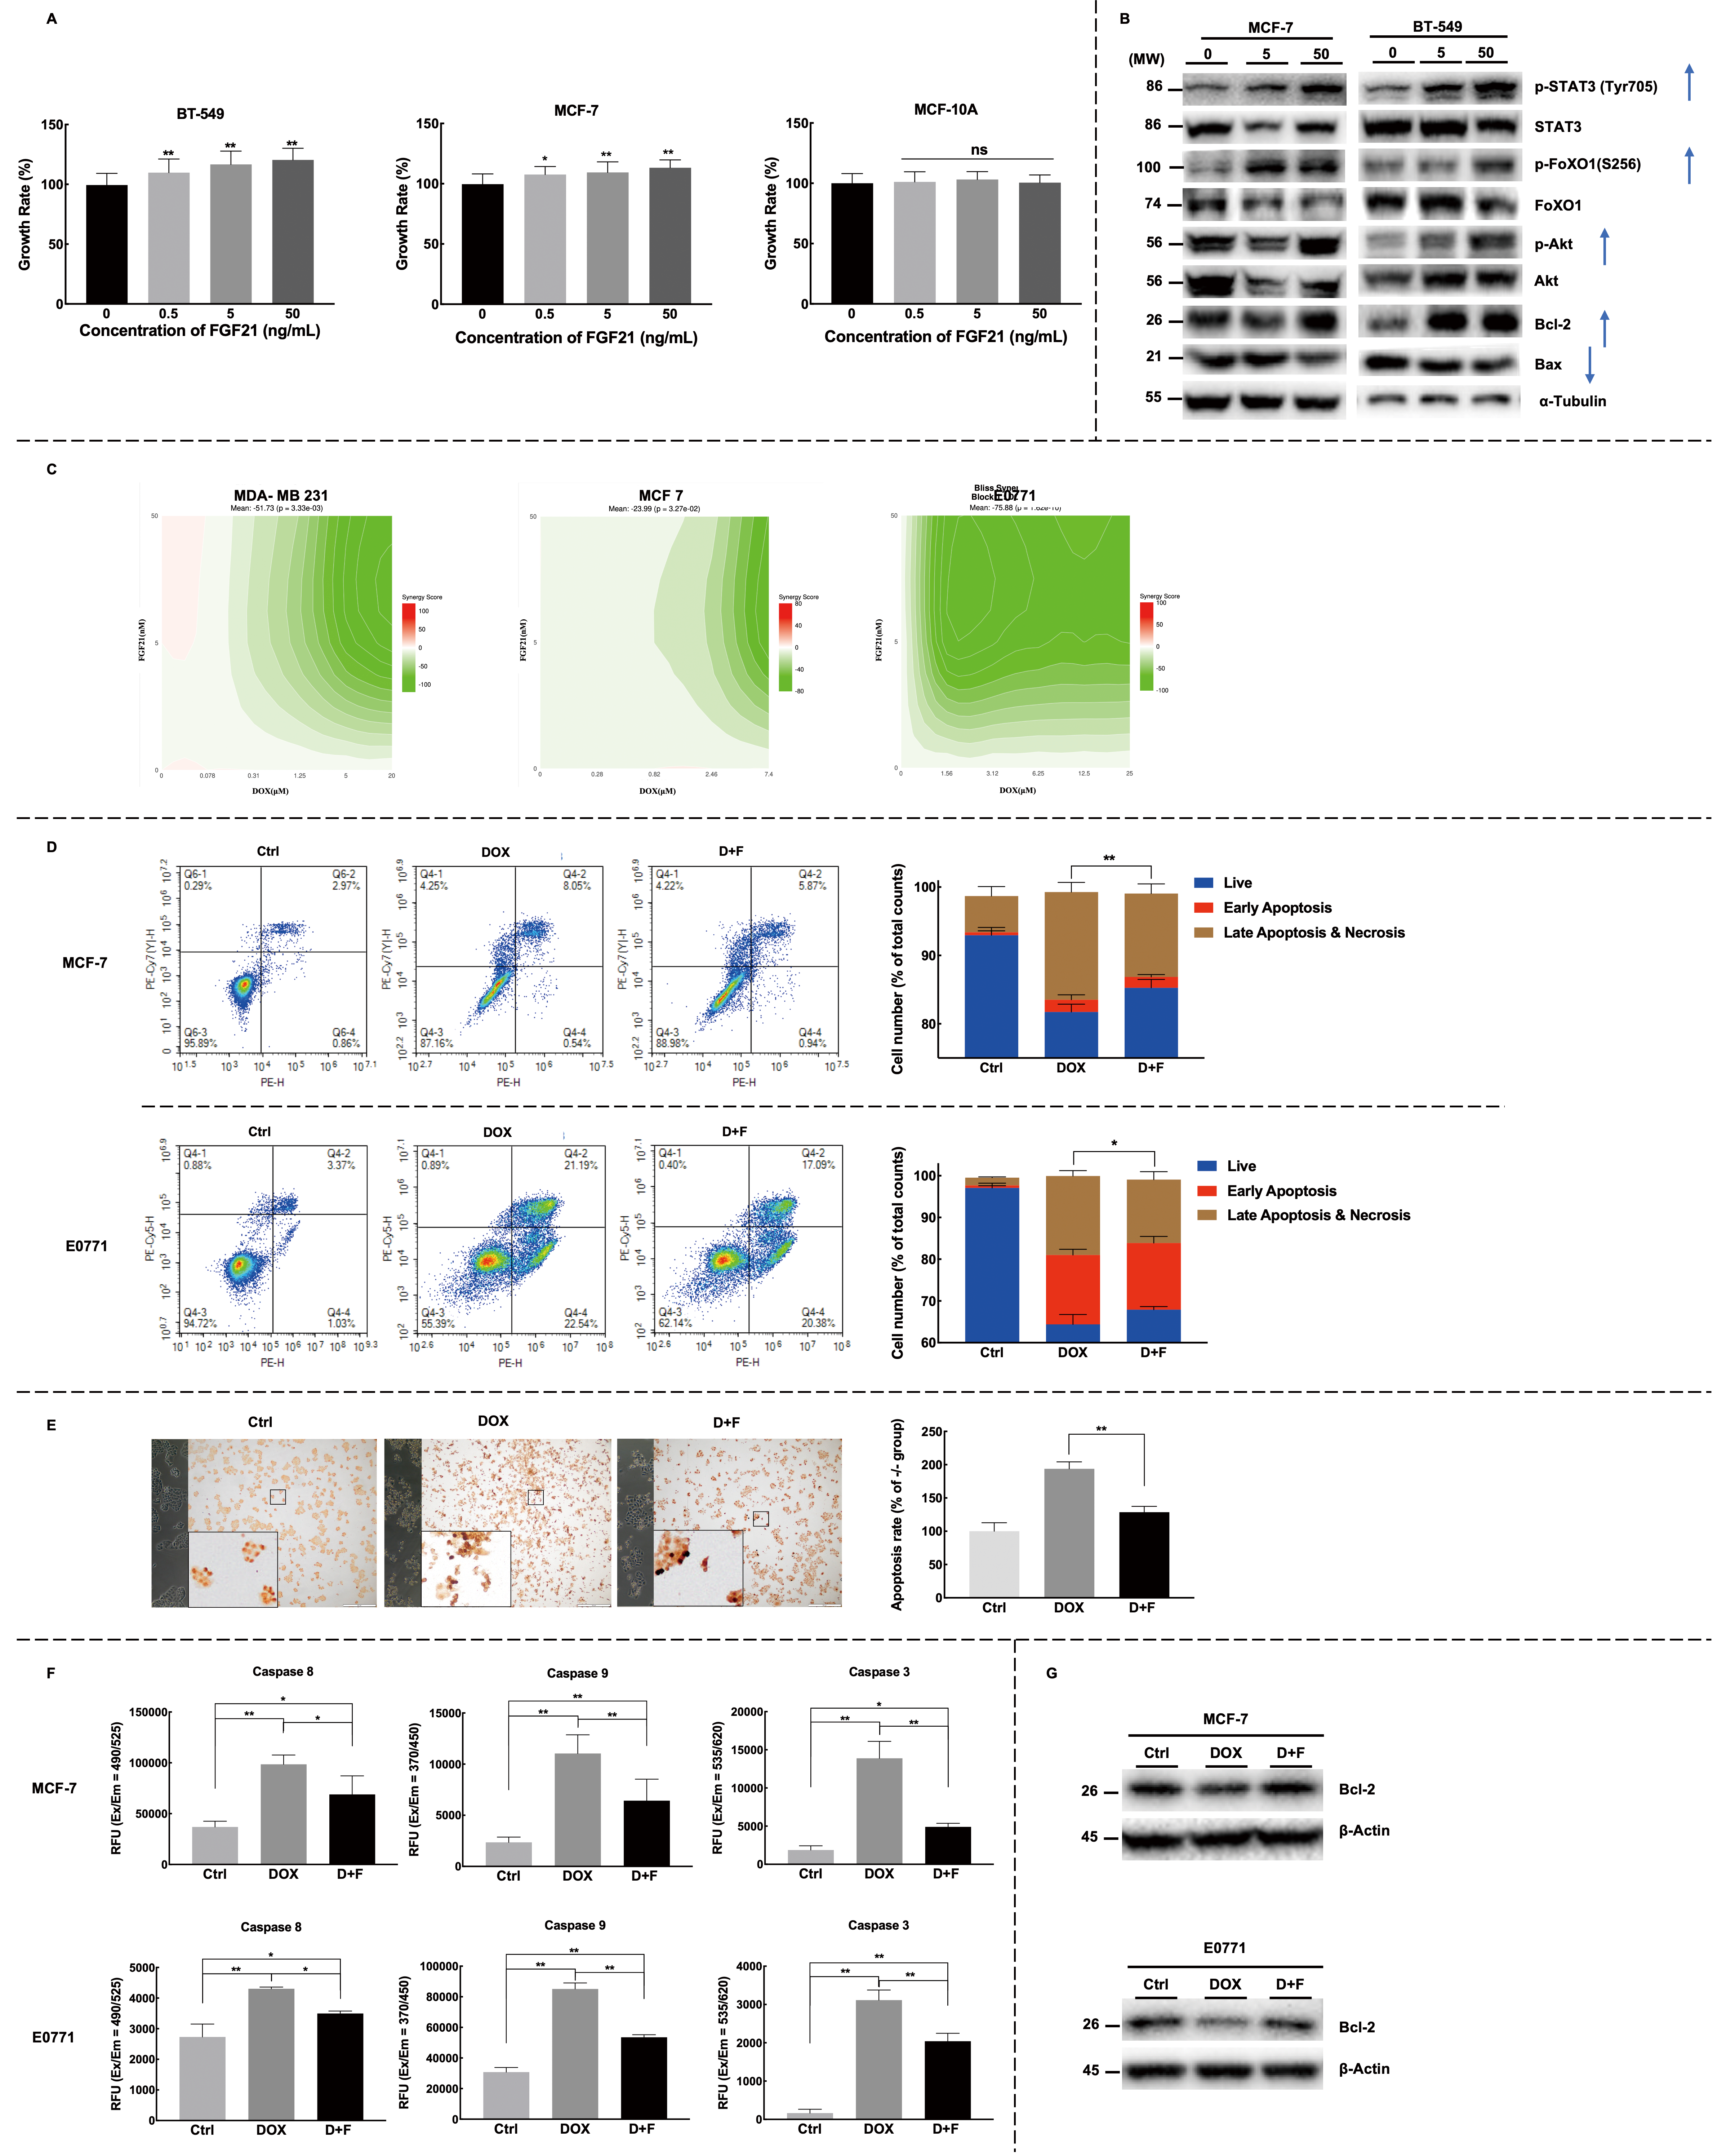
Fig.S2 Recombinant FGF21 promotes the anti-apoptosis ability of Bca cells via STAT3 and Akt/FoXO1 pathways. (A, B) Cells were treated with recombinant FGF21 (0, 0.5, 5, 50 ng/mL) for 24h before cell viability assay (A) or harvested for western blot analysis (B). MCF-10A is the normal mammary epithelial cell. (C) Antagonistic interactions between DOX and FGF21 were analyzed by the Bliss model. (D) The apoptosis proportion of MCF-7 and E0771 was detected with the PE Annexin V apoptosis detection kit after being treated with 50 nM FGF21 and doxorubicin (1.25 μM for E0771, 5 μM for MCF-7) for 20 hours. (E) TUNEL assay of MCF-7 was performed after cells were treated with 50 nM FGF21 and 5 μM doxorubicin for 20 hours. Representative images were shown as centered TUNEL staining images with live cell images merged on the left and summarized quantification results on the right. (F, G) The expression levels of apoptosis-related proteins were determined by the caspase activity test (F) and western blot (G). Data were expressed as mean ± SD. The difference between groups was assessed by One-way ANOVA combined with Turkey’s test for multiple comparison tests, * p < 0.05, ** p < 0.01. Live cell images were at 10 × magnification, TUNEL staining images were shown at 4×magnification with scale bars 500 μm, and insert images were at 20×magnification. Abbreviation: DOX, doxorubicin treatment group; D+F, doxorubicin plus FGF21 treatment group.

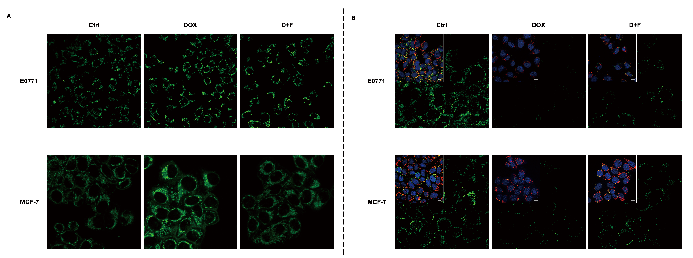
Fig.S3 FGF21 protects mitochondrial function. (A) Mitochondrial membrane potential was detected by JC-10. Cells were treated with FGF21 and DOX for 24h before staining with JC-10, and the fluorescence intensity in live cells was then detected by confocal microscopy. (B) The mitochondrial expression levels of cytochrome c were detected via immunofluorescence after being treated with DOX and FGF21 for 24h. Digitonin was used to permeabilize the plasma membrane of cells selectively. Cytochrome c was stained with anti-cytochrome c antibody in green, the nucleus was counterstained with DAPI in blue, and the mitochondrion was stained with mitotracker in red. Images were shown at 40×magnification, and scale bars 10 μm. Abbreviation: DOX, doxorubicin treatment group; D+F, doxorubicin plus FGF21 treatment group.

Supplementary Materials Table S1

Table S1 RT-qPCR primer sequences for genes screened out by RNA sequencing
Primer Name | Sequences
Mouse FGF21 forward | GCTGCTGGAGGACGGTTACA
Mouse FGF21 reverse | CACAGGTCCCCAGGATGTTG
Mouse A1bg forward | CGTTTGGTCAGAGGACAGCAAG
Mouse A1bg reverse | CATCGAAGCTGCACCGTTGAAC
Mouse Gdf15 forward | AGCCGAGAGGACTCGAACTCAG
Mouse Gdf15 reverse | GGTTGACGCGGAGTAGCAGCT
Mouse Ly6d forward | CATGCTTTAGCCATGATGGAGGC
Mouse Ly6d reverse | ATGTCATCAGCTCTTGGTGCCC
Mouse Lamb3 forward | TGACCAGACCTATGGACACGTG
Mouse Lamb3 reverse | GTCACAGTGACCTCGTTGGCAT
Mouse Itga4 forward | GCAAAGAGGTCCCAGGCTACAT
Mouse Itga4 reverse | CCTGTAATCACGTCAGAAGTCCC
Mouse Serpina12 forward | GGCAGACATCTTTGCCAAGTGG
Mouse Serpina12 reverse | CTCCTCAAAGATTTTGCTGATGCC
Mouse Vnn1 forward | CTTTCCTCGCGGCTGTTTAC
Mouse Vnn1 reverse | CCTCCAGGTATGGGTAGATCGT
Mouse Trem2 forward | CTACCAGTGTCAGAGTCTCCGA
Mouse Trem2 reverse | CCTCGAAACTCGATGACTCCTC
Mouse Apoa4 forward | CAGAAGACGGATGTCACTCAGC
Mouse Apoa4 reverse | AGCTGTACGACAAAGGGCACCA
Mouse Sema5b forward | GAAGCCGTGGGTCTTTAACTT
Mouse Sema5b reverse | CAAGAGCAAGCTGGGAGAAAT
Mouse Mmp12 forward | CACACTTCCCAGGAATCAAGCC
Mouse Mmp12 reverse | TTTGGTGACACGACGGAACAGG
Mouse Col1a1 forward | CCTCAGGGTATTGCTGGACAAC
Mouse Col1a1 reverse | CAGAAGGACCTTGTTTGCCAGG
Mouse Prss8 forward | GCATCACCTACGATGGCAACCA
Mouse Prss8 reverse | TGCTGTAGGAGTCTAGCTGGTG
Mouse Esm1 forward | CTGGAGAAACCTGCTACCGTAC
Mouse Esm1 reverse | CATTCCATCCCGAAGGTGCCAT
Mouse Adgrf1 forward | CCTCCAGAACTCCTCTTTGCCA
Mouse Adgrf1 reverse | CCAAAGGAGATGCTGTTACACGG
Mouse Ihh forward | CGGCTTCGACTGGGTGTATTAC
Mouse Ihh reverse | AGGAAAGCAGCCACCTGTCTTG
Mouse Angptl8 forward | GCCTCTATGACAGAGCACTGGA
Mouse Angptl8 reverse | AGCTCGAAGGTGTAAAGCGTCC
Mouse Adamts7 forward | CCTTGCTACCAAAGCCGCATCA
Mouse Adamts7 reverse | CCTTGAAGGTCCTGCTCACAGT
Mouse Adam11 forward | CAGTGGTCCTCACCAGCAACTT
Mouse Adam11 reverse | GTCTCCAGTAGGTCATCCTGCA
Mouse Itih5 forward | AAGTGCTGCCTCTCCACAACAG
Mouse Itih5 reverse | GCTTGTTGGACCACAGTAGGCT
Mouse Htra4 forward | AGCCACCGTCAAAGACATCG
Mouse Htra4 reverse | TGTGGTGCTGACAATCCCTG
Mouse Pcsk9 forward | ATGGCACCAGACAGAGGAAGAC
Mouse Pcsk9 reverse | CACGCTGTTGAAGTCGGTGATG
Mouse Ces2a forward | GCTCTCCAAGTGGCACATTTCC
Mouse Ces2a reverse | CAAAGGCAACGTCATCACCATGG
Mouse Kcp forward | TGCTTGCACCAGGTCACAGAAC
Mouse Kcp reverse | GTGACACATGCAGGAGGAACAG
a. produced by Integrated DNA Technologies

