Supplementary material for

Semi-synthesis and in vitro anti-tumor effects evaluation of novel xanthohumol derivatives

Xiaolong Sun¹, Jie Chen¹, Di Huang¹, Feng Ding^{1,2}, Long Zhao^{1,2}, Hong-Mei Li^{1,2}, Xiang-Shu Wang³, Yu-Xin Zhang^{2,3}*, Cheng-Zhu Wu^{1,2}*

¹ School of Pharmacy, Bengbu Medical College, 2600 Donghai Road, Bengbu 233030, Anhui, China
² Anhui Province Engineering Technology Research Center of Biochemical Pharmaceutical, Bengbu 233030, Anhui, China.
³ School of Laboratory Medicine, Bengbu Medical College, 2600 Donghai Road, Bengbu 233030, Anhui, China.

List of supplemental data

Table S1 and Figure S0 3
Figure S1 ¹H NMR spectrum of compound 1 4
Figure S2 ¹³C NMR spectrum of compound 1 4
Figure S3 ¹H NMR spectrum of compound 2 5
Figure S4 ¹³C NMR spectrum of compound 2 5
Figure S5 ¹H NMR spectrum of compound 3 6
Figure S6 ¹³C NMR spectrum of compound 3 6
Figure S7 ¹H NMR spectrum of compound 4 7
Figure S8 ¹³C NMR spectrum of compound 4 7
Figure S9 ¹H NMR spectrum of compound 5 8
Figure S10 ¹³C NMR spectrum of compound 5 8
Figure S11 ¹H NMR spectrum of compound 6 9
Figure S12 ¹³C NMR spectrum of compound 6 9
Figure S13 ¹H NMR spectrum of compound 7 10
Figure S14 ¹³C NMR spectrum of compound 7 10
Figure S15 ¹H NMR spectrum of compound 8 11
Figure S16 ¹³C NMR spectrum of compound 8 11
Figure S17 HR-ESI-MS spectrum of compound 1 12
Figure S18 HR-ESI-MS spectrum of compound 2 12
Figure S19 HR-ESI-MS spectrum of compound 3 13
Figure S20 HR-ESI-MS spectrum of compound 4 13
Figure S21 HR-ESI-MS spectrum of compound 5 14
Figure S22 HR-ESI-MS spectrum of compound 6 14
Figure S23 HR-ESI-MS spectrum of compound 7 15
Figure S24 HR-ESI-MS spectrum of compound 8 15
Druggability experiments methods. 16

Table S1 and Figure S0

Table S1 Equilibrium solubility and lipid-water partition coefficient of xanthohumol derivatives.

Compound | 1 | 2 | 3 | 4 | 5 | 6 | 7 | 8 | Xn
Equilibrium  solubility (μg/mL) | 0.16 | 0.11 | 0.51 | 0.08 | 3.84 | 1.91 | 0.02 | 50.74 | 0.77
Lipid-water  partition coefficient | 5.47 | 3.63 | 3.90 | 4.32 | 4.34 | 4.02 | 5.00 | 2.05 | 4.47

Figure S0 The stability of compound 8 for temperature and pH. (A) The stability of compound 8 in distilled deionized water after 30min at different temperatures (25, 37, 60, 80 and 100℃). (B) The stability of compound 8 in distilled deionized water after 30min at different pH (2, 5, 7, 9, 11 and 13).
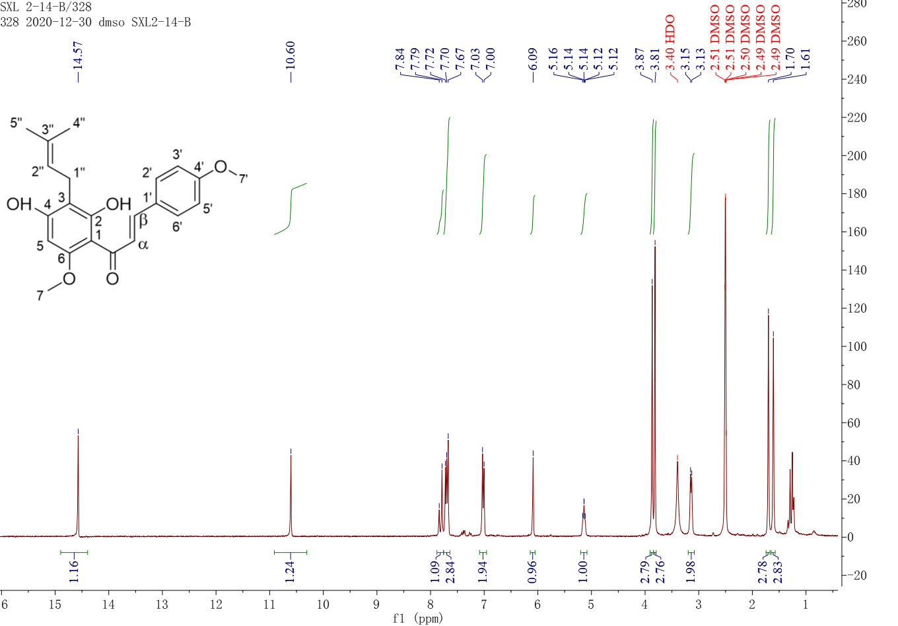

Figure S1 ¹H NMR spectrum of compound 1

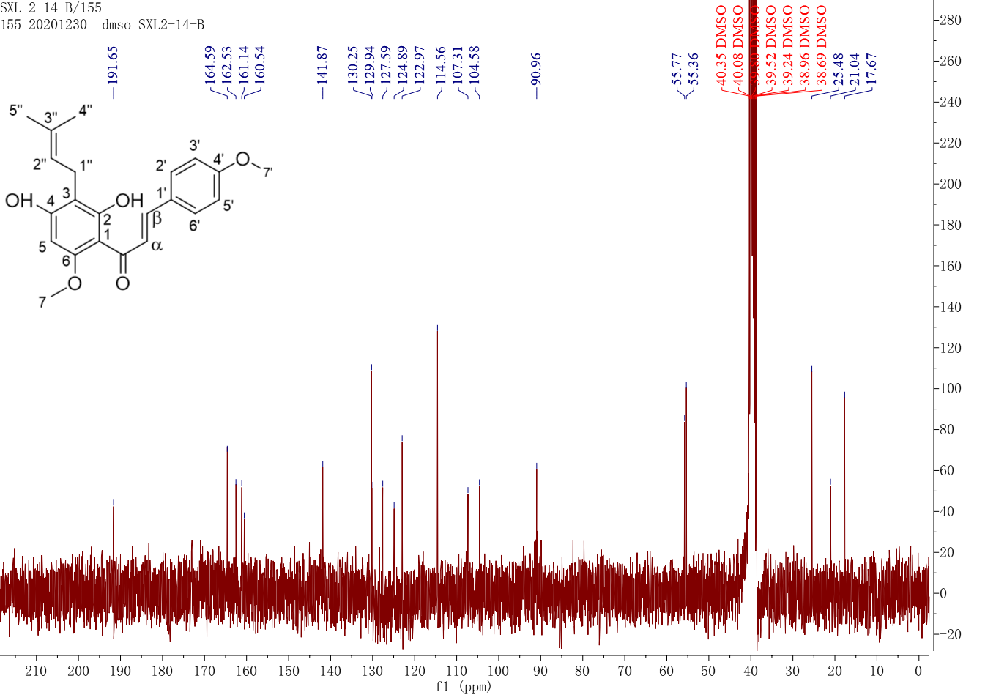

Figure S2 ¹³C NMR spectrum of compound 1

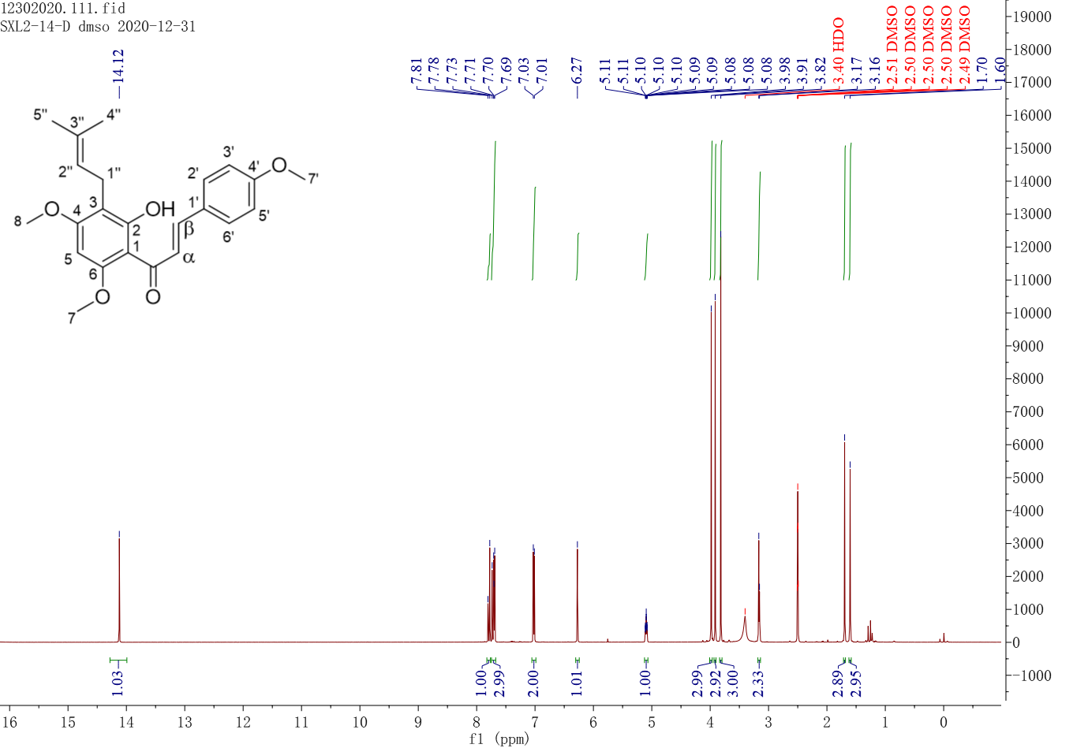

Figure S3 ¹H NMR spectrum of compound 2

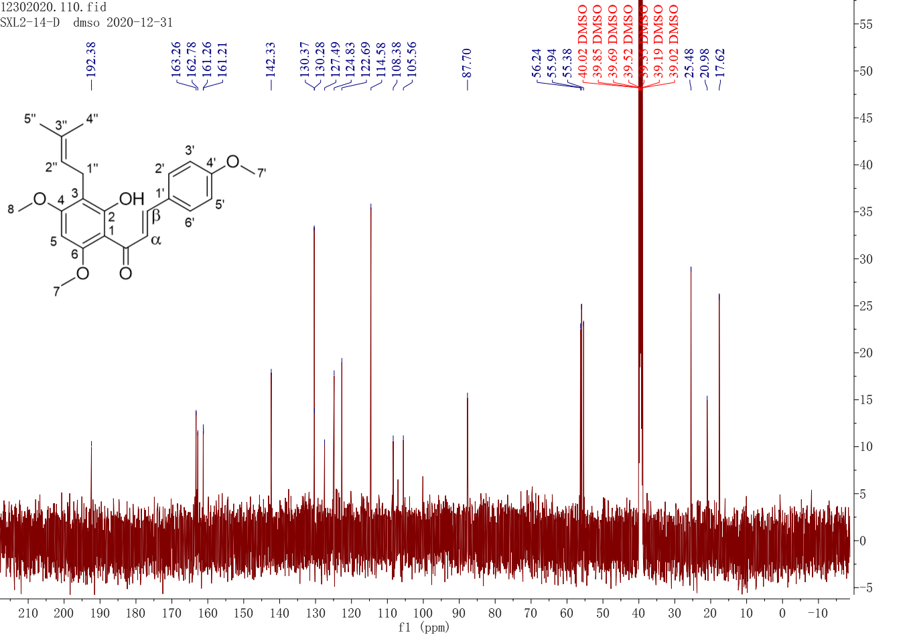

Figure S4 ¹³C NMR spectrum of compound 2

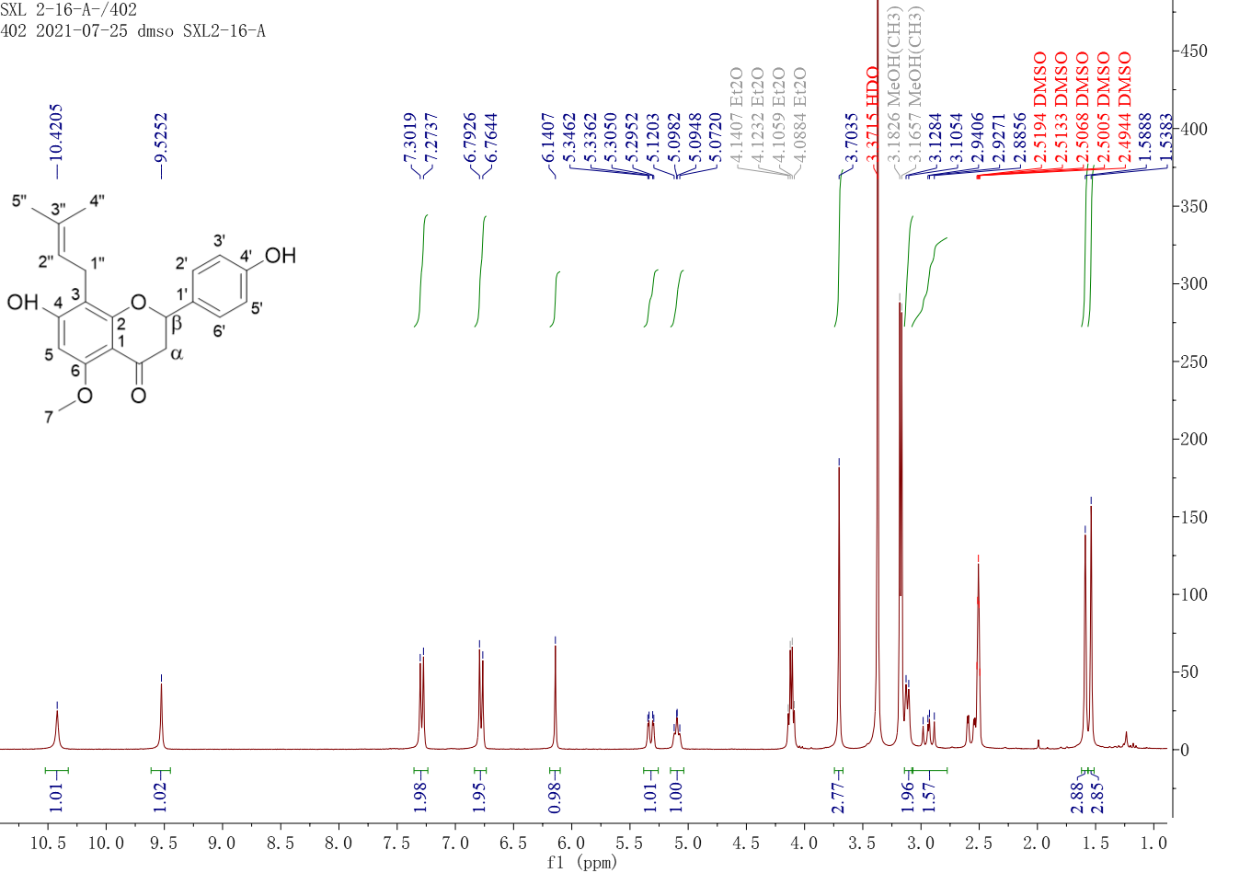

Figure S5 ¹H NMR spectrum of compound 3

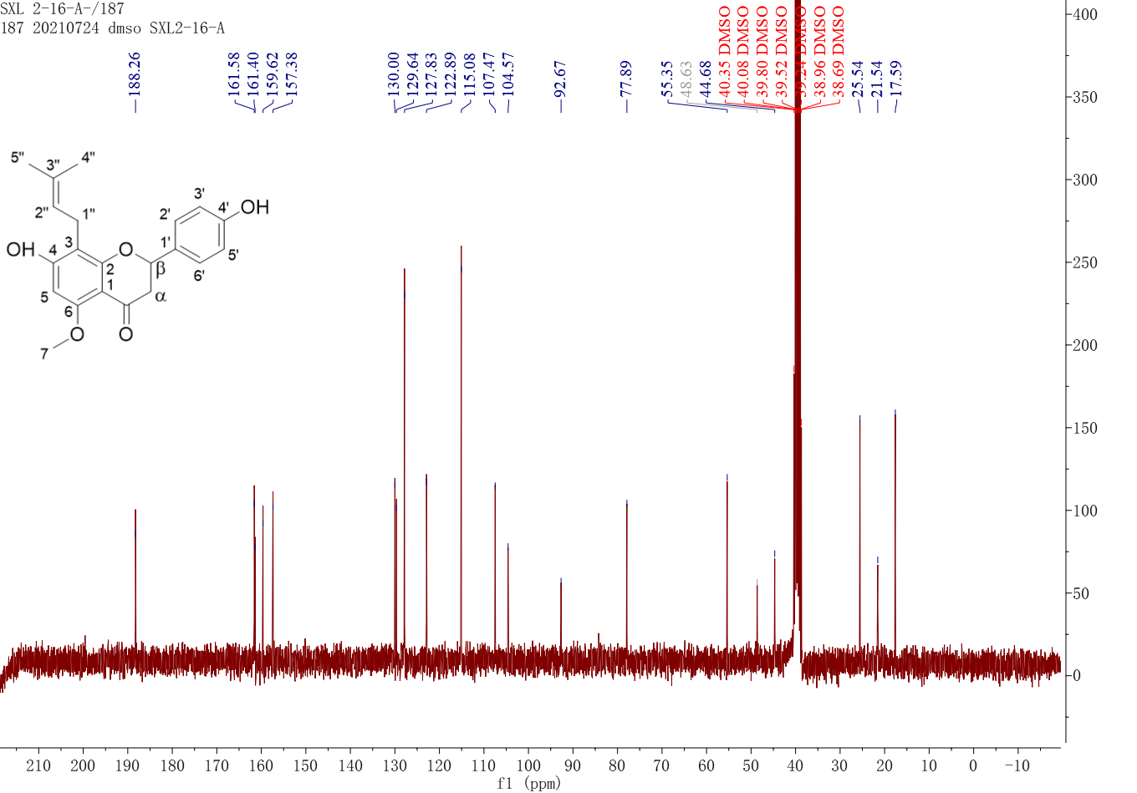

Figure S6 ¹³C NMR spectrum of compound 3

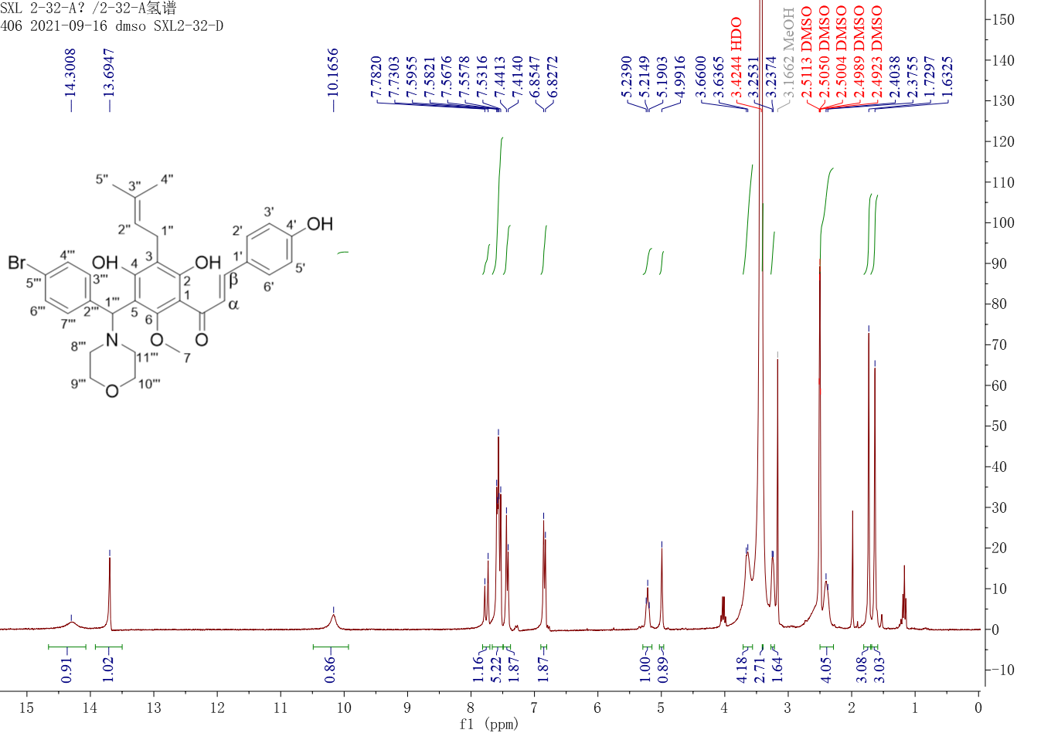

Figure S7 ¹H NMR spectrum of compound 4

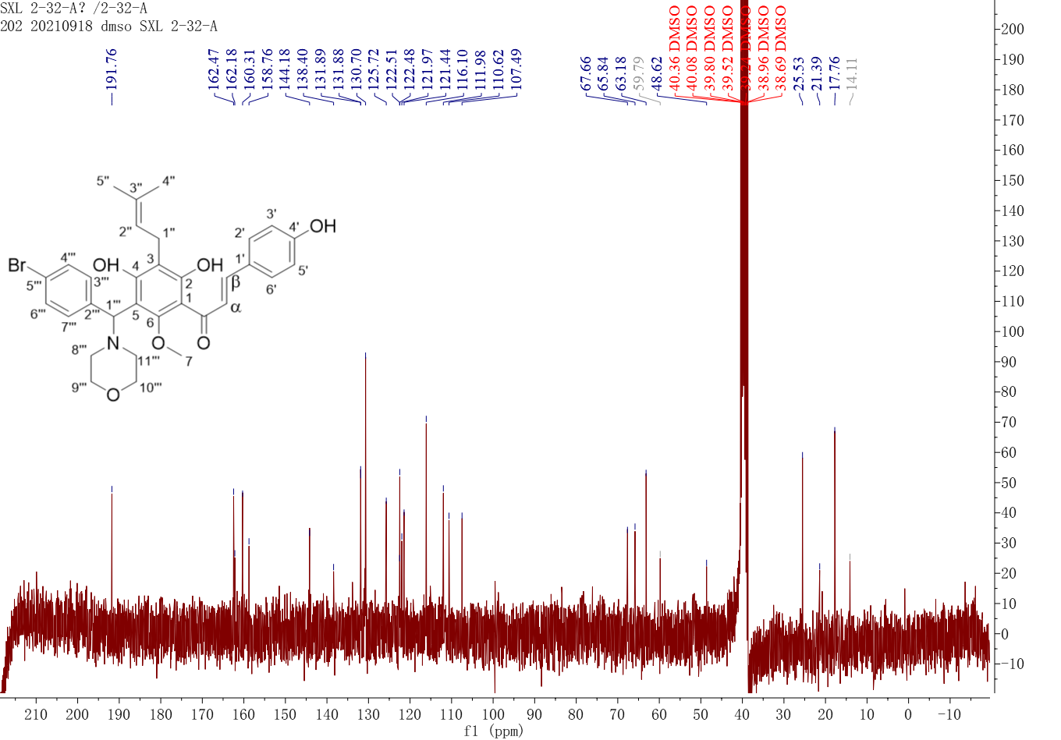

Figure S8 ¹³C NMR spectrum of compound 4

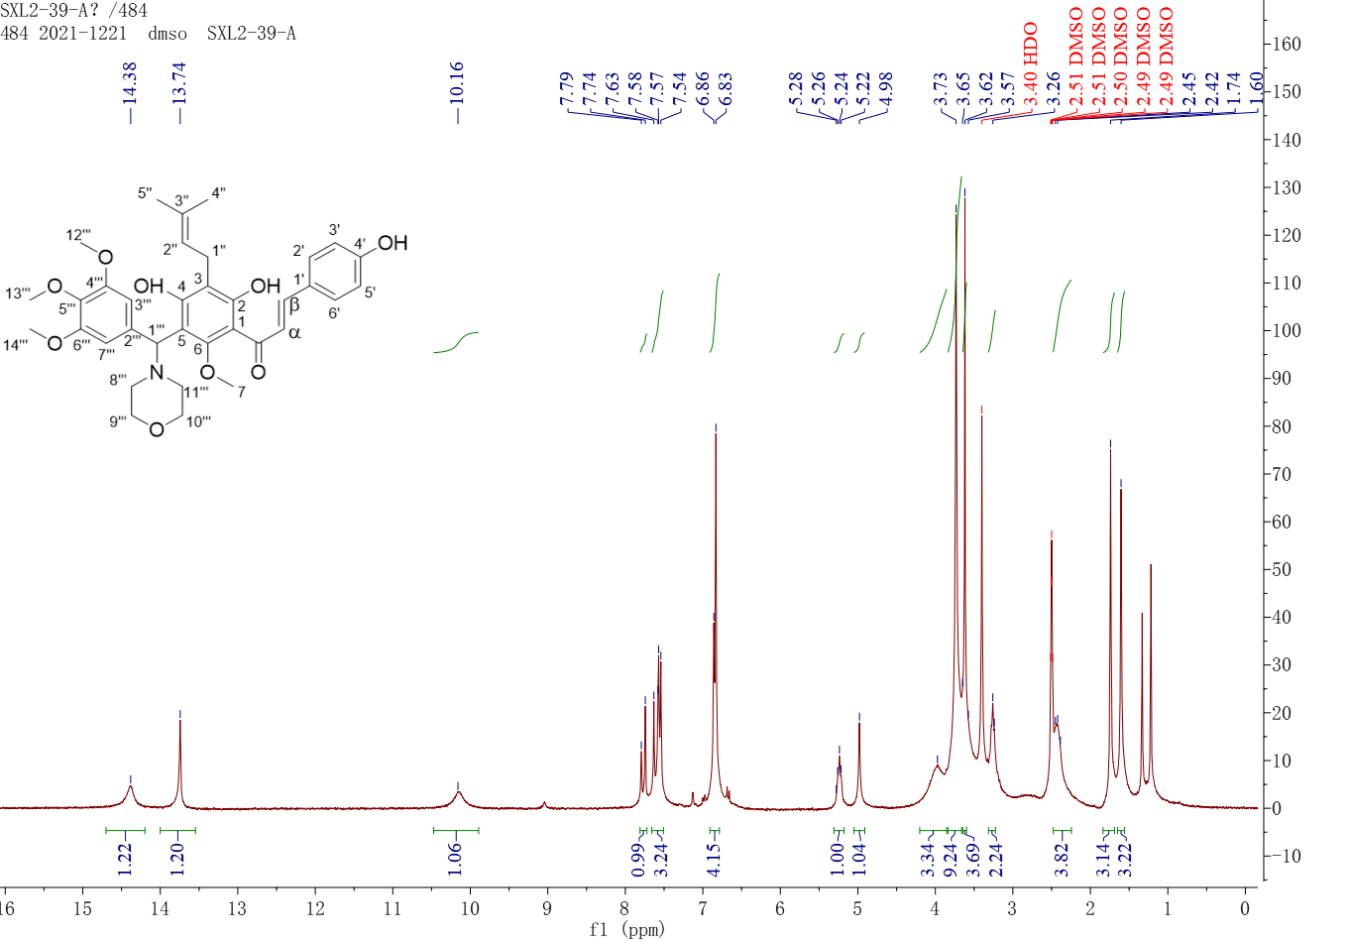

Figure S9 ¹H NMR spectrum of compound 5

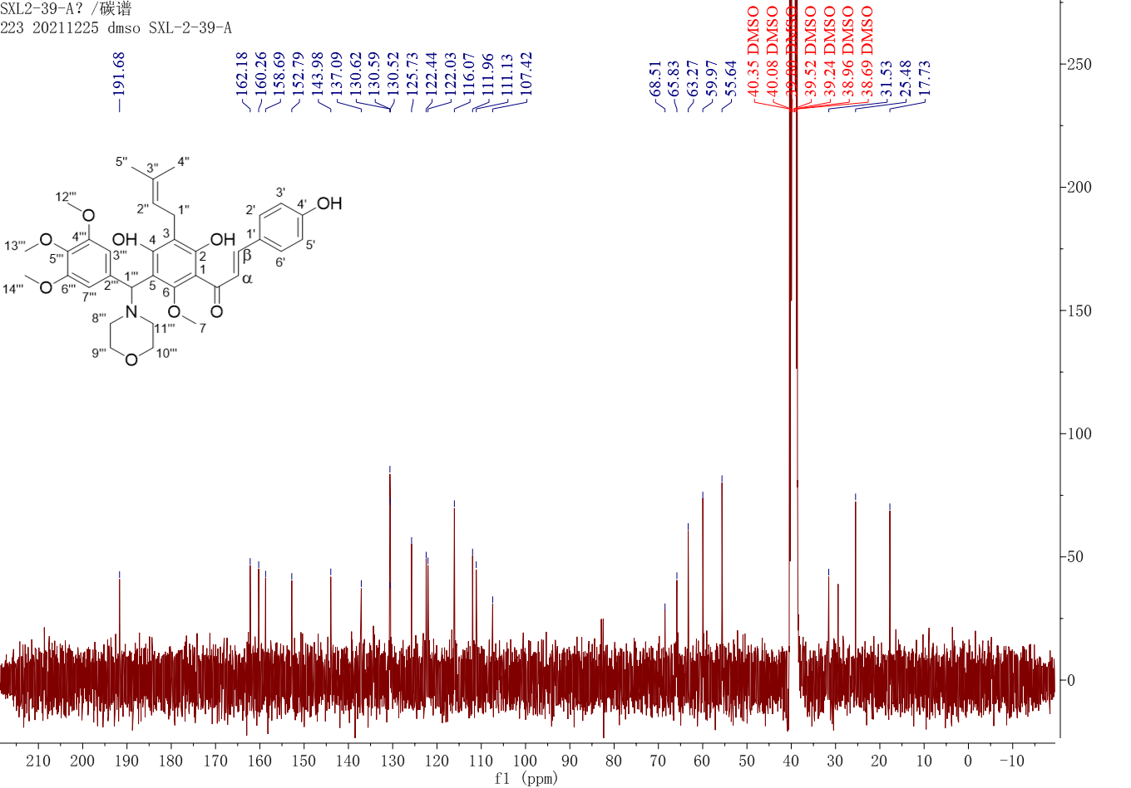

Figure S10 ¹³C NMR spectrum of compound 5

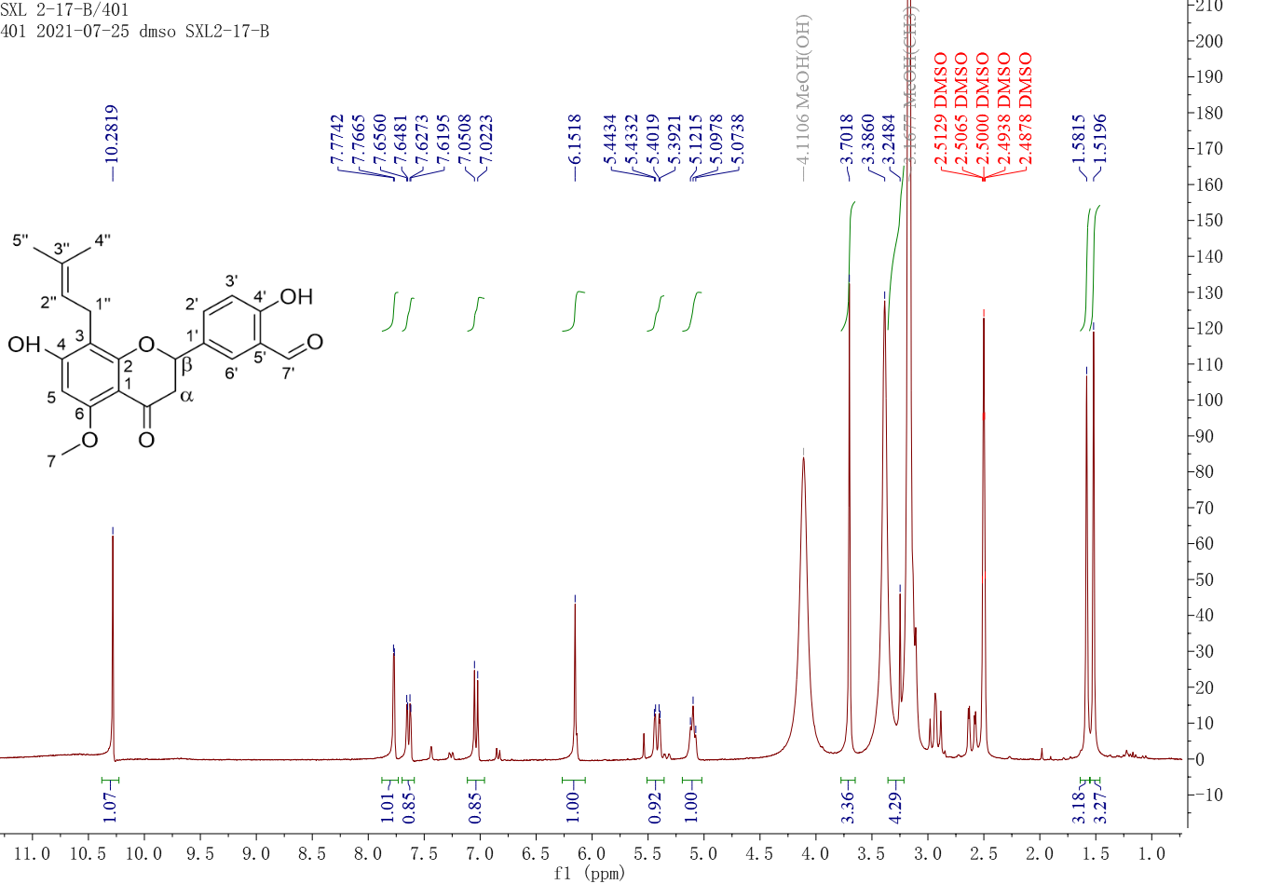

Figure S11 ¹H NMR spectrum of compound 6

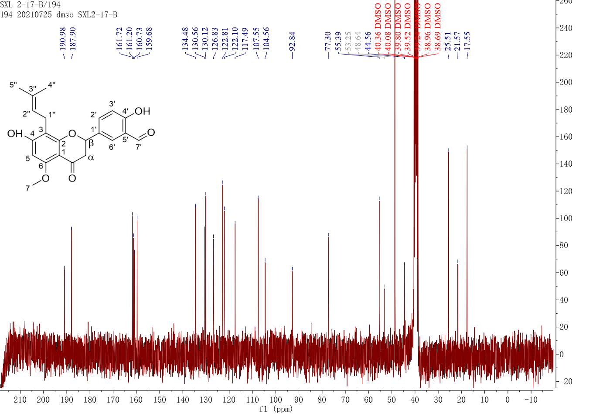

Figure S12 ¹³C NMR spectrum of compound 6

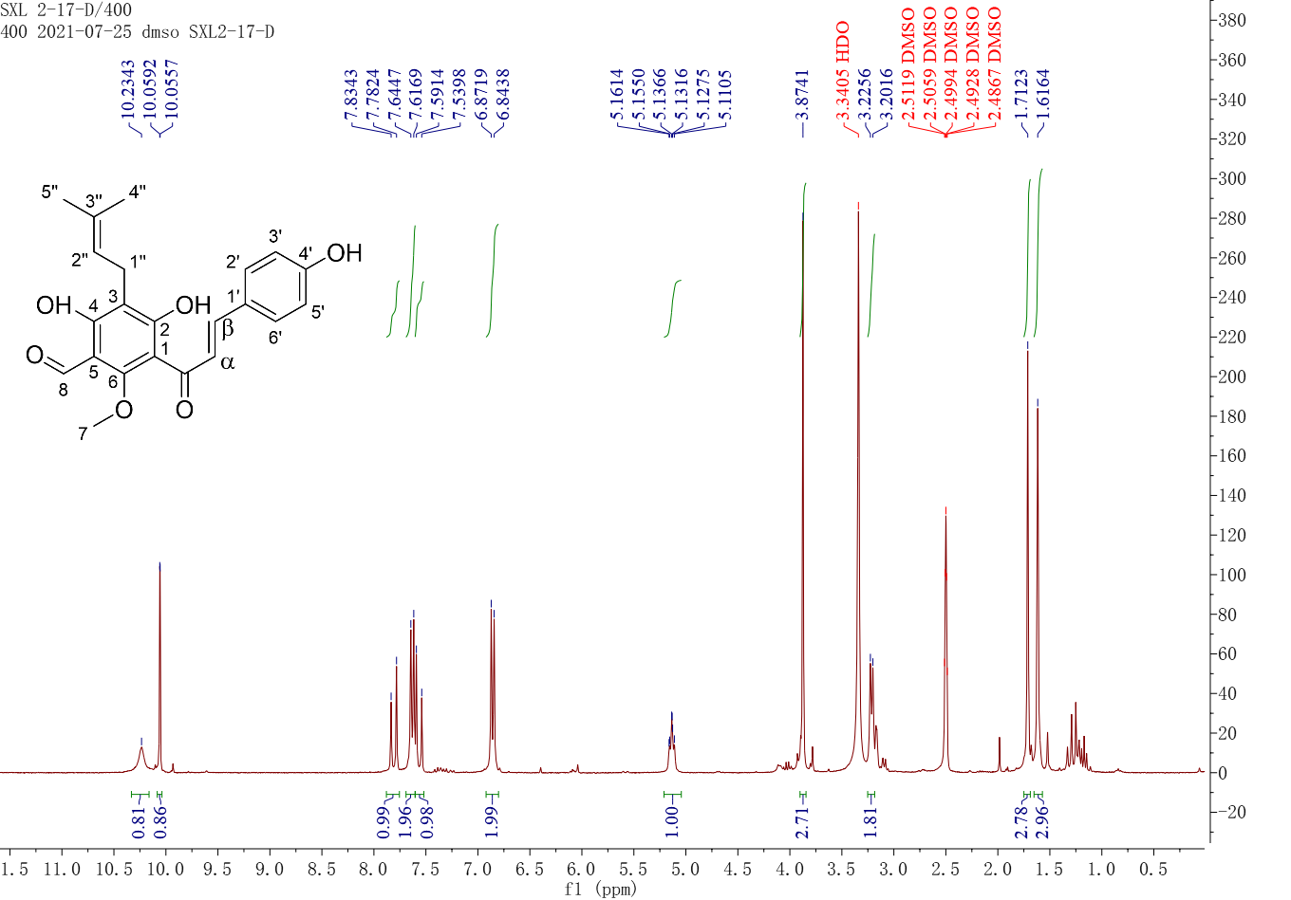

Figure S13 ¹H NMR spectrum of compound 7

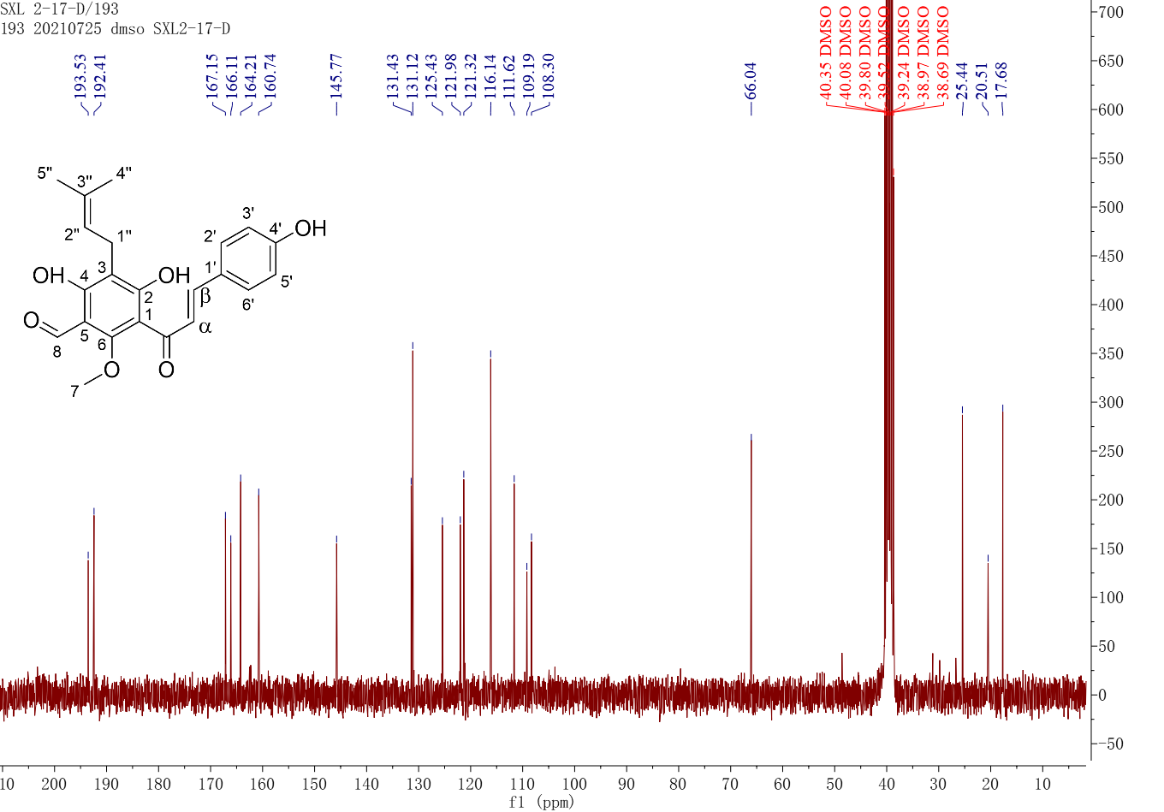

Figure S14 ¹³C NMR spectrum of compound 7

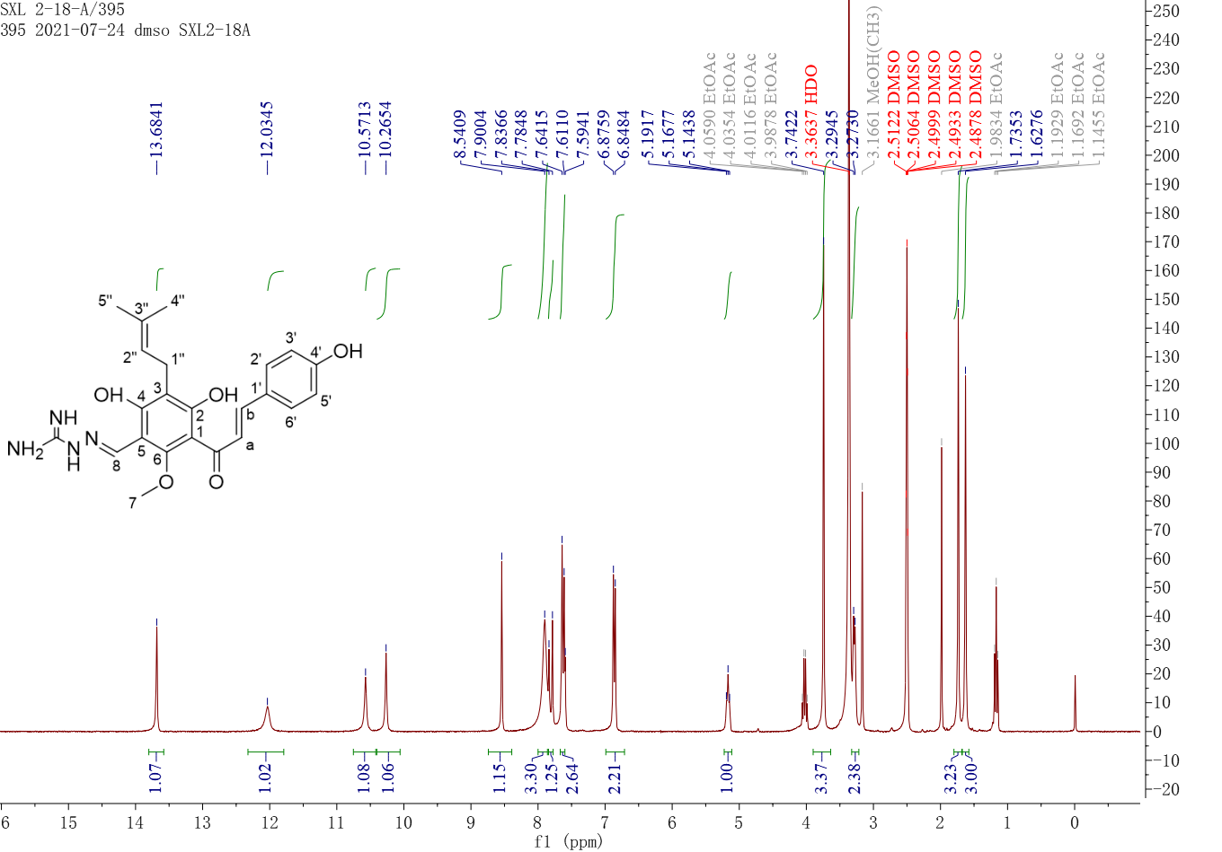

Figure S15 ¹H NMR spectrum of compound 8

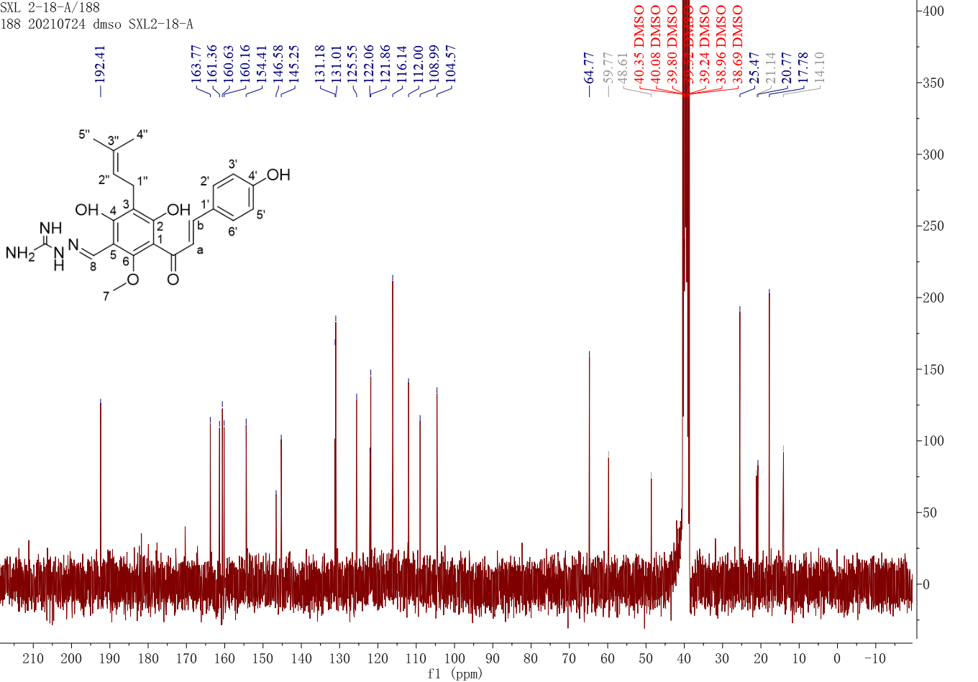

Figure S16 ¹³C NMR spectrum of compound 8

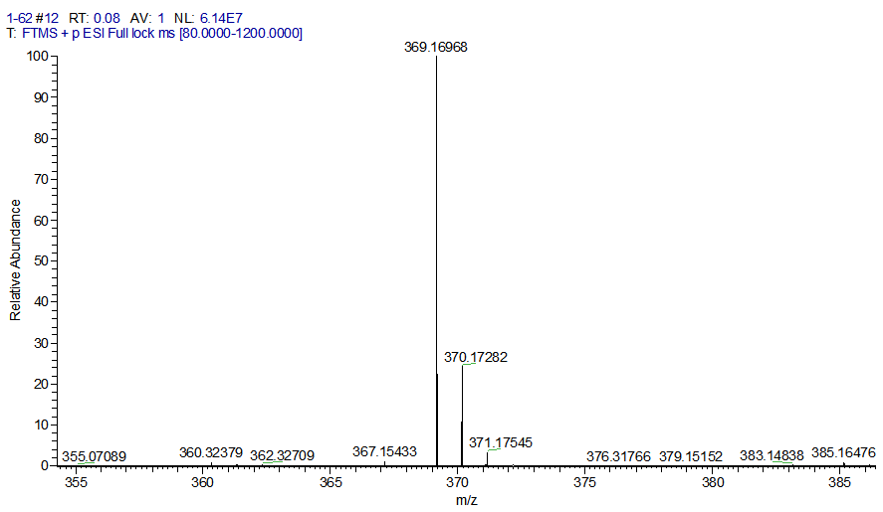

Figure S17 HR-ESI-MS spectrum of compound 1

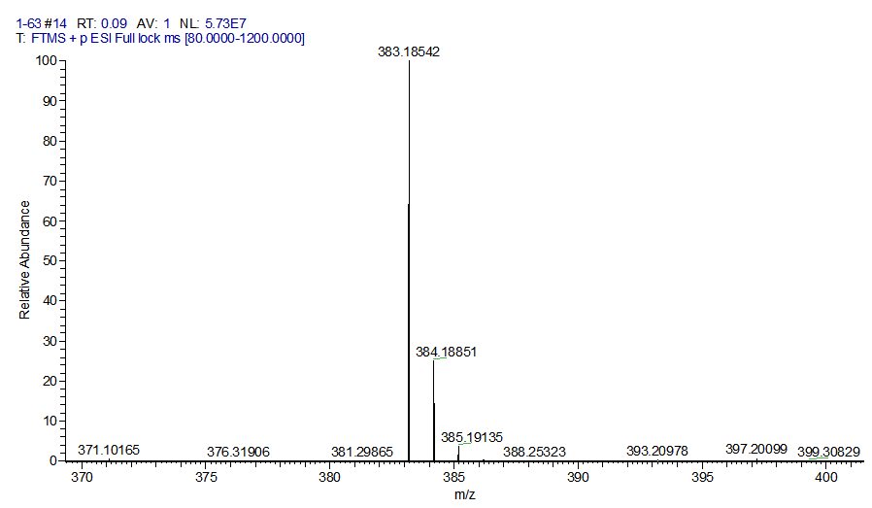

Figure S18 HR-ESI-MS spectrum of compound 2

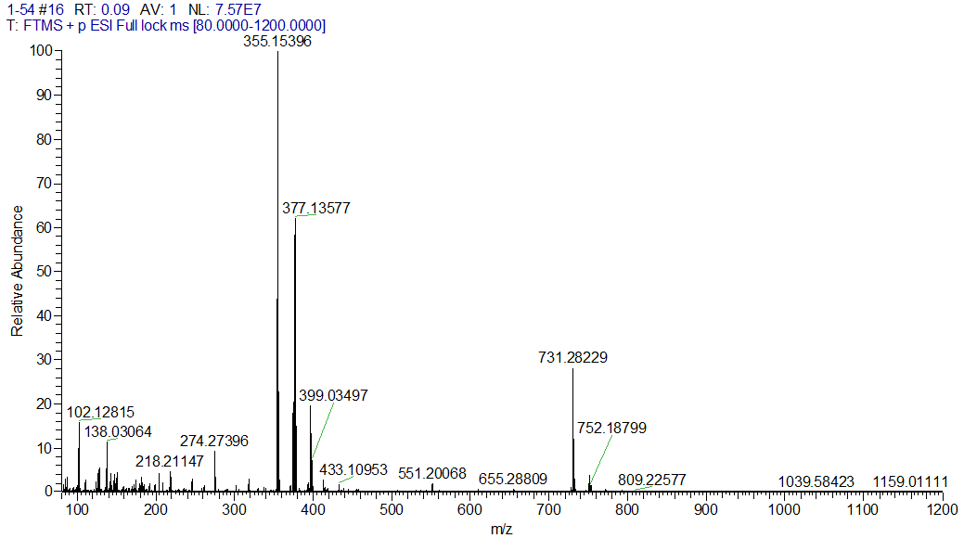

Figure S19 HR-ESI-MS spectrum of compound 3

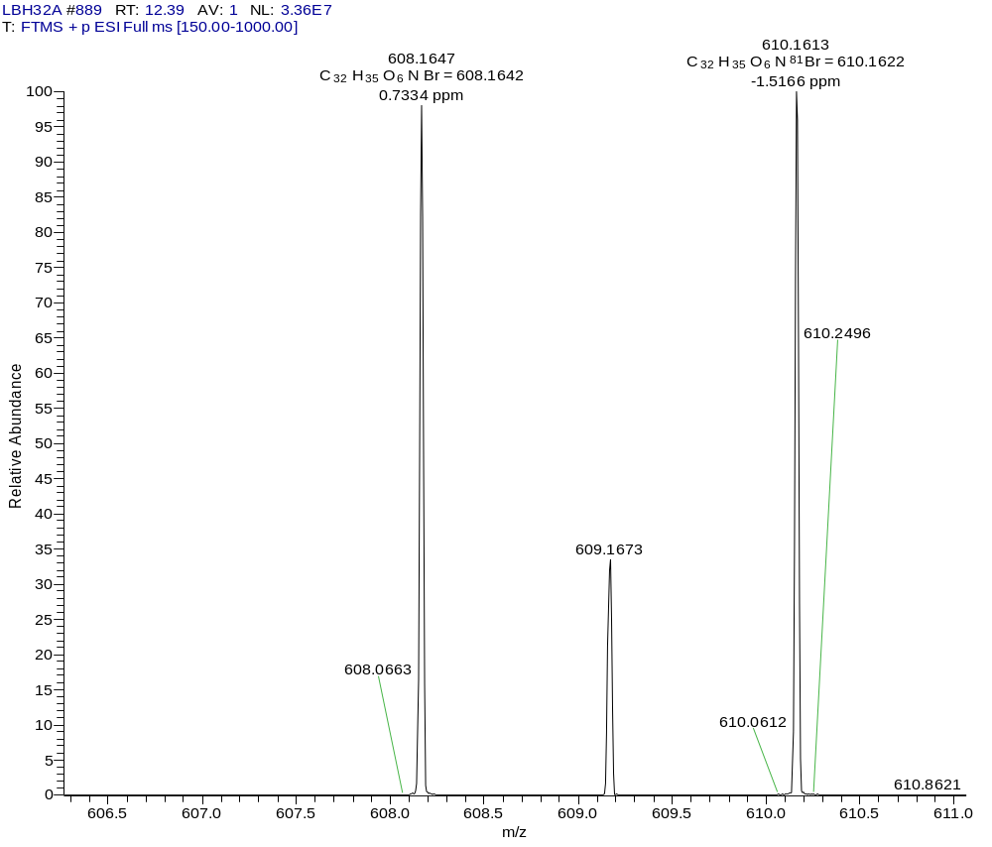

Figure S20 HR-ESI-MS spectrum of compound 4

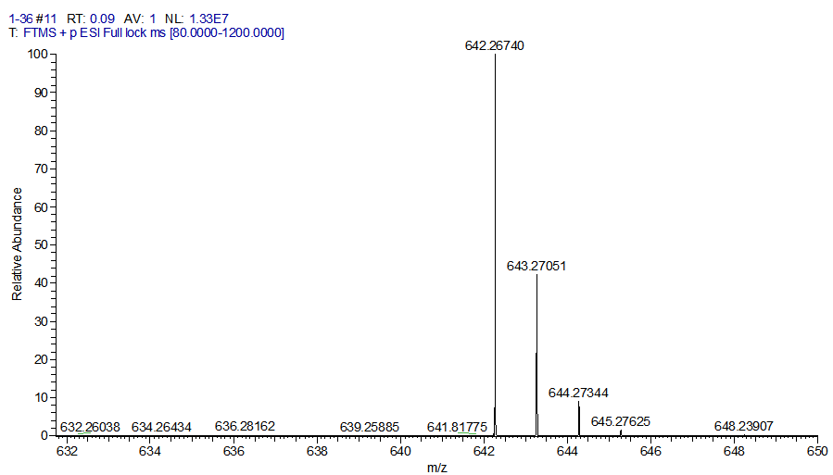

Figure S21 HR-ESI-MS spectrum of compound 5

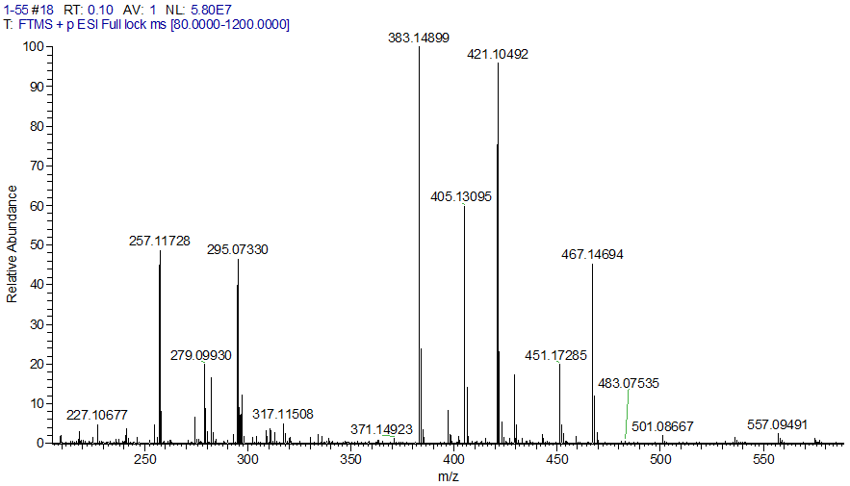

Figure S22 HR-ESI-MS spectrum of compound 6

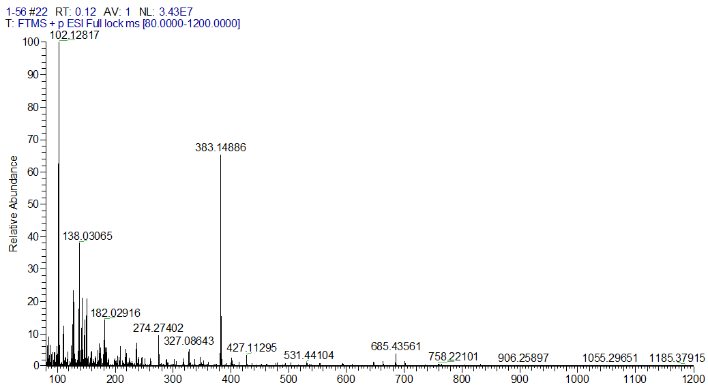

Figure S23 HR-ESI-MS spectrum of compound 7

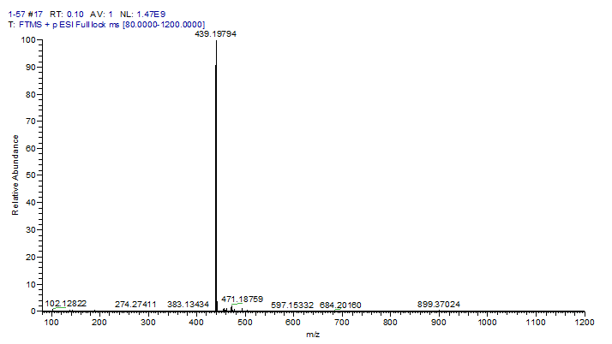

Figure S24 HR-ESI-MS spectrum of compound 8

Druggability experiments methods.

1. Equilibrium solubility assay
The excess derivatives were added in 1 mL of DDW, and the mixture was ultrasound at 37 ° C for 5 min and shaken for 24 h. Then the centrifuge was set at a speed of 15000 r/min and a time of 10 min for centrifugation, the supernatant was taken and the volume of the supernatant was recorded. The chromatographic methanol was added to lyophilized centrifugal tube and was detected on high performance liquid chromatography, and the corresponding concentration was calculated by the standard curve.

2. Lipid-water partition coefficient assay
Octanol and DDW were shaken at 25 °C for 24 h, and the oil phase and water phase were separated after standing. The derivatives were dissolved in water-saturated octanol solution, and the solution was added to octanol-saturated water and shaken at 37 °C and 120 r/min for 24 h. After that, the water phase was freeze-dried and added with known volume of chromatographic methanol into HPLC analysis. The oil phase was diluted with chromatographic methanol and analyzed by HPLC. Then calculate the fat water partition coefficient (calculation formula : logP = logC_{oil phase} / C_{water phase}).

3. The stability assay
Temperature stability: The excess derivatives were added to 1 mL DDW, and allowed to stand at 25, 37, 60, 80 and 100 °C for 30 min after ultrasonication. After centrifugation, the supernatant was analyzed by HPLC, and the temperature stability histogram of the compound was drawn.
pH stability : The solutions with pH 2, 5, 7, 9, 11, 13 were prepared respectively. The excess derivatives were placed in 1.5 mL the solution with corresponding pH. After ultrasonic treatment and standing at room temperature for 30 min, the supernatant was centrifuged and analyzed by HPLC, and the pH stability histogram of the compound was drawn.

