Appendix: Temporal change in phytoplankton diversity and functional group composition
Journal: Marine Biodiversity
Authors: Josie Antonucci di Cavalho^{1,2*} (Orcid ID: https://orcid.org/0000-0001-5436-6954), Lena Rönn⁴, Theo C. Prins⁵, Helmut Hillebrand^{1,2,3} (Orcid ID: https://orcid.org/0000-0001-7449-1613)
- Helmholtz-Institute for Functional Marine Biodiversity at the University of Oldenburg [HIFMB], Ammerländer Heerstrasse 231, 26129 Oldenburg
- Alfred Wegener Institute, Helmholtz-Centre for Polar and Marine Research [AWI], Bremerhaven
- Institute for Chemistry and Biology of Marine Environments [ICBM], Carl-von-Ossietzky University Oldenburg, Schleusenstrasse 1, 26382 Wilhelmshaven
- Lower Saxony Water Management, Coastal Defence and Nature Conservation Agency (NLWKN, Brake-Oldenburg), Oldenburg, Germany
- Deltares, PO Box 177, 2600 MH Delft, The Netherlands
e-mail address of the corresponding author: josie.antonucci@hifmb.de

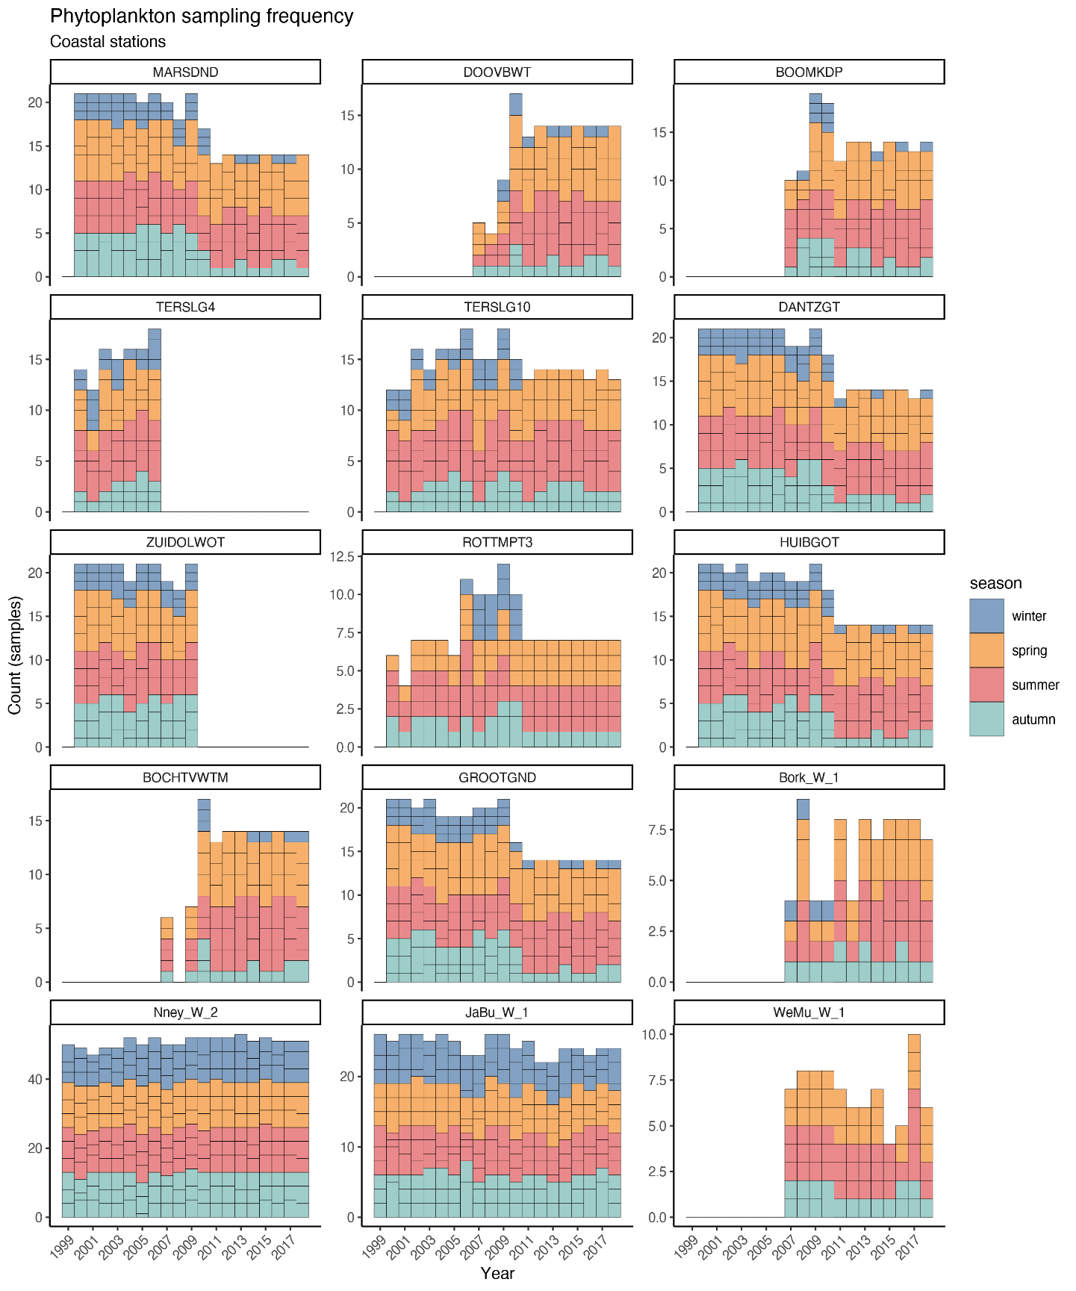
Fig. S1. Sampling frequency for phytoplankton abundance of the Wadden Sea coastal stations from 1999-2018. The bars represent the number of samples per year. The horizontal lines on each bar separates the months sampled. And the colors represent the season: winter = Dec, Jan, Feb; spring = Mar, Apr, May; summer = Jun, Jul, Aug; autumn = Sep, Oct, Nov.
Table S1. Results of the linear mixed effect model, analysing the change in phytoplankton standing diversity between years. Separate models per country, Netherlands (NL) and Germany (DE). Station ID is included as random effect.
 | NL - Annual Richness |  | DE - Annual Richness |  | NL - Annual ENS |  | DE - Annual ENS
Predictors | Estimates | p | Estimates | p | Estimates | p | Estimates | p
(Intercept) | 3683.877 | <0.001 | -2649.949 | <0.001 | 613.509 | <0.001 | -422.010 | 0.059
Year | -1.791 | <0.001 | 1.350 | <0.001 | -0.302 | <0.001 | 0.215 | 0.054
Random Effects
σ² | 172.49 |  | 100.45 |  | 7.69 |  | 22.15
τ₀₀ | 317.28 _{StationID} |  | 349.40 _{StationID} |  | 2.53 _{StationID} |  | 0.00 _{StationID}
ICC | 0.65 |  | 0.78 |  | 0.25
N | 9 _{StationID} |  | 4 _{StationID} |  | 9 _{StationID} |  | 4 _{StationID}
Observations | 149 |  | 64 |  | 149 |  | 64
Marginal R² / Conditional R² | 0.156 / 0.703 |  | 0.107 / 0.801 |  | 0.202 / 0.400 |  | 0.058 / NA

Table S2. Results of the linear mixed effect model, analysing the change in phytoplankton annual turnover based on richness (SERr) and on abundance (SERa). Separate models per country, Netherlands (NL) and Germany (DE). Station ID is included as random effect.
 | NL - SERr |  | DE - SERr |  | NL - SERa |  | DE - SERa
Predictors | Estimates | p | Estimates | p | Estimates | p | Estimates | p
(Intercept) | -8.062 | <0.001 | 14.933 | <0.001 | -12.557 | 0.110 | 20.628 | 0.026
Year | 0.004 | <0.001 | -0.007 | <0.001 | 0.006 | 0.097 | -0.010 | 0.032
Random Effects
σ² | 0.00 |  | 0.00 |  | 0.05 |  | 0.03
τ₀₀ | 0.00 _{StationID} |  | 0.00 _{StationID} |  | 0.00 _{StationID} |  | 0.00 _{StationID}
ICC | 0.23 |  | 0.12 |  | 0.07 |  | 0.05
N | 9 _{StationID} |  | 4 _{StationID} |  | 9 _{StationID} |  | 4 _{StationID}
Observations | 139 |  | 60 |  | 139 |  | 60
Marginal R² / Conditional R² | 0.125 / 0.325 |  | 0.206 / 0.301 |  | 0.019 / 0.089 |  | 0.076 / 0.125

Table S3. Results of the linear mixed effect model, analysing the change in phytoplankton cumulative turnover based on richness (SERr) and on abundance (SERa) over years (dist). Separate models per country, Netherlands (NL) and Germany (DE). Station ID is included as random effect.
 | NL - Cumulative SERr |  | DE - Cumulative SERr |  | NL - Cumulative SERa |  | DE - Cumulative SERa
Predictors | Estimates | p | Estimates | p | Estimates | p | Estimates | p
(Intercept) | 0.443 | <0.001 | 0.410 | <0.001 | 0.467 | <0.001 | 0.831 | <0.001
dist | 0.009 | <0.001 | 0.018 | <0.001 | 0.020 | <0.001 | 0.007 | <0.001
Random Effects
σ² | 0.00 |  | 0.01 |  | 0.05 |  | 0.02
τ₀₀ | 0.00 _{StationID} |  | 0.00 _{StationID} |  | 0.01 _{StationID} |  | 0.00 _{StationID}
ICC | 0.16 |  | 0.06 |  | 0.10 |  | 0.00
N | 9 _{StationID} |  | 4 _{StationID} |  | 9 _{StationID} |  | 4 _{StationID}
Observations | 1213 |  | 512 |  | 1213 |  | 512
Marginal R² / Conditional R² | 0.345 / 0.450 |  | 0.527 / 0.555 |  | 0.106 / 0.196 |  | 0.040 / 0.041

Table S4. Results of the linear mixed effect model, analyzing the change in phytoplankton biomass (LN μgC L⁻¹) and biomass of each functional groups (LN μgC L⁻¹) between years in the Dutch stations. Station ID is included as random effect.

 | NL - Biomass |  | NL - Diatoms |  | NL – Dinof. |  | NL – Flagel. |  | NL – Phae. |  | NL - Other
Predictors | Estimates | p | Estimates | p | Estimates | p | Estimates | p | Estimates | p | Estimates | p
(Intercept) | -185.270 | <0.001 | -190.267 | <0.001 | -39.465 | 0.026 | -135.072 | <0.001 | -84.948 | 0.007 | -219.279 | <0.001
Year | 0.096 | <0.001 | 0.098 | <0.001 | 0.021 | 0.019 | 0.069 | <0.001 | 0.043 | 0.006 | 0.111 | <0.001
Random Effects
σ² | 0.27 |  | 0.45 |  | 0.29 |  | 0.39 |  | 0.95 |  | 0.59
τ₀₀ | 0.27 _{StationID} |  | 0.60 _{StationID} |  | 0.20 _{StationID} |  | 0.26 _{StationID} |  | 0.16 _{StationID} |  | 0.03 _{StationID}
ICC | 0.51 |  | 0.57 |  | 0.41 |  | 0.40 |  | 0.14 |  | 0.04
N | 9 _{StationID} |  | 9 _{StationID} |  | 9 _{StationID} |  | 9 _{StationID} |  | 9 _{StationID} |  | 9 _{StationID}
Observations | 149 |  | 149 |  | 149 |  | 149 |  | 149 |  | 149
Marginal R² / Conditional R² | 0.323 / 0.666 |  | 0.204 / 0.660 |  | 0.024 / 0.424 |  | 0.168 / 0.503 |  | 0.045 / 0.183 |  | 0.361 / 0.387

Table S5. Results of the linear mixed effect model, analyzing the change in phytoplankton biomass (LN μgC L⁻¹) and biomass of each functional groups (LN μgC L⁻¹) between years in the German stations. Station ID is included as random effect.
 | DE - Biomass |  | DE - Diatoms |  | DE – Dinof. |  | DE – Flagel. |  | DE – Phaeo. |  | DE - Other
Predictors | Estimates | p | Estimates | p | Estimates | p | Estimates | p | Estimates | p | Estimates | p
(Intercept) | 44.954 | 0.042 | 35.006 | 0.112 | 32.655 | 0.257 | 72.004 | 0.001 | 25.848 | 0.637 | 86.913 | 0.014
Year | -0.020 | 0.063 | -0.015 | 0.157 | -0.016 | 0.272 | -0.035 | 0.001 | -0.012 | 0.654 | -0.043 | 0.015
Random Effects
σ² | 0.19 |  | 0.19 |  | 0.34 |  | 0.18 |  | 1.21 |  | 0.51
τ₀₀ | 0.32 _{StationID} |  | 0.29 _{StationID} |  | 0.07 _{StationID} |  | 0.05 _{StationID} |  | 0.42 _{StationID} |  | 0.04 _{StationID}
ICC | 0.63 |  | 0.60 |  | 0.17 |  | 0.21 |  | 0.26 |  | 0.07
N | 4 _{StationID} |  | 4 _{StationID} |  | 4 _{StationID} |  | 4 _{StationID} |  | 4 _{StationID} |  | 4 _{StationID}
Observations | 64 |  | 64 |  | 64 |  | 64 |  | 64 |  | 64
Marginal R² / Conditional R² | 0.023 / 0.640 |  | 0.014 / 0.611 |  | 0.018 / 0.188 |  | 0.138 / 0.315 |  | 0.003 / 0.261 |  | 0.091 / 0.152

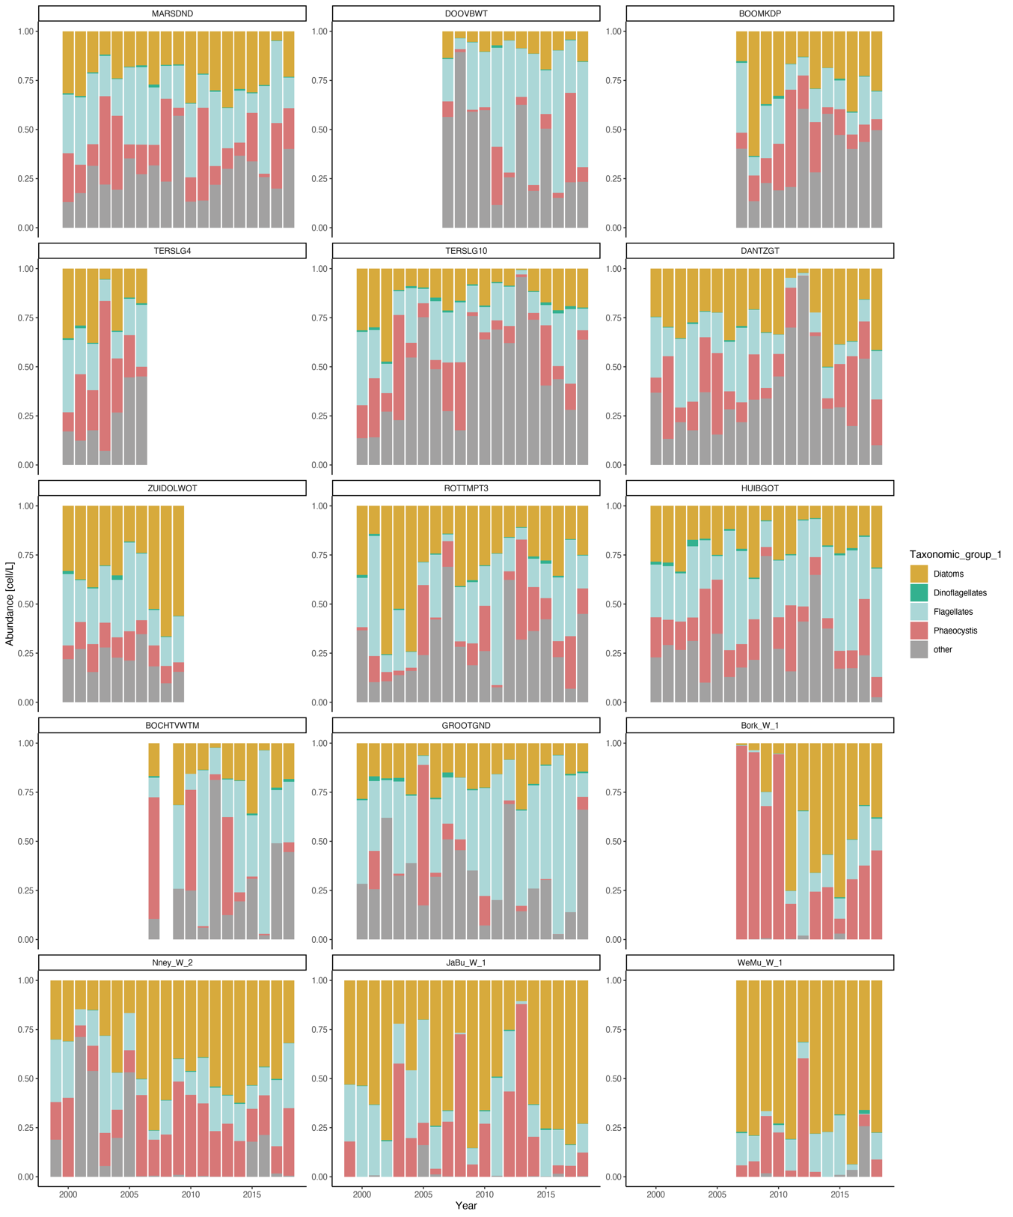
Fig. S2 Relative abundance of functional groups over time in the Wadden Sea stations over ~19 years.

