SUPPLEMENTARY DATA
Epigenetics Signatures
Materials and Methods
1.1 Participants and Study Cohort
The discovery cohort involved 12 female samples with confirmed pathogenic or likely pathogenic truncating variants in DDX3X. Controls were randomly selected from the EpiSign™ Knowledge Database (EKD) [1] matched for age, sex and array type.
1.2. Sample Processing
DNA was obtained from whole blood by using standard techniques. Bisulphite conversion was performed according to the Illumina protocol (Illumina, San Diego, CA, USA). DNA methylation analysis involved 500 ng bisulfite-converted DNA as the input for the Illumina Infinium MethylationEPIC BeadChip arrays (San Diego, CA, USA) according to the manufacturer’s protocols. To minimize the batch effect, samples were randomly divided over separate batches. Analysis and discovery of episignatures was based on our laboratory’s previously published protocols [1,2,3]. In brief, intensity data files containing methylated and unmethylated signal intensities were analyzed with R 4.1.1. Normalization of methylation data involved the Illumina normalization method with background correction with the minfi package (v1.40.0) [4]. From the 866,836 total probes available, the following probes were eliminated: probes with detection p > 0.1, probes located on chromosomes X and Y (n = 19,120 and n = 561, respectively), probes containing single-nucleotide polymorphisms at or near the CpG interrogation site or single-nucleotide extension sites (n = 31,647) and probes that cross-react with other genomic regions (n = 72,487). Samples containing failed probes of > 5% (p > 0.1, calculated with the minfi package) were removed. Principal component analysis was used to examine batch structure and identify case or control outliers. Matched controls were randomly selected from the EKD [2] and matched by age, sex and array type at a ratio of 1:5 by using the MatchIt package (v4.3.4) [5]. Methylation levels for each probe (beta values) were converted to M-values by logit transformation and linear regression applied to identify differentially methylated probes with the limma package (v3.50.0) [6]. Estimated blood cell proportions were incorporated into the model matrix as confounding variables [7]. The blood cell types used as covariates were CD4+ and CD8+ cells, natural killer cells, monocytes, granulocytes and B cells as described in the minfi package. P-values were moderated with the eBayes function in the limma package.
1.3. Probe Selection
Selection of probes involved three steps. First, 900 to 1000 probes were retained with the highest product of absolute methylation differences between cases and controls and the negative of the logarithm of p-values. Second, receiver operating characteristic (ROC) curve analysis was performed, and 300 to 500 probes were retained with the highest area under the ROC curve (AUC). Finally, we eliminated probes with pair-wise correlation > 0.60 measured by Pearson’s correlation coefficients for all probes. Unsupervised clustering models were applied using the remaining probes, including hierarchical clustering (heatmap), by using Ward’s method on Euclidean distance in the in R gplots package (v3.1.1) and multidimensional scaling by scaling the pair-wise Euclidean distances between samples.
References
- Aref-Eshghi, E.; Kerkhof, J.; Pedro, V.P.; Barat-Houari, M.; Ruiz-Pallares, N.; Andrau, J.-C.; Lacombe, D.; Van-Gils, J.; Fergelot, P.; Dubourg, C.; et al. Evaluation of DNA Methylation Episignatures for Diagnosis and Phenotype Correlations in 42 Mendelian Neurodevelopmental Disorders. Am. J. Hum. Genet. 2020, 106, 356–370.
- Aref-Eshghi, E.; Rodenhiser, D.I.; Schenkel, L.C.; Lin, H.; Skinner, C.; Ainsworth, P.; Paré, G.; Hood, R.L.; Bulman, D.E.; Kernohan, K.D.; et al. Genomic DNA Methylation Signatures Enable Concurrent Diagnosis and Clinical Genetic Variant Classification in Neurodevelopmental Syndromes. Am. J. Hum. Genet. 2018, 102, 156–174.
- Aref-Eshghi, E.; Kerkhof, J.; Pedro, V.P.; Barat-Houari, M.; Ruiz-Pallares, N.; Andrau, J.-C.; Lacombe, D.; Van-Gils, J.; Fergelot, P.; Dubourg, C.; et al. Evaluation of DNA Methylation Episignatures for Diagnosis and Phenotype Correlations in 42 Mendelian Neurodevelopmental Disorders. Am. J. Hum. Genet. 2020, 106, 356–370.
- Aryee, M.J.; Jaffe, A.E.; Corrada-Bravo, H.; Ladd-Acosta, C.; Feinberg, A.P.; Hansen, K.D.; Irizarry, R.A. Minfi: A flexible and comprehensive Bioconductor package for the analysis of Infinium DNA methylation microarrays. Bioinformatics 2014, 30, 1363–1369.
- Ho, D.; Imai, K.; King, G.; Stuart, E.A. MatchIt: Nonparametric Preprocessing for Parametric Causal Inference. J. Stat. Softw. 2011, 42, 1–28.
- Ritchie, M.E.; Belinda, P.; Wu, D.; Hu, Y.; Law, C.W.; Shi, W.; Smyth, G.K. limma powers differential expression analyses for RNA-sequencing and microarray studies. Nucleic Acids Res. 2015, 43, e47.
- Houseman, E.A.; Accomando, W.P.; Koestler, D.C.; Christensen, B.C.; Marsit, C.J.; Nelson, H.H.; Wiencke, J.K.; Kelsey, K.T. DNA methylation arrays as surrogate measures of cell mixture distribution. BMC Bioinform. 2012, 13, 86.

Supplementary Figure 1: Geographic distribution of individuals from the GENIDA cohort (“series 2”)

A
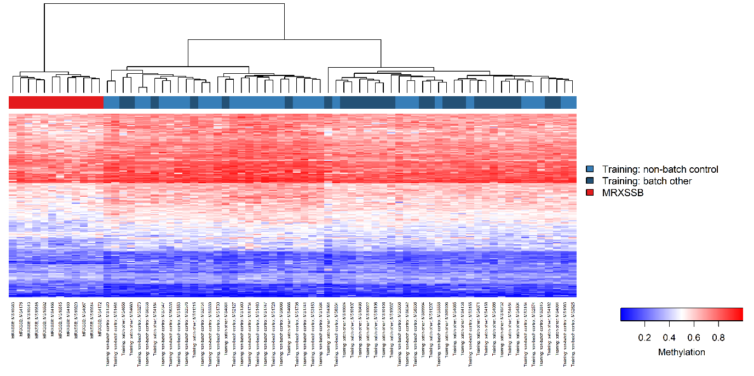
B
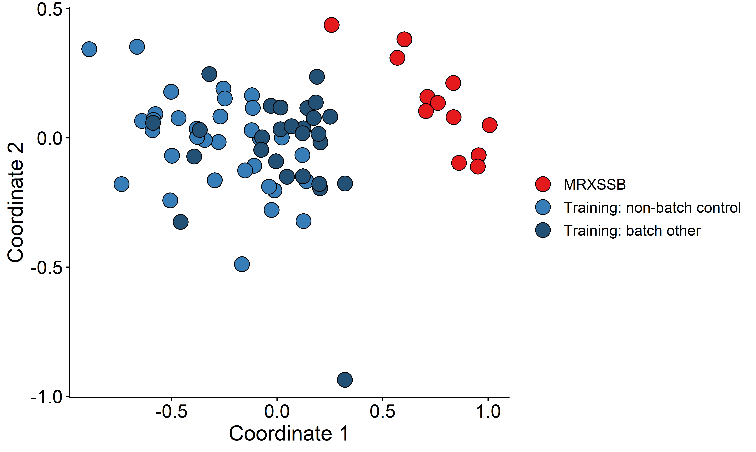
Supplementary Figure 2: Preliminary evidence of methylation changes in MRXSSB (DDX3X) truncating variants. A) Euclidean hierarchical clustering (heatmap): each column represents a MRXSSB case or control and each row 1 of the 177 CpG differentially methylated probes. This heatmap shows separation of 12 MRXSSB cases (red) used for training and controls (blue). B) Multidimensional scaling (MDS) plot showing separation of MRXSSB cases (red) and controls (blue). Other batch controls were processed in the same technical batch as MRXSSB cases and non-batch controls were processed separately and selected from the EKD.

Apgar score 1'/5' | 9.1 / 9.6
Feeding difficulties in newborn | 10/43
Jaundice | 5/43
Hypotonia in newborn | 5/43
Tying shoes | 5/25
Showering and brushing teeth | 23/25
Getting dressed | 22/25
Intellectual disability | 23/35
Autism | 6/35
Behavior problems | 27/42
Feeding problems | 13/43
Unstable walking | 13/41
Movement disorders | 31/44
Epilepsia | 11/44
Vision problems | 31/44
Hearing problems | 8/44
Sense of smell problems | 0/44
Sleeping disorders | 14/44
Dental anomalies | 12/44
Oral/buccal problems | 15/44
Cardiac problems | 5/44
Vascular problems | 1/43
Respiratory problems | 5/44
Digestive problems | 22/44
Renal/kidney, bladder and urogenital problems | 6/44
Musculoskeletal problems | 24/44
Skin, nails and hair problems | 15/44
Endocrine and metabolic problems | 3/44
Blood and immune system problems | 0/43
Cancer | 1/43

Supplementary Table 2: Complete list of reported data for DDX3X individual in GenIDA (“series 2”). [There are no mandatory responses in GenIDA to allow participants to skip questions (if they don't have an answer, or if they are not concerned), to answer the questionnaire out of order, and to answer in multiple rounds to reduce potential caregiver burden and maximize participation. This explains why the total number of responses per item does not always correspond to the total number of respondents in series 2 (n=44)]

