Extended Data
Extended Data Fig.1 Biochemical purification of porcine CIII. a, A representative trace of ion-exchange chromatography with CIII elution fractions in the box. Conc B (%) represents the percentage of buffer B (20 mM sodium phosphate, pH7.4, 1 M NaCl, 0.1%DDM). b, BN-PAGE of ion-exchange chromatography. c, A representative trace of size-exclusion chromatography with CIII elution fractions in the box. d, BN-PAGE of size-exclusion chromatography.

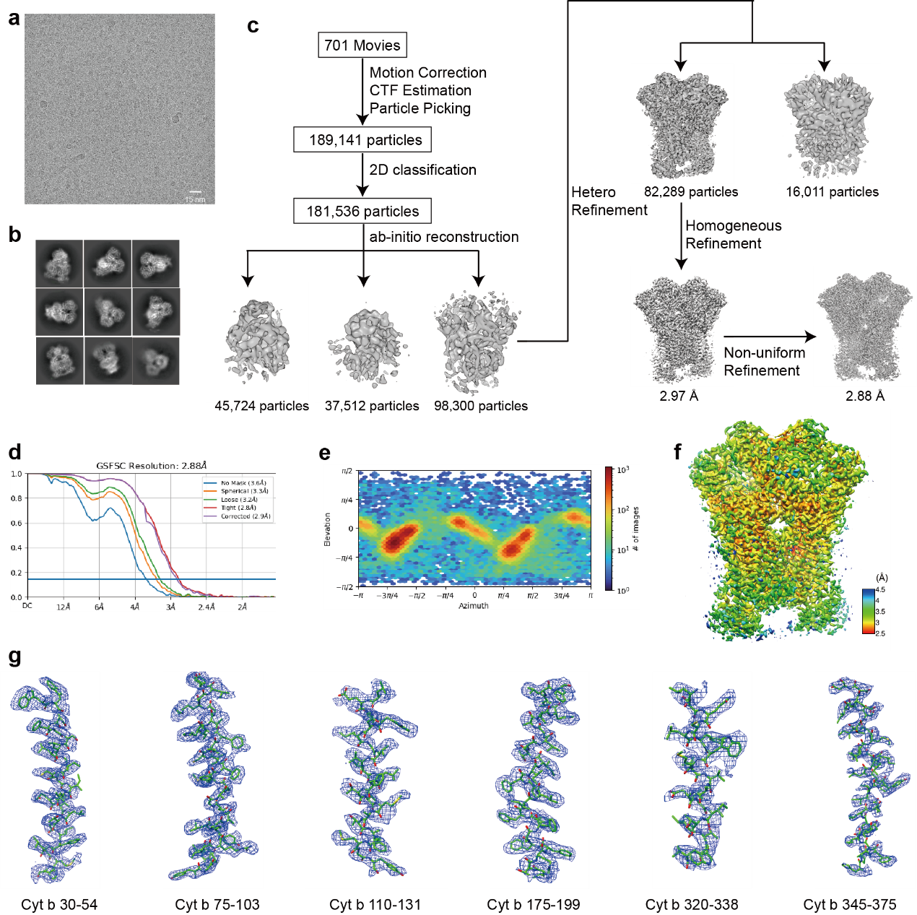
Extended Data Fig.2 Cryo-EM data processing for CIII. a, Representative micrograph of CIII used for particle picking. b, Representative 2D averages of CIII. c, Data processing workflow. Movie and particle counts, and resolution are indicated in the panel. d, Resolution of the data calculated using “gold standard” Fourier Shell Correlation (FSC)=0.143 criteria. e, Angular distribution of the CIII dataset calculated by cryoSPARC. f, Local resolution calculated using cryoSPARC. The map was colored according to the local resolution. g, Local density of the representative transmembrane helices.

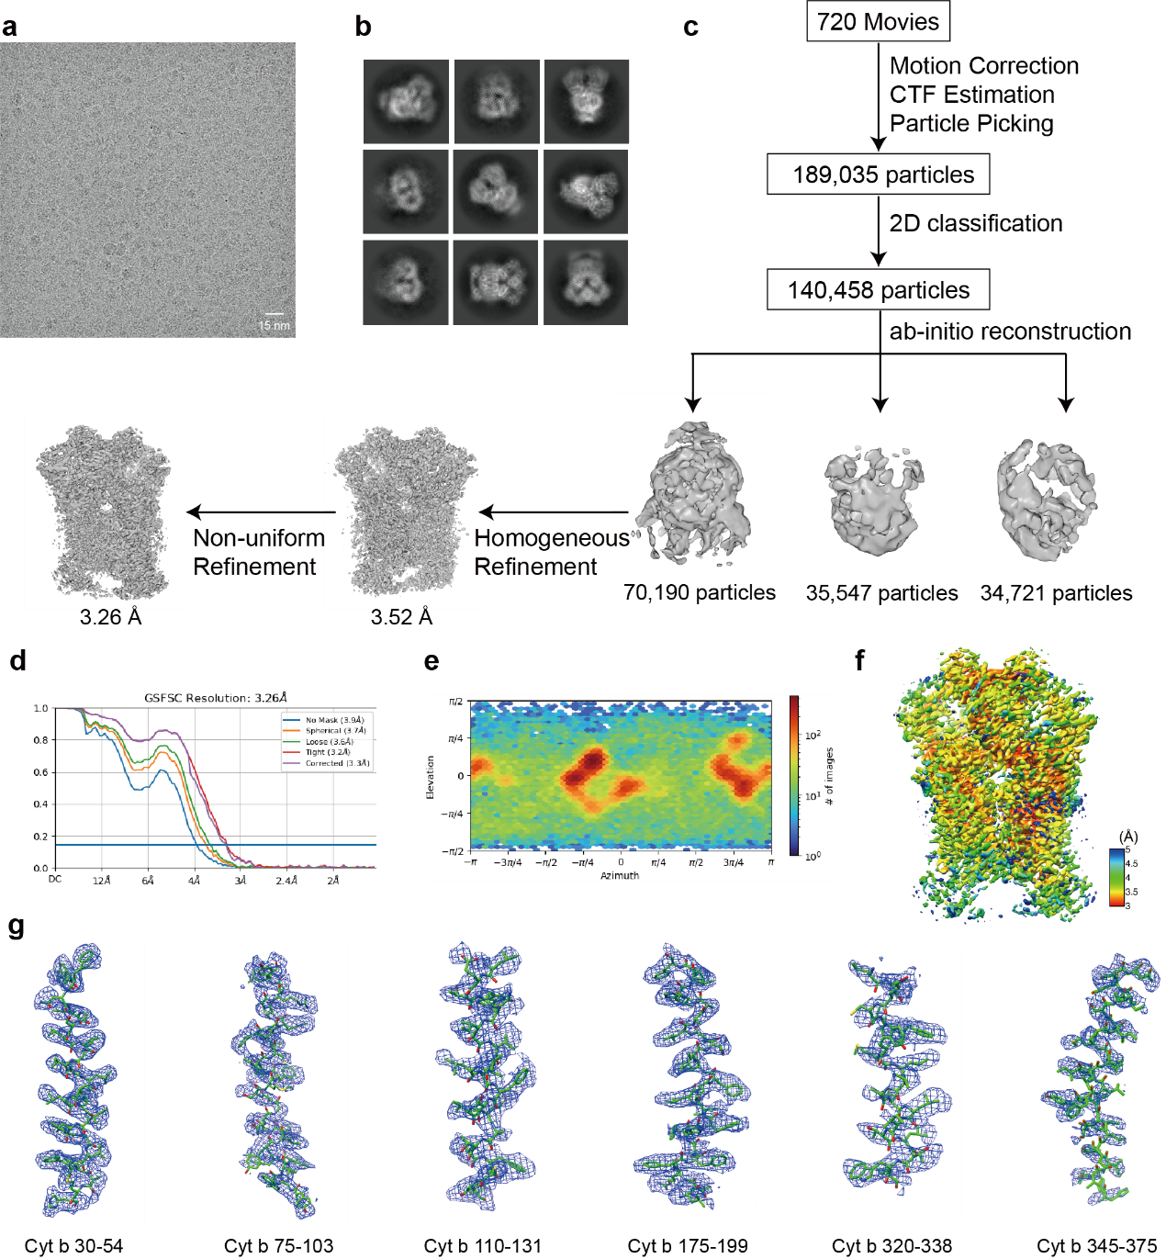
Extended Data Fig.3 Cryo-EM data processing for CIII+MET complex. a, Representative micrograph of CIII+MET complex used for particle picking. b, Representative 2D averages of CIII+MET complex. c, Data processing workflow. Movie and particle counts, and resolution are indicated in the panel. d, Resolution of the data calculated using “gold standard” Fourier Shell Correlation (FSC)=0.143 criteria. e, Angular distribution of the CIII dataset calculated by cryoSPARC. f, Local resolution calculated using cryoSPARC. The map was colored according to the local resolution. g, Local density of the representative transmembrane helices.

Extended Data Fig.4 The ISP head domain of porcine CIII. a, Electron density (blue) and structure(pink) is shown for ISP. b, The head domain of ISP undergoes diffusional movement. b-position close to b_{L}, c-position close to c₁ and intermediate-position is in a neutral position away from b_{L} and c₁.

Extended Data Fig.5 Sequence alignment of quinone reaction sites residues. a, The Q_{o} site residues are composed of two segments: 110-180 and 240-310 in S. cerevisiae sequence. b, The Q_{i} site residues are composed of three segments: 18-35, 180-200 and 210-238 in S. cerevisiae sequence.

Extended Data Fig.6 Electron density and Chemical structural formula are shown for the inhibitor. COB shown in cartoon with two MET shown in stick, MET-1(C is magenta) density is shown in blue and MET-2(C is salmon) density is shown in black.

Extended Data Fig.7 K_{i} determination curve. a, Inhibition curve for oxidoreductase activity of porcine CⅢ upon incubation with MET. b, Inhibition curve for oxidoreductase activity of porcine CⅢ upon incubation with AZO.

Extended Data Fig.8 Comparison of binding mode between MET and AZO. a, Binding pocket of MET and AZO. MET (C is magenta) and AZO (C is yellow) is shown in stick. The surface of COB is shown in different colors, porcine(MET) is green, bovine(AZO) is orange. b, Residues around functional groups are shown.

Extended Data Fig.9 Calculation of the pairwise energy between inhibitor and some key residues. a, The decompose energy (kcal/mol) between AZO-WT, AZO-G142A, and AZO-F128L. b, The decompose energy (kcal/mol) between MET-WT, MET-G142A, and MET-F128L.

Table S1 Summary of Cryo-EM Data Collection and Model Refinement
 | bc₁ complex_isolated state | bc₁ complex_MET bound
PDB Code | 8IOG | 8IOH
EMDB Code | EMD-35618 | EMD-35619
Data Collection/Processing
Voltage (kV) | 300 | 300
Magnification | 96,000 | 96,000
Defocus Range (μm) | -1.2 ~ -2.5 | -1.2 ~ -2.5
Pixel Size (Å) | 0.86 | 0.86
Symmetry imposed | C1 | C1
Total Electron Dose (e-/ Å²) | 49.2 | 57.6
Exposure Time (s) | 4.7 | 5.6
Number of images | 701 | 720
Number of Frames/Image | 32 | 32
Initial Particle Number | 191,014 | 145,386
Final Particle Number | 98,300 | 70,190
Resolution (unmasked, Å) | 3.6 | 3.9
Resolution (masked, Å) | 2.88 | 3.26
FSC threshold | 0.143 | 0.143
Refinement
Model resolution (Å) | 3.3 | 3.8
FSC threshold | 0.5 | 0.5
Model composition
Protein Residues | 4,181 | 4,181
Ligand | 13 | 18
B factor (Å²)
Protein | 71.64 | 85.82
Ligand | 65.39 | 80.49
RMS Deviations
Bond Lengths (Å) | 0.012 | 0.010
Bond Angles (°) | 1.420 | 1.372
Ramachandran
Favored (%) | 90.94 | 91.95
Allowed (%) | 8.65 | 7.28
Outlier (%) | 0.41 | 0.77

