

Supplementary Materials for

Blocking the FAM19A5-LRRC4B complex enhances neurite growth and synapse assembly.

Han-Byul Kim et al.

Corresponding author: Jae Young Seong, jyseong@korea.ac.kr

The PDF file includes:

Materials and Methods
Figs. S1 to S9
Tables S1 to S4
References

Materials and Methods
Human samples
Pooled normal human cerebrospinal fluid (CSF) was obtained from Innovative Research, Inc. with catalog number IPLA-CSFP, and used for the Co-IP experiment to determine the association between FAM19A5 and LRRC4B. Individual human CSF and plasma samples were obtained from BIOIVT & ELEVATING SCIENCE and were used to measure age-dependent FAM19A5 levels in CSF and the basal level of FAM19A5 in plasma, respectively. Additionally, individual human CSF samples were also used to determine total tau and phospho-tau levels.

Vertebrate animals
Obtained from the Jackson Laboratory were C57BL/6J mice (Strain No. 000664), APP/PS1 [B6.Cg-Tg (APPswe, PSEN1dE9) 85Dbo/J] mice (Strain No. 034832-JAX), P301S [B6.C3-Tg (Prnp-MAPT*P301S) PS19Vle/J] mice (Strain No. 008169), and 5xFAD [B6SJL-Tg (APPSwFlLon,PSEN1*M146L*L286V)6799Vas/Mmjax] mice (Strain No. 034840-JAX). Sprague-Dawley rats, and cynomolgus monkeys were obtained from Orient Bio. The FAM19A5 KO mice were generated using the CRISPR/Cas9 system by ToolGen as previously described (17). Homozygous FAM19A5 KO mice were generated through intercross breeding of heterozygous mice. The mice were housed under temperature-controlled conditions (22–23°C) with a 12-h light/12-h dark-light cycle (lights on at 8:00 am) and had ad libitum access to standard chow and water. All animal experiments were designed to minimize the number of mice used and anesthesia was administered for the procedures. The behavioral tests performed by CRO companies were approved by the Animal Experimentation Ethics Committee of KPC Co., Ltd. (Approval No. P191005) in accordance with the Animal Protection Act (Law No. 4372 enacted on May 31, 1991, partially revised Act No. 13023 on January 20, 2016). The procedures related to the analysis of animal samples were further approved by the Institutional Animal Care and Use Committee of Korea University (KOREA-2020-0031, KOREA-2020-0037, and KOREA-2021-0002). Ethical regulations were followed throughout.

Cell lines
HEK293 cells (ATCC# CRL-1573) were cultured in a humidified incubator at 37 °C with 5% CO₂. HEK293 cells were propagated in MEM with GlutaMAXTM (Gibco) supplemented with 10% fetal bovine serum (Gibco) and 100 U/ml penicillin-streptomycin (Gibco). For sub-culture, cells were washed with DPBS (Gibco) and dissociated in 0.25% Trypsin-EDTA (Gibco) for 5 min at 37 °C.

DNA constructs
The pCMV20-IgK_SP-FLAG and pCMV20-IgK_SP-hFc vector used for cloning were constructed by inserting a human IgK signal peptide (SP) sequence in front of the FLAG tag. The full-length (36-713) and serial deletion constructs (36-363, 36-576, 157-713, 230-713, 364-713, 453-713, 577-713, 364-576, Δ364-576, 453-576, 484-576 and 498-576) of human LRRC4B (NM_001080457.1) were constructed into pCMV20-IgK_SP-FLAG vector. The pCMV20-IgK_SP-hFc vector inserted IgK SP at the N-terminus of MCS (multiple cloning site) in pCMV20 plasmid and human-Fc (hFc) at the C-terminus. The ectodomain (36-576) and fragment (453-576) of human LRRC4B were constructed into MCS of the pCMV20-IgK_SP-hFc vector. Mutant constructs in which Thr488 and Thr489 of LRRC4B are substituted with alanine or serine were subcloned into pCMV20-IgK_SP-FLAG or pCMV20-IgK_SP-hFc vector. FAM19A5 (WT and MT) and LRRC4B fragments (36-576 and 453-576) were inserted in the pCAG1.1-IgK_SP-His-TEV vector. Mutant constructs in which Arg58, Arg59, and/or Arg125, Lys127 are substituted with alanine were subcloned into pCAG1.1-Ig K_SP-His-TEV vector. Full-length human LRRC4B was subcloned into pcDNA6 V5-His vector. FAM19A5 isoform 1 (NM_001252310.1) and isoform 2 (NM_015381.7) without tag were subcloned into pcDNA3.1 vector. The ectodomain (30-1263) of PTPRF (NM_002840.4) was inserted in pCMV20-IgK_SP-hFc vector. All cloning was performed using AccuRapid™ Cloning Kit (Bioneer) according to the manufacturer’s instructions. Primer sets used for cloning are listed in Table S1. Full-length human LRRC4B and PTPRF plasmid DNAs were purchased from Genscript.

Purification of recombinant proteins
Recombinant His-tagged proteins were purified according to the method described previously (17). In brief, FAM19A5 (WT and MT) and LRRC4B(36-576) with N-terminal 6xHis tags, followed by a tobacco etch virus protease (TEV) recognition sequence, were cloned into the pCAG1.1 vector and expressed in Expi 293F cells (Gibco# A14527). The supernatant containing His-TEV-FAM19A5 was collected for Ni-NTA affinity chromatography (Cytiva). After washing with a binding buffer containing 20 mM Tris-HCl (pH 7.5) and 200 mM NaCl, the proteins were eluted using binding buffers with increasing concentrations of imidazole (from 5 to 500 mM). Proteins eluted from the 50 to 500 mM imidazole fractions were concentrated using Amicon® Ultra-15 Centrifugal Filter Units (Millipore), and the buffer was exchanged for 1x DPBS (Gibco). The purified His-TEV-FAM19A5 proteins were digested overnight at 30°C with AcTEV protease (Invitrogen) to remove the His-tag and TEV sequence. The AcTEV protease containing the His-tag was then eliminated by overnight incubation with Ni-NTA, and digestion was confirmed using an anti-His tag antibody (Abcam). LRRC4B (ectodomain and fragments) and PTPRF (ectodomain) were cloned into the pCMV Igκ-SP human Fc (hFc) vector and expressed in Expi 293F cells. The supernatant containing hFc-fused proteins was collected using rProtein A GraviTrap (Cytiva), and the hFc-fused proteins were eluted using an Ab buffer kit (Cytiva) following the manufacturer's instructions.

Production of anti-FAM19A5 antibodies
We generated two chimeric chicken/human monoclonal antibodies against FAM19A5, named N-A5-Ab and C-A5-Ab, by immunizing chickens (Gallus gallusdomesticus) with purified recombinant FAM19A5 (rcFAM19A5) using a method previously described (17). In addition, we obtained an antibody called 2-13 that recognizes a conformational structure of FAM19A5, rather than a specific linear aa sequence. We further improved the N-A5-Ab and C-A5-Ab antibodies by a process called deimmunization and optimization of their physicochemical properties, resulting in the creation of the antibodies NS101 and SS01, respectively.

Production of fragment peptides
The aa sequences of LRRC4B FB-related peptides are listed in Fig. S2C-D and were custom-made from Anygen. To identify the epitopes of the FAM19A5 antibodies, the FAM19A5 linear sequence was divided into six groups, labeled F1 to F6. Further analysis was conducted to determine the crucial residue for binding, in which each aa sequence in F2 was replaced with Ala. The relevant name and aa sequences are listed in Table S2 and S3. All peptides related to FAM19A5 were custom-made from Peptron or Anygen.

Electroporation and co-IP
HEK293 cells were transfected with the NeonTM transfection kit (Invitrogen) according to the manufacturer’s description. For the general co-IP experiments, after transfection, cells were treated with rcFAM19A5 for 30 min. The cells were washed twice with cold phosphate-buffered saline (PBS) and resuspended in lysis buffer containing 20 mM Tris-HCl (pH 7.4), 150 nM NaCl, 0.5% NP40, and a protease and phosphatase inhibitor cocktail (Thermo). The supernatants were isolated by centrifugation at 12,000 × g at 4°C for 30 min and then mixed with 30 μl of Protein G Dynabeads (Invitrogen) that had been preincubated with antibodies. The mixtures were incubated at 4°C overnight in a rotating mixer. The beads were spun down and washed three times with 20 mM Tris-HCl (pH 7.4), 300 mM NaCl, and 0.5% NP40 in washing buffer. After adding 30 μl of 2× sample buffer containing a reducing agent to the beads and boiling at 100°C for 10 min, the proteins were separated by SDS-PAGE. For human CSF co-IP, pooled human CSFs (Innovative Research) were mixed with 0.5% NP40 and 50 μl of Pierce Protein A/G Plus Agarose (Thermo) that had been preincubated with 10 μg anti-human IgG, N-A5-Ab, and C-A5-Ab antibodies. The mixtures were rotated at 4°C overnight and washed three times. The protein complex in the beads was resolved by SDS-PAGE.

Immunoblots
Mouse biofluid samples and cells were homogenized and prepared in lysis buffer containing 20 mM Tris-HCl (pH 7.5), 500 mM NaCl, 5 mM MgCl₂, and protease inhibitor cocktail (Thermo). The primary antibodies are described in Table S4. Immunoblots of biofluid samples and cells were performed as described previously (17). The FAM19A5-NS101 complex in the sample was captured by interacting with the crosslinker DSG (Thermo) according to the manufacturer’s protocol.

ELISA
Total and phosphorylated tau levels were assessed using the commercial ELISA Kit, hTAU Ag (Fujirebio) and PHOSPHO-TAU (181P) (Fujirebio) according to the manufacturer’s protocol. FAM19A5 and NS101 levels were assessed using our in-house developed kit. To evaluate the binding affinity between FAM19A5 and LRRC4 family, several LRRC4/4B/4C deletion proteins, including LRRC4(39-527), LRRC4B(36-576), LRRC4B(453-576), LRRC4B(484-576), LRRC4B(498-576), LRRC4C(45-527) proteins were utilized as capture agents. WT and MT FAM19A5, including FAM19A5(R58A, R59A), FAM19A5(R125A, K127A), and FAM19A5(R58A, R59A, R125A, K127A) proteins were used for binding. Detection was performed using SS01. The cell culture medium of FAM19A5 was measured using 2-13, and SS01 was used for capture and detection.
To measure FAM19A5 in biofluids, LRRC4B(453-576) protein and a horseradish peroxidase (HRP)-conjugated SS01 were used for capture and detection, respectively. For measurement of CSF NS101, a pair of rabbit anti-human IgG heavy chain antibody (Invitrogen) and HRP-conjugated goat α-human IgG kappa light chain antibody (Thermo) were used.
To test the inhibition of FAM19A5-LRRC4B binding, LRRC4B(453-576) protein was first coated onto the plate, followed by the addition of the test sample and FAM19A5 protein. The binding inhibition was calculated by detecting FAM19A5 through SS01. For the PTPRF-LRRC4B binding inhibition test, LRRC4B(36-576) protein was coated on the plate, followed by the addition of the test sample and PTPRF protein. The binding inhibition was calculated by detecting PTPRF-hFc through the anti-human IgG Fc antibody.

Surface plasmon resonance (SPR)
All SPR experiments were carried out on a Biacore 8K (Cytiva) with active temperature control at 25°C following the manufacturer’s protocols. The running buffer was 1 × HBS-EP (10 mM HEPES, 150 mM NaCl, 3 mM EDTA, 0.05% Tween 20, pH 7.4). For immobilization, 6xHis-LRRC4B(453–576) in 10 mM sodium acetate, pH 4.5 buffer equivalent to 632–638 resonance units (RU), was injected onto a nitrilotriacetic acid (NTA) chip at a 30 µl/min flow rate. Another flow cell without the immobilized 6xHis-LRRC4B(453–576) coating was used to evaluate nonspecific binding. Increasing concentrations (0.78, 1.56, 3.12, 6.25, and 12.5 nM) of rcFAM19A5 were diluted in running buffer and flowed across the immobilized 6xHis-LRRC4B(453–576) for 180 s at a flow rate of 30 μl/min (association). The sample was replaced with a running buffer for 240 s (disassociation). The chip surface was regenerated with 350 mM EDTA and HBS-P+ 500 mM imidazole. For all samples, blank injection with buffer alone was subtracted from the resulting reaction surface data. Data were analyzed using Biacore 8K evaluation software (Cytiva).

In silico modeling of the FAM19A5-LRRC4B complex structure using AlphaFold2 and RoseTTAFold
We used AlphaFold2 (2) to model the structure of the FAM19A5-LRRC4B complex. Input paired multiple sequence alignments (paired MSAs) were generated following RoseTTAFold’s input generation protocol. hMSAs for the FAM19A5 protein and LRRC4B extracellular domain were generated by iterative sequence search against the UniClust30 database(3) using HHblits (4). To predict a complex structure, we generated a paired MSA based on individual MSA by pairing sequences from the same species. To provide pseudomultimer inputs to AlphaFold2, we used a gap insertion trick that has been previously applied to RoseTTAFold(5). The final models were ranked by predicted TM score (pTM score), and the best scored model was used for further study after structural relaxation using Rosetta (6).

In silico residue scanning of the FAM19A5-FB complex
We used the residue scanning module (Schrodinger Bioluminate®) for in silico residue scanning (e.g., Ala scanning) and to calculate the perturbation of protein-peptide binding affinity, which was defined as the binding free energy change. To evaluate the potential impact of a mutation, we used Δ Affinity and Δ Stability (solvated) values.

Immunocytochemistry
HEK293 cells were seeded at a density of 3 × 10⁴ cells/well on fibronectin-coated plastic film coverslips in 12-well plates. After 24 hours, the cells were cotransfected with 150 ng of FLAG-tagged LRRC4B and FAM19A5 isoform 1 or 2. After 24 hours of incubation, the cells were washed once with ice-cold DPBS and fixed with 4% paraformaldehyde (PFA) in PBS for 20 min. After washing three times with ice-cold DPBS, the cells were blocked with blocking buffer containing 3% bovine serum albumin (BSA) and 0.1% Triton X-100 in PBS for 30 min and incubated with primary antibodies overnight at 4°C. After three washes with DPBS, the cells were incubated with secondary antibodies and 20 mM Hoechst solution (Invitrogen) for 1 hour at room temperature. After three washes with DPBS, fluorescent images were acquired via a confocal microscope (Leica) using coverslips mounted with mounting solution (Biomeda). All images were processed using Las X software (Leica). NS101 and the recombinant proteins containing the FB domain were treated for 30 min before fixation.

Primary neuronal culture
Primary cortical or hippocampal neurons were prepared from postnatal C57BL/6 pups (postnatal day 1) (Nara Biotech) as previously described (7). The cells were maintained at 37°C in a 5% CO₂-humified incubator. Every 3–4 days, half of the medium from the culture dish was replaced with fresh culture medium. Neurons were cultured for DIV16, and total RNA was isolated and subjected to RNA-seq analysis as previously described (8).
Cells were fixed with 4% PFA, except for the spine density assay (2% PFA, 4% sucrose). The cells were permeabilized and blocked with blocking buffer containing 3% BSA and 0.1% Triton X-100 in PBS for 1 hour at room temperature. Then, the samples were incubated with primary antibodies diluted in blocking buffer overnight at 4°C and washed three times with PBS. Cells were incubated with the appropriate fluorescently labeled secondary antibodies and with Hoechst 33342 (Invitrogen) diluted in PBS for 30 min at room temperature. Cells were washed three times with PBS, and then coverslips were mounted using Crystal Mount (Biomeda). Images were acquired using a confocal microscope (Leica).
For the analysis of neurite growth, cultured neurons were treated with LRRC4B proteins or rcFAM19A5 at DIV 1 and DIV 2. At DIV 3, neurons were fixed and immunostained with anti-Tau5 (Thermo), and three parameters (total neurite length per neuron, number of primary neurites, and number of branch points) were measured using ImageJ (NIH).
For the quantification of pre- and postsynaptic molecules, cultured neurons were treated with or rcFAM19A5, hIgG or NS101 at DIV 3 and DIV 6. At DIV 7, neurons were fixed and immunostained with anti-SYP (Sigma) and anti-PSD95 (Invitrogen). Z-stack images (depth, 3 μm) were acquired with a confocal microscope (Leica), and 3D reconstruction and analysis were performed with Imaris software (Bitplane).
For measurement of FAM19A5 levels released into the culture medium, neurons were treated with hIgG or NS101 at DIV 9 and DIV 10. At DIV 11, culture media were collected and subjected to ELISA. For measurement of FAM19A5 levels in culture media, 2-13 and SS01 antibodies were used for capture and detection, respectively.

DiI staining and spine density analysis in vitro
To visualize dendritic spines, we used the well-characterized fluorescent lipophilic dye DiI (Invitrogen) according to the manufacturer’s instructions. Primary neurons were treated with hIgG or NS101 every 3 days starting at DIV 3. On the appropriate DIV, primary neurons were fixed with 2% PFA + 4% sucrose in PBS for 15 min at room temperature and washed three times with DPBS. The cells were incubated with DiI solution diluted in DPBS (5 μl/ml) for 20 min at room temperature and washed three times with DPBS. After labeling, the coverslips incubated in DPBS were stored in the dark overnight at 4°C to allow the DiI dye to diffuse. The following day, the coverslips were rinsed twice with sterile H₂O to reduce the background. The coverslips were mounted on slides using Crystal Mount (Biomeda) and cured for at least 2 days to allow complete migration of the dye into the spines. All images were acquired under a 552 nm laser using a confocal microscope (63× oil immersion objective) at a pixel resolution of 1024 × 1024 with a 3× optical zoom. Serial Z-stacks (0.2 μm intervals) were performed from top to bottom, covering all dendrites and protrusions. The 3D reconstruction of stacked images and analysis were performed using Imaris software, and the analysis was blinded. A protrusion width greater than 0.2 μm was defined as a dendritic spine.

Aβ_{1–42} preparation
Aβ_{1–42} peptide was purchased from AnaSpec (#AS-20276) and prepared as previously described (9). On the day of Aβ_{1–42} treatment, after incubation, the working solutions were centrifuged at 14000 × g at 4°C for 10 min to purify the oligomeric Aβ fraction from the fibrils.

Immunohistochemistry
Mice were transcardially perfused with 4% PFA in PBS, and isolated brains were postfixed in the same fixative for 24 hours. Brains were then cryoprotected in 30% sucrose, sectioned serially on a cryostat (40 mm), and stored in 50% glycerol/50% PBS at −20°C until use. Brain sections were blocked for 30 min in 3% BSA + 0.1% Triton X-100 in PBS and incubated with primary antibodies diluted in blocking buffer overnight at 4°C. After overnight incubation, sections were washed three times in PBS and incubated with secondary antibodies or Hoechst 33242 diluted in PBS for 30 min at room temperature. Subsequently, the sections were washed, mounted, and observed under a slide scanner (Zeiss) or a confocal microscope (Leica).

Hippocampal slice preparation and electrophysiology
APP/PS1 mice and WT mice (13 months old) were anesthetized with isoflurane (5% isoflurane, 95% O₂) and perfused with ice-cold sucrose artificial cerebrospinal fluid (aCSF) containing 195.5 mM sucrose, 2.5 mM KCl, 1 mM NaH₂PO₄, 32.5 mM NaHCO₃, 11 mM glucose, 2 mM Na pyruvate, and 1 mM Na ascorbate (all chemicals from Sigma) bubbled with 95% O₂/5% CO₂ at a pH of 7.4. After perfusion, the brains were quickly removed from the skull, and sagittal hippocampal slices (400 μm thick) were cut on a vibratome (Leica). The slices were incubated at 35°C for 15 min in an incubation solution containing 119 mM NaCl, 2.5 mM KCl, 1 mM NaH₂PO₄, 26.2 NaHCO₃, 11 mM glucose, 2 mM Na pyruvate, 1 mM Na ascorbate, 3 mM MgSO₄, and 1.5 mM CaCl₂. After incubation, the slices were transferred to aCSF solution at 23–24°C for 1 hour.
Field recordings were made with a concentric bipolar electrode positioned in the stratum radiatum of the CA1 region using an extracellular glass pipette (3–5 MΩ) filled with aCSF. Stimulation was delivered through a bipolar electrode (FHC, Bowdoin, ME, USA) placed in the SC-CA1. The SC circuit was visualized using differential interference contrast (DIC) microscopy at 4× magnification and identified by the ability to evoke short and constant latency fEPSPs at CA1 synapses by SC input stimulation. The test stimulation in all fEPSP experiments was measured before the experiments (30–300 μA), and a test-pulse stimulation strength that evoked 50% of the maximum fEPSP was used. Baseline synaptic responses were recorded for 30 min, and then LTP was induced by theta burst stimulation (100 Hz, 10 trains, 40 ms duration, 200 ms intertrain interval). LTP was calculated by an average of fEPSP amplitudes during the last 5 min of recordings. Recordings were made every 10 s for 1 hour using an Axopatch 700A amplifier (Molecular Devices) digitized at 10 kHz and filtered at two kHz with Digidata 1440A and pClamp 10.0 software (Molecular Devise).
To measure mEPSCs, the electrode was filled with an internal solution containing 135 mM Cs methane sulfonate, 8 mM NaCl, 10 mM HEPES, 0.5 mM EGTA, 4 mM Mg-ATP, 0.3 mM Na-GTP, and 5 mM QX-315 Cl; pH 7.25 with CsOH, 285 mOsm). Miniature currents were recorded in the presence of tetrodotoxin (1 μM TTX, Tocris) to block sodium currents and propagate action potentials.

Stereotaxic FAM19A5 injection
For stereotaxic injection of the WT and MT forms of FAM19A5, three-month-old male and female mice were anesthetized with xylazene and ketamine. An injection cannula was inserted stereotaxically into the striatum (mediolateral, 2.0 mm from bregma; anteroposterior, 0.5 mm; dorsoventral, 3.5 mm) unilaterally (inserted into the right hemisphere). The infusion was performed at a rate of 0.2 μl per min, and 2 μl of FAM19A5 (5 μg μl−1 in PBS) or the same volume of PBS was injected into the mouse.

Animal behavioral tests
Male mice used in all behavioral tests were 9–11 months old. All assays used littermates or age-matched animals. Behavioral tests were performed in a light- and noise-controlled behavioral room, where the animals were allowed to adapt for one hour before each behavioral test. All behavioral results were analyzed blindly.

Y-maze test
A Y-shaped maze consists of three identical arms (40 cm in length, 15 cm in height) at a 120° angle from each other. Mice were allowed to freely explore the three arms for 8 min with a luminosity of 40 lux. The sequence and the total number of arms entered were measured. Spontaneous alteration (%) was calculated as follows: the number of triads containing entries into all three arms/maximum possible alternations (the total number of arms entered – 2) × 100. Mice that constituted fewer than 10 of the total arm entries were omitted from the analysis.

Morris water maze test
Mice were trained to find the hidden platform (9 cm in diameter) in a stainless-steel pool (90 cm in diameter, 50 cm in height) filled with water (22 ± 1°C) to a depth of 30 cm. The platform was 1 cm below the water level. In the acquisition phase, mice were trained for six consecutive days with four trials/per day. Each trial ended either when an animal climbed onto the platform or when a maximum of 60 s had elapsed. Next, mice were allowed to remain on the platform for 10 s. If they failed to locate the platform within 60 s, they were guided to the platform and left there for 10 s, and the escape time was recorded as 60 s. On day 7, for the probe test, the platform was removed, and mice were allowed to explore freely for 60 s. The spatial memory ability of individual animals in the probe test was determined by the following parameters: latency to target, target crossing number, distance to the target, percentage in quadrant SW, and percentage in the target. Target and quadrant SW refer to the location and quadrant where the hidden platform was located, respectively. These parameters were analyzed by SMART video tracking software (Panlab). Mice displaying abnormal behaviors, such as freezing and floating, were excluded from the final data.

Passive avoidance test
The passive avoidance test, performed in plastic cages of identical size, assessed associative learning and memory by using the rodents’ innate preference for darkness. The inside of a darkened cage was designed to induce a foot shock; thus, when mice entered the dark compartment from the light compartment, a foot shock (0.5 mA intensity) was delivered for 3 s. To assess memory, we placed mice in the light compartment 24 hours later and measured the time it took to enter the dark compartment. The maximal latency was 300 s. Animals showing freezing behaviors (with acquisition time ≥ 200 s) or abnormal exploration were excluded from the final analysis.

Quantification and statistical analysis
All statistical analyses were performed using GraphPad Prism 8 with 95% confidence. Comparisons between two groups were performed using unpaired two-tailed Student’s t-test when the data followed a normal distribution, while the Mann-Whitney test was used when the data showed a nonnormal distribution. In the case of data comparing more than three groups, one-way ANOVA followed by Dunn’s multiple comparison test was used. All data are presented as the mean ± SEM. All the details of the statistical tests and results are reported in the figure legends. All experiments were duplicated or triplicated with similar results.

Fig. S1.

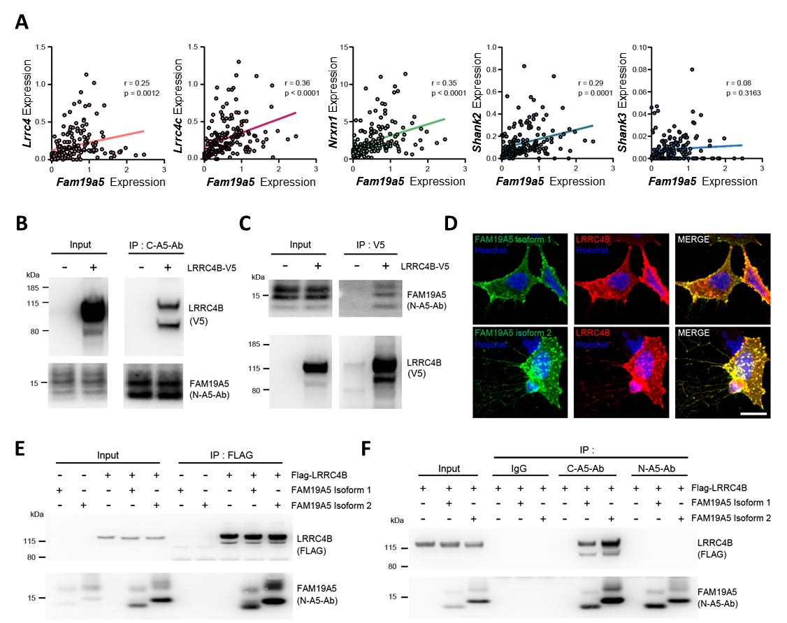
Figure S1. LRRC4B interacts with FAM19A5.
(A) Correlation of transcript levels between FAM19A5 and synaptic adhesion molecules from 168 cell types. Correlation coefficient values are indicated as r.
(B) Co-IP of FAM19A5 and LRRC4B.
(C) Counterpart co-IP of FAM19A5 and LRRC4B.
(D) Immunofluorescence staining of HEK293 cells cotransfected with either FAM19A5 isoform 1 or 2 (green) and FLAG-LRRC4B (red).
(E) Co-IP of LRRC4B and FAM19A5 isoforms.
(F) Counterpart co-IP of LRRC4B and FAM19A5 isoforms.

Fig. S2.

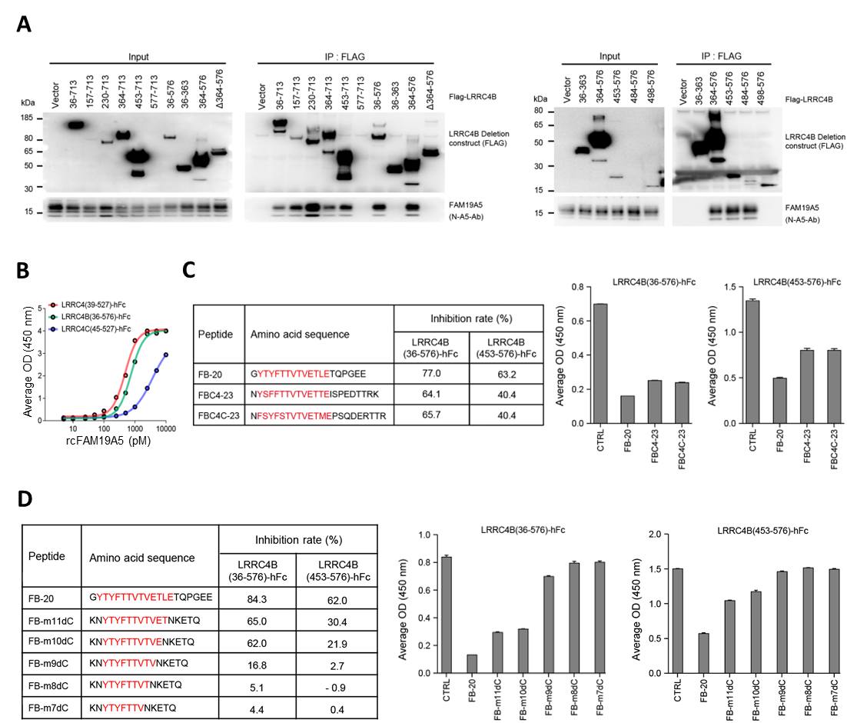

Figure S2. The effective FB amino acid sequence as a decoy for FAM19A5.
- Protein-protein interactions between FAM19A5 and LRRC4B deletion constructs.
- Binding affinity of rcFAM19A5 for LRRC4 family.
- Inhibition of FAM19A5-LRRC4B binding by FB peptides related to LRRC4 and LRRC4C.
- The optimization of amino acid sequence for FB peptides.

Fig. S3.

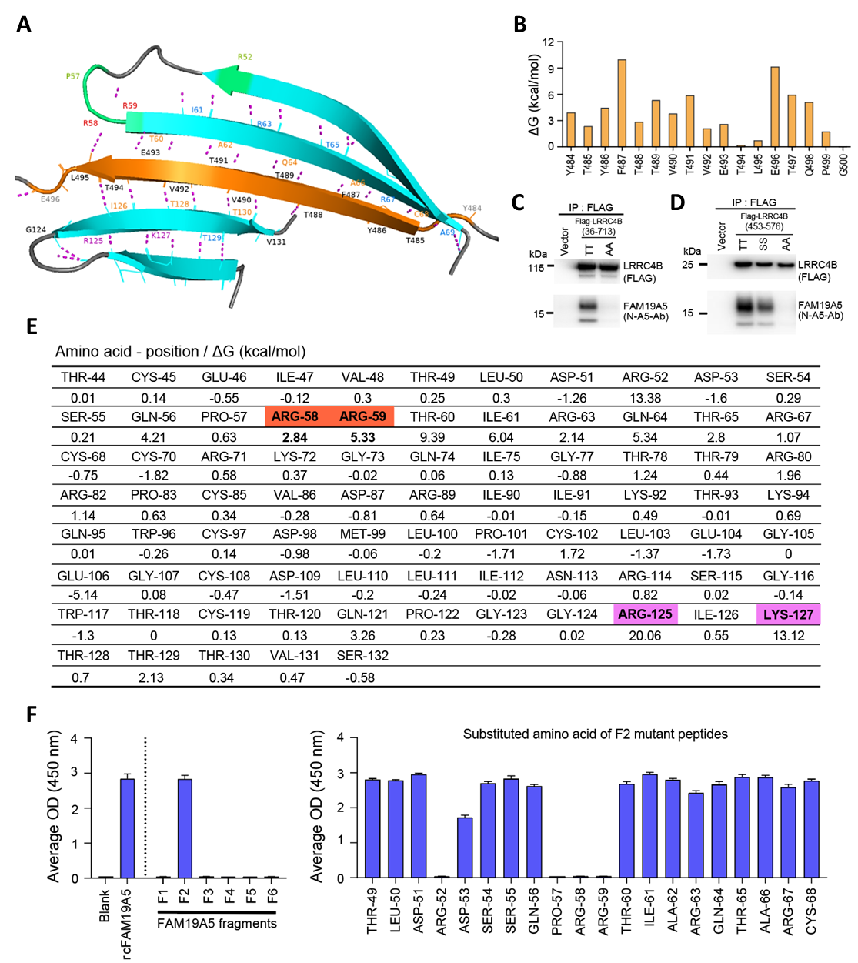
Figure S3. Residues responsible for the binding between FAM19A5 and LRRC4B FB.
(A) Molecular modeling of the LRRC4B FB-FAM19A5 complex. Predicted hydrogen-bond interactions between the intra-FAM19A5 β-strand (cyan) and the LRRC4B FB domain (orange) are represented as magenta dashed lines. The FB domain constituting residues (Y484- E496, orange main chain, labeled in gray); β-strand forming FB residues (T485 - L495, labeled in black). FB binding residues constituting the β-strand by forming hydrogen bonds (labeled in orange label); residues involved in constituting intra-FAM19A5 hydrogen-bonds (labelled in marine); residues affecting the binding affinity of LRRC4B FB and the FAM19A5 complex, identified via Ala mutagenesis (purple labels); R125 and K127; NS101 binding epitope (green main chain); R52, P57, R58, and R59; competitive binding sites for FB and NS101 (labelled in red); R58 and R59.
(B) The predicted changes in binding free energy based on Ala scanning of FB.
(C-D) Co-IP of FAM19A5 and LRRC4B(36-173) (C) or LRRC4B(453-573) (D). Wild-type LRRC4B(TT); mutant LRRC4B(AA, T488A, T489A); mutant LRRC4B (SS, T488S, T489S).
(E) The predicted changes in binding free energy based on Ala scanning of FAM19A5. Competitive binding sites for FB and NS101 (orange); R58 and R59. Residues affecting binding affinity between FB and FAM19A5 (pink); R125 and K127.
(F) Epitope mapping of NS101 for FAM19A5. Binding of NS101 to rcFAM19A5 and synthetic peptides (F1~F6 and F2 mutant peptides, see Table S2 and S3). The aa residues are numbered according to the human FAM19A5 sequence.

Fig. S4.

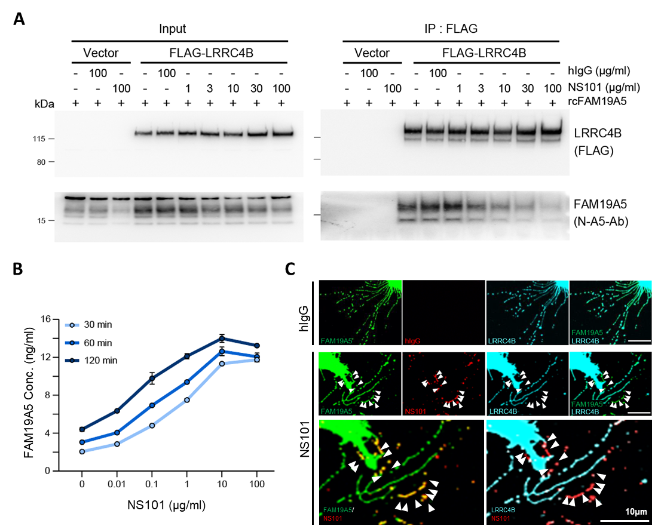
Figure S4. NS101 dissociates FAM19A5 from LRRC4B.
(A) Inhibition of FAM19A5-LRRC4B binding by NS101. HEK293 cells expressing FLAG-tagged LRRC4B were treated with rcFAM19A5 (1 μg/ml) and increasing concentrations of NS101.
(B) Concentration-dependent FAM19A5 release after treatment with NS101 in HEK293 cells expressing LRRC4B and FAM19A5 isoform 1.
(C) Immunofluorescence images of HEK293 cells expressing FLAG-LRRC4B (blue) and FAM19A5 isoform 2 (green) after treatment with hIgG or NS101. FAM19A5 signals were dissociated from LRRC4B by NS101 treatment (arrowheads).

Fig. S5.

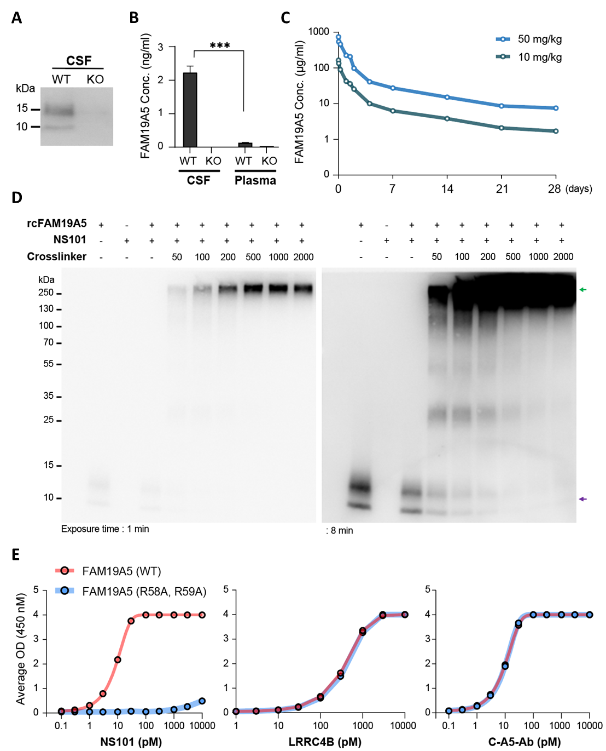
Figure S5. NS101 forms a complex with FAM19A5.
(A) Immunoblot analysis of FAM19A5 protein in the CSF of WT and FAM19A5 KO mice.
(B) FAM19A5 levels in the CSF and plasma of WT and FAM19A5 KO mice. WT CSF (n=7), KO CSF (n=6), WT plasma (n=7), KO plasma (n=6).
(C) Plasma NS101 levels at the indicated time points after iv administration of 10 mg/kg and 50 mg/kg NS101.
(D) FAM19A5 band shift induced by the crosslinker DSG. The purple arrow indicates the band for rcFAM19A5 without crosslinker, and the green arrow indicates the FAM19A5-NS101 complex.
(E) Binding affinity of WT and MT FAM19A5(R58A, R59A) for NS101, LRRC4B, and C-A5-Ab.
Data are presented as the mean ± SEM. Statistical analyses were performed using unpaired t-test. ***P < 0.001.

Fig. S6.

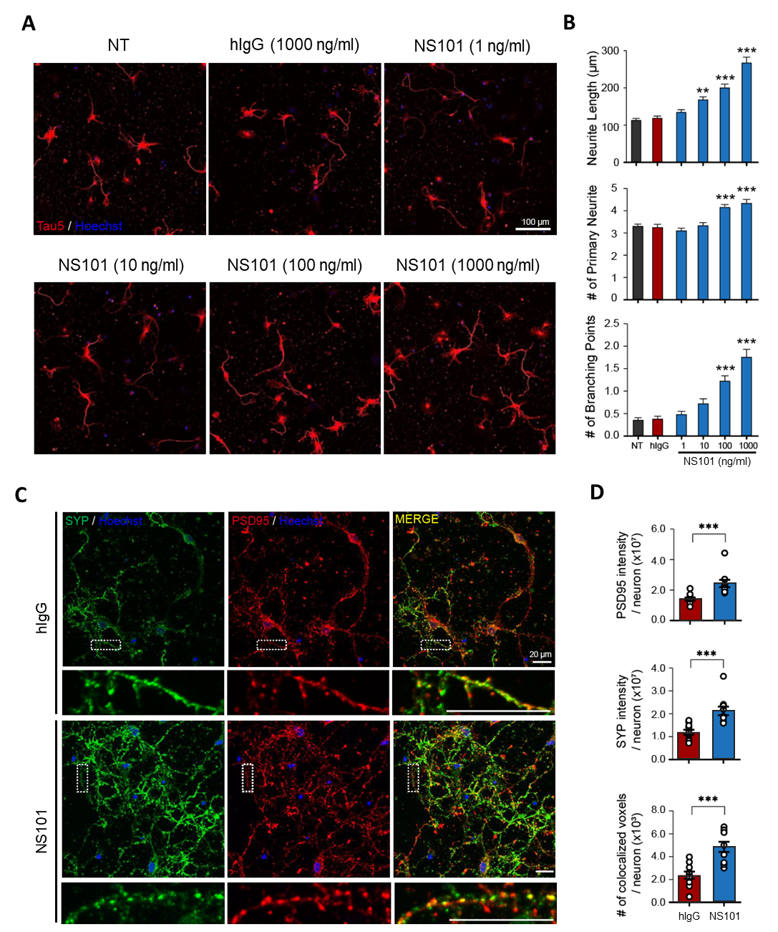
Figure S6. NS101 promotes neurite outgrowth and synaptogenesis.
(A) Immunofluorescence images of mouse hippocampal neurons treated with 1 μg/ml hIgG or 1, 10, 100, and 1000 ng/ml NS101.
(B) Quantification of the average total neurite length, number of primary neurites, and number of branching points for experiments in (A) NT (n=105), hIgG 1000 ng/ml (n=101), NS101 1 ng/ml (n=111); NS101 10 ng/ml (n=111), NS101 100 ng/ml (n=104), NS101 1000 ng/ml (n=100).
(C) Immunofluorescence images of 1000 ng/ml hIgG- or NS101-treated mouse cortical neurons labeled with SYP (green), PSD95 (red), and Hoechst (blue).
(D) The fluorescence intensity of PSD95 and SYP, and the number of colocalized voxels between SYP and PSD95 for the experiment in (C) (n=10).
Data are presented as the mean ± SEM. Statistical analyses were performed using one-way ANOVA followed by Tukey's multiple comparisons test (B; neurite length), Kruskal-Wallis test followed by Dunn’s multiple comparison test (B; number of neurite and branching points), and unpaired t-test (D). **P < 0.01, ***P < 0.001.

Fig. S7.
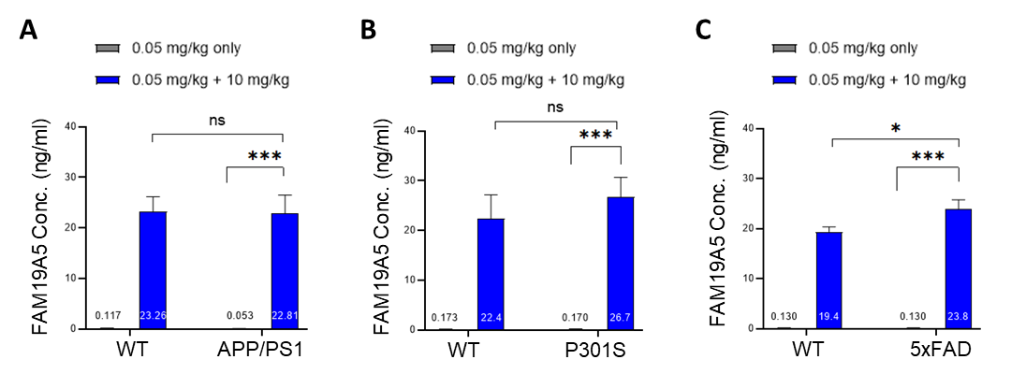
Figure S7. NS101 iv administration induces the release of FAM19A5 from the brain into the blood in wild type and AD mouse models.
(A-C) The plasma levels of FAM19A5 in wild type and three AD mouse models were measured after iv administration of NS101. All mice received a dose of 0.05 mg/kg NS101, and one day later, half of them received an additional dose of 10 mg/kg NS101, while the other half received no further treatment. FAM19A5 levels in the plasma were then measured using ELISA. n=3 for all groups except n=1 for APP/PS1 mice treated with 0.05 mg/kg only.
Data are presented as the mean ± SEM. Statistical analyses were performed using one-way ANOVA followed by Tukey's multiple comparisons test. n.s, not significant, *P < 0.05, ***P < 0.001.

Fig. S8.

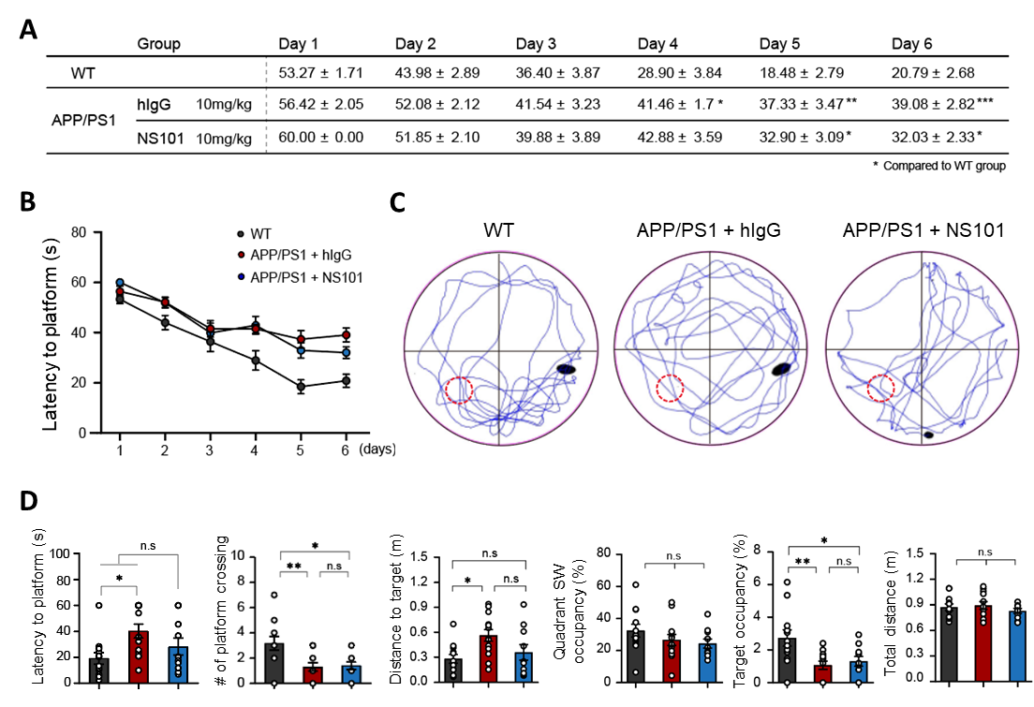
Figure S8. Morris water maze assessment of wild type and APP/PS1 mice treated with NS101.
(A-B) The escape latency time during the training trials of WT mice (n=12) and APP/PS1 mice treated with 10 mg/kg hIgG (APP/PS1+hIgG, n=13), or NS101 (APP/PS1+NS101, n=10).
(C) Swimming trajectory of mice.
(D) Behavioral parameters during the test trial.
Data are presented as the mean ± SEM. Statistical analyses were performed using one-way ANOVA followed by Tukey's multiple comparisons test. n.s, not significant, *P < 0.05, **P < 0.01, ***P < 0.001.

Fig. S9.
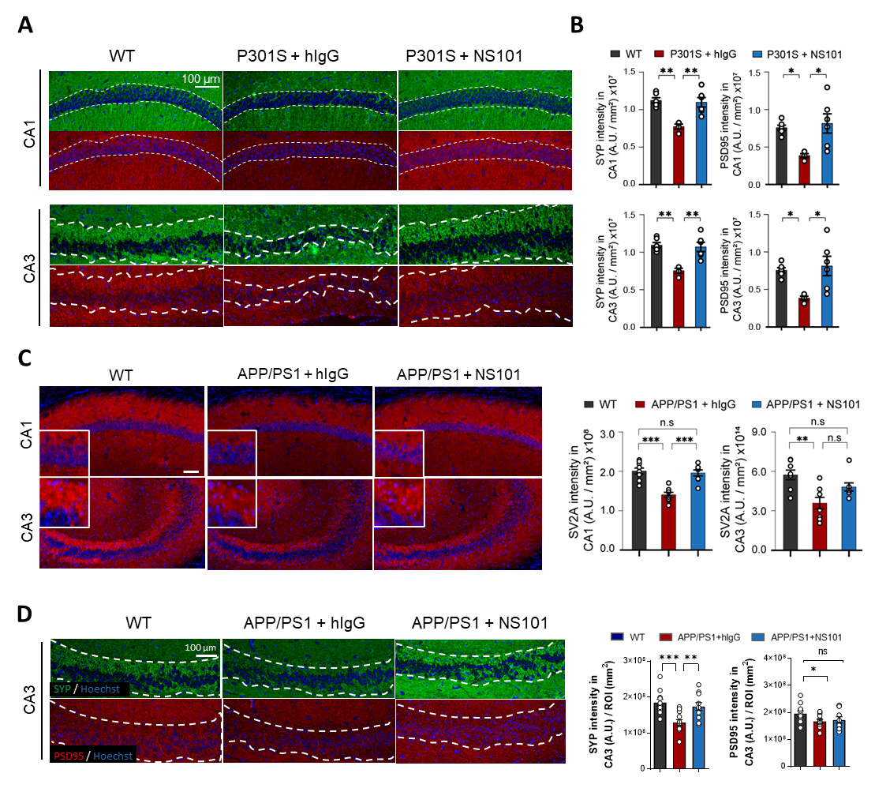
Figure S9. NS101 ameliorates synapse loss in AD mice.
(A-B) Immunofluorescence images and quantification of the fluorescence intensity of SYP (green) and PSD95 (red) in the CA1 and CA3 regions of WT mice (n=6) and P301S mice treated with 10 mg/kg hIgG (P301S+hIgG, n=4), or NS101 (P301S+NS101, n=6).
(C) Immunofluorescence images and quantification of SV2A signals in the CA1 and CA3 regions. WT (n=9), APP/PS1+hIgG (n=8), APP/PS1+NS101 (n=8).
(D) Immunofluorescence images and quantification of the fluorescence intensity of SYP (green) and PSD95 (red) in the CA3 region. WT (n=12), APP/PS1+hIgG (n=13), APP/PS1+NS101 (n=11).
Data are presented as the mean ± SEM. Statistical analyses were performed using one-way ANOVA followed by Tukey's multiple comparisons test (A, B, D). Kruskal-Wallis test followed by Dunn’s multiple comparison test (C) n.s, not significant, *P < 0.05, **P < 0.01, ***P < 0.001.
Table S1. Primers used for cloning.
Insert | Primer Sequence
LRRC4B 36-713 | For | GATGACGACAAGCTTGCCGGTGGAGGTGGAG
 | Rev | GTTTTTGTTCGGATCCTCAGATCTGCGTCTCTTGC
LRRC4B 157-713 | For | GATGACGACAAGCTTCTGTCCAAGCTGCGGG
LRRC4B 157-713 | Rev | GTTTTTGTTCGGATCCTCAGATCTGCGTCTCTTGC
LRRC4B 230-713 | For | GATGACGACAAGCTTCGCCTGGAGGAGCTGG
LRRC4B 230-713 | Rev | GTTTTTGTTCGGATCCTCAGATCTGCGTCTCTTGC
LRRC4B 364-713 | For | GATGACGACAAGCTTCCCGTCATCGTGGAGC
LRRC4B 364-713 | Rev | GTTTTTGTTCGGATCCTCAGATCTGCGTCTCTTGC
LRRC4B 453-713 | For | GATGACGACAAGCTTGTCTCGGCCGTGGACC
LRRC4B 453-713 | Rev | GTTTTTGTTCGGATCCTCAGATCTGCGTCTCTTGC
LRRC4B 577-713 | For | GATGACGACAAGCTTATCATCATCGGCTGCTTC
LRRC4B 577-713 | Rev | GTTTTTGTTCGGATCCTCAGATCTGCGTCTCTTGC
LRRC4B 36-576 | For | GATGACGACAAGCTTGCCGGTGGAGGTGGAG
LRRC4B 36-576 | Rev | GTTTTTGTTCGGATCCTCATTTGGTGGTCTTCATG
LRRC4B 36-363 | For | GATGACGACAAGCTTGCCGGTGGAGGTGGAG
LRRC4B 36-363 | Rev | GTTTTTGTTCGGATCCTCACGCATAGCAGGTG
LRRC4B 364-576 | For | GATGACGACAAGCTTCCCGTCATCGTGGAGC
LRRC4B 364-576 | Rev | GTTTTTGTTCGGATCCTCATTTGGTGGTCTTCATG
LRRC4B Δ364-576 | For | GATGACGACAAGCTTGCCGGTGGAGGTGGAG
LRRC4B Δ364-576 | InRev | GAAGCAGCCGATGATGATCGCATAGCAGGTGAAATG
LRRC4B Δ364-576 | InFor | CATTTCACCTGCTATGCGATCATCATCGGCTGCTTC
LRRC4B Δ364-576 | Rev | GTTTTTGTTCGGATCCTCAGATCTGCGTCTCTTGC
LRRC4B 453-576 | For | GATGACGACAAGCTTGTCTCGGCCGTGGACC
LRRC4B 453-576 | Rev | GTTTTTGTTCGGATCCTCATTTGGTGGTCTTCATG
LRRC4B 484-576 | For | GATGACGACAAGCTTTACACCTACTTCACCACGGTG
LRRC4B 484-576 | Rev | GTTTTTGTTCGGATCCTCATTTGGTGGTCTTCATG
LRRC4B 498-576 | For | GATGACGACAAGCTTCAGCCCGGAGAGGAGG
LRRC4B 498-576 | Rev | GTTTTTGTTCGGATCCTCATTTGGTGGTCTTCATG
LRRC4C 354-527 | For | GATGACGACAAGCTTCCGGTGATTGTGGAGCC
LRRC4C 354-527 | Rev | GTTTTTGTTCGGATCCTCATTTGGTAGTCTTCATGACC
LRRC4 353-527 | For | GATGACGACAAGCTTCCCTTCATCATGGACGC
LRRC4 353-527 | Rev | GTTTTTGTTCGGATCCTCACTTGGTGGTCTTCATGAC
LRRC4B 453-576  (T488A, T489A) | For | GATGACGACAAGCTTGTCTCGGCCGTGGACC
LRRC4B 453-576  (T488A, T489A) | InRev | CACGGTCACGGCCGCGAAGTAGGTGTAG
LRRC4B 453-576  (T488A, T489A) | InFor | CTTCGCGGCCGTGACCGTGGAGAC
LRRC4B 453-576  (T488A, T489A) | Rev | GTTTTTGTTCGGATCCTCATTTGGTGGTCTTCATG
LRRC4B 453-576  (T488S, T489S) | For | GATGACGACAAGCTTGTCTCGGCCGTGGACC
LRRC4B 453-576  (T488S, T489S) | InRev1 | GTCTCCACGGTCACAGACGAGAAGTAGGTGTAG
LRRC4B 453-576  (T488S, T489S) | InFor1 | CTACACCTACTTCTCGTCTGTGACCGTGGAGAC
LRRC4B 453-576  (T488S, T489S) | InRev2 | CAGACACCGTCAGACGAGGGCCCTG
LRRC4B 453-576  (T488S, T489S) | InFor2 | CAGGGCCCTCGTCTGACGGTGTCTG
 | Rev | GTTTTTGTTCGGATCCTCATTTGGTGGTCTTCATG
LRRC4B 36-713  (T488A, T489A) | For | GATGACGACAAGCTTGCCGGTGGAGGTGGAG
LRRC4B 36-713  (T488A, T489A) | InRev | CACGGTCACGGCCGCGAAGTAGGTGTAG
LRRC4B 36-713  (T488A, T489A) | InFor | CTACACCTACTTCGCGGCCGTGACCGTG
LRRC4B 36-713  (T488A, T489A) | Rev | GTTTTTGTTCGGATCCTCAGATCTGCGTCTCTTGC
FAM19A5 (R58A, R59A) | For | CAGCCAGCCTGCCGCCACGATC
FAM19A5 (R58A, R59A) | InRev | GATCGTGGCGGCAGGCTGGCTG
FAM19A5 (R58A, R59A) | InFor | ATGGAGACAGACACACTCCTGCTATGGGTACTG
FAM19A5 (R58A, R59A) | Rev | CAGTACCCATAGCAGGAGTGTGTCTGTCTCCAT
FAM19A5 (R125A, K127A) | For | CGGGGCCATAGCCACCACCACGGTCTC
FAM19A5 (R125A, K127A) | InRev | GAACGAAATAGACAGATCGCTGAGATAGGTGCCTCAC
FAM19A5 (R125A, K127A) | InFor | GTGAGGCACCTATCTCAGCGATCTGTCTATTTCGTTC
FAM19A5 (R125A, K127A) | Rev | GAGACCGTGGTGGTGGCTATGGCCCCG
PTPRF (30-1263) | For | GTTCCACTGGTGACAAGCTTGACAGCAAACCTGTC
PTPRF (30-1263) | Rev | CCACCGCCGAATTCCCACAGCATCTCCGGC

Table S2. The aa sequence of FAM19A5 fragment peptides
Name | Manufacturer | Lot No. | Amino acid sequence (C → S)
F1 | Peptron | 15-103901 | QFLKEGQLAAGTSEIVTLDR-GGGSC-BSA
F2 | Peptron | 15-103902 | TLDRDSSQPRRTIARQTARS-GGGSC-BSA
F3 | Peptron | 15-103903 | TARSASRKGQIAGTTRARPA-GGGSC-BSA
F4 | Peptron | 15-103904 | ARPASVDARIIKTKQWSDML-GGGSC-BSA
F5 | Peptron | 15-103905 | SDMLPSLEGEGSDLLINRSG-GGGSC-BSA
F6 | Peptron | 15-103906 | NRSGWTSTQPGGRIKTTTVS-GGGSC-BSA

Table S3. The aa sequences of point-mutated F2 fragments of FAM19A5
Name | Manufacturer | Lot No. | Amino acid sequence
F2-01 | Peptron | 16-105901 | TADRDSSQPRRTIARQTARC-BSA
F2-02 | Peptron | 16-105902 | TLARDSSQPRRTIARQTARC-BSA
F2-03 | Peptron | 16-105903 | TLDRASSQPRRTIARQTARC-BSA
F2-04 | Peptron | 16-105904 | TLDRDASQPRRTIARQTARC-BSA
F2-05 | Peptron | 16-105905 | TLDRDSAQPRRTIARQTARC-BSA
F2-06 | Peptron | 16-105906 | TLDRDSSAPRRTIARQTARC-BSA
F2-07 | Peptron | 16-105907 | TLDRDSSQARRTIARQTARC-BSA
F2-08 | Peptron | 16-105908 | TLDRDSSQPRATIARQTARC-BSA
F2-09 | Peptron | 16-105909 | TLDRDSSQPRRAIARQTARC-BSA
F2-10 | Peptron | 16-105910 | TLDRDSSQPRRTAARQTARC-BSA
F2-11 | Peptron | 16-105911 | TLDRDSSQPRRTIRRQTARC-BSA
F2-12 | Peptron | 16-105912 | TLDRDSSQPRRTIAAQTARC-BSA
F2-13 | Peptron | 16-105913 | TLDRDSSQPRRTIARQTVRC-BSA
F2-14 | Peptron | 17-99901 | ALDRDSSQPRRTIARQTARC-BSA
F2-15 | Peptron | 17-99902 | TLDADSSQPRRTIARQTARC-BSA
F2-16 | Peptron | 17-99903 | TLDRDSSQPARTIARQTARC-BSA
F2-17 | Peptron | 17-99904 | TLDRDSSQPRRTIARATARC-BSA
F2-18 | Peptron | 17-99905 | TLDRDSSQPRRTIARQAARC-BSA
F2-19 | Peptron | 17-99906 | TLDRDSSQPRRTIARQTAAC-BSA
F2-20 | Peptron | 17-99907 | TLDRDSSQPRRTIARQTARA-GGGSC-BSA

Table S4. The antibodies used for this study.
Mouse monoclonal anti-Synaptophysin | Sigma-Aldrich | Cat# S5768
Mouse monoclonal anti-PSD95 | Invitrogen | Cat# MA1-045
Mouse monoclonal anti-Tau5 | Invitrogen | Cat# AHB0042
Mouse monoclonal anti-NGL-3/LRRC4B | R&D Systems | Cat# MAB69191
Mouse monoclonal anti-FLAG M2 | Sigma-Aldrich | Cat# F1804
Mouse monoclonal anti-V5 | Invitrogen | Cat# R960CUS
Donkey anti-Human IgG-HRP | Jackson ImmunoResearch | Cat# 715-035-149
Donkey anti-Mouse IgG-HRP | Jackson ImmunoResearch | Cat# 715-035-150
Donkey anti-Human IgG-Cy3 | Jackson ImmunoResearch | Cat# 709-165-149
Rabbit anti-Human IgG Heavy chain | Invitrogen | Cat# SA5-10223
Rabbit anti-Human IgG Fc-HRP | Invitrogen | Cat# 31423
Goat anti-Human kappa light chain-HRP | Invitrogen | Cat# A18853
anti-Human isotype control | Invitrogen | Cat# 31154
Anti-Human IgG1, kappa isotype control | Sino Biological | Cat# HG1K

