Supplementary information

Sperm-fluid-cell interplays in the bovine oviduct: glycosaminoglycans modulate sperm binding to the isthmic reservoir

Coline Mahé^{1,*}, Thanya Pranomphon^{1,2}, Karine Reynaud¹, Ludivine Laffont¹, Thierry Meylheuc³, Jennifer Schoen^{4,}, Pascal Mermillod¹, Marie Saint-Dizier^{1,5, *}

¹ CNRS, IFCE, INRAE, Université de Tours, PRC, 37380, Nouzilly, France
² Embryo Technology and Stem Cell Research Center, School of Biotechnology,
Suranaree University of Technology, Nakhon Ratchasima, Thailand
³ INRAE, Pathologie Végétale, F-84143 Avignon, France
⁴ Department of Reproduction Biology, Leibniz Institute for Zoo and Wildlife Research (IZW), Berlin, Germany
⁵ Tours University, Faculty of Sciences and Techniques, Tours, France

*Corresponding author: coline.mahe@inrae.fr or marie.saint-dizier@univ-tours.fr

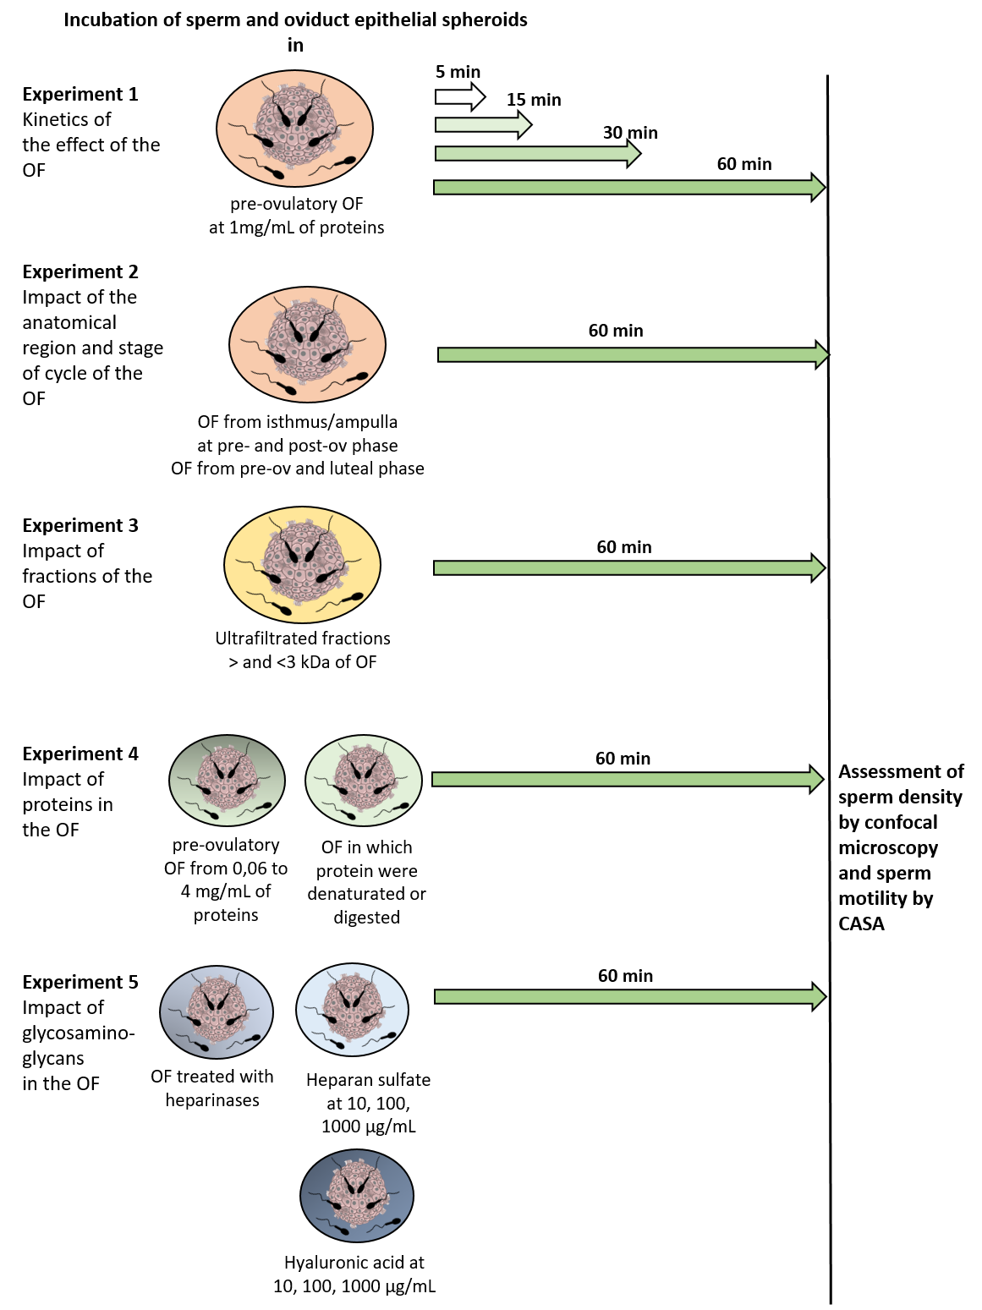
Supplementary Figure 1. Experimental design for sperm-oviduct epithelial spheroids incubation
Supplementary Dataset File 1. Sperm motility, membrane and acrosome integrity assessment during 1 h in control and in each treatment for sperm-spheroids incubation

