Supplementary file
Identification of Soybean Genes Correlated with Rhizobial Nitrogen Fixation Activity

Shunichi Yano¹, Teruya Takushima², Tatsuhiro Ezawa², Yusaku Sugimura², Akihiro Yamamoto³, Yuichi Saeki³ *

¹Interdisciplinary Graduate School of Agriculture and Engineering, University of Miyazaki, Miyazaki 889-2192, Japan; ²Graduate School of Agriculture, Hokkaido University, Sapporo, Hokkaido 060-8589, Japan; ³Faculty of Agriculture, University of Miyazaki, Miyazaki 889-2192, Japan

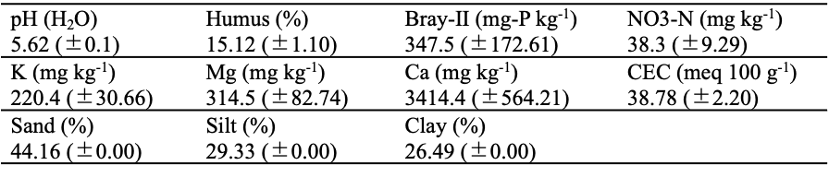
Table S1. Results of soil chemical analysis in the University of Miyazaki field. (mean ± SD)

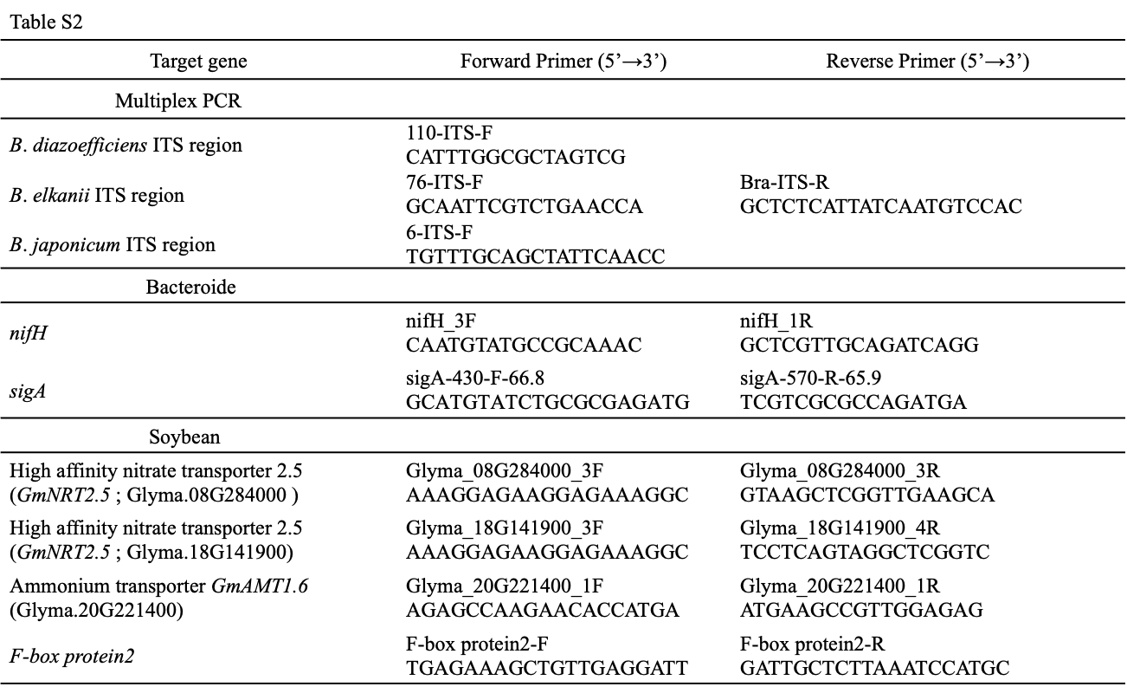
Table S2. ﻿Oligonucleotide primers used in this study.

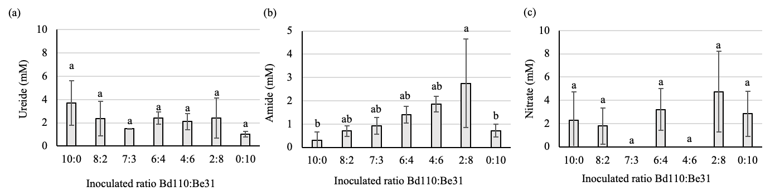
Fig. S1. Analysis of nitrogen compounds in xylem sap and relative ureide ratio of soybean grown under the field conditions. The figures indicate (a) ureide, (b) amide, and (c) nitrate concentrations (mM). (n = 3–4, mean ± SD, Tukey’s test, p < 0.05)

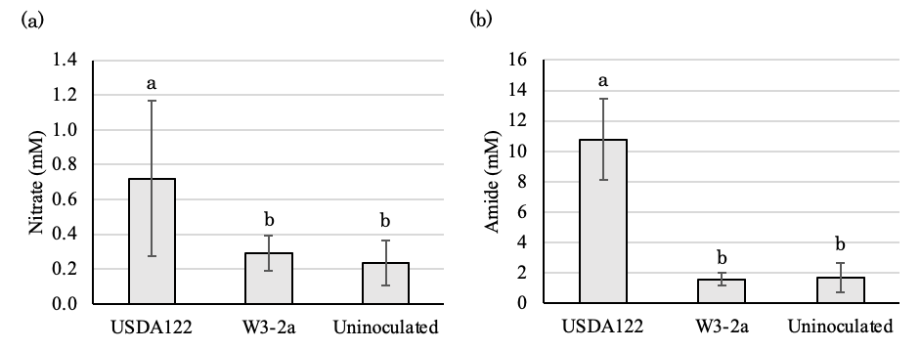
Fig. S2. Analysis of nitrogen compounds in xylem sap and relative ureide ratio of soybean inoculated with Bradyrhizobium diazoefficiens USDA122, W3-2a (nod+/fix-mutant), and uninoculated control. Figures indicate (a) amide and (b) nitrate concentrations (mM). (n = 6-8., mean ± SD; Tukey’s test, p < 0.05).

