Additional Materials
Figure S1. Service data spreadsheet template
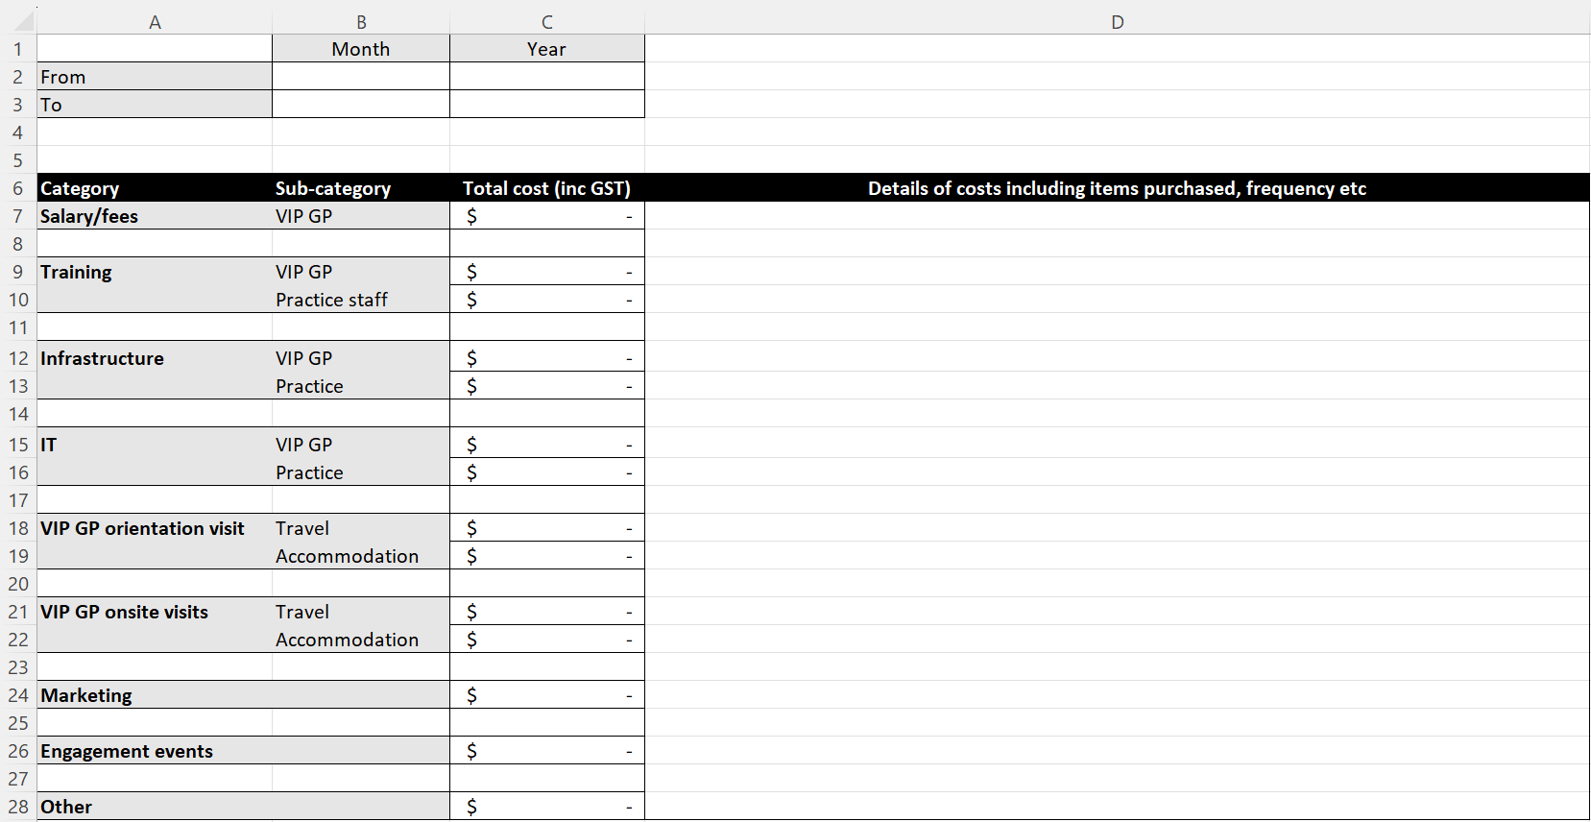
Figure S2. Cost data spreadsheet template

VIP patient survey

1. What is your age (years):
Note. If you are completing this survey on behalf of someone else, please record the age of the person whom the appointment was for.

2. What is your gender:
Note. If you are completing this survey on behalf of someone else, please record the gender of the person whom the appointment was for.

□ Male □ Female □ X (Indeterminate/Intersex/Unspecified)

3. What type of consultation did you have with the GP today:

□ Video □ Telephone

4. Did you attend the consultation at your local general practice?

□ Yes □ No

5. Have you had a previous appointment with the GP you saw today?
Note. You may tick more than one answer for this question.

□ In person □ Via video/telehealth □ Never

6. How well did your consult today meet your needs and expectations?

□ Very well □ Acceptable □ Did not meet my needs and expectations

7. Do you prefer virtual GP appointments or face-to-face?

□ Virtual □ Face-to-face □ No preference

8. Rate the importance of seeing the same GP on an ongoing basis for your current condition (please tick one box below):

Very important | Important | Moderately important | Somewhat important | Not important at all

9. If you were unable to have this virtual GP appointment, would you have attended any of the following instead?
□ Emergency Department
□ Other (Please specify):
…………………………………………………………………………………………………………………….………………………….………………………………………………………………………………………………………………………………………………..…………………………………………………………………………………………………………

10. Please rate your satisfaction with the health and medical care received via video/telehealth today

□ Highly satisfactory □ Satisfactory □ Unsatisfactory

11. For each statement please select an answer that best matches your experience of the video/telehealth appointment today (please tick one box for each statement below):

 | Strongly agree | Agree | Neither agree or disagree | Disagree | Strongly disagree
The video/telehealth appointment improved my access to the GP
I could easily talk to my GP and hear them clearly using
video/telehealth
I felt the service provided over the video/telehealth system was the
same as for an in-person visit
I felt comfortable communicating with the GP using the video/
telehealth system
I felt video/telehealth was an acceptable way to receive
healthcare services
I would use this GP video/ telehealth service again

Please provide any further feedback you have to help improve this service:
…………………………………………………………………………………………………………………….………………………….………………………………………………………………………………………………………………………………………………..…………………………………………………………………………………………………………

Table S1. Implementation cost data
Recurrent cost | Practice | Total ($AUD)
GP wage | Practice 1 | $1400/day
GP wage | Practice 2 | $1400/day
Staff and administration costs | Practice 1 | $0.00
Staff and administration costs | Practice 2 | $3060
GP on-site visits | Practice 1 | $12,530.46 (7 visits)
GP on-site visits | Practice 2 | $1907.97 (1 visit)
Non-recurrent cost | Practice | Total ($AUD)
IT (e.g., laptop) | Practice 1 | $3466.50
IT (e.g., laptop) | Practice 2 | $2836.50
Staff training | Practice 1 | $3445.00
Staff training | Practice 2 | $0.00

Table S2. Responses to 5-point Likert-scale questions
Statementª | Very important | Important | Moderately important | Somewhat important | Not important at all
Please rate the importance of seeing the same GP on an ongoing basis for your current condition | 15 (62.5) | 8 (33.3) | 1 (4.2) | 0 (0.0) | 0 (0.0)
Statement^{b} | Strongly agree | Agree | Neither agree nor disagree | Disagree | Strongly disagree
The video/telehealth appointment improved my access to the GP | 34 (77.3) | 8 (18.2) | 2 (4.5) | 0 (0.0) | 0 (0.0)
I could easily talk to my GP and hear them clearly using video/telehealth | 39 (88.6) | 4 (9.1) | 1 (2.3) | 0 (0.0) | 0 (0.0)
I felt the service provided over the video /telehealth system was the same as for an in-person visit | 24 (54.5) | 19 (43.2) | 1 (2.3) | 0 (0.0) | 0 (0.0)
I felt comfortable communicating with the GP using the video/telehealth system | 32 (72.3) | 13 (29.5) | 0 (0.0) | 0 (0.0) | 0 (0.0)
I felt video/telehealth was an acceptable way to receive healthcare services | 28 (63.6) | 15 (34.1) | 1 (2.3) | 0 (0.0) | 0 (0.0)
I would use this GP video/telehealth service again | 32 (72.3) | 12 (27.3) | 0 (0.0) | 0 (0.0) | 0 (0.0)
Missing data ªn=21; ^{b}n=1

