Supplementary Materials
Supplementary Figure 1. Illustration of the Overlapping patterns of annotation groups in the simulation studies. The $(i,j)$th element in the $K×K$ matrix represents the intersection over union (IOU) metric for the $i$th and $j$th annotation group. Suppose $K=4$ and each annotation group ($K1$,$K2$,$K3$,$K4$) contributes to 0, 0, 10%, 90% of the total heritability respectively. Left: The non-overlapping pattern assumes the sets of genetic variants in each annotation group are mutually exclusive; Middle: Overlapping pattern I assumes a higher IOU among the annotation groups with low heritability contribution; Right: Overlapping pattern II assumes a higher IOU among the annotation groups with high heritability contribution.
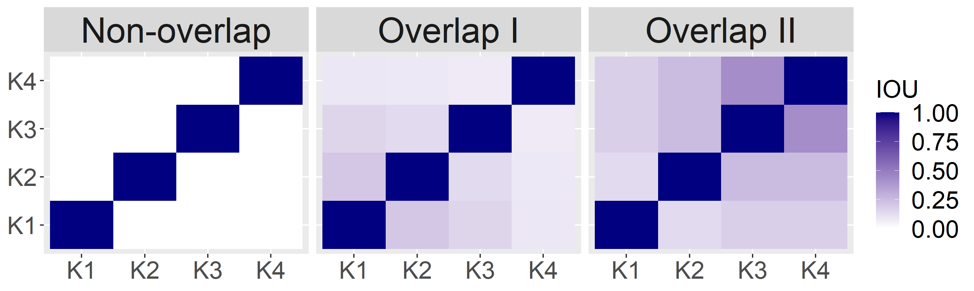

Supplementary Figure 2. Evaluation of $R^{2}$ from UK Biobank analysis results. Left panel: KEGG functional annotations; Right panel: Gene-based functional annotations from ANNOVAR.
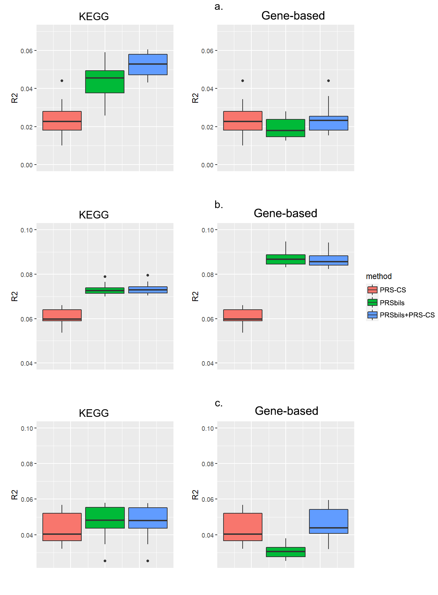

Supplementary Figure 3. Evaluation of $R^{2}$ from MGI data analysis results. Left panel: KEGG functional annotations; Right panel: Gene-based functional annotations from ANNOVAR. a: type II diabetes; b: BMI; c: LDL.
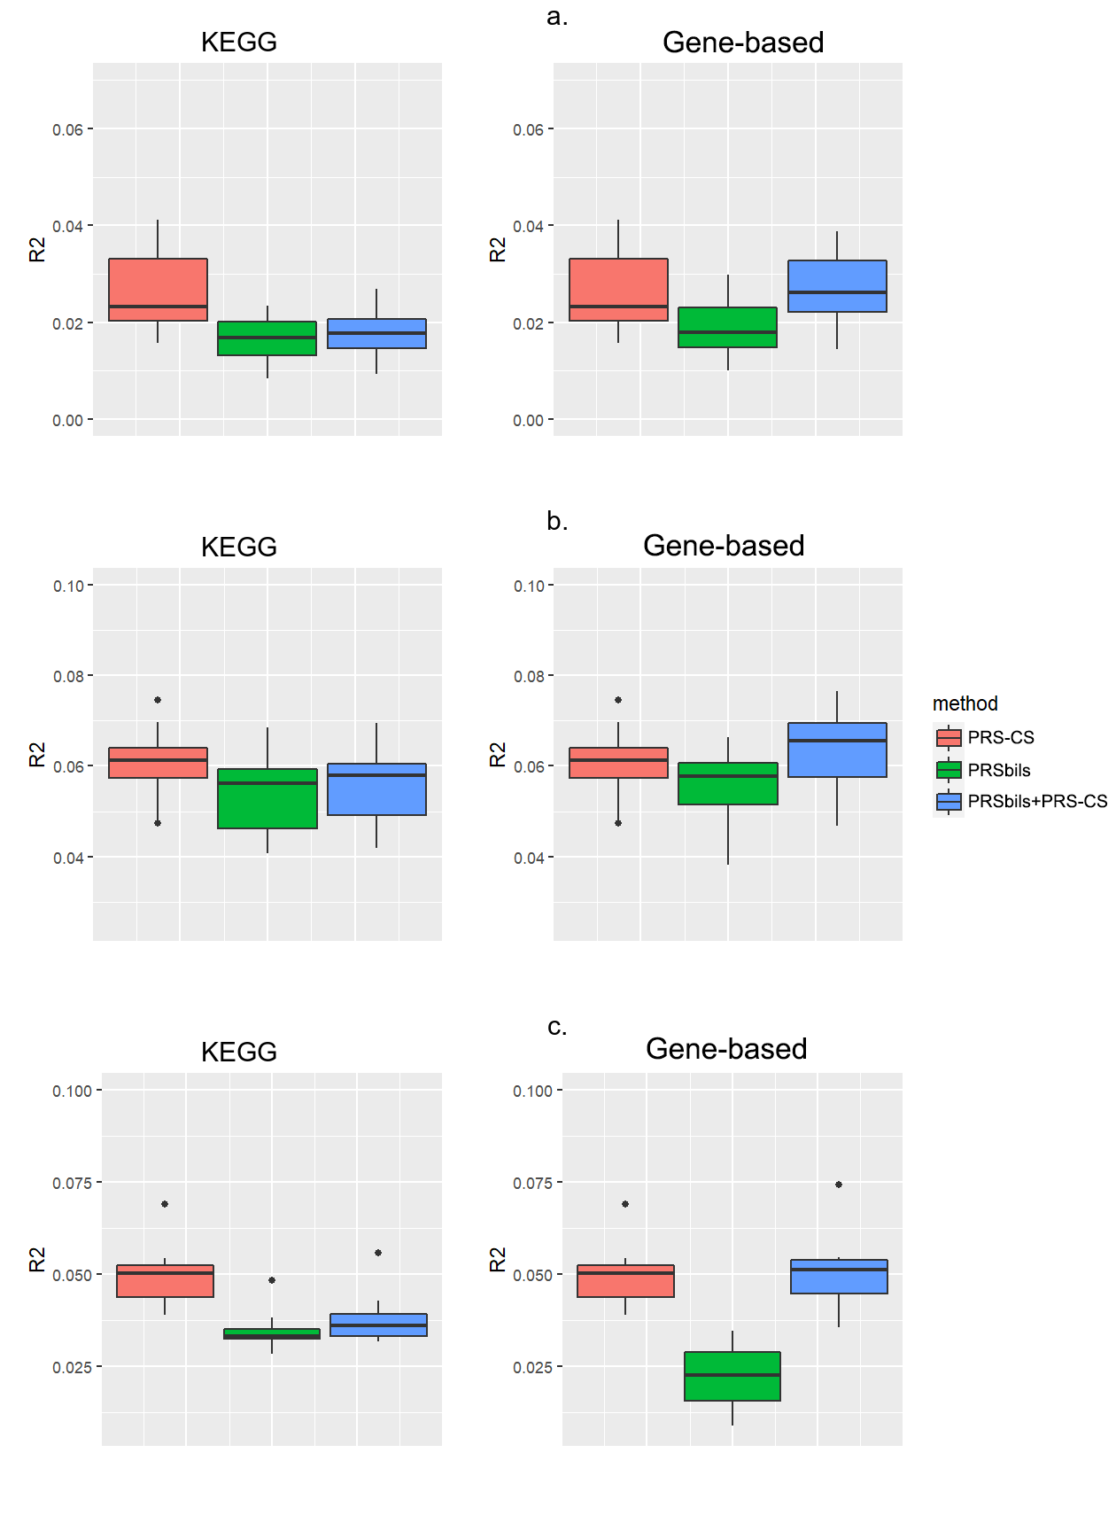

Supplementary Figure 4. Evaluation of KoGES analysis results. Left panel: KEGG functional annotations were used for the analysis of the proposed; Right panel: Refseq gene-based functional annotations from ANNOVAR were used for the analysis ofPRSbils. a: AUC of prediction accuracy for type II diabetes; b: Efron’s pseudo-$R^{2}$ for type II diabetes.
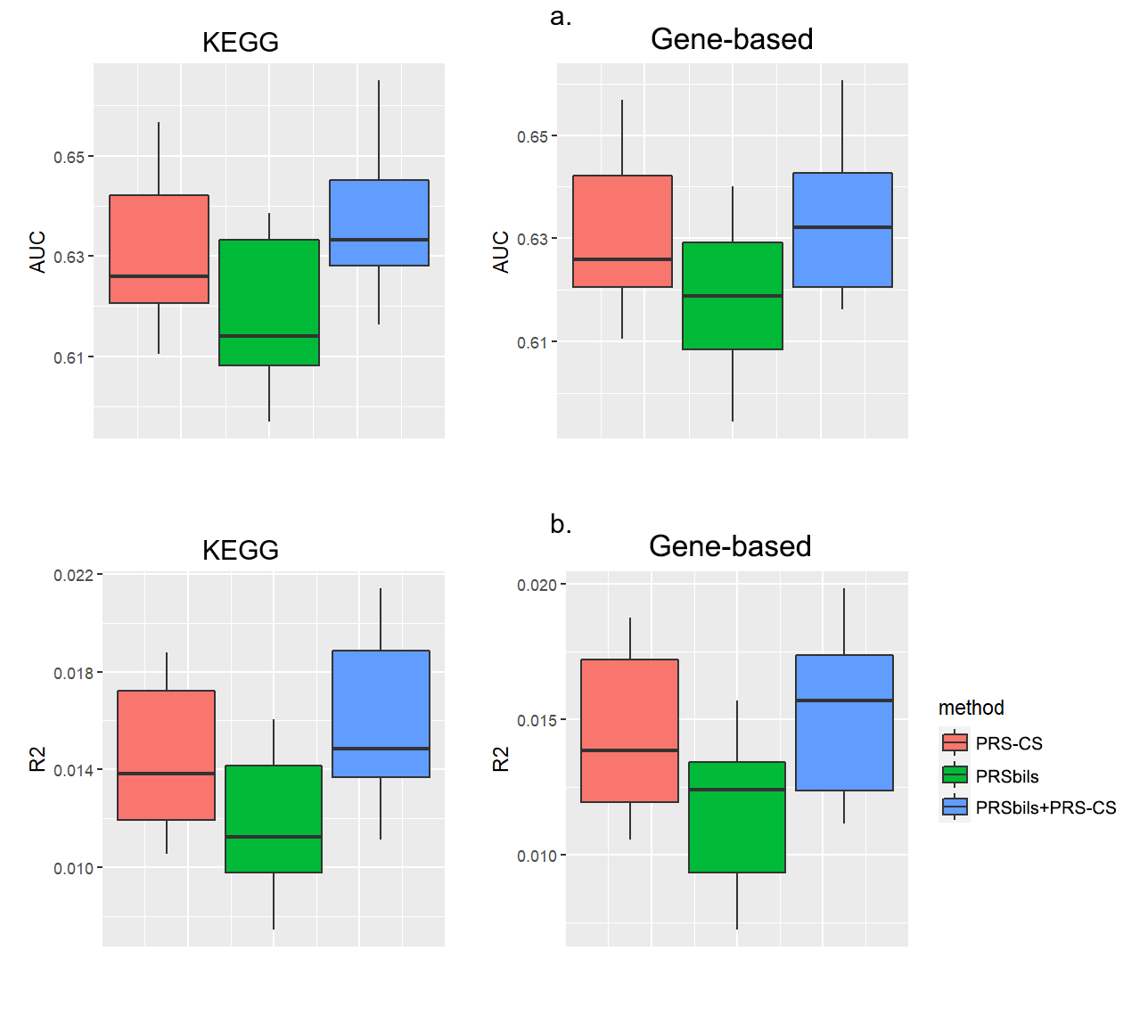

Supplementary Figure 5. Comparison of overall shrinkage between the proposed method (PRSbils) and the benchmark method for type II diabetes across the three data sources (UKB, MGI, KoGES). X axis: log of the absolute value of the overall shrinkage from the benchmark method; Y axis: log of the absolute value of the overall shrinkage from PRSbils. Dashed line: diagonal line indicating the same value for the two methods. a: Using KEGG annotation; b: Using Refseq gene-based annotation.
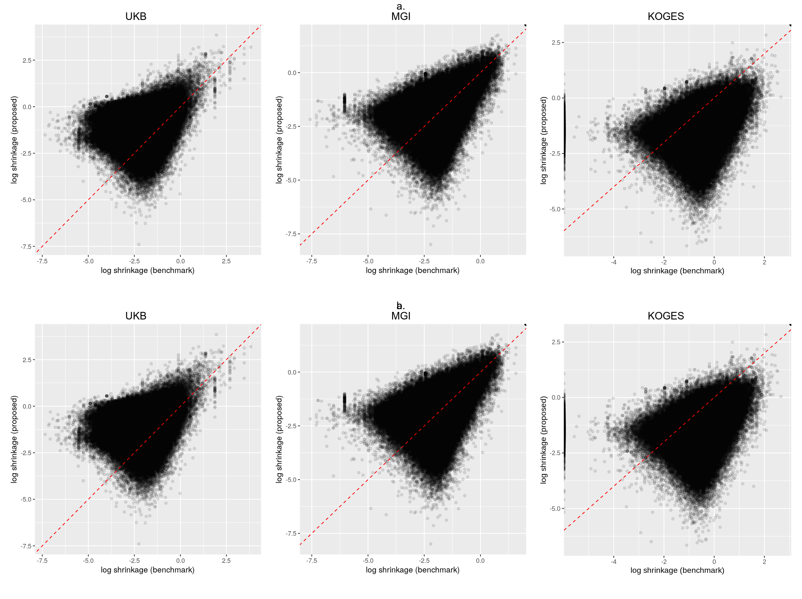

Supplementary Figure 6. Additional evaluation of $AUC$ from UK Biobank data analysis results for type II diabetes, with functional annotations in the baselineLD model together with KEGG annotations.
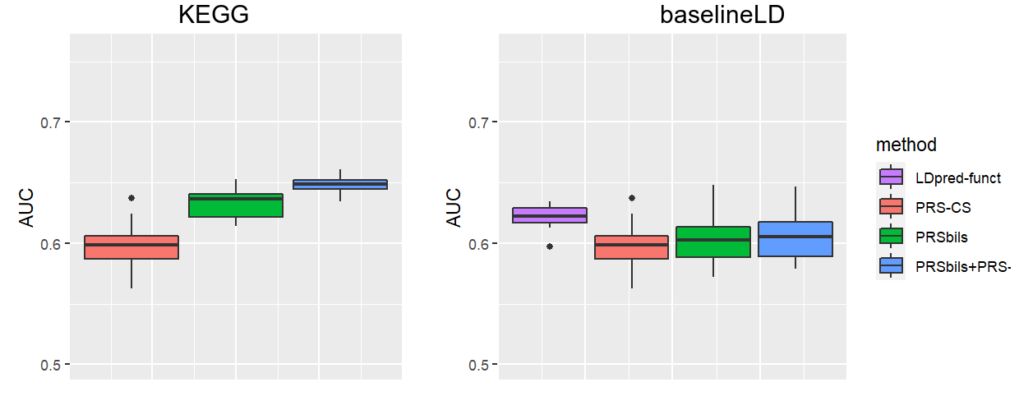

Supplementary Figure 7. Top 10 KEGG annotations with the highest average group-wise shrinkage from the UKB analysis for three phenotypes: type 2 diabetes, BMI, and LDL. The group-wise shrinkage for annotation group $k$ was calculated by taking the average of ${\hat{α}}_{k}\frac{{\tilde{β}}_{j}}{β_{0,j}}$ for each variant $j$ within the group. ${\hat{α}}_{k}$ is the coefficient estimate from $PRS=\sum_{k=1}^{K}{α_{k}}PRS_{k}$, ${\tilde{β}}_{j}$ is the adjusted genetic effect from PRSbils, $β_{0,j}$ is the original genetic effect from the summary statistics.
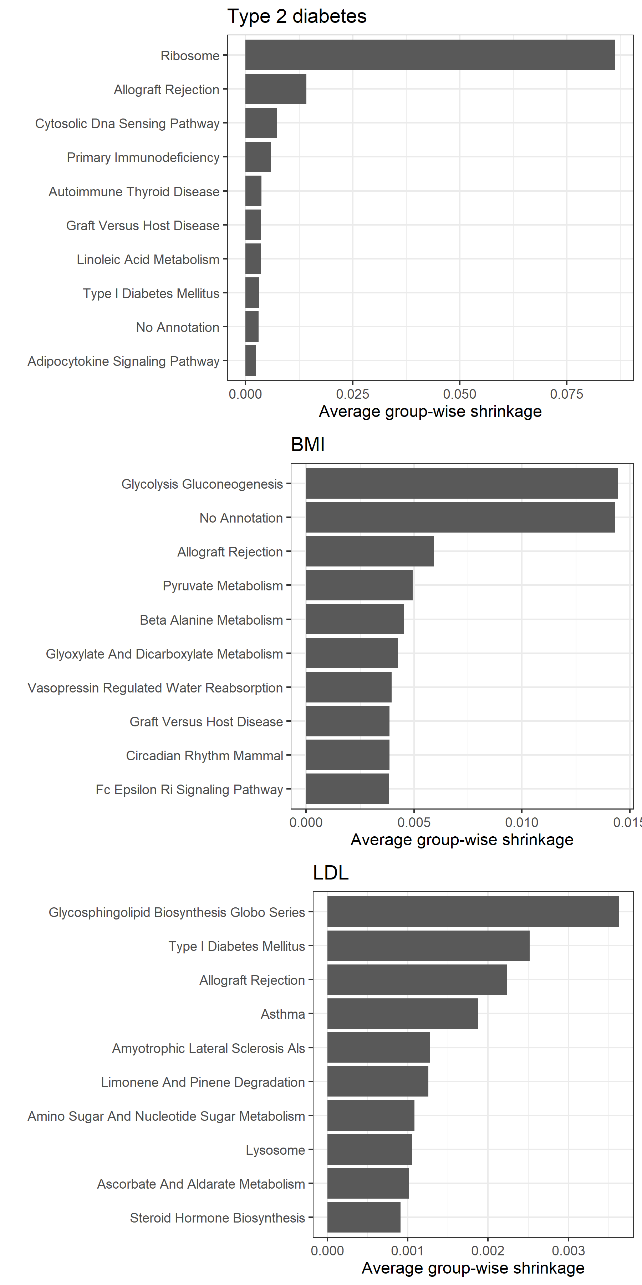
Supplementary Figure 8. Comparison of prediction performance with smaller sample size in simulation studies with non-overlapping annotation groups (Settings 1-5), measured by $R^{2}$. A total of M=125,000 SNPs were sampled from the UK Biobank data with 1KG as LD reference panel. Genetic effects were generated using a mixture of point-Normal models with total heritability fixed at 0.7. GWAS results from N_sumstat=50,000 simulated individuals were used as summary statistics. Prediction accuracy was evaluated in a test sample of $N_{t}est$=1,000 and 5,000 simulated individuals respectively with 10-fold cross-validation.
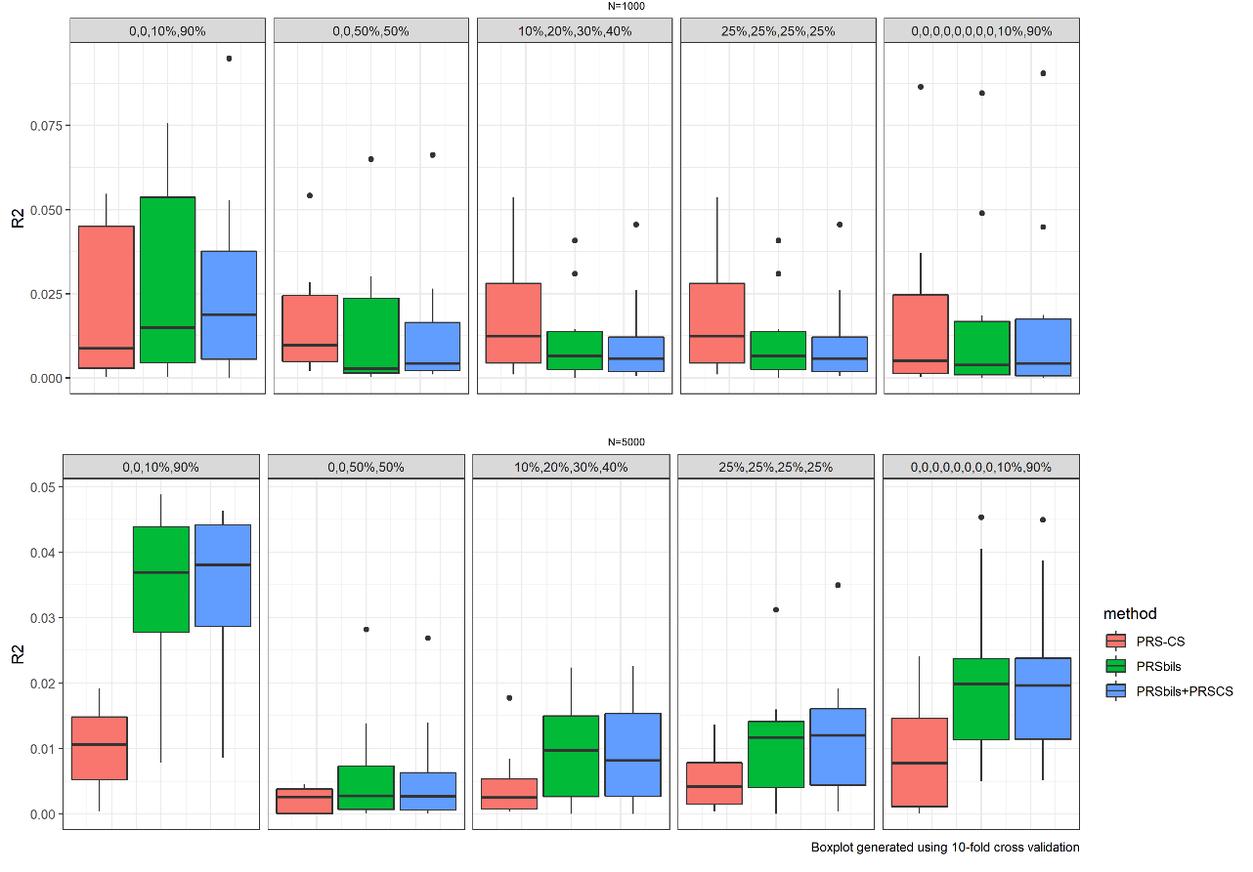

Supplementary Figure 9. Comparison of prediction performance with random annotation assignment in simulation studies with non-overlapping annotation groups (Settings 1-5), measured by $R^{2}$. A total of M=125,000 SNPs were sampled from the UK Biobank data with 1KG as LD reference panel. Genetic effects were generated using a mixture of point-Normal models with total heritability fixed at 0.7. After the phenotypes were generated using the “true” corresponding annotation assignment for each setting, the variants were then assigned a random “observed” annotation group with equal probability to train and test for prediction performance. GWAS results from $N_{sumstat}=50,000$ simulated individuals were used as summary statistics. Prediction accuracy was evaluated in a test sample of $N_{test}$=24,000 simulated individuals with 10-fold cross-validation.

