Supporting information

The Cryo-EM structure of renal amyloid fibril suggests structurally homogeneous multiorgan aggregation in AL amyloidosis
Sarita Puri¹, Tim Schulte², Antonio Chaves-Sanjuan^{1,3}, Giulia Mazzini^{4,5}, Serena Caminito^{4,5}, Carlo Pappone^{2,6,7}, Luigi Anastasia^{2,6}, Paolo Milani^{4,5}, Giampaolo Merlini^{4,5}, Martino Bolognesi^{1,3}, Mario Nuvolone^{4,5}, Giovanni Palladini^{4,5}, Stefano Ricagno^{1,2*}
- Department of Biosciences, Università degli Studi di Milano, Milan, Italy.
- Institute of Molecular and Translational Cardiology, IRCCS Policlinico San Donato, 20097, Milan, Italy.
- Pediatric Research Center Fondazione R.E. Invernizzi and NOLIMITS Center, Università degli Studi di Milano, Milan, Italy.
- Department of Molecular Medicine, University of Pavia, Pavia, Italy.
- Amyloidosis Research and Treatment Center, Fondazione IRCCS Policlinico San Matteo, Pavia, Italy.
- Faculty of Medicine, University of Vita-Salute San Raffaele, 20132 Milan, Italy.
- Arrhythmia and Electrophysiology Department, IRCCS Policlinico San Donato, San Donato, 20097 Milan, Italy.
* To whom correspondence may be addressed: E-mail address: Stefano.ricagno@unimi.it

Supporting table S1. CryoEM data collection, structure determination, and refinement statistics.
Data collection
Microscope | Talos Arctica
Voltage (kV) | 200
Camera | Falcon 3 direct electron detector
Magnification | x 120,000
Pixel size | 0.889 Å/pixel
Defocus range (µm) | -0.8 to -2.6
Total electron dose (e⁻/ Å²) | 40
Number of frames | 40
Reconstruction
Total micrographs | 1800
Box size (pixel) | 320
Inter-box distance (pixel) | 32
The initial number of segments | 91877
Segments (final reconstruction) | 49091
Map sharpening β-factor (Å²) | -139
Helical rise (Å) | 4.9
Helical twist (°) | -1.63°
Symmetry | C1
Model composition and statistics
No. of residues | 385
Subunits | 5
All-atom clash score | 4.35
Ramachandran outliers | 0
Ramachandran favored | 350
Bad bonds | 0/2975
Bad angles | 0/4040
Rotamer outliers | 0
Cβ deviation | 0
CA geometry outliers | 5
CryoEM ringer score | 3.72
Molprobity score | 1.5

Manual picking

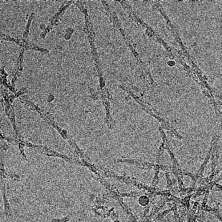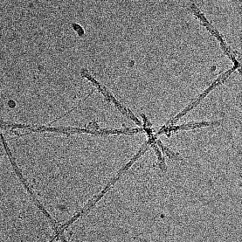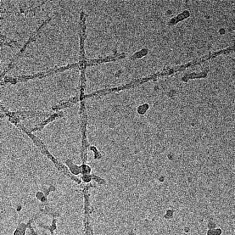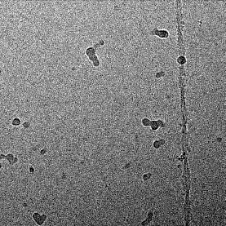
9452 fibril coordinates were picked from motion corrected and CTF estimated micrographs.

2D Classification (large box) | - 2D Classification (small box)
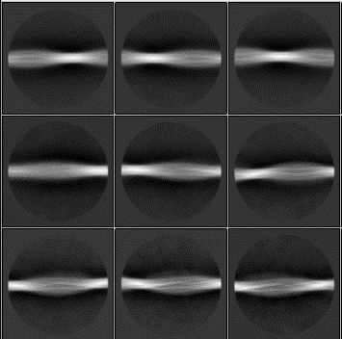  Segments: 28209  Box size: 768 pixels  Inter-box distance: 10 %  Tube diameter: 150 Å  Rise: 4.75  asu: 18  Estimated cross-over distance: 550 Å  Initial model from red highlighted class. | 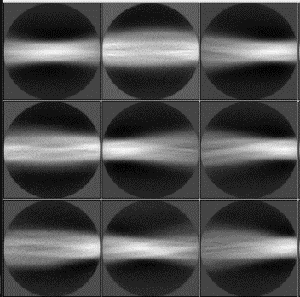  Segments: 91877  Box size: 320 pixels  Inter-box distance: 10 %  Tube diameter: 140 Å  Rise: 4.75  asu: 6

Initial model | - 3D classification (round 1)
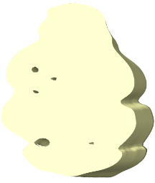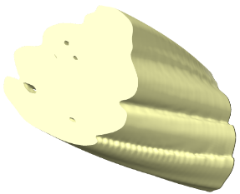  Side  Front | 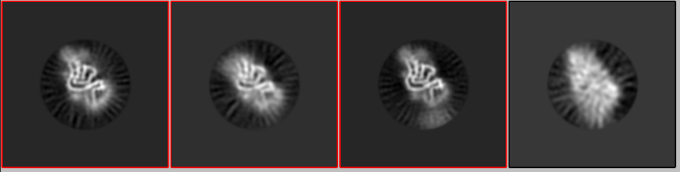  Selected particles: 63602 based on good-looking classes (red highlighted).

3D classification (round 2) | - 3D auto-refinement
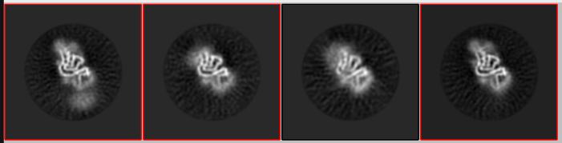  Selected particles: 49091 based on estimated higher resolution (red highlights). | 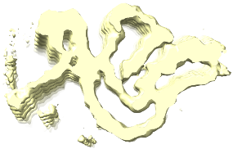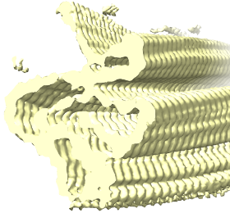  -1.63°, 4.9 Å (final resolution 4.33 Å)

- Masking and postprocessing | - FSC plot
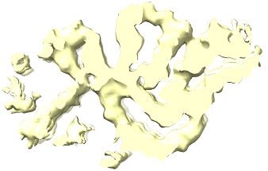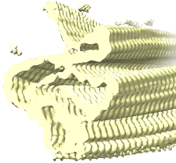  -1.63°, 4.9 Å (final resolution 4.0 Å) | 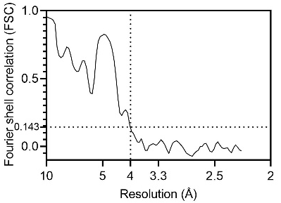
Supplementary figure S1. Workflow of cryo-EM data processing. The cryo-EM data processing was performed by RELION 3.1 (Gremer et al., 2017; He et al., 2017; Shi et al., 2021; Zivanov et al., 2018). (a) Raw micrographs showing fibrils. (b) Reference-free 2D classes using large and small box sizes. (c) Two rounds of 3D classifications. Red highlighted classes were used for the next step (d) 3D refinement on 49k good particles selected after the second round of 3D classification. The estimated resolution after multiple refinements reached 4.33 Å. (e) Masking and postprocessing on refined particles resulted in a final resolution of 4.0 Å according to the gold standard FSC of half maps. The final helical twist and rise are -1.63° and 4.9 Å. (f) FSC plot shows overall resolution.

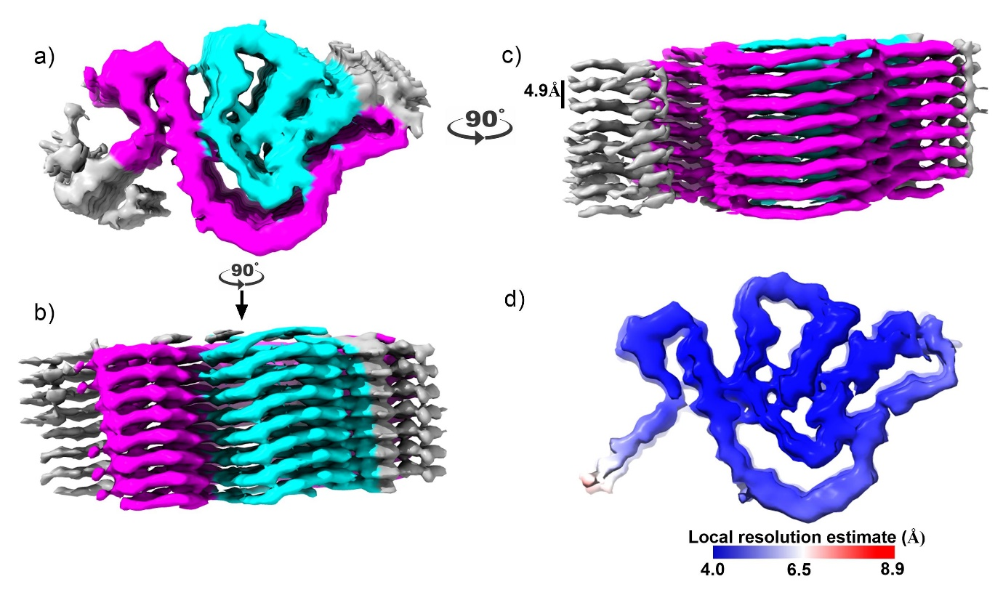
Supporting figure S2. Different views of post-processed 3D map and its local resolution estimates. (a-c) The orthogonal views of the post-processed 3D map at an overall resolution of 4.0 Å (FSC = 0.143). The inner fibril core in the snail shape is shown with cyan color while the outer C-shaped fibril structure is shown in magenta. (d) The local resolution of the cryoEM map of the renal AL55 fibril is colored according to a blue-white-red gradient scheme in a range of 4.0 to 8.9 Å.

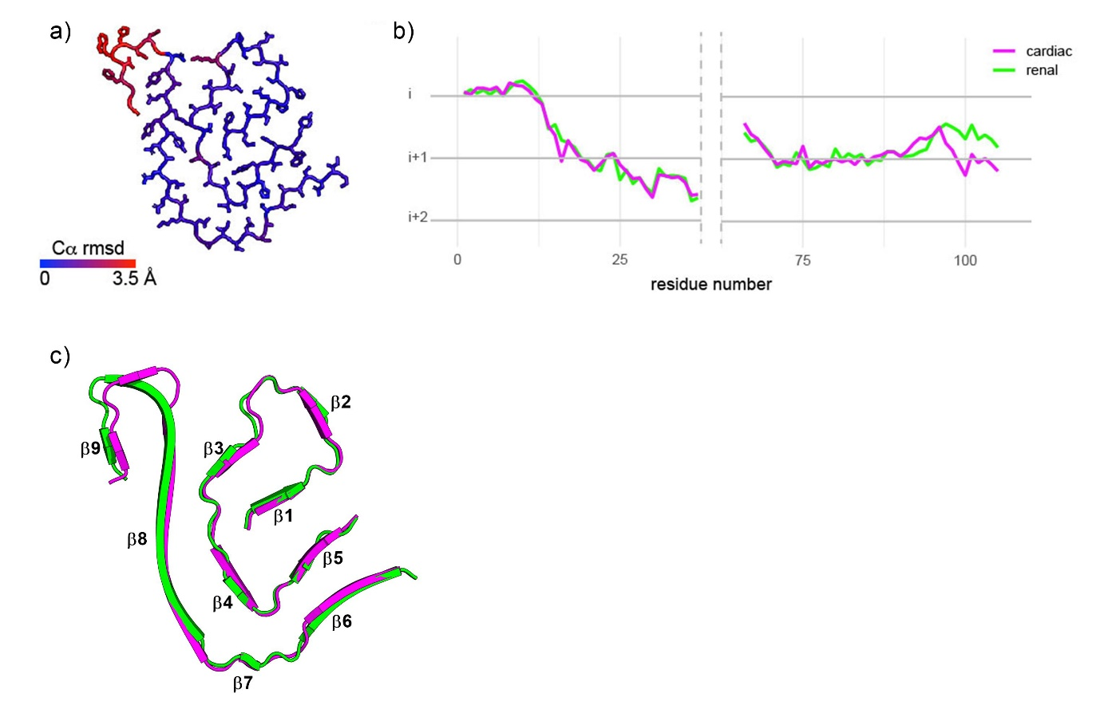
Supporting figure S3: Comparative structural features of renal and cardiac fibrils. (a) rmsd between cardiac and renal models on a scale of 0 to 3.5 Å in a blue-to-red gradient. (b) β-sheets arrangement in renal (green) and cardiac (magenta) fibril. (c) Layer line plot showing non-planarity in AL55 renal (green) and cardiac (magenta) amyloid fibrils. The position of Cα atoms from residues Asn-1 to Tyr-37 and Ser-66 to Gly-105 is plotted along the long fibril axis. The snail shape region shows a translational shift while the C-shaped region is planner. Each layer line lies at 4.9 Å and is represented as i, i+1, and i+2.
References
- Gremer, L. et al. Fibril structure of amyloid-β (1-42) by cryo-electron microscopy. Science 358(6359),116-119 (2017).
- He, S., Scheres, S. H. W. Helical reconstruction in RELION. Journal of Structural Biology 198(3), 163–176 (2017).
- Shi, Y. et al. Structure-based classification of tauopathies. Nature 598(7880), 359–363 (2021).
- Zivanov, J et al. New tools for automated high-resolution cryo-EM structure determination in RELION-3. eLife 7: e4216 (2018).

