Supporting information for “Evaluation of tornadic environments and their trends and projected changes in Japan”

Sho Kawazoe¹, Masaru Inatsu¹, Mikiko Fujita², Shiori Sugimoto², Yasuko Okada², Shingo Watanabe²

- Hokkaido University, Sapporo, Japan
- Japan Agency for Marine-Earth Science and Technology, Yokohama, Japan

Corresponding author: Sho Kawazoe, Hokkaido University, N10W8, Kita-ku, Sapporo, Hokkaido, Japan, 060-0810. Email: kawazoe@sci.hokudai.ac.jp

Reference:
Bunkers, M. J., Klimowski, B. A., Zeitler, J. W., Thompson, R. L. & Weisman, M. L. Predicting supercell motion using a new hodograph technique. Weather and Forecasting, 15, 61–79 (2000).
Inatsu, M. The neighbor enclosed area tracking algorithm for extratropical wintertime cyclones. Atmospheric Science Letters, 10, 267–272 (2009).

Radiosonde data:
Durre, I., Xungang, Y., Vose, R.S., Applequist, S. & Arnfield, J. Integrated Global Radiosonde Archive (IGRA), Version 2. NOAA National Centers for Environmental Information. (2016). Last access: July 2019.

Table S1. Formulas for calculating thermodynamic and kinematic parameters. Symbols denote: $g$ (gravitational acceleration), EL (equilibrium level), LFC (lifting condensation level), $T_{v}$ (virtual temperature of $p$ [parcel], $e$ [environment], and $b$ [average of layer]), $z_{i}$ (level of parcel origin), $T$ (air) and $D$ (dew point) temperature, $V$ (environmental wind), $k$ (unit vertical vector), and $c$ (storm motion vector).
Parameter | Formula
¹Convective available potential energy (CAPE) | $$g\int_{LFC}^{EL}{\left(\frac{T_{vp}-T_{ve}}{T_{ve}}\right)dz}$$
¹Convective inhibition (CIN) | $$g\int_{z_{i}}^{LFC}{\left(\frac{T_{ve}-T_{vp}}{T_{vb}}\right)dz}$$
²Lifting condensation level (LCL) | $$125\left(T_{ml}-D_{ml}\right)$$
³K-index (KI) | $$\left(T_{925 hPa}-T_{500 hPa}\right)+D_{925 hPa}-\left(T_{700 hPa}+D_{700 hPa}\right)$$
Deep layer shear (DLS) | $$V_{6 km}-V_{10 m}$$
⁴Storm relative helicity (SRH) | $$-\int_{10 m}^{1 km}{k×\frac{∂V}{∂z}dz∙\left(V-c\right)dz}$$
1. The near-surface to 500-m mixed-layer parcel is used to compute CAPE and CIN using methods from Marsh et al. (2009).
2. ml denotes surface to 500-m mean layer.
3. The 925-hPa is used instead of 850-hPa to represent lower-level environments better.
4. Storm motion vector is approximated following Bunkers et al. (2000).
Table S2. The annual average frequency of EHI, KHI, and STP for each region in the HIST and +2-K. Parathesis indicates the range from 30 +2-K ensemble members.
 |  | HIST | +2-K
wHokkaido | EHI | 3.1 (2.6 - 3.9) | 6.9 (4.8 - 9.6)
 | KHI | 6.9 (5.9 - 7.8) | 9.9 (8.5 - 10.8)
 | STP | 5.2 (4.5 - 5.9) | 8.9 (6.9 - 11.0)
eTohoku | EHI | 6.4 (5.9 - 7.1) | 13.9 (9.9 - 18.4)
 | KHI | 14.1 (12.9 - 14.7) | 16.7 (14.9 - 18.8)
 | STP | 7.2 (6.4 - 7.9) | 11.8 (9.6 - 14.5)
Kanto | EHI | 30.2 (29.0 - 31.9) | 41.6 (35.2 - 48.9)
 | KHI | 22.1 (20.4 - 23.6) | 24.7 (22.0 - 27.4)
 | STP | 21.4 (19.5 - 22.6) | 25.3 (22.5 - 28.7)
Kansai | EHI | 32.2 (30.1 - 35.3) | 44.0 (37.6 - 52.2)
 | KHI | 30.6 (28.9 - 34.3) | 34.1 (30.5 - 37.5)
 | STP | 26.3 (24.2 - 28.1) | 31.3 (26.8 - 36.9)
wKyushu | EHI | 40.1 (36.9 - 43.2) | 52.0 (40.4 - 64.2)
 | KHI | 24.3 (23.0 - 25.9) | 27.2 (23.1 - 30.7)
 | STP | 22.7 (21.4 - 24.3) | 27.1 (21.8 - 32.0)
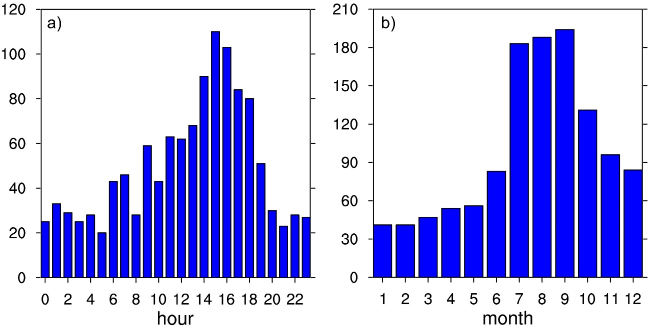
Figure S1. a) Hourly and b) monthly distribution of all tornadoes in Fig. 1.
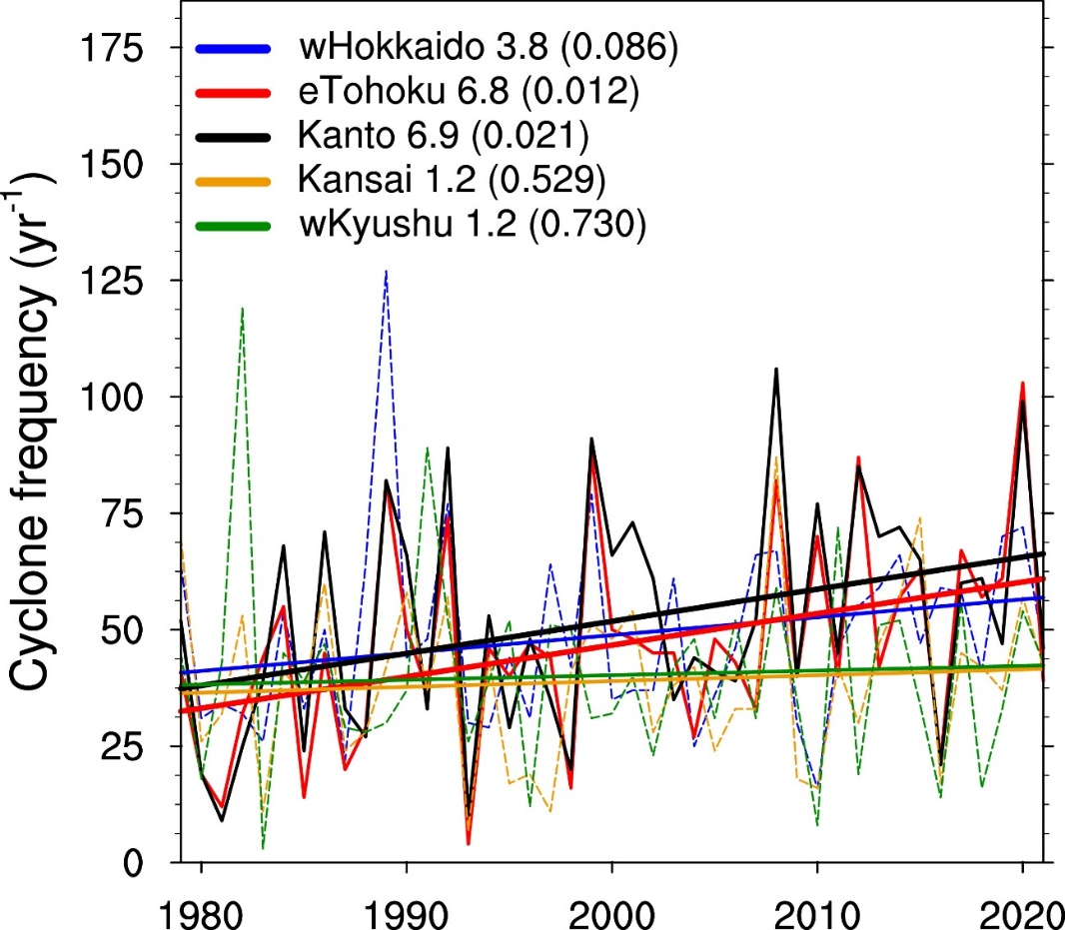

Figure S2. Trends in annual frequency of cyclones for each region. Each region is enlarged by 3º in all directions to account for remote cyclone influence. Cyclones are identified using the neighbor enclosed area tracking algorithm (Inatsu 2009). Tracking methods are the same as Kawazoe et al. (2023), except for relative vorticity, which is set aa 2.0 × 10⁻⁵ s⁻¹.

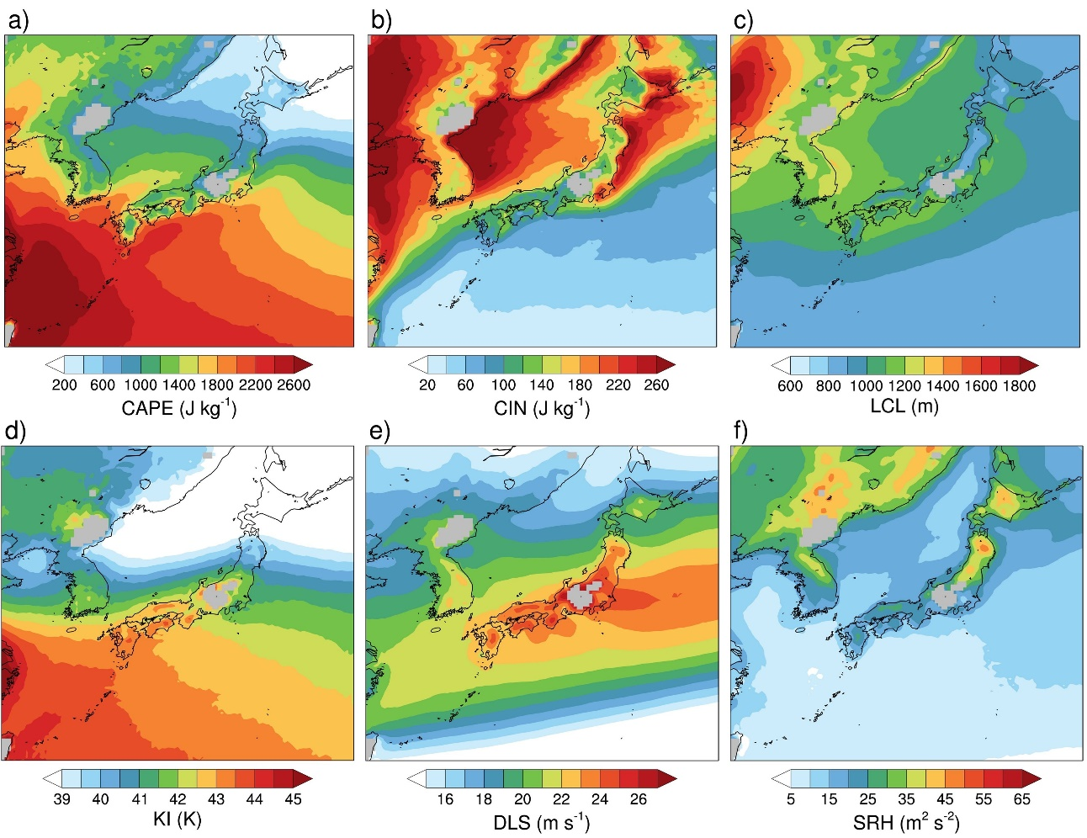
Figure S3. As in Fig. 4, but for ERA5.

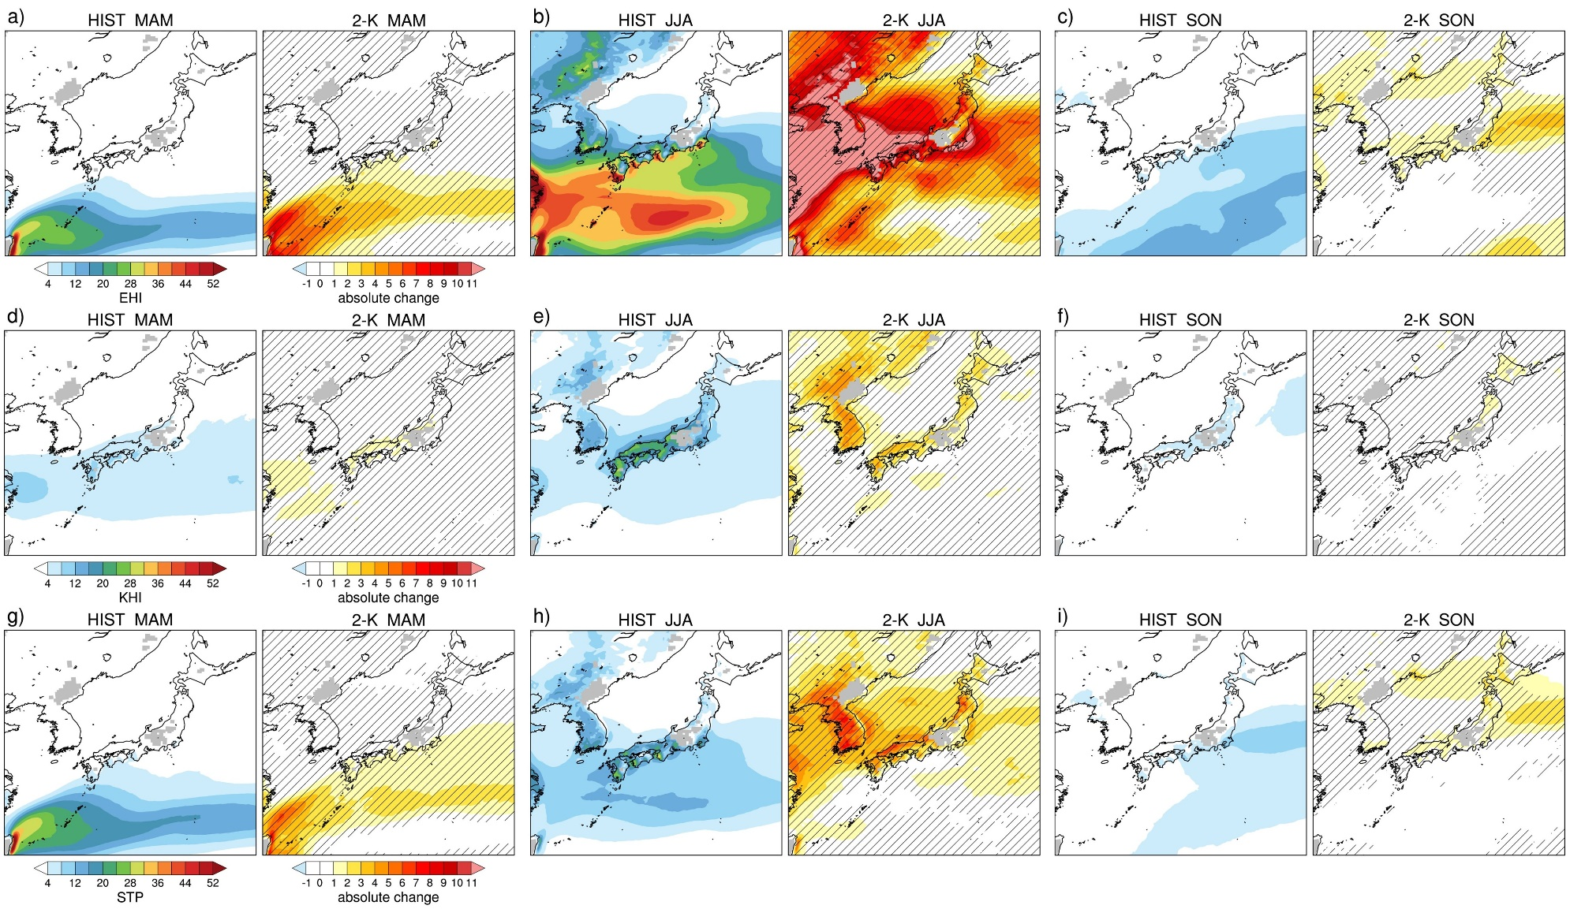
Figure S4. As in Fig. 5, but for (a-c) EHI, (d-f) KHI, and (g-i) STP in MAM, JJA, and SON.

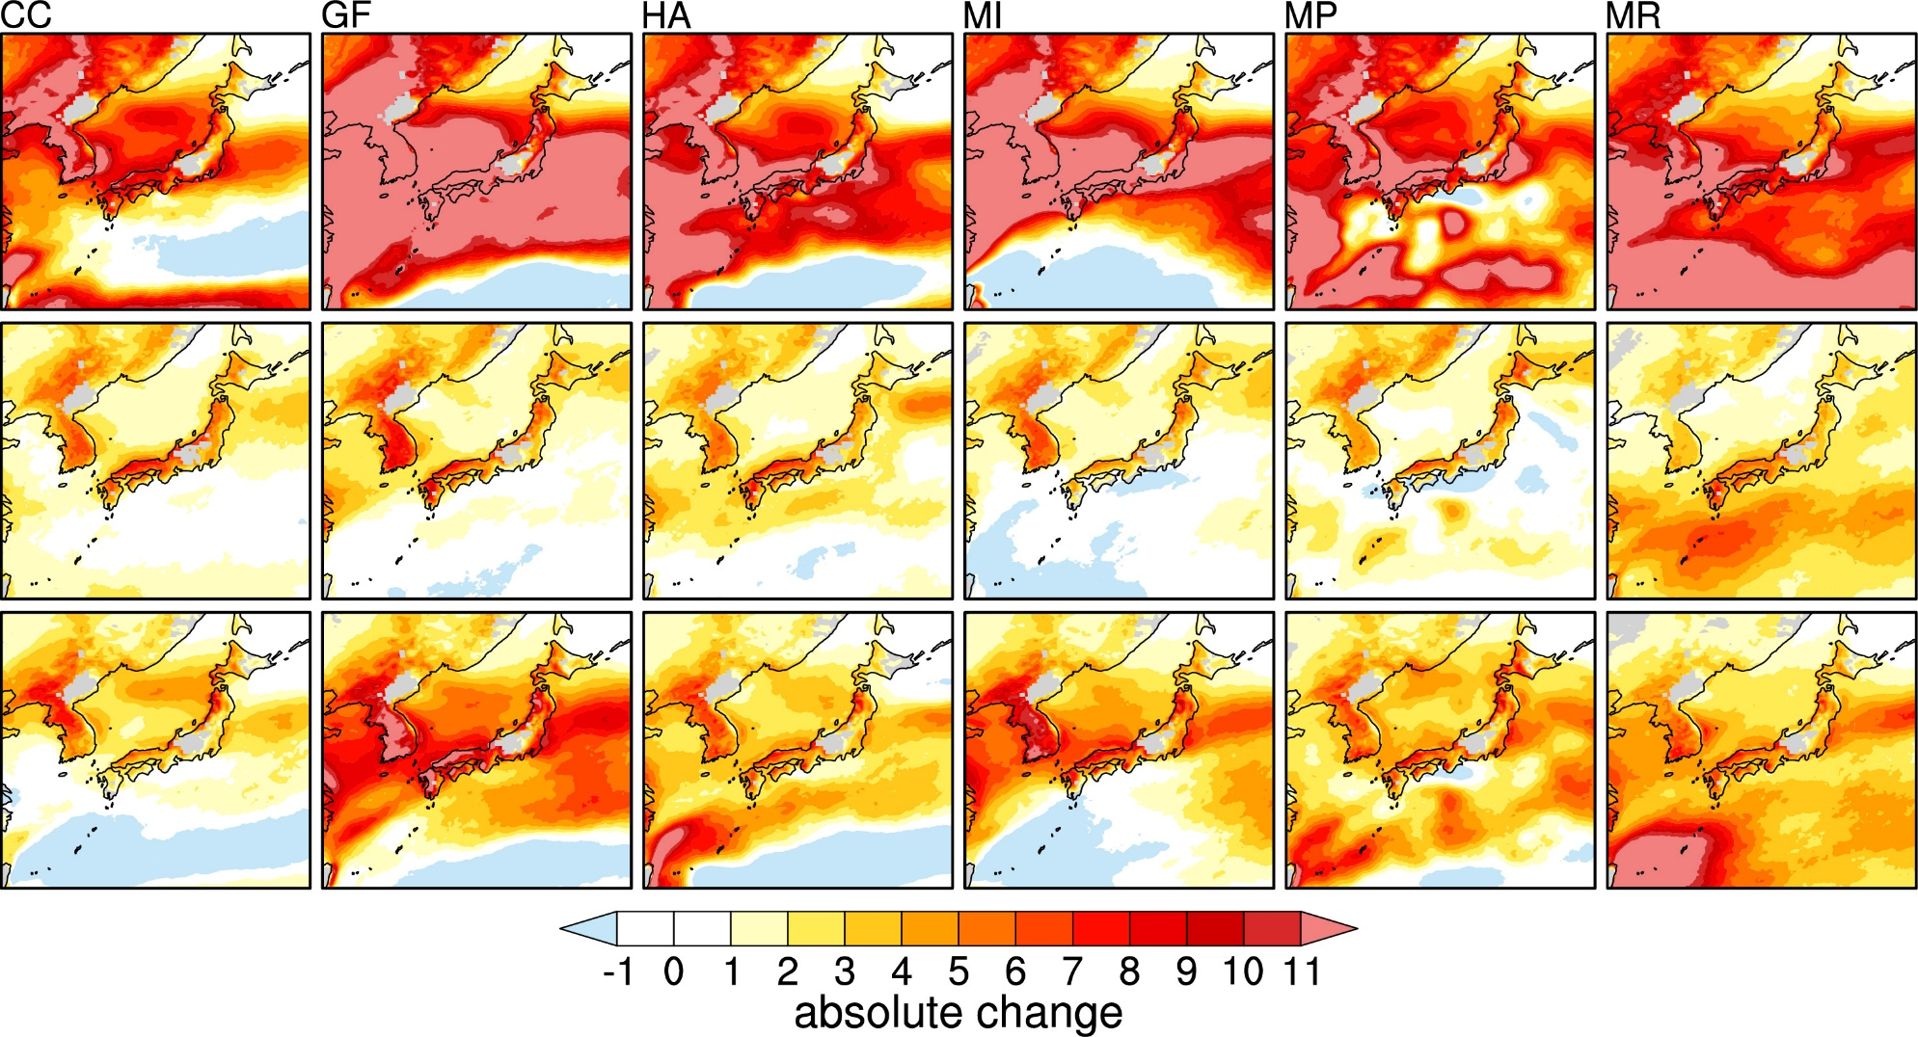
Figure S5. As in Fig. 5, but separated by ΔSST patterns for (top) EHI, (middle) KHI, and bottom (STP).

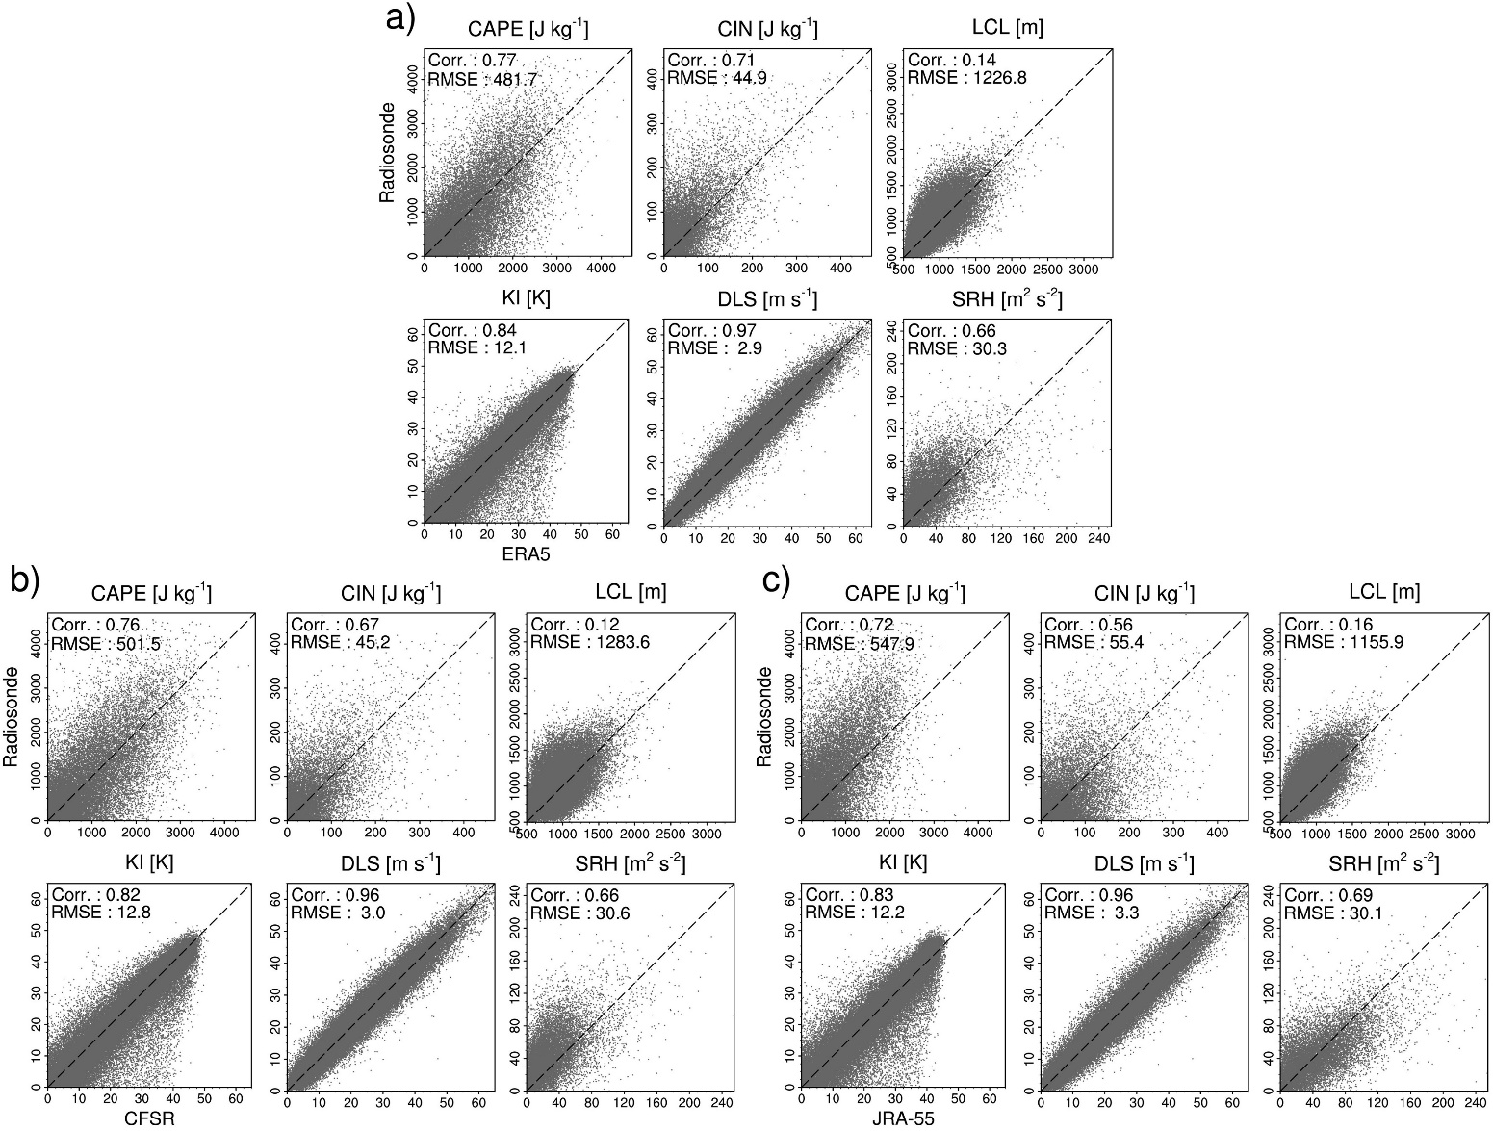
Figure S6. Comparison of radiosonde and nearest reanalysis [a) ERA5, b) CFSR, and c) JRA-55] sounding. Seventeen radiosondes either currently in operation or active for 30+ years, are used. The values denote the Pearson correlation coefficient (Corr.) and root mean square error (RMSE). For CFSR’s LCL, the sigma 0.995 level (~42 m) is treated as the surface, while 2-m values are used for the ERA5/JRA-55.

