Supplemental material

Disturbance tolerance of arbuscular mycorrhizal fungi: Trait-based characterization of arbuscular mycorrhizal fungal community along a disturbance gradient in a coastal sand dune ecosystem

Anjar Cahyaningtyas¹, and Tatsuhiro Ezawa^{1*}

Fig. S1. Experimental procedure to separate disturbance-tolerant (rapid regenerator) and -sensitive (slow regenerator) arbuscular mycorrhizal fungi in M. sinensis trap culture.

Table S1. GPS data for the sampling plots.

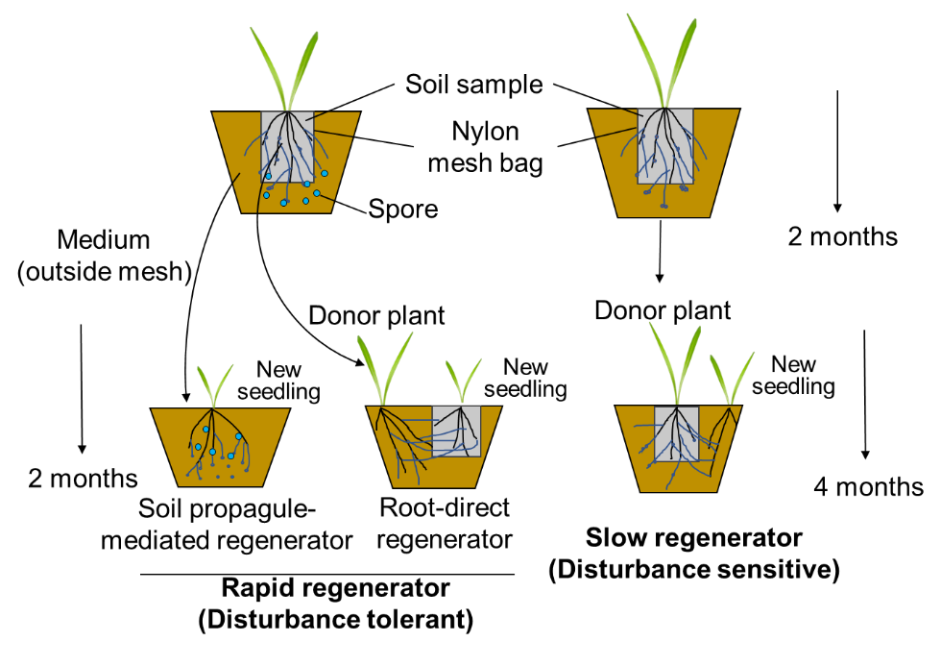

Fig. S1. Experimental procedure to separate disturbance-tolerant (rapid regenerator) and -sensitive (slow regenerator) arbuscular mycorrhizal fungi in M. sinensis trap culture. M. sinensis was sown onto the samples in cylindrical-shaped-nylon mesh bags surrounded by the dune soil and grown in a greenhouse for two months. To raise rapid regenerators, the plants (donor) were removed with the mesh bag, and the remaining whole was filled with the same medium, to which new seedlings of M. sinensis were grown for further two months (spore propagule-mediated regenerators). The roots of the donor plants were excised from the mesh bag, washed with tap water on a stainless mesh to remove adhering spore, and then transplanted to a new pot in which new seedlings were grown in a new mesh bag further for two months (root-direct regenerators). To raise slow regenerators, after two months growing of M. sinensis, new seedlings were grown outside of the mesh bag for further four months.

Table S1. GPS data of the sampling plots.
Plot ID | Soil sample ID | Latitude | Longitude
Landward slope
1L | 1L1 - 1L4 | 43º14'33"N | 141º20'40"E
2L | 2L1 - 2L4 | 43º14'27"N | 141º20'34"E
3L | 3L1 - 3L4 | 43º14'22"N | 141º20'28"E
4L | 4L1 - 4L4 | 43º14'18"N | 141º20'23"E
5L | 5L1 - 5L4 | 43º14'13"N | 141º20'17"E
Seaward slope
1S | 1S1 - 1S4 | 43º14'34"N | 141º20'37"E
2S | 2S1 - 2S4 | 43º14'29"N | 141º20'31"E
3S | 3S1 - 3S4 | 43º14'24"N | 141º20'26"E
4S | 4S1 - 4S4 | 43º14'20"N | 141º20'21"E
5S | 5S1 - 5S4 | 43º14'14"N | 141º20'15"E

