Supporting information
Topometric Design of Reticulated Nanofiber Composites for
Lithium-Sulfur Batteries

Mingqiang Wang¹, Kody Whisnant², Volkan Cecen², Lei Zhao¹, Zhengxiang Zhong¹, Li Liu¹, Yudong Huang*¹, Nicholas A. Kotov*^{2,3,4,5}
¹ School of Chemistry and Chemical Engineering, MIIT Key Laboratory of Critical Materials Technology for New Energy Conversion and Storage, State Key Laboratory of Urban Water Resource and Environment Harbin Institute of Technology, Harbin 150001, P. R. China. ² Department of Chemical Engineering, University of Michigan, Ann Arbor, Michigan 48109, USA; ³ Department of Biomedical Engineering, University of Michigan, Ann Arbor, Michigan 48109, USA; ⁴ Department of Materials Science and Engineering, University of Michigan, Ann Arbor, Michigan 48109, USA; ⁵ Biointerfaces Institute, University of Michigan, Ann Arbor, Michigan 48109, USA.
Corr. authors: Yudong Huang huangyd@hit.edu.cn, Nicholas A. Kotov kotov@umich.edu

Methods
1.1. Preparation of ANF-based reticulated nanofiber composites (RCNs)
Dispersions of aramid nanofibers (ANFs) were prepared according to previous work ¹ . In this work, 2.0 wt% ANFs dispersion was used by stirring Kevlar 69 (from Thread Exchange) in dimethyl sulfoxide (DMSO, Sigma Aldrich ≥99.9%) for one week in the presence of potassium hydroxide (KOH, Sigma Aldrich) until a dark red ANF solution was obtained. The spin coating method was then used to prepare ANF hydrogels membrane. Specifically, 2 mL of ANF (2 wt%) dispersion was dipped on a clean glass slide and spin-coated at 1500 rpm for 30 s. After that, the glass slides were immersed into DI water to remove the DMSO and then stored in methanol (Sigma Aldrich) solution for later use. It should be noted that prior to use, the glass slides were cleaned in piranha solution (3:1 H₂SO₄/H₂O₂) for 24 h, followed by thorough rinsing with deionized water.

1.2. Preparation of ANF@ZIF-67 composite aerogels
To prepare ANF@ZIF-67 composite membrane, ANF membranes (4 cm x 4 cm) were first immersed into 9 mL of 20.0 mM Co(NO₃)₂·6H₂O (≥99.0%, Sigma Aldrich) /methanol solution for 10 min. Subsequently, 15mL of 160.0 mM 2-methylimidazole (99.0%, Sigma Aldrich) /methanol was added into the above solution combined with strong magnetic stirring for around 10 min. The purple solution of ANF membrane was then kept in the with various time (1 h, 2 h, 3 h, and 4 h) at room temperature. The as-obtained ANF@ZIF with different reaction time (denoted as ANF@ZIF -1, ANF@ZIF-2, ANF@ZIF -3, and ANF@ZIF -4, respectively) were washed with methanol three times to remove excess ZIF-67 NPs, and subsequently dried via freeze-drying method. For comparison, ZIF-67 NPs were also prepared under the same conditions (kept for 3 h) without ANF membrane.
1.3. Preparation of CANN-based RNCs
CANN composites were fabricated by employing chemical vapor deposition (CVD) technique via the thermal annealing process of ANF@ZIF using melamine as a carbon source without any additional catalysts ². ANF@ZIF composites, serving as templates, were placed in a ceramic boat containing melamine (the mass ratio of melamine/ANF@ZIF=10:1), and subsequently carbonized at 700 °C for 1 h at a gradual heating rate of 2 °C min⁻¹ under N₂ atmosphere.

1.4. Materials characterization
Scanning electron microscope (SEM, FEI Nova Nanolab dual-beam FIB) and transmission electron microscope (TEM, JEOL JEM-2010 operating at 200 kV) were performed to observe the morphology of all RNCs: ANF, ANF@ZIF, CANN, CANN@S, CF, and rGO. The X-ray diffraction patterns (XRD, D/Max-2550 PC rotating anode X-ray generator with Cu Ka radiation between 5 ºC and 60 ºC at a scan rate of 2 º/min), Raman spectra (WITEC Alpha 300 S micro Raman system with a 488 nm laser under ambient conditions), X-ray photoelectron spectroscopy (XPS, RBD upgraded PHI-5000C ESCA, with monochromatic Al Ka (1486.6 eV) radiation) and Thermogravimetric Analyzer (TGA, TA Instruments Discovery, with a temperature ramp to 500 ℃ at 10 °C min⁻¹ at air atmosphere at a ﬂow rate of 30 mL min⁻¹ ). The specific surface area of CANN was measured with nitrogen adsorption/desorption isotherms (Micromeritics ASAP 2020 V3.00 H) method using Brunauer-Emmett-Teller (BET) theory.
Ultraviolet-visible (UV-Vis) absorption spectroscopy analysis was carried out to evaluate the polysulfide adsorption capability of rGO and CANN. About 4 mg each of rGO and CANN were separately put into sealed vials of Li₂S₄ solution (4 mL each, 0.1 mmol L⁻¹), and the pure Li₂S₄ solution was used as a reference. After absorption for 24 h, the ultraviolet-visible absorption spectra of these solutions were tested with an Evolution 300 UV-Vis spectrophotometer with baseline correction. The Li₂S₄ was prepared by a synproportionation reaction³ between Li₂S (99.9%, Sigma Aldrich) and sulfur (99.5%, Sigma Aldrich) with a mole ratio of 1:3 in DOL/DME (v:v=1:1) solution.
1.5. GT analysis, and calculations of the topological/topometric parameters
The key topological parameters of RNCs in Table 1 were extracted from GT processing of SEM images following the guidelines described in previous work⁴. In brief, selecting SEM images for StructuralGT, the images that do not form interconnected network structures or the details are not visible enough (i.e., have too small features) are not suitable for the analysis. Also, RNCs that are very dense and do not have sufficient contrast make it difficult to detect the features. Similarly, the nanofibers that are only several pixels wide may not appear or may become disconnected when the Gaussian filter is applied. The magnification for all SEM images should be similar and desirably identical for all the SEM images used in the processing. Note that, in this process, the magnification determines the number of nodes observed in the field of view. We do recommend it to be above 200 but below 2000 being approximately identical for each image intended for topological and topometric analysis. We recommend that the nodal degree, k, betweenness centrality, β, clustering coefficient, C, and other primary GT parameters would average across 10 graphs, named Average Nodal Degree, k̄, Average Betweenness Centrality, β̄; and Average Clustering Coefficient, C̄, which provides sufficient statistical confidence and is experimentally manageable. The length of nodes, l, measured in m, was calculated using StructuralGT by selected SEM images, ANF: 1.11 * 10⁻⁷ m; CANN: 7.81 * 10⁻⁸ m; CANF: 9.28 * 10⁻⁸ m; CF: 2.20 * 10⁻⁸ m; rGO: 3.8 * 10⁻⁶ m. The Volumetric Nodal Density, k_{V}, measured in 1/m³ and calculated according to the number of cubes in length of l within one cubic meter. Ohm betweenness, β_{Ω}, measured in Oms, Ω, and calculated according to the formula β_{Ω} = β*l/A_{e}σ, where the conductivity, σ, was taken from the data reported in Refs ^{5–9}. The cross-sectional area of the edge-filaments in physical space, A_{e}, was assessed based on the SEM microscopy images of the components in the assembled materials. Freundlich nodal density, k̄_{F}, measured in M•nm²/eV, was calculated according to the formula
k̄_{F} = k̄_{M} * A_{k} / E_{b}^{Av}
where molar nodal density, k̄_{M}, measured in mol/L, k̄_{M} = k̄_{v}*0.001/N_{a}; the coefficient 0.0001 is used here as a conversion factor from m³ to liters (dm³) necessary for using the units typical for chemical systems. A_{k} is the characteristic surface area per node-junction in physical space. It was assessed based on the SEM images and measured in nm². Binding energies for each LiPS species, E_{b}, measured in eV, were calculated using Density Functional Theory (DFT, see SI 1.7). E_{b}^{Av} was calculated as an average of the five species reported in Figure S18.

1.6. Electrochemical measurements
The electrolyte of Li-S battery was prepared by dissolving lithium trifluoromethanesulfonate (LiCF₃SO₃, 98%, Sigma Aldrich, 1M) and LiNO₃ (99%, Sigma Aldrich, 2 wt%) in DME (99%, Sigma Aldrich) and DOL (99.5%, Sigma Aldrich) (v:v=1:1). The cells (Standard CR2032 coin cell) were prepared in an Ar-filled glove box. Before assembling the batteries, the sulfur host of CANN@S cathodes was dried at 80 ℃ under vacuum in a drying oven for 12 h. CANN were shaped into plates to serve as cathodes directly with an area of 1.0 cm × 1.0 cm.
The various sulfur cathodes were fabricated by dropping the 0.5M S/CS₂ solution into the prepared host substrate, followed by being dried at 60 ℃ for 6 h and thermal treatment at 155 ℃ for 12 h to obtain CANN@S, CF@S, rGO@S, and CANF@S electrodes. The rGO electrodes were prepared as follows: 20 μL of ethylenediamine was added into 4 mL of GO solution (4 mg/mL) and sonicated for 10 min. The homogeneously dispersed solution was subjected to a hydrothermal reaction at 95 °C for 6 h. After cooling to room temperature, the resulting hydrogels were washed three times with DI water. After that, the rGO aerogel cathodes were obtained by freeze-drying for about 48 hours. For comparison, the CF and CANF electrodes were also prepared in a similar manner to the CANN fabrication except that no ANF template and ZIF-67 were added. The areal sulfur content was controlled at around 3.84 mg cm⁻² for regular electrodes, while higher sulfur contents of 7.68, 11.52, 15.35, and 19.20 mg cm⁻² were also fabricated via increasing the amount of S/CS₂ solution. The CelgardTM 2400 and pure lithium foil were used as separator and anode, respectively. The electrolyte contains 1M LiTFSLi in DME/DOL (v:v=1:1) solution with 2 wt% LiNO₃ as an additive. The total electrolyte/sulfur ratio was controlled at 8:1 (μL mg⁻¹). The assembled coin cells were measured in galvanostatic mode at different currents within a range of 1.7-2.8 V (versus Li/Li⁺) at room temperature using a LAND-CT2001A battery-testing instrument. The current rate set was varied from 0.2 C to 10 C (1C = 1675 mAg⁻¹). The EIS performed in the range from 100 kHz to 0.05 Hz with potential amplitude of 20 mV.

1.7 Density functional theory calculations
Density functional theory (DFT) was conducted to calculate the binding energy (E_{b}) between specific nanocarbon sites and LiPS, which can be defined for CANN as:
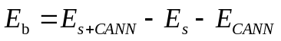
where E_{s+CANN} , E_{s}, and E_{CANN} are the energy of the LiPS- CANN, LiPS, and CANN, respectively. The initial conformation of all molecules was obtained by molecular mechanics (MM) method (Forcite module). The DFT calculations were conducted in the Dmol3 module of Accelrys Material Studio.

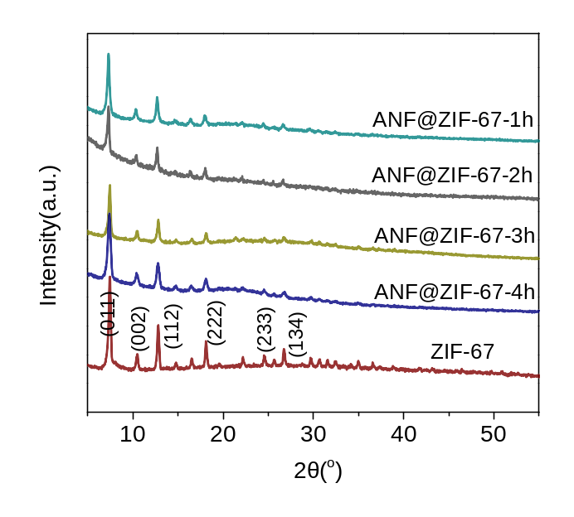
Figure S1. XRD patterns comparison of original ZIF-67 NPs and ANF @ZIF-67 composite with different reaction times.

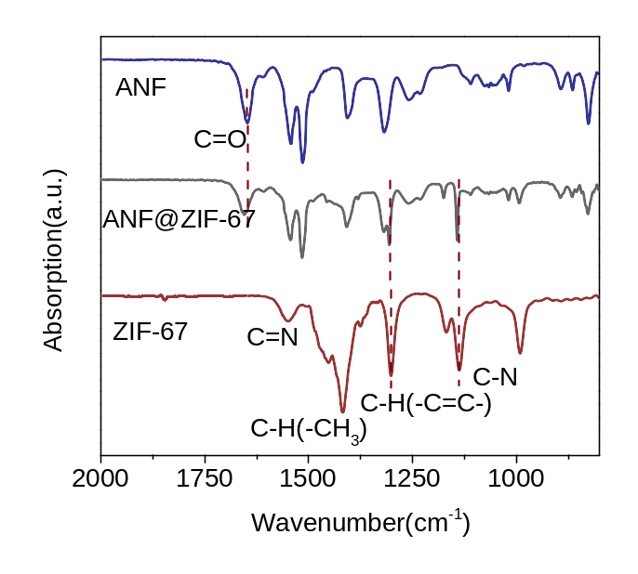

Figure S2. FTIR spectra comparison of ANF, ANF@ZIF-67, and ZIF-67 NPs.

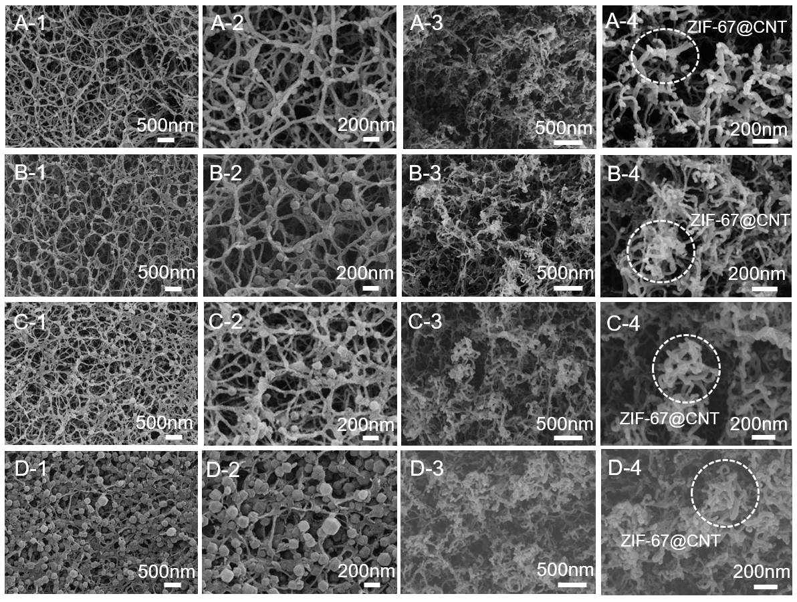
Figure S3. SEM images of ZIF-67 decorated ANF aerogel membranes with different immersing time in which ANF@ZIF-1,2,3,4 corresponding to 1, 2, 3, and 4 h incubation time: (A-1, A-2) ANF@ ZIF-67 -1 h; (B-1, B-2) ANF@ ZIF-67 -2 h; (C-1, C-2) ANF@ ZIF-67 -3 h and (D-1, D-2) ANF@ZIF-67 -4 h. SEM images of N-doped carbon aerogel @ Co-embedded hierarchical carbon hybrids @ CNT (denoted as CANN ): (A-3, A-4) CANN -1 h; (B-3, B-4) CANN -2 h; (C-3, C-4) CANN -3 h and (D-3, D-4) CANN -4 h.

Comment: Obviously, the surface density of ZIF-67 NPs (Figure S3C) affects the morphology of the CANN. For example, the carbonized network composite CANN-4 obtained from ANF@ZIF-4 is less uniform than CANN-3 obtained from ANF@ZIF-3 (Figure S3D) due to higher density of NPs.

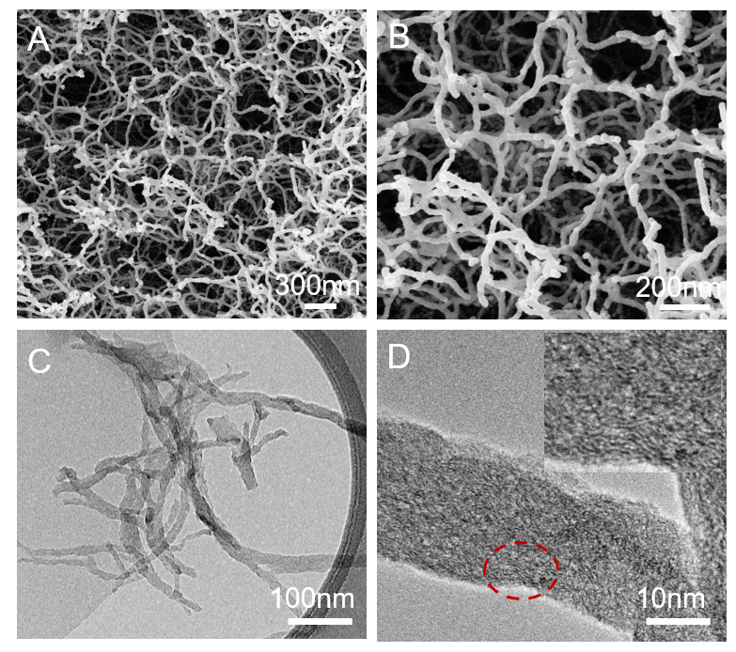
Figure S4. SEM images (A-B) and TEM images (C-D) of ANF after calcined in N₂ atmosphere under 700 ℃. Obviously, carbonization of ANF without NPs results in carbon nanofibers network with smooth surface.

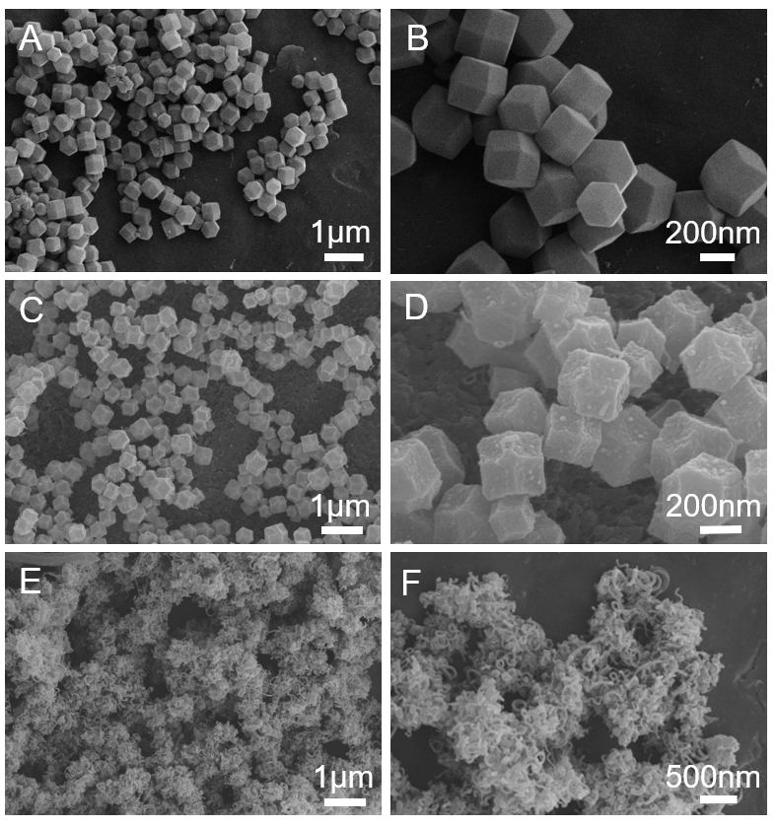
Figure S5. SEM image of (A-B) pristine ZIF-67 NPs, (C-D) ZIF-67 NPs after the carbonization process without melamine. In the absence of melamine, N-CNTs disappeared after annealing. (E-F) ZIF-67 NPs after the carbonization process with melamine.

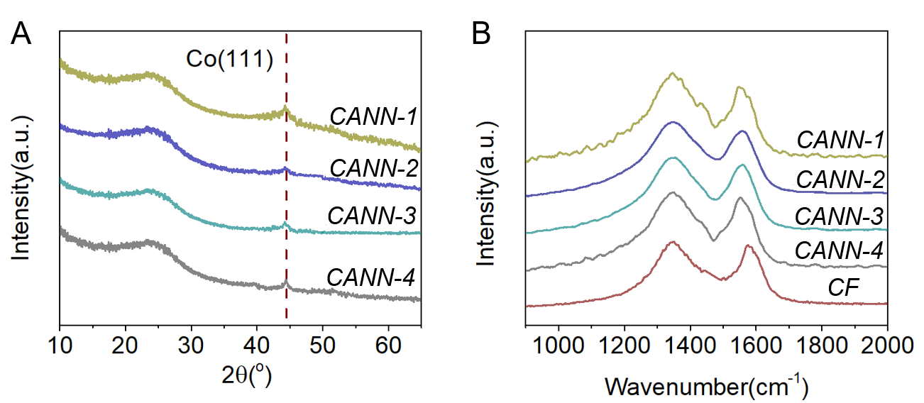
Figure S6. (A) XRD patterns and (B) Raman spectra of a series of CANN with different precursors.

Comment: There are two peaks in the XRD pattern of CANN (Figure S6A), the broad peak at about 26º is originated from the (002) plane of graphitized carbon, while the diffraction peak at 44.2° is the (111) plane of metallic Co. Moreover, Raman spectra show two characteristic bands at around 1350 and 1588 cm⁻¹, which belong to the disoriented carbon (D band) and graphitic carbon (G band), respectively (Figure S6B). The high band intensity ratio (ID/IG) indicates that large amount of defects existed in CANN, which is consistent with the TEM observation results.

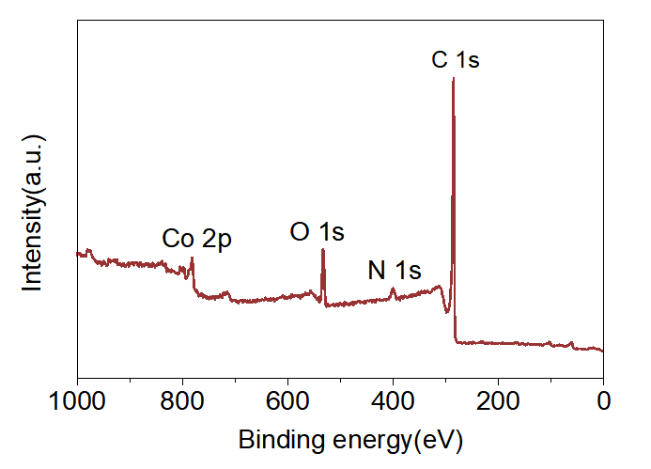
Figure S7. XPS survey spectrum of CANN.

Comment: The C 1s spectrum of CANN hierarchical composites demonstrates the difference in the two peaks at binding energies of 284.7 and 285.7 eV. The peak at 284.7 corresponds to graphitic C–C and C=C, which may be formed during the CVD treatment of ANF@ZIF-67. The peak centered at 285.7 eV can be indexed to the signals of C–N groups, confirming that N atoms have been successfully doped into the graphitic domain.

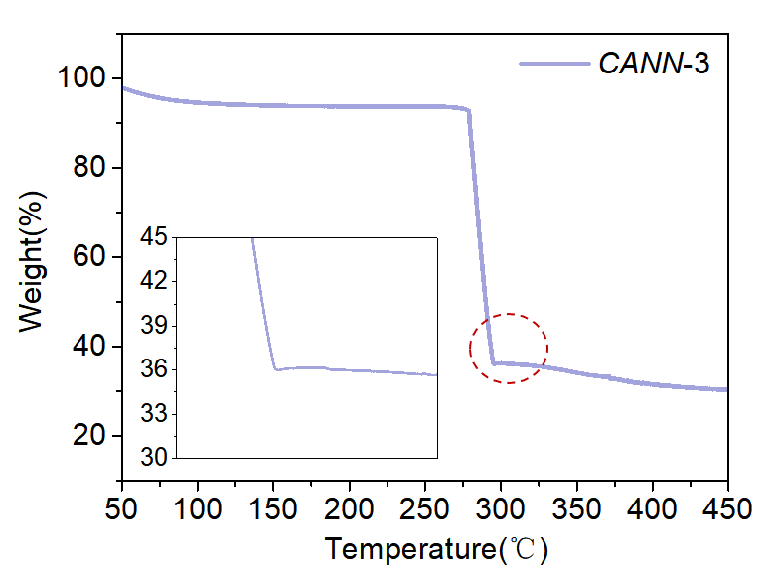
Figure S8. TGA analysis of CANN obtained with a temperature ramp to 500 °C at 10 °C min⁻¹ at air atmosphere.

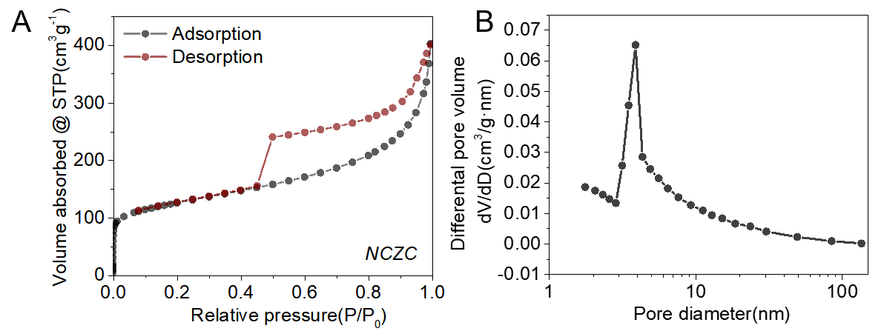
Figure S9. (A) Nitrogen adsorption/desorption isotherms and (B) pore-size distribution plots of CANN.

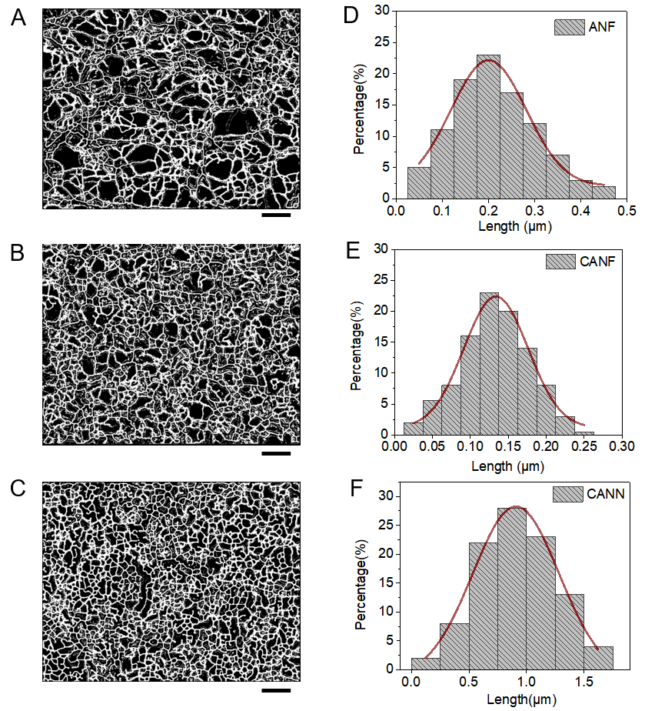

Figure S10. (A-C) SEM images of the ANF, CANF, and CANN, respectively, and (D-F) Corresponding statistical analysis of the length distribution. Scale bars: 500 nm

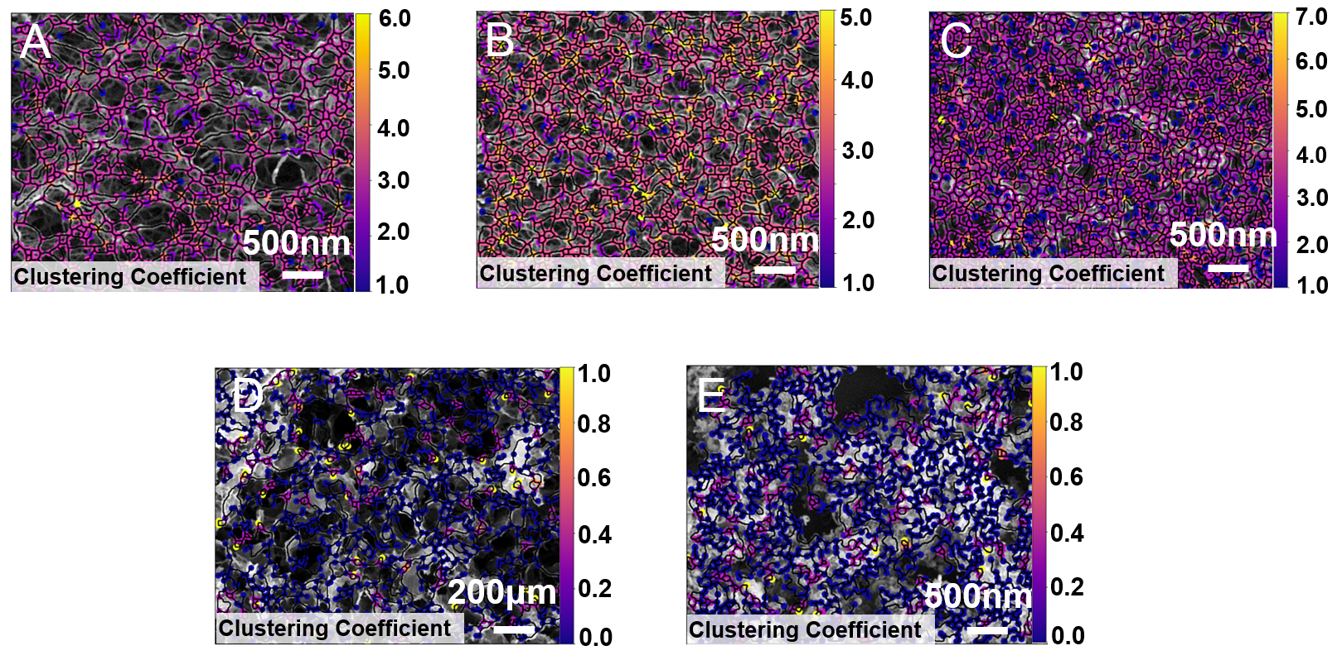
Figure S11. (A) Clustering coefficient, C, maps for (A) ANF; (B) CANF; (C) CANN; (D) rGO; and (E) CF.

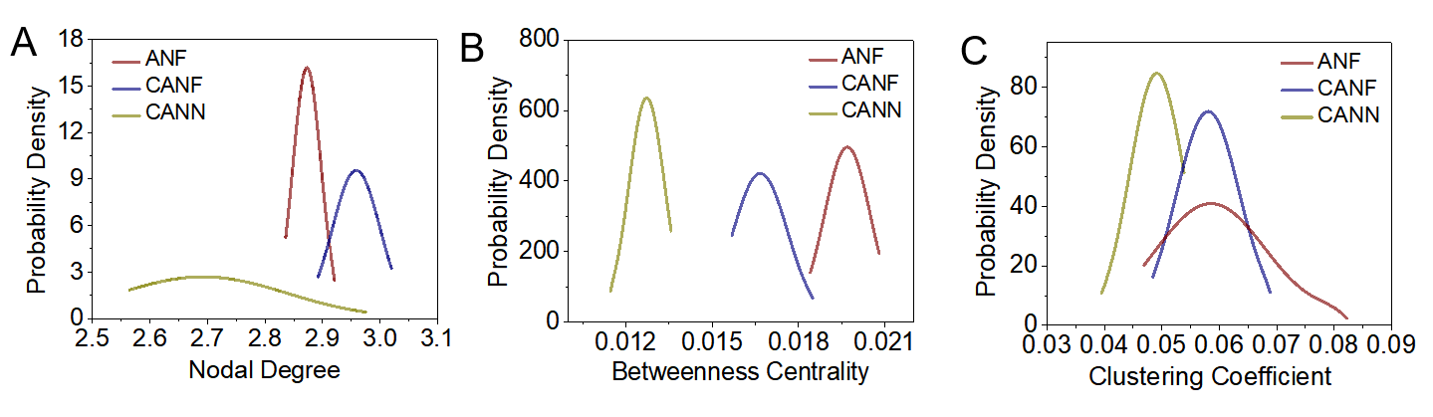
Figure S12. (A-C) Statistical distributions of nodal degree, betweenness centrality, and clustering coefficient for ANF, CANF, and CANN.

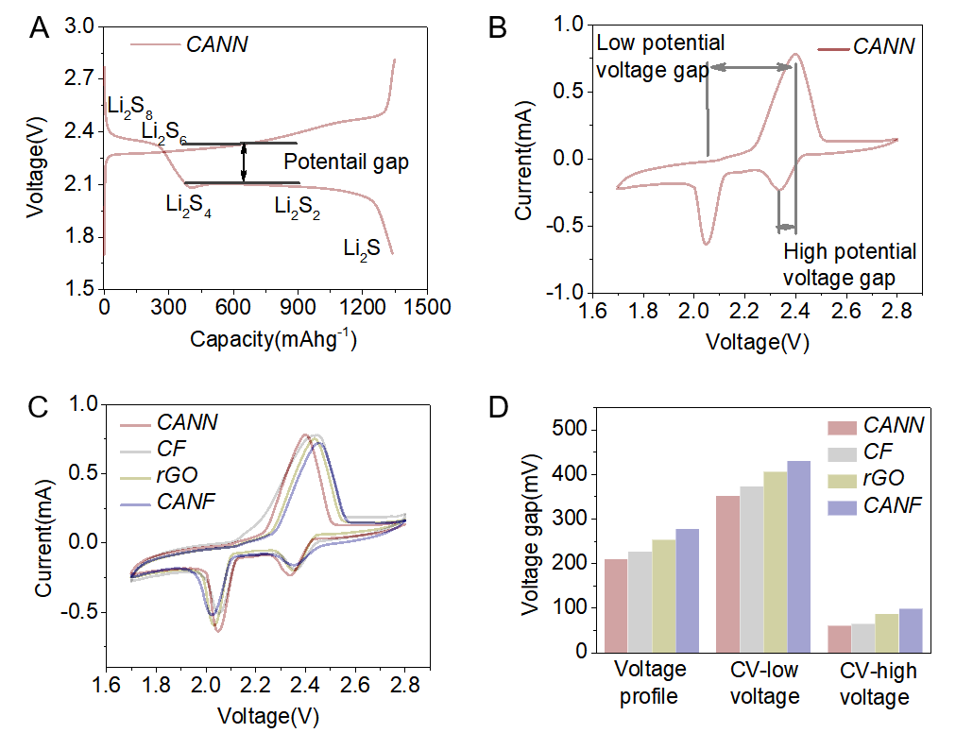
Figure S13. (A) The potential gap in voltage profile is defined as the potential difference between charge and discharge curves. (B-C) CV curves for various electrodes of CANN, CF, and rGO.
(D) The voltage gap for various RNCs as sulfur hosts.
High voltage gap reaction: 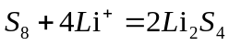
Low voltage gap reaction: 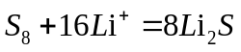
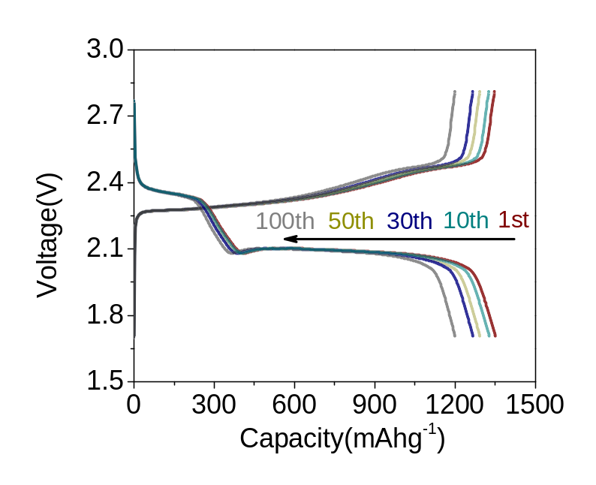
Figure S14. The charge/discharge curves of CANN-based Li-S batteries from the 1st to 100th cycles.

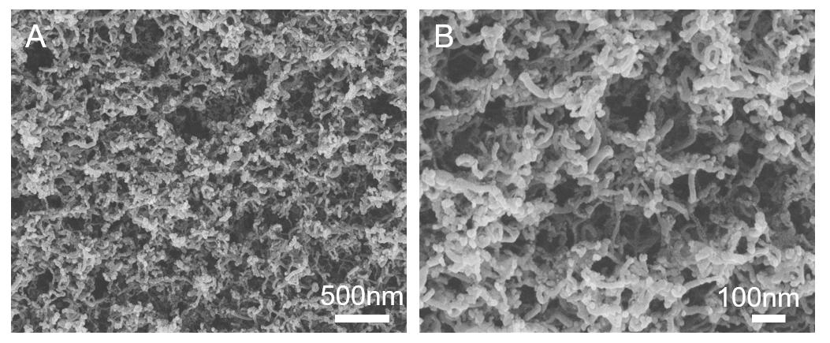
Figure S15. (A-B) SEM images of the cycled CANN@S cathode after washing with THF and CS₂ to remove the sulfur species (after 100 cycles at 0.2C).

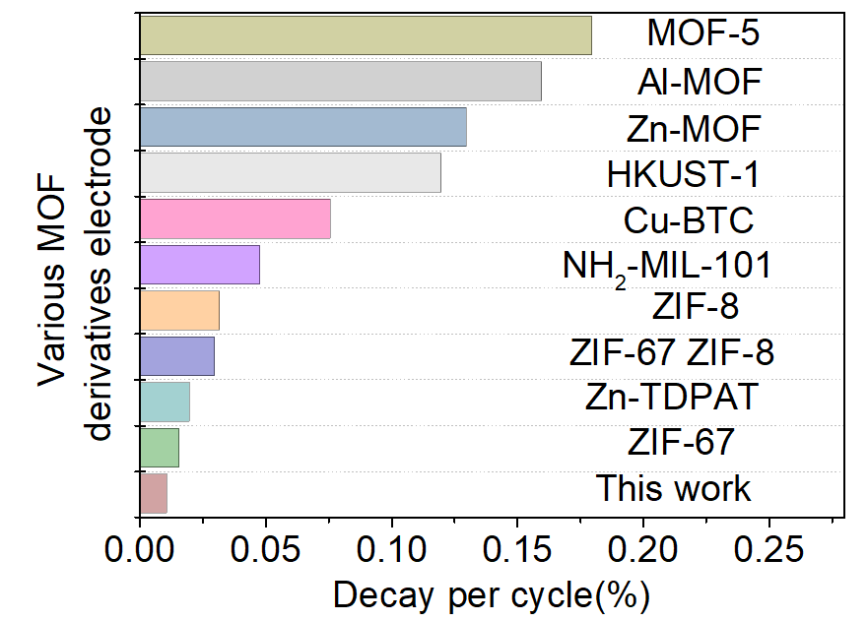
Figure S16. Comparison of capacity decay per cycle with carbon-based electrodes originated from various NPs (see details in Table S2).

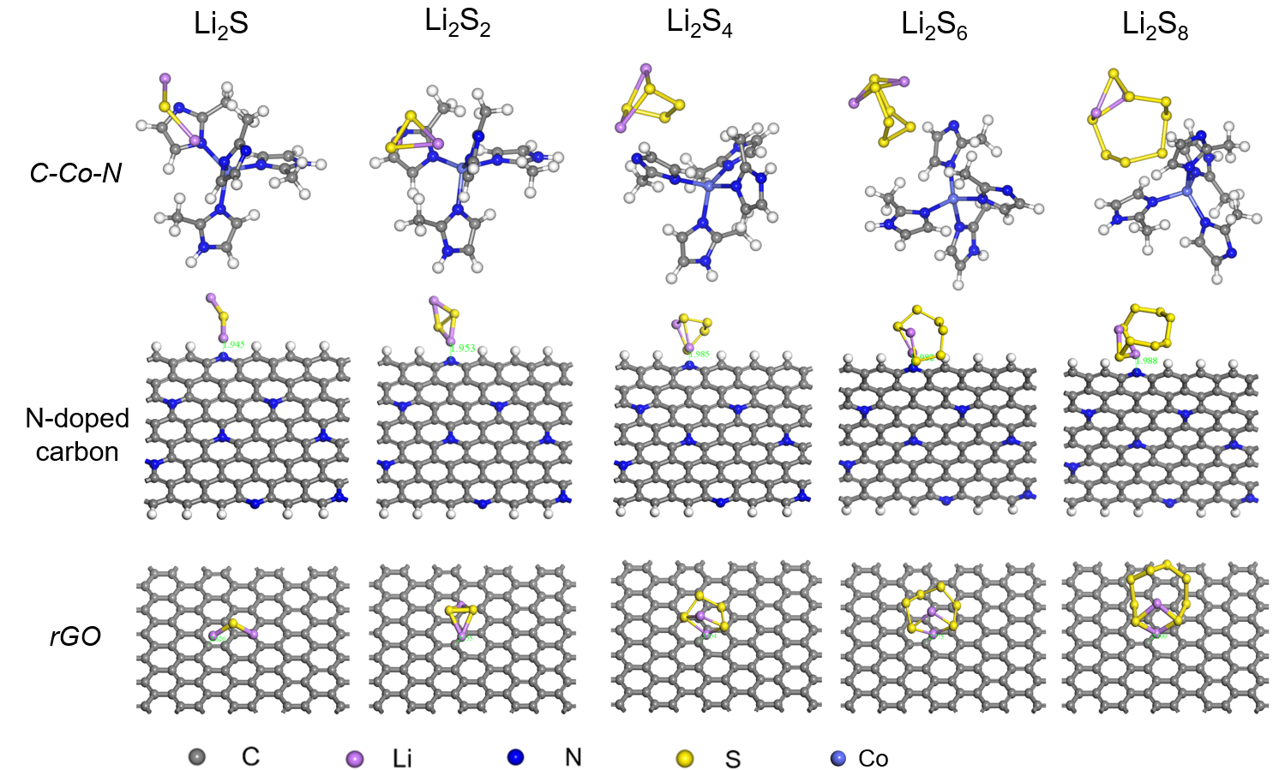
Figure S17. Optimized configurations for the binding of Li₂S_{X} (1≤ x ≤ 8) to C-Co-N and pyridinic atoms of nitrogen in CANN and rGO.

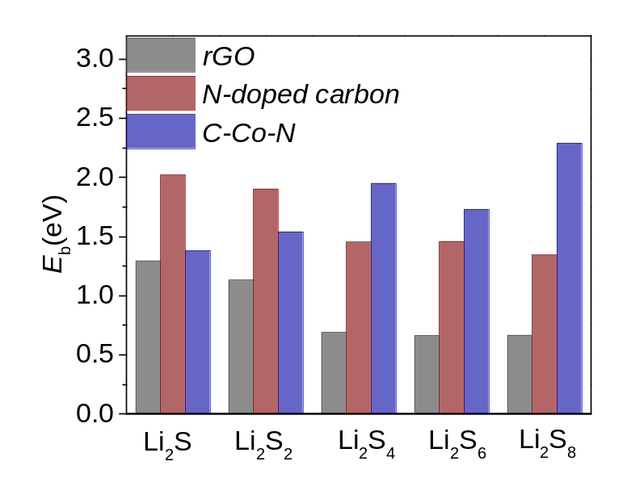

Figure S18. Binding energies (E_{b}) for the Li₂S_{X} (1≤ x ≤ 8) on rGO and CANN composed of C-Co-N, N-doped carbon, as given by first-principles calculations designed to study the interaction.

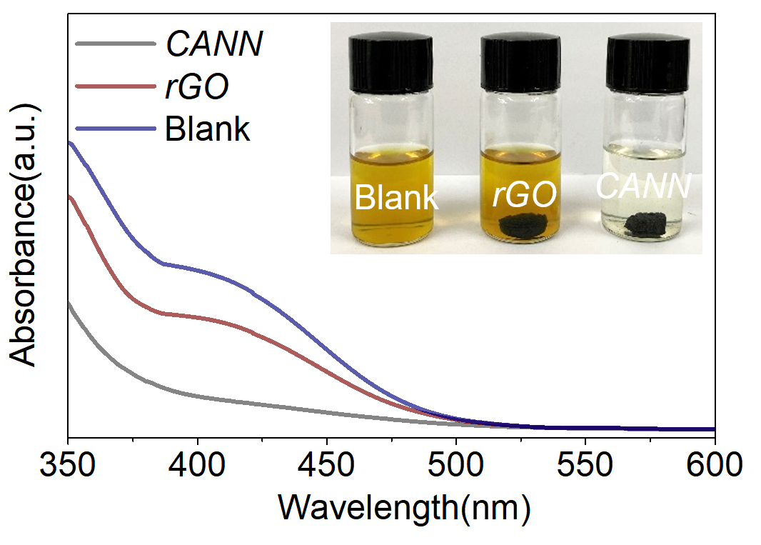
Figure S19. Ultraviolet/visible absorption spectra of a Li₂S₄ solution before and after the addition of rGO and CANN. The inset photograph is an optical photograph of the Li₂S₄ trapping by rGO and CANN after 24 hours.

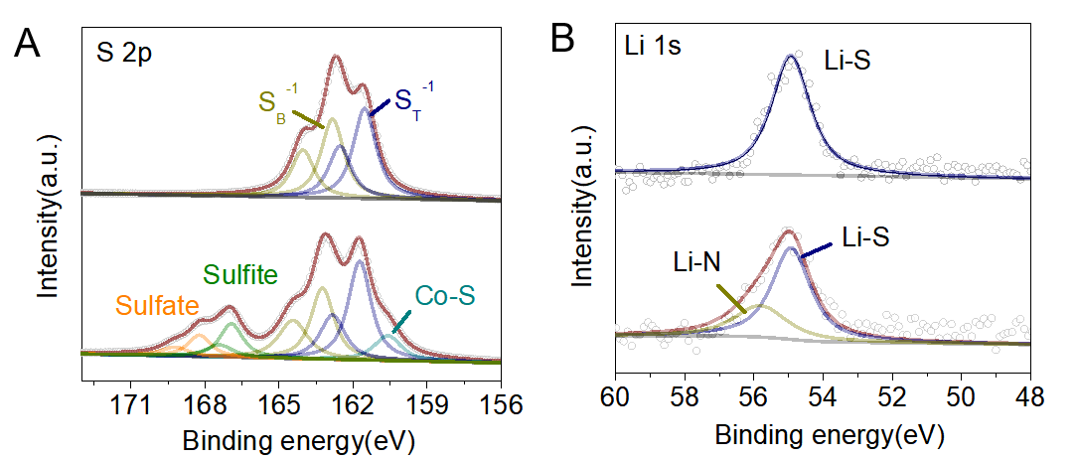
Figure S20. (A-B) High-resolution XPS S_{2p} and Li_{1s} spectra before and after adsorption of Li₂S₄.

Comment: Two pairs of typical binding energies located at 161.5 and 162.8 eV are observed in the S_{2p} spectrum of Li₂S₄, which are attribute to the terminal (S_{T}⁻¹) and bridging sulfur (S_{B}⁰), respectively⁵. After being contacted by CANN, a slight shift of these peaks towards a higher binding energy range is perceived, which illustrates the reduction of the electron cloud density in the sulfur atoms due to the formation of the chemical interaction between Li₂S₄ and CANN ^{6,7}. Two new pairs of peaks emerges in the high binding energy range, which corresponds to sulfite and sulfate, representing the interaction between polysulfide and oxidic species in CANN ⁸. Another new peak emerges at 160.5 eV, which originated from Co-S bonding, suggesting the interaction between polysulfide and the Co sites. The Li_{1s} spectra shows a broadened peak after absorbed by CANN and exhibits a new sub-peak appearing at 55.7 eV originated from the formation of Li-N bonding⁹, which is consistent with the above XPS analysis. These variations in XPS spectra collectively demonstrate the strong chemical adsorption ability of CANN to LiPs.

Table S1. Binding energy of Li-S species to C-Co-N, N-doped carbon from CANN and rGO.
 | Li₂S₈ | Li₂S₆ | Li₂S₄ | Li₂S₂ | Li₂S
C-Co-N | 2.29eV | 1.73 eV | 1.95 eV | 1.54eV | 1.38eV
Pyridinic N | 1.34 eV | 1.46 eV | 1.45 eV | 1.93eV | 2.02eV
rGO | 0.67 eV | 0.66 eV | 0.69 eV | 1.13eV | 1.29eV

Table S2. The comparison of rate capability and long-term cyclability of CANN sulfur host with representative sulfur electrode based on MOF-derived carbon hosts.

Sample | MOF | Rate Capability |  | Long-term Cyclability |  |  | REF
Sample | MOF | Highest Rate | Capacity (mAhg⁻¹) | Rate (1C = 1675 mA g⁻¹) | Capacity fade (% per cycle) | Number of cycles | REF
This work | ZIF-67 | 10C | 602 | 1C | 0.011% | 2500
N-Co₃O₄@N-C/rGO | ZIF-67 | 3C | 652 | 2C | 0.034% | 1000 | ¹⁰
Co-NGC | ZIF-67 | 5C | 565 | 1C | 0.09% | 500 | ¹¹
Li₂S@C-Co-N | ZIF-67 | 4C | 604.1 | 0.2C | 0.06% | 300 | ¹²
NPC/G | ZIF-67 | 1C | 786 | 1C | 0.043% | 300 | ¹³
CPZC | ZIF-67 | 10C | 622.6 | 1C | 0.016% | 2000 | ¹⁴
GC | ZIF-67 | 2C | 287 | 0.5C | 0.055% | 500 | ¹⁵
RGO/C-Co-S | ZIF-67 | 2Ag⁻¹ | 606 | 0.2 | -- | 300 | ¹⁶
HPTCF | ZIF-67 | 5C | 483.8 | 1C | 0.018% | 600 | ¹⁷
CNT-GC@NC | ZIF-67 ZIF-8 | 2C | 280 | 1C | 0.032% | 800 | ¹⁸
ZIF-8-NS-C | ZIF-8 | 2C | 785 | 0.5C | 0.12% | 300 | ¹⁹
BHPC-950 | ZIF-8 | 2C | 967 | 0.5C | 0.054% | 1000 | ²⁰
NDC | ZIF-8 | - | - | 0.2C | 0.17% | 100 | ²¹
P@rGO/ZIF-8(C) | ZIF-8 | 2C | 688 | 1C | 0.03% | 500 | ²²
CNTs@ZIF-8 | ZIF-8 | 1C | 550 | 1C | 0.05% | 300 | ²³
N-ZDC | ZIF-8 | 2C | 758 | 2C | 0.048% | 800 | ²⁴
HPCN | MOF-5 | - | - | 0.5C | - | 50 | ²⁵
GO@Meso-C | MOF-5 | 2C | 550 | 0.2C | 0.27% | 100 | ²⁶
AMCP-950/S | MOF-5 | 2C | 441 | 0.2C | 0.37% | 50 | ²⁷
Ti₃C₂T_{x}@Meso-C/S | MOF-5 | 4C | 544.3 | 0.5C | 0.18% | 300 | ²⁸
ISCF | HKUST-1 | 10C | 650 | 1C | 0.0054% | 500 | ²⁹
C@Cu_{1.96}S | HKUST-1 | 2C | 134 | 0.1C | 0.12% | 50 | ³⁰
CN-5@NSHPC | NH₂-MIL-101(Al) | 5C | 387 | 1C | 0.048% | 500 | ³¹
CHPCF | Cu-BTC | 15C | 535 | 5C | 0.076% | 500 | ³²
FMNCN | Zn-TDPAT | 5C | 759 | 2C | 0.02% | 1000 | ³³
FLHPC | Al-MOF | 2C | 763 | 0.5C | 0.16% | 200 | ³⁴
MPCN | Zn-MOF | 2C | 850 | 0.5C | 0.13% | 200 | ³⁵

BHPC: bicontinuous hierarchical porous carbon; CPZC: tube on cubecarbonaceous hybrid; HPTCF: hollow carbon polyhedra embedded on tubular carbon fabric; NDC: nitrogen-doped carbon; N-ZDC: N-doped ZIF-8-derived carbon nanosphere; HPCN: hollow porous carbon nanoplates; AMCP: activated mesoporous carbon polyhedron; ISCF: self-standing conductive framework; NSHPC: N- and S- co-doped hollow porous carbon shell; CHPCF: cross-linking hierarchical porous carbon fibers; FMNCN: flowerlike microporous nitrogen-doped carbon nanosheets; FLHPC: “French fries-like” hierarchical porous carbon (verbatim use of the notation); MPCN: micro/meso porous carbon nanorod; rGO: reduced graphene oxide; GO: graphene oxide; CNT: carbon nanotube; NS: nanosheets; MWCNT: multi-walled carbon nanotubes; Meso: mesoporous; GC: graphitic carbon; PC: porous carbon.

Table S3. Electrochemical performance of various carbon-based RNC cathodes in Li-S batteries.

Sample  (Cathode) | Mass loading of Sulfur (mg cm⁻²) | Rate (1C= 1675 mAg⁻¹) | Discharge capacity (mAhg⁻¹); Cycle number; Decay per cycle | REF
This work | 3.84 | 1C | 1048 (2500 cycles, 0.011% per cycle) | --
Carbon nanofibers | 2.0-3.0 | 1C | 745 (1500 cycles, 0.043% per cycle) | ³⁶
Carbon fiber | 6.5 | 150 mA g⁻¹ | 1057 (80 cycles, 0.30% per cycle) | ³⁷
Microporous carbon nanofibers–CNT composite | 0.8 | 50 mA g⁻¹ | 900 (100 cycles, 0.29% per cycle) | ³⁸
GO | 2.0 | 1C | 727 (500 cycles, 0.008% per cycle) | ³⁹
Graphene | 2.0 | 2C | 966 (500 cycles, 0.099% per cycle) | ⁴⁰
Graphene aerogel | 2.0 | 0.5C | 657 (300 cycles, 0.129% per cycle) | ⁴¹
Graphene foam | 10.1 | 1.5Ag ⁻¹ | 1000 (1000 cycles, 0.071% per cycle) | ⁴²
Crumpled N-doped graphene | 5.0 | 0.155C | 1000 (100 cycles, 0.12% per cycle) | ⁴³
N-graphene  g-C₃N₄ composite | 5.2 | 0.192 C | 990 (80 cycles, 0.75% per cycle) | ⁴⁴
3D graphene foam/rGO | 9.8 | 0.2C | 1000 (350 cycles, 0.1% per cycle) | ⁴⁵
Graphene encapsulated in hollow mesoporous carbon nanosheet | 5.0 | 1.0C | 899.9 (500 cycles, 0.04% per cycle) | ⁴⁶
N/S-co-doped graphene sponge | 4.6 | 2C | 430 (500 cycles, 0.078% per cycle) | ⁴⁷
rGO wrapped N,P-codoped mesoporous carbon | 4.1 | 0.5C | 1024 (100 cycles, 0.046% per cycle) | ⁴⁸
PEDOT/PSS-graphene composite | 3.0 | 1C | 1008 (500 cycles, 0.04% per cycle) | ⁴⁹
CNT | 2.0-3.0 | 6A g⁻¹ | 712 (100 cycles) | ⁵⁰
Mesoporous CNT | 1.875 | 0.1C | 1109 (100 cycles, 0.314% per cycle) | ⁵¹
N‑doped porous carbon-CNT | 1.5 | 1C | 986 (600 cycles, 0.105% per cycle) | ⁵²
3D CNT foam | 19.1 | 0.1C | 1010 (1000 cycles, 0.53% per cycle) | ⁵³
Porous carbon | 2.36 | 2C | 1115 (1000 cycles, 0.039% per cycle) | ⁵⁴
Microporous carbon | 1.0 | 0.5C | 378 (200 cycles, 0.1% per cycle) | ⁵⁵
Popcorn inspired porous macrocellular carbon | 4.0 | 0.2C | 1257.2 (500 cycles, 0.087% per cycle) | ⁵⁶
N/O co-doped carbon | 2.37 | 800 mAg⁻¹ | 690 (180 cycles, 0.046% per cycle) | ⁵⁷
N/P co-doped porous carbon | 1.0–1.8 | 1C | 810 (200 cycles, 0.145% per cycle) | ⁵⁸
N-doped carbon composites | 5.0 | 0.1C | 1480 (200 cycles, 0.05% per cycle) | ⁵⁹
N-doped hollow carbon spheres | 3.9 | 0.2C | 1360 (100 cycles, 0.30% per cycle) | ⁶⁰
N-doped hollow porous carbon bowls | 1.1–1.5 | 1C | 894 (400 cycles, 0.053% per cycle) | ⁶¹
Carbon polyhedrons | 6.4 | 0.2C | 890 (300 cycles, 0.07% per cycle) | ⁶²
Polyaniline | 2.0 | 0.2C | 1100 (200 cycles, 0.15% per cycle) | ⁶³

Table S4. Comparison of the areal capacity of CANN with that of recent publications in Li-S batteries that have high sulfur loadings more than 5 mg cm⁻².
 | Sample | Mass loading (mg cm⁻²) | Rate (mA cm⁻²)  (1C= 1675 mAg⁻¹) | Areal capacity (mAh cm⁻²) | REF
Number | This work | 15.4 | 0.2C | 17.0 (Initial)  10.1(200 cycles) | --
Number | This work | 19.2 | 0.2C | 19.5 (Initial)  15.5(50 cycles) | --
1 | Graphene foam | 10.1 | 3.6 | 9.3(Initial) | ⁴²
2 | N-graphene g-C₃N₄ | 10.2 | 1.0 | 10.8 (Initial)  6.0 (50 cycles) | ⁴⁴
3 | Crumpled N- doped graphene | 5.0 | 1.3 | 5.0 (Initial)  4.2 (100 cycles) | ⁴³
4 | 3D graphene | 12.0 | 0.1C | 6.0 (Initial)  4.2 (300 cycles) | ⁶⁴
5 | 3D graphene foam/rGO | 9.8 | 0.2C | 10.3 (Initial)  6.1 (350) | ⁴⁵
6 | Poly sulfur-graphene | 10.5 | 3.52 | 8.7 (Initial)  6.7 (100 cycles) | ⁶⁵
7 | N/S-co-doped  graphene sponge | 8.5 | 7.1 | 7.9 (Initial)  5.7 (200 cycles) | ⁴⁷
8 | 3D CNT foam | 19.1 | 0.32 | 19.3 (Initial)  9.0 (100 cycles) | ⁵³
9 | Carbon polyhedrons | 6.4 | 0.2C | 5.5 (Initial)  4.1 (300 cycles) | ⁶²
10 | Carbon fiber | 6.5 | 0.1C | 6.87 (Initial)  5.2 (100 cycles) | ³⁷
11 | N-doped carbon composites | 5.0 | 0.84 | 7.2 (Initial)  6.0 (100 cycles) | ⁵⁹
12 | Hollow carbon fiber foam | 16.5 | 0.1C | 16.5 (Initial)  12.0 (50 cycles) | ⁶⁶
13 | Thick carbon layer | 13.9 | 2.33 | 19.2 (Initial)  10.3 (300 cycles) | ⁶⁷
14 | TiS₂−Polysulfide | 12 | 2.01 | 11.5 (Initial)  9.0 (50 cycles) | ⁶⁸
15 | VS₂-graphene | 5.0 | 1.68 | 5.1 (Initial)  4.0 (50 cycles) | ⁶⁹
16 | Vanadium Nitride | 5.4 | 4.52 | 5.43 (Initial)  4.3 (200 cycles) | ⁷⁰
17 | Co@N-C composite | 7.5 | 0.63 | 7.75(Initial) | ⁷¹
18 | CNT/nanofibrillated cellulose | 8.1 | 3.4 | 7.69 (Initial)  6.8 (50 cycles) | ⁷²
19 | Co₉S₈-3D graphene foam | 10.4 | 0.1C | 10.9 (Initial)  7.5 (200 cycles) | ⁷³
20 | MgO-Decorated Carbon Foam@CNTs | 14.4 | 0.1C | 10.4 (Initial)  8.8 (60 cycles) | ⁷⁴
21 | Graphene in hollow carbon nanosheet | 10.0 | 0.1 C | 13.9 (Initial)  11.4 (50 cycles) | ⁴⁶
22 | Porous carbon nanofibers | 12.1 | 0.2C | 11.3 (Initial) | ⁷⁵
23 | Carbon-cotton | 61.4 | 0.1C | 56.5 (Initial) | ⁷⁶
Supplementary References
1. Zhu, J. et al. Branched aramid nanofibers. Angew. Chemie Int. Ed. 56, 11744–11748 (2017).
2. Du, M. et al. Stereoselectively assembled metal-organic framework (MOF) host for catalytic synthesis of carbon hybrids for alkaline-metal-ion batteries. Angew. Chem. Int. Ed. 58, 5307–5311 (2019).
3. Sun, J. et al. Towards a reliable Li-metal-free LiNO3-free Li-ion polysulphide full cell: Via parallel interface engineering. Energy Environ. Sci. 11, 2509–2520 (2018).
4. Vecchio, D. A., Mahler, S. H., Hammig, M. D. & Kotov, N. A. Structural analysis of nanoscale network materials using graph theory. ACS Nano 15, 12847–12859 (2021).
5. Tu, S. et al. A polysulfide-immobilizing polymer retards the shuttling of polysulfide intermediates in lithium-sulfur batteries. Adv. Mater. 1804581 (2018).
6. Hou, T. et al. Lithium bond chemistry in lithium-sulfur batteries. Angew.Chem.Int. Ed. 56, 8178–8182 (2017).
7. Pang, Q., Kundu, D., Cuisinier, M. & Nazar, L. F. Surface-enhanced redox chemistry of polysulphides on a metallic and polar host for lithium-sulphur batteries. Nat. Commun. 5, 1–8 (2014).
8. Liang, X. et al. A highly efficient polysulfide mediator for lithium–sulfur batteries. Nat. Commun. 6, 5682 (2015).
9. Seh, Z. W., Wang, H., Hsu, P., Zhang, Q. & Li, W. Facile synthesis of Li2S-polypyrrole composite structures for high-performance Li2S cathodes. Energy Environ. Sci 7, 672–676 (2014).
10. Xu, J. et al. MOF-derived porous N–Co3O4@N–C nanododecahedra wrapped with reduced graphene oxide as a high capacity cathode for lithium-sulfur. J. Mater. Chmesitry A 6, 2797–2807 (2018).
11. Li, Y.-J., Fan, J.-M., Zheng, M. & Dong, Q. A novel synergistic composite with multi-functional effects for high-performance Li–S batteries. Energy Environ. Sci. 9, 1998 (2016).
12. He, J. et al. From metal-organic framework to Li2S@C-capacity cathode for lithium-sulfur batteries. ACS Nano 10, 10981–10987 (2016).
13. Chen, K. et al. Metal-organic frameworks (MOFs)-derived nitrogen-doped porous carbon anchored on graphene with multifunctional effects for lithium-sulfurbatteries. Adv. Funct. Mater. 28, 1707592 (2018).
14. Li, G. et al. Stringed ‘“tube on cube”’ nanohybrids as compact cathode matrix for high-loading and lean-electrolyte lithium–sulfur batteries. Energy Environ. Sci. 11, 2372–2381 (2018).
15. Xiao, D., Li, Q., Zhang, H., Ma, Y. & Lu, C. A sulfur host based on cobalt-graphitic carbon nanocages for high performance lithium-sulfur batteries. J. Mater. Chem. A 5, 24901–24908 (2017).
16. Li, Z. et al. Reduced graphene oxide wrapped MOFs-derived cobalt-doped porous carbon polyhedrons as sulfur immobilizers as cathodes for high performance lithium sulfur batteries. Nano Energy 23, 15–26 (2016).
17. Cai, W. et al. The dual-play of 3D conductive scaffold embedded with Co , N codoped hollow polyhedra toward high-performance Li-S full cell. Adv. Energy Mater. 8, 1802561 (2018).
18. Yu, H. et al. Core-shell polyhedrons of carbon nanotubes-grafted graphitic carbon@nitrogen doped carbon as efficient sulfur immobilizers for lithium-sulfur batteries. Appl. Surf. Sci. 450, 364–371 (2018).
19. Jiang, Y. et al. Monoclinic ZIF‑8 nanosheet-derived 2D carbon nanosheets as sulfur immobilizer for high-performance lithium sulfur batteries. ACS Appl. Mater. Interface 9, 25239–25249 (2017).
20. Yang, M. et al. Bifunctional MOF-derived carbon photonic crystal architectures for advanced Zn-Air and Li-S batteries : highly exposed graphitic nitrogen matters. Adv. Funct. Mater. 27, 1701971 (2017).
21. Li, Z. & Yin, L. Nitrogen-doped MOF-derived micropores carbon as immobilizer for small sulfur molecules as a cathode for lithium sulfur batteries with excellent electrochemical performance. ACS Appl. Mater. Interface 7, 4029–4038 (2015).
22. Tan, Y., Jia, Z., Lou, P., Cui, Z. & Guo, X. Self-assembly sandwiches of reduced graphene oxide layers with zeolitic-imidazolate-frameworks-derived mesoporous carbons as polysul fi des reservoirs for lithium-sulfur batteries. J. Power Sources 341, 68–74 (2017).
23. Zhang, H. et al. Dense monolithic MOF and carbon nanotube hybrid with enhanced volumetric and areal capacities for lithium – sulfur battery †. J. Mater. Chem. A 7, 9195–9201 (2019).
24. Chang, Z. et al. Hierarchically porous multilayered carbon barriers for high-performance Li-S batteries. Chem. A Eur. J. 24, 3768–3775 (2018).
25. Guiyin Xu, Bing Ding, Laifa Shen, Ping Nie, J. H. and X. Z. Sulfur embedded in metal organic framework-derived hierarchically porous carbon nanoplates for high. J. Mater. Chemsitry A 1, 4490–4496 (2013).
26. Bao, W. et al. Facile synthesis of graphene oxide@mesoporous carbon hybrid nanocomposites for lithium sulfur battery. Electrochim. Acta 127, 342–348 (2014).
27. Cai, S. et al. Preparation and performance of metal-organic-frameworks-derived activated mesoporous carbon polyhedron with sponge-like structure for lithium-sulfur batteries. J. Electrochem. Soc. 163, A2922–A2929 (2016).
28. Bao, W., Su, D., Zhang, W., Guo, X. & Wang, G. 3D Metal carbide@mesoporous carbon hybrid architecture as a new polysulfide reservoir for lithium-sulfur batteries. Adv. Funct. Mater. 26, 8746–8756 (2016).
29. Liu, Y., Li, G., Fu, J., Chen, Z. & Peng, X. Strings of porous carbon polyhedrons as self-standing cathode host for high-energy-density lithium-sulfur batteries. Angew.Chem.Int.Ed. 56, 6176–6180 (2017).
30. Zhang, Z. et al. Carbon coated copper sulfides nanosheets synthesized via directly sulfurizing Metal-Organic Frameworks for lithium batteries. Mater. Lett. 181, 340–344 (2016).
31. Zhang, H. et al. Nanopore-confined g-C3N4 nanodots in N, S co-doped hollow porous carbon with boosted capacity for lithium-sulfur batteries. J. Mater. Chem. A 7133–7141 (2018). doi:10.1039/c8ta00529j
32. Yang, X. et al. 1-D oriented cross-linking hierarchical porous carbon fibers as a sulfur immobilizer for high performance lithium–sulfur batteries. J. Mater. Chem. A 4, 5965–5972 (2016).
33. Hong, X. et al. Efficient encapsulation of small S2‑4 molecules in MOF-derived flowerlike nitrogen-doped microporous carbon nanosheets for high-performance Li-S batteries. ACS Appl. Mater. Interface 10, 9435–9443 (2018).
34. Yang, X., Yan, N., Zhou, W. & Zhang, H. Sulfur embedded in one-dimensional French fries-like hierarchical porous carbon derived from a metal–organic framework for high performance lithium–sulfur batteries. J. Mater. Chem. A 15314–15323 (2015). doi:10.1039/c5ta03013g
35. Qian, X., Jin, L., Wang, S., Yao, S. & Rao, D. Zn-MOF derived micro/meso porous carbon nanorod for high performance lithium- sulfur. RSC Adv. 6, 94629–94635 (2016).
36. Lu, S., Cheng, Y., Wu, X. & Liu, J. Significantly improved long cycle stability in high-rate Li-S batteries enabled by coaxial graphene wrapping over sulfur-coated carbon nanofibers. Nano Lett. 13, 2485–2489 (2013).
37. Elazari, R., Salitra, G., Garsuch, A., Panchenko, A. & Aurbach, D. Sulfur-impregnated activated carbon fiber cloth as a binder-free cathode for rechargeable Li-S batteries. Adv. Mater. 23, 5641–5644 (2011).
38. Zeng, L. et al. Free-standing porous carbon nanofibers-sulfucomposite for flexible Li-S battery cathode. Nanoscale 6, 9579–9587 (2014).
39. Liu, W. et al. Ultrathin dendrimer-graphene oxide composite film for stable cycling lithium-sulfur batteries. Proc. Natl. Acad. Sci. 114, 3578–3583 (2017).
40. Lithium, P. et al. Sulfur-graphene nanostructured cathodes via ball-milling for high performance lithium-sulfur batteries. ACS Nano 8, 10920–10930 (2014).
41. Zhou, G., Paek, E., Hwang, G. S. & Manthiram, A. High-performance lithium-sulfur batteries with a self- supported, 3D Li2S-doped graphene aerogel cathodes. Adv. Energy Mater. 6, 1501355 (2016).
42. Zhou, G., Li, L., Ma, C. & Wang, S. A graphene foam electrode with high sulfur loading for fl exible and high energy Li-S batteries. Nano Energy 11, 356–365 (2015).
43. Song, J., Yu, Z., Gordin, M. L. & Wang, D. Advanced sulfur cathode enabled by highly crumpled nitrogen-doped graphene sheets for high-energy-density lithium-sulfur batteries. Nano Lett. 16, 864–870 (2016).
44. Pang, Q., Liang, X., Kwok, C. Y., Kulisch, J. & Nazar, L. F. A comprehensive approach toward stable lithium-Sulfur batteries with high volumetric energy density. Adv. Energy Mater. 7, 1601630 (2017).
45. Hu, G. et al. 3D graphene-foam-reduced-graphene-oxide hybrid nested hierarchical networks for high-performance Li-S batteries. Adv. Mater. 28, 1603–1609 (2016).
46. Pei, F. et al. Self-supporting sulfur cathodes enabled by two-dimensional carbon yolk-shell nanosheets for high-energy-density lithium-sulfur batteries. Nat. Commun. 1–10 (2017). doi:10.1038/s41467-017-00575-8
47. Zhou, G., Paek, E., Hwang, G. S. & Manthiram, A. Long-life Li/polysulphide batteries with high sulphur loading enabled by lightweight three-dimensional nitrogen/sulphur-codoped graphene sponge. Nat. Commun. 6, 1–11 (2015).
48. Zhao, Q. et al. High sulfur loading , rGO-linked and polymer binder-free cathodes based on rGO wrapped N, P-codoped mesoporous carbon as sulfur host for Li-S batteries. Chem. Eng. J. 361, 1043–1052 (2019).
49. Xiao, P., Bu, F., Yang, G., Zhang, Y. & Xu, Y. Integration of graphene, nano sulfur, and conducting polymer into compact , flexible lithium-sulfur battery cathodes with ultrahigh volumetric capacity and superior cycling stability for foldable devices. Adv. Mater. 29, 1703324 (2017).
50. Zhou, G. et al. A flexible nanostructured sulphur-carbon nanotube cathode with high rate performance for Li-S batteries. Energy Environ. Sci. 5, 8901–8906 (2012).
51. Sun, L. et al. Sulfur embedded in a mesoporous carbon nanotube network as a binder-free electrode for high-performance lithium-sulfur batteries. ACS Nano 10, 1300–1308 (2016).
52. Cai, J. et al. Templated and catalytic fabrication of N-doped hierarchical porous carbon-carbon nanotube hybrids as host for lithium-sulfur batteries. ACS Appl. Mater. Interfaces 9, 33876–33886 (2017).
53. Li, M., Carter, R., Douglas, A., Oakes, L. & Pint, C. L. Sulfur vapor-infiltrated 3D carbon nanotube foam for binder-free high areal capacity lithium-sulfur battery composite cathodes. ACS Nano 11, 4877–4884 (2017).
54. Li, G. et al. Three-dimensional porous carbon composites containing high sulfur nanoparticle content for high-performance lithium&ndash;sulfur batteries. Nat. Commun. 7, 1–10 (2016).
55. Li, Z. et al. A highly ordered meso@ microporous sulfur core-shell structured cathode for Li-S batteries. ACS Nano 8, 9295–9303 (2014).
56. Zhong, Y. et al. Popcorn inspired porous macrocellular carbon:rapid puffing fabrication from rice and its applications in lithium-sulfur batteries. Adv. Energy Mater. 8, 1701110 (2018).
57. Mi, K. et al. Sole chemical confinement of polysulfides on nonporous nitrogen/oxygen dual-Doped carbon at the kilogram scale for lithium-sulfur batteries. Adv. Funct. Mater. 27, 1604265 (2017).
58. Ai, W. et al. Nitrogen and phosphorus codoped hierarchically porous carbon as an e ffi cient sulfur host for Li-S batteries. Energy Storage Mater. 6, 112–118 (2017).
59. Song, J. et al. Strong lithium polysulfide chemisorption on electroactive sites of nitrogen-doped carbon composites for high-performance lithium-sulfur battery cathodes. Angew. Chem. Int. Ed. 54, 4325–4329 (2015).
60. Zhou, G., Zhao, Y. & Manthiram, A. Dual-confined flexible sulfur cathodes encapsulated in nitrogen-doped double-shelled hollow carbon spheres and wrapped with graphene for Li-S batteries. Adv. Energy Mater. 5, 1402263 (2015).
61. Pei, F. et al. From hollow carbon spheres to N-doped hollow porous carbon bowls:rational design of hollow carbon host for Li-S batteries. Adv. Energy Mater. 6, 1502539 (2016).
62. Liu, Y., Li, G., Fu, J., Chen, Z. & Peng, X. Strings of porous carbon polyhedrons as self-standing cathode host for high-energy-density lithium-sulfur batteries. Angew. Chem. Int. Ed. 56, 6176–6180 (2017).
63. Zhou, W., Yu, Y., Chen, H., Disalvo, F. J. & Abruña, H. D. Yolk-shell structure of polyaniline-coated sulfur for lithium-sulfur batteries. JACS 135, 16736–16743 (2013).
64. Lu, S., Chen, Y., Wu, X., Wang, Z. & Li, Y. Multifunctional hybrid sponges for lithium-sulfur batteries with large areal mass loading. Sci. Rep. 4, 4629 (2014).
65. Chang, C. & Manthiram, A. Covalently grafted polysulfur-graphene nanocomposites for ultrahigh sulfur-loading lithium-polysulfur batteries. ACS Energy Lett. 3, 72–77 (2017).
66. Fang, R., Zhao, S., Hou, P., Cheng, M. & Wang, S. 3D interconnected electrode materials with ultrahigh areal sulfur loading for Li-S batteries. Adv. Mater. 28, 3374–3382 (2016).
67. Qie, L. & Manthiram, A. High-energy-density lithium- sulfur batteries based on blade-cast pure sulfur electrodes. ACS Energy Lett. 1, 46–51 (2016).
68. Chung, S., Luo, L. & Manthiram, A. TiS2-polysulfide hybrid cathode with high sulfur loading and low electrolyte consumption for lithium-sulfur batteries. ACS Energy Lett. 3, 568–573 (2018).
69. Zhu, X. et al. In situ assembly of 2D conductive vanadium disulfide with graphene as a high-sulfur-loading host for lithium-sulfur batteries. Adv. Energy Mater. 8, 1800201 (2018).
70. Yuan, H. et al. Porous-shell vanadium nitride nanobubbles with ultrahigh areal sulfur loading for high-capacity and long-life lithium-sulfur batteries. Nano Lett. 17, 7839–7846 (2017).
71. Li, Y. et al. A honeycomb-like Co@N-C composite for ultrahigh sulfur loading Li-S batteries. ACS Nano 11, 11417–11424 (2017).
72. Yu, M. et al. Freestanding and sandwich-structured electrode material with high areal mass loading for long-life lithium-sulfur batteries. Adv. Energy Mater. 7, 1602347 (2017).
73. He, J., Chen, Y. & Manthiram, A. MOF-derived cobalt sulfide grown on 3D graphene foam as an efficient sulfur host for long-life lithium-sulfur batteries. IScience 4, 36–43 (2018).
74. Xiang, M. et al. A flexible 3D multifunctional MgO-decorated carbon foam @CNTs hybrid as self-supported cathode for high-performance lithium-sulfur batteries. Adv. Funct. Mater. 27, 1702573 (2017).
75. Zhao, X. et al. Root-like porous carbon nano fibers with high sulfur loading enabling superior areal capacity of lithium sulfur batteries. Carbon N. Y. 128, 138–146 (2018).
76. Chung, S., Chang, C. & Manthiram, A. A carbon-cotton cathode with ultrahigh-loading capability for statically and dynamically stable lithium-sulfur batteries. ACS Nano 10, 10462–10470 (2016).

