Appendix A
a) SEM Non-Treated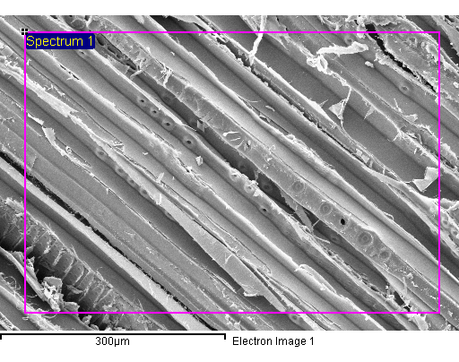 | b) SEM -90 kPa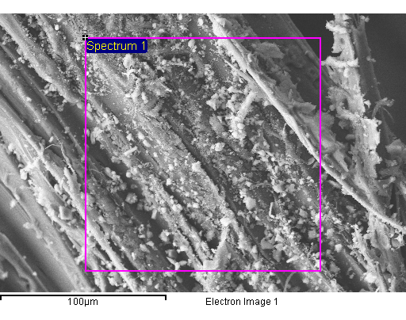
c) EDS Non-Treated
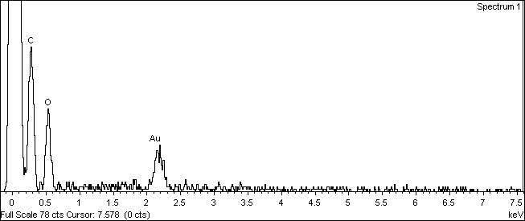

d) EDS -90 kPa
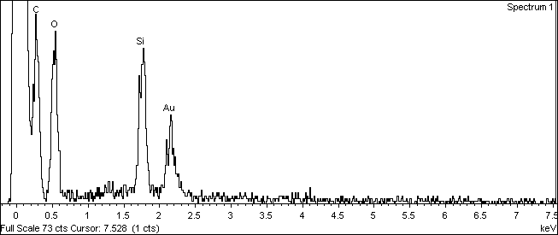

Figure A1: SEM, EDS micrographs of a,c) non-treated and b,d) -90 kPa treated samples dry

a) SEM Non-Treated Sat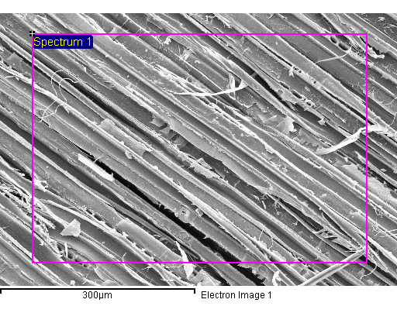 | b) SEM -90 kPa Sat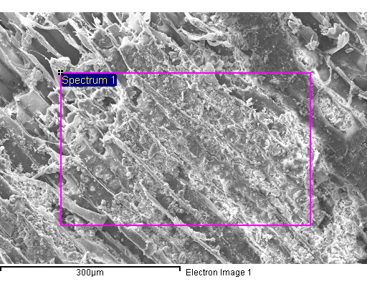
c) EDS Non-Treated Sat
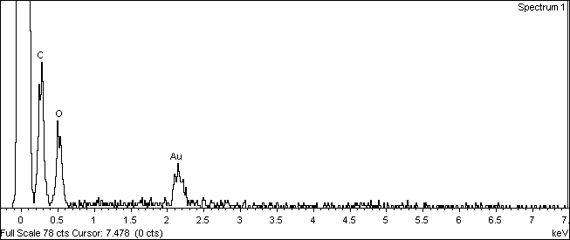

d) EDS -90 kPa Sat
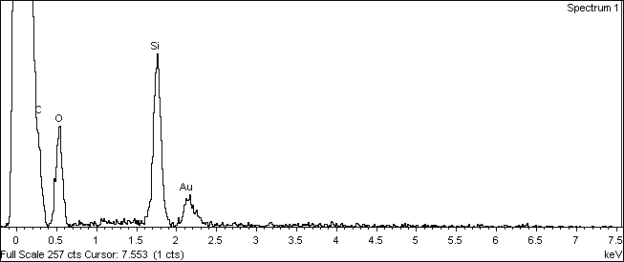

Figure A2: SEM, EDS micrographs of a,c) non-treated and b,d) -90 kPa treated samples saturated

