Supplementary Information for
Virtual Experimentations by Deep learning on Tangible Materials

List of Supplementary Tables:
Supplementary Table 1 Structures and properties of 7 type commercial CNTs. 3
Supplementary Table 2 Data set of electrical conductivity and specific surface area of 17 CNT films (seven types and ten mixtures of CNTs). 4
Supplementary Table 3 12-type CNT films used for test set of CNN models for predicting electrical conductivity and specific surface area. 5

List of Supplementary Figures:
Supplementary Figure 1 Transition of fake CNT blend images with different composition generated by GAN. Magnification: x100k. Combinations of the two CNTs are ordered to the value of averaged specific surface area. 6
Supplementary Figure 2 Progress of training of GAN model for generating CNT structures. a., Examples of generated CNT structures. b-d, Loss of GAN models during training at magnification of b., x02k, c., x20k, d., x50k, e., x100k. 7
Supplementary Figure 3 Progress of training the CNN model for predicting property of CNT film. 8
Supplementary Figure 4 Selection of CNT blend compositions from Ashby map for fabricating supercapacitors. 9
Supplementary Figure 5 Characterization of 4-type blended CNT supercapacitors. a, galvanostatic discharge curves and b, impedance spectrum. Energy density vs specific surface area and relaxation time constant vs electrical conductivity (Fig. 4) are also represented in b and d, respectively. 10
List of Supplementary Method:
Supplementary Method 1 11

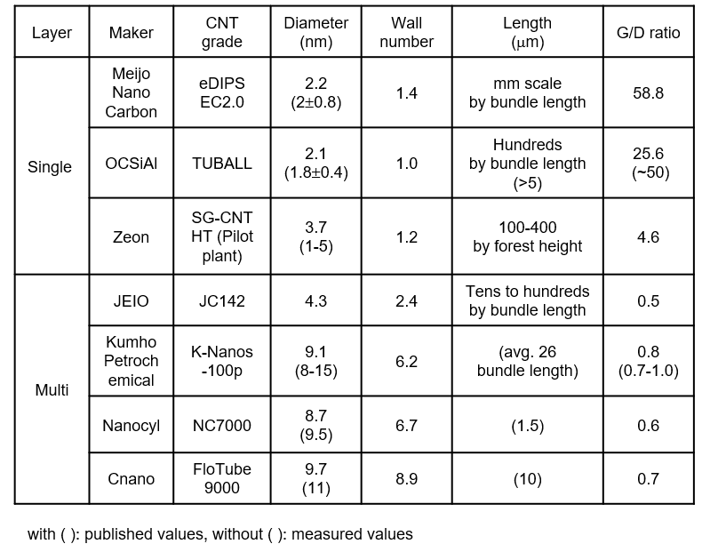
Supplementary Table 1 Structures and properties of 7 type commercial CNTs.
Values are cited from our previous work [S1].

[S1] Kobashi, K., Ata, S., Yamada, T. et al. Classification of Commercialized Carbon Nanotubes into Three General Categories as a Guide for Applications. ACS Appl. Nano Mater., 2, 4043–4047 (2019).

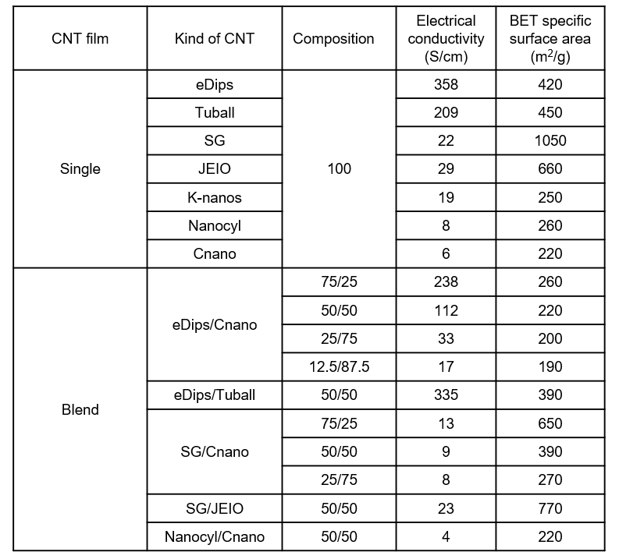
Supplementary Table 2 Data set of electrical conductivity and specific surface area of 17 CNT films (seven types and ten mixtures of CNTs).

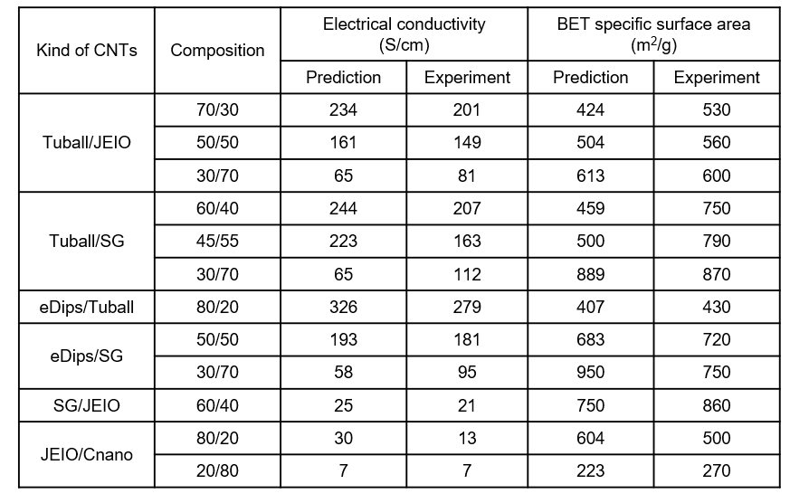
Supplementary Table 3 12-type CNT films used for test set of CNN models for predicting electrical conductivity and specific surface area.

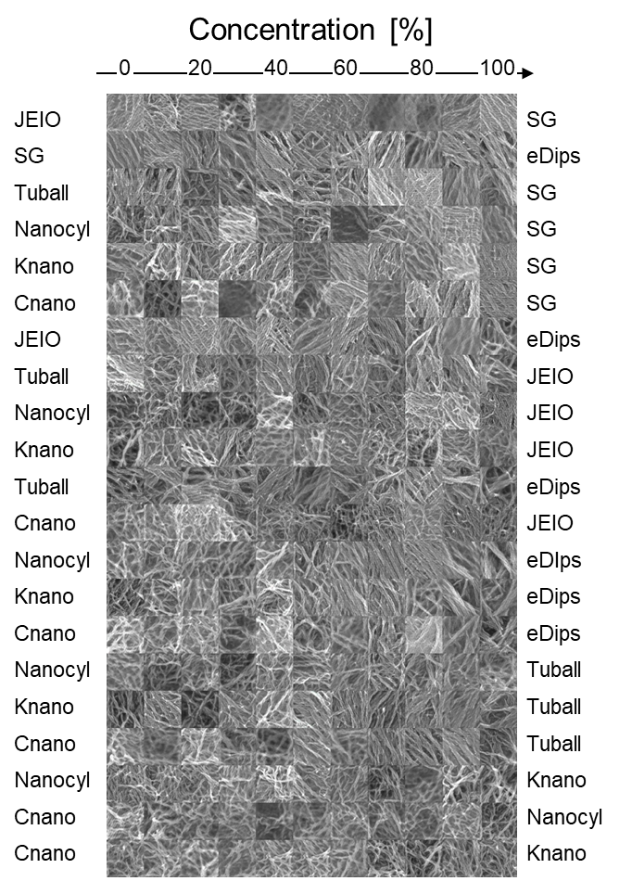
Supplementary Figure 1 Transition of fake CNT blend images with different composition generated by GAN. Magnification: x100k. Combinations of the two CNTs are ordered to the value of averaged specific surface area.

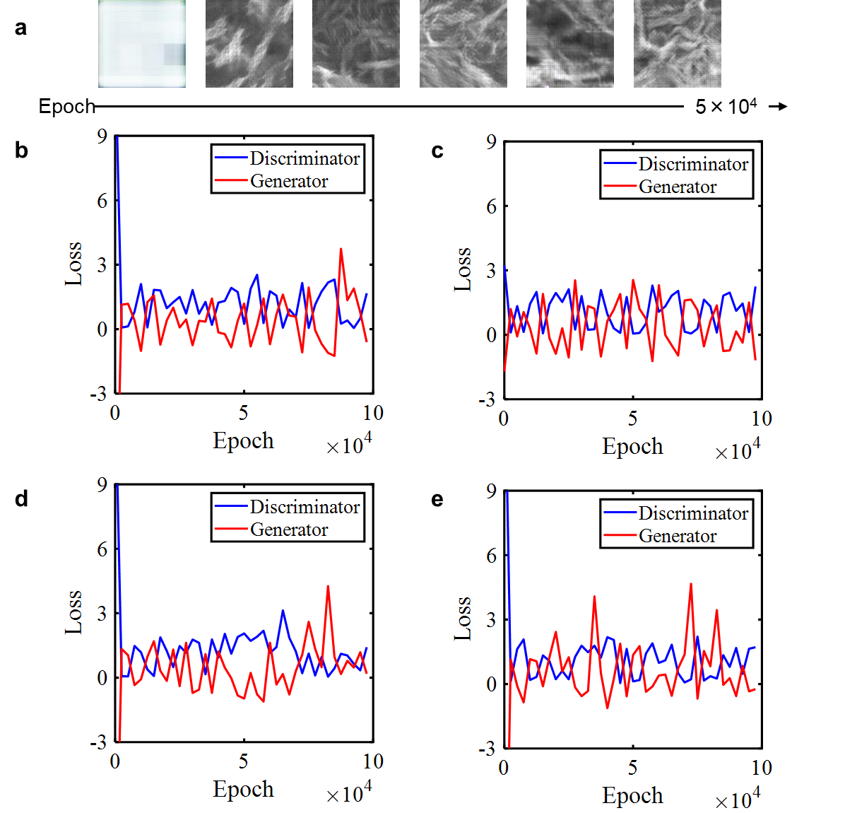
Supplementary Figure 2 Progress of training of GAN model for generating CNT structures. a., Examples of generated CNT structures. b-d, Loss of GAN models during training at magnification of b., x02k, c., x20k, d., x50k, e., x100k.

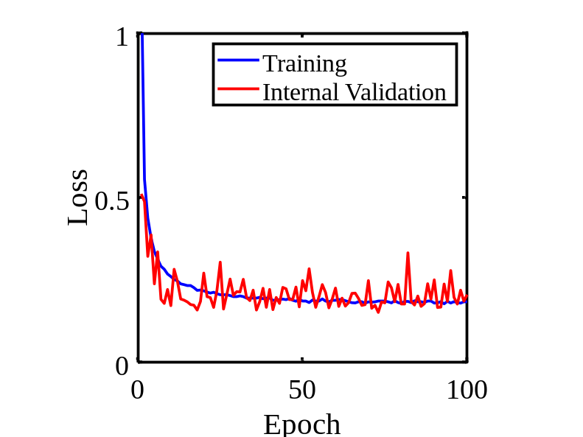
Supplementary Figure 3 Progress of training the CNN model for predicting property of CNT film.

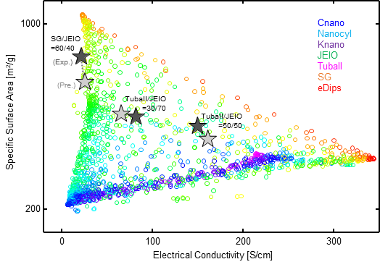
Supplementary Figure 4 Selection of CNT blend compositions from Ashby map for fabricating supercapacitors.

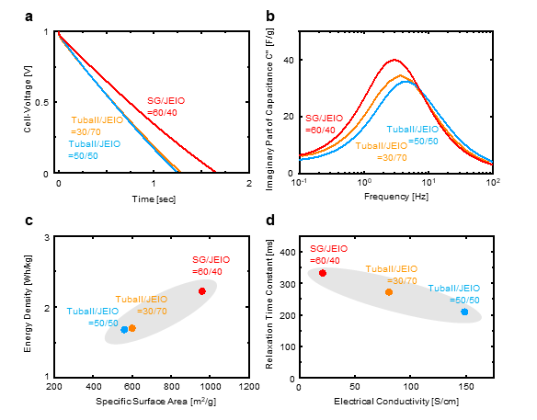
Supplementary Figure 5 Characterization of 4-type blended CNT supercapacitors. a, galvanostatic discharge curves and b, impedance spectrum. Energy density vs specific surface area and relaxation time constant vs electrical conductivity (Fig. 4) are also represented in b and d, respectively.

Supplementary Method 1
Economic performance of CNT film was defined by a linear combination of the raw CNT as follows:
 | $EconomicPerformance=-1-\log_{10}{(ΣC_{i}x_{i})}$ | (1)
where $C_{i}$ is the unit cost of ith CNT, $x_{i}$ is the fraction of ith CNT $(0≤x_{i}≤1)$. Here, unit costs of 7 kinds of CNTs were set to 0.6, 1, 1, 2, 100, 500, and 20 for Flotube9000, NC7000, K-Nanos-100p, JC142, SG-CNT HT, eDips EC2.0, and Tuball, respectively.

