Supplementary Information for
Projected amplification of summer marine heatwaves in a warming Northeast Pacific Ocean
Marylou Athanase¹, Antonio Sánchez-Benítez¹, Helge F. Goessling¹,
Felix Pithan¹, Thomas Jung^{1,2}

1: Alfred Wegener Institute, Helmholtz-Center for Polar and Marine Research, Bremerhaven, Germany
2: Institute of Environmental Physics, University of Bremen, Bremen, Germany

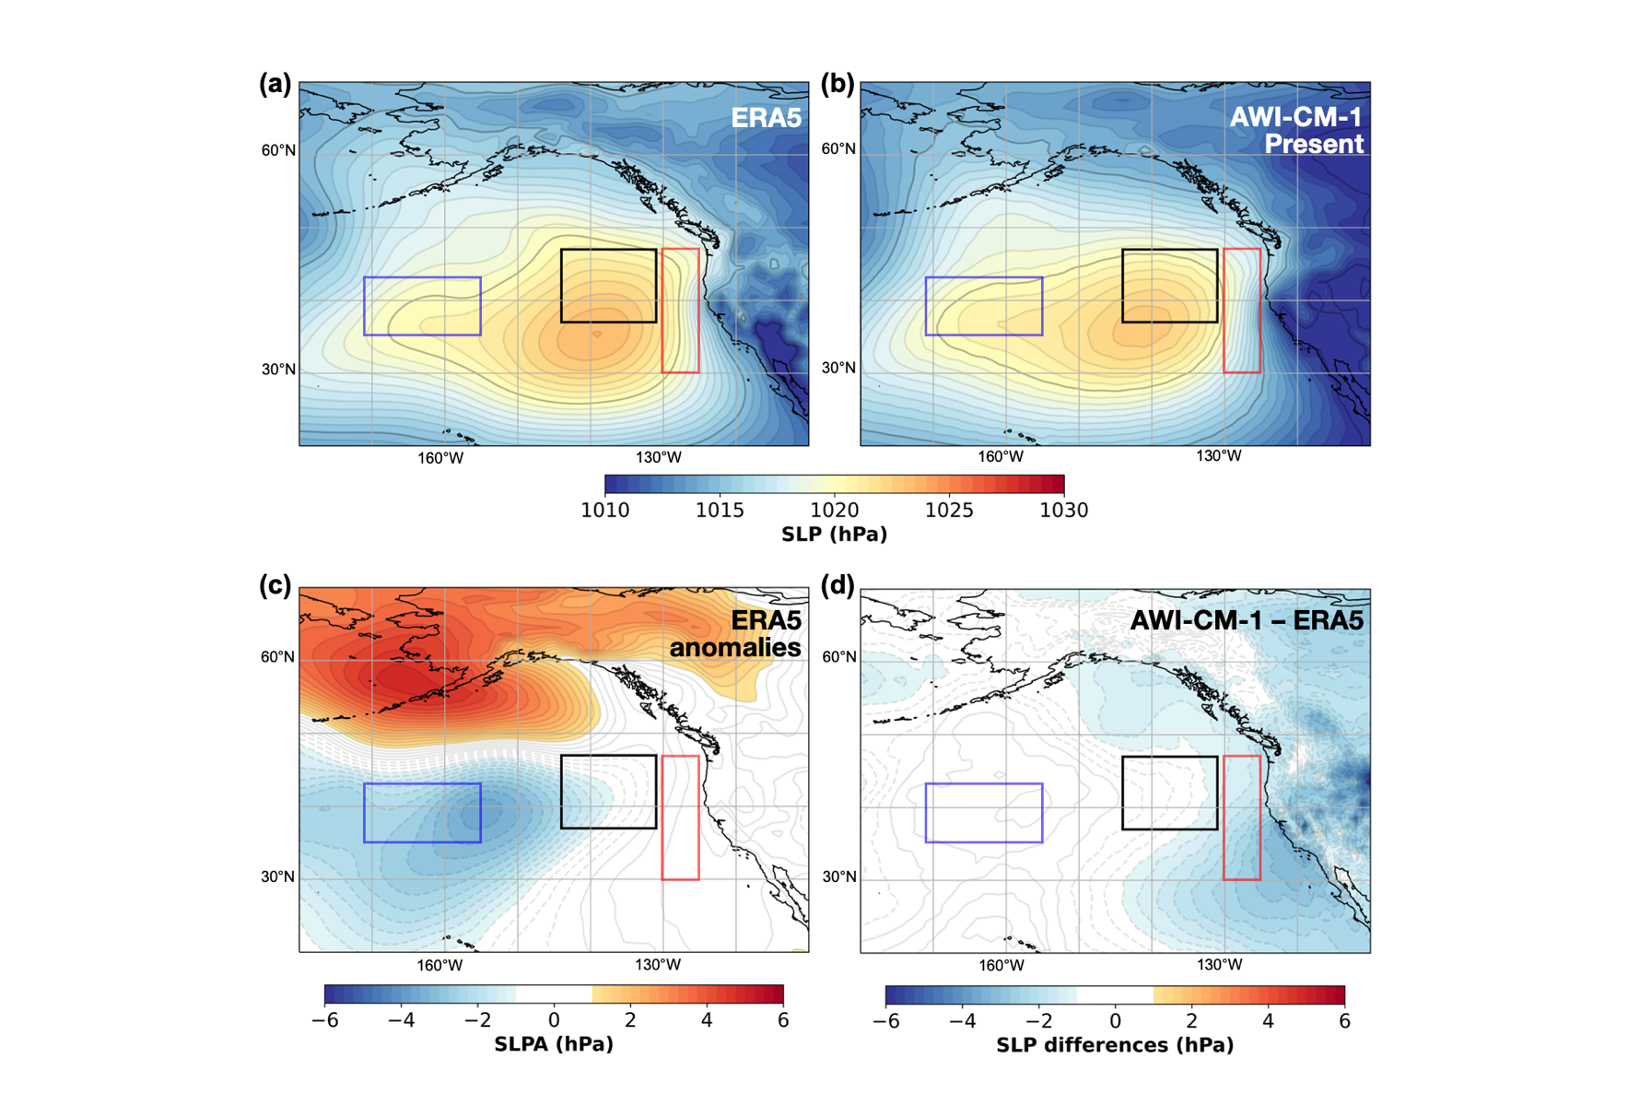
Supplementary Fig. 1. Sea level pressure (SLP, hPa) conditions in summer 2019. SLP in the Northeast Pacific in June-to-August 2019 (a) from ERA5 fields and (b) from the nudged storyline simulations with AWI-CM-1 (5-member ensemble mean) in the present-day climate. (c) SLP anomalies (SLPA, hPa) in summer 2019 from ERA5 fields. (d) Difference between the summer 2019 SLP from the present-day AWI-CM-1 nudged storyline simulations and from ERA5. The black, red and blue boxes indicate the marine heatwave core, coastal area, and central North Pacific region.

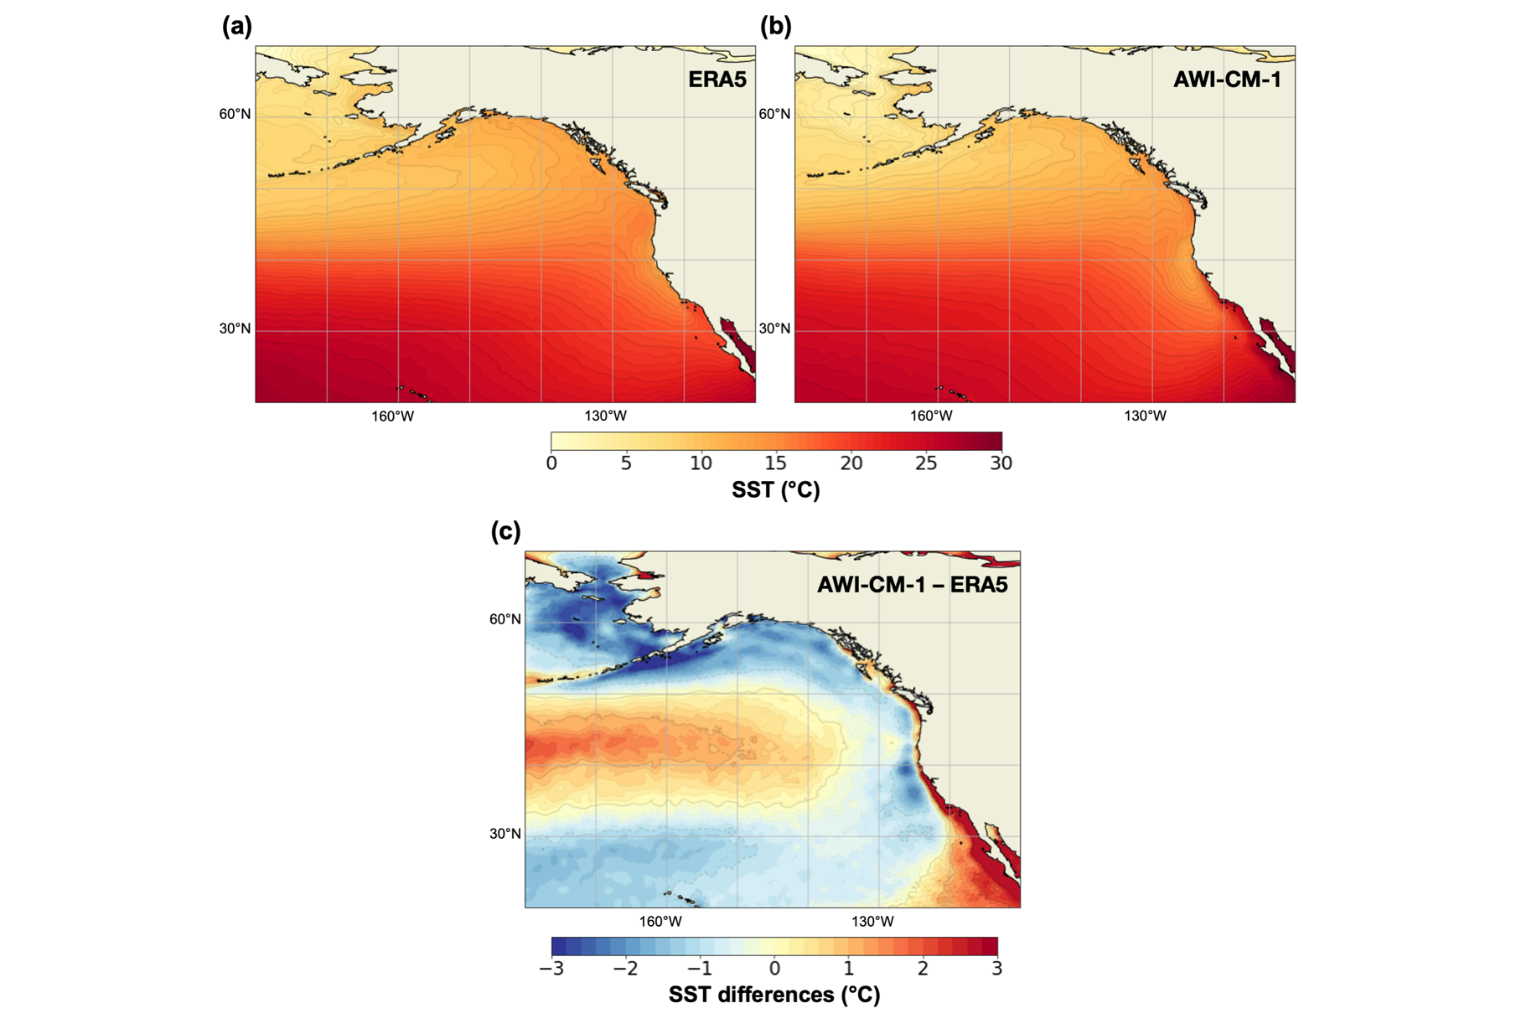
Supplementary Fig. 2. Northeast Pacific 1984-2014 summer SST climatology. Summer (June-to-August) SST from (a) ERA5 fields and from (b) our free-running AWI-CM-1 CMIP6 historical simulations, from which the nudged storyline experiments are branched off. The climatologies are used to derive SST anomalies respectively for ERA5 and for the nudged storyline simulations. (c) Difference between SST climatologies from the AWI-CM-1 CMIP6 simulations and from ERA5.

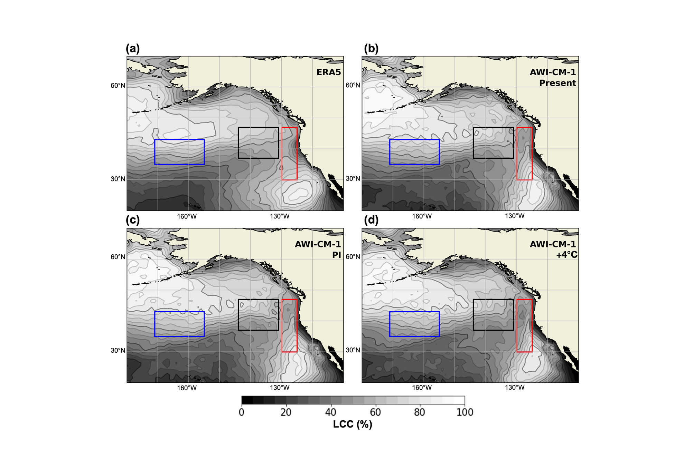
Supplementary Fig. 3. Low-cloud cover (LCC, %) in ERA5 and AWI-CM-1 storyline simulations. LCC in the Northeast Pacific from (a) summer 2019 ERA5 fields, and (b-d) AWI-CM-1 nudged storyline simulations (5-member ensemble mean) of the summer 2019 marine heatwave in (b) present-day, (c) preindustrial (PI) and (d) +4°C warmer climates. Fields are interpolated to a 1° grid. The black, red and blue boxes indicate the marine heatwave core, coastal area, and central North Pacific region.

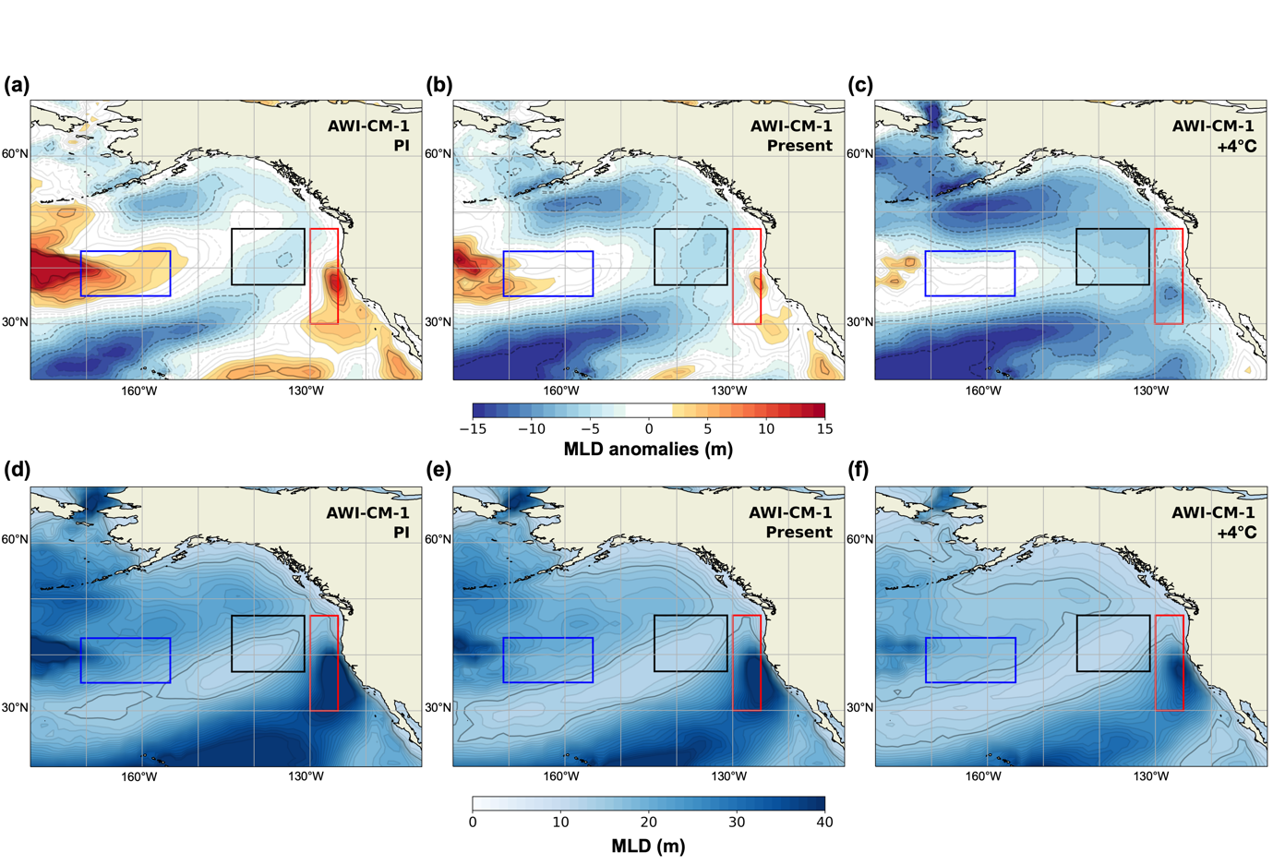
Supplementary Fig. 4. Mixed-layer depth (MLD, m) in AWI-CM-1 nudged storyline simulations. (a)-(c) MLD anomalies (MLDA, m) compared to the simulated 1984-2014 climatology, in the AWI-CM-1 nudged storylines of the summer 2019 marine heatwave for (a) present-day, (b) preindustrial (PI) and (c) +4°C warmer climates. (d)-(f) Same for the absolute MLD. The black, red and blue boxes indicate the marine heatwave core, coastal area, and central North Pacific region. The simulated present-day patterns and amplitude of the negative MLD anomalies in (b) are closely reminiscent of the observations reported in Amaya et al. 2021 (their Figure 1a).

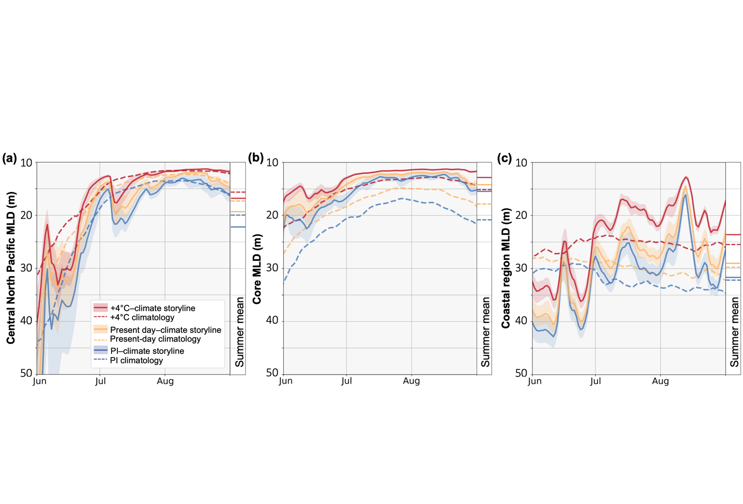
Supplementary Fig. 5. Summer mixed layer depth (MLD) for analogues of the marine heatwave in different climates. Time series of simulated mixed layer depth (MLD, m) area-averaged (a) over the central North Pacific region, to the west of the marine heatwave (blue box, Supplementary Fig. 4), (b) over the marine heatwave core (black box, Supplementary Fig. 4), and (c) over the coastal region (red box, Supplementary Fig. 4). The storyline simulations (solid lines) and climatological-mean states (dashed lines) are shown for PI, present-day, and +4°C warmer climates (blue, yellow, red lines respectively). Summer mean values are indicated on the same y-axis. Shaded envelopes are the area-averaged ensemble range of storyline simulations in each region.

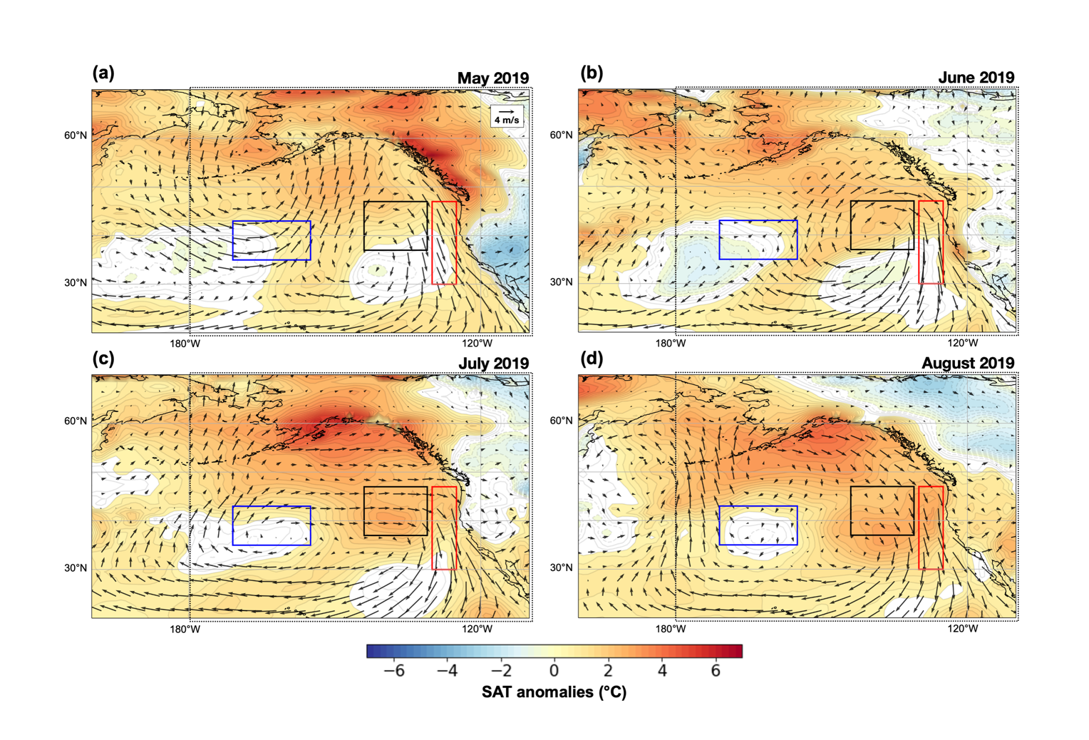
Supplementary Fig. 6. Near surface winds, and surface air temperature (SAT, °C) anomalies in May to August 2019. SAT anomalies (background color) and near surface wind vectors (black arrows) from the AWI-CM-1 present-day nudged storyline simulations in (a) May, (b) June, (c) July, and (d) August 2019. The black, red and blue boxes indicate the marine heatwave core, coastal area, and central North Pacific region. The area shown is larger than for all other figures: the focus area of other figures is reminded by the black frame.

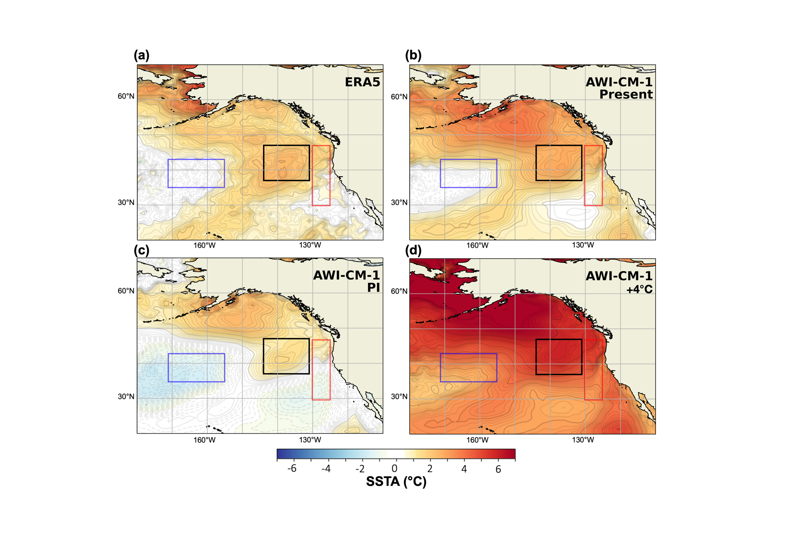
Supplementary Fig. 7. Summer SSTAs in 2019 reanalysis data and AWI-CM-1 nudged storyline simulations. Same as Fig. 1 but using the 1984-2014 climatology from AWI-CM-1 nudged simulations for the computation of SSTAs from AWI-CM-1 nudged storyline simulations in (b)-(d). (a) ERA5 SSTAs with respect to the ERA5 1984-2014 climatology (31 years). (b-d) Same but for nudged AWI-CM-1 storylines (5-member ensemble mean) in (b) present-day, (c) preindustrial (PI) and (d) +4°C warmer climates, with respect to the nudged 1984-2014 climatology. The black, red and blue boxes indicate the marine heatwave core, coastal area, and central North Pacific region.

