EXTENDED DATA

TABLES

Extended Data Table 1: Placebo-controlled, single-blinded, graded oral food challenge protocol

Food challenge dose | Form of food | Amount of food protein in dose (mg) | Cumulative peanut dose (mg protein)
Placebo Challenge
1 | Oat flour | 30 mg | n/a
2 | Oat flour | 1 mg | n/a
3 | Oat flour | 10 mg | n/a
Peanut Challenge
4 | Peanut flour | 1 mg | 1 mg
5 | Peanut flour | 3 mg | 4 mg
6 | Peanut flour | 10 mg | 14 mg
7 | Peanut flour | 30 mg | 44 mg
8 | Peanut flour | 100 mg | 144 mg
9 | Peanut flour | 300 mg | 444 mg
10 | Peanut flour | 600 mg | 1,044 mg
11 | Peanut flour | 1,000 mg | 2,044 mg
12 | Peanut flour | 1,000 mg | 3,044 mg
13 | Peanut flour | 1,000 mg | 4,044 mg

Extended Data Table 2: Symptom scoring system during oral food challenges

Symptom | Score
I. Skin
- Pruritus
Absent | 0
Mild: occasional scratching | 1
Moderate: scratching continuously for >2 minutes at a time | 2
Severe: hard, continuous scratching; excoriations | 3
- Urticaria/Angioedema
Absent | 0
Mild: <3 hives or mild lip edema | 1
Moderate: <10 hives but >3; significant lip/face edema | 2
Severe: generalized involvement | 3
- Rash
Absent | 0
Mild: few areas of faint erythema | 1
Moderate: areas of erythema | 2
Severe: generalized marked erythema (>50%) | 3
II. Upper Respiratory
- Sneezing/Itching
Absent | 0
Mild: rare bursts; occasional sniffing | 1
Moderate: bursts <10; intermittent rubbing of nose and/or eyes; frequent sniffing; mild conjunctival injection | 2
Severe: continuous rubbing of nose and/or eyes; periocular swelling; long bursts of sneezing; persistent rhinorrhea; moderate-severe conjunctival injection | 3
- Laryngeal
Absent | 0
Mild: >3 discrete episodes of throat clearing or cough, or persistent throat tightness/pain; uvular erythema | 1
Moderate: hoarseness, frequent dry cough; uvular edema (mild) | 2
Severe: stridor; uvular edema (moderate-severe) | 3
III. Lower Respiratory
- Wheezing
Absent | 0
Mild: expiratory wheezing to auscultation | 1
Moderate: inspiratory and expiratory wheezing | 2
Severe: use of accessory muscles; audible wheezing | 3
IV. Gastrointestinal
- Subjective Complaints
Absent | 0
Mild: complaints of nausea or abdominal pain; itchy mouth/throat (mild) | 1
Moderate: frequent complaints of nausea or pain with normal activity; itchy mouth/throat (moderate-severe) | 2
Severe: notably distressed due to GI symptoms with decreased activity | 3
- Objective Complaints
Absent | 0
Mild: 1 episode of emesis or diarrhea | 1
Moderate: 2-3 episodes of emesis or diarrhea or 1 of each | 2
Severe: >3 episodes of emesis or diarrhea or 2 of each | 3
V. Cardiovascular/Neurologic
Normal heart rate or BP for age/baseline | 0
Mild: subjective response (weak, dizzy), or tachycardia | 1
Moderate: drop in blood pressure and/or >20% from baseline, or significant change in mental status | 2
Severe: cardiovascular collapse, signs of impaired circulation; unconscious | 3

Extended Data Table 3: Participant inclusion and exclusion criteria

Inclusion Criteria
History of immunoglobulin E (IgE)-mediated food allergy to peanut or tree nut
Positive skin puncture test to the trigger food (either peanut or tree nut)
Objective clinical reaction to 1,044 mg or less of the food allergen protein during baseline oral food challenge
Women of child bearing potential must agree to two forms of highly effective contraception (hormonal, device, or barrier method of birth control; abstinence) for the duration of study participation.
Ability to understand and the willingness to sign a written informed consent
Ability to clearly understand and speak English at an 8th grade reading level
Exclusion Criteria
Participants who have been on immunomodulatory therapies or oral corticosteroids within 1 month prior to enrollment
Participants with symptoms consistent with food reactions other than type 1 hypersensitivity
History of allergic reaction to acalabrutinib
History of idiopathic urticaria, dermatographism, idiopathic or unexplained anaphylaxis, or anaphylaxis (to foods or otherwise) resulting in intubation, prolonged hypotension, or neurological sequelae
History of cardiovascular disease
History of a bleeding disorder, or those currently taking blood thinners
History of stroke
History of gastrointestinal ulcer
History of cancer (other than skin cancer)
Positive HIV status or history of other immunodeficiency
Active or latent Hepatitis B or C infection based on laboratory testing
Currently pregnant or nursing
Current use of proton pump inhibitors (Note: participants currently receiving proton pump inhibitors who switch to H2-receptor antagonists or other antacids are eligible for enrollment to this study).
Active significant infection
Major surgical procedure within 28 days of enrollment
Uncontrolled autoimmune hemolytic anemia or idiopathic thrombocytopenic purpura
Difficulty swallowing oral medication, or significant gastrointestinal disease that would limit absorption of oral medication
Concurrent participation in another therapeutic clinical trial

Extended Data Table 4: Summary of rescue medications administered during oral food challenges

Patient ID | Rescue medications administered during baseline oral food challenge | Rescue medications administered during acalabrutinib oral food challenge
001 | Epinephrine 0.5 mL IM x 1 dose  Cetirizine 20 mg PO | None
002 | IM epinephrine 0.5 mL x 1 dose  Cetirizine 20 mg PO  Albuterol HFA 2 puffs via inhalation | None
005 | Epinephrine 0.5 mL IM x 3 doses  Cetirizine 20 mg PO  Albuterol HFA 8 puffs via inhalation  Prednisone 60 mg PO  Supplemental oxygen (8 L)  In Emergency Department, received the following:  Diphenhydramine 25 mg PO  Famotidine 20 mg PO  Albuterol nebulization treatment 2.5 mg x 1 via inhalation | None
006 | Epinephrine 0.5 mL IM x 1 dose  Cetirizine 20 mg PO | Epinephrine 0.5 mL IM x 1 dose  Cetirizine 20 mg PO  Albuterol HFA 4 puffs via inhalation
007 | Epinephrine 0.5 mL IM x 1 dose  Cetirizine 20 mg PO | None
008 | Epinephrine 0.5 mL IM x 1 dose  Cetirizine 20 mg PO  Albuterol HFA 2 puffs via inhalation | None
009 | Epinephrine 0.5 mL IM x 1 dose  Cetirizine 20 mg PO | None
011 | Epinephrine 0.5 mL IM x 1 dose  Cetirizine 20 mg PO  Albuterol HFA 8 puffs via inhalation | Epinephrine 0.5 mL IM x 1 dose  Cetirizine 20 mg PO  Albuterol HFA 4 puffs via inhalation
013 | Epinephrine 0.5 mL IM x 1 dose  Cetirizine 40 mg PO  Albuterol HFA 1 puff via inhalation | Epinephrine 0.5 mL IM x 1 dose  Cetirizine 20 mg PO  Albuterol HFA 8 puffs via inhalation

Abbreviations: HFA, hydrofluoroalkane; IM, intramuscular; PO, per oral
Extended Data Table 5: Toxicity monitoring

Laboratory test | Baseline | During acalabrutinib therapy* | Follow-up | p =
White blood cell count (K/mm³) | 7.38 (1.58) | 7.17 (2.11) | 7.34 (2.76) | 0.99
Hemoglobin (g/dL) | 13.3 (1.60) | 13.2 (1.44) | 13.9 (1.25) | 0.012
Platelet count (K/mm³) | 279 (105) | 256 (106) | 275 (122) | 0.15
Absolute neutrophil count (K/mm³) | 4.56 (1.31) | 3.76 (1.81) | 4.27 (2.24) | 0.27
Absolute lymphocyte count (K/mm³) | 1.99 (0.477) | 2.43 (0.399) | 2.21 (0.874) | 0.008
Absolute monocyte count (K/mm³) | 0.502 (0.173) | 0.540 (0.143) | 0.504 (0.110) | 0.43
Absolute eosinophil count (K/mm³) | 268 (119) | 363 (257) | 300 (155) | 0.34
Absolute basophil count (K/mm³) | 50.0 (25.5) | 48.0 (20.6) | 48.5 (29.9) | 0.97
Sodium (mmol/L) | 140 (1.64) | 140 (1.48) | 140 (1.58) | 0.95
Potassium (mmol/L) | 3.97 (0.295) | 3.91 (0.331) | 4.26 (0.508) | 0.06
Chloride (mmol/L) | 107 (1.93) | 107 (2.67) | 107 (2.17) | 0.86
Glucose (mg/dL) | 90.3 (6.69) | 93.8 (10.3) | 102 (29.7) | 0.29
BUN (mg/dL) | 11.9 (3.32) | 12.9 (2.64) | 14.2 (3.12) | 0.09
Creatinine (mg/dL) | 0.812 (0.141) | 0.843 (0.170) | 0.865 (0.110) | 0.15
Calcium (mg/dL) | 9.07 (0.320) | 9.00 (0.350) | 9.07 (0.211) | 0.75
Total protein (g/dL) | 7.21 (0.475) | 7.10 (0.435) | 7.36 (0.366) | 0.27
Albumin (g/dL) | 3.78 (0.503) | 3.79 (0.264) | 4.03 (0.467) | 0.06
Alkaline phosphatase (U/L) | 75.3 (20.3) | 74.9 (23.6) | 81.4 (29.5) | 0.21
Aspartate aminotransferase (U/L) | 19.9 (4.91) | 19.8 (9.43) | 21.4 (8.92) | 0.73
Alanine aminotransferase (U/L) | 28.5 (7.23) | 28.2 (7.00) | 37.2 (20.7) | 0.16
Bilirubin (mg/dL) | 0.500 (0.271) | 0.630 (0.226) | 0.530 (0.211) | 0.14
Quantitative immunoglobulins (mg/dL)  IgG  IgA  IgM  IgE | 1,057 (167)  213 (85.2)  105 (38.4)  472 (896) | 1,058 (187)  210 (75.4)  105 (37.8)  470 (801) | 1,092 (174)  228 (82.6)  109 (41.0)  650 (1,015) | 0.27  0.15  0.47  0.24

All values are expressed as mean (standard deviation). Data were analyzed using 1-way ANOVA.

*N=9 for blood counts while on acalabrutinib therapy due to lab error (lost sample) for Patient 006. N=10 for all other tests.

Extended Data Table 6: Total adverse events

Category | Number
Total adverse events | 15
Grade 1  Anemia  COVID-19 infection (asymptomatic)  Eosinophilia  Elevated liver function tests (Alk Phos, AST, and ALT)  Hyperglycemia  Hypoalbuminemia*  Neutrophilia | 1  1  1  1  1  1  1
Grade 2  Anemia*  Hyperglycemia  Hypokalemia*  Neutropenia | 1  1  1  1
Grade 4  Emergency-room visit after baseline food challenge  Sports-related fall and injury  Sports-related concussion | 1  1  2

*Present at baseline prior to study procedures or drug, not worsened by acalabrutinib.

Abbreviations: Alk Phos, alkaline phosphatase; ALT, alanine aminotransferase; AST, aspartate aminotransferase

FIGURES

Extended Data Fig. 1: Skin testing to dilutions of peanut extract
Skin puncture test wheal area (in mm³) to peanut extract dilutions as well as positive (histamine) and negative (saline) controls at patients’ baseline (blue circles), during treatment with acalabrutinib (orange circles), and at follow-up (green circles) are shown. Box plot midline represents the median, box depicts 25th and 75th percentiles, and whiskers depict range.
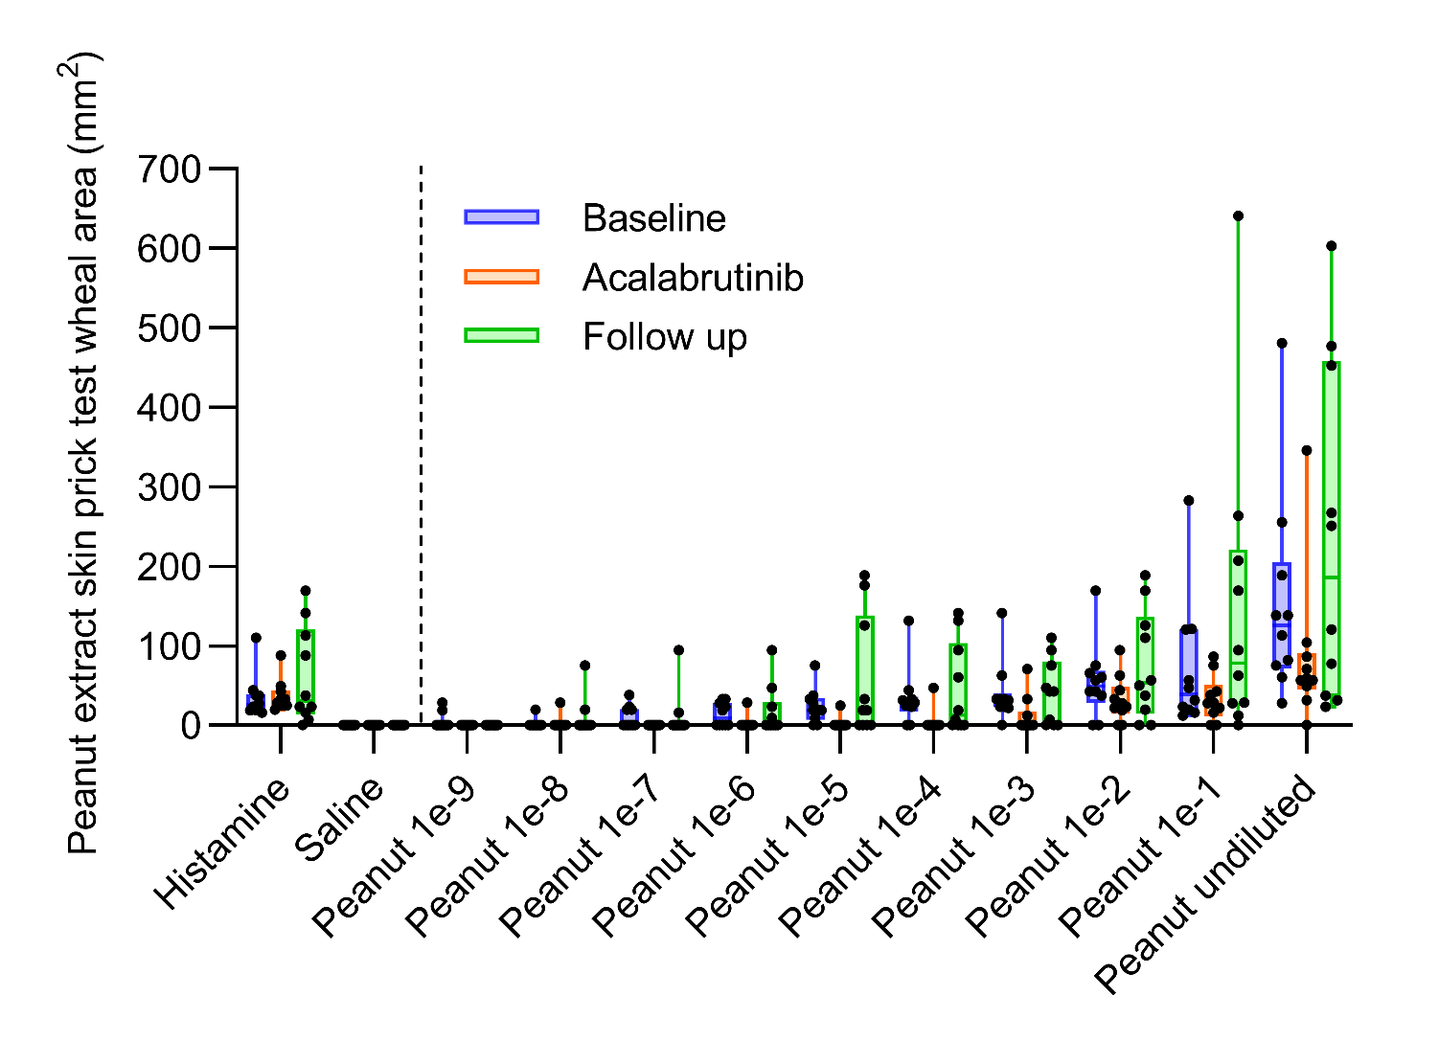

Extended Data Fig. 2: Peanut specific IgE levels at all timepoints
Peanut and peanut-component specific IgE levels for all patients at baseline (blue circles), during acalabrutinib treatment (orange circles), and follow-up (green circles) are shown. Box plot midline represents the median, box depicts 25th and 75th percentiles, and whiskers depict range.

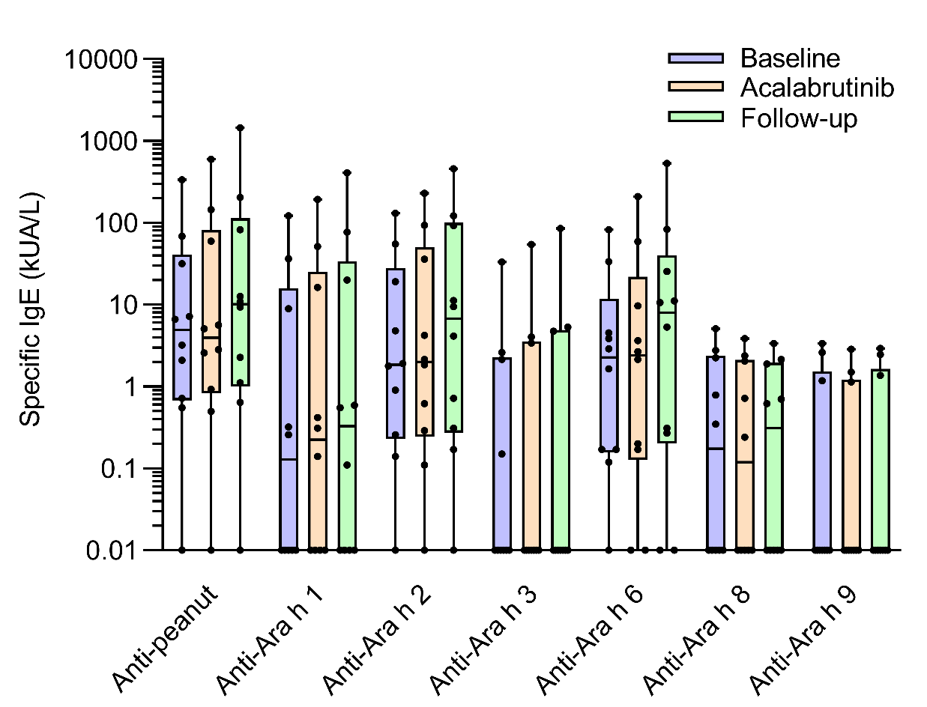

EXTENDED DATA REFERENCES:

26. Crevel, R.W., et al. Thresholds for food allergens and their value to different stakeholders. Allergy. 63, 597-609 (2008).

