Supplement Figues
Supplemental Figures S1: K-mer analysis and flow cytometry result.
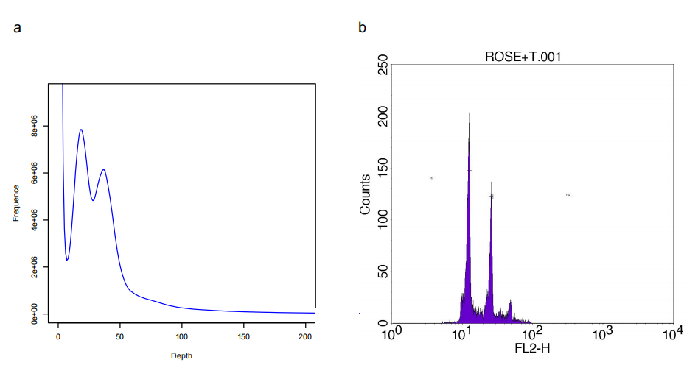

Supplemental Figures S2: Inter-chromosomal Hi-C contact map of each chromosome.
The intensity of each pixel represents the count of Hi-C links between 500kb windows on chromosomes on a logarithmic scale. Darker red pixels indicate a higher contact probabilities.
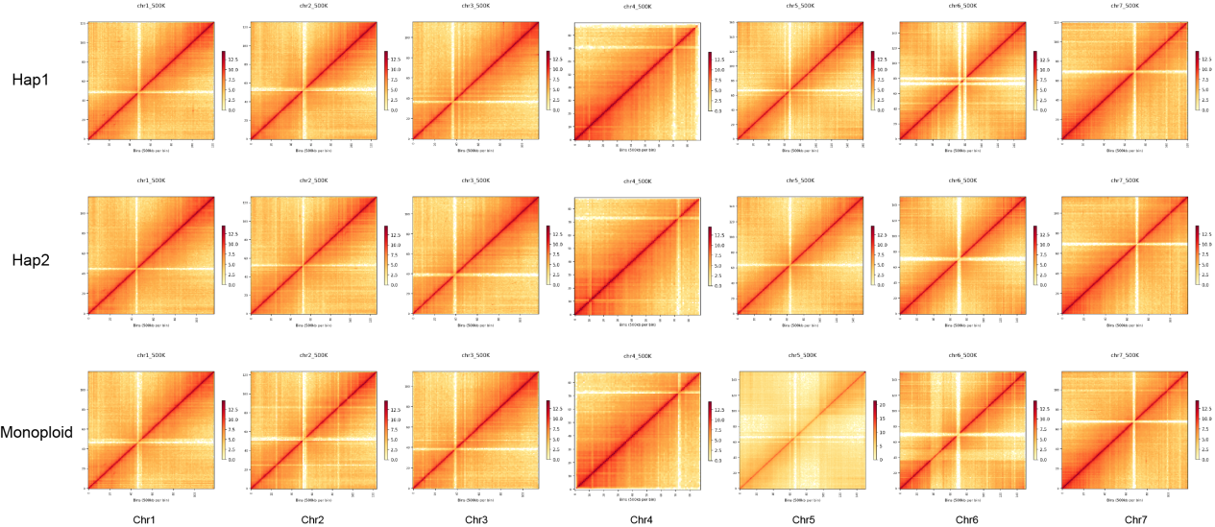

Supplemental Figures S3: Three genomes’s BUSCO results.
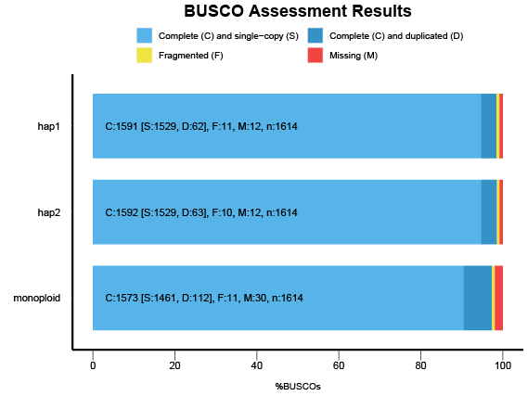

Supplemental Figures S4: Three genomes’s BUSCO results.
LAI distribution of each chromosome of the three genomes with a window length of 3M.
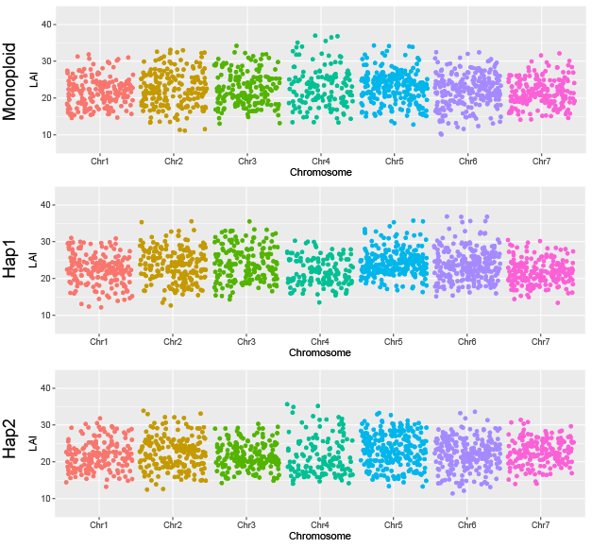

Supplemental Figures S5: Coverage of three genomes by the Ilumina reads.
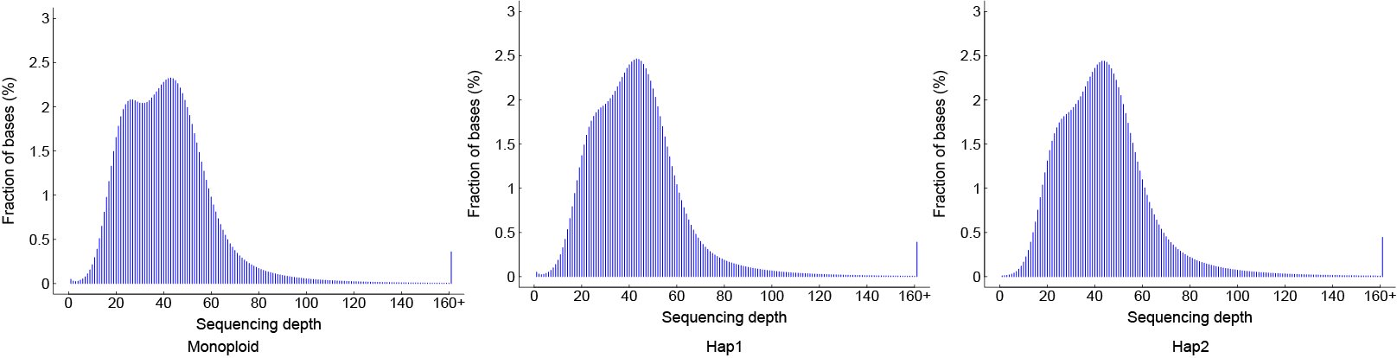

Supplemental Figures S6: Comparison of gene structural features(gene length, CDS length, exon length) of monoploid genome, hap1 genome and hap2 genome.

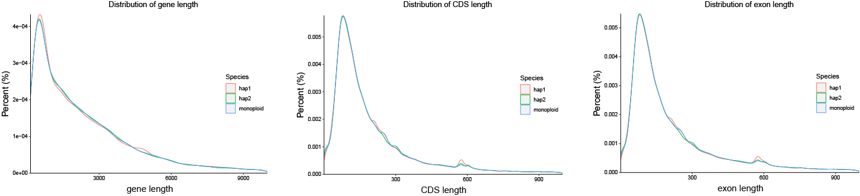

Supplemental Figures S7: Rose population’s PCA analysis.
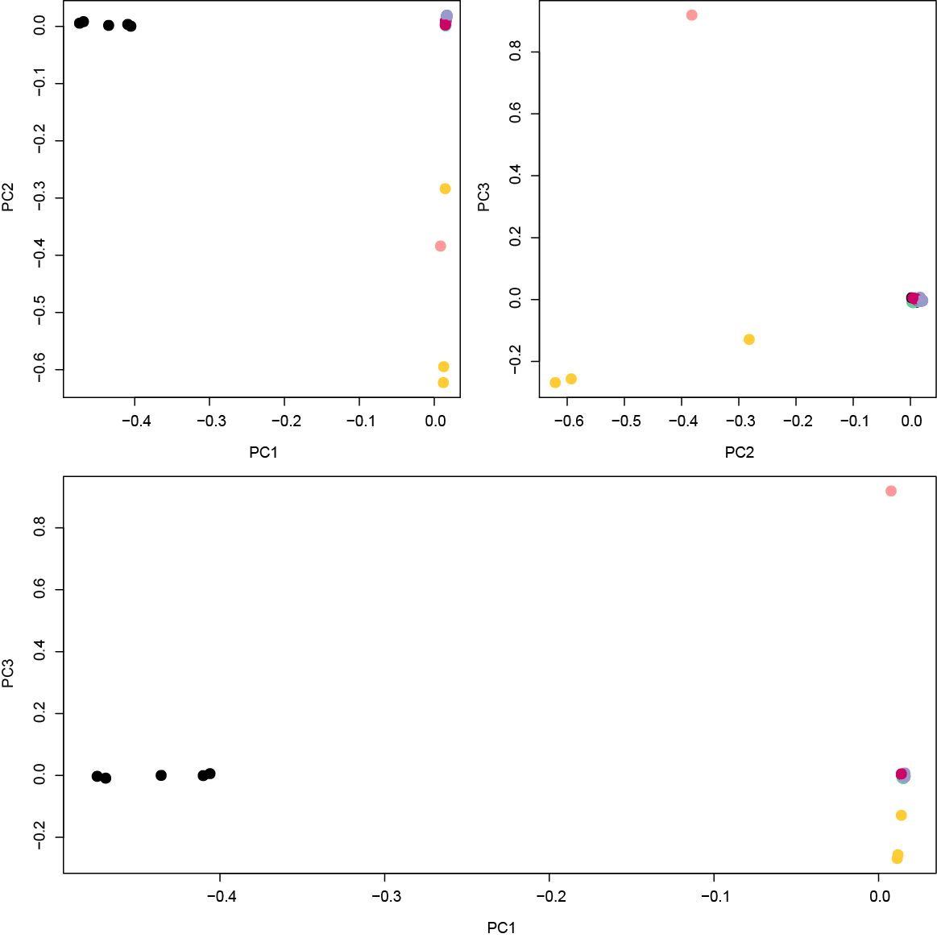

Supplemental Figures S8: Comparison of three genes’s SV number.




