Supplementary Materials for

Anomalous Sabatier principle on high entropy alloy catalysts

Zhi Wen Chen^{1,2†}, Jian Li^{1†}, Pengfei Ou³, Jianan Erick Huang³, Zi Wen¹, Li Xin Chen², Xue Yao², Guang Ming Cai⁴, Chun Cheng Yang^{1*}, Chandra Veer Singh^{2,5*}, Qing Jiang^{1*}

Correspondence to: ccyang@jlu.edu.cn, chandraveer.singh@utoronto.ca and jiangq@jlu.edu.cn

This PDF file includes:

Materials and Methods
Figs. S1 to S41
Tables S1 and S2
References

Materials and Methods
Materials
Iron(III) chloride (FeCl₃), Cobalt(II) chloride hexahydrate (CoCl₂·6H₂O), Nickel(II) chloride hexahydrate (NiCl₂·6H₂O), Copper(II) chloride dihydrate (CuCl₂·2H₂O) and Chloroplatinic acid (H₂PtCl₆·6H₂O) were purchased from Sigma Aldrich. All chemicals are of analytical purity and used without further purification.

Synthesis of PtFeCoNiCu HEA catalyst
0.5 mM of FeCl₃, CoCl₂·6H₂O, NiCl₂·6H₂O, CuCl₂·2H₂O and H₂PtCl₆·6H₂O were added into 40 mL ultrapure water to form a uniform mixture. The mixture was stirred constantly in an oil bath at 80 °C until all water evaporated, forming a dark yellow slurry. The HEA-300, HEA-400 and HEA-500 were obtained through annealing the slurry under 5% H₂/Ar atmosphere for 2 h at 300°C, 400°C and 500°C, respectively.

Synthesis of PtFeCoNi and PtFeCo catalysts
The synthesis method of PtFeCoNi is the same with that of HEA-400, except that the precursor of CuCl₂·2H₂O was not added. The synthesis method of PtFeCo is the same with that of HEA-400, except that the precursors of CuCl₂·2H₂O and NiCl₂·6H₂O were not added.

Material Characterization
For the structural characterization, X-ray diffraction (XRD) was performed on a D/max2500pc diffractometer with a Cu Kα radiation. X-ray photoelectron spectroscopy (XPS) detection was through an ESCALAB 250Xi spectrometer with a monochromatic Al-K source. The morphology characterization was conducted using a JEM-2100F transmission electron microscope (TEM) for TEM images, high-resolution TEM (HRTEM) images and selected area electron diffraction (SAED) patterns. The high angle annular dark field (HAADF) images were obtained through a double-corrected FEI Titan Themis 300 electron microscope. The component analysis was confirmed using an inductively coupled plasma optical emission spectroscopy (ICP-OES).

Electrochemical Measurements
All electrochemical measurements were performed on an Ivium-n-Stat electrochemical workstation under a standard three-electrode system. A graphite electrode, a saturated calomel electrode (SCE) and a rotating disk electrode (RDE) covered with catalyst films were used as the counter electrode, reference electrode, and working electrode, respectively. 3 mg of each catalyst powders distributed into 0.5 mL water-isopropanol solution (4:1, v/v) were used as the catalyst ink. 30 μL of the catalyst ink was taken and dried on the RDE surface for measurement each time. 15 μL Nafion-isopropanol solution (1:19, v/v) was taken and covered on the dried catalyst films as a binder.
The HER performance measurements were conducted in N₂-saturated 0.5 M H₂SO₄. For activating HEA catalysts, cyclic voltammetry (CV) tests were performed at a potential range of 100 ~ 530 mV (vs. reversible hydrogen electrode, RHE) at a scan rate of 400 mV s⁻¹. Linear sweep voltammetry (LSV) tests were conducted at a scan rate of 5 mV s⁻¹ with a rotation rate of 2025 rpm. For measuring the double-layer capacitance, CV tests were performed at a potential range of 10 to 20 mV (vs. RHE) at scan rates of 20, 40, 60, 80 and 100 mV s⁻¹, respectively. Galvanostatic tests were performed at an applied current density of -10 mA cm⁻² for 80 h. Electrochemical impedance measurements were performed at 10 mV (vs. RHE) from 100 kHz to 0.1 Hz. All the measurements were performed at room temperature. All the potentials converted to the RHE were through E_{RHE} = E_{SCE} + 0.059 pH + 0.267 V, where E_{RHE} and E_{SCE} denote the reversible hydrogen evolution potential and the measured potential, respectively.

Turnover frequency calculation
The approach proposed by Jaramillo et al. was adopted for the calculation of turnover frequency (TOF) (1). The TOF is calculated according to:
$\text{TOF per site = }\frac{\# × J × A}{N × A}$ (1)
where #, J, A, and N represent hydrogen turn over event, the current density at an applied overpotential, geometric area of the catalyst, and active site number per unit area, respectively. In this work, # is 3.12 × 10¹⁵ s⁻¹ cm⁻² per mA cm⁻² according to the previous report, and A is 0.19625 cm² corresponding to the geometric area of RDE. It is noted that the surface site density of all materials is reasonably approximated to be 10¹⁵ cm⁻². Therefore, N can be calculated through
N = C_{dl}/C_{s} × 10¹⁵ cm⁻² (2)
where C_{dl} and C_{s} represent double layer capacitance and specific capacitance. When taking general Cs of 0.035 mF cm⁻² (2), the N values for HEA-400, HEA-500, and Pt/C are calculated to be 3.19 × 10¹⁸, 1.15 × 10¹⁸, and 2.30 × 10¹⁸ cm⁻², respectively. At an overpotential of 20 mV (vs. RHE), the J values for HEA-400, HEA-500, and Pt/C are 44.6, 22.2, and 7.2 mA cm⁻². Thus, the TOF per site at 20 mV (vs. RHE) are 4.36 × 10⁻², 6.02 × 10⁻² and 0.98 × 10⁻² s⁻¹ for HEA-400, HEA-500 and Pt/C, respectively.

Density functional theory calculation
All calculations were performed using the Vienna ab initio simulation package (VASP) based on spin-polarized density function theory (DFT) (3). The projector-augmented wave pseudopotential was applied to treat the core electrons (4). The generalized gradient approximation (GGA) with the Perdew-Burke-Ernzerhof functional (PBE) was adopted in the DFT calculations (5). The kinetic energy cutoff for the wave-function calculations was set to 550 eV. The Fermi smearing function was applied with a smearing width of 0.1 eV. The 4 × 4 supercell with five layers was considered for all systems. The Monkhorst-Pack grid of k-points were 2 × 2 × 1, and a vacuum gap of more than 12 Å was used to avoid interactions between the system and its mirror images. The geometric relaxation was stopped when the incremental changes in total energy and forces were smaller than 1 × 10⁻⁵ eV and 0.05 eV/Å, respectively. The van der Waals interaction was considered through DFT-D3 method proposed by Grimme (6). All the transition states were obtained using the climbing image nudged elastic band (CI-NEB) method with the convergence force smaller than 0.05 eV/Å (7).
The adsorption energy (ΔE_{X*}) of adsorbates (X = H, C, O, N) was calculated by the following equation:
ΔE_{X*} = E_{X*} – E_{cat} – E_{X} (3)
where E_{X*}, E_{cat}, and E_{X} represent the total energy of the catalyst with the adsorbate, isolated catalyst, and the corresponding adsorbate, respectively. Note that the energies of H, C, O, and N refer to the energies of H₂, graphene, H₂O, and NH₃, respectively. The adsorption energy was corrected by considering the zero-point energy and entropy, as shown below:
ΔG_{X*} = ΔE_{X*} + ΔZPE – TΔS (4)
where ΔG_{X*}, ΔZPE, and TΔS denote the adsorption free energy, zero-point energy change, and entropy change, respectively.

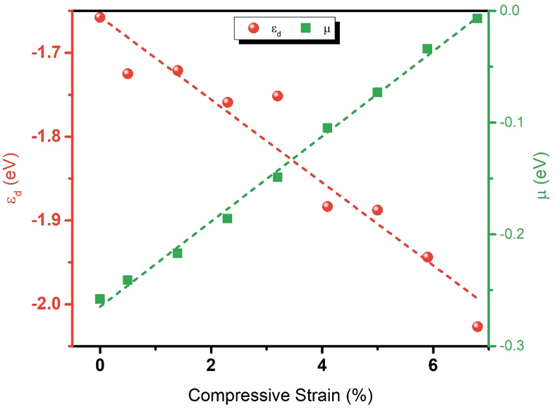

Fig. S1.
The structure (compressive strain)-property (ε_{d}, d-band center)-performance (μ, the expectation of Gaussian distribution of ΔG_{H*}) relation on HEA catalysts.

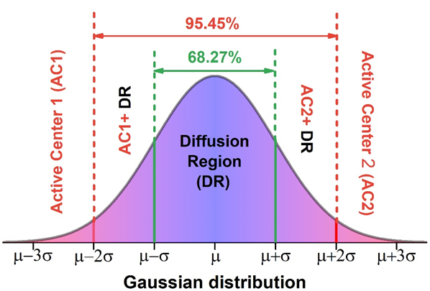

Fig. S2.
Schematic diagram of Gaussian distribution of ΔG_{H*} on HEA surfaces. Active center 1 (AC1) and active center 2 (AC2) are used for Volmer reaction (* + H⁺ + e⁻ → H*) and Tafel (H* + H* → H₂) or Heyrovsky reaction (H* + H⁺ + e⁻ → H₂), respectively, due to the strong adsorption of H* on AC1 and the weak adsorption of H* on AC2. The region around μ (68.27%) is diffusion region (DR) for H* spillover. There are two coexistence regions of active center and DR between 68.27% and 95.45% in the Gaussian distribution of ΔG_{H*}.

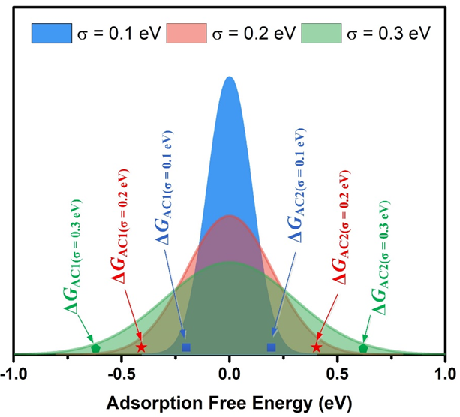

Fig. S3.
Schematic diagram of Gaussian distribution of adsorption free energy with μ = 0 eV and different σ values (0.1 eV, 0.2 eV, and 0.3 eV).

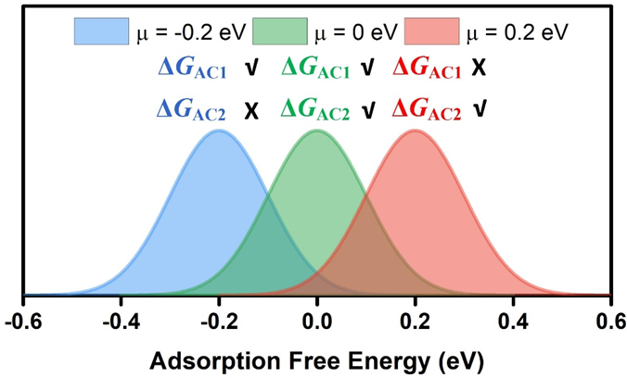

Fig. S4.
Schematic diagram of Gaussian distribution of adsorption free energy with σ = 0.1 eV and different μ values (-0.2 eV, 0 eV, and 0.2 eV). The potential limiting steps of the three Gaussian distributions are ΔG_{AC2} (μ = -0.2 eV), ΔG_{AC1} = ΔG_{AC2} (μ = 0 eV), ΔG_{AC1} (μ = 0.2 eV) for HER. Obviously, the Gaussian distribution with μ = 0 eV has a better catalytic performance than those of the other two.

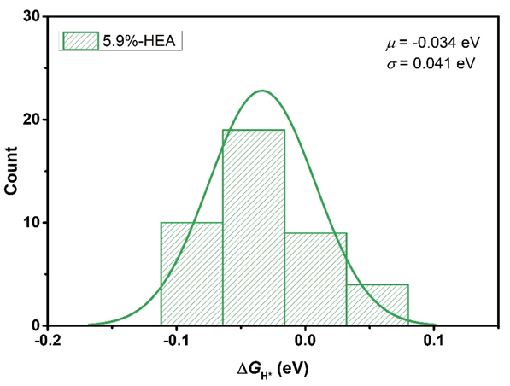

Fig. S5.
Gaussian distribution of adsorption free energy of H* (ΔG_{H*}) on 5.9%-HEA.

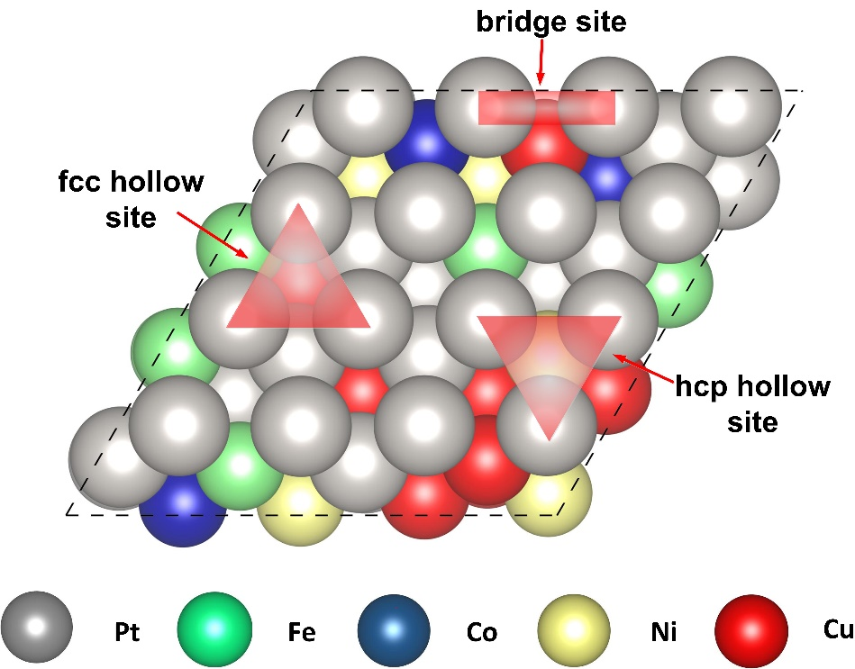

Fig. S6.
Adsorption sites of the bridge, fcc hollow, and hcp hollow sites for H* on HEA (111).

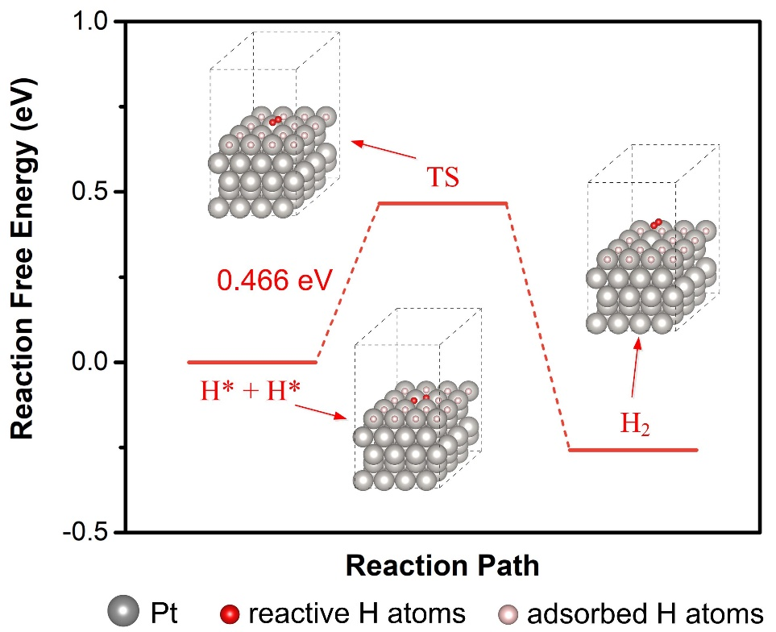

Fig. S7.
The energy barrier of Tafel reaction (H* + H* → H₂) on Pt (111) with high H* coverage.

Fig. S8.
(A) Volmer-Heyrovsky mechanism of HER on 5.9%-HEA (111) without H* spillover and Pt (111). (B) Volmer-Tafel mechanism of HER on 5.9%-HEA (111) without H* spillover and Pt (111).

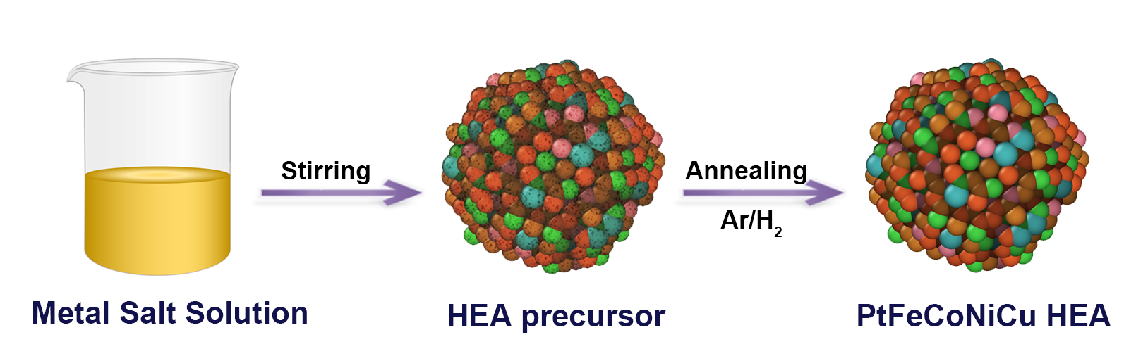
Fig. S9.
Schematic illustration of the synthesis route of HEA catalysts.

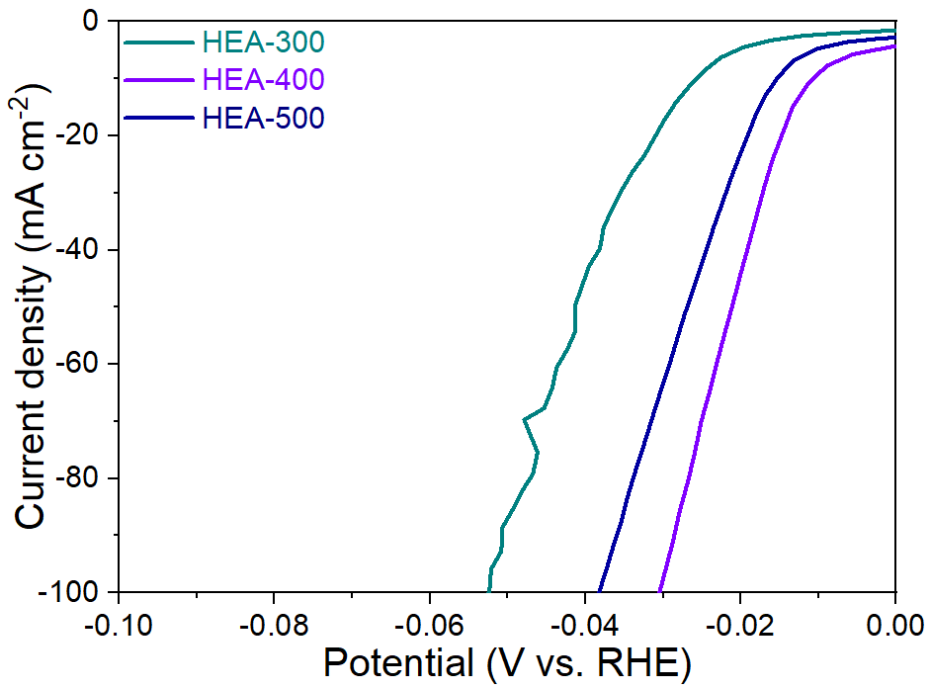
Fig. S10.
Polarization curves of HEA catalysts annealed at different temperatures.

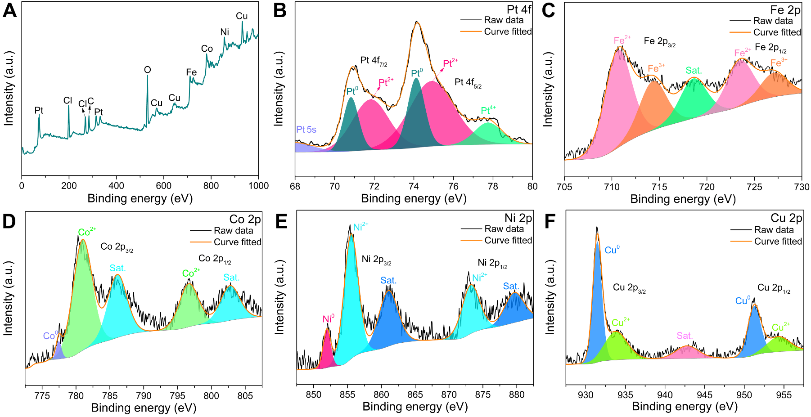

Fig. S11.
(A) XPS survey spectrum of HEA-300. (B-F) Pt 4f, Fe 2p, Co 2p, Ni 2p and Cu 2p high-resolution XPS spectra of HEA-300.

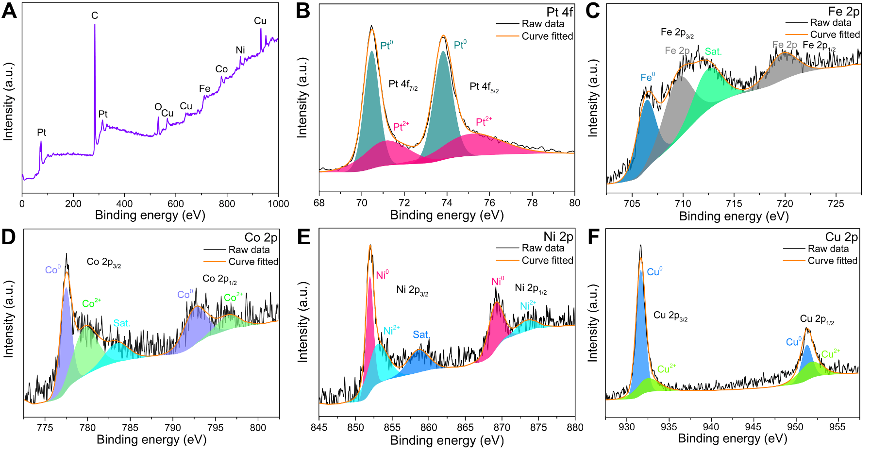

Fig. S12.
(A) XPS survey spectrum of HEA-400. (B-F) Pt 4f, Fe 2p, Co 2p, Ni 2p and Cu 2p high-resolution XPS spectra of HEA-400.

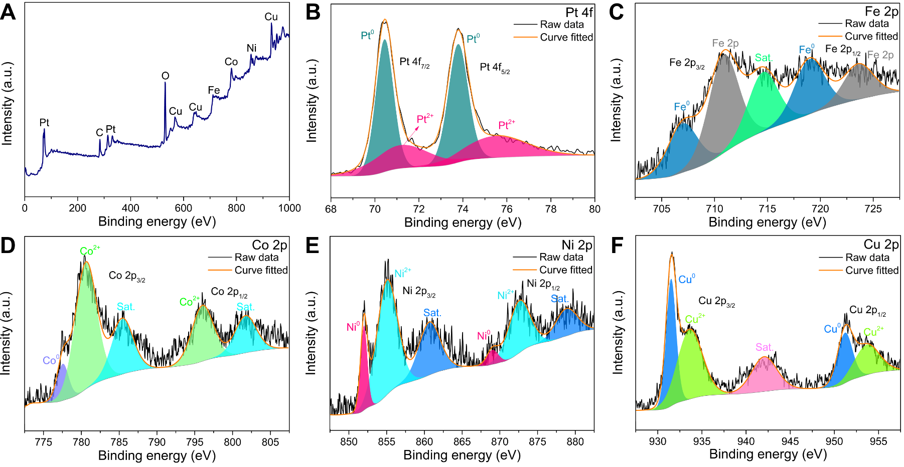

Fig. S13.
(A) XPS survey spectrum of HEA-500. (B-F) Pt 4f, Fe 2p, Co 2p, Ni 2p and Cu 2p high-resolution XPS spectra of HEA-500.

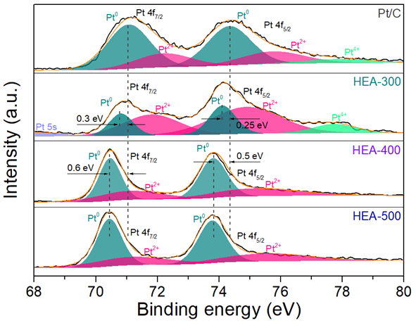

Fig. S14.
Pt 4f high-resolution XPS spectra of Pt/C, HEA-300, HEA-400, and HEA-500.

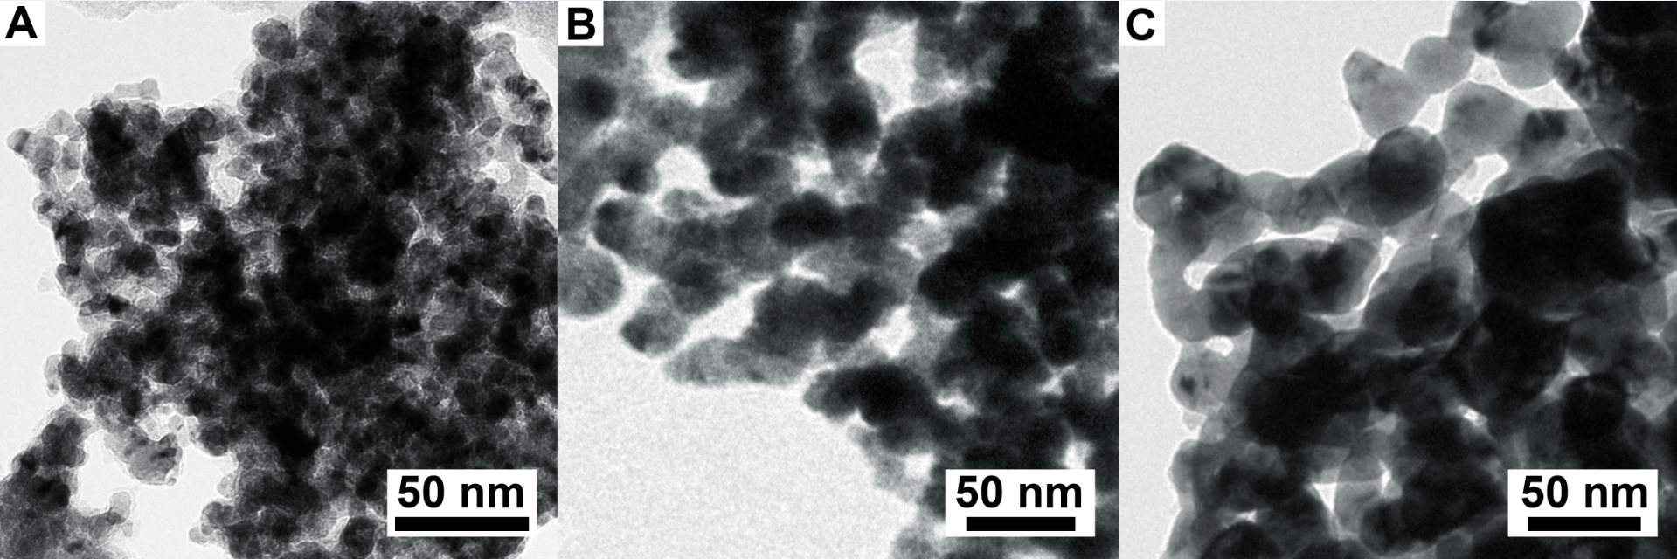

Fig. S15.
TEM images of (A) HEA-300, (B) HEA-400, and (C) HEA-500.

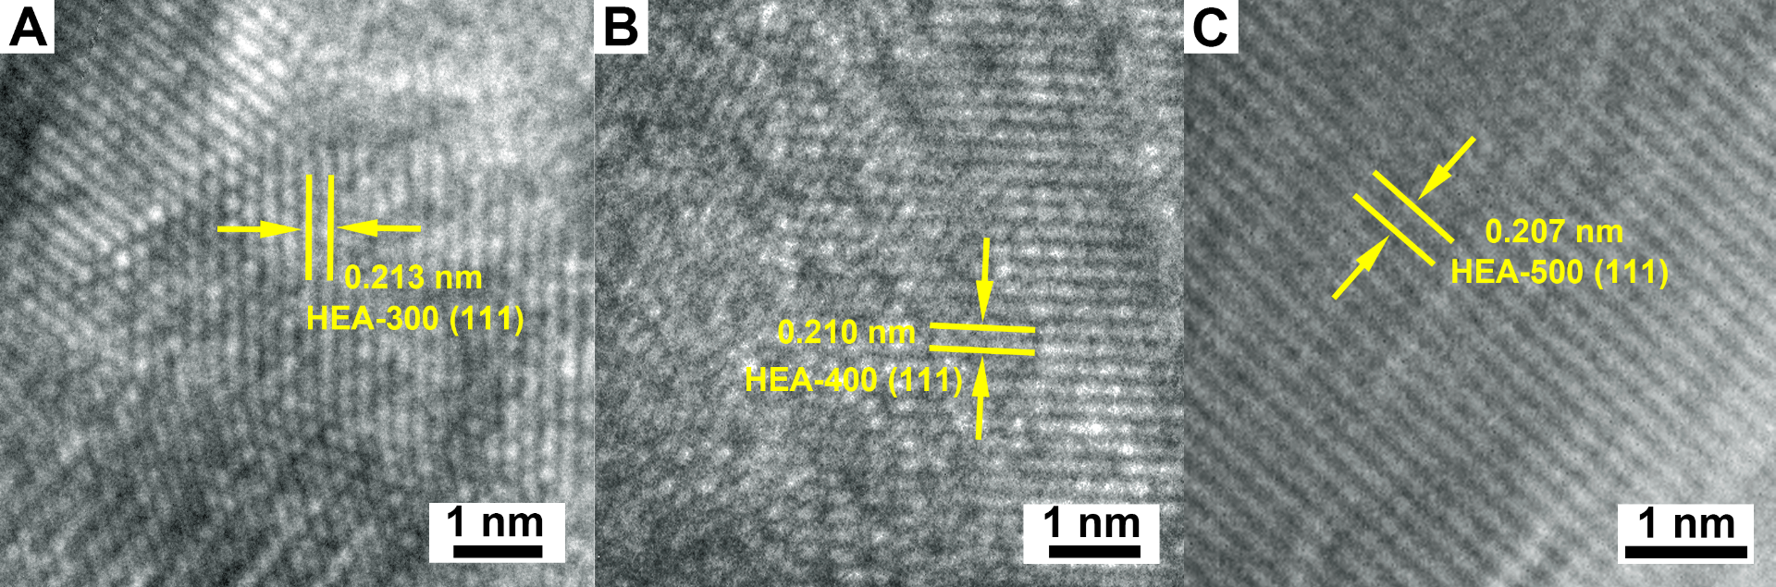

Fig. S16.
HRTEM images of (A) HEA-300, (B) HEA-400, and (C) HEA-500.

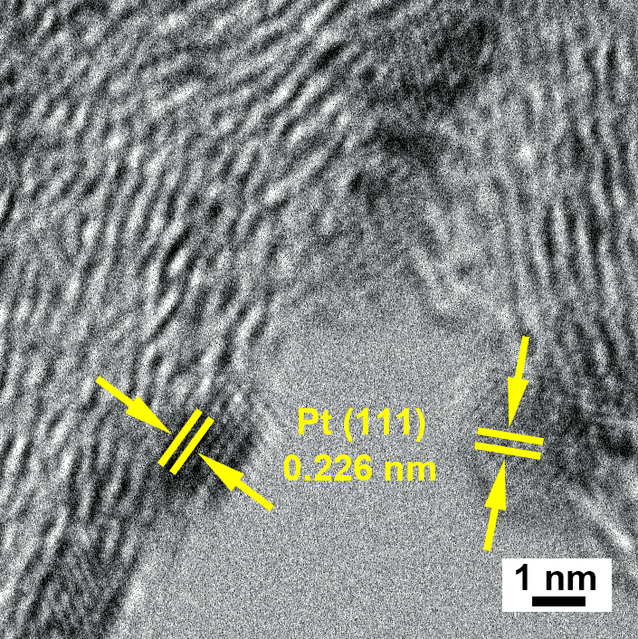

Fig. S17.
HRTEM image of Pt/C.

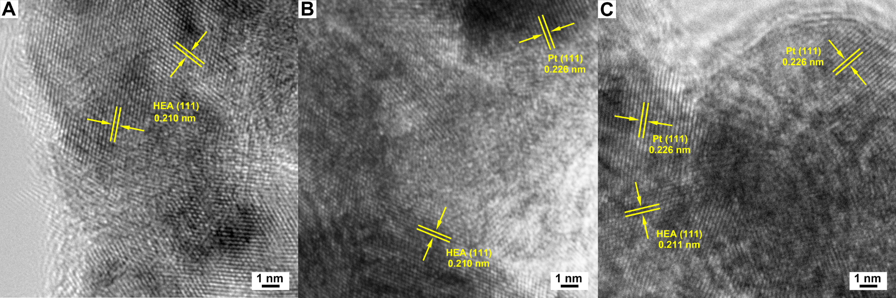

Fig. S18.
HRTEM images of (A) HEA-400-2000, (B) HEA-400-5000, and (C) HEA-400-10000.

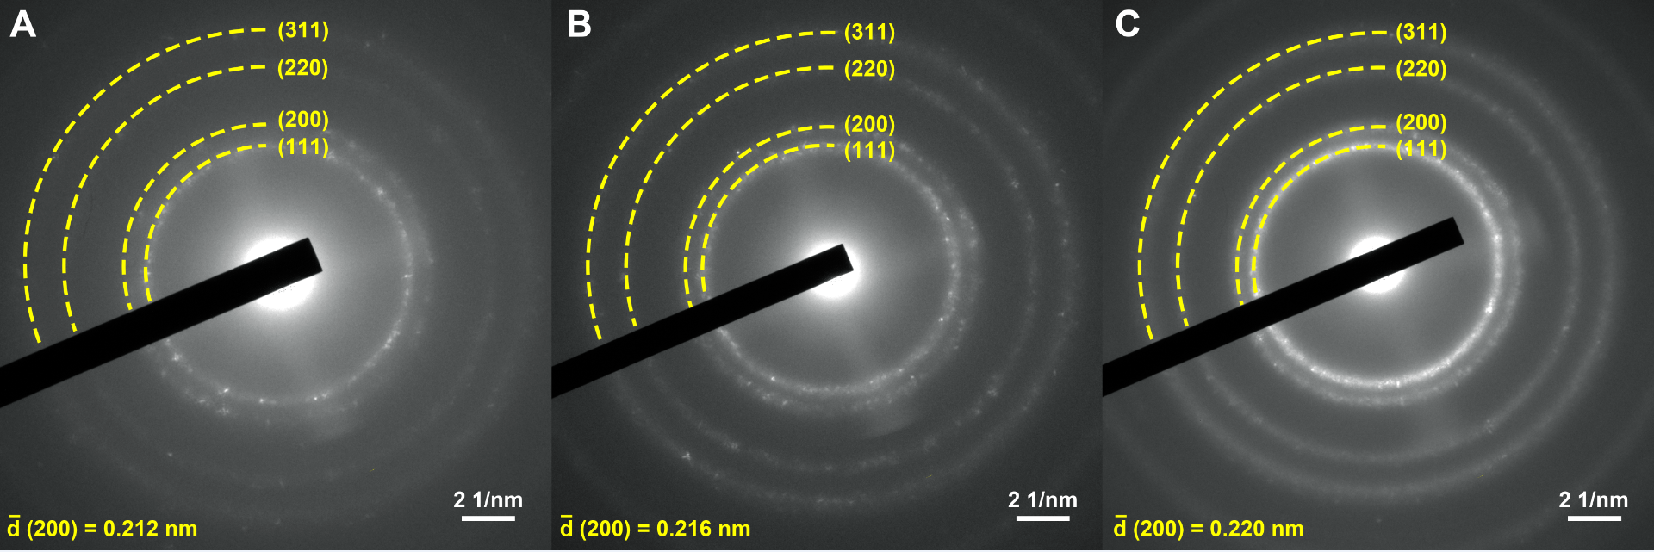

Fig. S19.
SAED patterns of (A) HEA-400-2000, (B) HEA-400-5000, and (C) HEA-400-10000.

Fig. S20.
Atomic-resolution HAADF-STEM image of HEA-400-5000.

Fig. S21.
Origin HAADF TEM image of Fig. 3E. The circled areas I and II are selected for detailed analysis, as shown in fig. S20 and fig. S21, respectively.

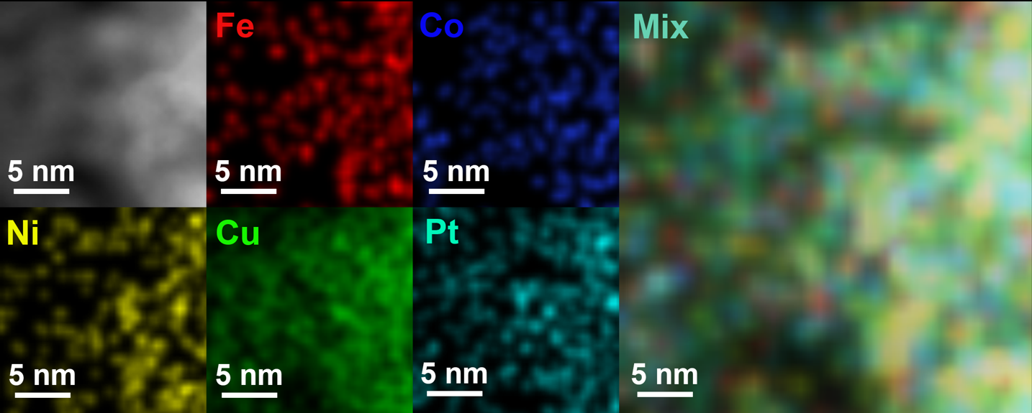

Fig. S22.
HAADF-EDS elemental maps of HEA-400-5000 selected in the near-surface area I in fig. S21.

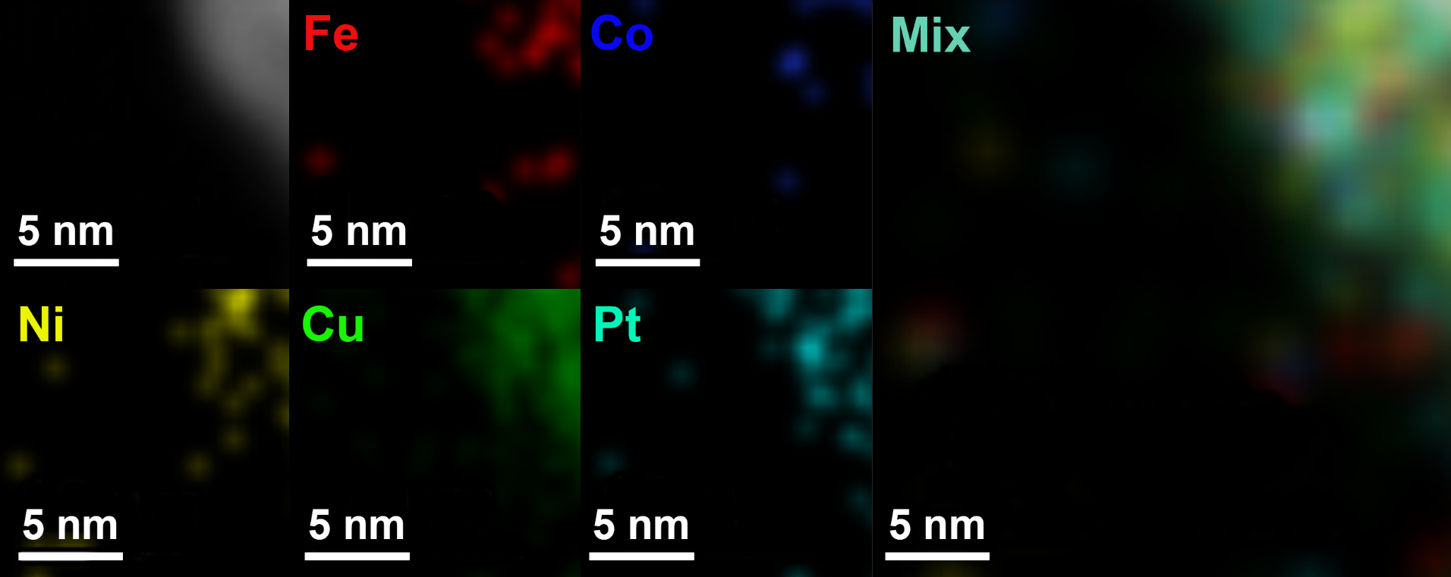

Fig. S23.
HAADF-EDS elemental maps of HEA-400-5000 selected in the near-surface area II in fig. S21.

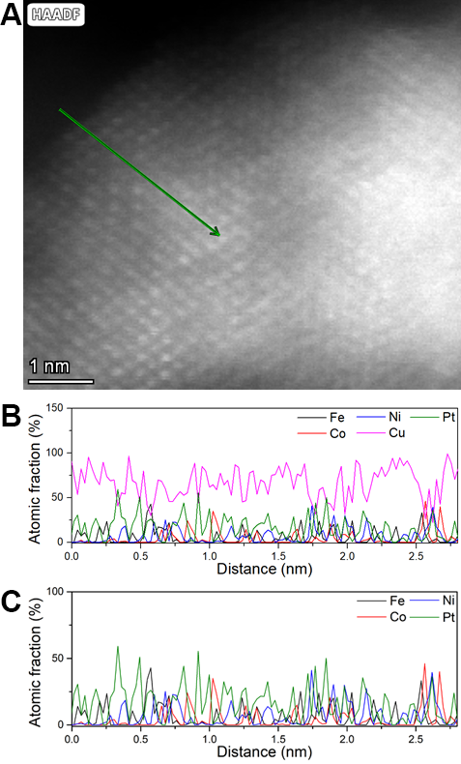

Fig. S24.
(A) HAADF image of HEA-400-5000. (B) HAADF line scan of Fe, Co, Ni, Cu, and Pt elements along the green line showed in figure S24A. (C) HAADF line scan of Fe, Co, Ni, and Pt elements along the green line showed in figure S24A. Note that inevitable errors exist in the data of the Cu element due to the equipment factors. Thus, they are removed for clarity.

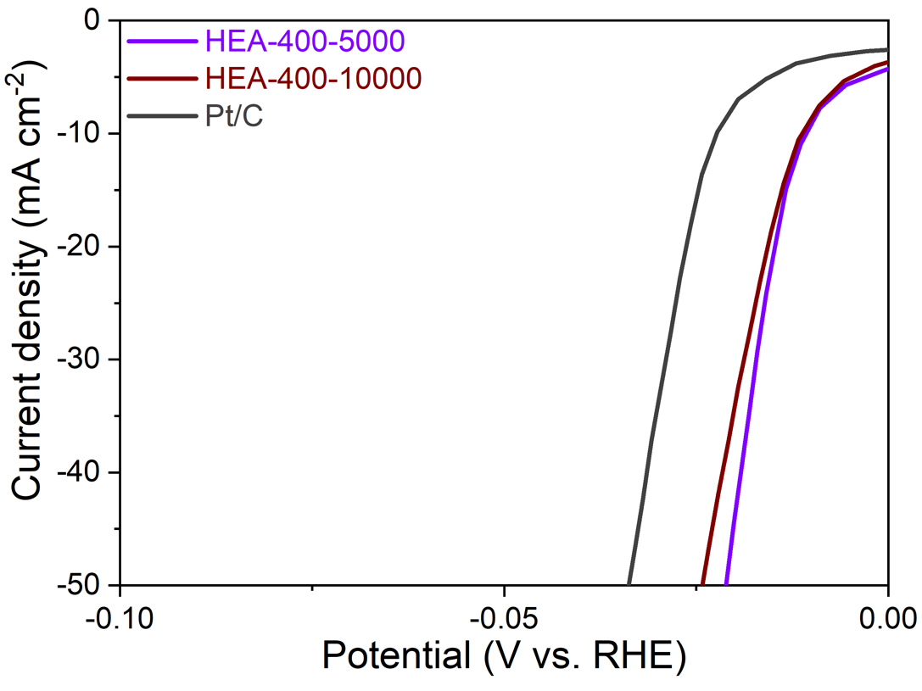
Fig. S25.
Polarization curves of HEA-400-5000, HEA-400-10000 and Pt/C.

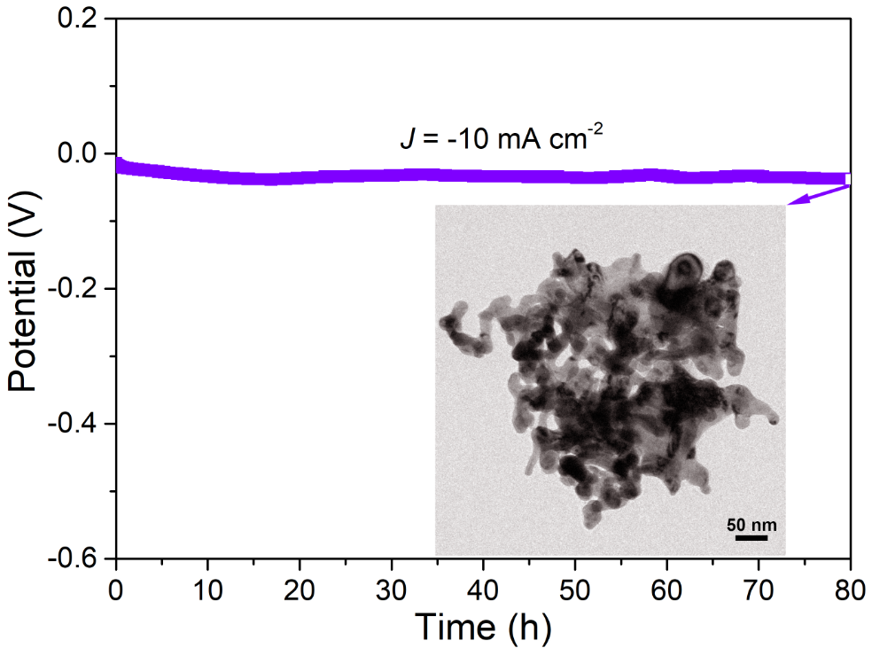
Fig. S26.
The galvanostatic plot of activated HEA-400 (HEA-400-5000) at -10 mA cm⁻² for 80 h. The inset shows a TEM image of HEA-400-5000 after the 80-h test.

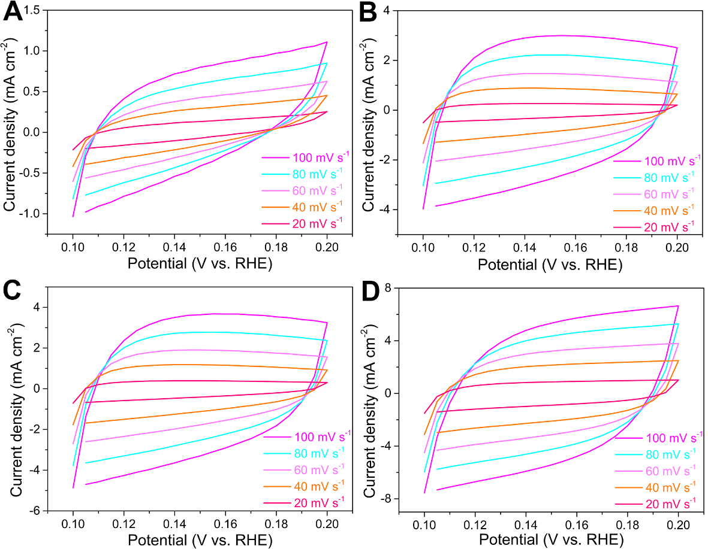
Fig. S27.
(A-D) Detailed cyclic voltammetry data for HEA-400-initial, HEA-400-100, HEA-400-2000, and HEA-400-5000 in Fig. 3B, respectively.

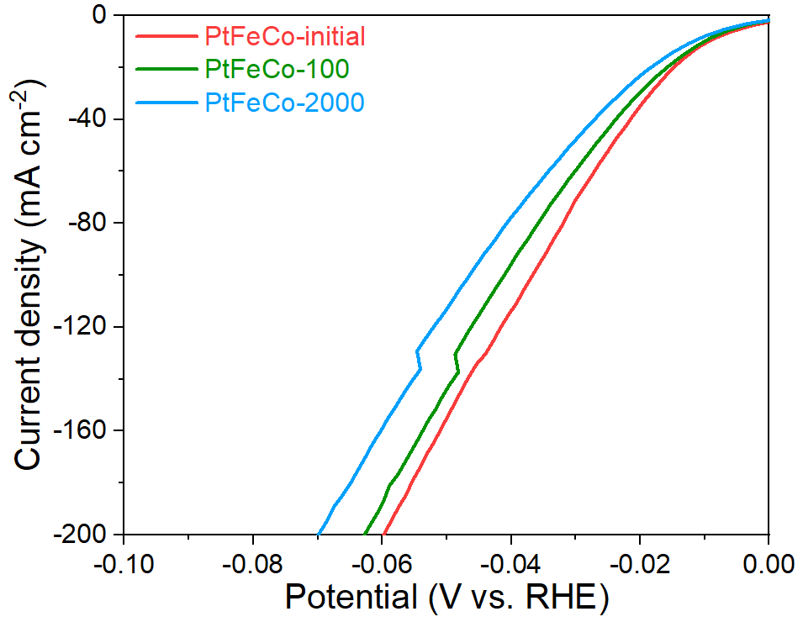

Fig. S28.
Polarization curves of a ternary PtFeCo alloy before and after CV test. The electrochemical activation effect is not observed in PtFeCo, demonstrating that the dual-gradient system is unable to form when the components in the alloy are inadequate.

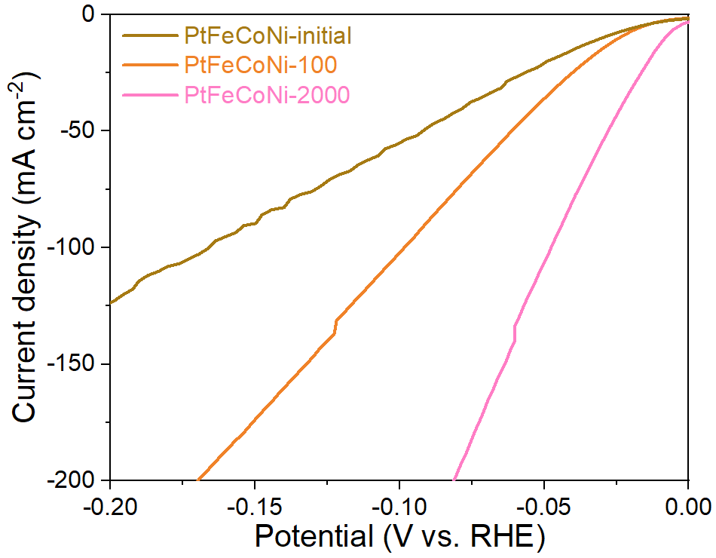

Fig. S29.
Polarization curves of a quaternary PtFeCoNi alloy before and after CV test. The electrochemical activation effect is observed.

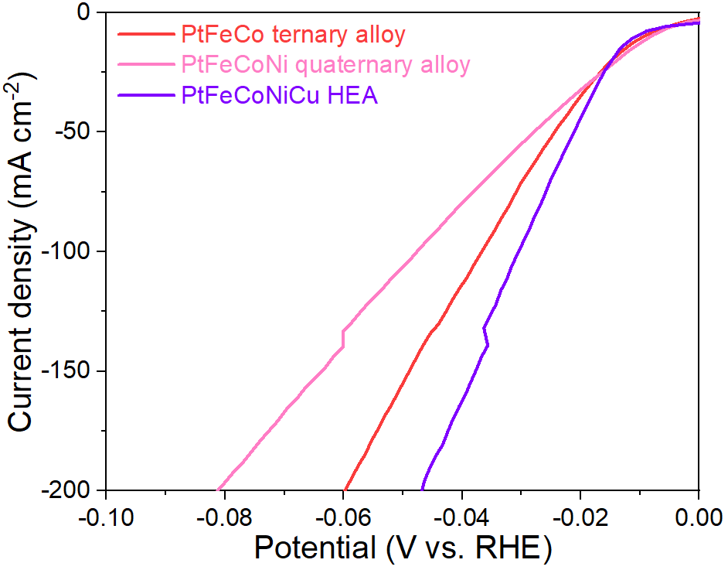

Fig. S30.
Comparison of polarization curves among PtFeCo, PtFeCoNi and PtFeCoNiCu HEA.

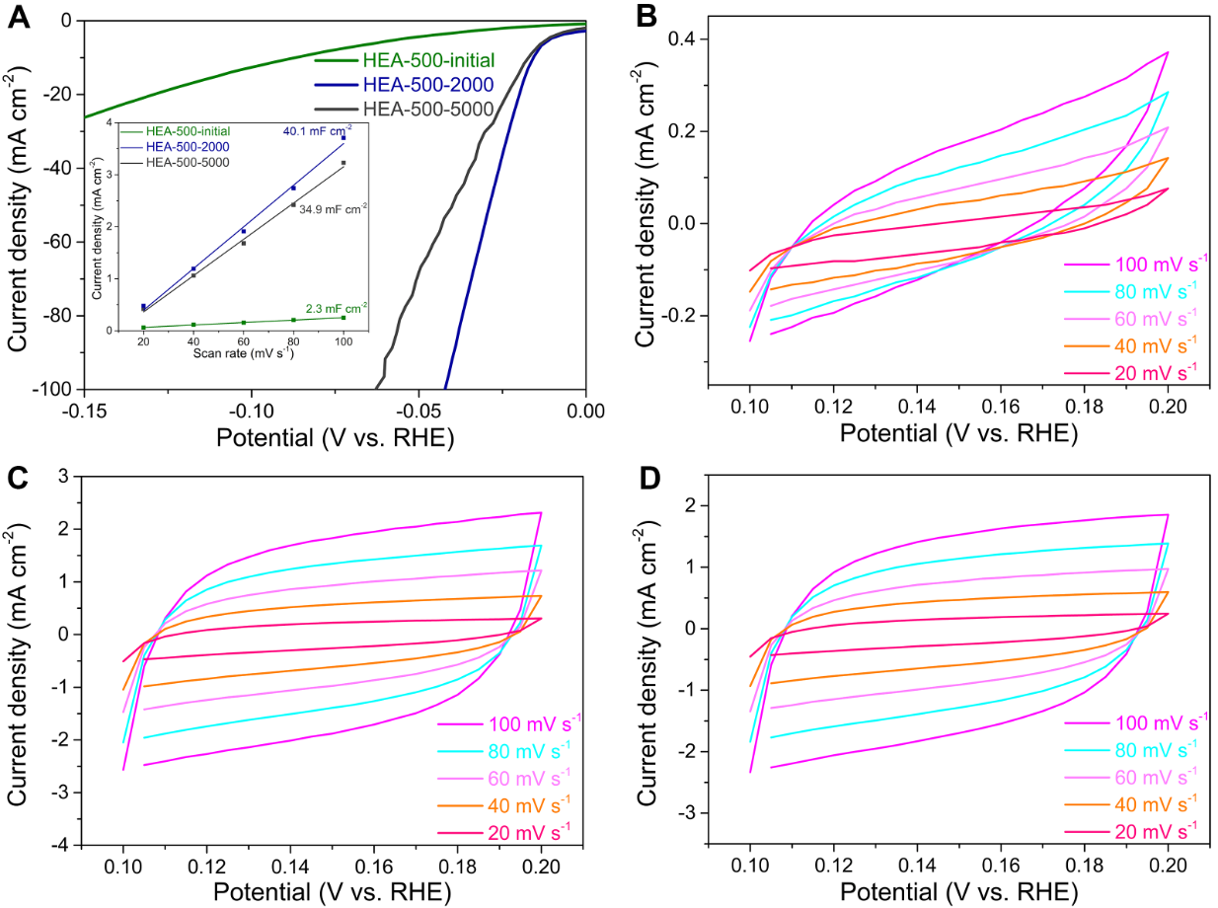

Fig. S31.
(A) Polarization curves of HEA-500 before and after electrochemical activation. The inset shows the plots of capacitive currents with various scan rates for HEA-500 before and after electrochemical activation. (B-D) are the corresponding cyclic voltammetry data for HEA-500-initial, HEA-500-2000, and HEA-500-5000, respectively.

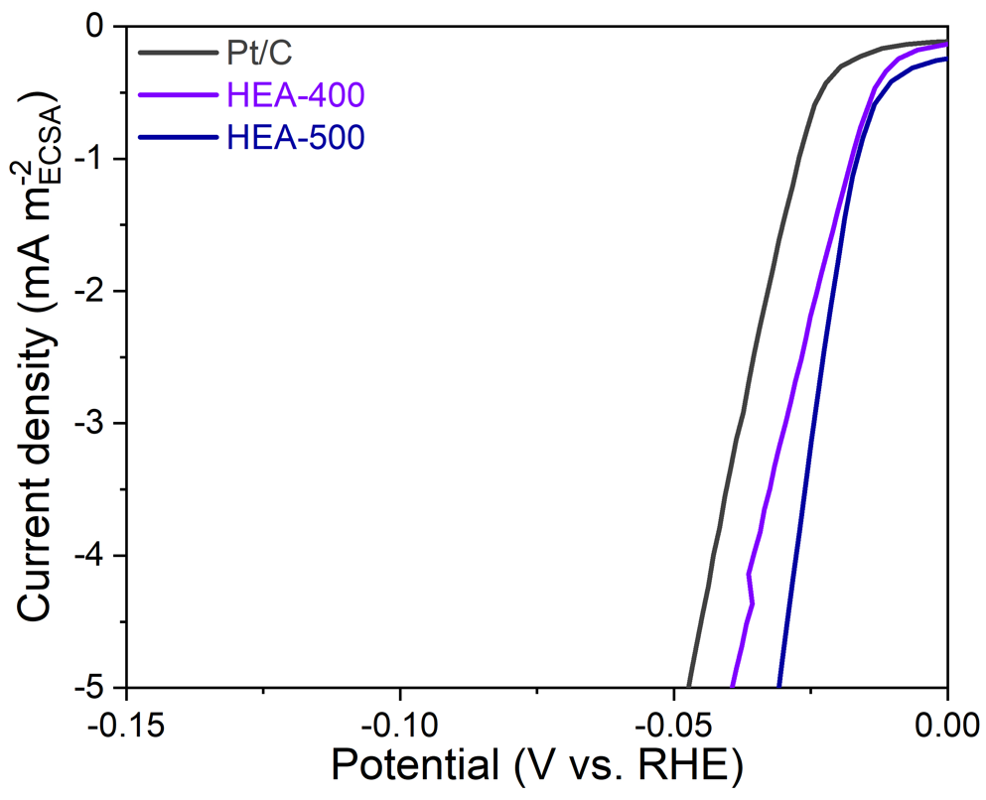

Fig. S32.
Polarization curves normalized to ECSA for activated HEA-400, activated HEA-500, and Pt/C.

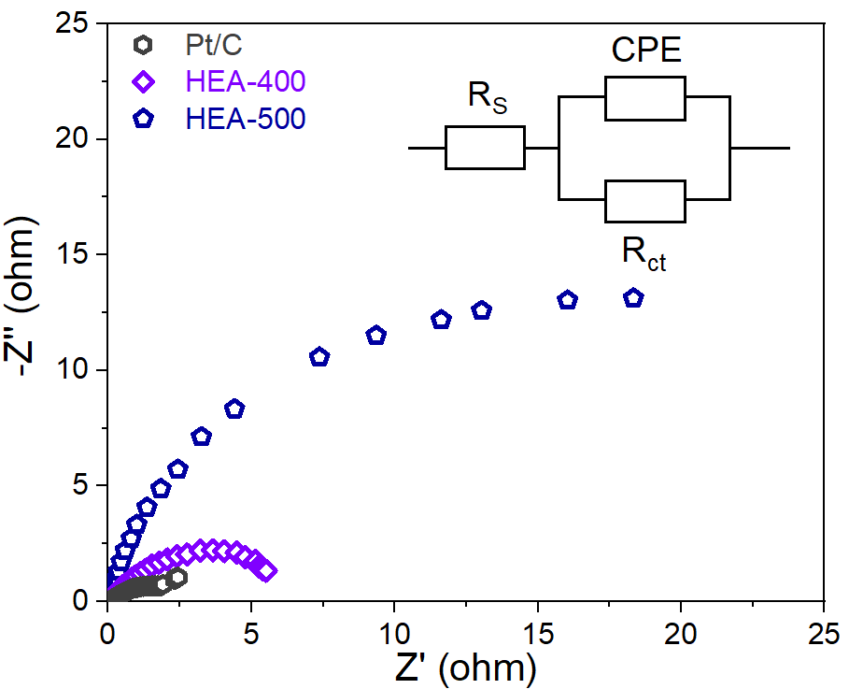

Fig. S33.
Nyquist plots of activated HEA-400 (HEA-400-5000), activated HEA-500 (HEA-500-2000), and Pt/C, the inset shows the equivalent electrical circuit diagram.

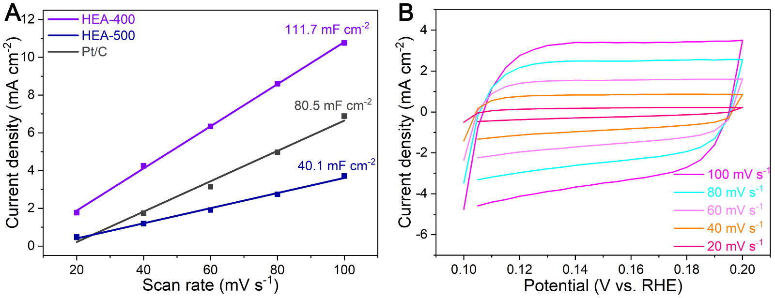

Fig. S34.
(A) Plots of capacitive currents with various scan rates for activated HEA-400 (HEA-400-5000), activated HEA-500 (HEA-500-2000), and Pt/C. (B) Detailed CV data for Pt/C.

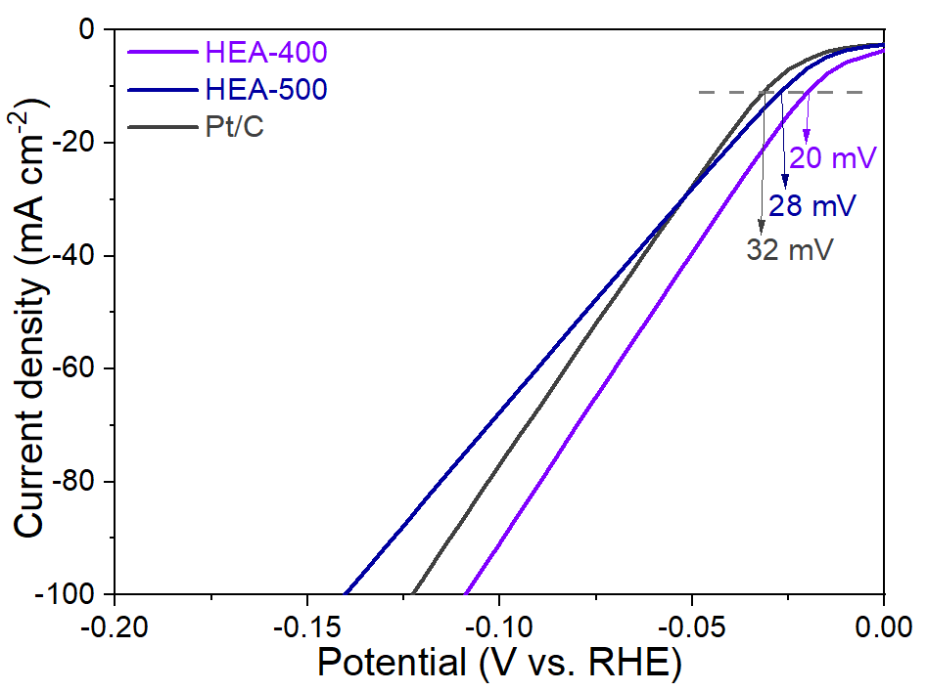

Fig. S35.
Polarization curves of activated HEA-400 (HEA-400-5000), activated HEA-500 (HEA-500-2000), and Pt/C without iR-compensation.

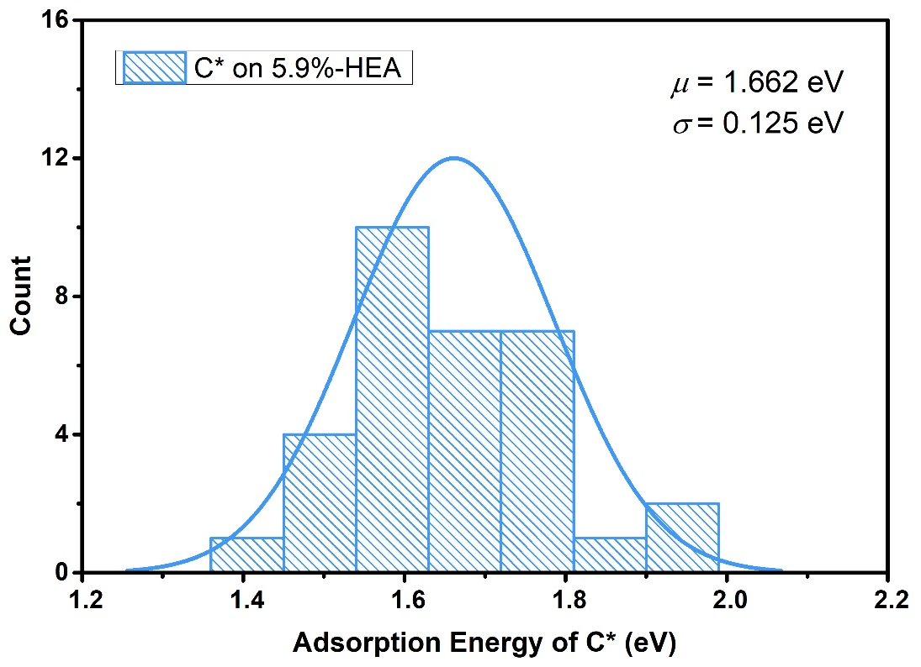

Fig. S36.
Gaussian distribution of adsorption energy of C* on 5.9%-HEA.

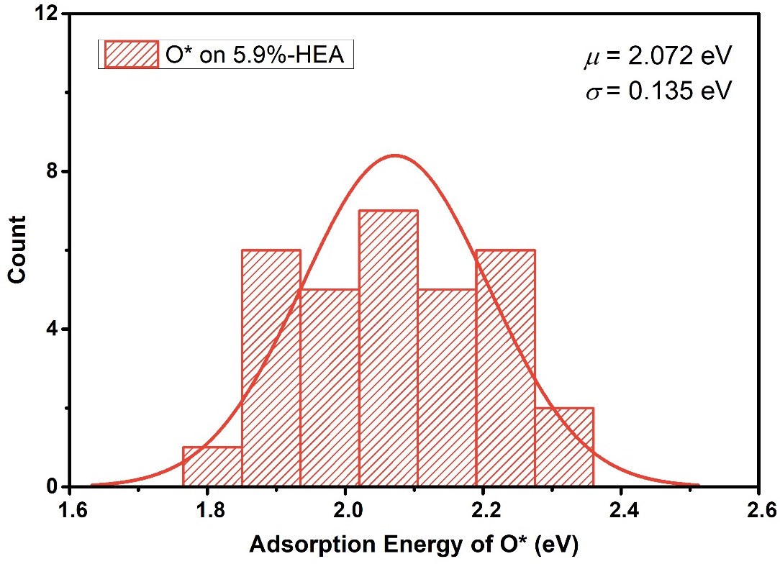
Fig. S37.
Gaussian distribution of adsorption energy of O* on 5.9%-HEA.

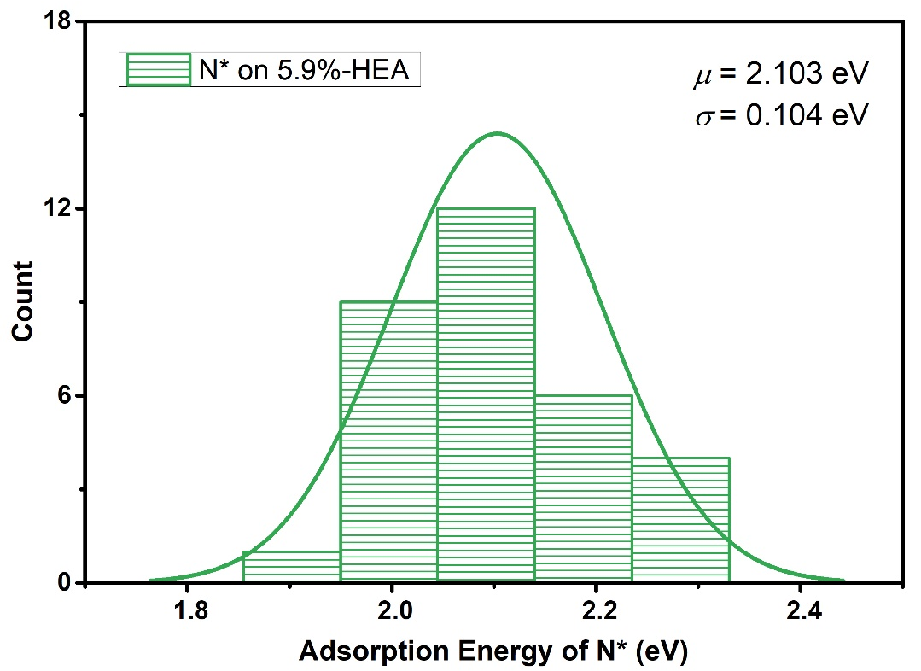
Fig. S38.
Gaussian distribution of adsorption energy of N* on 5.9%-HEA.

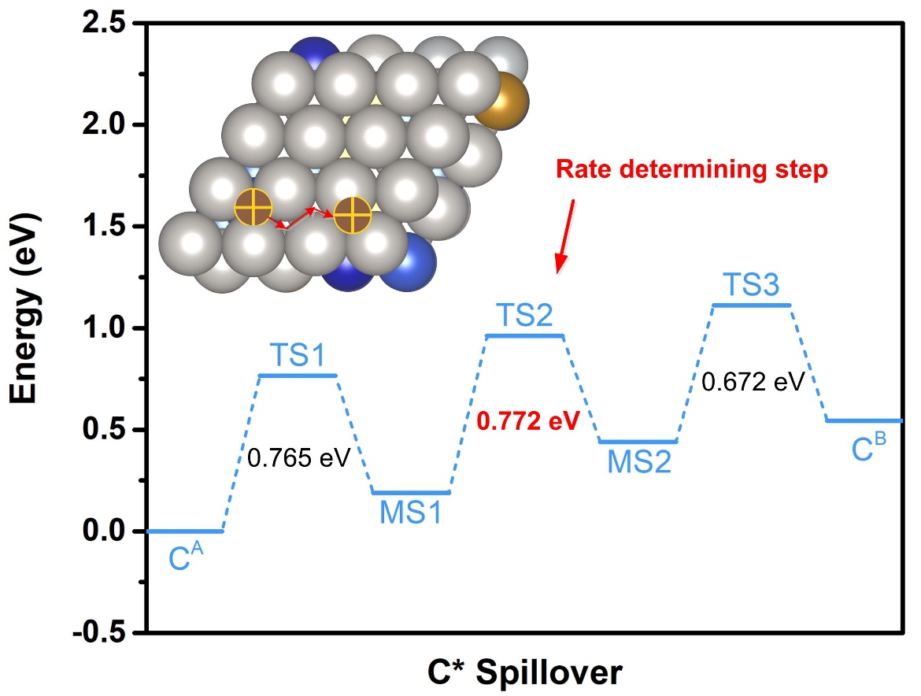
Fig. S39.
C* spillover on 5.9%-HEA (111).

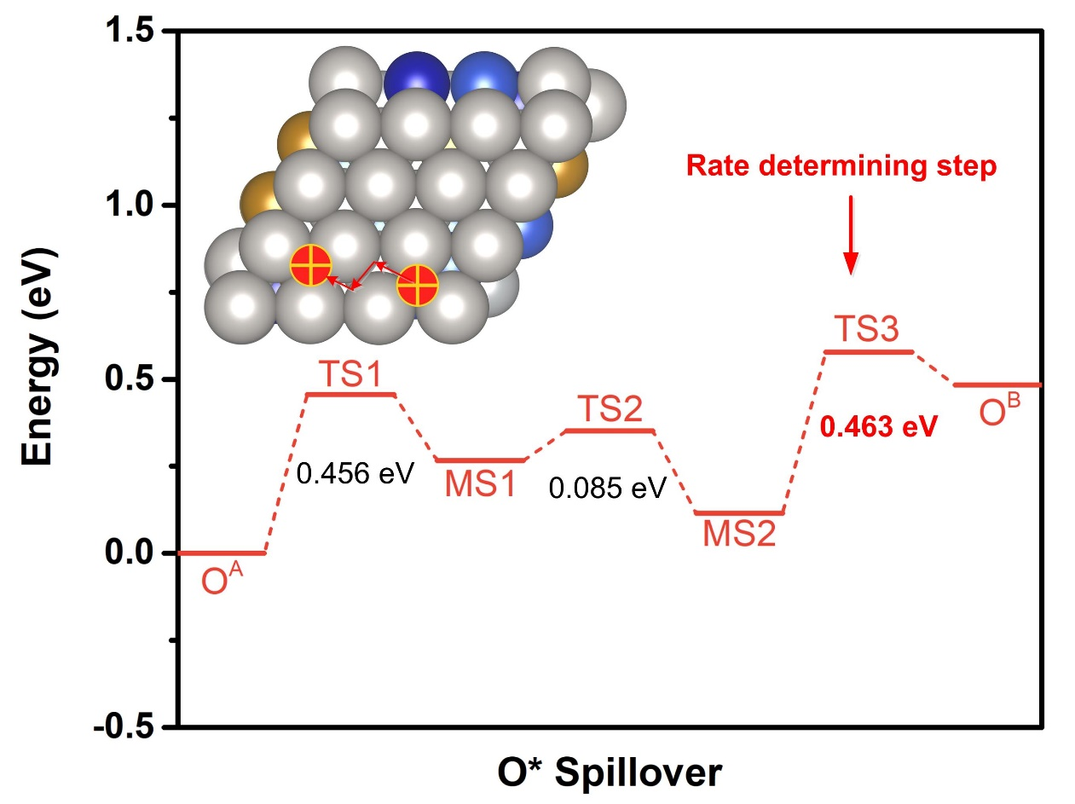
Fig. S40.
O* spillover on 5.9%-HEA (111).

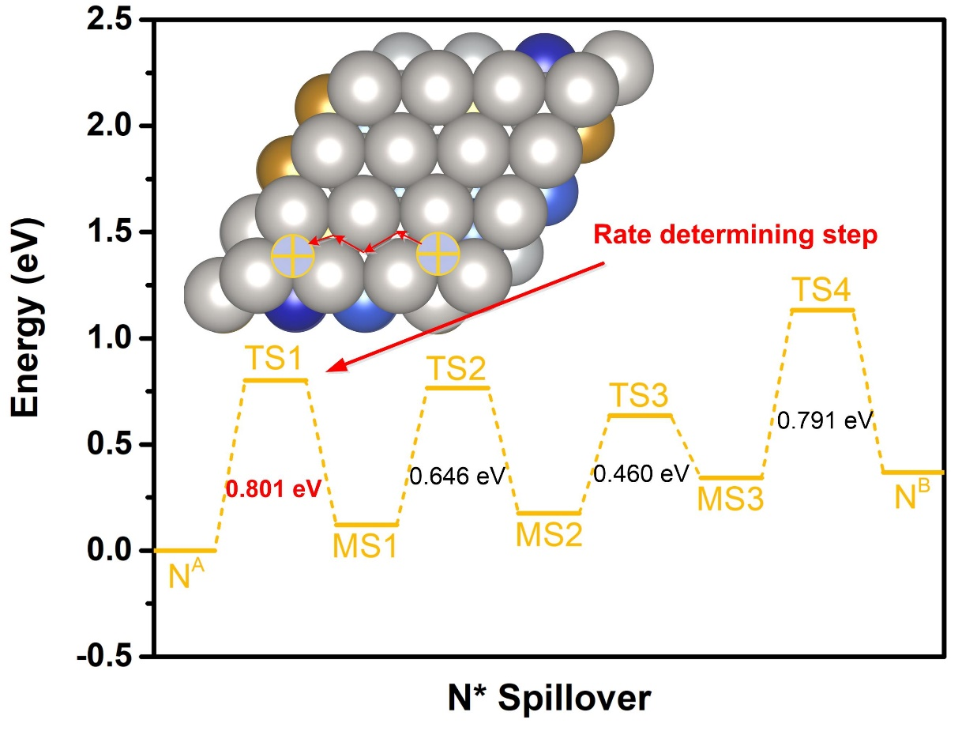
Fig. S41.
N* spillover on 5.9%-HEA (111).

Table S1.
Contents of Pt, Fe, Co, Ni and Cu in the electrolytes after different cycles of CV activation for HEA-400.

Electrolytes | Pt (mg/L) | Fe (mg/L) | Co (mg/L) | Ni (mg/L) | Cu (mg/L)
HEA after 100 CV cycles | 0 | 0.0587 | 0.1299 | 0.0635 | 0.0255
HEA after 2000 CV cycles | 0 | 0.1040 | 0.1480 | 0.0928 | 0.1546
HEA after 5000 CV cycles | 0 | 0.1112 | 0.1514 | 0.0951 | 0.1656
HEA after 10000 CV cycles | 0 | 0.1009 | 0.1560 | 0.1048 | 0.1722

Table S2.
Comparison of HER performance among some reported catalysts in 0.5 M H₂SO₄.

Catalysts | Overpotential at 10 mA cm⁻² (mV) | Tafel slope  (mV dec⁻¹) | Reference
PtFeCoNiCu HEA | 10.8 | 28.1 | This work
Pt/MoS₂ | 14 | 96 | (8)
PtSA/NT/NF | 24 | 30 | (9)
ALDPt/NGNs | 48 | 29 | (10)
Pt/MoS₂ | 32.9 | 25 | (11)
AL-Pt/Pd₃Pb | 13.8 | 18 | (12)
Pt/AG | 12 | 29.3 | (13)
Mo₂TiC₂T_{x}-Pt_{SA} | 30 | 30 | (14)
Pt₁/OLC | 38 | 36 | (15)
Pt/np-Co_{0.85}Se | 55 | 35 | (16)
Rh/MoS₂ | 67 | 54 | (17)
Pt/PCM | 105 | 65.3 | (18)
RuCoP | 11 | 31 | (19)
Ir/CON | 13.6 | 32 | (20)
Pt/RuCeO_{x} | 41 | 31 | (21)
Pt/WO₃ | 39 | 32.9 | (22)
Ir/SiNW | 22 | 20 | (23)
EG-Pt/CoP | 21 | 42.5 | (24)
PbPtCuNiP | 62 | 44.6 | (25)
K₂PtCl₄/NC | 11 | 21 | (26)
Pt/MC | 27.3 | 26 | (27)

References and Notes
1. J. D. Benck, Z. B. Chen, L. Y. Kuritzky, A. J. Forman, T. F. Jaramillo, Amorphous Molybdenum Sulfide Catalysts for Electrochemical Hydrogen Production: Insights into the Origin of their Catalytic Activity. ACS Catal. 2, 1916-1923 (2012).
2. C. C. L. McCrory, S. Jung, I. M. Ferrer, S. M. Chatman, J. C. Peters, T. F. Jaramillo, Benchmarking Hydrogen Evolving Reaction and Oxygen Evolving Reaction Electrocatalysts for Solar Water Splitting Devices. J. Am. Chem. Soc. 137, 4347-4357 (2015).
3. G. Kresse, J. Furthmuller, Efficient iterative schemes for ab initio total-energy calculations using a plane-wave basis set. Phys. Rev. B 54, 11169 (1996).
4. P. E. Blochl, Projector augmented-wave method. Phys. Rev. B 50, 17953-17979 (1994).
5. J. P. Perdew, K. Burke, M. Ernzerhof, Generalized gradient approximation made simple. Phys. Rev. Lett. 77, 3865 (1996).
6. S. Grimme, J. Antony, S. Ehrlich, H. Krieg, A consistent and accurate ab initio parametrization of density functional dispersion correction (DFT-D) for the 94 elements H-Pu. J. Chem. Phys. 132, 154104 (2010).
7. G. Henkelman, B. P. Uberuaga, H. Jonsson, A climbing image nudged elastic band method for finding saddle points and minimum energy paths. J. Chem. Phys. 113, 9901-9904 (2000).
8. J. Deng, H. B. Li, J. P. Xiao, Y. C. Tu, D. H. Deng, H. X. Yang, H. F. Tian, J. Q. Li, P. J. Ren, X. H. Bao, Triggering the electrocatalytic hydrogen evolution activity of the inert two-dimensional MoS₂ surface via single-atom metal doping. Energy Environ. Sci. 8, 1594-1601 (2015).
9. L. H. Zhang, L. L. Han, H. X. Liu, X. J. Liu, J. Luo, Potential-cycling synthesis of single Pt atoms for efficient hydrogen evolution in neutral media. Angew. Chem. Int. Edit. 56, 13694-13698 (2017).
10. N. C. Cheng, S. Stambula, D. Wang, M. N. Banis, J. Liu, A. Riese, B. W. Xiao, R. Y. Li, T. K. Sham, L. M. Liu, G. A. Botton, X. L. Sun, Platinum single-atom and cluster catalysis of the hydrogen evolution reaction. Nat. Commun. 7, 13638 (2016).
11. Z. X. Chen, K. Leng, X. X. Zhao, S. Malkhandi, W. Tang, B. B. Tian, L. Dong, L. R. Zheng, M. Lin, B. S. Yeo, K. P. Loh, Interface confined hydrogen evolution reaction in zero valent metal nanoparticles-intercalated molybdenum disulfide. Nat. Commun. 8, 14548 (2017).
12. Y. C. Yao, X. K. Gu, D. S. He, Z. J. Li, W. Liu, Q. Xu, T. Yao, Y. Lin, H. J. Wang, C. M. Zhao, X. Q. Wang, P. Q. Yin, H. Li, X. Hong, S. Q. Wei, W. X. Li, Y. D. Li, Y. Wu, Engineering the electronic structure of submonolayer Pt on intermetallic Pd₃Pb via charge transfer boosts the hydrogen evolution reaction. J. Am. Chem. Soc. 141, 19964-19968 (2019).
13. S. H. Ye, F. Y. Luo, Q. L. Zhang, P. Y. Zhang, T. T. Xu, D. S. He, L. C. Guo, Y. Zhang, C. X. He, X. P. Ouyang, Q. Wang, M. Gu, J. H. Liu, X. L. Sun, Highly stable single Pt atomic sites anchored on aniline-stacked graphene for hydrogen evolution reaction. Energy Environ. Sci. 12, 1000-1007 (2019).
14. J. Q. Zhang, Y. F. Zhao, X. Guo, C. Chen, C. L. Dong, R. S. Liu, C. P. Han, Y. D. Li, Y. Gogotsi, G. X. Wang, Single platinum atoms immobilized on an MXene as an efficient catalyst for the hydrogen evolution reaction. Nat. Catal. 1, 985-992 (2018).
15. D. B. Liu, X. Y. Li, S. M. Chen, H. Yan, C. D. Wang, C. Q. Wu, Y. A. Haleem, S. Duan, J. L. Lu, B. H. Ge, P. M. Ajayan, Y. Luo, J. Jiang, L. Song, Atomically dispersed platinum supported on curved carbon supports for efficient electrocatalytic hydrogen evolution. Nat. Energy 4, 512-518 (2019).
16. K. Jiang, B. Y. Liu, M. Luo, S. C. Ning, M. Peng, Y. Zhao, Y. R. Lu, T. S. Chan, F. M. F. Groot, Y. W. Tan, Single platinum atoms embedded in nanoporous cobalt selenide as electrocatalyst for accelerating hydrogen evolution reaction. Nat. Commun. 10, 1743 (2019).
17. X. Y. Meng, C. Ma, L. Z. Jiang, R. Si, X. G. Meng, Y. C. Tu, L. Yu, X. H. Bao, D. H. Deng, Distance synergy of MoS₂-confined Rhodium atoms for highly efficient hydrogen evolution. Angew. Chem. Int. Edit. 59, 10502-10507 (2020).
18. H. B. Zhang, P. F. An, W. Zhou, B. Y. Guan, P. Zhang, J. C. Dong, X. W. Lou, Dynamic traction of lattice-confined platinum atoms into mesoporous carbon matrix for hydrogen evolution reaction. Sci. Adv. 4, eaao6657 (2018).
19. J. Y. Xu, T. F. Liu, J. J. Li, Y. F. Liu, B. S. Zhang, D. H. Xiong, I. Amorim, W. Li, L. F. Liu, Boosting the hydrogen evolution performance of ruthenium clusters through synergistic coupling with cobalt phosphide. Energy Environ. Sci. 11, 1819-1827 (2018).
20. J. Mahmood, M. A. R. Anjum, S. H. Shin, I. Ahmad, H. J. Noh, S. J. Kim, H. J. Jeong, J. S. Lee, J. B. Baek, Encapsulating iridium nanoparticles inside a 3D cage-like organic network as an efficient and durable catalyst for the hydrogen evolution reaction. Adv. Mater. 30, 1805606 (2018).
21. T. T. Liu, W. B. Gao, Q. Q. Wang, M. L. Dou, Z. P. Zhang, F. Wang, Selective loading of atomic platinum on a RuCeO_{x} support enables stable hydrogen evolution at high current densities. Angew. Chem. Int. Edit. 59, 20423-20427 (2020).
22. C. Xie, W. Chen, S. Q. Du, D. F. Yan, Y. Q. Zhang, J. Chen, B. Liu, S. Y. Wang, In-situ phase transition of WO₃ boosting electron and hydrogen transfer for enhancing hydrogen evolution on Pt. Nano Energy 71, 104653 (2020).
23. M. Q. Sheng, B. B. Jiang, B. Wu, F. Liao, X. Fan, H. P. Lin, Y. Y. Li, Y. Lifshitz, S. T. Lee, M. W. Shao, Approaching the volcano top: Iridium/Silicon nanocomposites as efficient electrocatalysts for the hydrogen evolution reaction. ACS Nano 13, 2786-2794 (2019).
24. J. Y. Li, H. X. Liu, W. Y. Gou, M. K. Zhang, Z. M. Xia, Z. Zhang, C. R. Chang, Y. Y. Ma, Y. Q. Qu, Ethylene-glycol ligand environment facilitates highly efficient hydrogen evolution of Pt/CoP through proton concentration and hydrogen spillover. Energy Environ. Sci. 12, 2298-2304 (2019).
25. Z. Jia, K. Nomoto, Q. Wang, C. Kong, L. G. Sun, L. C. Zhang, S. X. Liang, J. Lu, J. J. Kruzic, A self-supported high-entropy metallic glass with a nanosponge architecture for efficient hydrogen evolution under alkaline and acidic conditions. Adv. Funct. Mater. 31, 2101586 (2021).
26. H. Y. Jin, S. Sultan, M. R. Ha, J. N. Tiwari, M. G. Kim, K. S. Kim, Simple and scalable mechanochemical synthesis of noble metal catalysts with single atoms toward highly efficient hydrogen evolution. Adv. Funct. Mater. 30, 2000531 (2020).
27. H. H. Wei, K. Huang, D. Wang, R. Y. Zhang, B. H. Ge, J. Y. Ma, B. Wen, S. Zhang, Q. Y. Li, M. Lei, C. Zhang, J. Irawan, L. M. Liu, H. Wu, Iced photochemical reduction to synthesize atomically dispersed metals by suppressing nanocrystal growth. Nat. Commun. 8, 1490 (2017).

