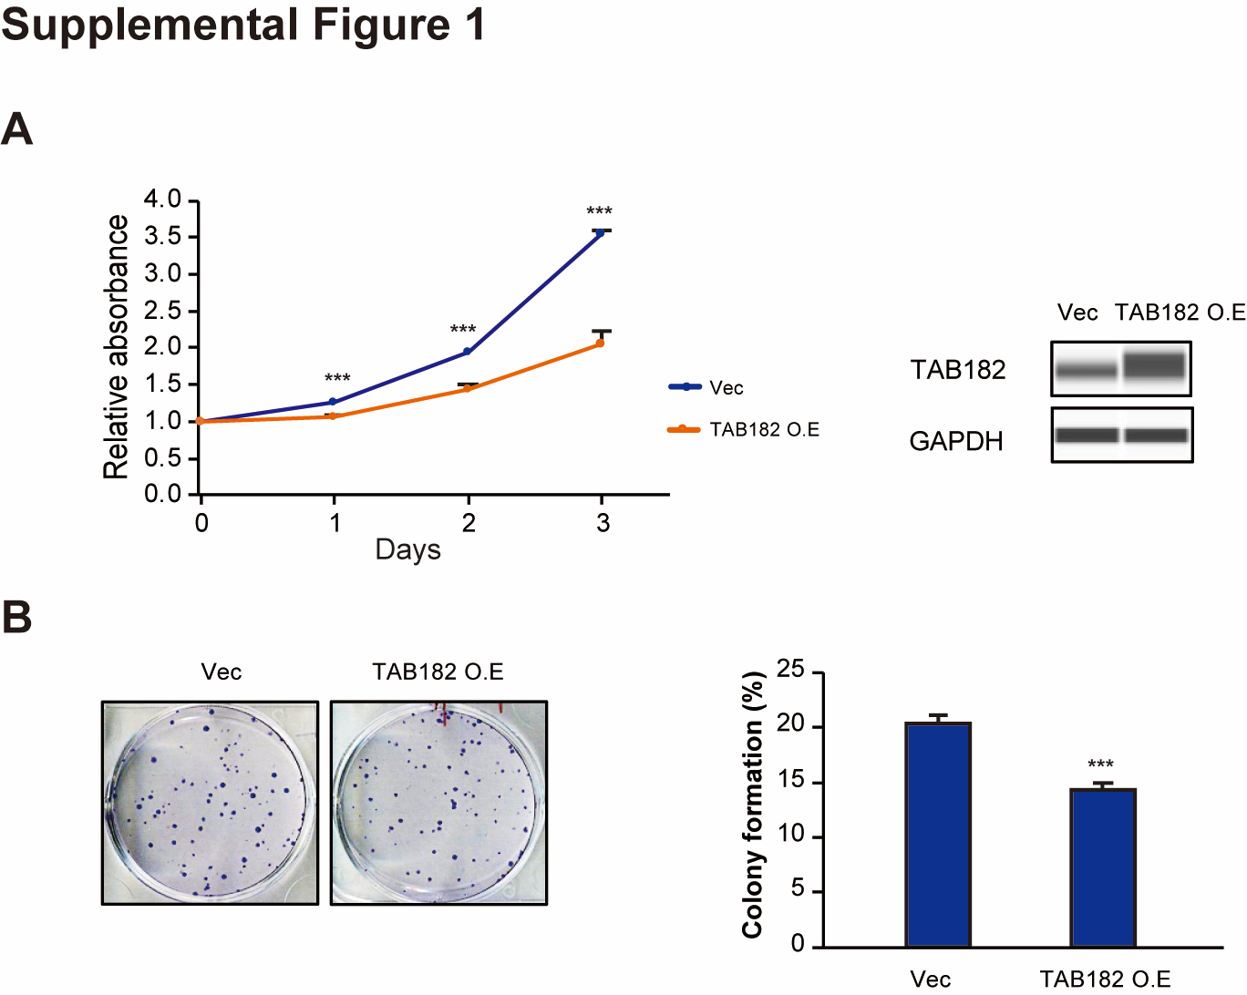
Fig. S1. Overexpression of TAB182 inhibits cell proliferation and colony formation. (A) CCK-8 cell proliferation assay was measured at indicated time points in MDA-MB-231 cells transfected with pcDNA3.1+ TAB182 overexpression plasmid (TAB182 O.E) or Empty vector. Absorbance measured at day 0 was used for normalization. *** P<0.001 by Student’s t-test (n=3). The overexpression of TAB182 was verified by Western blot analysis using the anti-TAB182 antibody, and GAPDH was used as a loading control (right panel of C). (B) The representative photos and quantification results of cell colony formation assay in TAB182 overexpressed MDA-MB-231 cells. *** P<0.001 by Student’s t-test (n=3).

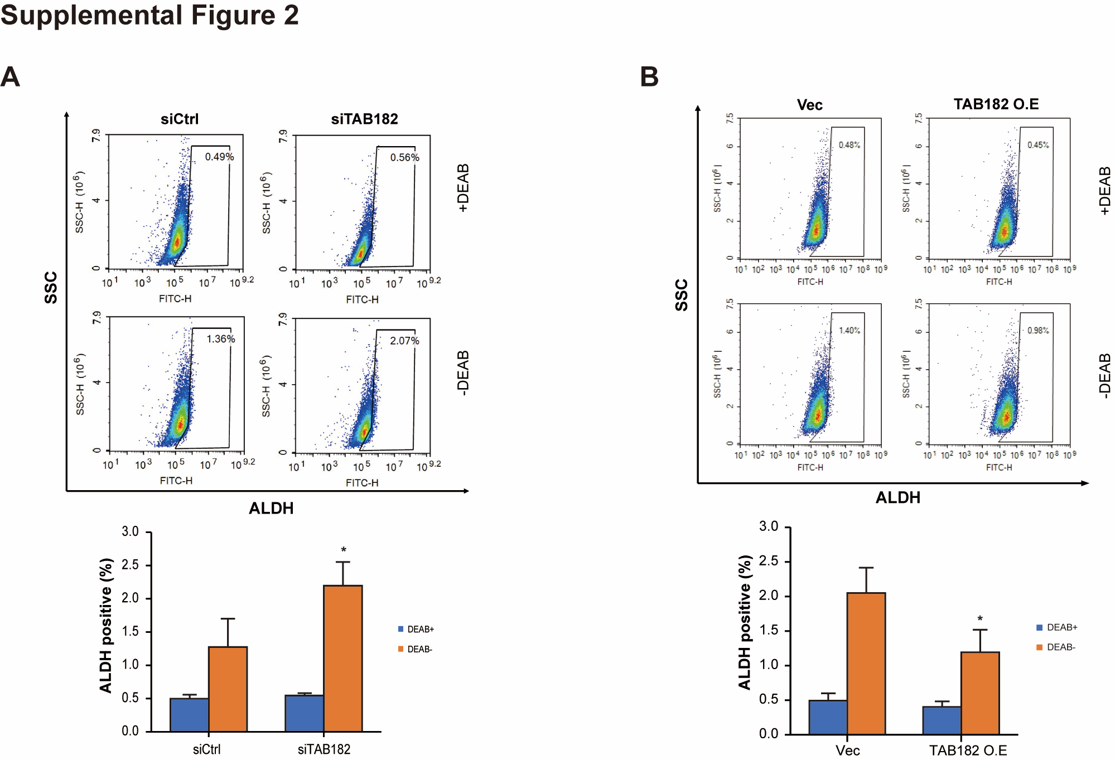
Fig. S2. TAB182 deletion increases the percentage of ALDH-positive cells. ALDEFLUOR assay was performed to detect changes in percentages of the ALDH-positive population in BT549 cells upon TAB182 deletion (A) or overexpression (B). DEAB was used as the negative control. SSC: side scatter. FITH: the fluorescence signal of ALDH. Percentages of ALDH positive cells were presented at the bottom of A and B. * P < 0.05, DEAB- siTAB182/TAB182 O.E vs. DEAB- siCtrl/Vec, by Student’s t-test.

