Enhancing the electrical conductivity and strength of PET by single-wall carbon nanotube film coating
Wu-Tong Ding^{a,b}, Xin-Yu Jiao^{a,b}, Yi-Ming Zhao^{a,b}, Xin-Yang Sun^{a,b}, An-Ping Wu, Yu- An-Ping Wuª, Tian Ding^{c*}, Peng-Xiang Hou^{a,b*}, Chang Liu^{a,b*}
ª Shenyang National Laboratory for Materials Science, Institute of Metal Research, Chinese Academy of Sciences, Shenyang 110016, China
^{b} School of Materials Science and Engineering, University of Science and Technology of China, Hefei 230026, China
^{c} State Key Laboratory of Advanced Processing and Recycling of Non-ferrous Metals, Lanzhou University of Technology, Lanzhou, Gansu 730050, PR China

*e-mail: cliu@imr.ac.cn; pxhou@imr.ac.cn; dingyt@lut.edu.cn

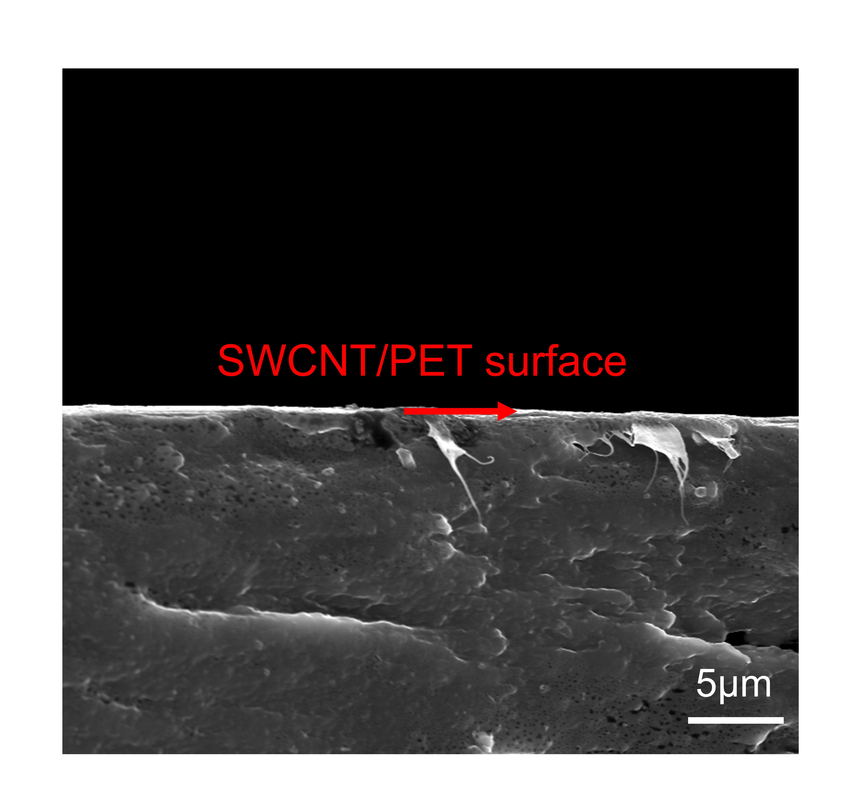
Fig. S1. SEM image of the cross section of SWCNT/PET-240-10 film.
Fig. S2. (a) Low magnification and (b) high magnification TEM images of the SWCNT film
Fig. S3. D mode and G mode Raman spectra of the SWCNT/PET-240-10 film after hot pressing
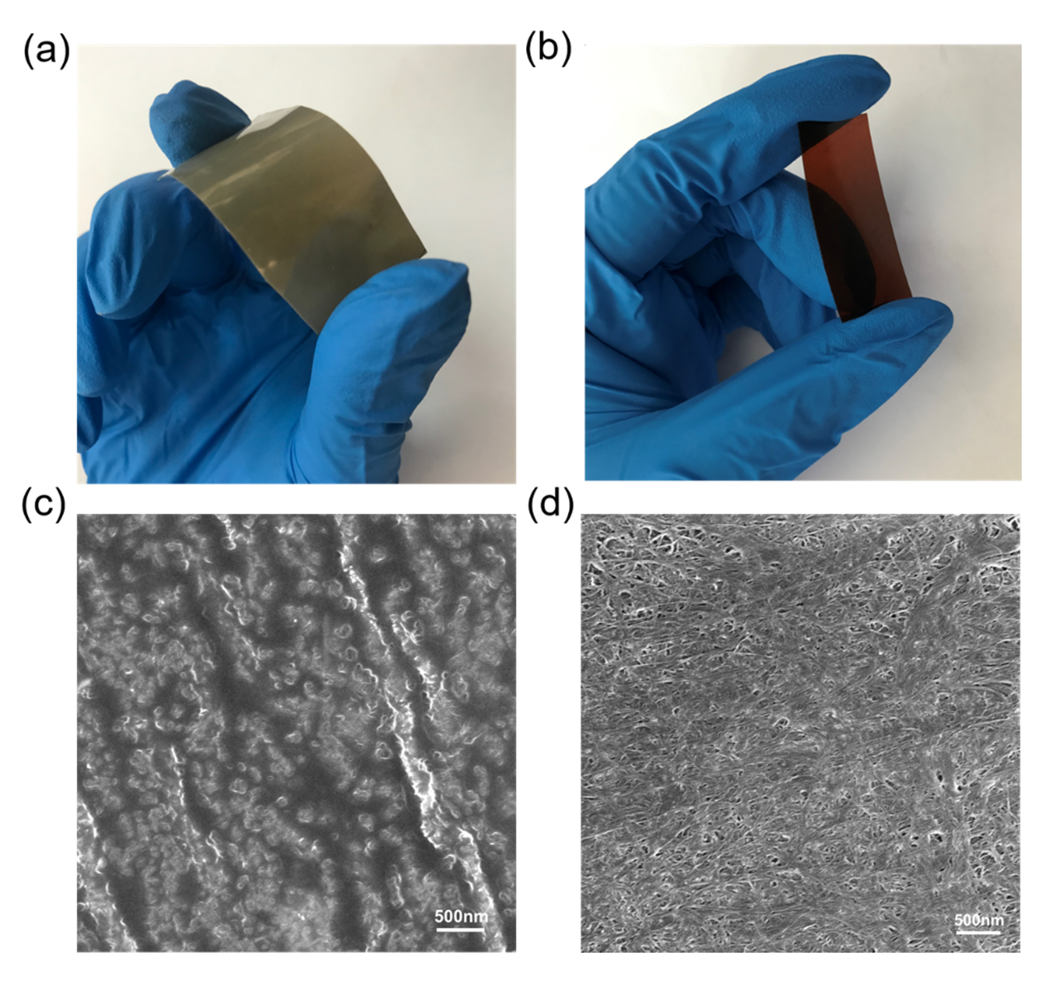
Fig. S4. Optical images of (a) SWCNT/PEEK and (b) SWCNT/PAI films; SEM images of (b) SWCNT/PEEK and (c) SWCNT/PAI films
Fig. S5. Typical stress-strain curves of PET and SWCNT/PET-240-10 film.

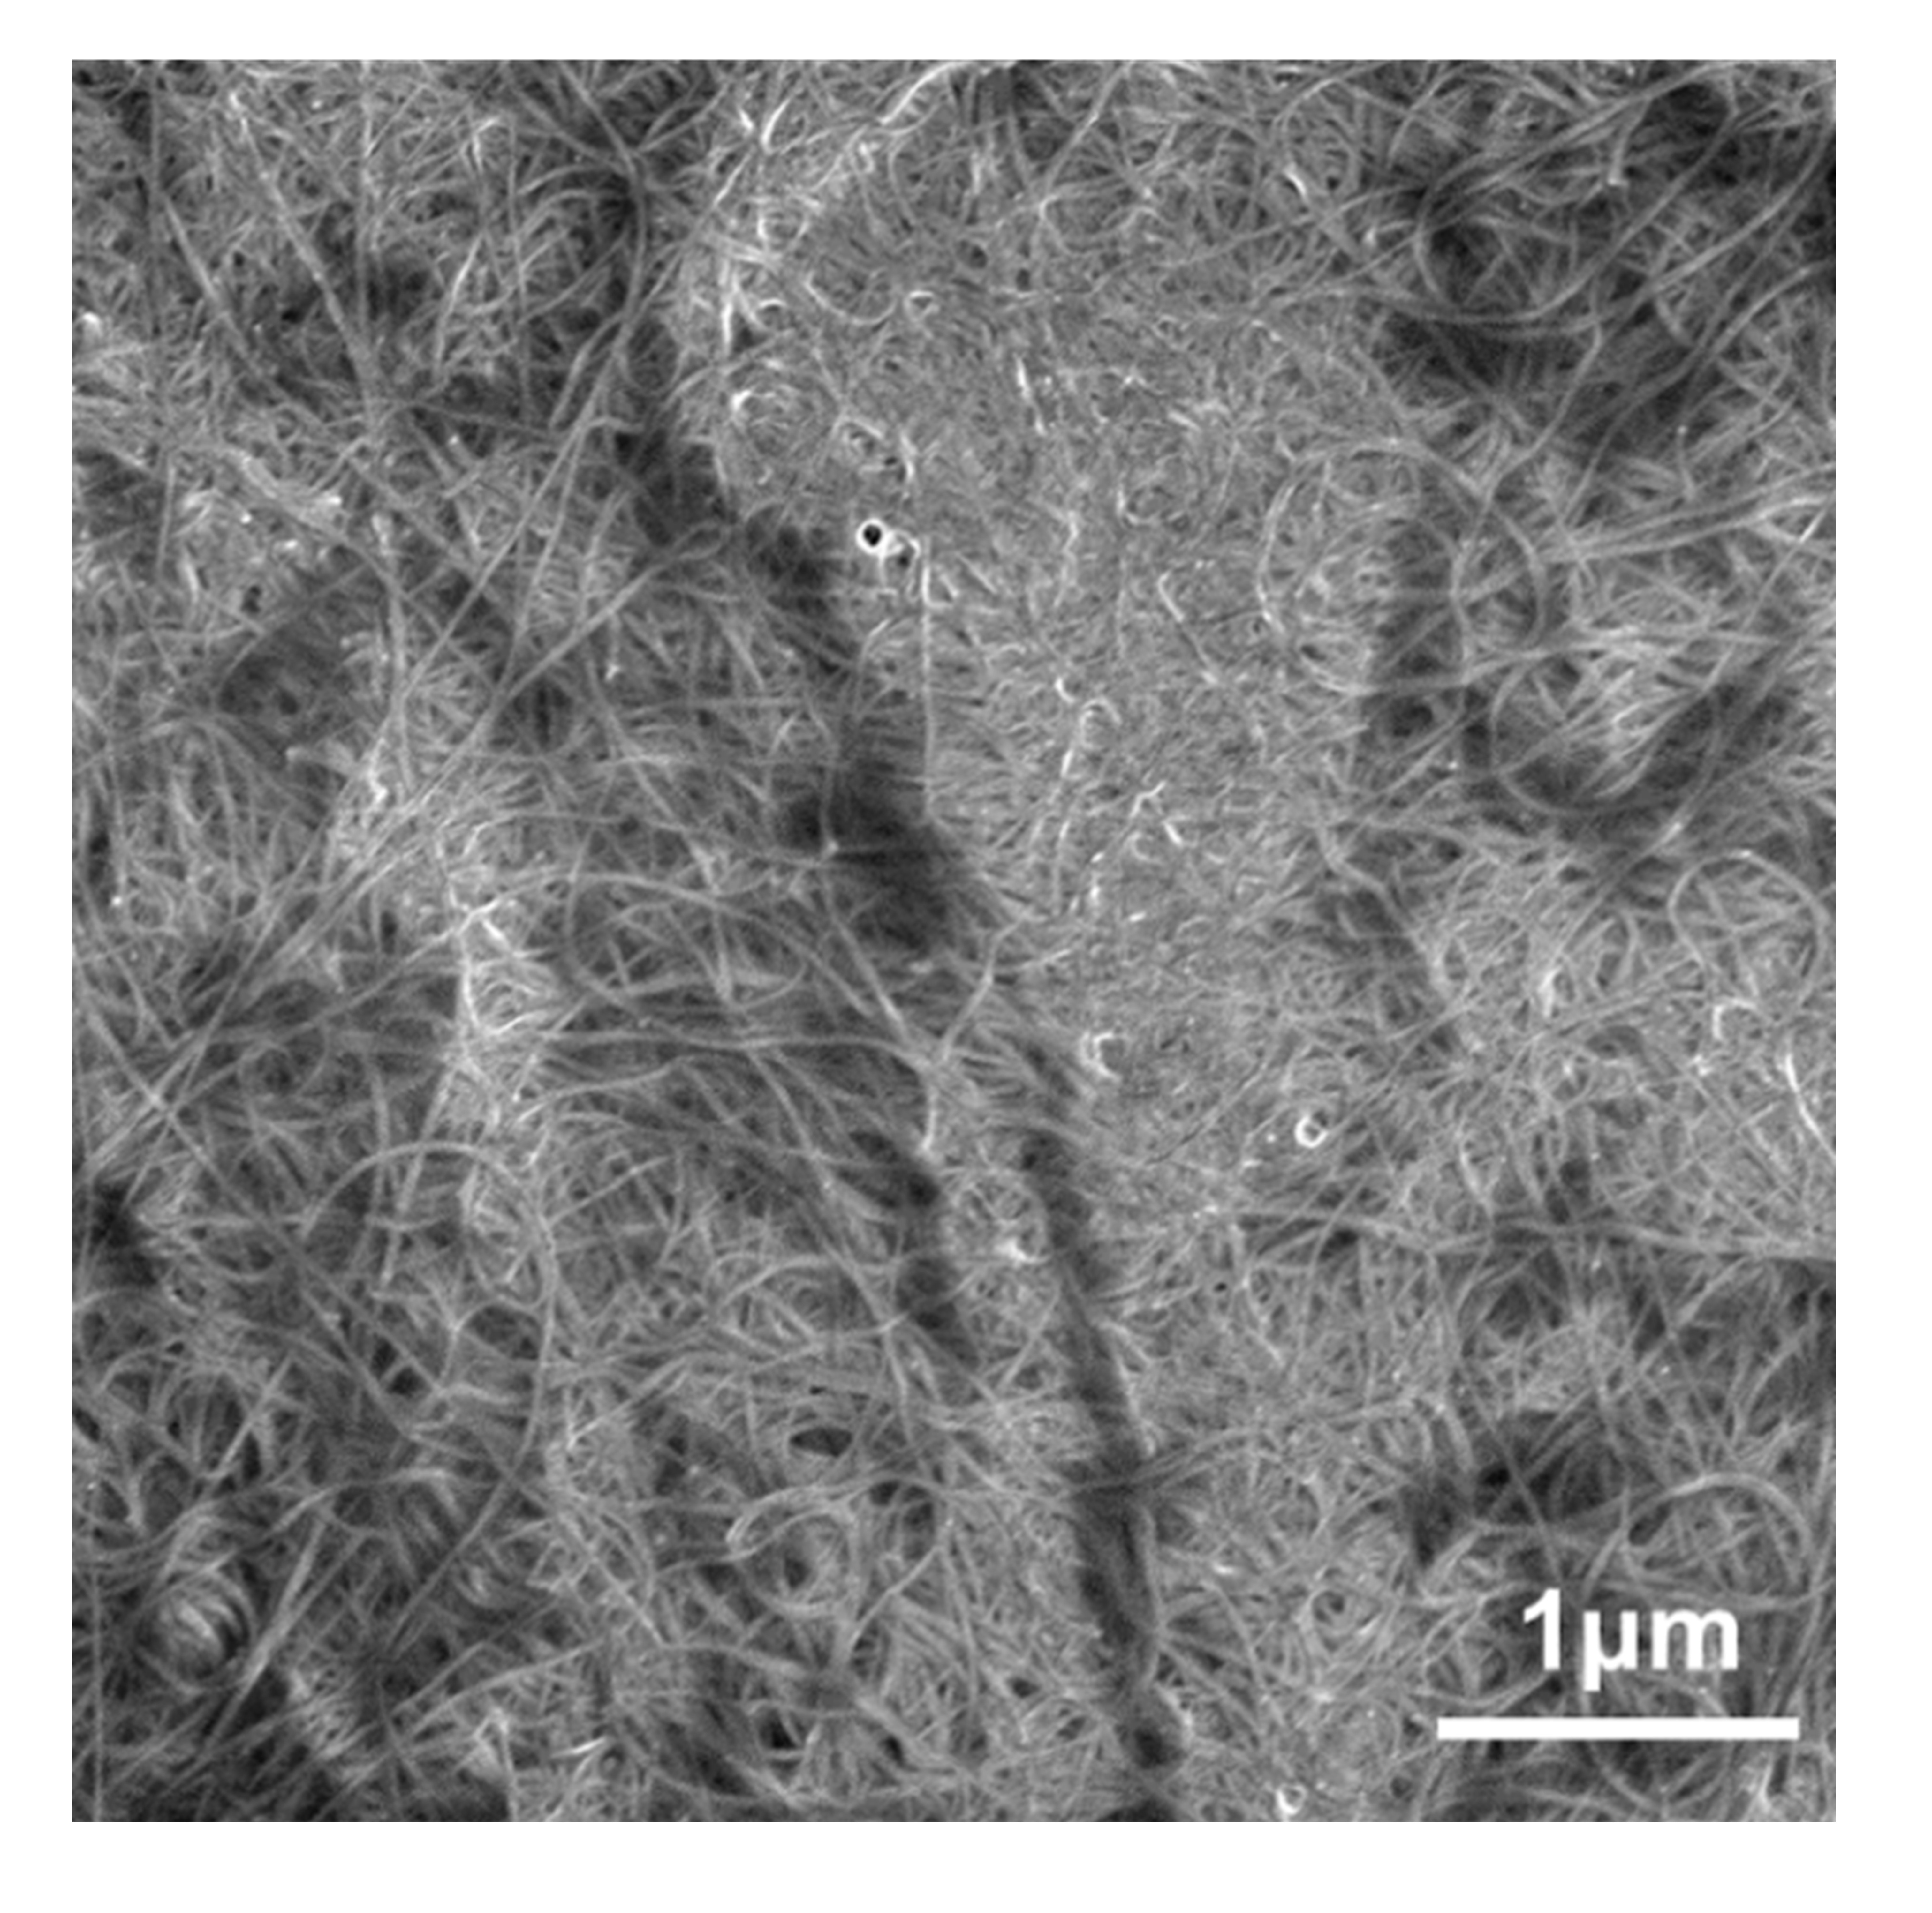
Fig. S6. SEM image of the SWCNT/PET-240-5 film.
Fig. S7. SEM image of the SWCNT/PET-240-15 film.

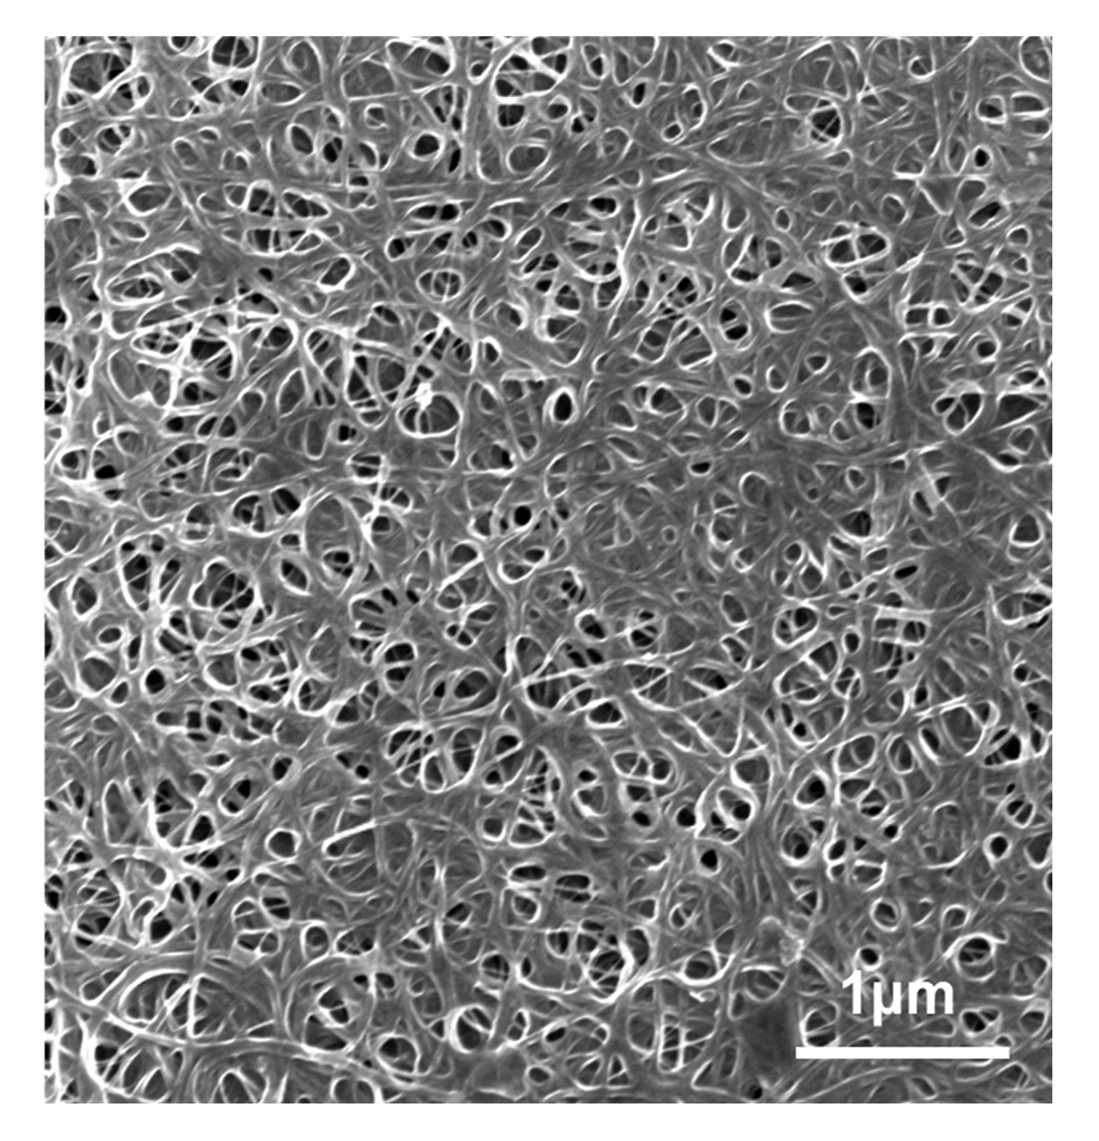
Fig. S8. SEM image of the SWCNT/PET-235-10 film.
Figure S9. Optical images of SWCNT/PET films bend at different angles.

Table S1. Mechanical performance of PET and SWCNT/PET films hot-pressed at different temperatures and times
 | Temperature  (℃) | Time  (min) | Young’s modulus  (GPa) | Tensile strength  (MPa)
PET |  |  | 3.3 | 119
SWCNT/PET | 240 | 5 | 3.4 | 124
SWCNT/PET | 240 | 10 | 4.6 | 148
SWCNT/PET | 240 | 15 | 3.6 | 127
SWCNT/PET | 235 | 10 | 3.8 | 115

Table S2. Electricity performance of PET and SWCNT/PET films hot-pressed at different temperatures and times
Sample | Surface resistance(Ω)/Sheet resistance(Ω/□)
PET | >10¹⁶
SWCNT/PET-240-5 | 120
SWCNT/PET-240-10 | 128
SWCNT/PET-240-15 | 133
SWCNT/PET-235-10 | 130

Supplementary Note 1
We measured the thickness of SWCNT films using a Step profiler. The as-collected SWCNT films were dry transferred onto the surface of a silicon wafer for the measurement. Five points of the SWCNT films were randomly selected for each sample and the averaged value obtained was used as the mean film thickness.
Supplementary Note 2
The Young’s moduli were calculated based on the initial elastic stage in the static tensile strengths of sample using the formula of E=σ/ε. For example, Fig. S5 is a typical stress-strain curve of the SWCNT/PET-240-10 composite film[1, 2]. The slope of this linear segment is the Young's modulus of the sample. As shown in Fig. S5 the Young's modulus of the SWCNT/PET-240-10 composite film is thus calculated to be ~4.6 GPa.
References:
[1] Jiang Q, Wang X, Zhu Y, Hui D, Qiu Y. (2014) Mechanical, electrical and thermal properties of aligned carbon nanotube/polyimide composites. Composites Part B: Engineering. 56, 408.http://doi.org/10.1016/j.compositesb.2013.08.064.
[2] Liu X, Liu W, Xia Q, Feng J, Qiu Y, Xu F. (2019) Highly tough and strain sensitive plasma functionalized carbon nanotube/epoxy composites. Composites Part A: Applied Science and Manufacturing. 121, 123.http://doi.org/10.1016/j.compositesa.2019.03.015.

