Supplementary Methods
Quantitative real-time PCR (RT-qPCR).
RT-qPCR was performed in triplicate using the SYBR premix ExTaq (Takara, Japan) and MX3000P thermal cycler (Stratagene, USA). Thermal cycling was performed at 95 °C for 30 s, followed by 40 cycles of 95 °C for 5 s, 55 °C for 30 s, and 72 °C for 30 s. All PCR reactions were performed in triplicate, and to check for specificity of the PCR reactions, melting curves were analyzed for each data point. α- tubulin of M. alternatus was used as the internal control for normalization. The primers used for this study are included in Table S1. The expression value was calculated using the ΔΔCt method and normalized to α-tubulin expression level. Results were shown as mean ± SEM of three independent biological repeats.
Determination of TAG and FFA levels
M. alternatus fat were homogenized in 100 μL PBS containing 0.5% Tween-20 and were incubated at 70 °C for 5 min. Then, the samples were incubated with triglyceride reagent (Sigma) for 30 min at 37 °C. Following centrifugation, samples were transferred into 96-well plates, incubated with free glycerol reagent (Sigma) for 5 min at 37 °C, and then assayed using SpectraMax Plus384 with a wavelength of 540 nm.
Larval fat body were frozen in liquid nitrogen and ground in 1 mL of a 2% H₂SO₄/98% methanol solution. Samples were sealed with a cap and incubated at 80 °C for 1 h. After the addition of 0.3 mL of hexane and 1.5 mL of H₂O, the fatty acid methyl esters were extracted into the hexane layer by shaking and then were centrifuged at 5,000 × g for 10 min. Samples of the organic phase were carried out by means of GC-MS on an Agilent Technologies 6890N GC-5973N mass selective detector. The GC was equipped with a HP-5MS column [60 mm × 0.25 mm (i.d.); film thickness 0.25 μm] (J&W Scientific). One-microliter samples were injected at a temperature of 280 °C; the GC-MS transfer line temperature was 280 °C, ion source 230 °C, and quadrupole 150 °C. All compounds were analyzed with 70 eV nominal electron energy and a scan range of 35–400 atomic mass units, with a solvent delay of 3 min. After injection, the column temperature was held at 50 °C for 0.5 min and then was increased to 200 °C at 5 °C/min, followed by an increase to 240 °C at 2 °C/min and then an increase to 250 °C at 5 °C/min and held for 10 min. Subsequently, the temperature was increased further to 280 °C at 3 °C/min and held for 3 min. Compounds were identified by comparing their retention time with those of authentic reference compounds and comparing the spectra with that of mass spectral library NIST02 (Rev. D.04.00; Agilent Technologies).
Protein structural prediction
AlphaFold ³³ was adopted to predict the structure of AKHR and DAF-38. Sequences of AKHR and DAF-38 were retrieved from databases (bfd, uniclust30, uniref90, and mgnify) using HHblits or jackhammer with default parameters to build multiple sequence alignment (MSA). Residues at the N- and C-terminus with plDDT score lower than 70 were deleted in the final model as developer suggested as low confidence. The structure comparison was performed on DALI server against the Protein Data Bank.
RNA extraction, RNA sequencing, transcriptome and phylogenetic analysis
A total of 12 libraries were constructed from the fat body of white-type larvae (white), fat body of beige-type larvae (beige), fat body of recovery-type larvae (recovery), and fat body of recovery-type larvae injected with asc-C9 (recovery+C9). Total RNA was isolated from the tissues using Trizol Reagent (Invitrogen, Carlsbad CA, USA) according to the manufacturer’s instructions. RNA sample concentration and purity were determined using a ND-1000 spectrophotometer (NanoDrop Technologies, Inc., Wilmington, USA). The RNA-seq library preparation kit for whole transcriptome discovery (-Illumina compatible) was used (Genome gene, San Diego, USA). The 320-420 bp products was purified using MiniElute gel extraction kit (Qiagen, Germany) and sequenced using the Illunima HiseqTM 2000 platform. All unigenes were annotated based on the BlastX results against non-redundant protein database (nr) at NCBI (http://www.ncbi.nlm.nih.gov/) and Swiss-prot database with the set e-value of < 10⁻⁵. The hierarchical clustering of all unigenes was performed with FPKM value (fragments kilobase of exon model per million mapped reads) more than 0.5. DEGs (differentially expressed genes) were identified by comparing libraries between uninfected to infected beetles, and transcripts with greater than 2-fold change (p < 0.001) were considered differentially expressed. Heat map analysis was performed by R package of pheatmap method (http://www.r-project.org/). Multiple sequence alignments were carried out using Clustal X software with Blosum series of weight matrices. Phylogenetic trees were constructed by the neighbor-joining (NJ) method in MEGA7 with statistical analysis by the bootstrap method, using 1000 repetitions.
Lewis lung carcinoma (LLC)-bearing model
To establish Lewis lung carcinoma (LLC)-bearing mice, thirty 8-week-old female BALB/C mice were respectively inoculated subcutaneously with 200ul LLC cells (1×10⁶/mouse), after their abdomens were sterilized with 75% ethanol. On the 7th day after tumor cell injection, the mice were randomly divided into three groups of 10 mice each. Different doses of asc-C9 were administered intraperitoneally every two days. The two-dimensional growth of the tumor was measured with vernier caliper, and tumor volumes were calculated using the formula V = 1/2 LW² (V- volume，L-length，W-width). Body weight (before mouse killing) and tumor weight (after mouse killing) were measured for all mice.

Supplementary Figures
Supplementary Fig. 1 Beige-type larvae are protected against cold shock.
a. The cold shock recovery of white-, beige-, and recovery-type larvae kept at -10 °C for 17 h and then transferred to 25°C for 24h (n=4 with 20 beetles per group).
b-c. The body temperature of white- and beige-type larvae at 25°C over the course of 30 min and over the course of 4 d (n=4 with 5 beetles per group).
d. Heat map showing differentially expressed genes in fatty acid biosynthesis, fatty acid degradation, protein kinase A (PKA) pathway, and mitochondrial genes in beige-, white-, and recovery-type larvae (n=3 with 3 beetles per group).
e. Transmission electron microscopy of lipid droplets in beige-, white-, and recovery-type larvae (n=3 with 3 beetles per group).
f. The levels of lipids in beige-, white-, and recovery-type larvae as shown by quantification of triacylglyceride (TAG) levels (n=3 with 5 beetles per group).
g. The levels of free fatty acid (18:0 and 18:2) in beige-, white-, and recovery-type larvae (n=3 with 5 beetles per group).
h-j. Respiration rates after 24 h of feeding with oligomycin or stearic acid in white- and beige-type larvae, and the UCP inhibitor guanosine nucleotide (GTP) in beige-type larvae (n ≥ 5 with 10 beetles per group).

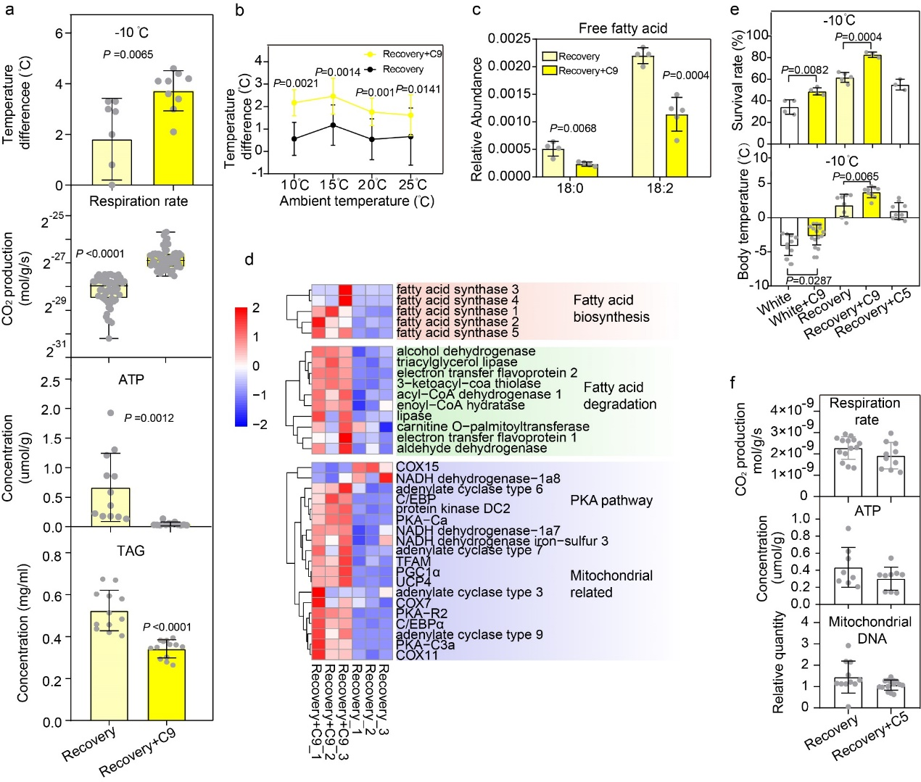
Supplementary Fig. 2 Asc-C9 mediates protection against cold shock.
a. The temperature difference between the beetle body surface and the ambient temperature at -10°C for 30 min; the respiration rate, ATP and TAG content of recovery-type larvae and recovery-type larvae with either vehicle or asc-C9 injection (n=5 with 10 beetles per group).
b. The temperature difference between body temperature and ambient temperature from 10°C to 15°C, 20°C and 25°C of recovery-type larvae injected with either vehicle or asc-C9 (n=3 with 20 beetles per group).
c. The levels of free fatty acid (18:0 and 18:2) in recovery-type larvae injected with either vehicle or asc-C9 (n=3 with 5 beetles per group).
d. Heat map showing differentially expressed genes in fatty acid biosynthesis, fatty acid degradation, PKA pathway, and mitochondrial genes in recovery-type larvae injected with either vehicle or asc-C9 (n=3 with 3 beetles per group).
e. Survival rate and body temperature at -10°C of white-type larvae with and without asc-C9 feeding, and recovery-type larvae injected with either vehicle or asc-C5 or asc-C9 (n=4 with 20 beetles per group).
f. The respiration rate, ATP concentration, and the relative quantity of mitochondrial DNA in recovery-type larvae and recovery-type larvae injected with either vehicle or asc-C5 (n=3 with 10 beetles per group).

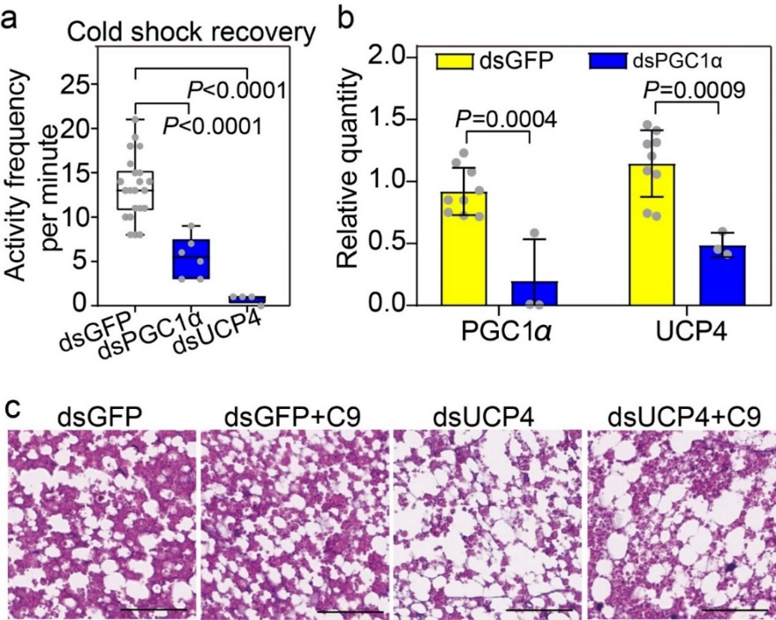
Supplementary Fig. 3 Asc-C9 functions through UCP4.
a. The activity (head swings per minute) of UCP4- and PGC1α-depleted larvae after transfer from -10°C to 25°C for 24h (n=3 with 10 beetles per group).
b. PGC1α and UCP4 expression in dsGFP- and PGC1α-depleted beige-type larvae (n=3 with 10 beetles per group).
c. The hematoxylin-eosin staining of subcutaneous fat body of GFP-depleted beige-type larvae, and UCP4-depleted beige-type larvae injected with either vehicle or asc-C9 (n=3 with 3 beetles per group).

Supplementary Fig. 4 Asc-C9 functions through AKHR.
a. The transcript expression of GPCR genes in the fat body of white-type, beige-type larvae, and recovery-type larvae injected with either vehicle or asc-C9 (n=3). Stan functions in cell adhesion and signal reception ^{34,35}, H2R (histamine H2 receptor) stimulates H2-histaminergic activation of lipolysis in WAT ^{36,37}, and Mth (Methuselah) receptor modulates insulin-like peptide secretion and extends life span³⁸⁻⁴¹. 5-HT (5-hydroxytryptamine), octopamine receptors and AKHR (adipokinetic hormone receptor) take part in cold response by regulating metabolic homeostasis⁴². 5-HT and octopamine receptors evoke insulin-like peptides or AKH release to regulate cold-resistant feeding and lipolysis ^{43,44}.
b. The qPCR analysis of receptor expression in recovery-type larvae injected with vehicle or asc-C9 (n=3 with 10 beetles per group).
c. The relative quantity of AKHR in AKHR-depleted larvae (n=3 with 12 beetles per group). The activity (head swings per min) after cold shock recovery in dsGFP beige-type larvae, dsGFP beige-type larvae injected with asc-C9, AKHR-depleted beige-type larvae, and AKHR-depleted beige-type larvae injected with asc-C9 (n=5 with 10 beetles per group).
d. Similarity analysis of the predicted structures of AKHR and DAF-38. Sequence alignment of AKHR and DAF-38.

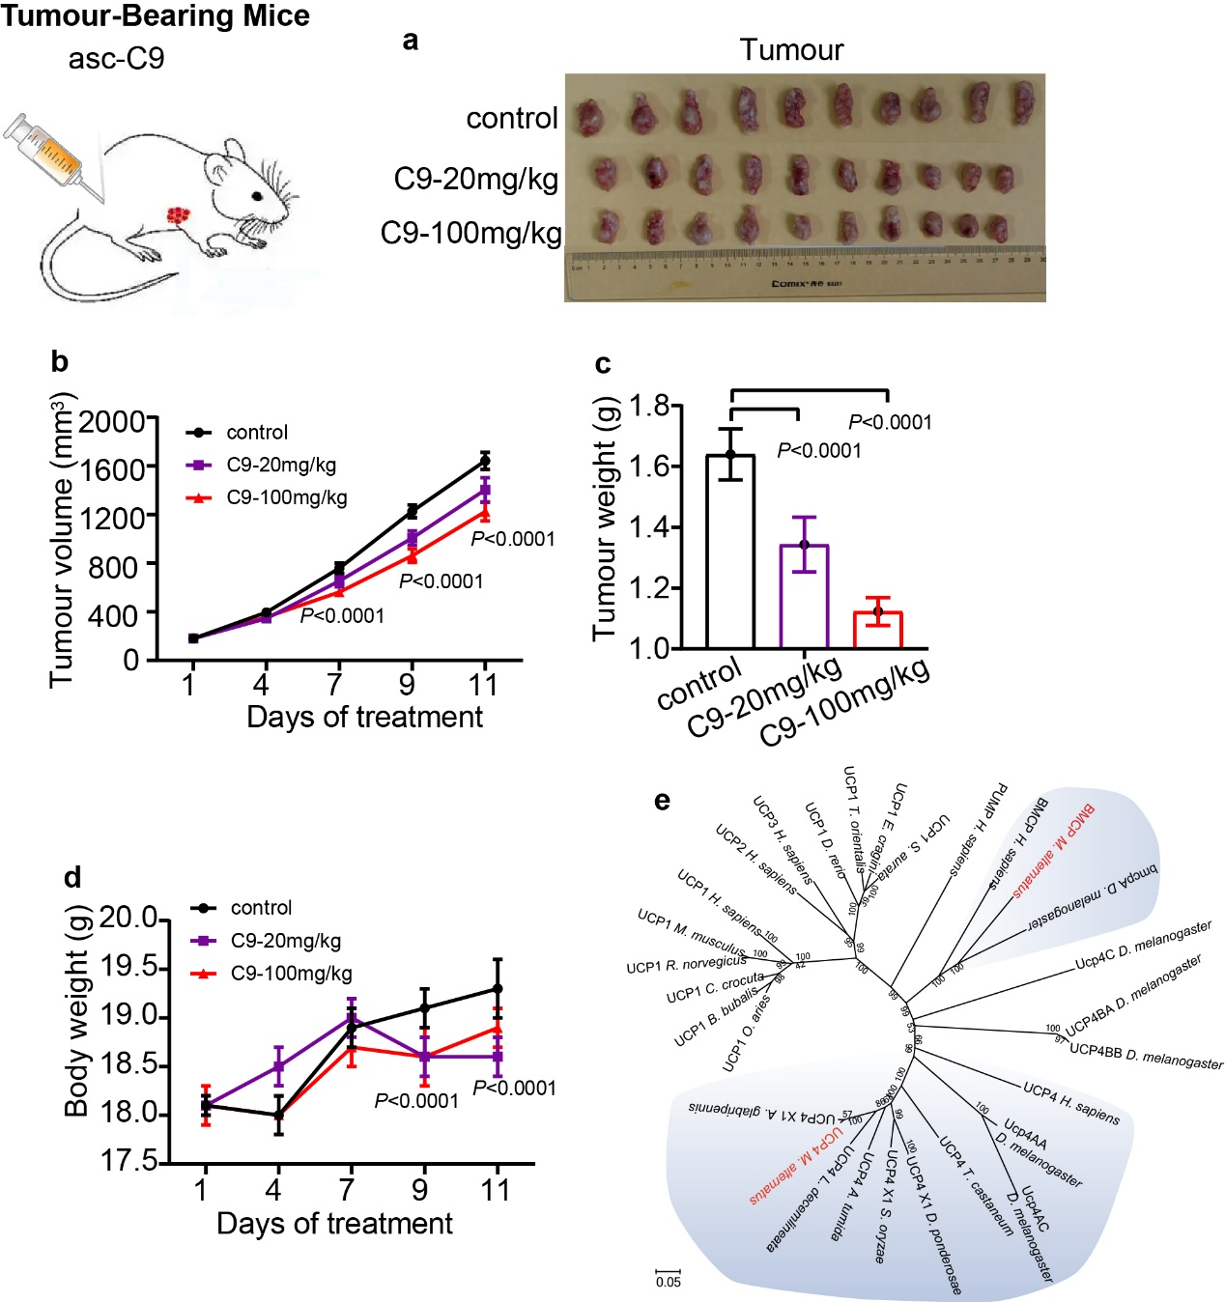
Supplementary Fig. 5 The effect of asc-C9 on tumour growth in mice.
a-d. The volume and weight of the tumour of mice treated with 20mg/kg and 100mg/kg asc-C9. The body weight of tumour-bearing mice (n=3 with 10 mice per group).
e. A phylogenetic tree of UCPs in animals.

