Appendix 1:
Table 4: Logistic regression analyses of the relationship between SES and ME/CFS, including interaction terms. Estimations are relative to hospital diagnosed controls (Model 1) and a healthy randomly selected sample of the Norwegian population (Model 2). Odds ratio (standard deviations in parentheses).
 | (1) | (2)
 | Risk of ME/CFS relative to a hospital diagnosed controls | Risk of ME/CFS relative to a healthy population sample
Low educational attainment | 0.640*** | 0.256***
 | (0.0718) | (0.0305)
High educational attainment | 1.417** | 1.475**
 | (0.183) | (0.202)
Women with low educational attainment | 1.444**  (0.182) | 1.316*  (0.182)
Women with high educational attainment | 0.828  (0.123) | 0.557**  (0.101)
Low household income | 0.830 | 1.112
 | (0.115) | (0.179)
High household income | 0.883  (0.125) | 0.943  (0.158)
Women belonging to low-income households | 1.202  (0.181) | 1.509*  (0.307)
Women belonging to high household incomes | 0.917  (0.153) | 1.490  (0.354)
Working | 0.715*** | 0.417***
 | (0.0282) | (0.0264)
Married | 0.836*** | 0.870*
 | (0.0355) | (0.0603)
Divorced/separated | 0.907 | 0.989
 | (0.0495) | (0.0951)
Women | 1.757*** | 4.061***
 | (0.0843) | (0.250)
Age 18-24 | 0.425*** | 1.777***
 | (0.0411) | (0.179)
Age 25-34 | 0.118*** | 1.155
 | (0.0109) | (0.117)
Age 35-44 | 0.0649*** | 1.124
 | (0.00598) | (0.117)
Age 45-54 | 0.0289*** | 0.793*
 | (0.00269) | (0.0870)
Age 55-64 | 0.00988*** | 0.344***
 | (0.000995) | (0.0421)
Age 65+ | 0.000706*** | 0.0364***
 | (0.0000969) | (0.00564)
N | 119449 | 10137
R² | 0.2835 | 0.1468
Exponentiated coefficients; Standard errors in parentheses
* p < 0.05, ** p < 0.01, *** p < 0.001

Appendix 2:

Graphical presentations of the predicted marginal effects of household income and educational attainment on risk of ME/CFS diagnosis by gender, for the hospital diagnosed control population and the healthy randomly selected population sample of the Norwegian population.

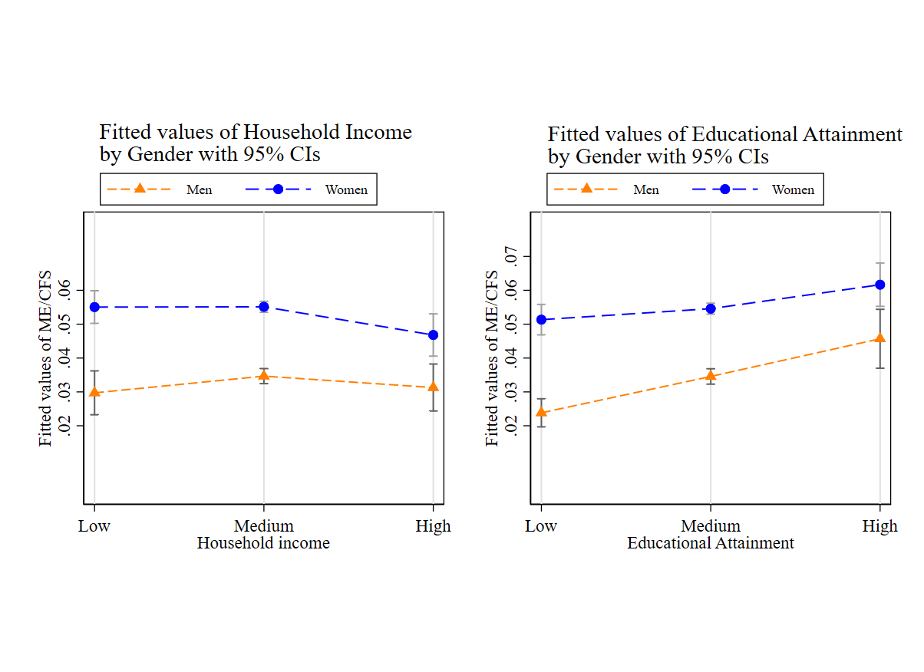
Figure 2: Predicted marginal effects of household income and educational attainment on risk of ME/CFS diagnosis by gender, for the hospital diagnosed control population.

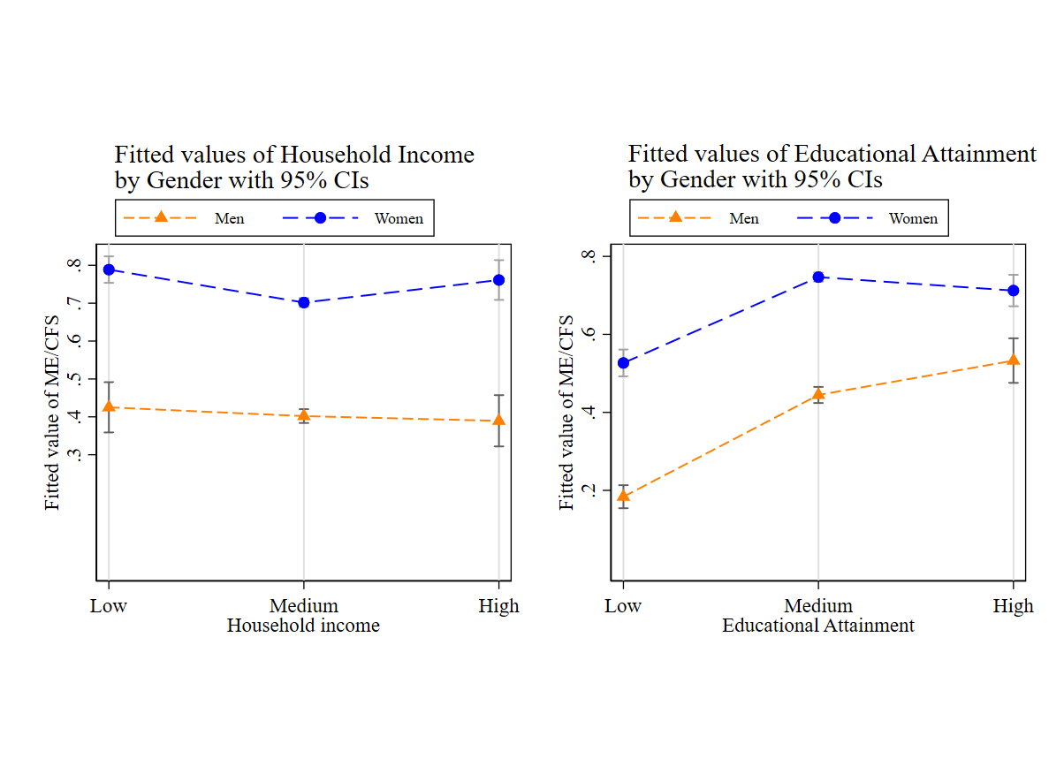
Figure 3: Predicted marginal effects of household income and educational attainment on risk of ME/CFS diagnosis by gender, for the healthy randomly sampled control population.

