Supplementary Material
Table S1: The identified recharge events in the cave and groundwater bores, with amount of rainfall 7, 14, and 21 days prior, and percent of groundwater bores that show a response.
Event number | Date of recharge increase (cave) | Date of recharge increase (GW) | 21-day P (mm) | 14-day P (mm) | 7-day P (mm) | % of GW bores that show a response
1 | 7/03/2012 | 6/03/2012 | 150.0 | 127.2 | 109.6 | 100%
2 | 13/07/2012 | 17/07/2012 | 58.0 | 54.0 | 51.8 | 100%
3 |  | 25/07/2013 | 54.1 | 53.7 | 14.9 | 100%
4 | 17/09/2013 |  | 60.6 | 60.4 | 60.4 | 0%
5 | 26/06/2016 | 21/06/2016 | 100.9 | 71.1 | 50.1 | 77%
6 | 9/07/2016 | 7/07/2016 | 106.0 | 39.9 | 25.2 | 54%
7 | 20/07/2016 | 19/07/2016 | 98.0 | 80.8 | 50.2 | 77%
8 | 4/08/2016 | 2/08/2016 | 97.2 | 47.0 | 35.0 | 54%
9 | 3/09/2016 | 31/08/2016 | 107.0 | 107.0 | 81.6 | 100%
10 | 20/09/2016 | 20/09/2016 | 137.9 | 56.1 | 37.4 | 69%
11 | 1/10/2016 | 1/10/2016 | 112.4 | 89.3 | 38.9 | 38%
12 | 3/05/2020 | 30/04/2020 | 72.0 | 44.8 | 44.8 | 45%
13 | 29/07/2020 |  | 65.5 | 43.6 | 43.6 | 0%

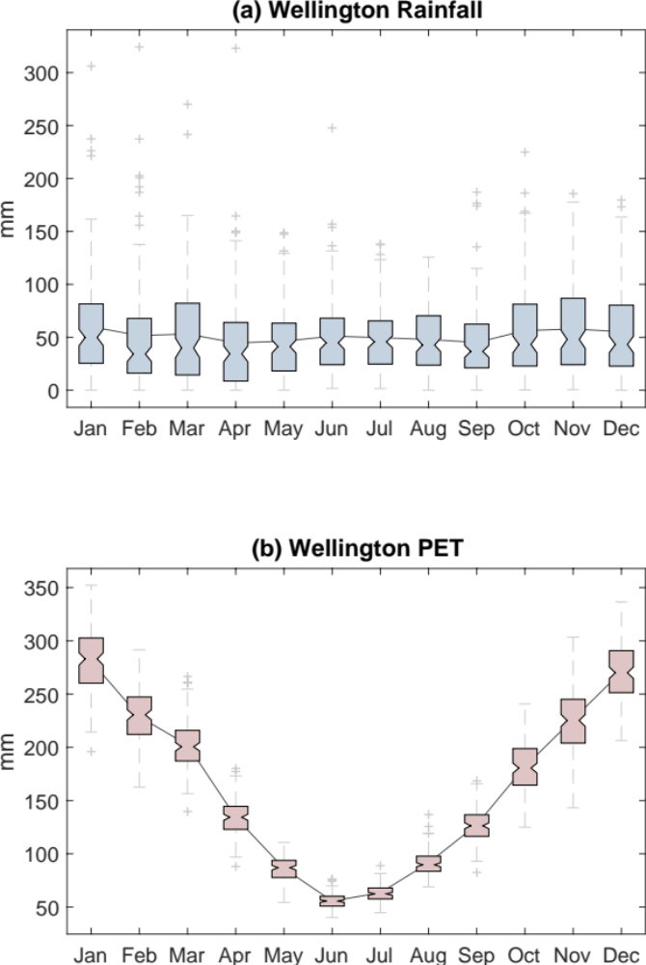
Figure S1. Climatology of (a) rainfall and (b) evapotranspiration of Wellington, NSW, Australia. Monthly distribution of data represented by box marks, with central mark indicating the median, bottom and top edges of the box showing the 25th and 75th percentiles, respectively. The whiskers extend to extreme data points and plus symbols represent outliers. Data from Wellington Research Station (WRS) site (32.572480°S; 148.985090°E) from January 1889 to December 2021 available at the Australian Bureau of Meteorology website.
Figure S2. Comparison between the modelled deep drainage from the Australian Water Landscape Model and the calculated soil recharge from the Wellington soil moisture model.
Figure S3: Histogram of the potential recharge events identified from the Wellington Soil Moisture Model on a monthly basis, grouped by climate drivers.

