Environmentally Friendly Catalyst- and Solvent-Free Synthesis of 2-Anilino Nicotinic Acids Derivatives as a Potential Lead COX Inhibitors

Mahsa Yarhorhosseiniª, Shahrzad Javanshir^{*a}, Ahmad Shahir Sadr^{*b}, Milad Nooriª, Navid Dastyaftehª, Maryam Esmkhaniª Aida Iraji^{*c,d}, Mohammad Mahdavi^{e},
ª Heterocyclic chemistry Research Laboratory, Department of Chemistry, Iran University of Science and Technology, Tehran 16846-13114, Iran. E-mail: shjavan@iust.ac.ir
^{b}Bioinformatics Research Center,‎Cheragh Medical institute& Hospital, Kabul, Afghanistan
^{c}Stem Cells Technology Research Center, Shiraz University of Medical Sciences, Shiraz, Iran
^{d} Central Research Laboratory, Shiraz University of Medical Sciences, Shiraz, Iran
^{e} Endocrinology and Metabolism Research Center, Endocrinology and Metabolism Clinical Sciences Institute, Tehran University of Medical Sciences, Tehran, Iran

Figure S1: a) 2D representation of ligand-residue interactions that occur at least 30% of simulation time at the equilibrated phase of MD simulation b) Timeline rendering of numbers of hydrogen bonds formed COX-1 and derivative 10…………………………………………………………………………………..2
Figure S2: 2D representation of ligand-residue interactions that occur at least 30% of simulation time at the equilibrated phase of MD simulation, including COX-2 with compound 10 (a). Timeline rendering of interacting residues during the whole simulation time in COX-2 complexed with compound 10(b) ...........................……………………………………………………………………………………………3
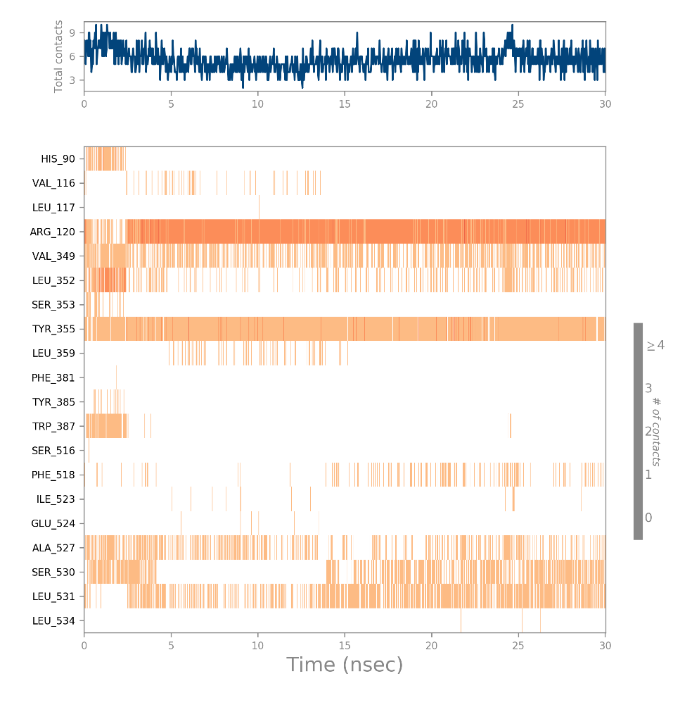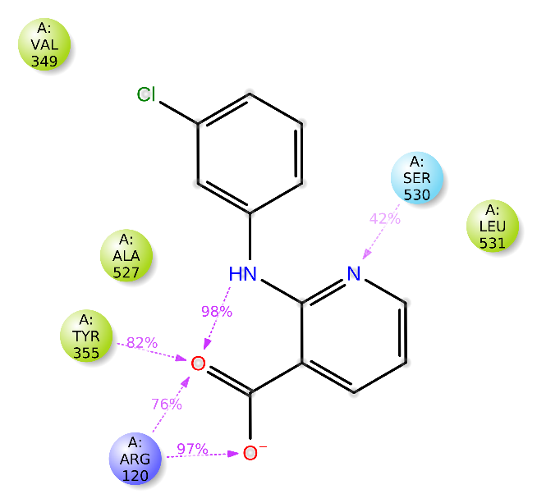
a)
b)
Figure S 1. a) 2D representation of ligand-residue interactions that occur at least 30% of simulation time at the equilibrated phase of MD simulation b) Timeline rendering of numbers of hydrogen bonds formed COX-1 and derivative 10.

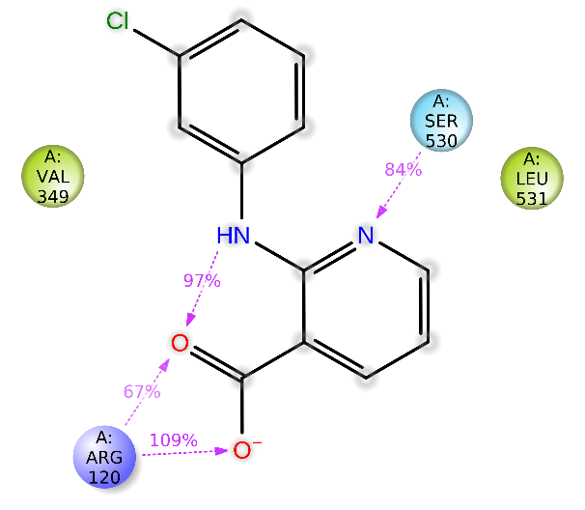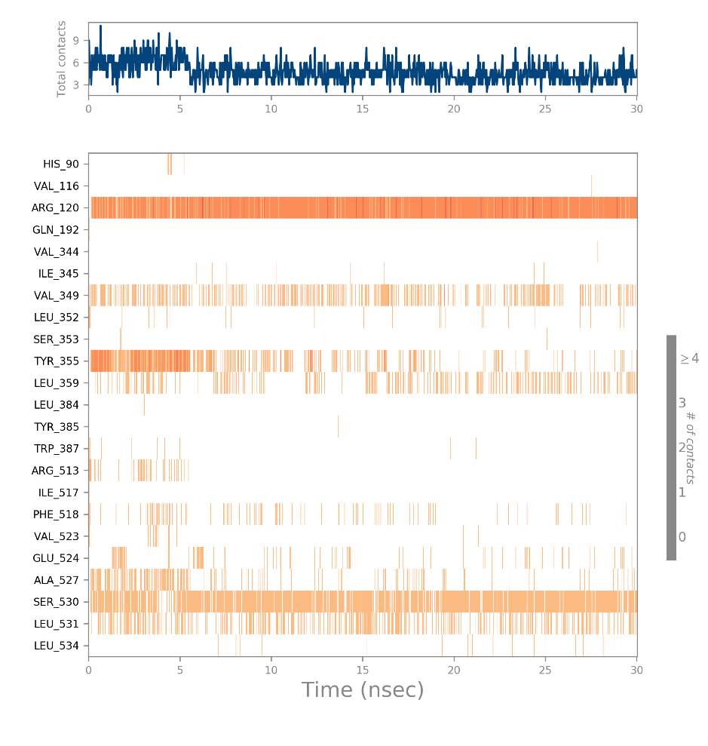
a)
b)
Figure S 2. 2D representation of ligand-residue interactions that occur at least 30% of simulation time at the equilibrated phase of MD simulation, including COX-2 with compound 10 (a). Timeline rendering of interacting residues during the whole simulation time in COX-2 complexed with compound 10 (b).

