Supporting Information

Structural revolution of PVDF crystallized on nanocarbon surface on a gradient temperature stage and its dielectric properties

Shuhui Liª, Hai Wangª, Xiaobin Liang ^{b*}, Meijie Quª, Mingshuai Fanª, Rui Zhangª, Ken Nakajima ^{b}, Yuezhen Bin^{a*}
ª Department of Polymer Science and Engineering, School of Chemical Engineering, Dalian University of Technology, Dalian 116024, PR China
^{b} Department of Chemical Science and Engineering, School of Materials and Chemical Technology, Tokyo Institute of Technology, Tokyo 152-8552, Japan
ª*E-mail: binyz@dlut.edu.cn
^{b}*E-mail: liang.x.ac@m.titech.ac.jp

Table S1. The sample names under different preparation conditions
Nucleus  T_{c} (℃) | GN | MWCNT | No nucleus
117 | PGN-117 | PCNT-117 | PN-117
111 | PGN-111 | PCNT-111 | PN-111
104 | PGN-104 | PCNT-104 | PN-104
… | … | … | …
51 | PGN-51 | PCNT-51 | PN-51
45 | PGN-45 | PCNT-45 | PN-45

Figure S1. The samples’ observation surface after slicing for AFM.

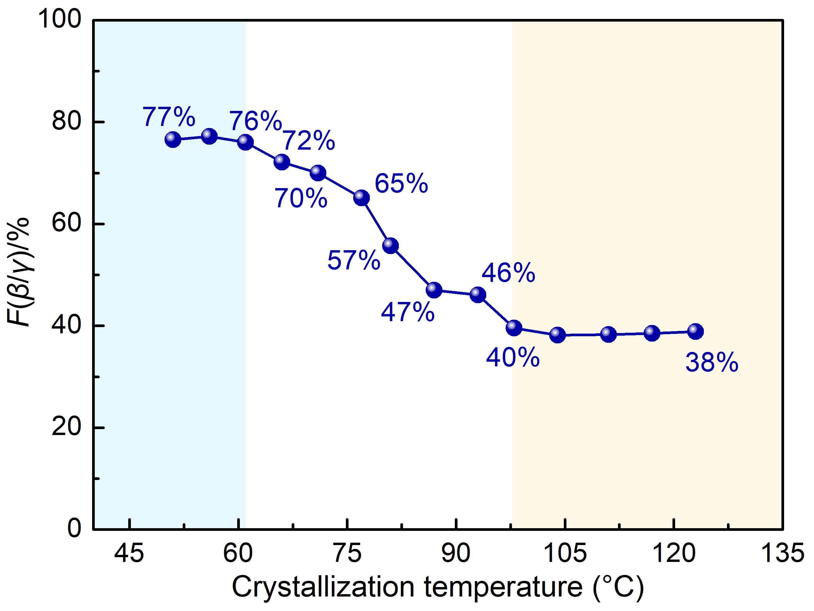
Figure S2. The β&γ phase content of PVDF at the crystallization temperature range from 61 to 117 ℃.

Figure S3. 1D-WAXD curves of PGN and PCNT which were crystallized from 61 ℃ to 117 ℃.

Table S2. The calculated peak area ratio of γ (021) plane.
T_{c} (℃) | 117 | 111 | 104 | 98 | 93 | 87 | 81 | 71 | 61
PN | 1.7% | 1.0% | 1.6% | 2.7% | 3.6% | 4.6% | 8.5% | 14.2% | 15.4%
PGN | 4.4% | 4.8% | 4.8% | 8.7% | 11.2% | 9.2% | 10.2% | 15.6% | 17.7%
PCNT | 7.0% | 7.4% | 8.8% | 10.6% | 9.0% | 9.4% | 8..9% | 14.2% | 17.1%

Table S3. The detail crystal characteristics of PN.
Samples | X_{c}/% | q/nm⁻¹ | L/nm | L_{c}/nm | L_{a}/nm | D_{-α(110)}/nm | D_{-γ(021)}/nm
PN-117 | 43.4 | 0.535 | 11.7 | 5.1 | 6.6 | 14.8 | 14.1
PN-111 | 44.4 | 0.553 | 11.4 | 5.0 | 6.3 | 15.3 | 14.0
PN-104 | 43.4 | 0.559 | 11.2 | 4.9 | 6.3 | 14.9 | 14.1
PN-98 | 43.2 | 0.588 | 10.7 | 4.6 | 6.1 | 15.1 | 13.9
PN-93 | 42.2 | 0.599 | 10.5 | 4.4 | 6.1 | 15.0 | 13.4
PN-87 | 41.1 | 0.626 | 10.0 | 4.1 | 5.9 | 15.1 | 13.2
PN-81 | 35.6 | 0.663 | 9.5 | 3.4 | 6.1 | 14.8 | 12.3
PN-71 | 28.7 | 0.79 | 8.0 | 2.3 | 5.7 | 11.9 | 10.6
PN-61 | 27.1 | 0.801 | 7.8 | 2.1 | 5.7 | 12.1 | 9.4

Table S4. The detail crystal characteristics of PGN.
Samples | X_{c}/% | q/nm⁻¹ | L/nm | L_{c}/nm | L_{a}/nm | D_{-α(110)}/nm | D_{-γ(021)}/nm
PGN-117 | 43.6 | 0.552 | 11.4 | 5.0 | 6.4 | 15.6 | 10.4
PGN-111 | 42.8 | 0.603 | 10.4 | 4.5 | 6.0 | 15.4 | 10.7
PGN-104 | 43.4 | 0.622 | 10.1 | 4.4 | 5.7 | 15.4 | 10.6
PGN-98 | 39.3 | 0.612 | 10.3 | 4.0 | 6.2 | 14.7 | 10.4
PGN-93 | 33.8 | 0.628 | 10.0 | 3.4 | 6.6 | 12.2 | 10.6
PGN-87 | 37.5 | 0.689 | 9.1 | 3.4 | 5.7 | 14.5 | 10.8
PGN-81 | 39.5 | 0.728 | 8.6 | 3.4 | 5.2 | 11.9 | 10.3
PGN-71 | 30.8 | 0.774 | 8.1 | 2.5 | 5.6 | 12.0 | 9.9
PGN-61 | 32.0 | 0.701 | 9.0 | 2.9 | 6.1 | 11.9 | 9.3

Table S5. The detail crystal characteristics of PCNT.
Samples | X_{c}/% | q/nm⁻¹ | L/nm | L_{c}/nm | L_{a}/nm | D_{-α(110)}/nm | D_{-γ(021)}/nm
PCNT-117 | 44.8 | 0.544 | 11.5 | 5.2 | 6.4 | 15.2 | 9.7
PCNT-111 | 45.2 | 0.580 | 10.8 | 4.9 | 5.9 | 15.2 | 9.7
PCNT-104 | 43.7 | 0.604 | 10.4 | 4.6 | 5.9 | 14.8 | 9.5
PCNT-98 | 41.5 | 0.613 | 10.2 | 4.3 | 6.0 | 14.6 | 9.5
PCNT-93 | 40.6 | 0.646 | 9.7 | 3.9 | 5.8 | 13.2 | 9.7
PCNT-87 | 38.5 | 0.665 | 9.5 | 3.6 | 5.8 | 13.7 | 9.8
PCNT-81 | 38.4 | 0.660 | 9.5 | 3.7 | 5.9 | 12.6 | 9.8
PCNT-71 | 31.7 | 0.778 | 8.1 | 2.6 | 5.5 | 11.5 | 8.9
PCNT-61 | 28.3 | 0.711 | 8.8 | 2.5 | 6.3 | 11.4 | 8.6

