Supplementary Information for
Resilience of South Asian mangroves to climate extremes and changing water chemistry Tejasvi Ashish Chauhan¹, Punyasloke Bhadury^{2,3}, Suraj Reddy Rodda⁴, Kiran Chand Thumaty⁴, Chandra Shekhar Jha⁴ and Subimal Ghosh^{1,5}
- Department of Civil Engineering, Indian Institute of Technology Bombay, India
- Centre for Climate and Environmental Studies, Indian Institute of Science Education and Research Kolkata, West Bengal, India
- Integrative Taxonomy and Microbial Ecology Research Group, Department of Biological Sciences, Indian Institute of Science Education and Research Kolkata, West Bengal, India
- Forestry and Ecology Group, National Remote Sensing Centre (ISRO), Hyderabad, India
- Interdisciplinary Programme in Climate Studies, Indian Institute of Technology Bombay, India

Contents:
Supplementary Figures S1-S4

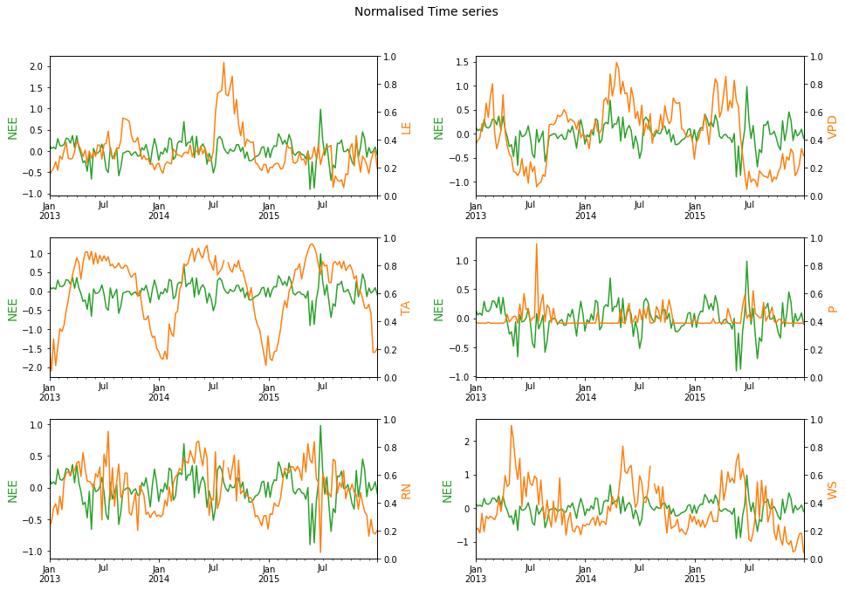
Figure S1: Standardised anomalies (diurnal cycle removed) of variables from flux tower averaged to weekly time scale.
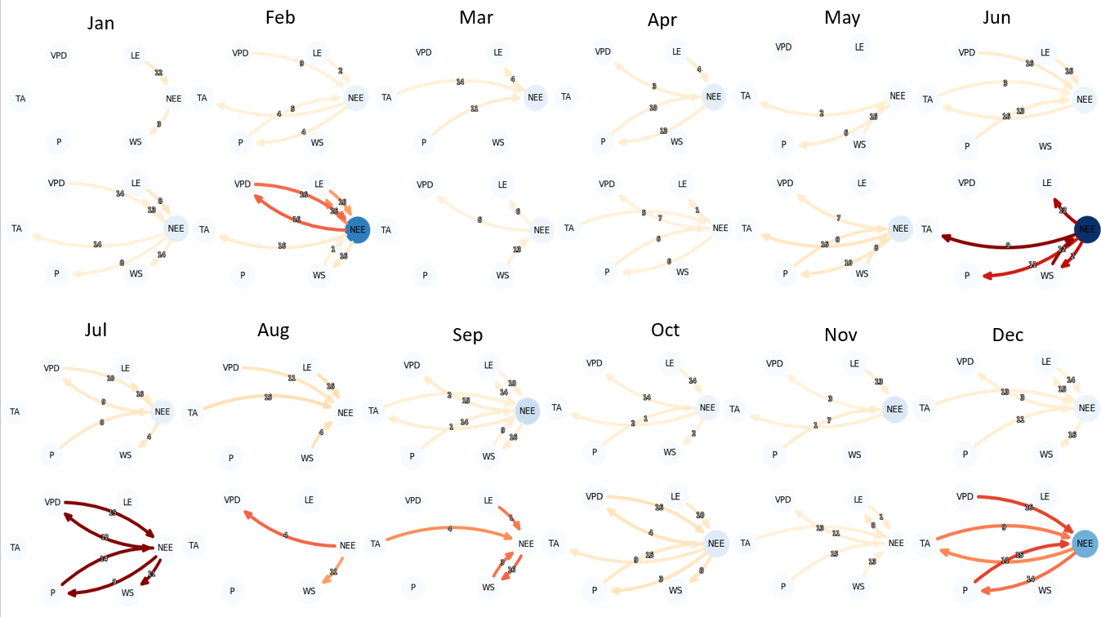
2015

2013

2013

2015

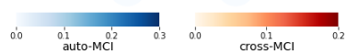
Figure S2: Monthly networks comparing 2013 months with 2015. Networks are generated using 3-hour data with a maximum lag of 16 (48 hours). Link color (Cross-MCI) and Node color (Auto-MCI) represent link strength and autocorrelation, respectively. Link labels show the lag at which statistically significant (alpha=0.05) links were found.

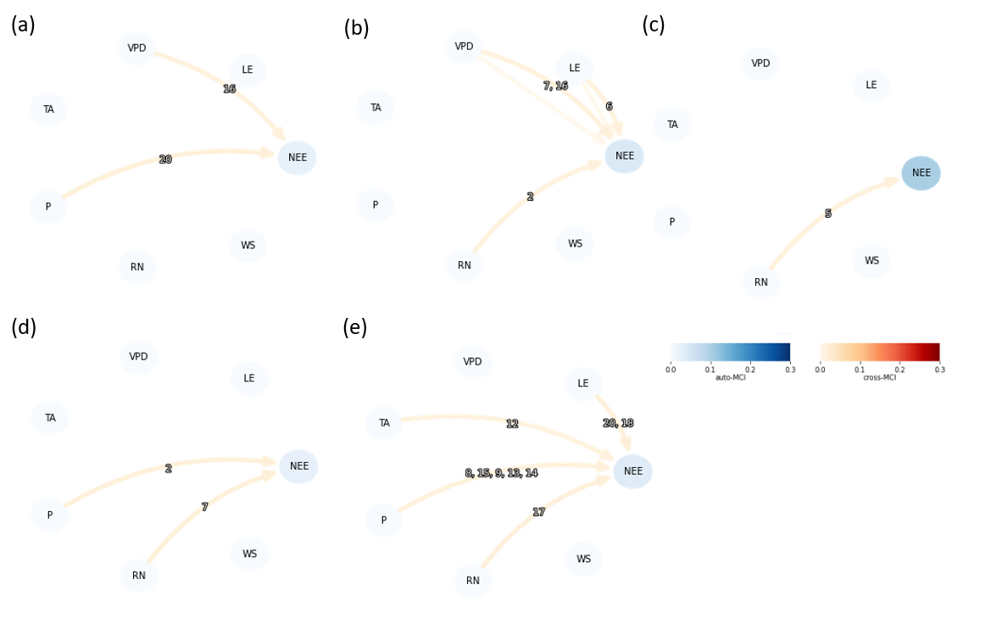
Figure S3: Weekly networks during cyclone Viyaru (10-13th May 2013) starting from 29th April 2013 (a-e). Link labels show the lag at which the statistically significant (alpha = 0.05) links were found. Link color represents the strength of the link (labeled ‘cross-MCI’ in colorbar), and node color represents autocorrelation (labeled ‘auto-MCI’ in colorbar). Figure shows that the links reduce during the cyclone but quickly recover in the next week.

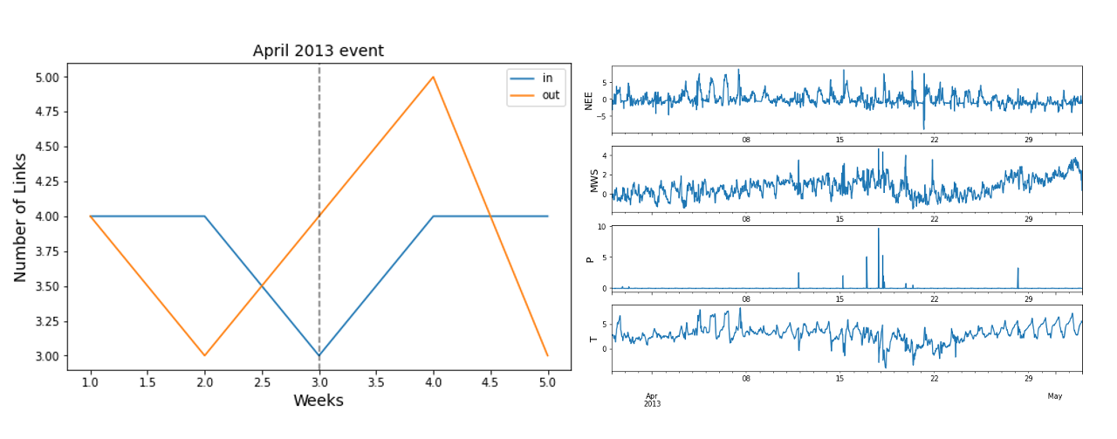
Figure S4: (a) Number of incoming and outgoing links from NEE in weekly networks during a norwester events in April 2013. Networks were generated for five weeks keeping the week with norwester event at the center (week 3). (b) Anomalies of NEE and other hydrometeorological variables during April month

