Supplementary Material
Table S.1. The month and year each fish species was collected throughout the Churchill River, Churchill River estuary, and Hudson Bay, Manitoba
Species | n | Collection Date
brook trout | 5 | 2019-Jul
brook trout | 3 | 2020-Jun
burbot | 2 | 2019-Jul
burbot | 1 | 2020-Aug
burbot | 3 | 2020-Sep
capelin | 20 | 2019-Jun
capelin | 20 | 2020-Jun
cisco | 20 | 2019-Jul
cisco | 6 | 2020-Jun
cisco | 1 | 2020-Aug
cisco | 1 | 2020-Sep
fourhorn sculpin | 28 | 2019-Jul
fourhorn sculpin | 1* | 2020-Aug
Greenland cod | 20 | 2019-Jul
lake whitefish | 4 | 2019-May
lake whitefish | 24 | 2019-Jul
lake whitefish | 15 | 2020-Jun
lake whitefish | 24 | 2020-Aug
longnose sucker | 1 | 2019-Jul
longnose sucker | 12 | 2020-Sep
nine-spine stickleback | 3 | 2019-May
nine-spine stickleback | 2 | 2020-Aug
northern pike CR | 7 | 2019-Jul
northern pike CR | 2 | 2020-Aug
northern pike CR | 4 | 2020-Sep
northern pike GC | 20 | 2019-May
trout-perch | 19 | 2020-Sep
walleye | 1 | 2020-Sep
white sucker | 2 | 2019-Jul
white sucker | 5 | 2020-Aug
white sucker | 3 | 2020-Sep

Table S.2. The total number of fish sent for aging, out of those sent for stable isotope analysis during 2019 and 2020, and the structures sent for analysis. Samples were either sectioned, crack and burned, or analyzed whole.
Year | 2019 |  |  | 2020
Species | Structure | Analysis | Number | Structure | Analysis | Number
brook trout | Ototlith | Sectioned | 3 | Ototlith | Crack and Burn | 1
burbot |  |  |  | Ototlith | Crack and Burn | 3
cisco | Ototlith | Crack and Burn | 1 | Ototlith | Crack and Burn | 7
cisco | Ototlith | Whole | 1 | Ototlith | Crack and Burn | 7
cisco | Ototlith | Sectioned | 18 | Ototlith | Crack and Burn | 7
fourhorn sculpin | Ototlith | Sectioned | 27
Greenland cod | Ototlith | Sectioned | 20
lake whitefish | Ototlith | Crack and Burn | 22 | Ototlith | Crack and Burn | 40
lake whitefish | Ototlith | Whole | 5 | Ototlith | Crack and Burn | 40
longnose sucker |  |  |  | Ototlith | Sectioned | 3
northern pike | Cleithrum | Whole | 27 | Cleithrum* | Whole | 6
white sucker |  |  |  | Ototlith | Sectioned | 2
*several cleithra were actually preopercular bones, which are less accurate for aging in northern pike.
Table S.3. Wilcoxon Rank Sum Squares test results (p-values) comparing stable isotope ratios between May and July for northern pike and lake whitefish collected in 2019 based on tissue type. The bolded values indicate significant differences between months (Holm-Bonferroni sequential correction to α).
 |  |  | p-values
Species | Location | Tissue | δ¹³C | δ¹⁵N
northern pike | GC-CR | Muscle | 0.19 | <0.001
lake whitefish | GC-CR | Muscle | 1.00 | 0.04
lake whitefish | GC-E | Muscle | 0.13 | 0.13
lake whitefish | GC-HB | Muscle | 0.13 | 0.13
northern pike | GC-CR | Liver | 0.79 | <0.001
lake whitefish | GC-CR | Liver | 0.91 | 0.85
lake whitefish | GC-E | Liver | 0.13 | 0.53
lake whitefish | GC-HB | Liver | 0.13 | 0.13

Table S.4. Wilcoxon Rank Sum Squares test results (p-values) comparing stable isotope ratios between 2019 and 2020 for each species and tissue type. The bolded values indicate significant differences between years (Holm-Bonferroni sequential correction to α).
 |  | p-values
Species | Tissues | δ¹³C | δ¹⁵N
brook trout | Muscle | 0.38 | 0.57
burbot | Muscle/ whole body | 0.13 | 0.53
capelin | Muscle | 0.01 | 0.03
cisco | Muscle | 0.07 | 0.82
lake whitefish | Muscle | 0.62 | 0.22
longnose sucker | Muscle | 0.31 | 0.62
nine-spine stickleback | Whole body | 0.20 | 0.20
northern pike CR | Muscle | 0.01 | 0.45
white sucker | Muscle | 0.18 | 0.27
sculpin | Muscle | 0.41 | 0.12
seals* | Muscle | 0.56 | 0.11
brook trout | Liver | 0.04 | 0.57
capelin | Liver | 1.00 | 0.59
cisco | Liver | 0.05 | 0.06
lake whitefish | Liver | 0.53 | 0.31
longnose sucker | Liver | 0.77 | 0.92
northern pike CR | Liver | 0.41 | 0.93
white sucker | Liver | 0.25 | 0.25
ringed seals | Liver | 0.40 | 0.40
*harbour and ringed seal muscle data were combined.

Table S.5. Mean (‰) ± standard error (SE) of δ¹³C, δ¹⁵N, and δ³⁴S values of (a) muscle and (b) liver for each fish and seal species based on the sampling locations.
(a)
 | δ13C Muscle |  |  |  | δ¹⁵N Muscle
 | 2019 |  | 2020 |  | 2019 |  | 2020
Marine Mammal | n | Mean ± SE | n | Mean ± SE | n | Mean ± SE | n | Mean ± SE
Churchill River
harbour seal | 4 | -19.87 ± 0.23 | 0 |  | 4 | 18.06 ± 0.19 | 0
ring seal | 1 | -20.9 | 4 | -19.58 ± 0.26 | 1 | 16.03 | 4 | 17.41 ± 0.34
 | δ¹³C Muscle |  |  |  | δ¹⁵N Muscle
 | 2019 |  | 2020 |  | 2019 |  | 2020
Fish | n | Mean ± SE | n | Mean ± SE | n | Mean ± SE | n | Mean ± SE
Hudson Bay
brook trout | 5 | -21.71 ± 0.32 | 2 | -22.48 ± 0.52 | 5 | 15.37 ± 0.29 | 2 | 14.89 ± 0.57
capelin | 20 | -21.09 ± 0.08 | 20 | -21.46 ± 0.13 | 20 | 14.89 ± 0.11 | 20 | 14.53 ± 0.12
cisco | 20 | -21.69 ± 0.16 | 6 | -20.33 ± 0.47 | 20 | 13.65 ± 0.09 | 6 | 14.46 ± 0.39
fourhorn sculpin | 8 | -20.13 ± 0.30 | 0 |  | 8 | 15.17 ± 0.13 | 0
Greenland cod | 20 | -19.98 ± 0.10 | 0 |  | 20 | 17.00 ± 0.17 | 0
lake whitefish | 2 | -19.78 ± 0.66 | 15 | -19.94 ± 0.40 | 2 | 11.61 ± 0.97 | 15 | 12.49 ± 0.29
Estuary
burbot | 0 |  | 1 | -25.3 | 0 |  | 1 | 6.34
cisco | 0 |  | 1 | -21.67 | 0 |  | 1 | 11.45
fourhorn sculpin | 20 | -20.83 ± 0.07 | 1 | -21 | 20 | 15.35 ± 0.10 | 1 | 8.68
lake whitefish | 2 | -21.34 ± 1.09 | 5 | -24.01 ±0.52 | 2 | 9.62 ± 0.13 | 5 | 9.76 ± 0.61
Churchill River
burbot | 2 | -26.58 ± 0.07 | 3 | -25.43 ± 0.11 | 2 | 8.41 ± 0.21 | 3 | 9.53 ± 0.06
cisco | 0 |  | 1 | -29.65 | 0 |  | 1 | 8.76
lake whitefish | 20 | -24.66 ± 0.44 | 20 | -25.85 ± 0.25 | 20 | 9.33 ± 0.23 | 20 | 8.80 ± 0.16
longnose sucker | 1 | -27.65 | 12 | -27.05 ± 0.17 | 1 | 7.65 | 12 | 7.82 ± 0.12
northern pike | 7 | -25.40 ± 0.22 | 6 | -27.40 ± 0.63 | 7 | 9.92 ± 0.24 | 6 | 9.53 ± 0.40
nine-spine stickleback | 3 | -22.60 ± 0.21 | 2 | -19.10 ± 1.05 | 3 | 12.61 ± 0.56 | 2 | 9.15  ± 2.27
trout-perch | 0 |  | 19 | -26.52 ± 0.10 | 0 |  | 19 | 9.80 ± 0.06
walleye | 0 |  | 1 | -28.34 | 0 |  | 1 | 10.7
white sucker | 2 | -27.23 | 8 | -28.11 ± 0.43 | 2 | 8.64 ± 0.27 | 8 | 8.10 ± 0.13
Goose Creek
lake whitefish | 4 | -24.78 ± 0.48 | 0 |  | 4 | 7.95 ± 0.50 | 0
northern pike | 20 | -25.53 ± 0.62 | 0 |  | 20 | 6.78 ± 0.22 | 0

(b)
 | δ¹³C Liver |  |  |  | δ¹⁵N Liver
 | 2019 |  | 2020 |  | 2019 |  | 2020
Marine Mammal | n | Mean ± SE | n | Mean ± SE | n | Mean ± SE | n | Mean ± SE
Churchill River
harbour seal* | 4 | -20.66 ± 0.46 | 0 |  | 4 | 17.94 ± 0.37 | 0
ring seal | 1 | -20.8 | 4 | -19.13 ± 0.27 | 1 | 16.82 | 4 | 18.24 ± 0.46
 | δ¹³C Liver |  |  |  | δ¹⁵N Liver
 | 2019 |  | 2020 |  | 2019 |  | 2020
Fish | n | Mean ± SE | n | Mean ± SE | n | Mean ± SE | n | Mean ± SE
Hudson Bay
brook trout | 5 | -20.80 ± 0.10 | 3 | -20.49 ± 0.03 | 5 | 15.05 ± 0.15 | 3 | 14.63 ± 0.39
capelin | 15 | -20.58 ± 0.09 | 8 | -20.65 ± 0.24 | 15 | 13.73 ± 0.14 | 8 | 13.61 ± 0.17
cisco | 20 | -21.46 ± 0.19 | 6 | -20.40 ± 0.32 | 20 | 12.78 ± 0.12 | 6 | 14.21 ± 0.42
fourhorn sculpin | 8 | -19.82 ± 0.39 | 0 |  | 8 | 14.27 ± 0.22 | 0
Greenland cod | 20 | -19.88 ± 0.12 | 0 |  | 20 | 16.57 ± 0.18 | 0
lake whitefish | 2 | -20.09 ± 1.33 | 15 | -20.58 ± 0.41 | 2 | 11.81 ± 0.92 | 15 | 11.76 ± 0.29
Estuary
burbot | 0 |  | 0 |  | 0 |  | 0
cisco | 0 |  | 1 | -21.79 | 0 |  | 1 | 9.39
fourhorn sculpin | 20 | -20.41 ± 0.09 | 0 |  | 20 | 13.85 ± 0.13 | 0
lake whitefish | 2 | -21.54 ± 0.70 | 5 | -23.44 ± 0.72 | 2 | 8.78 ± 0.16 | 5 | 8.54 ± 0.47
Churchill River
burbot | 0 |  | 3 | -25.72 ± 0.13 | 0 |  | 3 | 10.06 ± 0.05
cisco | 0 |  | 0 |  | 0 |  | 0
lake whitefish | 20 | -25.25 ± 0.40 | 20 | -26.51 ± 0.32 | 20 | 8.26 ± 0.25 | 20 | 7.83 ± 0.20
longnose sucker | 1 | -27.66 | 12 | -28.06 ± 0.19 | 1 | 6.97 | 12 | 6.86 ± 0.15
northern pike | 7 | -24.98 ± 0.24 | 4 | -25.52 ± 0.56 | 7 | 10.08 ± 0.22 | 4 | 9.96 ± 0.48
nine-spine stickleback | 0 |  | 0 |  | 0 |  | 0
trout-perch | 0 |  | 0 |  | 0 |  | 0
walleye | 0 |  | 0 |  | 0 |  | 0
white sucker | 1 | -26.71 | 7 | -28.48 ± 0.22 | 1 | 8.06 | 7 | 7.11 ± 0.15
Goose Creek
lake whitefish | 4 | -25.24 ± 0.45 | 0 |  | 4 | 8.03 ± 0.51 | 0
northern pike | 20 | -25.35 ± 0.47 | 0 |  | 20 | 7.34 ± 0.20 | 0
*tissue samples for harbour seals was hair

Table S.6. Fish and seal species δ¹³C and δ¹⁵N liver values (‰, mean ± SE), plus trophic position (mean ± SE, with the range in parentheses).
Species | n | δ¹³C | δ¹⁵N | Trophic Position
harbour seal* | 4 | -19.87 ± 0.23 | 18.06 ± 0.19 | 5.11 ± 0.12 (4.85-5.44)
Greenland cod | 20 | -19.88 ± 0.12 | 16.57 ± 0.18 | 4.85 ± 0.07 (4.40-5.41)
ringed seal | 5 | -19.46 ± 0.39 | 17.95 ± 0.45 | 4.82 ± 0.15 (4.45-5.15)
brook trout | 8 | -20.68 ± 0.08 | 14.89 ± 0.17 | 4.25 ± 0.06 (3.88-4.48)
burbot | 3 | -25.72 ± 0.13 | 10.06 ± 0.05 | 3.93 ± 0.02 (3.90-3.96)
northern pike summer | 13 | -25.18 ± 0.23 | 10.04 ± 0.19 | 3.92 ± 0.07 (3.48-4.27)
fourhorn sculpin | 28 | -20.24 ± 0.13 | 13.97 ± 0.11 | 3.86 ± 0.08 (3.49-4.39)
capelin | 23 | -20.60 ± 0.10 | 13.69 ± 0.11 | 3.83 ± 0.04 (3.48-4.23)
cisco | 27 | -21.24 ± 0.18 | 12.97 ± 0.22 | 3.57 ± 0.08 (2.29-4.52)
lake whitefish | 68 | -24.20 ± 0.34 | 9.03 ± 0.23 | 3.07 ± 0.06 (1.69-4.49)
northern pike spring | 20 | -25.35 ± 0.47 | 7.34 ± 0.20 | 2.95 ± 0.07 (2.52-3.59)
white sucker | 8 | -28.26 ± 0.29 | 7.23 ± 0.18 | 2.91 ± 0.06 (2.63-3.21)
longnose sucker | 13 | -28.03 ± 0.18 | 6.87 ± 0.14 | 2.78 ± 0.05 (2.54-3.09)
*hair samples were used for the harbour seal since there was no liver sample

Table S.7. Measurements of fish and seal species (mean ± SE, n) within the Churchill River and Churchill River estuary.
Species | Length (mm) | Mass (g) | Age (yrs)
harbour seal | 1443 ± 99, 3
ringed seal | 1227 ± 190, 5 | 67620 ± 11986, 5
brook trout | 440, 1 |  | 4.3 ± 0.5, 4
burbot | 255 ± 64, 4 | 161 ± 47, 3 | 3, 3
capelin | 117 ± 1, 40 | 9 ± 1, 40
cisco | 302 ± 13, 28 | 466 ± 66, 28 | 4.9 ± 2.8, 27
fourhorn sculpin | 193 ± 7, 29 | 89 ± 7, 28 | 2.7 ± 0.1, 27
Greenland cod | 312 ± 13, 20 | 358 ± 42, 19 | 4.1 ± 0.2, 20
lake whitefish | 337 ± 9, 68 | 614 ± 42, 68 | 5.8 ± 0.4, 66
longnose sucker | 229 ± 18, 13 | 196 ± 71, 13 | 3, 2
nine-spine stickleback | 33 ± 3, 2
northern pike summer | 412 ± 47, 13 | 756 ± 165, 13 | 4.4 ± 0.9, 13
northern pike spring | 280 ± 5, 25 | 167 ± 12, 25 | 1.3 ± 0.11, 25
trout-perch | 73 ± 1, 19 | 5 ± 0.1, 19
walleye | 86 | 5
white sucker | 251 ± 13, 10 | 253 ± 35, 10 | 3.5 ± 0.5, 2

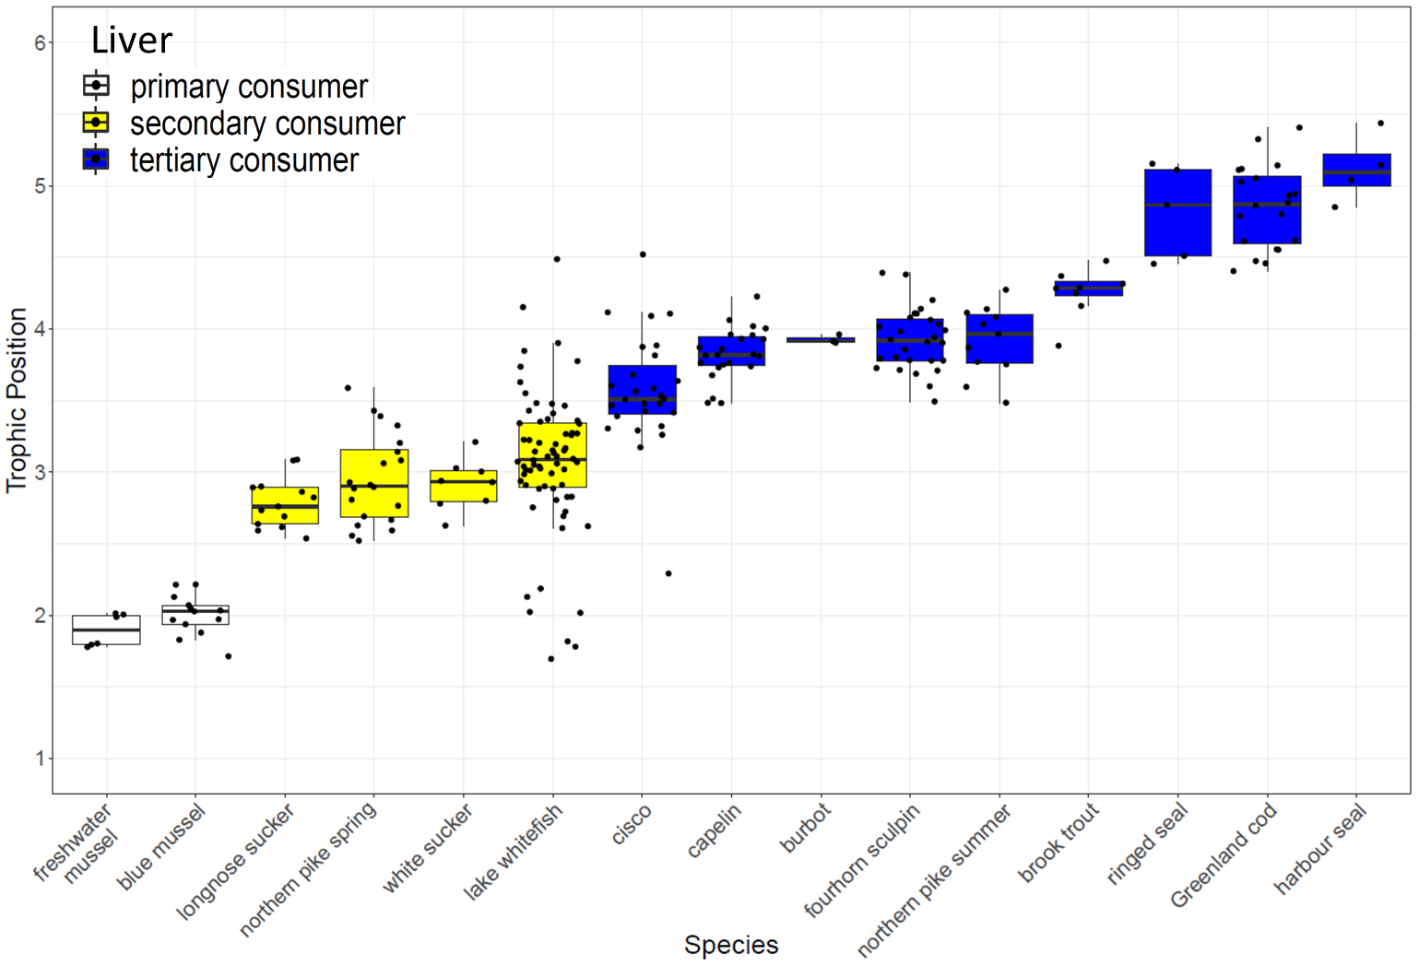
Figure S.1. Boxplot (median and one standard deviation) of consumers trophic positions within the Churchill River and Churchill River estuary based on liver data.

