Supporting Information for
It’s not just noise: The consequences of inequitable noise for urban wildlife.

Author list: Jasmine R. Nelson-Olivieri^{1,a}, Tamara J. Layden^{1,a}, Edder Antunez¹, Ali Khalighifar¹,
Monica Lasky¹, Theresa M. Laverty^{2,3}, Karina A. Sanchez⁴, Graeme Shannon⁵, Steven Starr¹, Anahita K. Verahrami¹, Sara P. Bombaci¹

- Department of Fish, Wildlife, and Conservation Biology, Colorado State University, Fort Collins, CO 80523
- Department of Ecology and Evolution, University of Chicago, Chicago, IL 60637
- Department of Fish, Wildlife, and Conservation Ecology, New Mexico State University, Las Cruces, NM 88003
- Department of Natural Resources and the Environment, University of New Hampshire, Durham
NH 03824
- School of Natural Sciences, Bangor University, Bangor LL57 2UW, UK

ªJ.R.N.-O and T.J.L contributed equally to this work.

*Corresponding Author: Jasmine R. Nelson-Olivieri
Email: Jazz.Nelson@colostate.edu

This PDF file includes:

Supporting text
Figure S1
Tables S1 to S3

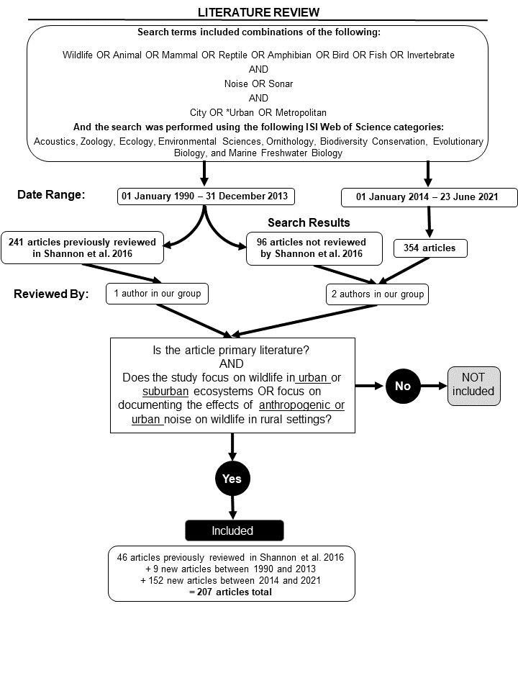
Fig. S1. A PRISMA flowchart demonstrating the methodology used to select and assess papers for the systematic literature review conducted.

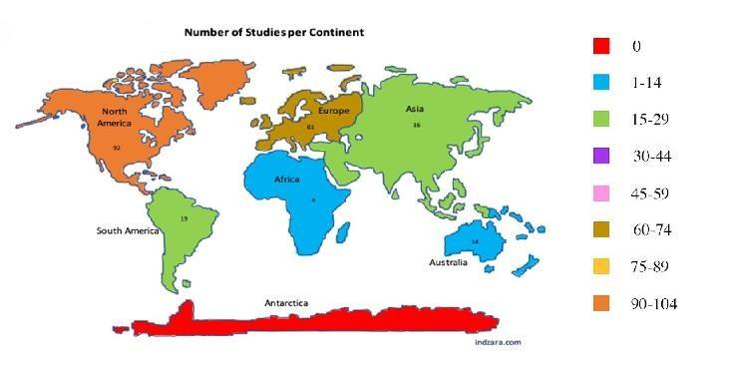

Fig. S2. Number of papers studied by continent. North America has the most studies followed by Europe, highlighting an inequity in the distribution of urban noise studies conducted in the Global North as compared to the Global South.

Table S1. Linear model results for the best-fitted model testing the effects of HOLC category and city population size on the mean noise exceedance metric N (dB/900m2).

CI
Predictors Estimates S.E.
lower upper

Intercept | 2.23 | 0.08 | 2.08 | 2.38
HOLC-B | 0.36 | 0.10 | 0.15 | 0.56
HOLC-C | 0.60 | 0.10 | 0.39 | 0.80
HOLC-D | 0.79 | 0.10 | 0.59 | 1.00
City population size | <0.01 | <0.01 | <0.01 | <0.01

Observations | 324
R2 | 0.235
AIC | 657.065

Table S2. List of U.S. cities included in the spatial analysis of the distribution of noise pollution across HOLC grades.

City | State |  | City (cont’d) | State (cont’d)
Akron | Ohio |  | Miami | Florida
Atlanta | Georgia |  | Milwaukee | Wisconsin
Augusta | Georgia |  | Nashville | Tennessee
Austin | Texas |  | New Haven | Connecticut
Baltimore | Maryland |  | New Orleans | Louisiana
Birmingham | Alabama |  | New York City | New York
Boston | Massachusetts |  | Newark area | New Jersey
Buffalo | New York |  | Norfolk | Virginia
Charleston | West Virginia |  | Oakland | California
Chattanooga | Tennessee |  | Oklahoma City | Oklahoma
Chicago | Illinois |  | Omaha | Nebraska
Cleveland | Ohio |  | Philadelphia | Pennsylvania
Columbia | South Carolina |  | Phoenix | Arizona
Columbus | Georgia |  | Pittsburgh | Pennsylvania
Columbus | Ohio |  | Portland | Oregon
Dallas | Texas |  | Providence | Rhode Island
Dallas/Ft. Worth | Texas |  | Pueblo | Colorado
Davenport | Iowa |  | Richmond | Virginia
Dayton | Ohio |  | Roanoke | Virginia
Denver | Colorado |  | Rochester | New York
Des Moines | Iowa |  | Sacramento | California
Detroit | Michigan |  | Salt Lake City | Utah
Dubuque | Iowa |  | San Antonio | Texas
Flint | Michigan |  | San Diego | California
Fort Worth | Texas |  | San Francisco | California
Fresno | California |  | San Jose | California
Grand Rapids | Michigan |  | Savannah | Georgia
Greater Kansas City Missouri |  |  | Seattle | Washington
Hartford Connecticut |  |  | Sioux City | Iowa
Houston Texas |  |  | Spokane | Washington
Indianapolis Indiana |  |  | St. Louis | Missouri
Jackson Mississippi |  |  | St. Paul | Minnesota
Jacksonville Florida |  |  | St. Petersburg | Florida
Knoxville Tennessee |  |  | Stamford | Connecticut
Little Rock Arkansas |  |  | Syracuse | New York
Los Angeles California |  |  | Tacoma | Washington
Louisville Kentucky |  |  | Tampa | Florida
Macon Georgia |  |  | Toledo | Ohio
Madison Wisconsin |  |  | Topeka | Kansas
Manchester New Hampshire |  |  | Tulsa | Oklahoma
Memphis Tennessee |  |  | Waterloo | Iowa
 |  |  | Wichita | Kansas

Table S3. Variables recorded from our literature review of empirical studies published between 1990 and our search date of June 23, 2021 that documented the effects of anthropogenic noise on wildlife in urban or suburban ecosystems or the effects of urban noise on wildlife in rural environments.

Variable | Description
Study type | Natural experiment, playback, theoretical, combination
Location of Experiment | lab, field, both, or theoretical
Geographic region | The general geographic region in which the study took place: Africa, Antartica, Asia, Atlantic Ocean,  Australia, Baltic Sea, Europe, Global, Indian  Ocean, Mediterranean, North America, Pacific  Ocean, South America,
Biological response measured | The response of the study organism(s), specifically the response to anthropogenic noise: ecosystem, foraging behavior, life  history/reproduction, mating behavior, movement behavior, physiological, population, vigilance behavior, vocal behavior
Organism type | Birds, fish, herpetofauna, invertebrates, mammals, multiple
Trophic level | Carnivore, herbivore, omnivore, multiple
Habitat | Aquatic, terrestrial
Was the frequency of noise reported? | Whether the frequency range of the received noise was reported in the paper
Background (ambient) levels | The range or point estimate for background (ambient) noise level(s) if it was reported
Noise level that caused a response (record multiple noise levels if appropriate) | The noise level at which the study organism responded (measured biological response) to the sound/noise stimulus. Report associated unit (dB, Hz, etc.)
Specific biological response from the organism (report for each noise level) | How did the biological response change? E.g., Minimum frequency, number of songs, or duration of calls increased or decreased, species richness increased or decreased, etc.
Non-significant biological responses | List of any non-significant biological responses to noise described in the paper
Time period | When the study took place

