Supplementary file 1

S1a. Feeding test
The feeding system was tested on Aedes albopictus in cages and BG traps placed in insectary (14:10 light-dark; 70±10% RH; 26±2°C), to assess the mosquitoes’ ability to take a sugar meal and estimate the sugar feeding rate on the FTA cards. Methylene blue, a dye with low toxicity for mosquitoes, was added to the sugar solution to identify fed specimens after feeding on the FTA card. To allow a gradual release of solution over the time, hydroxy-ethyl cellulose (HEC), a colloidal mixture of polymers with the feature of absorbing large quantities of water (over 90-95%), was also added. Under insectary conditions all the FTA cards inserted in feeders remained moist for over a week, reducing the volume of solution up to 50% without drying.
Different delivery systems (∅ 6 cm petri dish containing 4.7ml of solution; ∅ 2 cm stopper containing 1.6 ml of solution; 15 ml tube with sponge and 15 ml tube, both containing 5 ml of solution) and sugar solutions (honey/30% sucrose with HEC at 2%, 5%, 8%, 10% at the following proportions: 1:1, 1:3, 3:2) were tested in BG traps (Tab. S1). The highest feeding rate in BG trap (58%) was achieved with FTA-card partially soaked in a solution based on honey and 2% HEC in 3:2 proportion, inserted in a 15ml tube.

Delivery system/solution | N mosquitoes | mean % fed | N tests
∅ 6cm petri dish with filter paper | 778 | 40% | 27
Cage | 778 | 40% | 27
8% HEC + Honey (1:1) | 62 | 0% | 3
10% HEC + 30% Honey (1:1) | 41 | 5% | 2
10% HEC + Honey (1:3) | 427 | 12% | 11
5 % HEC + Honey (3:2) | 248 | 86% | 11
∅ 6cm petri dish with FTA-card | 71 | 21% | 4
Cage | 34 | 43% | 2
8% HEC + Honey (3:2) | 34 | 43% | 2
BGS | 37 | 0% | 2
5% HEC + Honey (3:2) | 19 | 0% | 1
8% HEC + Honey (3:2) | 18 | 0% | 1
∅ 2cm stopper with FTA-card | 120 | 12% | 8
Cage | 20 | 9% | 2
2% HEC + 30% sucrose | 9 | 0% | 1
2% HEC + Honey (3:2) | 11 | 18% | 1
BGS | 100 | 13% | 6
5% HEC + Honey (3:2) | 89 | 1% | 4
HEC 2% + Honey (3:2) | 6 | 33% | 1
HEC 2% + 30% sucrose | 5 | 40% | 1
15ml tube with FTA-card and sponge | 341 | 12% | 8
Cage | 236 | 2% | 4
2% HEC + Honey (3:2) | 118 | 2% | 2
2% HEC + 30% sucrose | 118 | 2% | 2
BG | 105 | 23% | 4
2% HEC + 30% sucrose | 51 | 20% | 2
2% HEC + Honey (3:2) | 54 | 26% | 2
15ml tube with FTA-card | 940 | 42% | 36
Cage | 469 | 23% | 14
2% HEC + Honey (3:2) | 240 | 22% | 7
2% HEC + 30% sucrose | 229 | 24% | 7
BG | 471 | 54% | 22
2% HEC + 30% sucrose | 140 | 46% | 7
2% HEC + Honey (3:2) | 331 | 58% | 15
Total | 2250 | 35% | 83
Table S1. Sugar feeding tests performed with Aedes albopictus using different solutions and delivery systems.

S1b. WNV-1 detection from FTA-card collected at different time points.
FTA cards were infected with WNV-1 CT 678 strain at 3.25x10⁵ PFU/ml diluted 1:50 (20µl of seed + 980 µl of dilution buffer) directly spotted on the substrate to obtain a final viral load of 32.5 PFU (5µl + 15µl dilution buffer). Feeders with infected FTA cards were placed in BG traps and collected at different time points (7-, 10- and 15-days post deployment), testing 2 traps outdoors and 1 trap indoors for each time point. RNA extraction and detection of WNV-1 from collected FTA-cards was performed as described in Materials and Methods. All viral RNA from FTA-card was successfully amplified at all time points (Tab. S2, Fig. 1 and 2).

7 days |  | 10 days |  | 15 days
Tm mean | Ct mean | Tm mean | Ct mean | Tm mean | Ct mean
85,12 | 31,28 | 85,10 | 31,21 | 85,15 | 31,57
85,19 | 31,89 | 85,12 | 31,36 | 85,22 | 31,34
85,07 | 31,48 | 85,14 | 31,19 | 85,12 | 30,78
Table S2. Signal parameters of real-time PCR for WNV-1 extracted from FTA cards at different time points . Mean ct values (ct mean) and melting temperature (Tm) of tested samples.

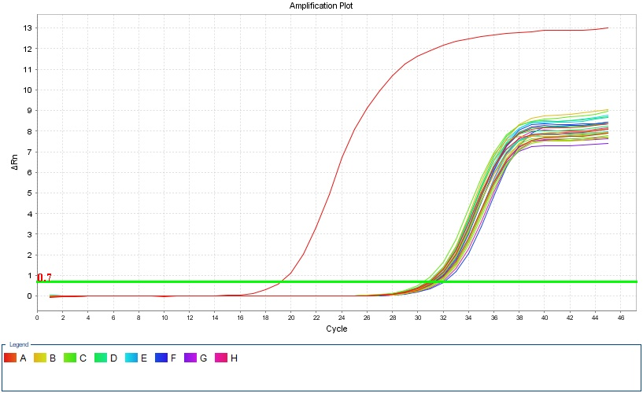
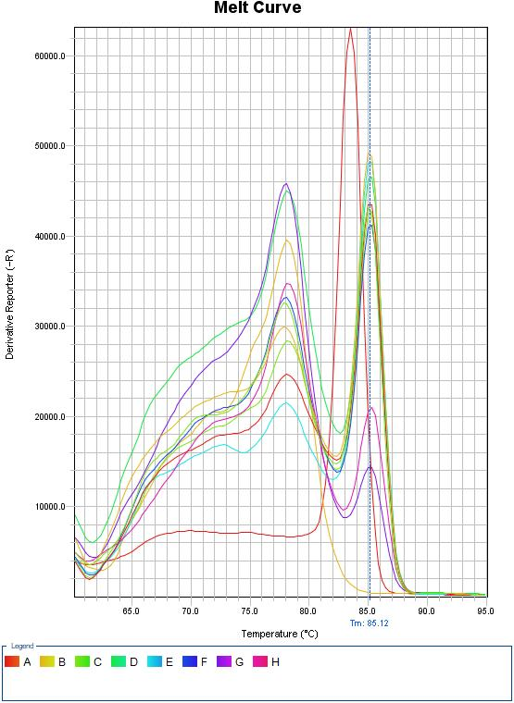
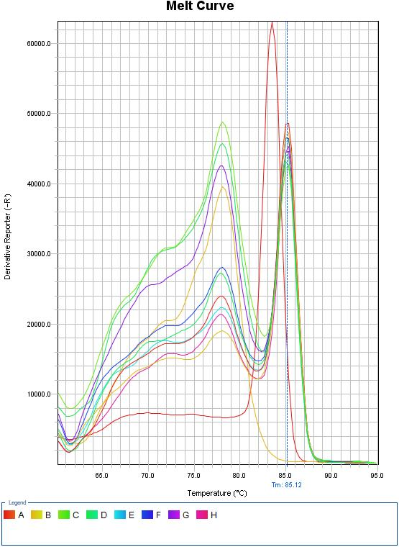
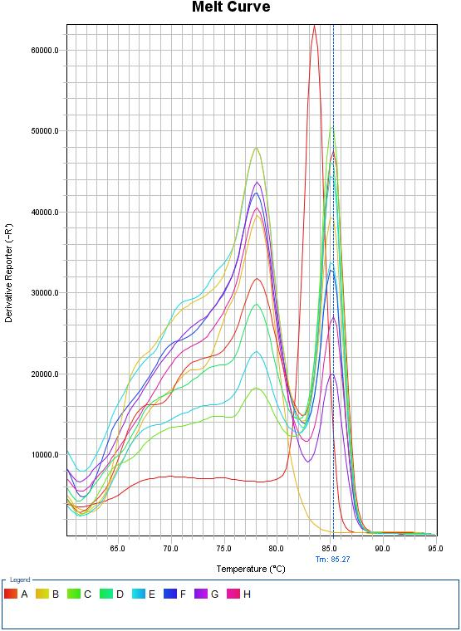
Figure S1- Amplification curve of real-time PCR for WNV-1 extracted from FTA cards at different time points. In red positive control (USUV from cell culture), the other curves represent tested samples and negative controls. All samples were tested in triplicate wells.
7 days
15 days
10 days

Figure S2 - Melt curve plot. In red positive control (USUV from cell culture), the other curves represent tested samples and negative controls. All samples were tested in triplicate wells.

