Supporting Information

Self-healable Printed Electronic Cryogels for Plant Monitoring

Eloïse Bihar^{1,*}, Elliot J. Strand^{+, 2}, Catherine A. Crichton^{+,1}, Megan N. Renny^{+, 2,} Ignacy Bonter⁵, Tai Tran¹, Madhur Atreya¹, Adrian Gestos⁴, Jim Haseloff ⁵, Robert R. McLeod^{2, 3}, Gregory L. Whiting^{1, 2 *}

* Gregory.whiting@colorado.edu and Eloise.bihar@colorado.edu

Figure S1.

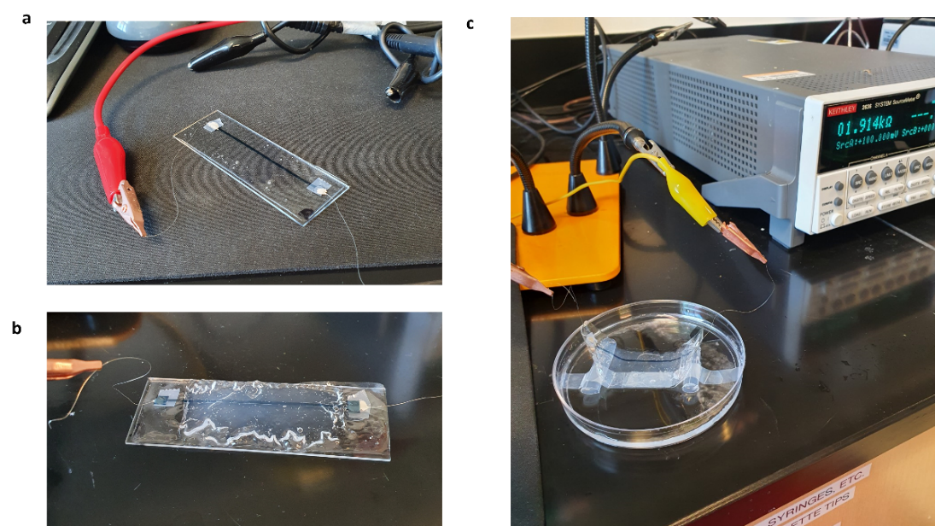

a Photograph of an air-dried jelly printed conducting trace. Photograph of cryogel printed conducting trace in air b and in water c connected to a source-meter. The resistance is respectively 0.80 kΩ for the air-dried printed conducting trace, 1.71 kΩ for the cryogel printed conducting trace in air and 1.91 kΩ in water. (The air-dried electronic gel contacts are kept dry while the electronic cryogel is placed in water)

Figure S2.

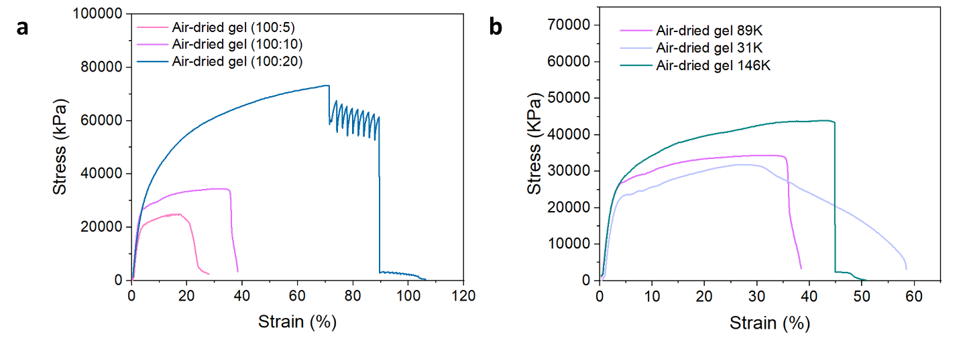

a Stress (kPa) of air-dried gels measured with different strains with different deionized Water: PVA weight ratios (100:5, 100:10, 100:20). b Stress (kPa) of air-dried electronic gels measured with different strains. The PVA used had different molecular weights (M_{w} 31000-50000, 89000-98000, 146000-186000).

Figure S3.

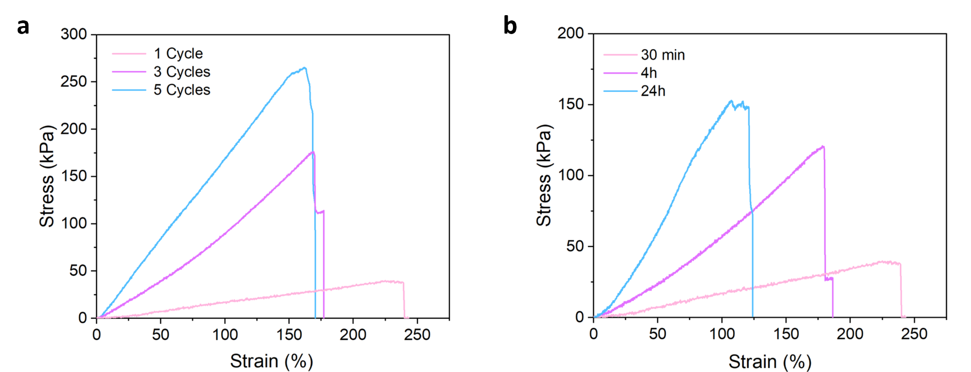

a Stress (kPa) of cryogels created with 1 freeze thaw cycle for a duration of 30min, 4h, and 24h. b Stress (kPa) of cryogels created with 1, 3, 5 freeze thaw cycles of 30min.

Figure S4.

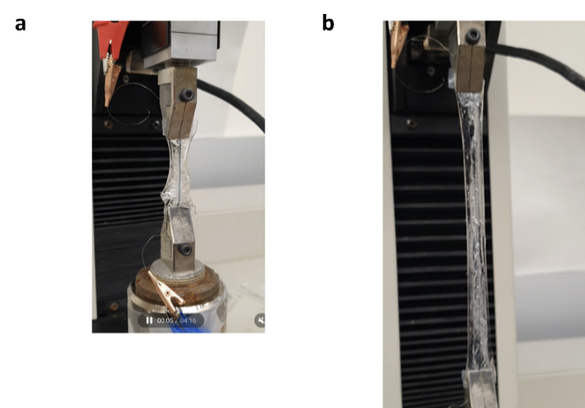

Photograph of a printed cryogel-based traces before a and after b stretching.

Figure S5.
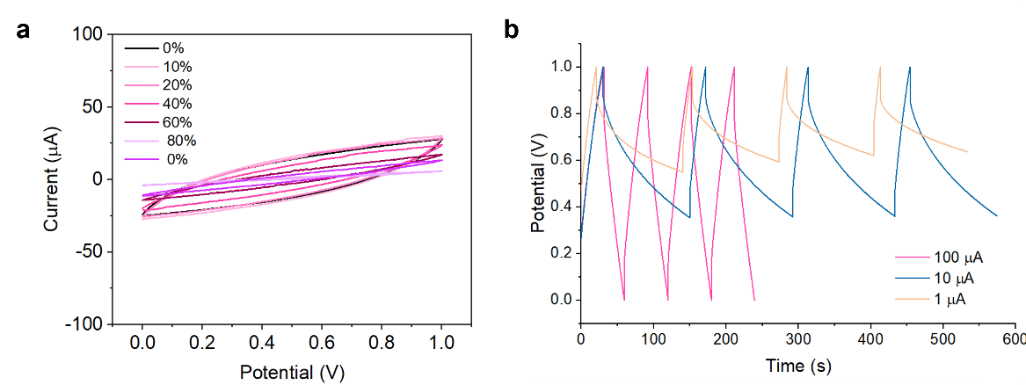

a Voltammetric cycles within an applied voltage window range from 0 to 1V of the air-dried printed capacitor gel while different stretching was applied at a scan rate of 20mV.s⁻¹. b Galvanostatic charge/discharge curves of the air-dried capacitor gels at different current densities (1 µA, 10 µA, 100 µA) (The current density for the charge is fixed at 100 µA) within an applied voltage window range from 0 to 1V.

Figure S6.
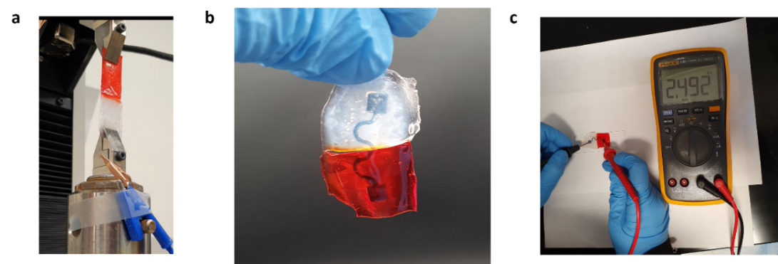

a Photograph of a self-healed cryogel before stretching. b Photograph of an electronic trace healed, and c measurement of the resistance of the healed trace with a digital multimeter

Figure S7.
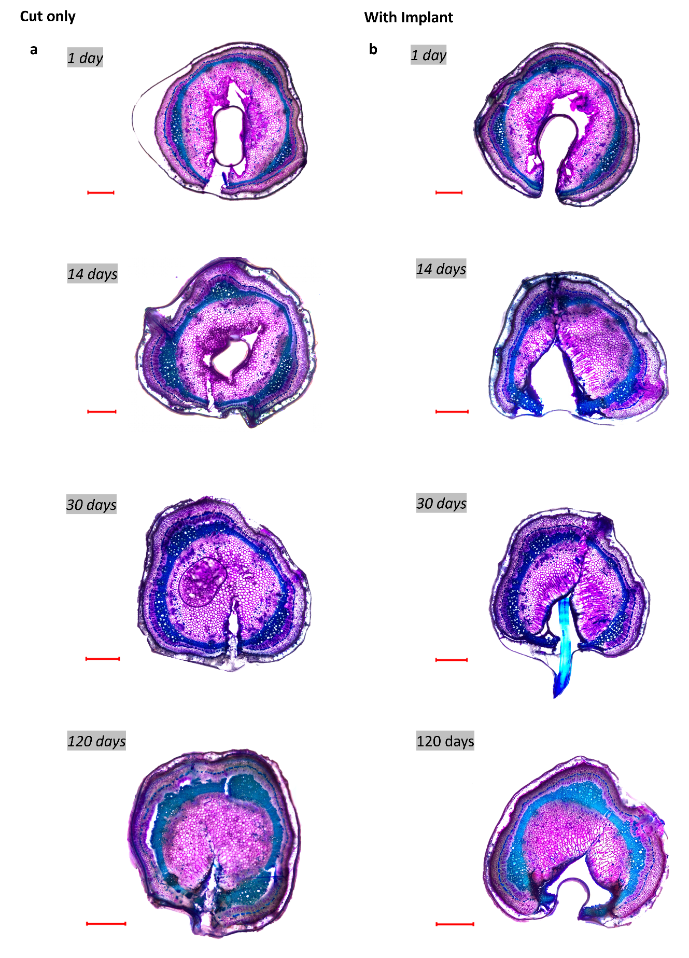
Optical micrographs of the transversal cut of the stem with implants a. and without implants b after 1, 14, 30 and 120 days of implantation/cut (scale bar is 1mm)

Figure S8.
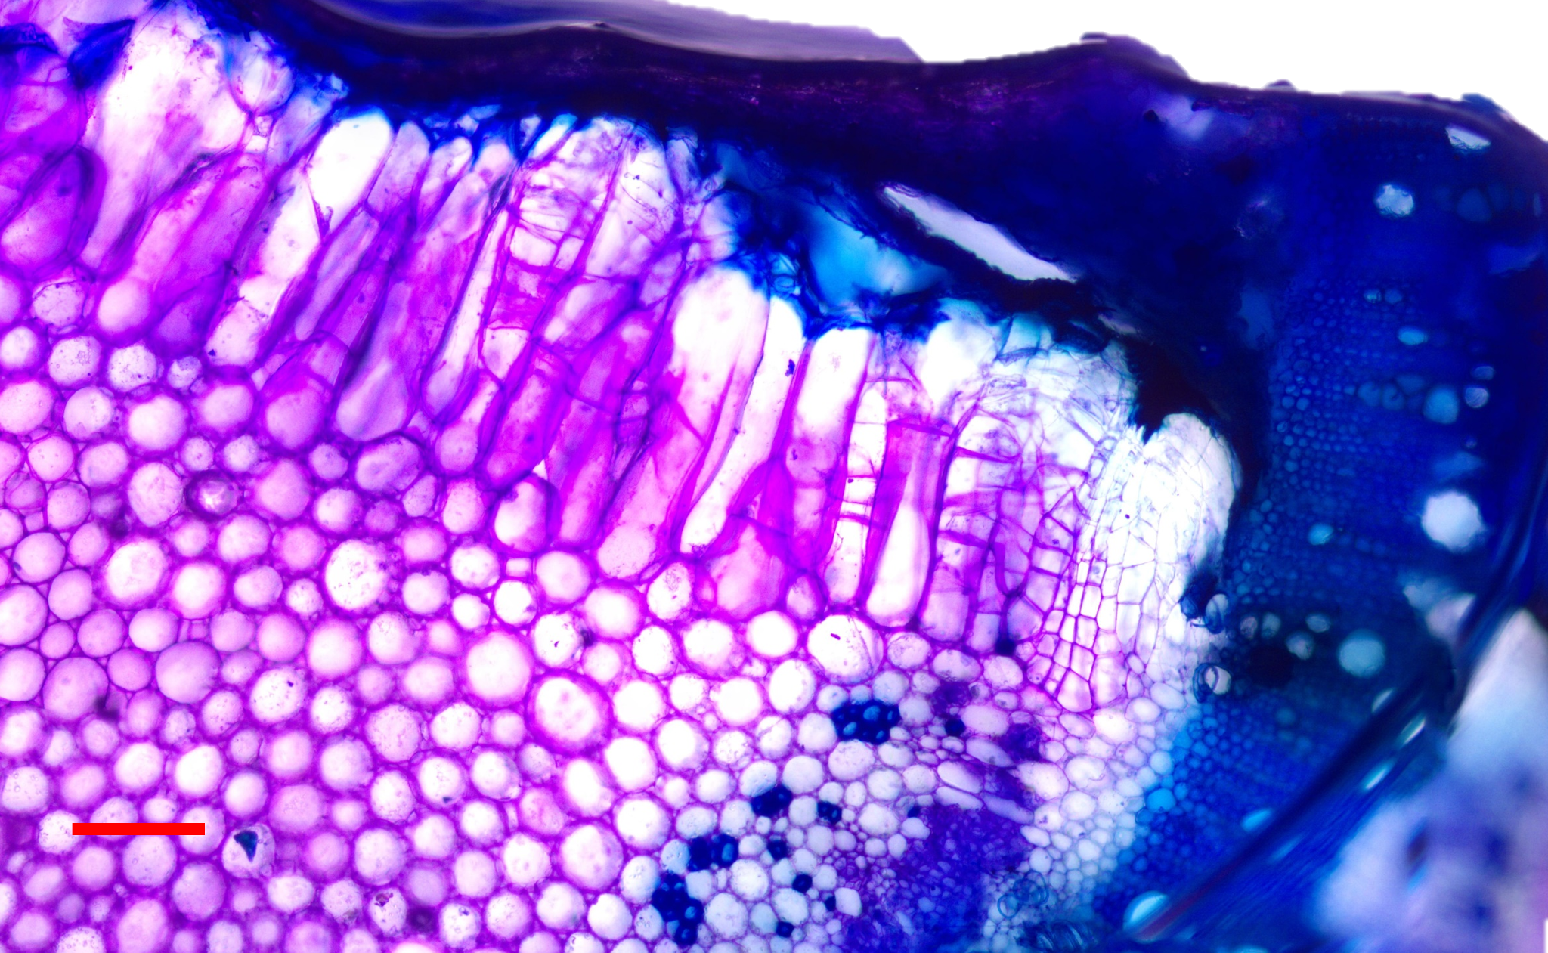
Optical micrographs of the transversal cut of the stem who was carrying an implant after 14 days of implantation (scale bar is 200 µm).

Figure S9.
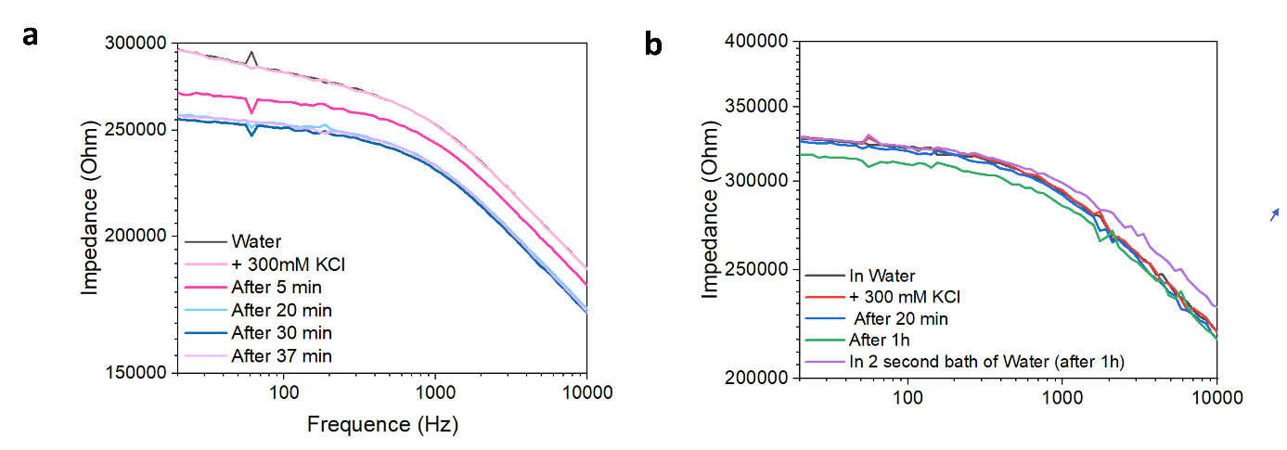
Variation of the electrochemical impedance of implants in 2 different stems after day 8 of implantation, immersed successively from an aqueous solution to a 300 mM KCl a, and from an aqueous solution to a 300 mM KCl for 1h and then water for an 1h b.

Figure S10.
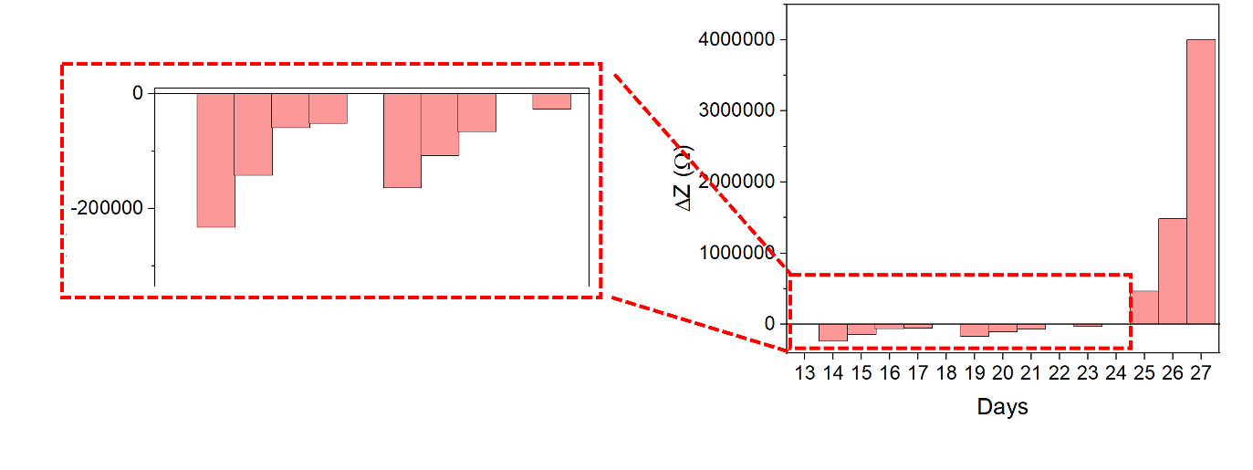Variation of the electrochemical impedance of a stem immersed successively in an aqueous solution and in 300 mM KCl (for 24h) for 14 days.

Figure S11.

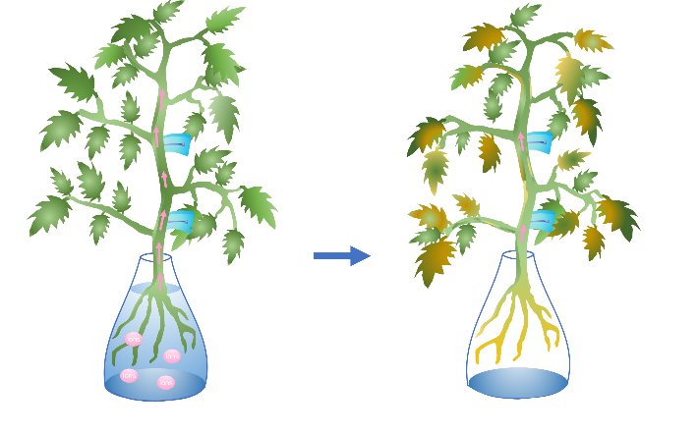
Schematic of the 2 gel electrodes implanted in the tomato stem in water and in drought conditions.

Figure S12.
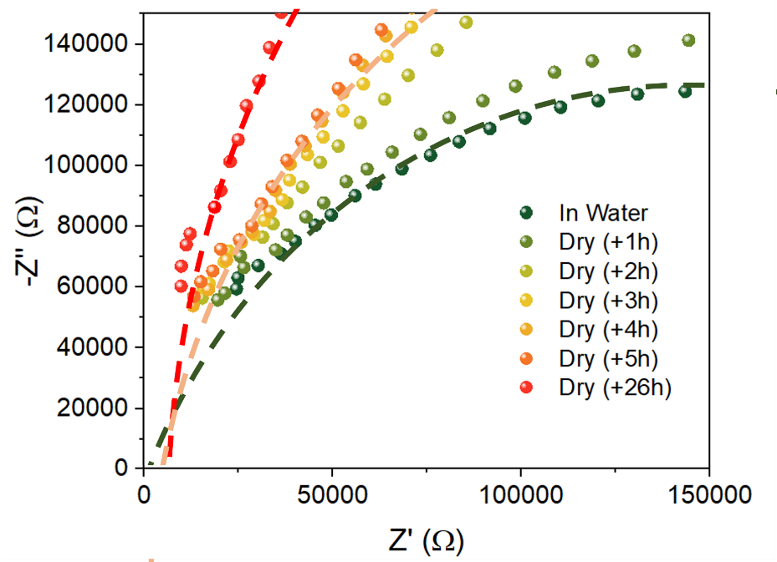
Comparison between the Nyquist plot of the cryogel electrodes implanted in the stem in water and left for 6 and 26 hours to dry and their equivalent circuit fitting.

Figure S13.
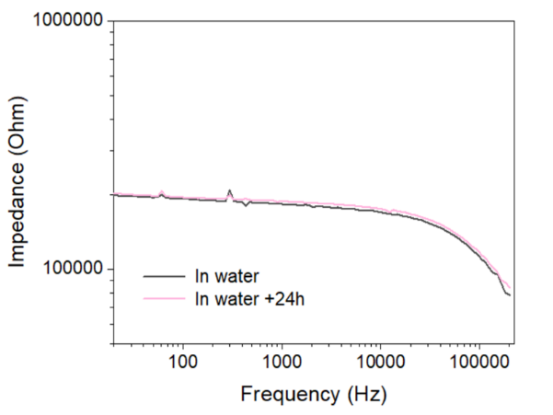
Electrochemical impedance spectra obtained from cryogel electrodes implanted in a second stem and left in water over 24h as control experiment (measured after 21 days of implantation)

Figure S14.
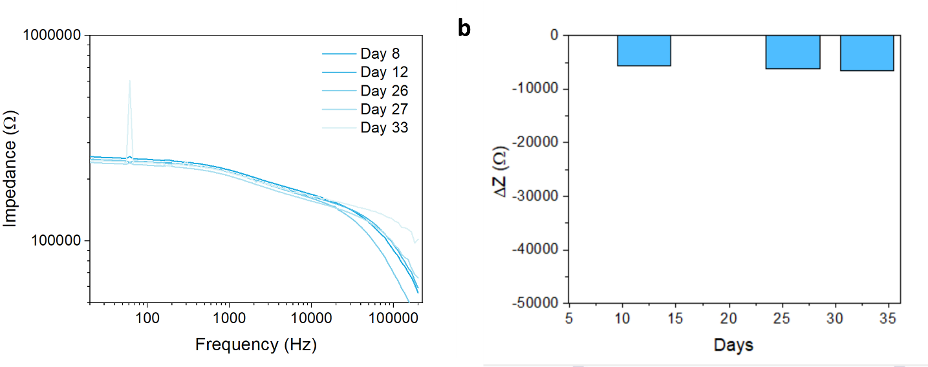
Electrochemical impedance spectra obtained from cryogel electrodes implanted in a stem and left in water over 15 days as control experiment (measured after 13 days of implantation)

Figure S15.
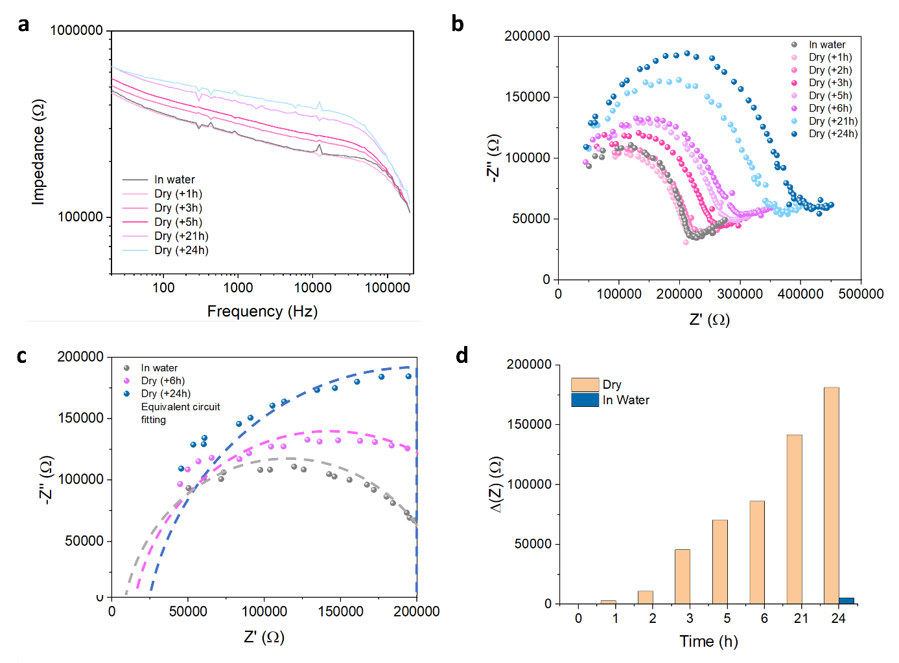
a Electrochemical impedance spectra obtained from cryogel electrodes implanted in the stem in drought conditions for 24 h and a control stem is kept in water. The impedances are measured on day 21 after implantation. b Nyquist plot of the cryogel electrodes implanted in the stem left for 24 hours to dry. c Comparison between the Nyquist plot of the cryogel electrodes implanted in the stem in water and left for 6 and 24 hours to dry and their equivalent circuit fitting. d Comparison of the variation of the electrochemical impedance between a stem in an aqueous solution and a stem left to dry for 24 h.

Figure S16.

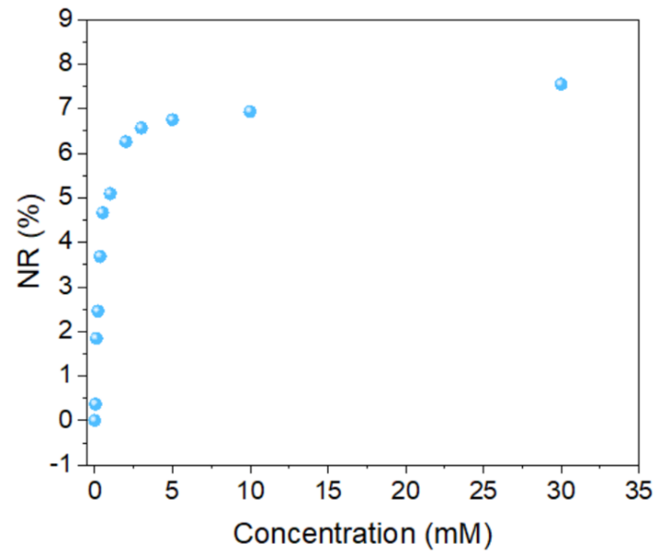
Normalized response (NR) in % of Id is plotted at different K⁺ concentrations.

Figure S17.
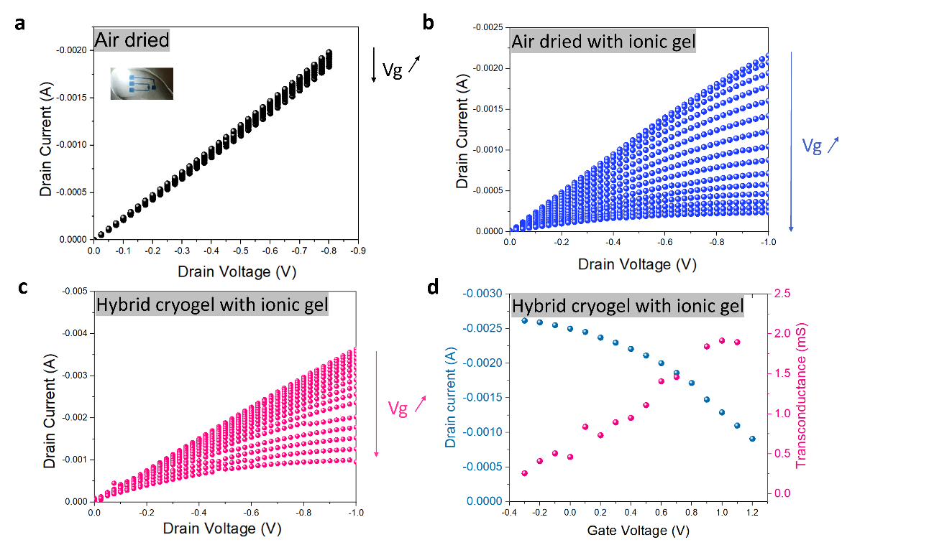
IV curves of a an air-dried gel OECT with no electrolyte, b an air-dried gel and c cryogel OECT with a methylcellulose ionic gel. d Transconductance and transfer curve of the cryogel OECT with a methylcellulose ionic gel

Figure S18.
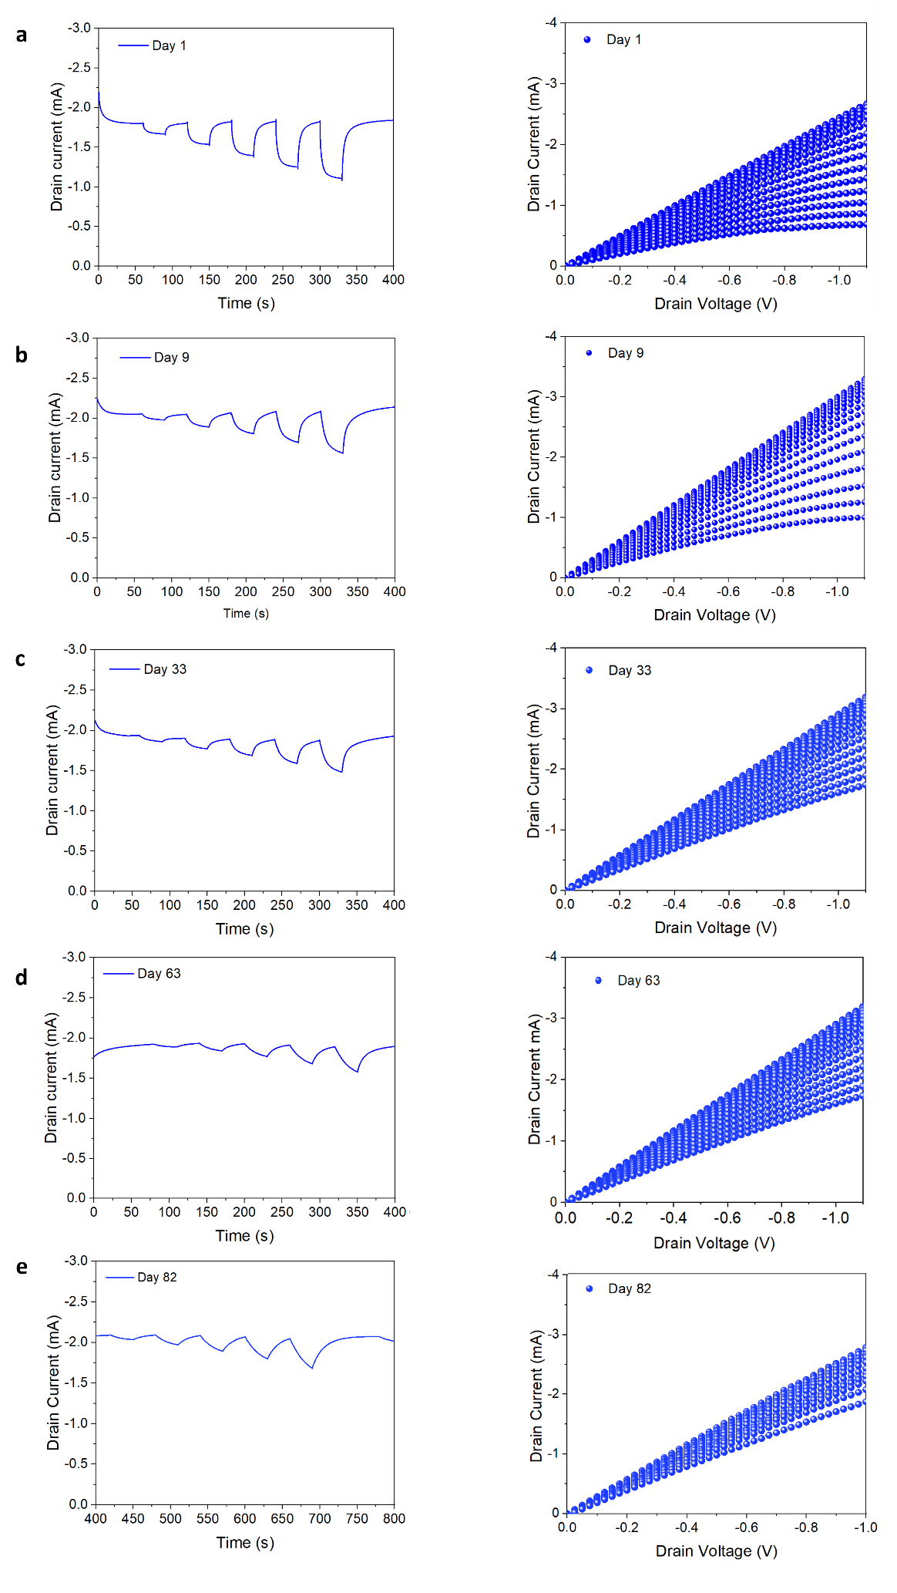
a) Drain current response to gate pulses applied with different voltages (respectively 0 V, 0.1 V, 0.2 V, 0.3 V, 0.4 V, and 0.5 V) and IV curves of a cryogel OECT implanted in tomato stems after 1 day a, 9 days b, 33 days c, 63 days and d, 83 days e of implantation
Figure S19.
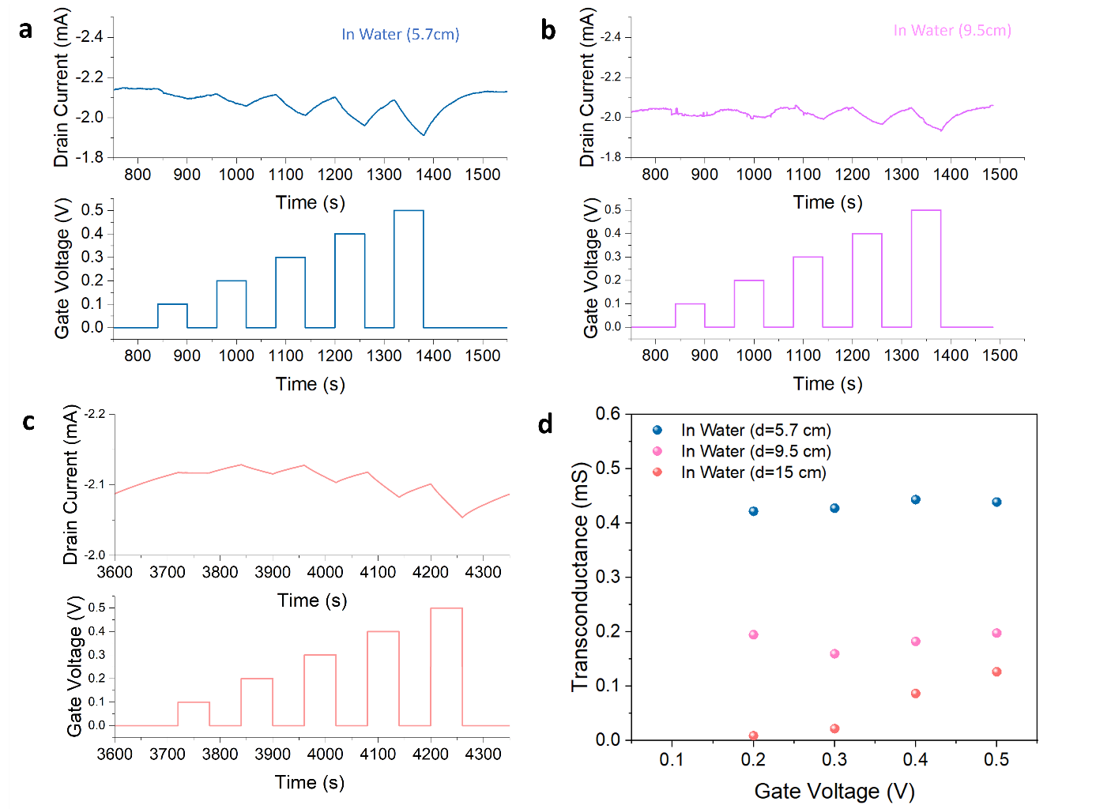
Drain current response to gate pulses applied with different voltages (respectively 0 V, 0.1 V, 0.2 V, 0.3 V, 0.4 V, and 0.5 V) of a cryogel OECT implanted in tomato stems after 6 days of implantation in water. The channel is placed at a 5.7cm b 9.5 cm from the gate on the same tomato stem. c Drain current response to gate pulses applied with different voltages (respectively 0 V, 0.1 V, 0.2 V, 0.3 V, 0.4 V, and 0.5 V) of a cryogel OECT implanted in tomato stems after 6 days of implantation in water. The channel is located 15cm from the gate. d Comparison of the transconductance of the OECT with different distances between the channel and gate.

Figure S20.
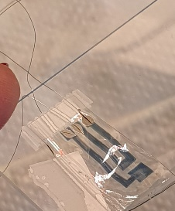

Photograph of an air-dried gel OECT and the wires connections

Figure S21.
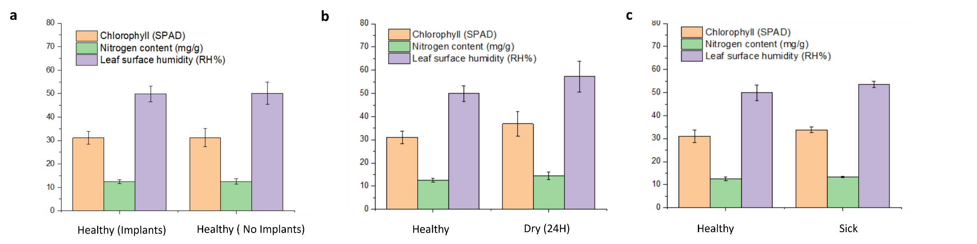
Comparison of the Chlorophyll, nitrogen and humidity measured on leaves for a stem with and without implants (after 30 days of implantation)

