Supporting information for:
Label-free isolation of circulating tumor cells using negative lateral dielectrophoresis-assisted inertial microfluidics
Aliasghar Mohammadiª, Morteza Safariª, and Mehdi Rahmanian^{b}
ªDepartment of Chemical and Petroleum Engineering, Sharif University of Technology, Tehran, Iran
^{b}Department of Biomaterials and Tissue Engineering, Breast Cancer Research Center, Motamed Cancer Institute

Table of content
S1. Theory..……………………………………………………………………………………….3
S2. Simulation of the microfluidic device..……………………………………………….……..7
S3. Design of microelectrodes..………………………………………………………….……...12
S4. Physical characteristics of cells...…….....………………………………………………….13
S5. Mesh independency analysis…………………………………………………………….…14
S6. The lift force calculation ……………………………………………………………..……16
S7. The Clausius–Mossotti factor……………………..………………………………….…....21
S8. Microfluidic device fabrication….…………………..…………………………..……..….22
S9. Sample preparation ….………………………………………………………………….....25
S10. Operating procedure….…….………………………………………………………….....28
S11. The simulation of the electric-field distribution………..…………………………….…30
S12. The movies ……………………………………………..……………………………….…31
References……………………………………………….………………………………………32

S1. Theory
S1.1. Inertial migration
The inertial migration phenomenon is observed for randomly dispersed particles within a channel flow in which the particles migrate to specific equilibrium positions in the channel cross-section depending on the characteristics of the particles and fluid as well as channel structure [1]. For a particle with a diameter of $d_{p}$ suspended in a straight microchannel with a hydraulic diameter of $D_{h}$, inertial migration occurs when $d_{p}/D_{h}≥0.07$; in other words, the particle migrates to equilibrium positions in a sufficiently long microchannel.
For a channel with a rectangular cross-section, the inertial migration involves two steps. In the first step, the particles migrate to equilibrium positions located on lines upon shear-gradient and wall-induced lift forces [2]. The shear-gradient lift force arises from the parabolic velocity profile around the particles, which pushes the particles towards the walls. In contrast, in the vicinity of the walls, the particles are pushed towards the channel centerline due to the wall-induced lift force, stemming from the interaction of the flow field with the particle and confining wall. As such, the equilibrium lines are defined as the locus of the points where the resultant of the lift forces becomes zero [2, 3]. In the second step, the effect of rotation-induced lift forces comes into play and the particles located on equilibrium lines migrate to equilibrium positions close to the center of larger walls, which are called equilibrium points [2].
Various methods have been developed for calculating the lift forces. For instance, the resultant of the lift forces are given by [4]
$$F_{L}=\frac{ρu_{f}^{2}d_{p}^{4}}{D_{h}^{2}}C_{L}(Re,{[y}_{p},z_{p}]), (S1)$$
where $ρ$, $u_{f}$, and $C_{L}$ stand for the fluid density, the average fluid velocity, and the lift coefficient, respectively. It must be noted that the lift coefficient depends on the Reynolds number ($Re)$ of the channel and the particle position in the microchannel cross-section ($y_{p},z_{p})$.
In curved microchannels, there is another lateral force with a significant role in particle migration. In general, when fluid flows through a curvilinear channel, the mismatch of velocity arising from centrifugal acceleration, leads to a radial pressure gradient. Therefore, two counter-rotating vortices, so-called Dean vortices, are generated to satisfy the continuity of fluid. The strength of the Dean vortices depends on the Dean number, $De$, defined as
$De=Re {\left(\frac{D_{h}}{2R}\right)}^{0.5}, (S2)$
where$μ$ and $R$ are the fluid dynamic viscosity and channel curvature, respectively. The magnitude of the Dean velocity depends on the Dean number as [5, 6]
$$u_{d}=1.8×{10}^{-4}De^{1.63} . (S3)$$
As a result, the drag force caused by the Dean vortices is [5, 6]
$$F_{Dean}=5.4×{10}^{-4}πμd_{p}De^{1.63} . (S4)$$
In this study, spiral microchannels were employed as part of the microfluidic device. Therefore, inertial lift and Dean drag forces are the main lateral forces that impart the inertial migration. It is known that relatively large particles equilibrate close to the inner wall of the spiral microchannel owing to the resultant of the inertial lift and Dean drag forces. On the other hand, relatively small particles are solely modulated by the Dean drag force and continuously rotate by the Dean vortices [7]. Thus, it is possible to collect larger and smaller particles/cells from the inner and outer outlets of a spiral microchannel, respectively (see figure 1).
S1.2. White blood cells
White blood cells comprise two groups of phagocytes and lymphocytes. While phagocytes includes cells of the innate immune system and function rapidly after infection, lymphocytes mediate the acquired immune response. Phagocytes, themselves, are divided into granulocytes (neutrophils, basophils, and eosinophils) and monocytes. Table S1 shows the characteristics and images of the five categories of white blood cells.

Table S1. The characteristics of white blood cells
cell type | d_{p} (μm) | % in blood
Neutrophils | 12-16 | 60
Eosinophils | 14-16 | 3
Basophils | 14-16 | 1
Monocytes | 14-20 | 6
Lymphocytes | 8-15 | 30

S1.3. Dielectrophoresis
When dielectric particles are exposed to a non-uniform electric field, the particles experience an external force, which is called the DEP force. For spherical particles, the DEP force is [8]
$$F_{DEP}=\frac{π}{4}ε_{m}d_{p}^{3} Re\left[f_{cm}\right]∇|{E|}^{2} , (S5)$$
where $ε_{m}$ is the permittivity of the medium, $E$ shows the electric field vector, and $Re\left[f_{cm}\right]$represents the real part of the Clausius-Mossotti factor. For spherical particles, the Clausius-Mossotti factor is [8]
$$f_{cm}=\frac{ε_{p}^{*}-ε_{m}^{*}}{ε_{p}^{*}+2ε_{m}^{*}} , (S6)$$
where $ε_{p}^{*}$and $ε_{m}^{*}$ are the complex permittivity of the particles and medium, respectively, given by [8]
$$ε^{*}=ε-\frac{iσ}{ω} , (S7)$$
with $ε$being the permittivity. $σ$ denotes the electrical conductivity, and $ω$ stands for the angular frequency of the electric field.
The real part of the Clausius-Mossotti factor ranges from -0.5 to 1. When $Re\left[f_{cm}\right]>0$, particles are pulled towards regions with higher electric field gradients as a result of positive DEP force. For $Re\left[f_{cm}\right]<0$, negative DEP force pushes particles away from large electric-field gradient regions. Needless to say, particles do not experience DEP force when$Re\left[f_{cm}\right]=0$.

S2. Simulation of the microfluidic device
We performed a three-dimensional simulation to analyze micro-and bioparticles dynamics in the spiral-DEP platform. For this purpose, all the blood cells were considered rigid spherical particles with diameters of 6, 10, 15, and 15 μm to represent RBCs, small WBCs, larger WBCs, and CTCs, respectively. The physical characteristics and population of the cells in the suspending medium are listed in table S2. Also, the particle tracing module was employed to address the dynamics of the cells within the microfluidic device through the Newton law of motion
$$\frac{d\left(m_{p}u_{p}\right)}{dt}=F_{Drag}+F_{Added Mass}+F_{Lift}+F_{DEP}, \left(S8\right)$$
where $m_{p}$ is the particle mass, $u_{p}$ denotes the particle velocity. $F_{Drag}$,$F_{Added Mass}$ , $F_{Lift}$, and $F_{DEP}$ also stand for the drag, added mass, resultant inertial lift, and DEP forces, respectively. Drag and added mass forces are
$$F_{Drag}=3 πμd_{p}(u-u_{p}) (S9)$$
and
$$F_{Added Mass}=\left(π/12\right)ρd_{p}^{3}\frac{d}{dt}\left(u-u_{p}\right), (S10)$$
where $u$ is the fluid velocity, which must be determined to calculate the drag and added mass forces.
The fluid velocity was determined by solving the equations of the mass- and momentum-conservation laws for the corresponding fluid within the spiral microchannel. For this purpose, the fluid was considered an incompressible Newtonian fluid. The momentum-conservation law of the fluid requires
$$ρ\left[\frac{∂u}{∂t} +\left(u∙∇\right)u\right]=μ∇^{2}u-∇p, (S11)$$
where p denotes the fluid pressure. As the fluid is incompressible, the mass-conservation law demands
$$∇∙u=0. (S12)$$
It must be noted that the blood is per se a shear-thinning fluid. But the blood is diluted with PBS in clinical cell separation applications as well as in our experiments. Therefore, the assumption of the blood as an incompressible Newtonian fluid is reasonable [9]. Also, the physical properties of the fluid were set constant. The boundary conditions at the inlets involved fully developed velocities for the sample and sheath fluid. For the outlets, atmospheric pressure was assumed. Also, the no-slip boundary conditions were adopted for the fluid velocity at the microchannel walls.
Equations S11 and S12 were solved using the COMSOL Multiphysics software version 5.6, which is a finite element-based computational fluid dynamics software. In this venue, the laminar flow module was employed under isothermal conditions at stationary mode. Moreover, the quadratic discretizing scheme was adopted for both velocity and pressure. The relative error in numerical calculations was considered 0.001. Furthermore, structured mesh elements were generated for the simulation with the optimum number of the elements being obtained using the mesh independency analysis. The details of mesh independency analysis are presented in section S5 of the supporting information. Moreover, parallelized computations were performed for the simulations on 24-core high-performance computing clusters.
Returning to equation S8, the resultant inertial lift force must be also calculated to track the dynamics of the cells. Various approaches have been used to calculate the inertial lift forces; among which, explicit equations are an approximate one. Commercial softwares, such as the COMSOL Multiphysics software, employ an explicit equation to calculate the resultant inertial lift force as suggested by Ho and Leal. This approach, however, suffers from few restrictions, including finite $Re$ numbers for the suspending medium. Also, such an equation cannot be employed in many-body practical situations [10].
The fluid-structure interaction simulation is the most precise approach for calculating the resultant inertial lift force. This approach provides the forces that result in fluid-particle interaction, but it is relatively time-consuming and costly. Furthermore, it is very challenging in the case of particle-laden flow within a long channel.
In this study, the Di Carlo algorithm was employed for calculating the resultant inertial lift force [11]. This algorithm was explained in detail in section S6 of the supporting information. The calculated inertial lift forces were mapped on the proposed spiral microchannel as a point force.
Finally, the DEP force must be calculated for implementing equation S8 to ascertain the cell dynamics. For this purpose, the electrostatic potential distribution in the microchannel was determined by solving the Laplace equation ($∇φ^{2}=0$ with $φ$ being the electrostatic potential) [12]. To this end, the electric current physic module in the COMSOL Multiphysics software was employed. Then, the frequency-dependent approach was used to compute the electrostatic potential. Subsequently, the dielectrophoresis force was calculated using equation S5.
It must be noted that DEP-based cell separation platforms rely on differences in the dielectric properties of the cells, where the electric-field frequency has a modulating impact on the properties. Hence, a proper frequency was selected using a dielectrophoretic spectrum in which $Re[f_{cm}]$ is plotted as a function of frequency for all cells. For plotting the spectrum, the single-shell model was adopted for calculating the dielectric properties of RBCs, WBCs, and CTCs in which the equivalent permittivity and conductivity of the cells were determined by
$$ε_{eq}^{*}=ε_{mem}^{*}\frac{α^{3}+2β }{α^{3}-2β} (S13)$$
with
$$α=\frac{r}{r-d} \left(S14\right)$$
and
$$β=\frac{ε_{cyt}^{*}-ε_{mem}^{*}}{ε_{cyt}^{*}+2ε_{mem}^{*}}. (S15)$$
Note that $ε_{mem}^{*}$ is the shell permittivity. $r$ and $d$ respectively denote the radius of the corresponding cell and the shell thickness. $ε_{cyt}^{*}$ represents the cytoplasm permittivity of the corresponding cell. Table S3 shows the single-shell model parameters for typical blood and cancer cells adopted in this study. In the developed microfluidic device, non-target cells should undergo negative DEP while the target cells experience negligible DEP. Therefore, as revealed by the plots in figure S4, the frequency was set to 170 kHz.
After the determination of all forces contributing to the dynamics of cells in the developed microfluidic device, the particle tracing analysis was implemented to examine the cell dynamics in the spiral-DEP platform. The interparticle interactions were neglected in the numerical analysis. This assumption is guaranteed considering the concentration of cells in the simulation. While the volume fraction of cells in the studied samples was more than 1 vol.%, the employed sheath fluid was diluting the samples within the microfluidic device such that the resulting concentration fell below 0.2 vol.%. As such, ignoring interparticle interactions is warranted in these simulations [13].
In the next step, equation S8 was solved using the particle tracing module in the COMSOL Multiphysics software in a time-dependent mode. To this end, all particles were abruptly introduced to the microchannel with zero initial velocity. Then, the particles went through the spiral microchannel with a velocity governed by equation S8 through coupling the laminar flow and particle tracing modules within the software.

S3. Design of microelectrodes

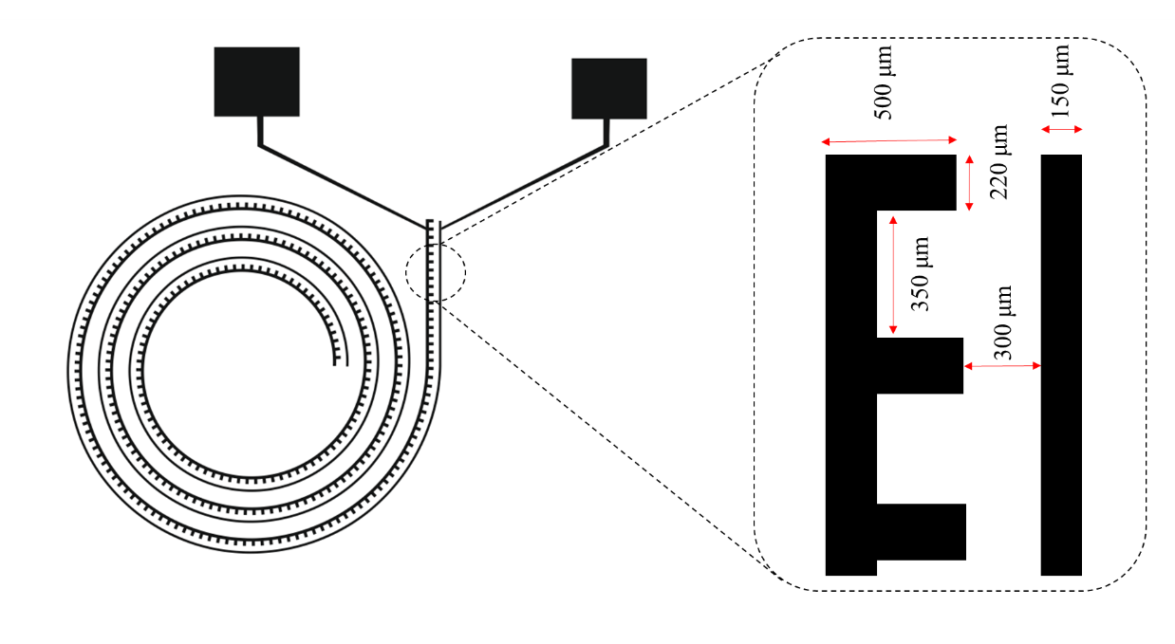
Figure S1. The pattern of designed microelectrodes in the present study

S4. Physical characteristics of cells
Table S2. The characteristics and properties of the cells studied in our simulations
cell type | morphology | d_{p}  (μm) | density  (kg m⁻³) | number of cells  released in simulations
RBCs | spherical | 5 | 1050 | 500
small WBCs | spherical | 10 | 1050 | 200
large WBCs | spherical | 15 | 1050 | 200
CTCs | spherical | 15 | 1050 | 200

Table S3. Dielectric properties of blood cells and CTCs
cell type | $${ε_{cyt}}/{ε_{0}}$$ | $$σ_{cyt}$$  (S m⁻¹) | $${ε_{mem}}/{ε_{0}}$$ | $$σ_{mem}$$  (S m⁻¹) | membrane thickness  (nm) | reference
RBCs | 59 | 0.31 | 4.44 | 1.00×10⁻⁶ | 4.5 | [14]
Platelets | 50 | 0.16 | 7.2 | 1.00×10⁻⁶ | 4 | [15]
Granulocyte | 65 | 0.6 | 5 | 1.00×10⁻⁶ | 4 | [16]
T Lymphocyte | 104 | 0.65 | 5 | 1.00×10⁻⁶ | 4 | [17]
B Lymphocyte | 154 | 0.73 | 5 | 1.00×10⁻⁶ | 4 | [17]
Monocyte | 127 | 0.56 | 5 | 1.00×10⁻⁶ | 4 | [17]
MDA-MB-231 | 52 | 0.62 | 11.75 | 1.00×10⁻⁶ | 4 | [16]

S5. Mesh independency analysis
We employed structured mesh elements for our simulations. The proper number of elements was obtained using the mesh independency analysis. The analysis was performed by following the lateral velocity, $\sqrt{{\left|u_{y}\right|}^{2}+{\left|u_{z}\right|}^{2}}$, profile as a function of the mesh elements. The lateral velocity profile was adopted on the symmetrical cut line along the microchannel lower and upper walls of a cross-section, located at the first turn of the spiral microchannel (see figure S2a). According to the results plotted in figure S2b, the elements were set to be more than 176550 in all our simulations.

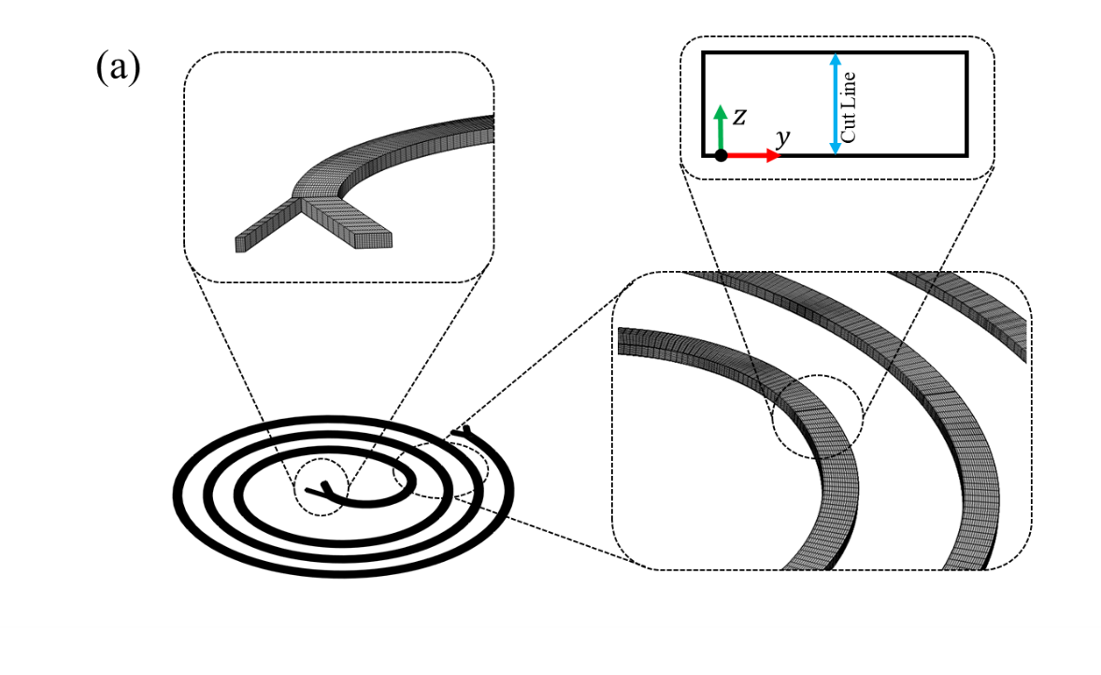
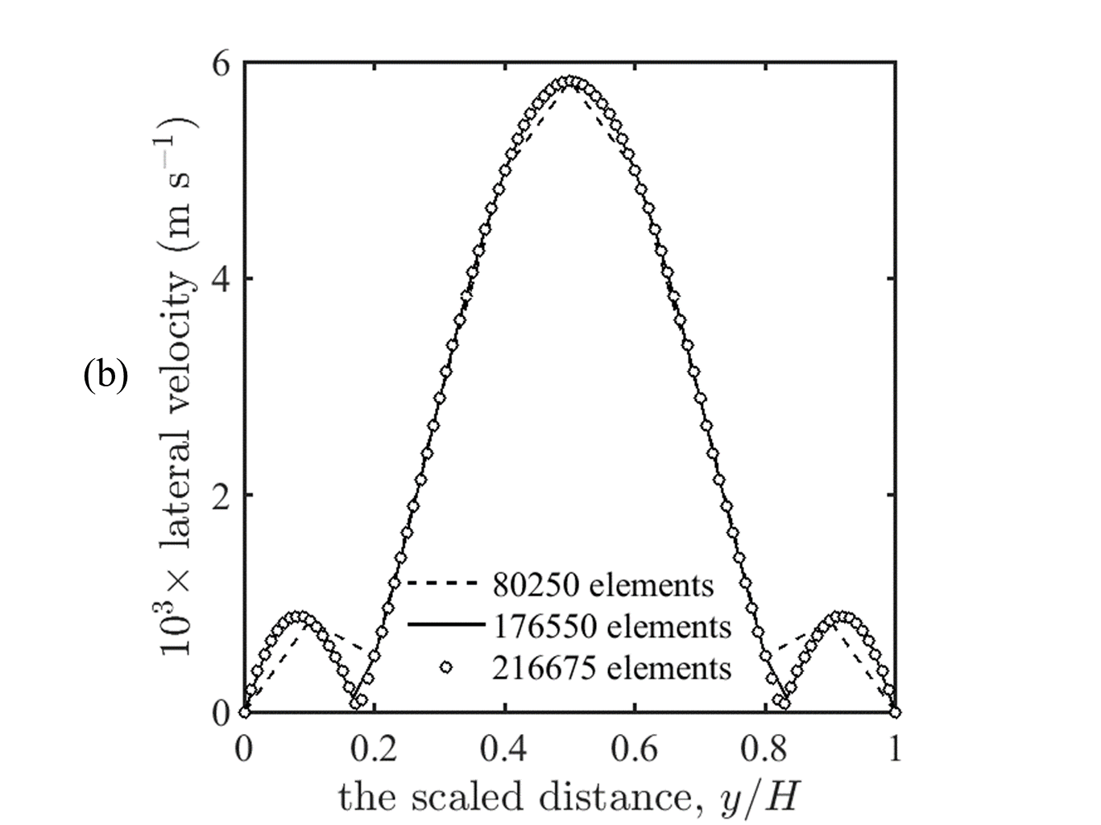
Figure S2. The schematics of employed structured mesh elements, and the location of the cut line selected for the mesh independency analysis (a). The lateral velocity profile at various mesh elements (b).
S6. The lift force calculation
Consider a micro- or bioparticle within the spiral microchannel. The resultant inertial lift force on the micro- or bioparticle depends on its position within the microchannel. In other words, the force is subject to the micro- or bioparticle position not only on the existing cross-section but also on the longitudinal position along the microchannel.
As an initial step towards calculating the force, it is assumed that the force be independent of the longitudinal position. Hence, the force is ascertained for a specified cross-section. Afterwards, the obtained force is used for the other cross-sections within the microchannel with the aid of an adjustment parameter.
For the purpose of our calculations, the specified cross-section is opted within the second turn of the spiral microchannel. Keeping this in mind, the task is to calculate the force just at various points on the specified cross-section. In general, there are three steps for calculating the resultant inertial lift force on a micro- or bioparticle at each point within the specified cross-section in the spiral microchannel, which are outlined below.
- At the beginning, the fluid velocity on the specified cross-section of the spiral microchannel in the absence of any micro- or bioparticle is determined. For this purpose, the Navier-Stokes equations (equations S11 and S12) are solved using the COMSOL MultiPhysics software at the stationary mode for the spiral microchannel. The physical properties of the fluid are set constant. The fully-developed velocity is adopted for the sample and sheath fluid at the inlets. At the outlets, atmospheric pressure is assumed. Also, the no-slip boundary condition is adopted for the fluid velocity on the microchannel walls. Moreover, the quadratic discretizing scheme is selected for both velocity and pressure. The mesh morphology and elements are the same as those provided in section S5. The relative error in numerical calculations is considered 0.001.
- A straight microchannel is constructed in the COMSOL MultiPhysics software. The microchannel cross-section is the same as that of our spiral microchannel. Also, the microchannel length is twenty times the micro- or bioparticle diameter. The physical properties of the fluid are set constant. The component of the fluid velocities at the microchannel inlet and outlet normal to the pertinent cross-sections are set the same as the corresponding normal component of the fluid velocity afforded from step 1. The other components of the fluid velocities at the inlet and outlet are set to zero. Afterwards, the Navier-Stokes equations (equations S11 and S12) are solved using the Live Link for MATLAB-COMSOL to obtain the fluid-velocity field within the microchannel. Finally, the velocity, $U_{P,0}$, and angular velocity, $ω$, are ascertained at the point wherein the particle center is supposed to be located.
- Again, a straight microchannel is constructed in the COMSOL MultiPhysics software in the same manner as that in step 2. Then, the micro- or bioparticle is located at the desired position within the microchannel. The micro- or bioparticle is allowed to rotate with the angular velocity, $ω$, around its diameters without any translational motion. This demands $F_{y}$, $M_{x}$, and $M_{z}$ be zero. It must be realized that $F_{y}$ is the $y$ component of the force, $F$, on the micro- or bioparticle. Also, $M_{x}$ and $M_{z}$ represent the, respectively, $x$ and $z$ components of the torque, $M$, on the micro- or bioparticle. To meet this demand, the walls should be set in motion with a proper velocity, which must be determined. To this end, the velocity afforded by step 2, $U_{P,0}$, is adopted for the velocity as an initial guess. As such, this requires that the velocities at the inlet and outlet of the straight microchannel be
$$u\left(x,y=±10d_{p},z\right)=u_{1}\left(x,z\right)-U_{P,0}, (S16)$$
where $u_{1}\left(x,z\right)$ is the normal component of the fluid velocity afforded from step 1. Also, the velocities at the walls of the straight microchannel are
$$u\left(x=±w/2,y,z=±h/2\right)=-U_{P,0}. (S17)$$
Moreover, the boundary conditions on the micro- or bioparticle surface are
$$u_{x}=\left(y-y_{p}\right)ω_{z}-\left(z-z_{p}\right)ω_{y} (S18)$$
$$u_{y}=\left(z-z_{p}\right)ω_{x}-\left(x-x_{p}\right)ω_{z} (S19)$$
$$u_{z}=\left(x-x_{p}\right)ω_{y} -\left(y-y_{p}\right)ω_{x} (S20)$$
as the fluid was sticks to the micro- or bioparticle surface, given the no-slip condition. Note that $ω_{x}$, $ω_{y}$, and $ω_{z}$ are the, respectively, $x$, $y$, and $z$ components of $ω$. Also, $u_{x}$, $u_{y}$, and $u_{z}$ are the, respectively, $x$, $y$, and $z$ components of $u$. Given the Navier-Stokes equations (equations S11 and S12) along with the aforementioned boundary conditions, the fluid velocity and pressure distributions within the microchannel are determined with the aid of the COMSOL MultiPhysics software. Next, the force and torque on the micro- or bioparticle are calculated through integrating the hydrodynamic stresses on the surface. If the calculated $F_{y}$, $M_{x}$, and $M_{z}$ are less than the corresponding thresholds, the opted velocity would be the proper one. Otherwise, a better guess must be opted for the velocity. In this study, the convergence thresholds were 10⁻¹⁴ and 10⁻²⁰ for, respectively, the force and torques. For the better guess, the $U_{p}$, $ω_{x}$, and $ω_{z}$ are updated as
$$U_{p,new}=U_{p,old}+\left({∆t}/{m_{p}}\right)F_{y} \left(S21\right) \\ ω_{x,new}=ω_{x,old}+\left({∆t}/{I_{p}}\right)M_{x} (S22) \\ ω_{z,new}=ω_{z,old}+\left({∆t}/{I_{p}}\right)M_{z}, (S23)$$
where
$${ I}_{p}=\left(1/10\right)m_{p}d_{p}^{2} (S24)$$
for the spherical particle. Once the convergence conditions are satisfied, the lift forces are obtained.
The above-outlined procedure is repeated for the other points on the specified cross-section, which are selected by dividing the cross-section into 10×15 subareas. Moreover, the inertial lift force is calculated solely on the points, which are located within one-quarter of the cross-section, owing to the symmetrical distribution of the inertial lift force on the cross-section.
It is known that inertial lift forces are subject to the velocity profile. Since the curvature affects the velocity profile by generating the Dean vortices, the lift forces depend on the position along the microchannel. In other words, the above-calculated lift force can not be used for the other trun. Therefore, an adjustment parameter, α, is used to account for the effect of the curvature on the inertial lift force. The parameter is calculated via a cubic interpolation of the calculated average velocity in different turns.
Finally, the calculated lift forces are mapped onto the spiral microchannel to predict the micro- or bioparticle motion. For this purpose, the calculated lift forces in the spiral microchannel are imported to the COMSOL MultiPhysics software using the interpolation function. Then, the net lift forces are introduced to the software as a point force using a mapping procedure, suggested by Su et al. [18].

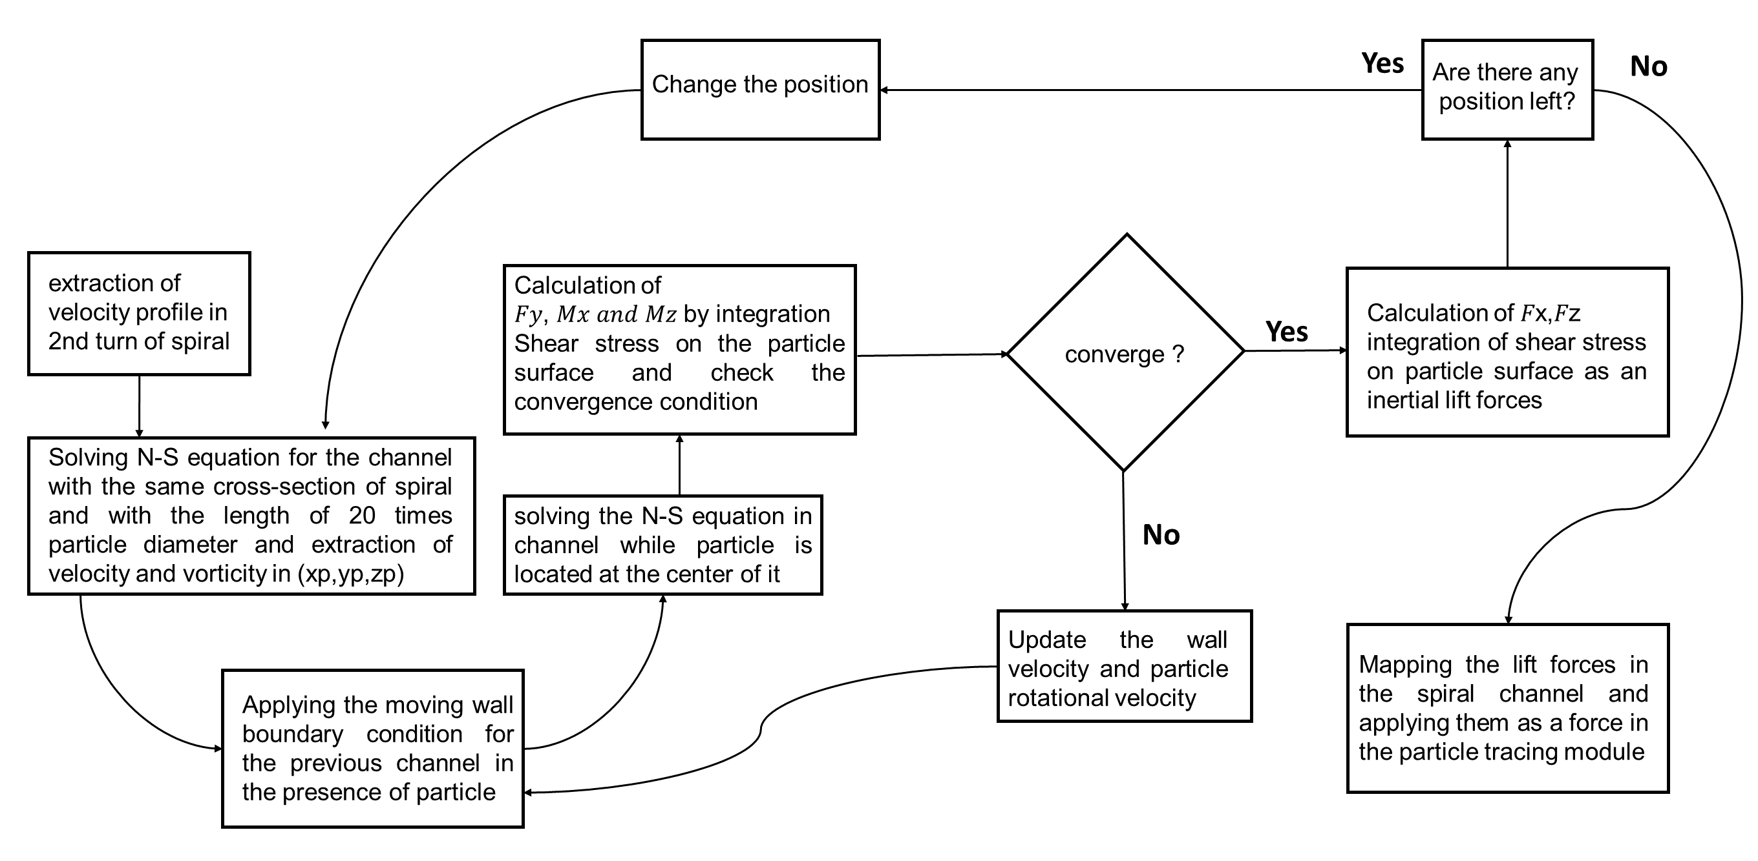
Figure S3. Flowchart for the algorithm of calculating the resultant inertial lift force in a rectangular cross-section [11].

S7. The Clausius–Mossotti factor
Figure S4.The real part of the Clausius–Mossotti factor, $Re[f_{CM}]$, for blood cells and CTCs as a function of frequency. The cells modeled by core-shell approach and the required information for calculation of $Re[f_{CM}]$ are given in table S2.

S8. Microfluidic device fabrication
At the beginning, the pattern of the microchannel was designed using the AutoCAD 2000 software. A silicon wafer, as a substrate, was rinsed with, sequentially, acetone, isopropyl alcohol, as well as double-distilled water and, then, dried with a nitrogen stream. Afterwards, hexamethyl disilazane was coated on the substrate using a spin coater (SC5, Samaneh Tajhiz) at 750 rpm for 60 s to improve the photoresist adhesion to the wafer. The negative photoresist, SU8-2050, Microchem, was coated on the wafer to achieve 170 μm thickness. To this end, based on the Microchem datasheet, the photoresist was poured on the wafer surface. The spin-coater angular velocity was increased to 750 rpm in 2.5 s, and was kept at the angular velocity for 57.5 s. Subsequently, the velocity was increased to 1400 rpm in 4.7 s, and was kept at the angular velocity for 55.3 s. Finally, the spin-coater was stopped. The angular velocity of the spin coater was increased or decreased at a constant ramp of 300 rpm s⁻¹ for all steps.
The resulting wafer was sequentially baked on a hot plate at 65 ºC for 4 min and 95 ºC for 19.5 min. After that, a negative photomask was placed on the baked wafer and, then, was exposed to the ultra-violet light (UV) for 60 s. The exposed substrate was sequentially baked at 65 ºC for 1 min and 95 ºC for 9.5 min. After the post-exposure bake, the substrate was immersed in a developing solution for 9.5 min. Finally, the substrate was baked at 150 ºC for 2 min after visual inspection.
After preparation of the master mold (figure S5a), 10 g polydimethylsiloxane (PDMS) was mixed with 1 g of its curing agent (Sylgard 184, Dow Corning). After degassing the resulting mixture, it was poured on the prepared mold and, then, cured in a vacuum oven at 80 ºC and 0.4 mbar for 2 h. Finally, the PDMS layer was separated from the mold.
In the next step, the following instruction was implemented for fabricating the microelectrodes. First, a thin layer of gold and titanium (120 nm gold and 30 nm titanium) was deposited on a glass substrate (60×60×1 mm³) using the conventional sputtering (SATALAB SP7 sputter). Then, a positive photoresist (Shipley S1813) was coated on the resulting substrate, and, subsequently, baked at 95 ºC for 2 min. After cooling the substrate to room temperature, a photomask was placed on it and exposed to UV light for 80 s. Afterwards, the resulting substrate was placed in the pertinent developing solution and, again, baked at 95 ºC for 1 min. Finally, the extra gold and titanium were removed by wet etching, and the photoresist washed out with acetone (figure S5b).
Despite many DEP-based cell separation platforms employing plasma bonding, a clamp-type bonding was used here in which PDMS and glass were bonded by two poly(methyl methacrylate) sheets (see figure S5c). Without a doubt, each bonding method has its own merits. But our employed bonding method is temporary such that the microchannel and microelectrodes can be separated for cleaning. Another advantage of this bonding method is the suppressed fluid stress-induced PDMS microchannel deformation [19, 20].

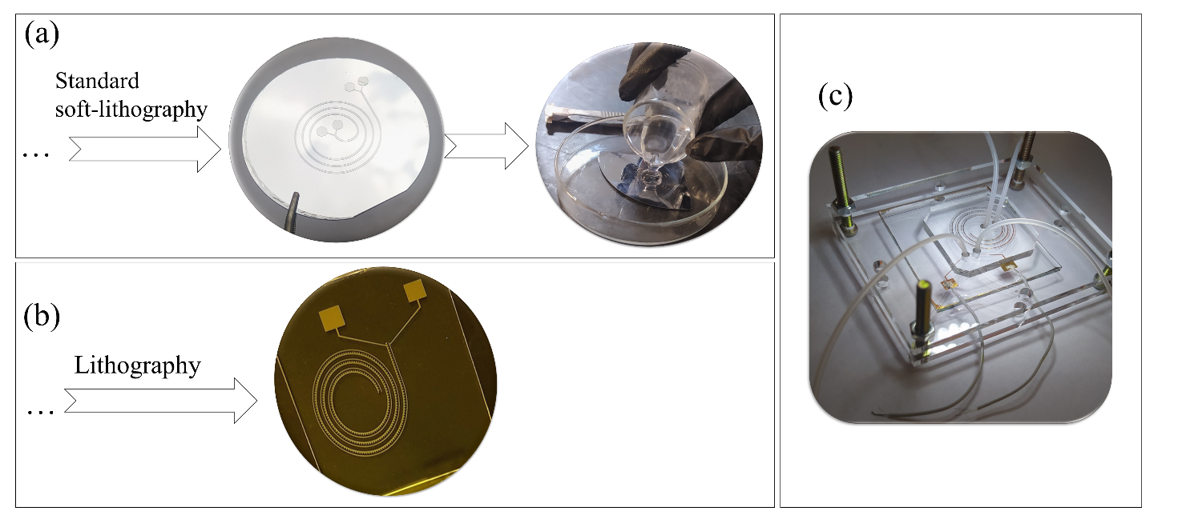
Figure S5. Schematics of the fabrication process. Fabricated mold on a silicon wafer substrate using standard soft-lithography (a). Fabricated microelectrodes on a glass substrate using lithography (b). An image of the spiral-DEP platform, which was prepared by careful alignment and clamp-type bonding of the spiral microchannel and microelectrodes (c).

S9. Sample preparation
In this study, the microfluidic device was tested with two distinct samples: polystyrene microparticles (non-biological sample) and diluted blood samples spiked with MDA-MB-231 cell line (biological sample). The procedure of the sample preparation was comprising two parts, which are explained in the following.
In the first part, polystyrene microparticles with an average diameter of 5 and 15 μm were suspended in deionized water with the conductivity and relative permittivity being, respectively, 2×10⁻⁴ S m⁻¹ and 78.5 [21]. The volume concentration of polystyrene microparticles was adjusted to 0.1 vol.%. Then, Tween 20 (Sigma-Aldrich) at 0.5 wt.% was added to the suspension in order to prevent adhesion and aggregation of microparticles. In addition, the resulting suspension was sonicated in an ultrasonic bath (Pars nahand, Parsonic 2600s) for 30 min.
In the second part, the following procedure was employed for the biological sample preparation. A tumor-derived breast cancer cell line, called MDA-MB-231 as spiked circulating tumor cells, was used to simulate cancer samples for tests. The cells were cultured in high-glucose Dulbecco’s modified Eagle’s medium (DMEM; Gibco brand) in combination with 9 vol.% fetal bovine serum (FBS; Gibco brand) and 1 vol.% penicillin-streptomycin (PS; Gibco brand). As part of the cultivation process, cells were grown in T25 flasks at 37 °C in a humidified incubator with 5 vol.% CO₂. When cells reached 80-90% confluency, they were washed with 1 x PBS and trypsinized with Trypsin-Ethylenediaminetetraacetic acid (EDTA). In addition, the CTCs were stained with a nuclear dye, 4',6-diamidino-2-phenylindole (DAPI; Beyotime Institute of Biotechnology, USA) to have a better visualization of CTCs after separation from other blood cells. To this end, first, the cells were fixed with formaldehyde (4 vol.%), and, then, were stained with DAPI. It must be noted that apart from stained MDA-MB-231 cell lines, we also prepared unstained MDA-MB-231 cell lines sample for viability tests. For this purpose, CTCs were stained with a 0.4 vol.% trypan blue solution at room temperature. Then, the hemocytometer chamber was employed to count dead (blue-stained) and alive (unstained) cells.
The whole blood sample was obtained from a healthy donor for all experiments. EDTA solution (Sigma-Aldrich, product no. E8008) was added to the blood sample (3.5 μL EDTA:1 mL blood) as an anticoagulant. Afterwards, the anticoagulated blood sample was diluted with PBS containing 0.5% (wt./vol.) bovine serum albumin (BSA) at different levels of hematocrit (1, 5, and 10 vol.%). Finally, 2×10⁵ cells mL⁻¹ from MDA-MB-231 cells were added to 20 mL of the diluted blood sample (corresponding to 0.017 vol.%).

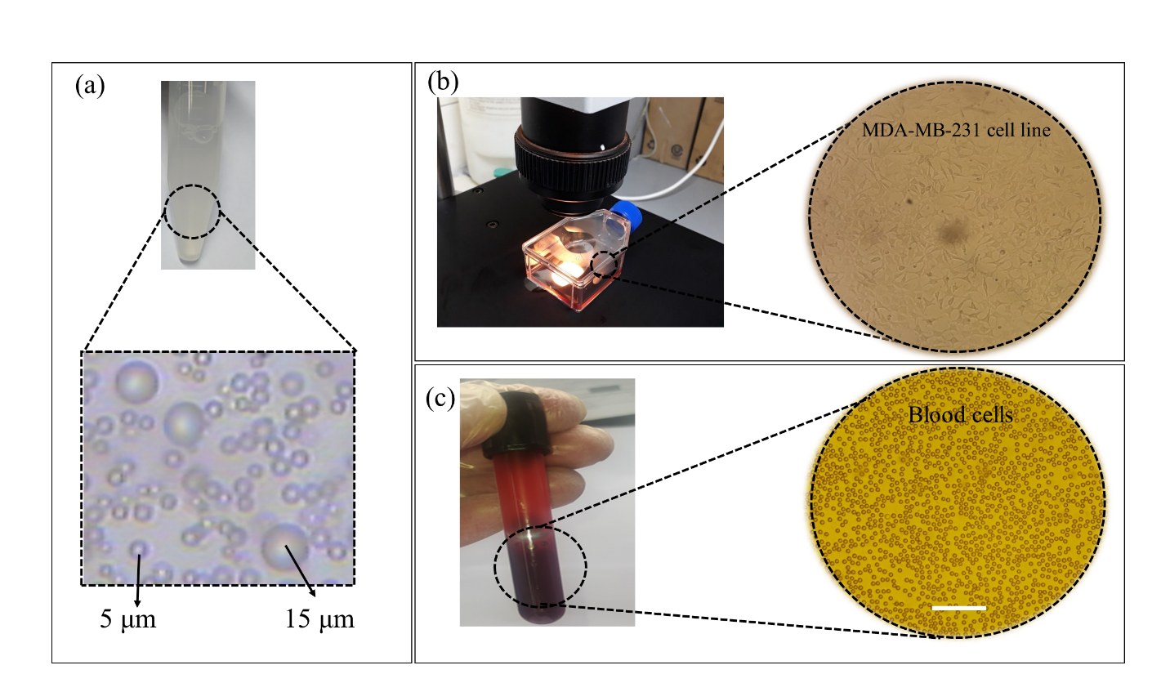
Figure S6. Microscopic image of a binary mixture of 5 and 15 μm polystyrene microparticles that were injected into the microfluidic device (the scale bar is 65 μm) (a). Microscopic image of the live MDA-MB-231 cell line in T25 flask with 90% confluency (the scale bar is 75 μm) (b). Microscopic image of the blood cells in a diluted blood sample with 1% Hct, obtained from a healthy donor (the scale bar is 25 μm) (c).

S10. Operating procedures
Throughout all the experiments, the microfluidic device was mounted on an inverted optical microscope equipped with 60X NA 1.0 water-immersion (UMPLFLN, Olympus) and 10X NA 0.25 air-immersion (PLN, Olympus) objective lenses [22]. While the former lens was employed for determining the distribution of particles/cells sizes via image processing, the latter lens was for measuring the number of particles/cells in the inlets and outlets via a hemocytometer chamber (Marienfeld, Neubauer) and monitoring particles/cells trajectory using a Nikon J5 camera (at the rate of 1200 fps). Moreover, two syringe pumps (HSP 2000, Fanavaran Nano-Meghyas) were utilized for the injection of the sample and sheath fluid (PBS). While the sample flow rate was fixed at 100 μL min⁻¹ in all our experiments, the sheath fluid flow rate was ranged from 150 to 750 μL min⁻¹. An electric field was generated by a function generator (A2510, Afzar Azma) which was amplified by a custom-built high-voltage amplifier to be applied to the microelectrodes via copper wires. The transfer function of the high-voltage amplifier was flat up to 1 MHz.
In the initial experiments, the samples of polystyrene microparticles with PBS, as sheath fluid, were injected into the microfluidic device. Then, the particle size distribution at the inlets and outlets was investigated via image processing. For this purpose, three different samples from the inlet, inner outlet, and outer outlet at various flow rates were analyzed with the ImageJ software version 1.52a.
In the latter experiments, at the beginning, a PBS solution, comprising 0.5% (wt./vol.) BSA, was loaded into the microfluidic device. The loaded microfluidic device was then kept at room temperature for 15 min to prevent cell adhesion to the tubes, microchannel walls, and microelectrodes. Then, the sample and sheath fluid were pumped into the microfluidic device. After each experiment, the samples collected from the inner and outer outlets were examined using the hemocytometer chamber.
In addition, the viability of isolated CTCs is a decisive factor in the development of three-dimensional CTC-derived tumor models for drug discovery applications [23]. In DEP-based cell separation platforms, the effect of DEP on the viability of the CTCs is a critical concern. Accordingly, a trypan blue exclusion assay was performed in inertial and inertial-DEP platforms to measure the viability of the CTCs.

S11. The simulation of the electric-field distribution

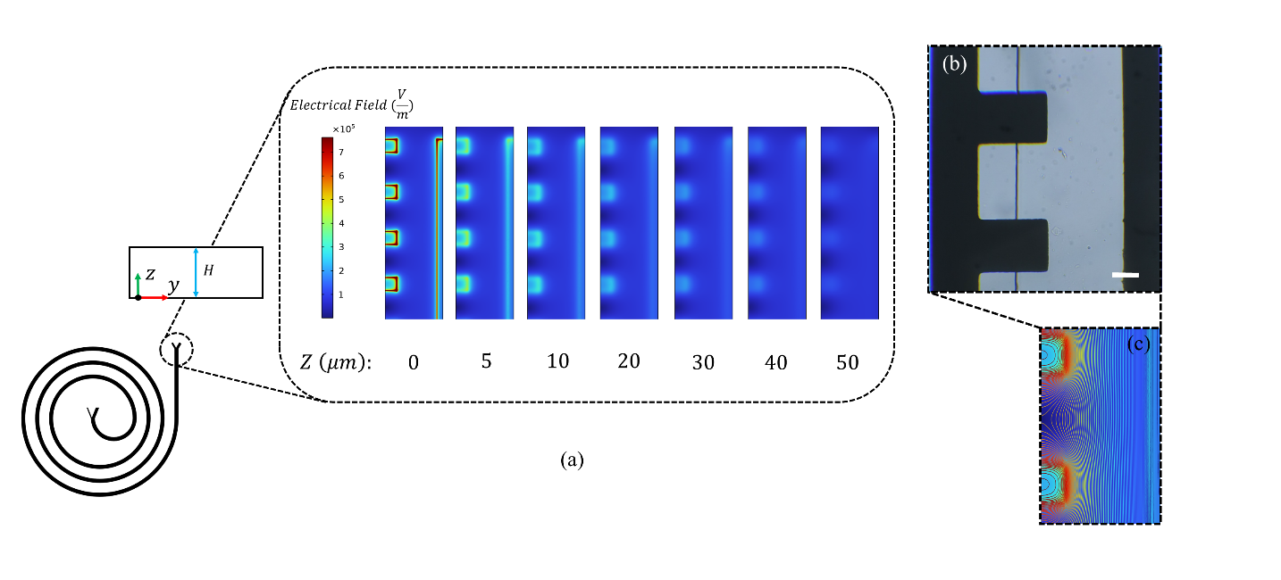
Figure S7. The simulated distribution of electric field at various depths within the microchannel (a). Microscopic image of the fabricated microelectrodes aligned with the spiral microchannel (b). Distribution of the electric field around the microelectrodes (c). The scale bar indicates 100 μm.

S12. The movie
Movie S1
High-speed video (1200 fps) illustrating the position of the 15 μm polystyrene microparticles at the outlet of the spiral-DEP platform at three voltages; 0 V, 20 V, and 50 V.

References
[1] G. Segre, A. Silberberg, Behaviour of macroscopic rigid spheres in Poiseuille flow Part 2. Experimental results and interpretation, Journal of fluid mechanics 14(1) (1962) 136-157.
[2] J. Zhou, I. Papautsky, Fundamentals of inertial focusing in microchannels, Lab on a Chip 13(6) (2013) 1121-1132.
[3] G. Guan, L. Wu, A.A. Bhagat, Z. Li, P.C. Chen, S. Chao, C.J. Ong, J. Han, Spiral microchannel with rectangular and trapezoidal cross-sections for size based particle separation, Scientific reports 3(1) (2013) 1-9.
[4] E.S. Asmolov, The inertial lift on a spherical particle in a plane Poiseuille flow at large channel Reynolds number, Journal of fluid mechanics 381 (1999) 63-87.
[5] S. Ookawara, R. Higashi, D. Street, K. Ogawa, Feasibility study on concentration of slurry and classification of contained particles by microchannel, Chemical Engineering Journal 101(1-3) (2004) 171-178.
[6] S. Ookawara, D. Street, K. Ogawa, Numerical study on development of particle concentration profiles in a curved microchannel, Chemical engineering science 61(11) (2006) 3714-3724.
[7] H.W. Hou, M.E. Warkiani, B.L. Khoo, Z.R. Li, R.A. Soo, D.S.-W. Tan, W.-T. Lim, J. Han, A.A.S. Bhagat, C.T. Lim, Isolation and retrieval of circulating tumor cells using centrifugal forces, Scientific reports 3(1) (2013) 1-8.
[8] H. Zhang, H. Chang, P. Neuzil, DEP-on-a-chip: Dielectrophoresis applied to microfluidic platforms, Micromachines 10(6) (2019) 423.
[9] F.J. Gijsen, F.N. van de Vosse, J. Janssen, The influence of the non-Newtonian properties of blood on the flow in large arteries: steady flow in a carotid bifurcation model, Journal of biomechanics 32(6) (1999) 601-608.
[10] B. Ho, L. Leal, Inertial migration of rigid spheres in two-dimensional unidirectional flows, Journal of fluid mechanics 65(2) (1974) 365-400.
[11] D. Di Carlo, J.F. Edd, K.J. Humphry, H.A. Stone, M. Toner, Particle segregation and dynamics in confined flows, Physical review letters 102(9) (2009) 094503.
[12] A. Mohammadi, Transport in droplet-hydrogel composites: response to external stimuli, Colloid and Polymer Science 293(3) (2015) 941-962.
[13] J. Sun, M. Li, C. Liu, Y. Zhang, D. Liu, W. Liu, G. Hu, X. Jiang, Double spiral microchannel for label-free tumor cell separation and enrichment, Lab on a chip 12(20) (2012) 3952-3960.
[14] A. Valero, T. Braschler, P. Renaud, A unified approach to dielectric single cell analysis: Impedance and dielectrophoretic force spectroscopy, Lab on a Chip 10(17) (2010) 2216-2225.
[15] N. Piacentini, G. Mernier, R. Tornay, P. Renaud, Separation of platelets from other blood cells in continuous-flow by dielectrophoresis field-flow-fractionation, Biomicrofluidics 5(3) (2011) 034122.
[16] A. Aghilinejad, M. Aghaamoo, X. Chen, J. Xu, Effects of electrothermal vortices on insulator‐based dielectrophoresis for circulating tumor cell separation, Electrophoresis 39(5-6) (2018) 869-877.
[17] M. Aghaamoo, A. Aghilinejad, X. Chen, J. Xu, On the design of deterministic dielectrophoresis for continuous separation of circulating tumor cells from peripheral blood cells, Electrophoresis 40(10) (2019) 1486-1493.
[18] J. Su, X. Chen, Y. Zhu, G. Hu, Machine learning assisted fast prediction of inertial lift in microchannels, Lab on a Chip 21(13) (2021) 2544-2556.
[19] S.R. Bazaz, A. Mihandust, R. Salomon, H.A.N. Joushani, W. Li, H.A. Amiri, F. Mirakhorli, S. Zhand, J. Shrestha, M. Miansari, Zigzag microchannel for rigid inertial separation and enrichment (Z-RISE) of cells and particles, Lab on a Chip 22(21) (2022) 4093-4109.
[20] J. Shrestha, S.R. Bazaz, L. Ding, S. Vasilescu, S. Idrees, B. Söderström, P.M. Hansbro, M. Ghadiri, M.E. Warkiani, Rapid separation of bacteria from primary nasal samples using inertial microfluidics, Lab on a Chip 23(1) (2023) 146-156.
[21] B. Yafouz, N.A. Kadri, F. Ibrahim, Dielectrophoretic manipulation and separation of microparticles using microarray dot electrodes, Sensors 14(4) (2014) 6356-6369.
[22] M.-S. Seyedkarimi, H. Mirzadeh, A. Mohammadi, S. Bagheri-Khoulenjani, Mechanical Characteristics of SPG-178 Hydrogels: Optimizing Viscoelastic Properties through Microrheology and Response Surface Methodology, Iranian Biomedical Journal 24(2) (2020) 110.
[23] S. Sharma, R. Zhuang, M. Long, M. Pavlovic, Y. Kang, A. Ilyas, W. Asghar, Circulating tumor cell isolation, culture, and downstream molecular analysis, Biotechnology advances 36(4) (2018) 1063-1078.

Email: amohammadi@sharif.edu

